MLOps Fraud Detection with Autoencoders – Assignment Report

GitHub Repository
• MLopsAutoencoder GitHub Repository: https://github.com/LovepreetSinghGhuman/MLopsAutoencoder.git
• Demo Video:

Project Overview
This project demonstrates a complete MLOps workflow for fraud detection using an autoencoder neural network. The solution covers data preprocessing, model training on Azure ML, automated CI/CD with GitHub Actions, and deployment to Kubernetes (AKS) with a user-friendly frontend.

Data & Preprocessing
- Dataset: IEEE-CIS Fraud Detection dataset (preprocessed).
- Preprocessing: Data cleaning, feature engineering, and scaling are performed in both the notebook and src/train.py. Steps include log-transforming transaction amounts, device info grouping, and feature scaling.
- Artifacts: Cleaned and reduced datasets are stored in Data/Processed/.

Model
- Type: Autoencoder neural network for anomaly detection.
- Training Script: src/train.py
- Artifacts: Model, scaler, config, and threshold are saved in models/.

Task 1: Cloud Training (Azure ML)
- Service: Azure ML is used for model training and retraining.
- Automation: Training is triggered by GitHub Actions (.github/workflows/azure-pipelines-ci-cd.yaml), which submits a pipeline job (deployment/pipeline-job.yaml) using a registered component (deployment/train-component.yaml).
- Artifacts: Model files are downloaded after training and used for deployment.
- Reproducibility: All preprocessing steps are consistent between notebook, training script, and API.
Screenshots to include:
- Azure ML job submission and completion (portal or CLI).
- Pipeline run in GitHub Actions.
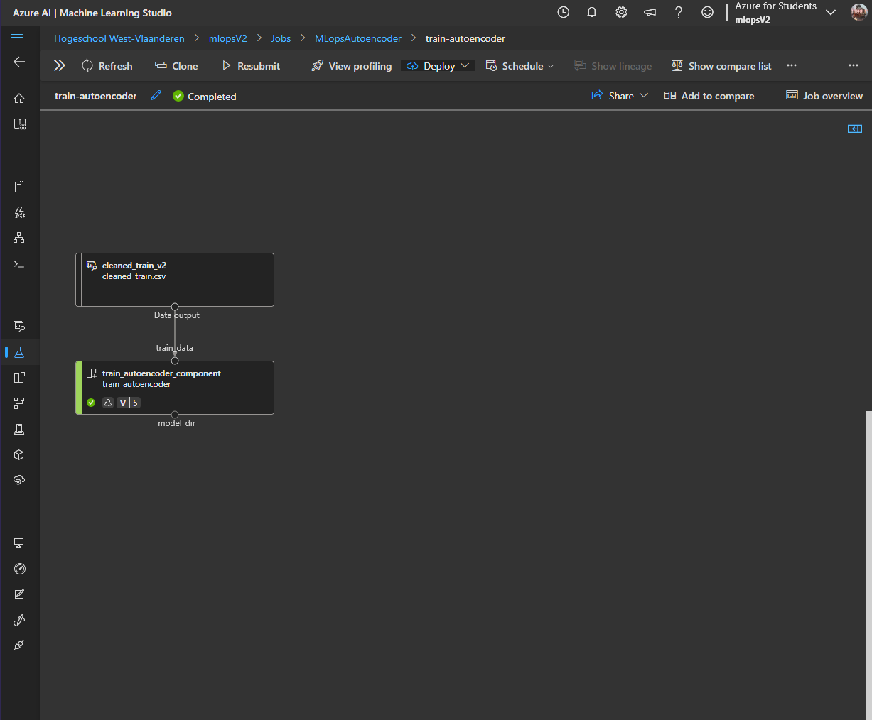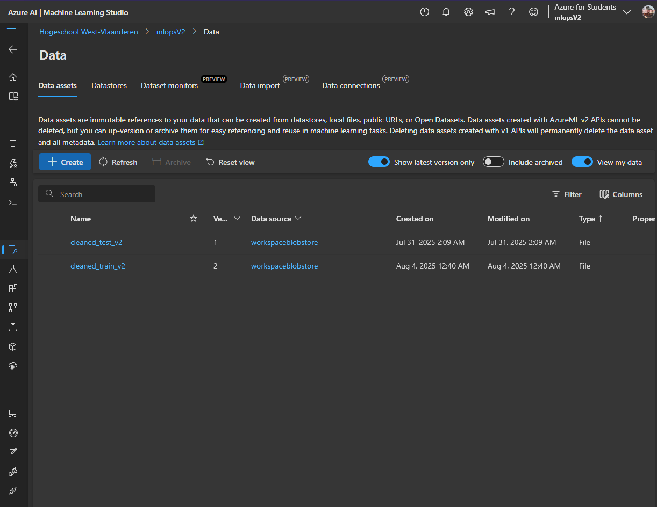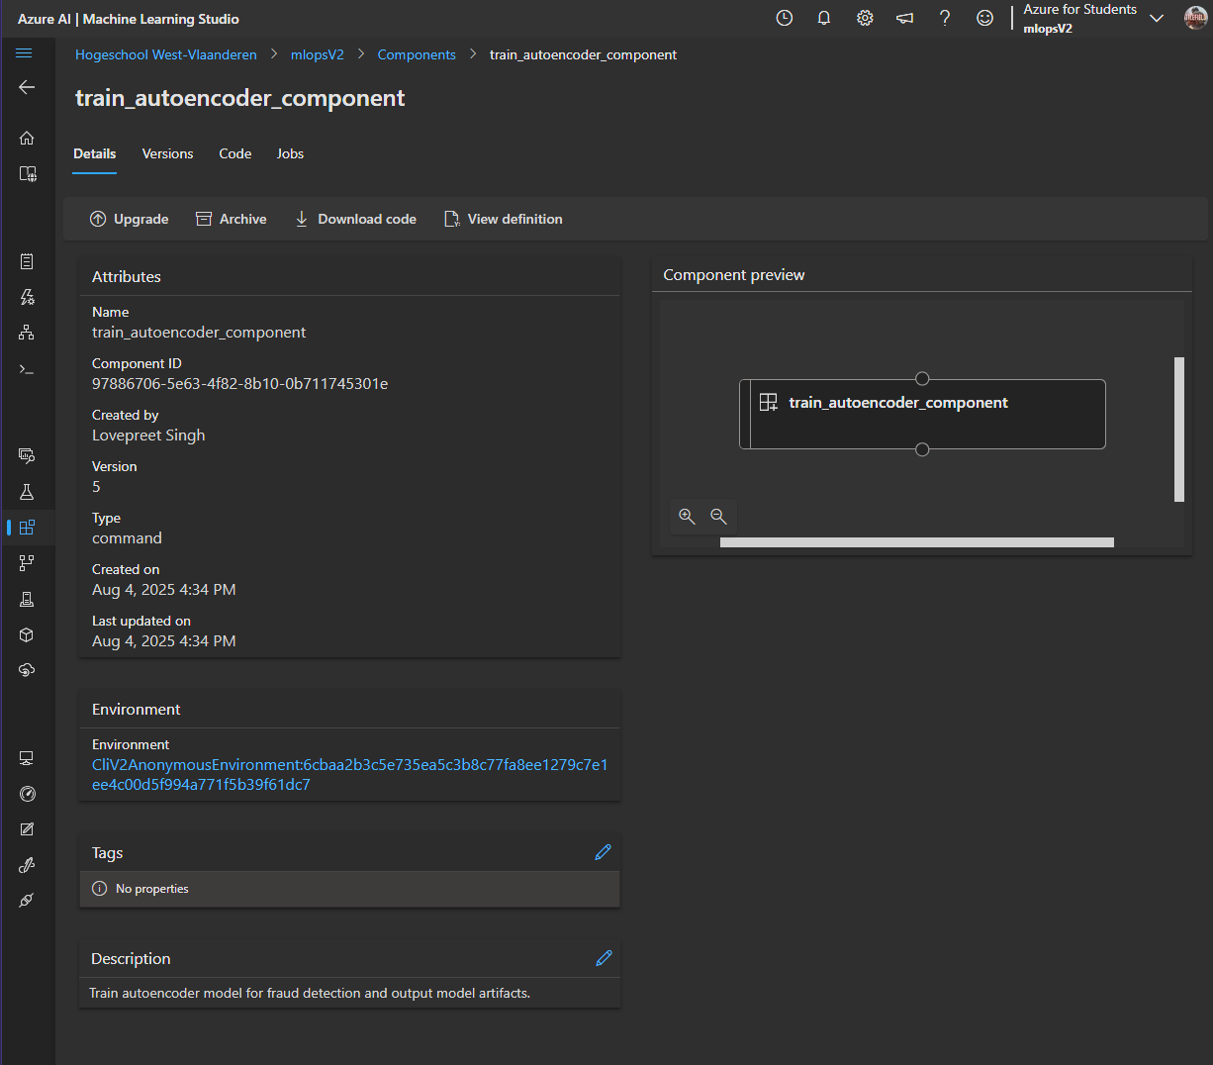

Task 2: Kubernetes Deployment
- Backend: FastAPI app (src/score.py), containerized with deployment/Dockerfile.
- Frontend: Responsive HTML/CSS/JS (frontend/index.html, frontend/style.css, frontend/script.js), served by NGINX (frontend/Dockerfile).
- Kubernetes Manifests: Backend (deployment/k8s/deployment.yaml, deployment/k8s/service.yaml), Frontend (frontend/frontend-nginx-deployment.yaml, frontend/frontend-nginx-service.yaml), Ingress (deployment/k8s/ingress.yaml).
- Ingress: NGINX Ingress controller is installed and configured for routing and public access.
- User Interaction: Users upload a CSV/Excel file and view predictions in a scrollable, styled table.
- Microservice Communication: [User] --> [Frontend (NGINX)] --> [K8s Ingress] --> [FastAPI (Autoencoder)] --> [Model Artifacts]
Screenshots to include:
- Frontend UI (file upload and result table).
- FastAPI /docs page.
- Output of kubectl get pods,svc,ingress. 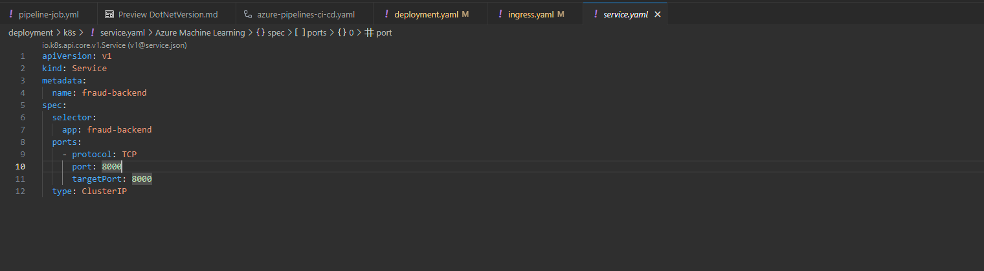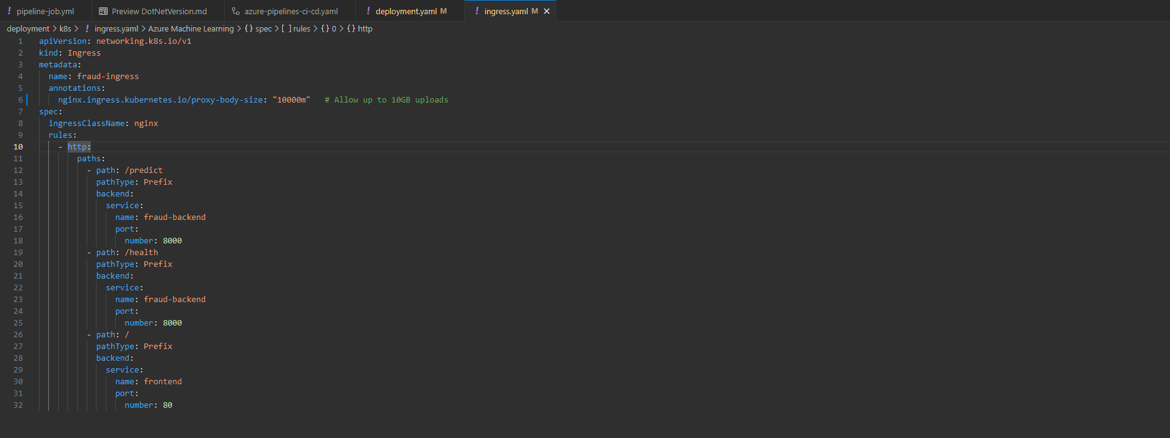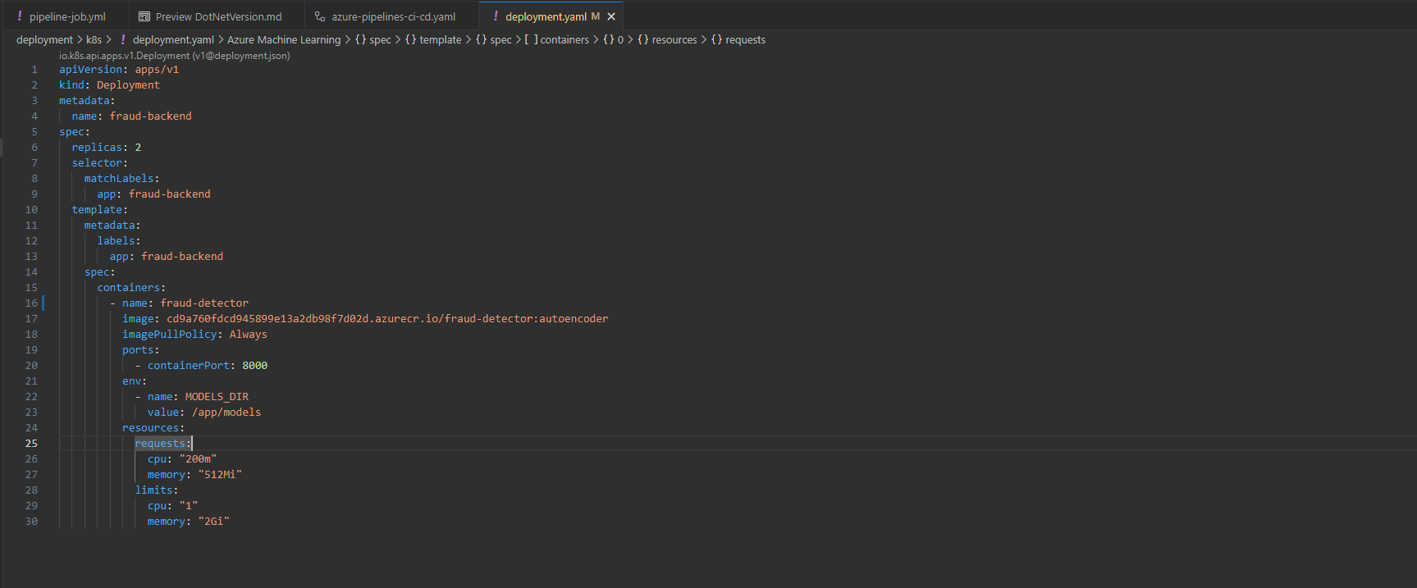
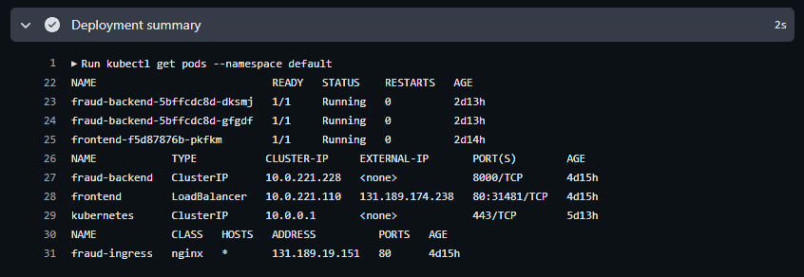

Task 3: CI/CD Automation (GitHub Actions)
- Retraining: On every push to main, the workflow triggers a new Azure ML training job.
- Redeployment: After training, the workflow builds and pushes new Docker images for backend and frontend, and updates the AKS deployments.
- Minimal Manual Steps: All steps are automated after code is pushed to main.
- Model Versioning: Handled via Azure ML's model registry.
- Secrets: Managed via GitHub Actions secrets.
Screenshots to include:
- GitHub Actions workflow runs (showing retrain, build, deploy steps).

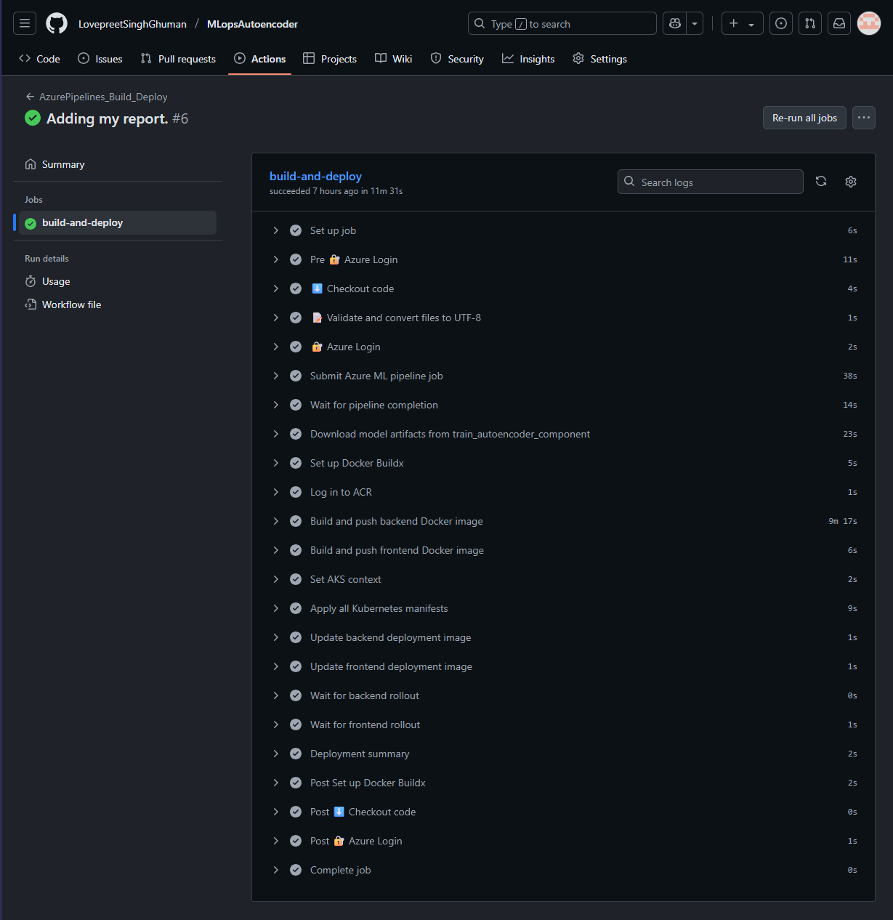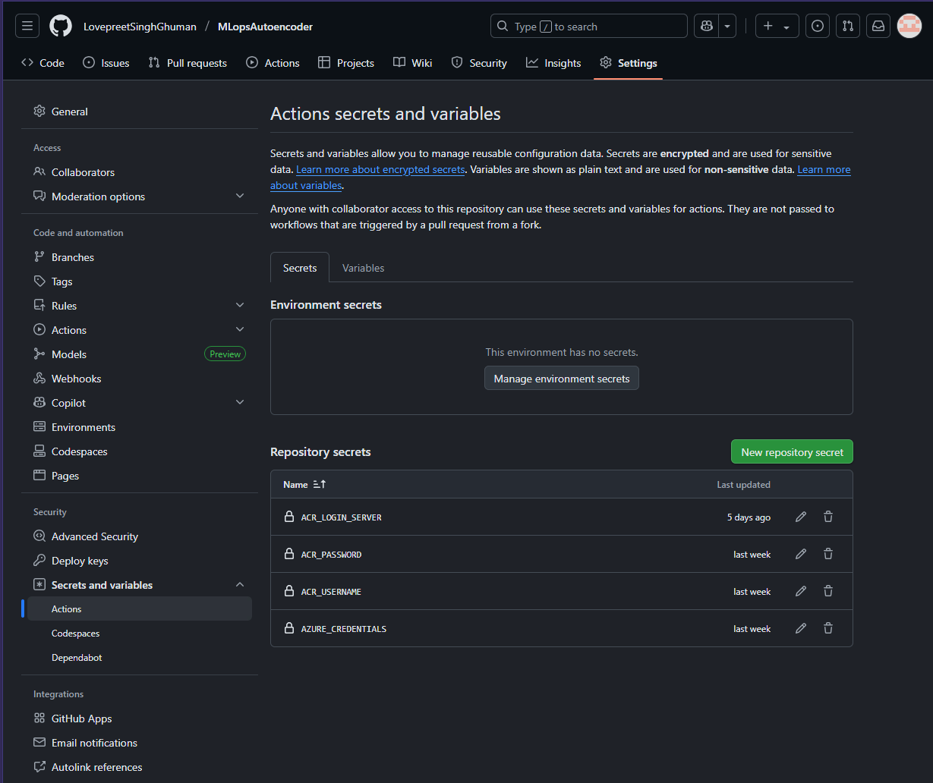

Reflection
During this project, I learned how to orchestrate a full MLOps pipeline using Azure ML, Kubernetes, and GitHub Actions. The most challenging part was ensuring reproducibility between local and cloud environments, especially for data preprocessing and model artifact management. I solved this by centralizing all preprocessing logic in shared scripts and automating artifact handling in the pipeline. Setting up the NGINX Ingress controller and ARM64 Docker builds for AKS also required extra troubleshooting, but provided valuable experience with real-world cloud deployment issues.

Demo Video
A short demo video is included, showing:
- The frontend UI for file upload and result display.
- The FastAPI /docs page.
- The running Kubernetes cluster (kubectl get pods,svc,ingress).

Additional Notes
- All files are UTF-8 encoded and checked in the pipeline.
- Model artifacts are managed by the pipeline and not tracked in git.
- For any issues, logs are available in GitHub Actions and Kubernetes pods.
Author:
Lovepreet Singh
MLOps and AI design patterns

