# DEVELOP PEAS DESCRIPTION FOR GIVEN AI TASKS

EXPT NO: 1

### AIM:

To develop PEAS description for given AI Tasks.

ALGORITHM:

PEAS stand for a performance measure, environment, Actuator, Sensor.

Performance Measure:

Performance measure is the unit to define the success of an agent. Performance varies with agents based on their different precepts.

Environment:

Environment is the surrounding of an agent at every instant. It keeps changing with time if the agent is set in motion. There are 5 major types of environments.

* Fully observable and partially observable.
* Episodic and sequential.
* Static and Dynamic.
* Discrete and Continuous.
* Deterministic and stochastic.

Actuator:

An actuator is a part of the agent that delivers the output of action to the environment.

Sensor:

Sensors are the receptive part of an agents that takes in the input for the agent.

PROGRAM:

import java.util.Scanner;

public class ChatBot {

String[][] chatBot = {

{"hi", "hello", "hola", "ola", "howdy"},

{"hi", "hello", "hey"},

{"how are you", "how r you", "how r u", "how are u"},

{"good", "doing well"},

{"yes"},

{"no", "NO", "NO!!!!!!!"},

{"good", "bye", "I am not supposed to say"}

};

ChatBot() {

Scanner in = new Scanner(System.in);

while (true) {

System.out.print("You: ");

String quote = in.nextLine();

if (quote.equals("exit") || quote.isEmpty()) {

System.out.println("Bye...");

break;

}

System.out.print("Bot: ");

while (

quote.charAt(quote.length() - 1) == '!' ||

quote.charAt(quote.length() - 1) == '.' ||

quote.charAt(quote.length() - 1) == '?'

) {

quote = quote.substring(0, quote.length() - 1);

}

byte response = 0;

int j = 0;

while (response == 0) {

if (inArray(quote.toLowerCase(), chatBot[j * 2])) {

response = 2;

int r = (int) Math.floor(Math.random() * chatBot[(j * 2) + 1].length);

System.out.print(chatBot[(j * 2) + 1][r]);

}

j++;

if (j * 2 == chatBot.length - 1 && response == 0) {

response = 1;

}

}

if (response == 1) {

int r = (int) Math.floor(Math.random() * chatBot[chatBot.length - 1].length);

System.out.print(chatBot[chatBot.length - 1][r]);

}

System.out.println();

}

}

public static void main(String[] args) {

new ChatBot();

}

public boolean inArray(String in, String[] str) {

for (String s : str) if (s.equals(in)) return true;

return false;

}

OUTPUT:

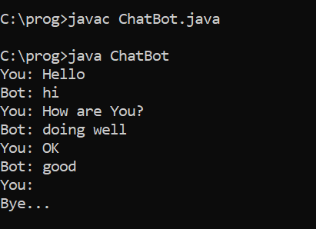

RESULT:

Thus the program to develop PEAS description for given AI Tasks.

# DEPTH FIRST SEARCH

EXPT NO: 2a

### AIM:

To write a code to perform depth first search using Depth first search algorithm.

ALGORITHM:

Step 1: Create a class graph for representing directional graph.

Step 2: Call a function add edges to the graph.

Step 3: Mark all not visited vertices.

Step 4: Call helper function point DFS.

Step 5: End.

PROGRAM:

import java.util.*;

class DFS {

private final int V;

private final LinkedList<Integer>[] adj;

@SuppressWarnings("unchecked")

DFS(int v) {

V = v;

adj = new LinkedList[v];

for (int i = 0; i < v; ++i)

adj[i] = new LinkedList();

}

public static void main(String[] args) {

DFS g = new DFS(4);

g.addEdge(0, 1);

g.addEdge(0, 2);

g.addEdge(1, 2);

g.addEdge(2, 0);

g.addEdge(2, 3);

g.addEdge(3, 3);

System.out.println("Following is Depth First Traversal");

g.DFS();

}

void addEdge(int v, int w) {

adj[v].add(w);

}

void DFSUtil(int v, boolean[] visited) {

visited[v] = true;

System.out.print(v + " ");

for (int n : adj[v]) {

if (!visited[n])

DFSUtil(n, visited);

}

}

void DFS() {

boolean[] visited = new boolean[V];

for (int i = 0; i < V; ++i)

if (!visited[i])

DFSUtil(i, visited);

}

}

OUTPUT:

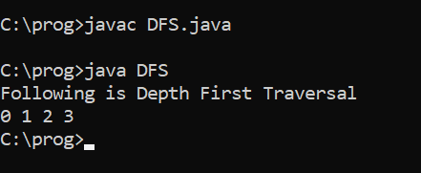

RESULT:

Thus the java program for implementing using DFS is successfully executed.

# BREADTH FIRST SEARCH

EXPT NO: 2b

### AIM:

To write a java program to print the BFS traversal from the given source vertex.

ALGORITHM:

Step 1: Create a class graph for representing directed graph.

Step 2: Create a constructor.

Step 3: Call a function to add an edge into the graph.

Step 4: Make all the vertices as not visited.

Step 5: Create a queue for BFS.

Step 6: Make the current node as visited and enqueue it.

Step 7: Print statement.

Step 8: End.

PROGRAM:

import java.util.*;

class BFS {

private final int V;

private final LinkedList<Integer>[] adj;

@SuppressWarnings("unchecked")

BFS(int v) {

V = v;

adj = new LinkedList[v];

for (int i = 0; i < v; ++i) adj[i] = new LinkedList();

}

public static void main(String[] args) {

BFS g = new BFS(4);

g.addEdge(0, 1);

g.addEdge(0, 2);

g.addEdge(1, 2);

g.addEdge(2, 0);

g.addEdge(2, 3);

g.addEdge(3, 3);

System.out.println("Following is Breadth First Traversal (starting from vertex 2)");

g.BFS(2);

}

void addEdge(int v, int w) {

adj[v].add(w);

}

void BFS(int s) {

boolean[] visited = new boolean[V];

LinkedList<Integer> queue = new LinkedList<Integer>();

visited[s] = true;

queue.add(s);

while (queue.size() != 0) {

s = queue.poll();

System.out.print(s + " ");

for (int n : adj[s]) {

if (!visited[n]) {

visited[n] = true;

queue.add(n);

}

}

}

}

}

OUTPUT:

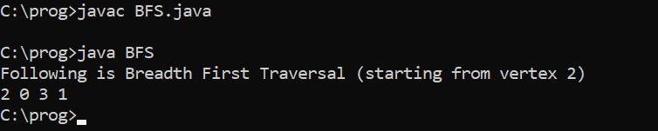

RESULT:

Thus the java program for implementing and executing BFS is executed successfully.

# IMPLEMENT A* AND MEMORY BOUNDED A* ALGORITHMS

EXPT NO: 3

### AIM:

To implement A* and memory bounded A*algorithms.

ALGORITHM:

We create two lists – Open list and closed list.

//A* Search Algorithm.

1. Initialize the open list
2. Initialize the closed list

Put the starting mode on the open list (you can leave its f at zero)

1. While the open list is not empty
2. Find the node with the least F on the open list, call it “q”.
3. Pop q off the open list.
4. Generate q’s 8 successors and set their parents to q.
5. For each successor.

If successor is the goal, stop search.

else, compute both g and h for successor.

Successor. g = q. g + distance between successor and q.

Successor. h = distance from goal to successor.

Successor. f = successor. g + successor. h

If a node with same position as successor is in the OPEN list which has a lower f than successor, skip this successor.

If a node with same position as successor is in the CLOSED list which has a lower f than successor, skip this successor otherwise. Add the node to the open list end (for loop).

Push q on the closed list end (while loop).

PROGRAM:

import java.util.*;

public class AstarSearchAlgo {

public static void main(String[] args) {

Node n1 = new Node("Arad", 366);

Node n2 = new Node("Zerind", 374);

Node n3 = new Node("Oradea", 380);

Node n4 = new Node("Sibiu", 253);

Node n5 = new Node("Fagaras", 178);

Node n6 = new Node("Rimnicu Vilcea", 193);

Node n7 = new Node("Pitesti", 98);

Node n8 = new Node("Timisoara", 329);

Node n9 = new Node("Lugoj", 244);

Node n10 = new Node("Mehadia", 241);

Node n11 = new Node("Drobeta", 242);

Node n12 = new Node("Craiova", 160);

Node n13 = new Node("Bucharest", 0);

Node n14 = new Node("Giurgiu", 77);

n1.adjacencies = new Edge[]{

new Edge(n2, 75),

new Edge(n4, 140),

new Edge(n8, 118)

};

n2.adjacencies = new Edge[]{

new Edge(n1, 75),

new Edge(n3, 71)

};

n3.adjacencies = new Edge[]{

new Edge(n2, 71),

new Edge(n4, 151)

};

n4.adjacencies = new Edge[]{

new Edge(n1, 140),

new Edge(n5, 99),

new Edge(n3, 151),

new Edge(n6, 80),

};

n5.adjacencies = new Edge[]{

new Edge(n4, 99),

new Edge(n13, 211)

};

n6.adjacencies = new Edge[]{

new Edge(n4, 80),

new Edge(n7, 97),

new Edge(n12, 146)

};

n7.adjacencies = new Edge[]{

new Edge(n6, 97),

new Edge(n13, 101),

new Edge(n12, 138)

};

n8.adjacencies = new Edge[]{

new Edge(n1, 118),

new Edge(n9, 111)

};

n9.adjacencies = new Edge[]{

new Edge(n8, 111),

new Edge(n10, 70)

};

n10.adjacencies = new Edge[]{

new Edge(n9, 70),

new Edge(n11, 75)

};

n11.adjacencies = new Edge[]{

new Edge(n10, 75),

new Edge(n12, 120)

};

n12.adjacencies = new Edge[]{

new Edge(n11, 120),

new Edge(n6, 146),

new Edge(n7, 138)

};

n13.adjacencies = new Edge[]{

new Edge(n7, 101),

new Edge(n14, 90),

new Edge(n5, 211)

};

n14.adjacencies = new Edge[]{

new Edge(n13, 90)

};

AstarSearch(n1, n13);

List<Node> path = printPath(n13);

System.out.println("Path: " + path);

}

public static List<Node> printPath(Node target) {

List<Node> path = new ArrayList<>();

for (Node node = target; node != null; node = node.parent) {

path.add(node);

}

Collections.reverse(path);

return path;

}

public static void AstarSearch(Node source, Node goal) {

Set<Node> explored = new HashSet<>();

PriorityQueue<Node> queue = new PriorityQueue<>(20,

Comparator.comparingDouble(i -> i.f_scores)

);

source.g_scores = 0;

queue.add(source);

boolean found = false;

while ((!queue.isEmpty()) && (!found)) {

Node current = queue.poll();

explored.add(current);

if (current.value.equals(goal.value)) {

found = true;

}

for (Edge e : current.adjacencies) {

Node child = e.target;

double cost = e.cost;

double temp_g_scores = current.g_scores + cost;

double temp_f_scores = temp_g_scores + child.h_scores;

if ((explored.contains(child)) &&

(temp_f_scores >= child.f_scores)) {

} else if ((!queue.contains(child)) ||

(temp_f_scores < child.f_scores)) {

child.parent = current;

child.g_scores = temp_g_scores;

child.f_scores = temp_f_scores;

queue.remove(child);

queue.add(child);

}

}

}

}

}

class Node {

public final String value;

public final double h_scores;

public double g_scores;

public double f_scores = 0;

public Edge[] adjacencies;

public Node parent;

public Node(String val, double hVal) {

value = val;

h_scores = hVal;

}

public String toString() {

return value;

}

}

class Edge {

public final double cost;

public final Node target;

public Edge(Node targetNode, double costVal) {

target = targetNode;

cost = costVal;

}

}

OUTPUT:

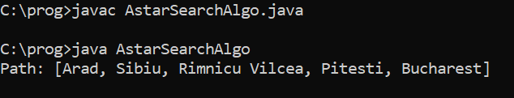

RESULT:

Thus the java program for implementation A* and memory bounded A* Algorithms is executed and verified successfully.

# IMPLEMENT GENETIC ALGORITHMS FOR AI TASKS

EXPT NO: 4

### AIM:

To implement Genetic Algorithm for AI Tasks.

ALGORITHM:

Step 1: Start

Step 2: The first step is to create a population of random bit strings. We could use Boolean values True and False, string values ‘0’ and ‘1’, or integer values 0 and 1. In this case, we will use integer values

Step 3: To use a function named objective () as a generic objective function and call it to get a fitness score.

Step 4: We can then call this function one time for each position in the population to create a list of parents.

Step 5: End.

PROGRAM:

import java.util.Random;

public class SimpleDemoGA {

Population population = new Population();

Individual fittest;

Individual secondFittest;

int generationCount = 0;

public static void main(String[] args) {

Random rn = new Random();

SimpleDemoGA demo = new SimpleDemoGA();

demo.population.initializePopulation();

demo.population.calculateFitness();

System.out.println("Generation: " + demo.generationCount + " Fittest: " + demo.population.fittest);

while (demo.population.fittest < 5) {

++demo.generationCount;

demo.selection();

demo.crossover();

if (rn.nextInt() % 7 < 5) {

demo.mutation();

}

demo.addFittestOffspring();

demo.population.calculateFitness();

System.out.println("Generation: " + demo.generationCount + " Fittest: " + demo.population.fittest);

}

System.out.println("\nSolution found in generation " + demo.generationCount);

System.out.println("Fitness: " + demo.population.getFittest().fitness);

System.out.print("Genes: ");

for (int i = 0; i < 5; i++) {

System.out.print(demo.population.getFittest().genes[i]);

}

System.out.println();

}

void selection() {

fittest = population.getFittest();

secondFittest = population.getSecondFittest();

}

//Crossover

void crossover() {

Random rn = new Random();

int crossOverPoint = rn.nextInt(population.individuals[0].geneLength);

for (int i = 0; i < crossOverPoint; i++) {

int temp = fittest.genes[i];

fittest.genes[i] = secondFittest.genes[i];

secondFittest.genes[i] = temp;

}

}

void mutation() {

Random rn = new Random();

int mutationPoint = rn.nextInt(population.individuals[0].geneLength);

if (fittest.genes[mutationPoint] == 0) {

fittest.genes[mutationPoint] = 1;

} else {

fittest.genes[mutationPoint] = 0;

}

mutationPoint = rn.nextInt(population.individuals[0].geneLength);

if (secondFittest.genes[mutationPoint] == 0) {

secondFittest.genes[mutationPoint] = 1;

} else {

secondFittest.genes[mutationPoint] = 0;

}

}

Individual getFittestOffspring() {

if (fittest.fitness > secondFittest.fitness) {

return fittest;

}

return secondFittest;

}

void addFittestOffspring() {

fittest.calcFitness();

secondFittest.calcFitness();

int leastFittestIndex = population.getLeastFittestIndex();

population.individuals[leastFittestIndex] = getFittestOffspring();

}

}

class Individual {

int fitness;

int[] genes = new int[5];

int geneLength = 5;

public Individual() {

Random rn = new Random();

for (int i = 0; i < genes.length; i++) {

genes[i] = Math.abs(rn.nextInt() % 2);

}

fitness = 0;

}

public void calcFitness() {

fitness = 0;

for (int i = 0; i < 5; i++) {

if (genes[i] == 1) {

++fitness;

}

}

}

}

class Population {

Individual[] individuals = new Individual[10];

int fittest = 0;

public void initializePopulation() {

for (int i = 0; i < individuals.length; i++) {

individuals[i] = new Individual();

}

}

public Individual getFittest() {

int maxFit = Integer.MIN_VALUE;

int maxFitIndex = 0;

for (int i = 0; i < individuals.length; i++) {

if (maxFit <= individuals[i].fitness) {

maxFit = individuals[i].fitness;

maxFitIndex = i;

}

}

fittest = individuals[maxFitIndex].fitness;

return individuals[maxFitIndex];

}

public Individual getSecondFittest() {

int maxFit1 = 0;

int maxFit2 = 0;

for (int i = 0; i < individuals.length; i++) {

if (individuals[i].fitness > individuals[maxFit1].fitness) {

maxFit2 = maxFit1;

maxFit1 = i;

} else if (individuals[i].fitness > individuals[maxFit2].fitness) {

maxFit2 = i;

}

}

return individuals[maxFit2];

}

public int getLeastFittestIndex() {

int minFitVal = Integer.MAX_VALUE;

int minFitIndex = 0;

for (int i = 0; i < individuals.length; i++) {

if (minFitVal >= individuals[i].fitness) {

minFitVal = individuals[i].fitness;

minFitIndex = i;

}

}

return minFitIndex;

}

public void calculateFitness() {

for (Individual individual : individuals) {

individual.calcFitness();

}

getFittest();

}

}

OUTPUT:

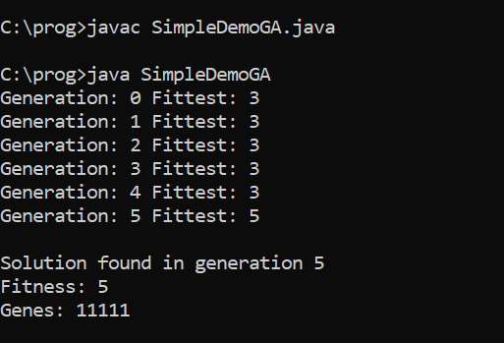

RESULT:

Thus the program to implement Genetic Algorithms for AI Tasks has been executed and verified successfully.

IMPLEMENT SIMULATED ANNEALING ALGORITHMS FOR AI TASKS

EXPT NO: 5

AIM:

To implement Simulated Annealing algorithms for AI Tasks.

ALGORITHM:

Step 1: Start

Step 2: initial_temp = 90

final_temp = .1

alpha = 0.01

current_temp = initial_temp

Step 3: Set initial state and set it as the solution. You can set it up as a particular state or generate it randomly.

current_state = initial_state

solution = current_state

Step 4: Repeat this process until the current temperature is less than the final temperature.

while current_temp > final_temp

Step 5: For each iteration, we will get a random neighbor of the current state ( the following state that we of from the current state)

neighbor = random.choice(self.get_neighbors())

cost_diff = self.get_cost(self.current_state) = self.get_cost(neighbour)

Step 6: End

PROGRAM:

import java.util.Arrays;

public class SimulatedAnnealing {

static final double Tmin = .0001;

static final double alpha = 0.9;

static final int numIterations = 100;

static final int M = 5, N = 5;

public static double T = 1;

public static void main(String[] args) {

String[][] sourceArray = new String[M][N];

Solution min = new Solution(Double.MAX_VALUE, null);

Solution currentSol = genRandSol();

while (T > Tmin) {

for (int i = 0; i < numIterations; i++) {

if (currentSol.CVRMSE < min.CVRMSE) {

min = currentSol;

break;

}

Solution newSol = neighbor(currentSol);

double ap = Math.pow(Math.E,

(currentSol.CVRMSE - newSol.CVRMSE) / T);

if (ap > Math.random())

currentSol = newSol;

}

T *= alpha;

}

System.out.println(min.CVRMSE + "\n\n");

for (String[] row : sourceArray) Arrays.fill(row, "X");

for (int object : min.config) {

int[] coord = indexToPoints(object);

sourceArray[coord[0]][coord[1]] = "-";

}

for (String[] row : sourceArray)

System.out.println(Arrays.toString(row));

}

public static Solution neighbor(Solution currentSol) {

return currentSol;

}

public static Solution genRandSol() {

int[] a = {1, 2, 3, 4, 5};

return new Solution(-1, a);

}

public static int[] indexToPoints(int index) {

return new int[]{index % M, index / M};

}

static class Solution {

public double CVRMSE;

public int[] config;

public Solution(double CVRMSE, int[] configuration) {

this.CVRMSE = CVRMSE;

config = configuration;

}

}

}

OUTPUT:

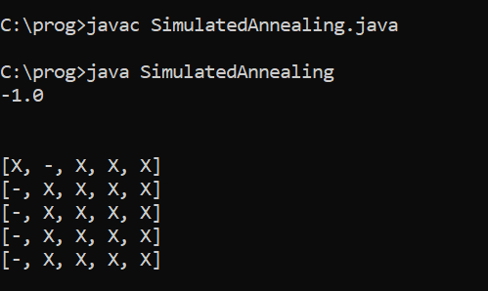

RESULT:

Thus the program to implement Simulated Annealing algorithm for AI Tasks is executed and verified successfully.

IMPLEMENT ALPHA-BETA TREE SEARCH

EXPT NO: 6

AIM:

To implement Alpha-Beta Tree Search with MINIMAX

ALGORITHM:

Step 1: Start

Step 2: Start with the initial move and define the worst-class alpha and beta values, I.e, α = -∞ and β = +∞. Since the initial value of alpha is less than beta so we didn’t prune it. Now it’s my turn for MAX. So at node D, the value of alpha will be calculated.

Step 3: Now the next move will be on node B and its turn for MIN now, Som at node B, the value of alpha- beta will be MIN

Step 4: In the next step the algorithm again comes to node A from node B. At node A Alpha will be changed to maximum value as MAX

Step 5: At node F the value of Alpha will be compared to the left branch which is 0

Step 6: Now node F will return the node value 1 to C and will compare the beta value at C. Now its turn for MIN

Step 7: Return Output

Step 8: Stop

PROGRAM:

class CFG{

static int MAX = 1000;

static int MIN = -1000;

static int minmax(int depth, int nodeIndex, boolean maximizingPlayer,

int[] values, int alpha, int beta){

if (depth==3) return values[nodeIndex];

if (maximizingPlayer){

int best = MIN;

for (int i =0; i<2; i++){

int val = minmax(depth+1, nodeIndex*2+i, false,

values, alpha, beta);

best = Math.max(best, val);

alpha = Math.max(alpha, best);

if (beta<=alpha) break;

}

return best;

}

else

{

int best = MAX;

for (int i = 0; i<2; i++){

int val = minmax(depth+1, nodeIndex*2+i, true,

values, alpha, beta);

best = Math.min(best, val);

beta = Math.min(beta, best);

if (beta<=alpha) break;

}

return best;

}

}

public static void main(String[] args){

int[] values = {3, 5, 6, 9, 1, 2, 0, -1};

System.out.println("The Optimal Value is: "+

minmax(0, 0, true, values, MIN, MAX));

}

}

OUTPUT:

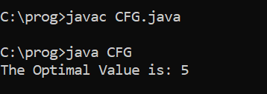

RESULT:

Thus the program to implement alpha-beta search with MINIMAX is executed and verified successfully.

IMPLEMENT BACKTRACKING ALGORITHMS FOR CSP

EXPT: 7

AIM:

To implement backtracking algorithms for CSP with N-Queens Problem.

ALGORITHM:

Step 1: Start

Step 2: A utility function to check if a queen can be placed on board[row][col]. Note that this function is called when “col” queens are already placed in columns from 0 to col-1. So we need to check only the left side for attacking queens.

Step 3: Check upper and lower diagonal on left side.

Step 4: Consider each column and try placing the queen in all rows one by one.

Step 5: Return Output

Step 6: Stop

PROGRAM:

public class NQueenproblem {

final int N = 4;

void printSolution(int board[][])

{

for (int i = 0; i < N; i++) {

for (int j = 0; j < N; j++)

System.out.print(" " + board[i][j] + " ");

System.out.println();

}

}

Boolean isSafe( int board[][], int row, int col)

{

int i, j;

for (i = 0; i < col; i++)

if (board[row][i] == 1)

return false;

for (i = row, j = col; i >= 0 && j >= 0; i--, j--)

if (board[i][j] == 1)

return false;

for (i = row, j = col; j >= 0 && i < N; i++, j--)

if (board[i][j] == 1)

return false;

return true;

}

boolean solveNQUtil(int board[][], int col)

{

if (col >= N)

return true;

for (int i = 0; i < N; i++) {

if (isSafe(board, i , col)) {

board[i][col] = 1;

if (solveNQUtil(board, col + 1) == true)

return true;

board[i][col] = 0;

}

}

return false;

}

boolean solveNQ()

{

int board[][] = { { 0, 0, 0, 0 },{ 0, 0, 0, 0 },{ 0, 0, 0, 0 },{ 0, 0, 0, 0 } };

if (solveNQUtil(board, 0) == false) {

System.out.print("Solution does not exist");

return false;

}

printSolution(board);

return true;

}

public static void main(String args[])

{

NQueenproblem Queen = new NQueenproblem();

Queen.solveNQ();

}

}

OUTPUT: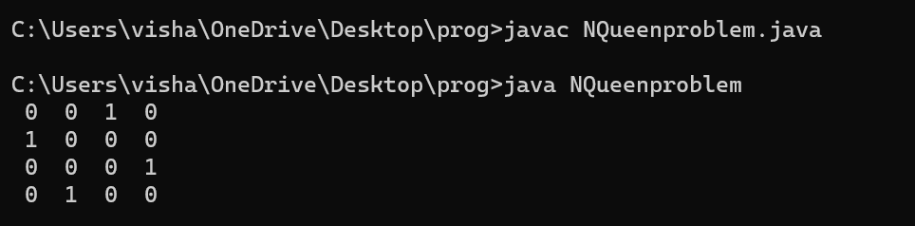

RESULT:

Thus the program to implement backtracking algorithms for CSP with N-Queens Problem is executed and verified successfully.

IMPLEMENT LOCAL SEARCH STRATEGIES FOR SELECTED AI APPLICATIONS

EXPT: 8

AIM:

To implement local search strategies for selected AI Applications such as Depth-First Search.

ALGORITHM:

Step 1: Start

Step 2: From collections import default dict

Step 3: Mark the current node as visited

Step 4: Recur for all the vertices

Step 5: Create a set to store visited vertices

Step 6: Call the recursive helper function

Step 7: Return Output

Step 8: Stop

PROGRAM:

import java.util.*;

public class JavaApplication5

{

Integer weight[]={25,8,20,6,12,0};

int[][] graph={{0,1,1,0,0,0},

{1,0,1,1,0,0},

{1,1,0,0,1,0},

{0,1,0,0,1,1},

{0,0,1,1,0,1},

{0,0,0,1,1,0}};

int[] FLAG_ARR={0,0,0,0,0,0};

int[] temp=new int[3];

List successors(int i)

{

List t=new Vector();

FLAG_ARR[i]=1;

for(int j=0;j<6;j++)

{

if(graph[i][j]==1 && FLAG_ARR[j]!=1)

{

t.add(weight[j]);

}

else if(FLAG_ARR[j]==1)

t.remove(weight[j]);

}

return t;

}

public static void main(String[] args)

{

JavaApplication5 jap=new JavaApplication5();

ArrayList que=new ArrayList();

int a=0;

for(int i=0;i<6;i++)

{

if(a==5)

{

System.out.println("SUCCESSFULLY IMPLEMENTED");

break;

}

else

{

que.addAll(jap.successors(a));

Collections.sort(que);

}

a=Arrays.asList(jap.weight).indexOf(que.get(0));

System.out.print(a);

if(que.isEmpty())

System.out.print("FAILURE");

que.remove(0);

System.out.println(que);

}

}}

OUTPUT:

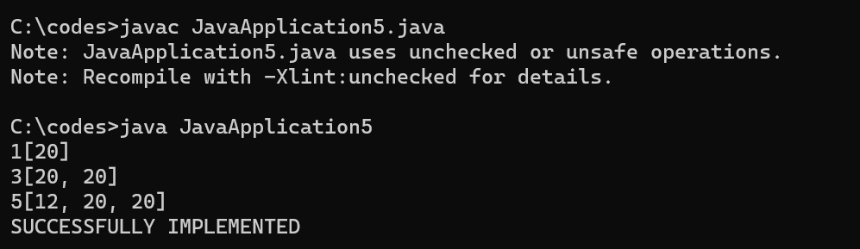

RESULT:

Thus the program to implement local search strategies for selected AI Applications is executed and verified successfully.

IMPLEMENT PROPOSITIONAL LOGIC INFERENCES FOR AI TASKS

EXPT: 9

AIM:

To implement propositional logic inferences for AI tasks

ALGORITHMS:

* Propositional logic is also called Boolean logic as it works on 0 and 1.
* In propositional logic, we sue symbolic variables to represent the logic, and we can use any symbol for representing a proposition, such A,B,C,P,Q,R, etc.
* Propositions can be wither true or false, but it cannot be both.
* Propositional logic consists of an object, relations or function, and Logical Connectives.
* These connectives are also called logical operators.
* The propositions and connectives are the basic elements of the propositional logic.
* Connectives can be said as a logical operator which connects two sentences.
* A proposition formula which is always true is called tautology, and it is also called a valid sentence.
* A proposition formula which is always false is called Contradiction.
* A proposition formula which has both true and false values is called
* Statements which are questions, commands, or opinions, are not propositions such as “Where is Rohini”, “How are you”, “What is your name”, are not propositions.

PROGRAM:

public class PropConstant implements Wff {

private String propConstant;

public PropConstant(String str) {

this.propConstant = str;

}

public String toString() {

return propConstant;

}

public boolean eval(Valuation val) {

return val.get(this);

}

}

import java.util.HashMap;

public class Valuation {

HashMap<PropConstant, Boolean> val = new HashMap<PropConstant, Boolean>();

public boolean get(PropConstant propConstant) {

return val.get(propConstant);

}

public Boolean put(PropConstant propConstant, boolean tv) {

return val.put(propConstant, tv);

}

}

public enum Operator {

NEG("~"), AND("&"), OR("|"), IMP("->"), IFF("<->");

private String symbol;

Operator(String symbol) {

this.symbol = symbol;

}

public String toString() {

return symbol;

}

}

public class PropLogicLauncher {

public static void main(String[] args) {

PropConstant p = new PropConstant("P");

PropConstant q = new PropConstant("Q");

PropConstant r = new PropConstant("R");

Wff e0 = new NotWff(p);

Wff e1 = new AndWff(q, e0);

Wff e2 = new OrWff(e1, p);

Wff e3 = new IfWff(e1, p);

Wff e4 = new NotWff(e2);

System.out.println("Display form of Wff e0 is: " + e0);

System.out.println("Display form of Wff e1 is: " + e1);

System.out.println("Display form of Wff e2 is: " + e2);

System.out.println("Display form of Wff e3 is: " + e3);

System.out.println("Display form of Wff e4 is: " + e4);

System.out.println();

Valuation val = new Valuation();

val.put(p, true);

val.put(q, false);

val.put(r, true);

System.out.println("The value of Wff e0 is: " + e0.eval(val));

System.out.println("The value of Wff e1 is: " + e1.eval(val));

System.out.println("The value of Wff e2 is: " + e2.eval(val));

System.out.println("The value of Wff e3 is: " + e3.eval(val));

System.out.println("The value of Wff e4 is: " + e4.eval(val));

}

}

OUTPUT:

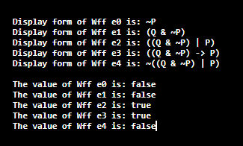

RESULT:

Thus the program to implement propositional logic inferences for AI Tasks has been executed and verified successfully.

IMPLEMENT RESOLUTION BASED FIRST ORDER LOGIC INFERENCES FOR AI TASKS

EXPT: 10

AIM:

To implement resolution based first order logic inferences for AI tasks.

ALGORITHM:

* Conversion of facts into first-order logic.
* Convert FOL statements into CNF.
* Negate the statement which needs to prove (proof by contradiction)
* Draw resolution graph (unification)

PROGRAM:

import java.util.function.Predicate;

import java.util.*;

import java.util.stream.Collectors;

import java.util.stream.Stream;

class User

{

    String name, role;

    User(String a, String b) {

        name = a;

        role = b;

    }

    String getRole() { return role; }

    String getName() { return name; }

    public String toString() {

    return "User Name : " + name + ",

    Role :" + role;

    }

    public static void main(String args[])

    {

        List<User> users =

            new ArrayList<User>();

        users.add(new User("John", "admin"));

        users.add(new User("Peter", "member"));

    List admins = users.stream()

    .filter((user) -> user.getRole().equals("admin"))

    .collect(Collectors.toList());

    System.out.println(admins);

    }

}

OUTPUT:



RESULT:

Thus the program to implement resolution based first order logic inferences for AI tasks has been executed and verified successfully.

IMPLEMENT CLASSICAL PLANNING ALGORITHM

EXPT: 11

AIM:

To implement classical planning algorithm.

ALGORITHM:

Progression (State, goal-list, ʌ, path)

1. If state satisfies each conjunct in goal-list.
2. Then return path.
3. Else let Act = choose from ʌ an action whose precondition is satisfied by state
   1. If no such choice was possible
   2. Then return failure
   3. Else let S= the rest of simulated annealing executions of Act in state and return Progression(S, goal-list, ʌ, Concatenate(path,Act)).

Regression (init-state, cur-goals, ʌ, path)

1. If init-state satisfies each goal in cur-goals.
2. Then return path,
3. Else do:
4. Let Act = choose from ʌ an action whose effects matches at least one conjunct in cur-goals
5. Let G = the results of regression cur-goals through Act
6. If no choice for Act was possible or G is undefined, or G cur-goals
7. Then return failure
8. Else return Regression(init-state, cur-goals, ʌ, path)

PROGRAM:

public class Example1 {

public static void main(String[] args) throws PlPlanException {

System.out.println(quot-- TEST1 --quot);

PLPlan planner = new PLPlan();

planner.setAlgorithm(EnumAlgorithm.GRAPHPLAN);

planner.addFact("td");

planner.addFact("ocd");

planner.addFact("obc");

planner.addFact("oab");

planner.addFact("na");

planner.addGoalFact("oca");

planner.addGoalFact("odb");

planner.addGoalFact("ta");

planner.addGoalFact("tb");

planner.addGoalFact("nc");

planner.addGoalFact("nd");

List<String> precond = new ArrayList<String>();

precond.add("na");

precond.add("oab");

List<String> neg = new ArrayList<String>();

neg.add("oab");

List<String> pos = new ArrayList<String>();

pos.add("ta");

pos.add("nb");

planner.addOperator("uAB",precond, neg, pos);

precond = new ArrayList<String>();

precond.add("nb");

precond.add("obc");

neg = new ArrayList<String>();

neg.add("obc");

pos = new ArrayList<String>();

pos.add("tb");

pos.add("nc");

planner.addOperator("uBC",precond, neg, pos);

precond = new ArrayList<String>();

precond.add("nc");

precond.add("ocd");

neg = new ArrayList<String>();

neg.add("ocd");

pos = new ArrayList<String>();

pos.add("tc");

pos.add("nd");

planner.addOperator("uCD",precond, neg, pos);

precond = new ArrayList<String>();

precond.add("na");

precond.add("tc");

precond.add("nc");

neg = new ArrayList<String>();

neg.add("na");

neg.add("tc");

pos = new ArrayList<String>();

pos.add("oca");

planner.addOperator("sCA", precond, neg, pos);

precond = new ArrayList<String>();

precond.add("nb");

precond.add("td");

precond.add("nd");

neg = new ArrayList<String>();

neg.add("nb");

neg.add("td");

pos = new ArrayList<String>();

pos.add("odb");

planner.addOperator("sDB", precond, neg, pos);

List resultats = planner.findPlan();

System.out.println(resultats);

}

}

OUTPUT:



RESULTS:

Thus the program to implement classical planning algorithm has been executed and verified successfully.