**Ex No:**

**Date:**

**INVOCATION OF SERVLETS FROM HTML FORMS**

To create a servlet application in Netbeans IDE, you will need to follow the following (simple) steps :

1. Open Netbeans IDE, Select **File** -> **New Project**

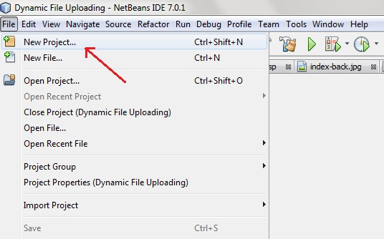

1. Select **Java Web** -> **Web Application**, then click on Next,

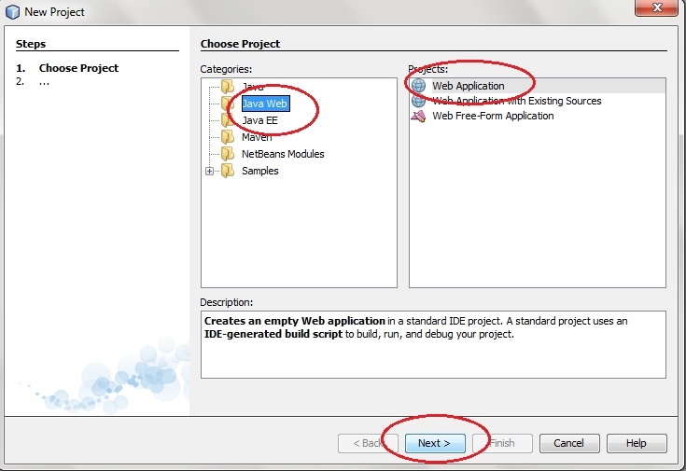

1. Give a name to your project and click on Next,

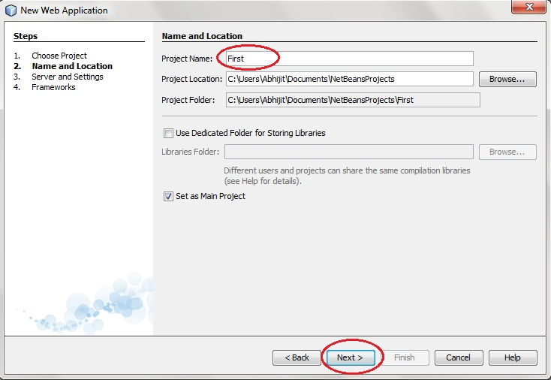

1. and then, Click **Finish**

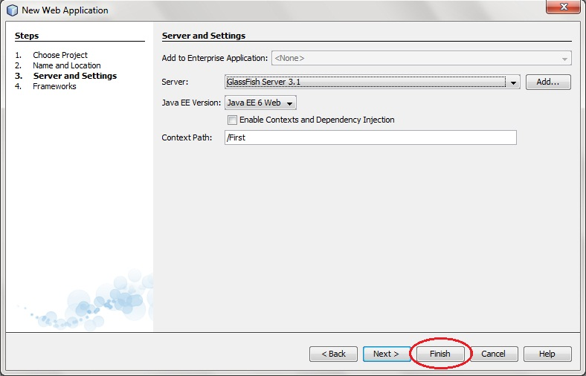

1. The complete directory structure required for the Servlet Application will be created automatically by the IDE.

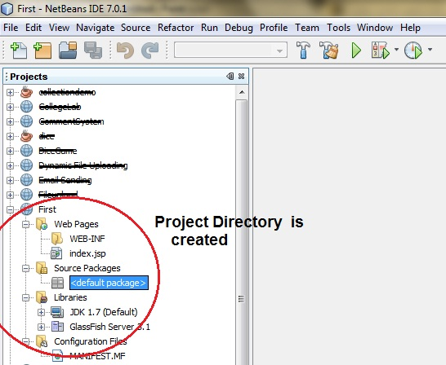

1. To create a Servlet, open **Source Package**, right click on **default packages** -> **New** -> **Servlet**.

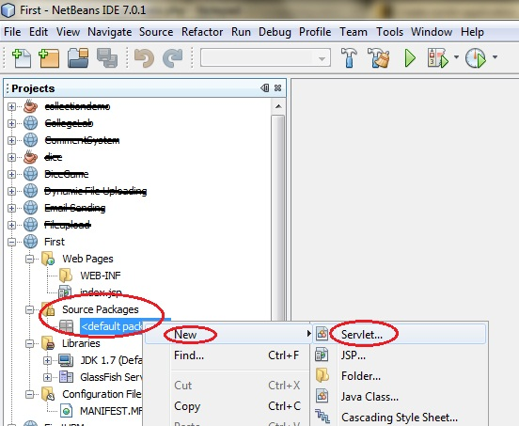

1. Give a Name to your Servlet class file,

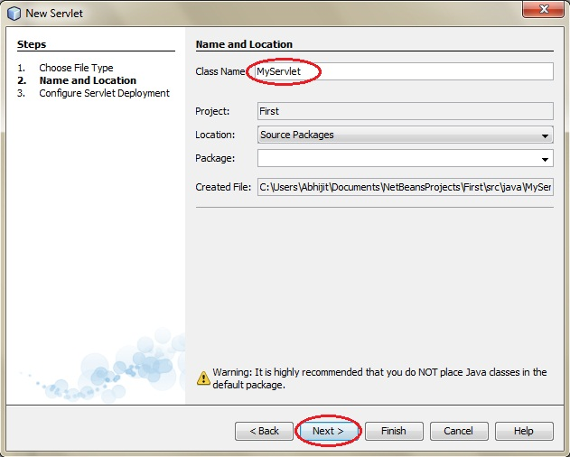

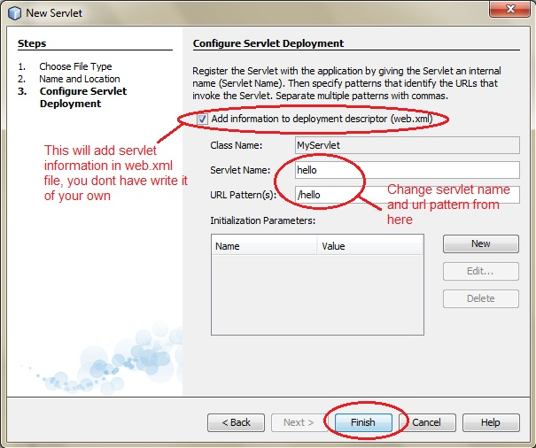

1. Now, your Servlet class is ready, and you just need to change the method definitions and you will good to go.

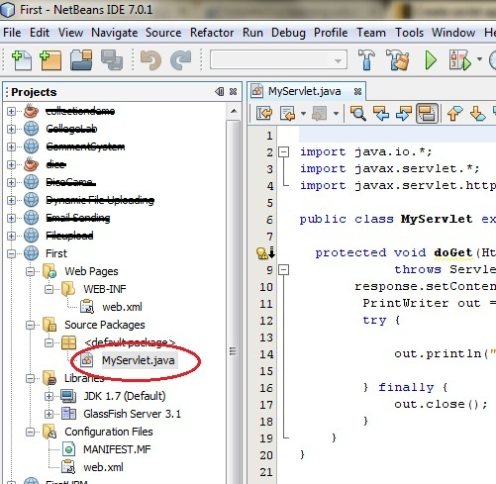

1. Write some code inside your Servlet class.

**MyServlet.java**

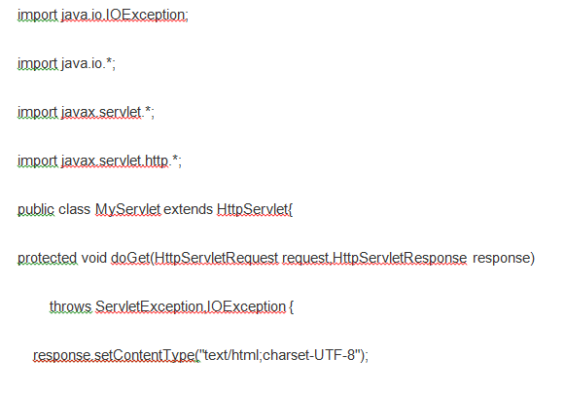

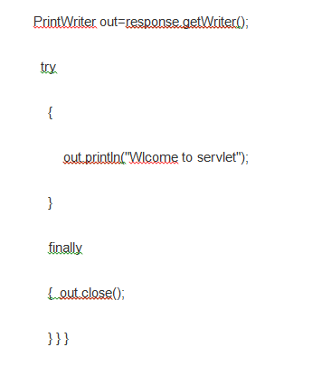

1. Create an HTML file, right click on **Web Pages** -> **New** -> **HTML**

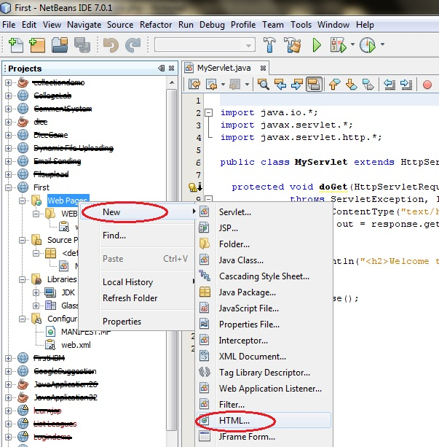

1. Give it a name. We recommend you to name it index, because browser will always pick up the index.html file automatically from a directory. Index file is read as the first page of the web application.

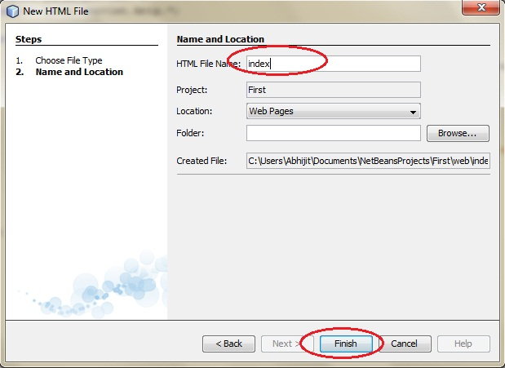

1. Write some code inside your HTML file. We have created a hyperlink to our Servlet in our HTML file.

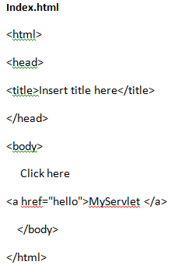

1. Edit **web.xml** file. In the web.xml file you can see, we have specified the **url-pattern** and the **servlet-name**, this means when hello url is accessed our servlet file will be executed.

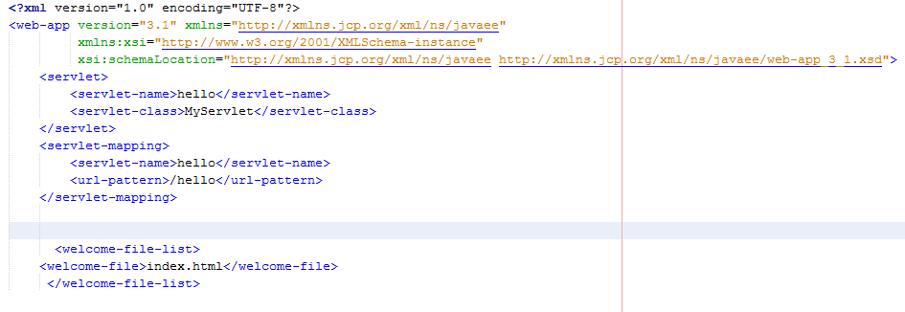**Web.xml**

1. Run your application, right click on your Project and select **Run**

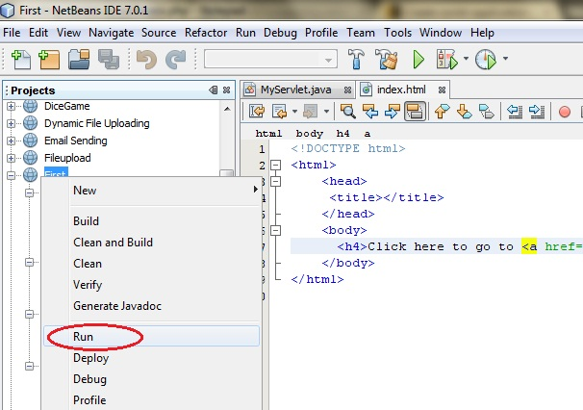

**OUTPUT:**

1. Click on the link created, to open your Servlet.

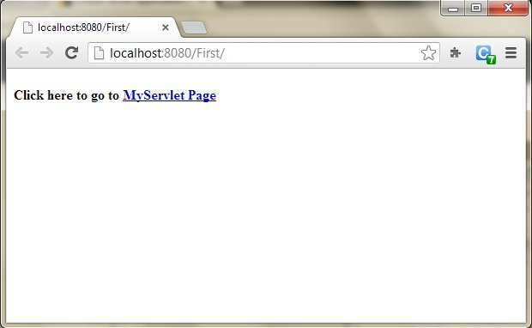

1. Hurray! Our First Servlet class is running.

