**EX NO:**

**DATE:**

**SESSION TRACKING IN SERVLETS**

To create a servlet application in Netbeans IDE, you will need to follow the following (simple) steps :

1. Open Netbeans IDE, Select **File** -> **New Project**

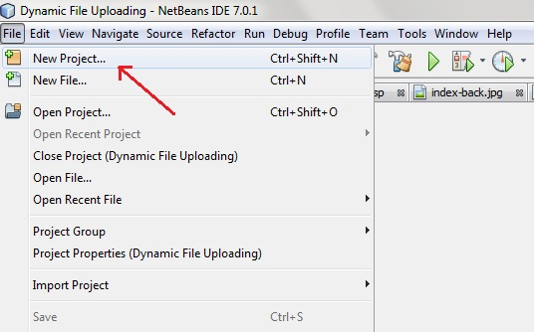

1. Select **Java Web** -> **Web Application**, then click on Next,

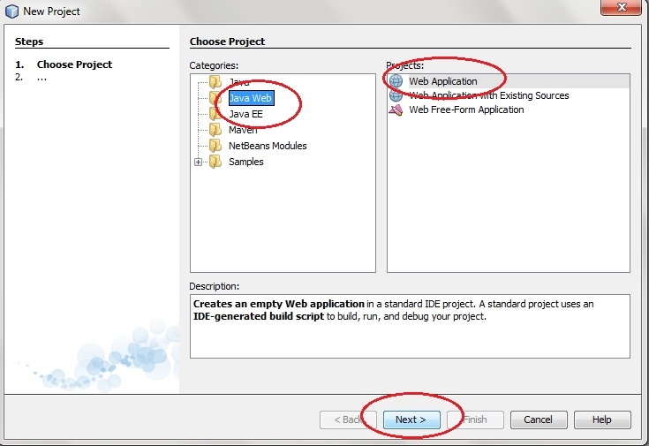

1. 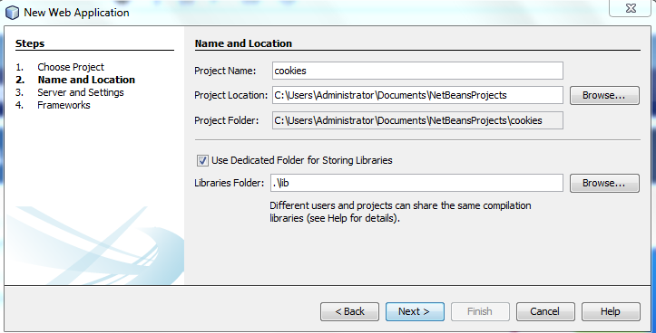 Give a name to your project and click on Next,
2. 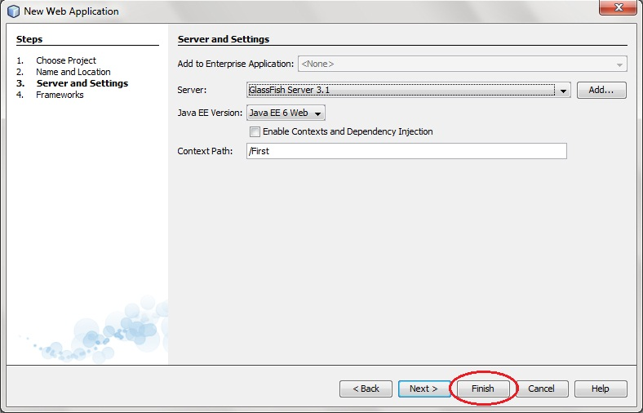and then, Click **Finish**
3. The complete directory structure required for the Servlet Application will be created automatically by the IDE.

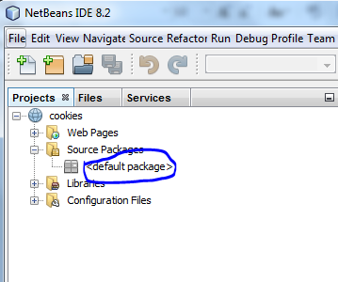

1. To create a Servlet, open **Source Package**, right click on **default packages** -> **New** -> **Servlet**

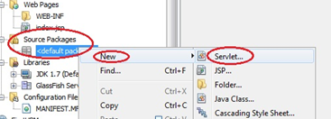

1. Give a Name to your Servlet class file,

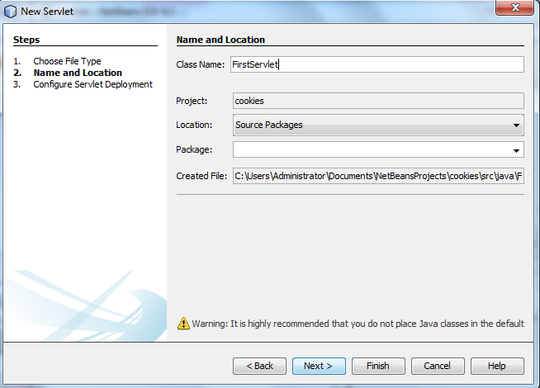

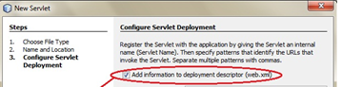

1. Write some code inside your Servlet class.

**FirstServlet.java**

import java.io.*;

import javax.servlet.*;

import javax.servlet.http.*;

public class FirstServlet extends HttpServlet {

public void doPost(HttpServletRequest request, HttpServletResponse response){

try{

response.setContentType("text/html");

PrintWriter out = response.getWriter();

String n=request.getParameter("userName");

out.print("Welcome "+n);

Cookie ck=new Cookie("uname",n);//creating cookie object

response.addCookie(ck);//adding cookie in the response

//creating submit button

out.print("<form action='servlet2' method='post'>");

out.print("<input type='submit' value='go'>");

out.print("</form>");

out.close();

}catch(Exception e){System.out.println(e);}

}}

1. Now create another servlet class and give name as SecondServlet. Then type the code.

**SecondServlet.java**

import java.io.*;

import javax.servlet.*;

import javax.servlet.http.*;

public class SecondServlet extends HttpServlet {

public void doPost(HttpServletRequest request, HttpServletResponse response){

try{

response.setContentType("text/html");

PrintWriter out = response.getWriter();

Cookie ck[]=request.getCookies();

out.print("Hello "+ck[0].getValue());

out.close();

}catch(Exception e){System.out.println(e);}

}

}

1. Write some code inside your HTML file. We have created a hyperlink to our Servlet in our HTML file.

Index.html

<form action="servlet1" method="post">

Name:<input type="text" name="userName"/><br/>

<input type="submit" value="go"/>

</form>

1. Edit **web.xml** file. In the web.xml file you can see, we have specified the **url-pattern** and the **servlet-name**, this means when hello url is accessed our servlet file will be executed.

**Web.xml**

<?xml version="1.0" encoding="UTF-8"?>

<web-app version="2.5"

xmlns="http://java.sun.com/xml/ns/javaee"

xmlns:xsi="http://www.w3.org/2001/XMLSchema-instance"

xsi:schemaLocation="http://java.sun.com/xml/ns/javaee

http://java.sun.com/xml/ns/javaee/web-app_2_5.xsd">

<servlet>

<description>This is the description of my J2EE component</description>

<display-name>This is the display name of my J2EE component</display-name>

<servlet-name>Servlet1</servlet-name>

<servlet-class>FirstServlet</servlet-class>

</servlet>

<servlet>

<description>This is the description of my J2EE component</description>

<display-name>This is the display name of my J2EE component</display-name>

<servlet-name>SecondServlet</servlet-name>

<servlet-class>SecondServlet</servlet-class>

</servlet> <servlet-mapping>

<servlet-name>Servlet1</servlet-name>

<url-pattern>/servlet1</url-pattern>

</servlet-mapping>

<servlet-mapping>

<servlet-name>SecondServlet</servlet-name>

<url-pattern>/servlet2</url-pattern>

</servlet-mapping>

<welcome-file-list>

<welcome-file>index.html</welcome-file>

</welcome-file-list>

</web-app>

**OUTPUT:**

1. 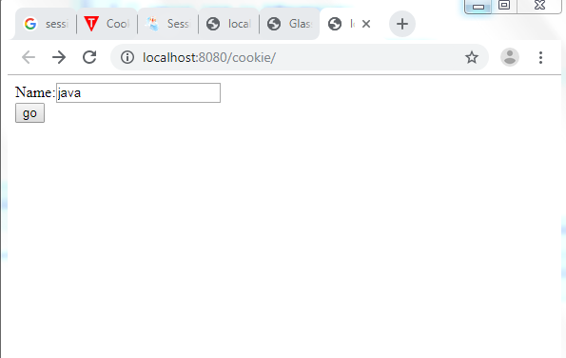Run your application, right click on your Project and select **Run**

