**EX NO:**

**DATE:**

**CONNECTION USING JDBC TO A MICROSOFT ACCESS DATABASE.**

**CREATING A DATABASE:**

 Step 1:Open Microsoft Access and select  **Blank database**option and give the database name as **File name** option

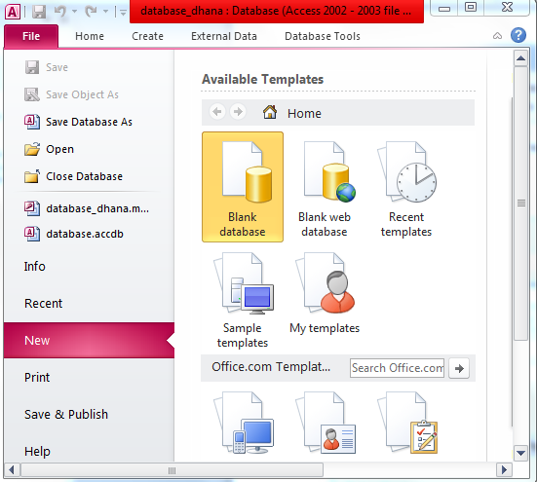

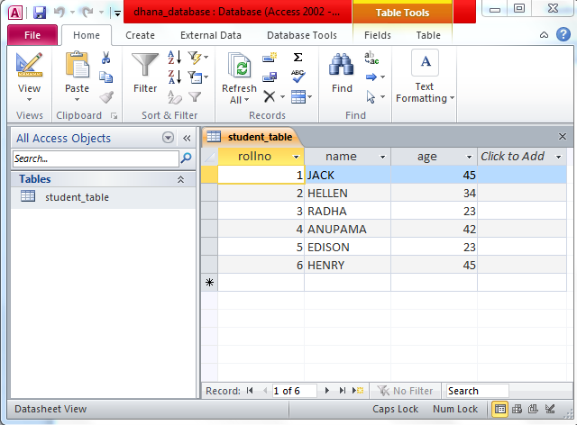Step 2: Create a table and insert your data into the table and save the table with the table name student_table.

Now Creating DSN of your database

**Step 3:** Open your Control Panel and then select Administrative Tools.

**Step 4 :** Click on Data Source(ODBC)-->System DSN.

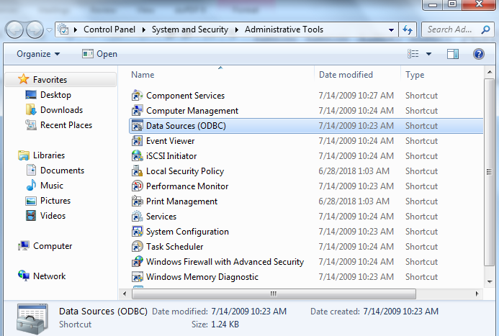

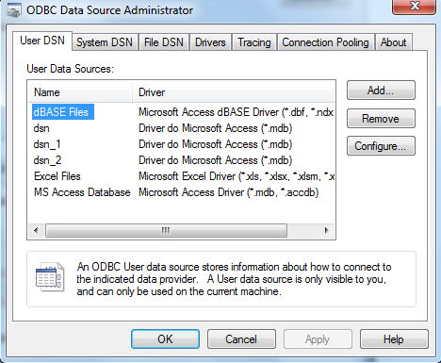

**Step 5:**Now click on **add**option for making a new DSN.select**Microsoft Access Driver (*.mdb. *.accdb)**and then click on**Finish**

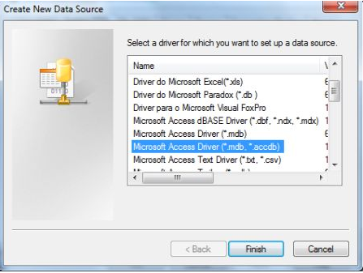

**Step 6:** Make your desired **Data Source Name** and then click on the **Select** option, for example in this article we use the name **mydsn**

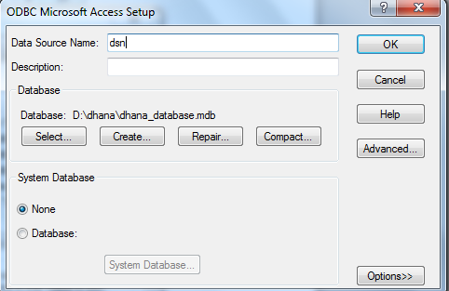

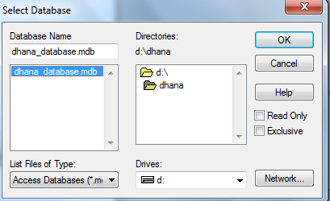**Step 7:** Now you select your data source file for storing it and then click ok and then click on Create and Finish

**Step 8: Java program code**

**MsAccessODBC.java**

import java.sql.*;

public class MsAcessODBC {

public static void main(String[] args) {

try {

// loading thejdbc odbc driver

Class.forName("sun.jdbc.odbc.JdbcOdbcDriver");

// creating connection toth data base

Connection con = DriverManager.getConnection("jdbc:odbc:dsn_2", "", "");

Statement st = con.createStatement();

// create an execute sql command on database

ResultSet rs = st.executeQuery("Select * from student_table order by rollno asc");

ResultSetMetaData rsmd = rs.getMetaData();

// this getColumnCount reurn the number of column in the selected table

int numberOfColumns = rsmd.getColumnCount();

// while loop and with while loop code use for print the data

while (rs.next()) {

for (int i = 1; i <= numberOfColumns; i++) {

if (i > 1)

System.out.print(", ");

String columnValue = rs.getString(i);

System.out.print(columnValue);

}

System.out.println("");

}

st.close();

con.close();

} catch (Exception ex) {

System.err.print("Exception: ");

System.err.println(ex.getMessage());

}

}

}

**OUTPUT:**

