**EX NO:**

**DATE:**

**CLIENT SIDE SCRIPTS FOR VALIDATING WEB**

**FORM CONTROLS**

**validate.html**

<html>

<head> <h1 align=center>Welcome to Validation Checking</h1><hr width=50%> <script language="javascript">

function validation()

{

var x=f.un.value; var len=x.length; var val=x.charCodeAt(0); var p=f.pw.value; var c=f.cpw.value;

var a=f.email.value; var atpos=a.indexOf("@"); var dotpos=a.lastIndexOf("."); if(len<6 || x=='' || x==null)

{

alert("check your username! must be minimum 6 characters"); if(val<65 || val>90 && val <97 || val>122)

alert("username must begin with an alphabet"); return false;

}

else if(val<65 || val>90 && val <97 || val>122)

{

alert("username must begin with an alphabet"); return false;

}

else if(p=='' || c=='' || p.length<6 || c.length<6 || p!=c)

{

alert("Password and Confirm Password should be same and greater than 6 characters!"); return false;

}

else if(atpos<6 || dotpos<atpos+6 || dotpos+2>=a.length)

{

alert("Not a valid email id"); return false;

}

else

alert("Congragulations! you have submited successfully");

}

</script>

</head>

<title> Validation Check! </title> <body>

<table align=center border=1>

<form name="f" action="success.html" onsubmit="return validation();" method="post"> <tr><td>User Name:</td><td><input type="text" name="un"/></td></tr> <tr><td>Password:</td><td><input type="password" name="pw"/></td></tr> <tr><td>Confirm Password:</td><td><input type="password" name="cpw"/></td></tr> <tr><td>E-mail ID:</td><td><input type="text" name="email"/></td></tr> <tr><td></td><td><input type="submit" value="Submit"/></td></tr>

</form></table>

</body>

</html>

**OUTPUT:**

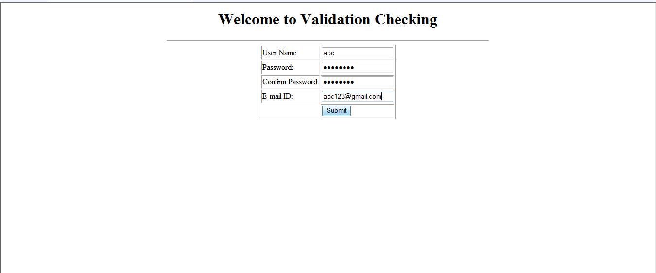

After the details entered and by clicking submit button it show the dialog box as follows:

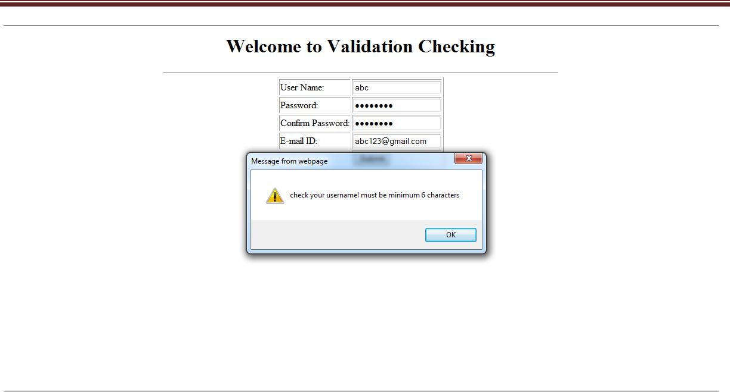

After clicking OK button it is redirected to validate.html

If the username, password, confirm password, and e-mail are entered correctly then it shows the dialog box as follows:

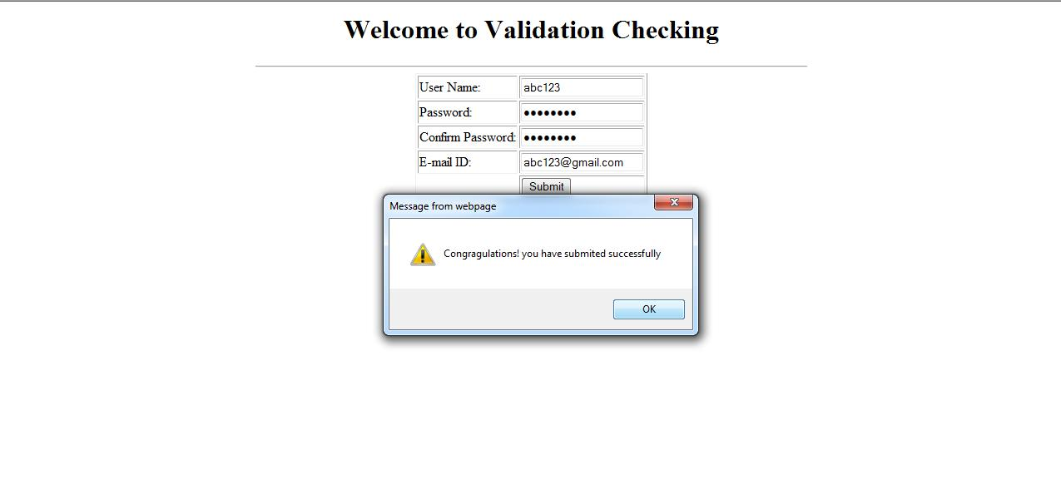

After clicking OK button the page is redirected to success.html