**EX NO:**

**DATE:**

**CSS POSITIONING ELEMENTS**

1. **Absolute.html**

<html>

<head>

<style>

.textpos{

position:absolute;

left:150px;

top:50px;

font-family:aerial;

text-decoration:overline;

text-align:center;

color:green;

}

</style>

</head>

<body>

<p>we are in IT class</p>

<p class="textpos">

are you listening?

</p>

</body>

</html>

**OUTPUT:**

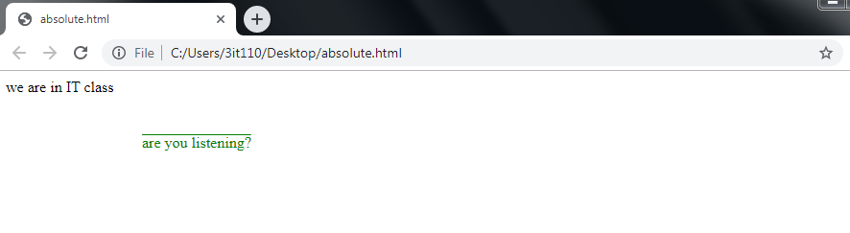

1. **Relative.html**

<html>

<head>

<style>

.textpos{

position:relative;

left:150px;

top:50px;

font-family:aerial;

text-decoration:overline;

text-align:center;

color:green;

}

</style>

</head>

<body>

<p>we are in IT class</p>

<p class="textpos">

are you listening?

</p>

</body>

</html>

**OUTPUT:**

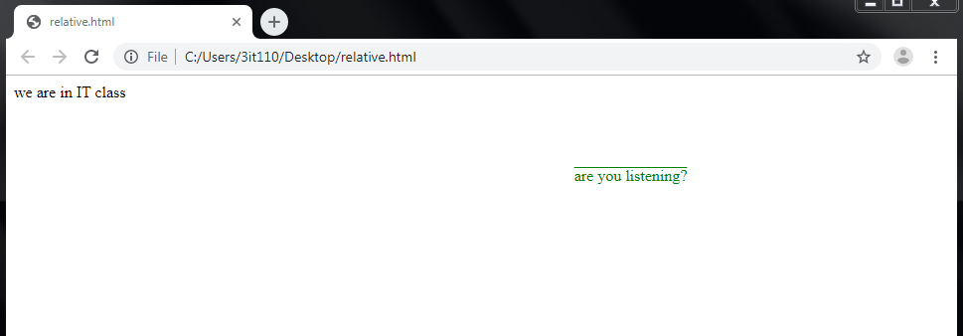

C)  **Float.html**

<html>

<head>

<style>

img{

float:right;

}

</style>

</head>

<body>

<h1> the float property</h1>

<p>in this image is float to right in text</p>

<p><img src="Tulips.jpg"alt="Tulips"style="width:170px;height:170px;margin-left:15px;">

hellooooo hiii how are youuuuu.... welcome to our class</p>

</body>

</html>

**OUTPUT:**

