**EX NO:**

**DATE:**

**CREATE WEB SERVICE APPLICATION**

To create a webservice application in Netbeans IDE, you will need to follow the following (simple) steps:

1. Open Netbeans IDE, Select **File** -> **New Project**

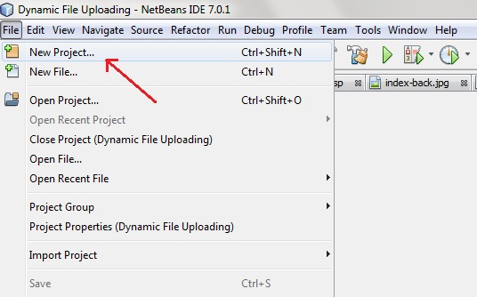

1. Select **Java Web** -> **Web Application**, then click on Next,

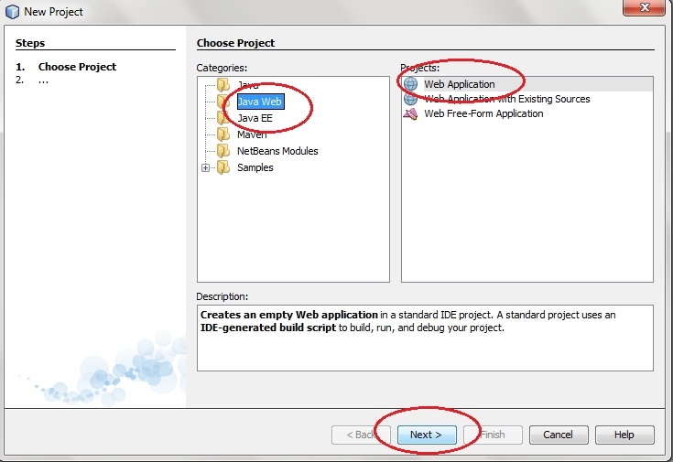

1. Name the project CalculatorWSApplication. Click Next.

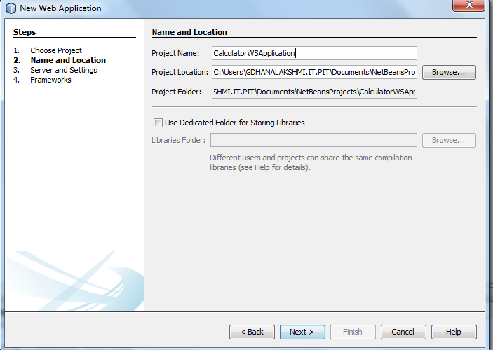

1. 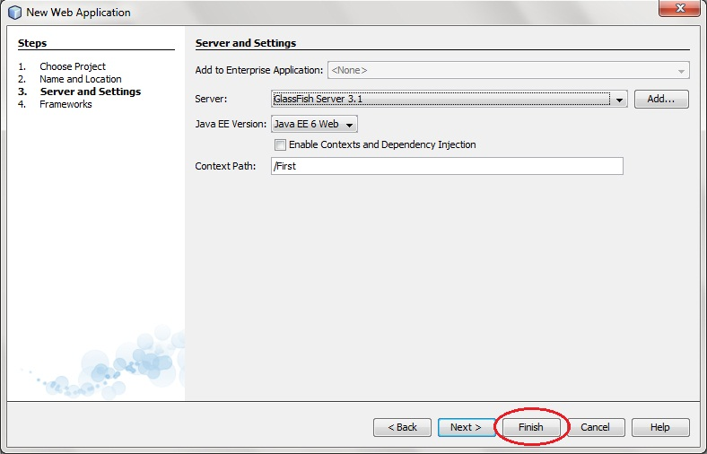and then, Click **Finish**

**Creating a Web Service from a Java Class**

1. Right-click the **CalculatorWSApplication** node and choose **New > Web** **Service.**
2. Name the web service **CalculatorWS** and type **calc** in Package. Leave Create Web Service from Scratch selected.

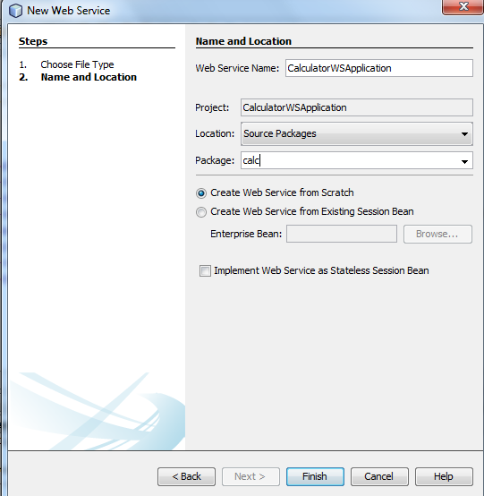

1. Click Finish. The Projects window displays the structure of the new web service and the source code is shown in the editor area.
2. Change to the Design view in the editor.

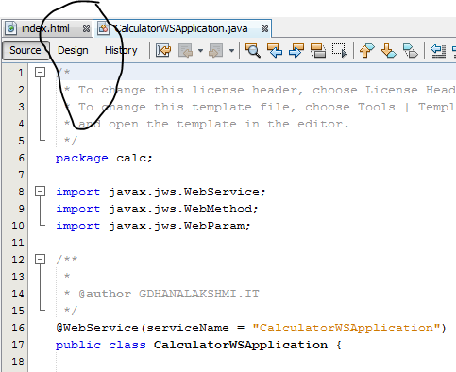

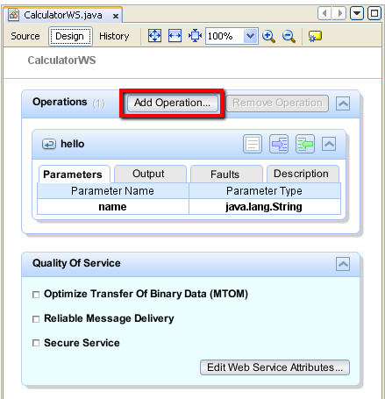

1. Find the web service's node in the Projects window. Right-click that node. A context menu opens.

Give the file name **operation**

Change the return type as **java.lang.Integer**

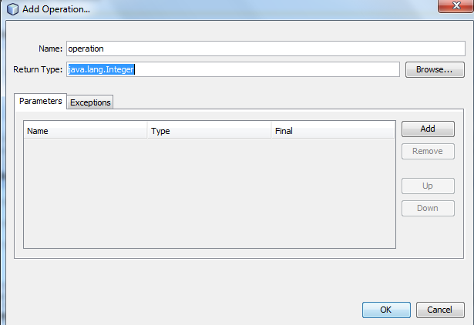

1. Click Add Operation in either the visual designer or the context menu. The Add Operation dialog opens.
2. In the upper part of the Add Operation dialog box, type add in Name and type int in the Return Type drop-down list.
3. 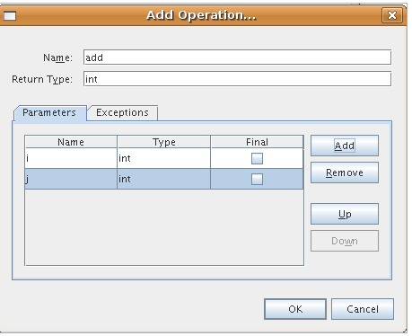In the lower part of the Add Operation dialog box, click Add and create a parameter of type int named i.
4. Click Add again and create a parameter of type int called j.
5. Click OK at the bottom of the Add Operation dialog box. You return to the editor.
6. Remove the default hello operation, either by deleting the hello() method in the source code or by selecting the hello operation in the visual designer and clicking Remove Operation.

The visual designer now displays the following:

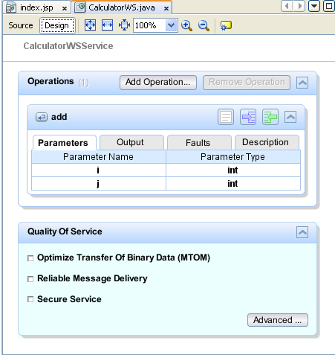

1. Click Source and view the code that you generated in the previous steps.

In the source code move the cursor to the end of the code and change the return statement as follows.

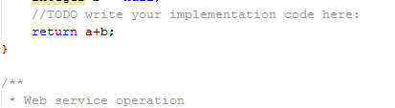

**To test successful deployment to a GlassFish or WebLogic server:**

1. **Right-click the project** and choose **Deploy**. The IDE starts the application server, builds the application, and deploys the application to the server. You can follow the progress of these operations in the CalculatorWSApplication (run-deploy) and the GlassFish server or Tomcat tabs in the Output view.
2. In the IDE's Projects tab, **expand the Web Services** node of the CalculatorWSApplication project. **Right-click the CalculatorWS node**, and **choose Test Web Service**.

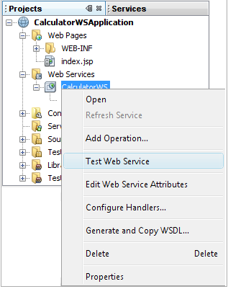

The IDE opens the tester page in your browser, if you deployed a web application to the GlassFish server. For the Tomcat Web Server and deployment of EJB modules, the situation is different:

If you deployed to the GlassFish server, type two numbers in the tester page, as shown below:

**OUTPUT:**

