All the tested prompt used and obtain output are below: all the figures are the obtained output.

GUI Interface

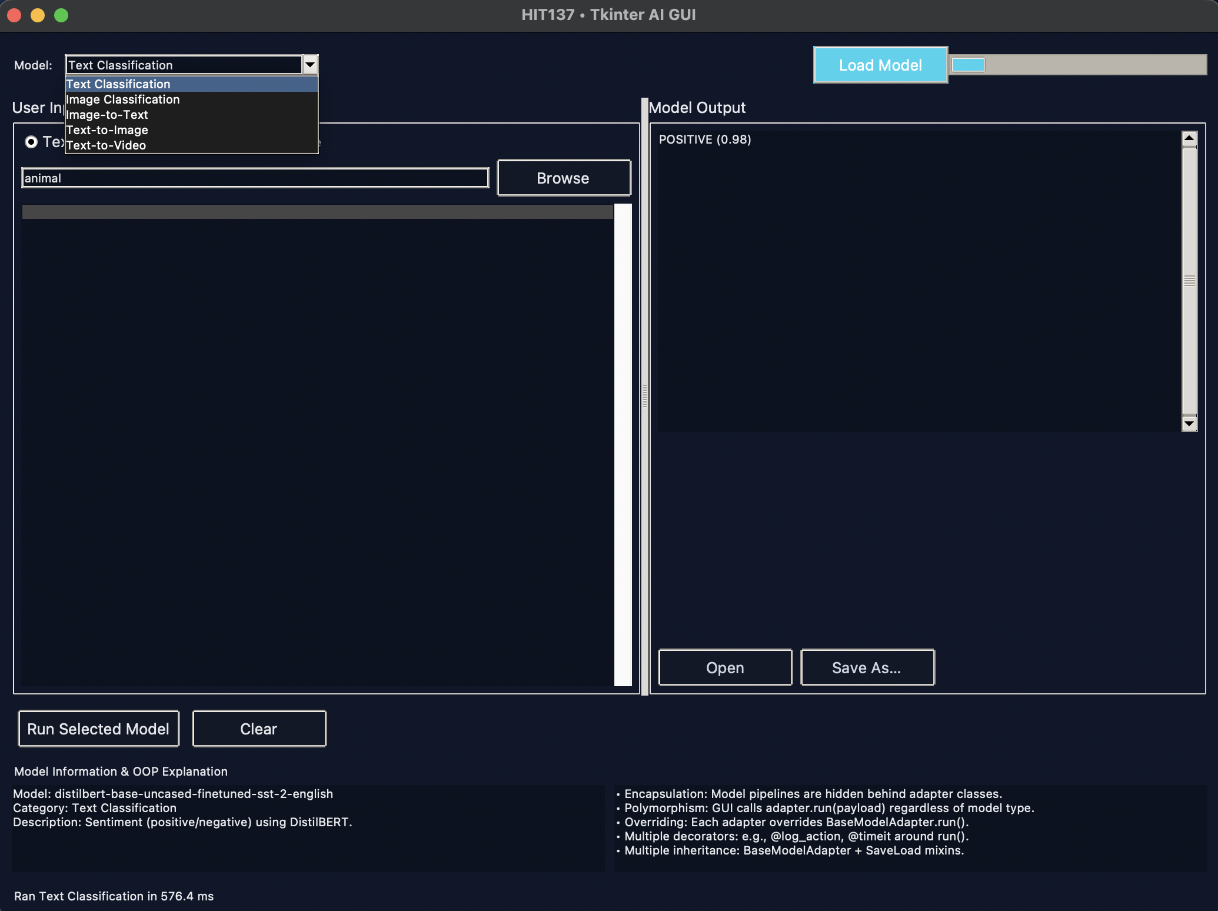

Model used

**Text to Image**

A fantasy landscape with a glowing castle on a mountain, in digital art style.

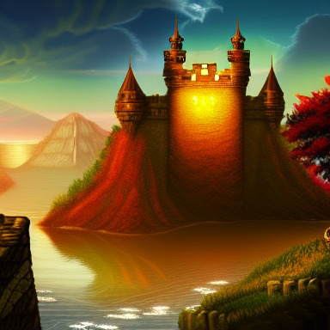

A realistic photograph of a young man sitting in a café, using a laptop, with soft lighting.



An anime-style illustration of a girl standing under cherry blossoms at sunset.

