ACTIVITY TIMEOUTS
Definition:
An Activity Timeout occurs when a task or activity is not completed within a specified time limit. BPMN uses Timer Events to monitor deadlines and trigger alternative actions when the allowed time expires.
Why it is important:
• Prevents processes from getting stuck.
• Helps organizations meet Service Level Agreements (SLAs).
• Improves efficiency and customer satisfaction.
• Ensures overdue tasks are detected and handled.
In real business processes, some activities have deadlines. If a task is not completed on time, the process should not wait forever. BPMN solves this problem using activity timeouts.
HOW ACTIVITY TIMEOUTS OCCUR
An activity timeout can occur when:
• A loan officer delays review.
• A customer fails to respond.
• An external system is unavailable.
• Required resources are unavailable.
• A deadline or SLA is exceeded.
Example:
A loan officer must review a loan application within 48 hours. If the review is not completed within that period, the timeout exception is triggered.
> The timeout is not caused by an error. It happens because too much time has passed without completing the task.
BPMN NOTATION FOR ACTIVITY TIMEOUTS
BPMN Symbol:
Timer Boundary Event
Characteristics:
• Appears as a circle attached to the boundary of a task.
• Contains a clock icon.
• A solid border indicates an interrupting timer.
• When triggered, the original activity is cancelled.
• The process follows an exception path.
The timer boundary event listens for a deadline. When the deadline is reached, BPMN stops the current task and moves the process to an alternative flow.
VISUAL BPMN EXAMPLE
This diagram shows a timer attached to the review task. If the officer does not finish within 48 hours, the application is escalated to a senior officer and the customer is notified.
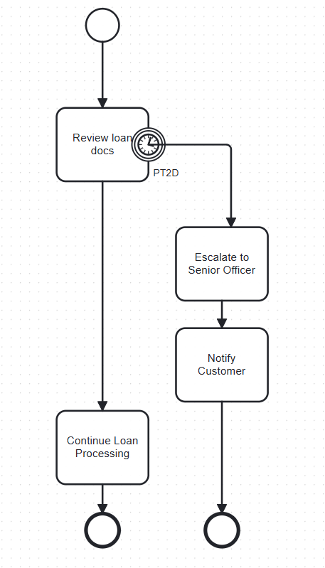
Explanation:
• The officer reviews documents.
• A timer boundary event monitors the 48-hour deadline.
• If time expires before completion, the review task is interrupted.
• The application is escalated to a senior officer.
This diagram shows a timer attached to the review task. If the officer does not finish within 48 hours, the application is automatically escalated.

BUSINESS SCENARIO
Scenario: Loan Processing
- Customer submits a loan application.
- Loan officer reviews documents.
- BPMN timer is set for 2 business days.
- If the review is completed on time, processing continues normally.
- If the deadline passes, the timer triggers.
- The case is escalated to a senior underwriter and the customer is notified.
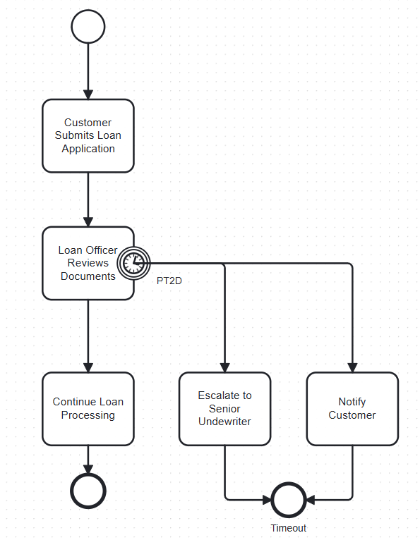
Benefits:
• Faster turnaround times.
• Reduced delays.
• Better compliance with service standards.
RECOMMENDATIONS
• Define clear time limits for important activities.
• Use interrupting timer events for overdue tasks.
• Monitor and record timeout occurrences.
• Regularly review timeout data to improve process performance.

