

IRM4724

Assignment 2



June 27, 2022

MISS MPHO Manamela

64360989

Contents

**Question 1** 2

**Question 2** 4

**Question 3** 6

**Question 4** 9

**Question 5** 10

**References** 13

# **Question 1**

<!DOCTYPE html>

<html>

<head>

<style>

table, th, td {

border: 1px solid black;

}

</style>

</head>

<body>

<h2>Question 1</h2>

<table style="width:100%">

<tr>

<td>Apple iOS</td>

<td>iPad</td>

<td>iPhone</td>

<td>iPod Touch</td>

<td></td>

</tr>

<tr>

<td>Google Android</td>

<td>Nexus 7</td>

<td>Samsung Galaxy Notes 8</td>

<td>Samsung Galaxy Notes 4</td>

<td>HP Slate 7</td>

</tr>

<tr>

<td>Blackberry OS</td>

<td>Blackberry Z10</td>

<td>Blackberry Q10</td>

<td></td>

<td></td>

</tr>

<tr>

<td>Microsoft Windows Phone OS/RT</td>

<td>Nokia</td>

<td>Samsung ATIV</td>

<td>Surface</td>

<td></td>

</tr>

</table>

</body>

</html>

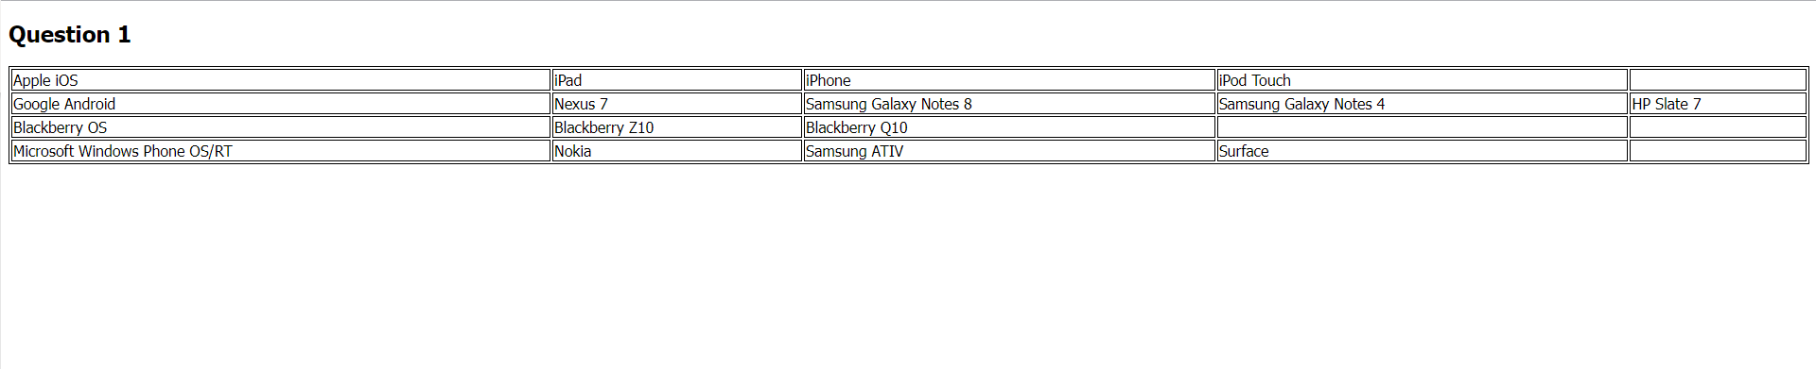

# **Question 2**

<!doctype html>

<html>

<head>

<style>

body.solid {border-style: solid;}

</style>

</head>

<body class="solid">

<h1>First HTML5 Document</h1>

<h3>Available on the web</h3>

<nav></nav>

<article>

<section>I am reading this book to learn how to develop websites</section>

<section>that can be accessed from any device and can serve as cross-platform apps.</section>

<section>The device I will test by running the following</section>

<section> operating systems:</section>

<dl>

<dt>Apple iOS</dt>

<dt>Google Android</dt>

<dt>Blackberry OS</dt>

<dt>Microsoft Windows Phone OS</dt>

</dl>

</article>

<aside></aside>

<div id=”footer” ></div>

</body>

</html>

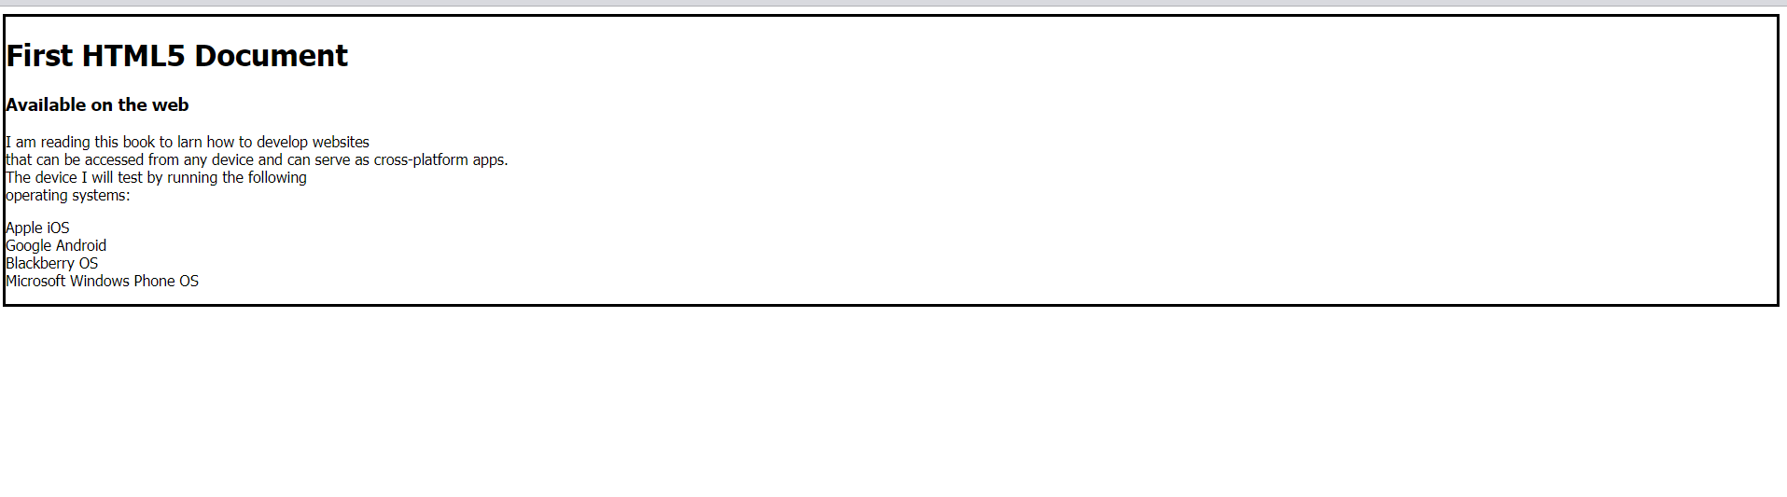

# **Question 3**

<!DOCTYPE html>

<html>

<head>

<meta name = "viewport" content = "width = device-width, initial-scale = 1">

<link rel = "stylesheet" href = "https://code.jquery.com/mobile/1.4.5/jquery.mobile-1.4.5.min.css">

<script src = "https://code.jquery.com/jquery-1.11.3.min.js"></script>

<script src = "https://code.jquery.com/mobile/1.4.5/jquery.mobile-1.4.5.min.js"></script>

</head>

<body>

<div data-role = "button" id = "pageone">

<div data-role = "header">

<h1>Converting fluid measurements</h1>

</div>

<div data-role = "main" class = "ui-content">

<p>

<label>Enter the quantity in gallons:</label>

<input id="inputGallons" type="number" placeholder="Gallons">

<button type="button" class="btn btn-secondary" (click)=" convertGallons();" >

Display

</button>

</p>

<p><span id="outputConvertedValue"></span></p>

</div>

<div data-role = "footer">

<h1>Fluid quantity converter</h1>

</div>

</div>

<script>

function convertGallons()

{

var inputVal = document.getElementById("inputGallons").value ;

document.getElementById("outputConvertedValue").innerHTML = inputVal ;

alert(inputVal);

}

</script>

</body>

</html>

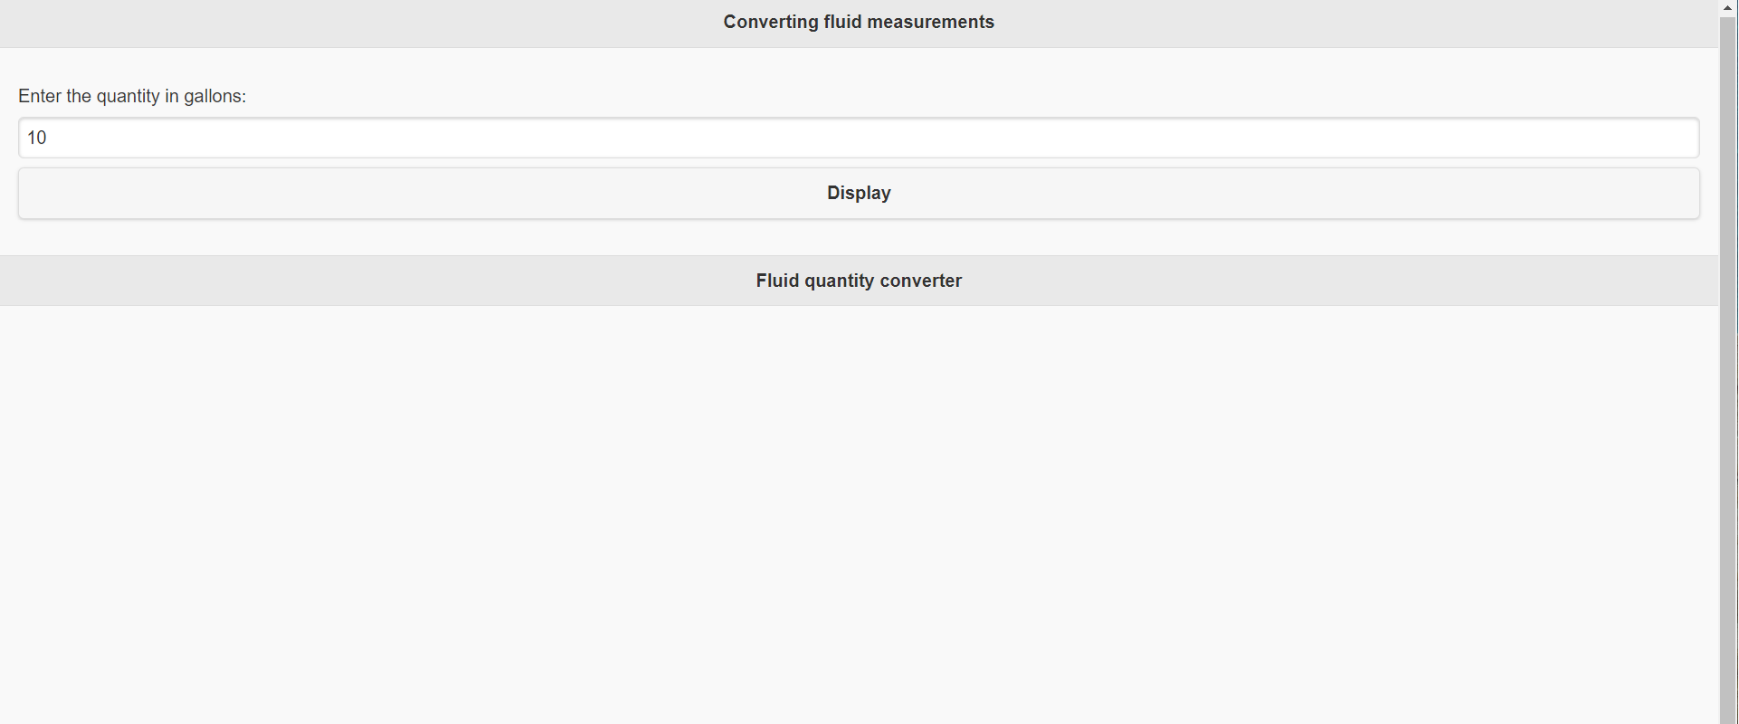

# **Question 4**

function convertGallons()

{

var inputVal = document.getElementById("inputGallons").value ;

document.getElementById("outputConvertedValue").innerHTML = inputVal ;

alert(inputVal);

}

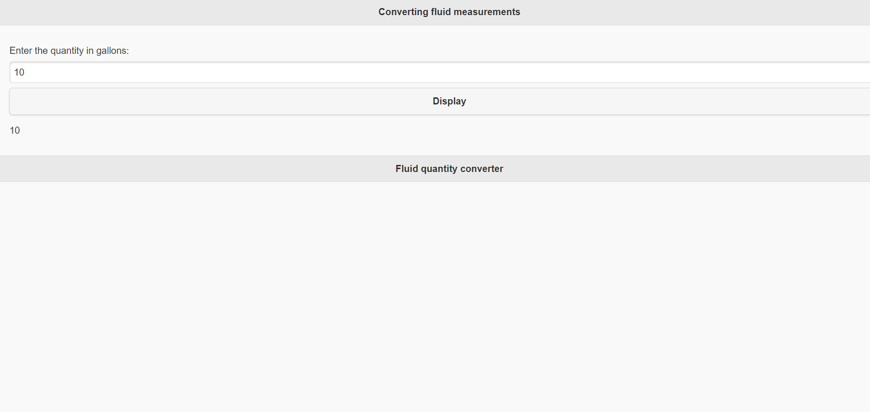

# **Question 5**

<!DOCTYPE html>

<html>

<head>

<meta name = "viewport" content = "width = device-width, initial-scale = 1">

<link rel = "stylesheet" href = "https://code.jquery.com/mobile/1.4.5/jquery.mobile-1.4.5.min.css">

<script src = "https://code.jquery.com/jquery-1.11.3.min.js"></script>

<script src = "https://code.jquery.com/mobile/1.4.5/jquery.mobile-1.4.5.min.js"></script>

</head>

<body>

<div data-role = "button" id = "pageone">

<div data-role = "header">

<h1>Cylinder on a canvas</h1>

</div>

<div data-role = "main" class = "ui-content">

<p>

<button type="button" class="btn btn-secondary" (click)="drawCylinder(50,35,50,35);" >

Display

</button>

</p>

<p><span id="outputConvertedValue"></span></p>

</div>

</div>

<script>

function drawCylinder ( x, y, w, h ) {

context.beginPath(); //to draw the top circle

for (var i = 0 * Math.PI; i < 2 * Math.PI; i += 0.001) {

xPos = (this.x + this.w / 2) - (this.w / 2 * Math.sin(i)) *

Math.sin(0 * Math.PI) + (this.w / 2 * Math.cos(i)) *

Math.cos(0 * Math.PI);

yPos = (this.y + this.h / 8) + (this.h / 8 * Math.cos(i)) *

Math.sin(0 * Math.PI) + (this.h / 8 *

Math.sin(i)) * Math.cos(0 * Math.PI);

if (i == 0) {

context.moveTo(xPos, yPos);

}

else

{

context.lineTo(xPos, yPos);

}

}

context.moveTo(this.x, this.y + this.h / 8);

context.lineTo(this.x, this.y + this.h - this.h / 8);

for (var i = 0 * Math.PI; i < Math.PI; i += 0.001) {

xPos = (this.x + this.w / 2) - (this.w / 2 * Math.sin(i)) * Math.sin(0 * Math.PI) + (this.w / 2 * Math.cos(i)) * Math.cos(0 * Math.PI);

yPos = (this.y + this.h - this.h / 8) + (this.h / 8 * Math.cos(i)) * Math.sin(0 * Math.PI) + (this.h / 8 * Math.sin(i)) * Math.cos(0 * Math.PI);

if (i == 0) {

context.moveTo(xPos, yPos);

}

else

{

context.lineTo(xPos, yPos);

}

}

context.moveTo(this.x + this.w, this.y + this.h / 8);

context.lineTo(this.x + this.w, this.y + this.h - this.h / 8);

context.stroke();

}

</script>

</body>

</html>

# **References**

<https://www.w3schools.com/graphics/tryit.asp?filename=trycanvas_draw>

<https://www.w3schools.com/tags/ref_canvas.asp>

<https://www.tutorialspoint.com/jquery_mobile/jquery_mobile_quick_guide.htm>