Supplemental Information
Blood transcriptomic signatures of bronchopulmonary dysplasia largely reflect maturity and immune-cell composition
Moreira et al.
Contents: Figures S1-S7. Tables S1-S16 are provided as a separate Excel file (Table S1, BPD definitions; S2, overlap audit; S3, signature; S4, genes of the originally submitted 21-gene signature (reviewer request); S5-S8, pathways and programs; S9, reconstruction and evaluation of published signatures; S10, prediction; S11-S13, GA-adjusted discovery and protocol; S14, neutrophil-T-cell balance; S15, time course and steroid proxy; S16, external cohort).

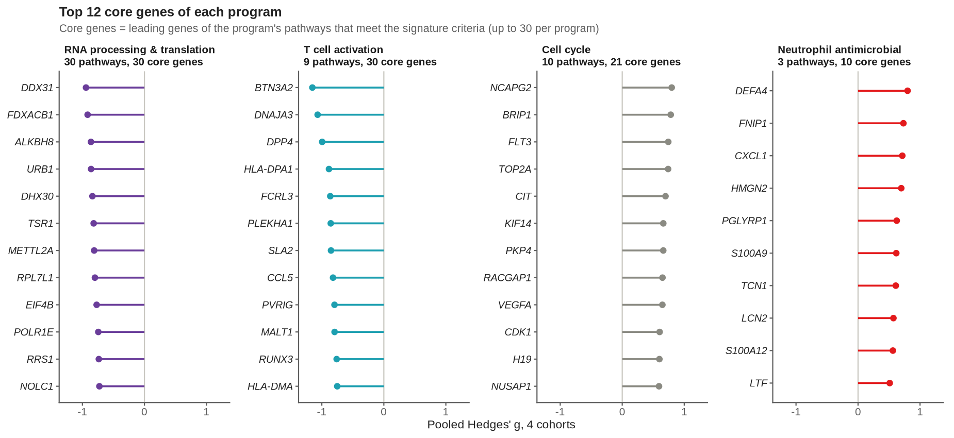
Figure S1. Core genes of the four programs, related to Figure 2
The 12 core genes with the smallest pooled p value in each program, with pooled Hedges' g across the four first-week blood cohorts. Core genes are the leading genes of each program's conserved processes that meet the signature criteria (up to 30 per program; Table S6).

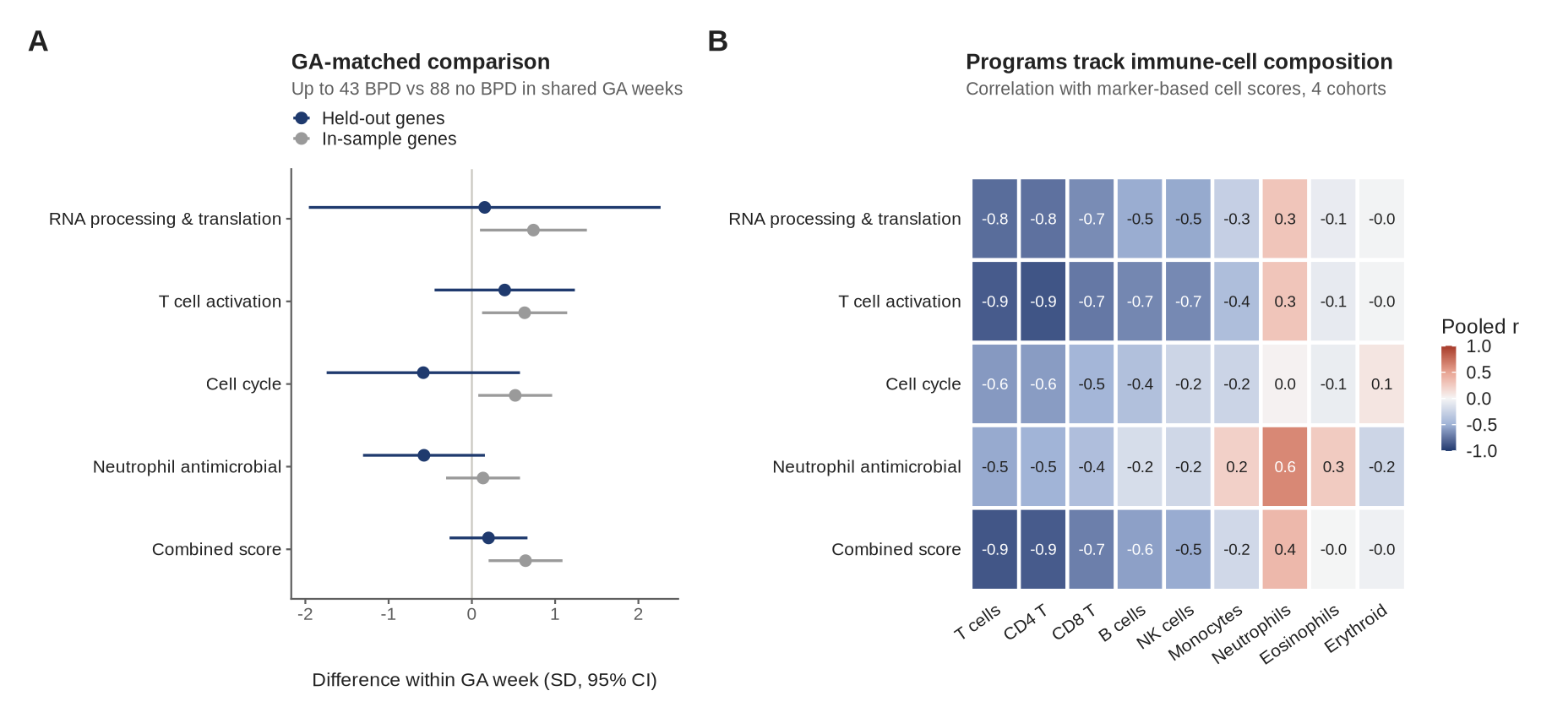
Figure S2. Gestational-age matching and cell composition, related to Figure 2
(A) Difference in program scores between BPD and no BPD within the same completed week of gestational age (GA), weighted by stratum size and pooled across the three cohorts reporting GA (up to 43 BPD versus 88 no BPD), with in-sample (gray) and held-out (navy) core genes (95% CI). (B) Pooled correlation of program scores with marker-based cell scores in the four cohorts.

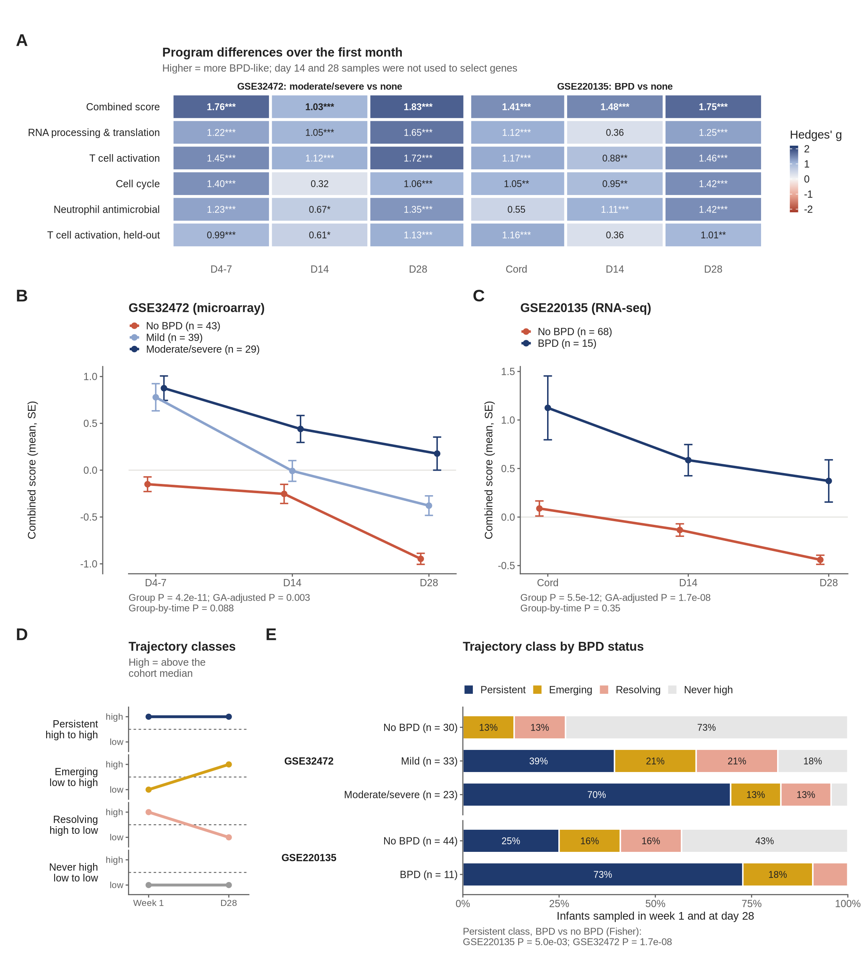
Figure S3. Programs over the first month of life, related to Figure 4
GSE32472 (days 4-7, 14, 28; moderate/severe versus no BPD, mild shown separately) and GSE220135 (cord blood, days 14, 28; BPD versus no BPD), scored with in-sample core genes. (A) Hedges' g by time point; *p < 0.05, **p < 0.01, ***p < 0.001. (B and C) Combined score (mean ± SE) with mixed-model p values for group, GA-adjusted group, and group-by-time interaction. (D) Trajectory classes defined by the cohort median in the first week and at day 28. (E) Trajectory classes by BPD status; Fisher's exact test for the persistent class. Week-1 samples contributed to core-gene selection.

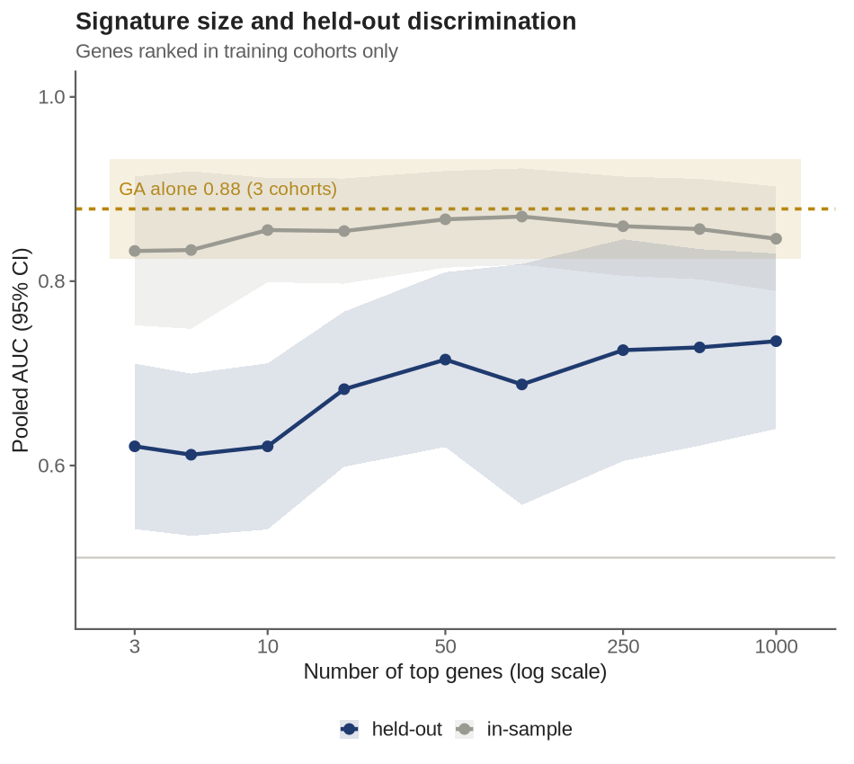
Figure S4. Signature size and held-out discrimination, related to Figure 5
Pooled AUC (95% CI) of signed scores built from the top N genes, ranked in training cohorts only and scored in the held-out cohort (navy), or ranked in all four cohorts (gray, in-sample). Gold line and band, GA alone in the three cohorts reporting GA.

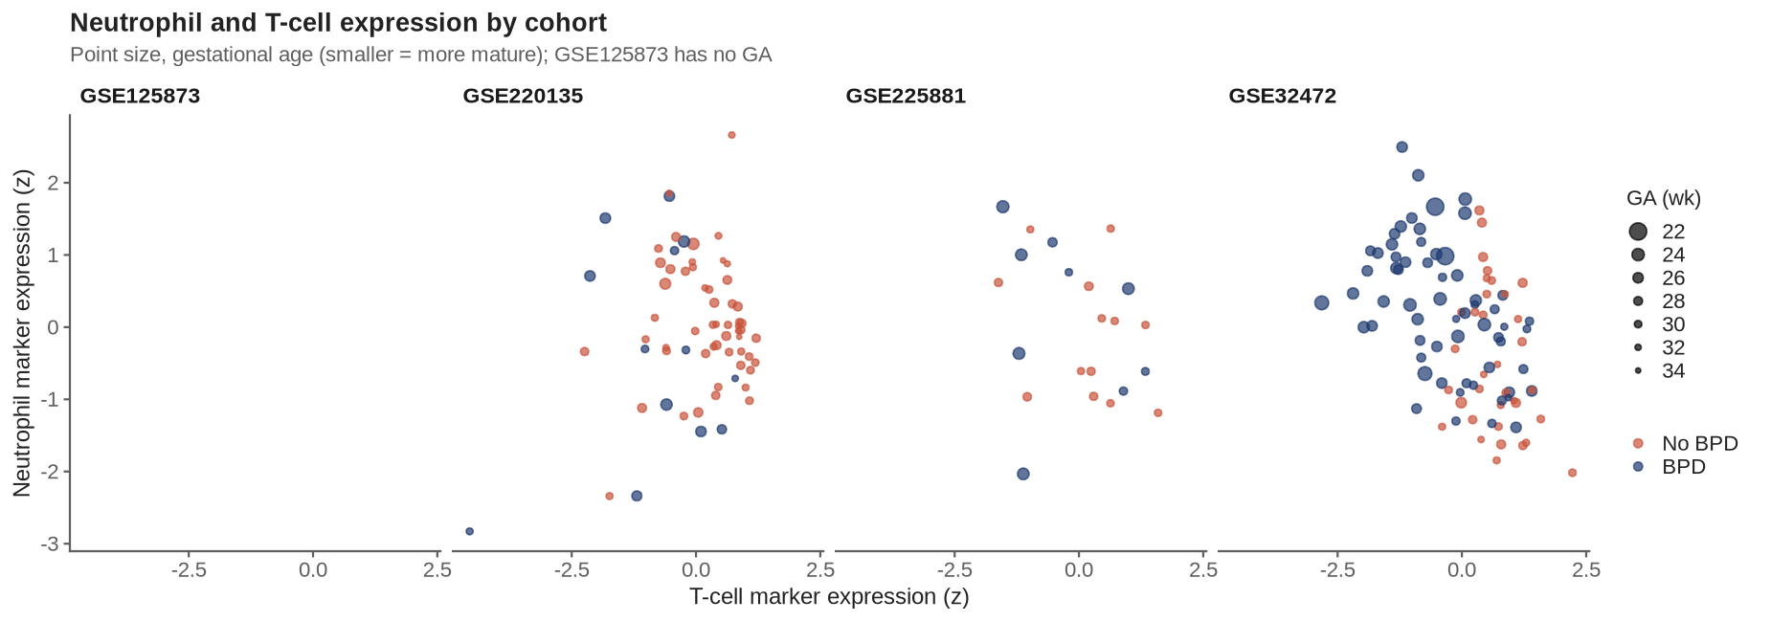
Figure S5. Neutrophil and T-cell marker expression, related to Figure 3
Standardized mean log expression of six neutrophil genes (CSF3R, CXCR2, FPR1, FCGR3B, MME, CMTM2) versus six T-cell genes (CD3D, CD3E, CD3G, CD2, CD247, LCK) for each infant in the first week, by cohort and BPD status; point size is inversely related to GA.
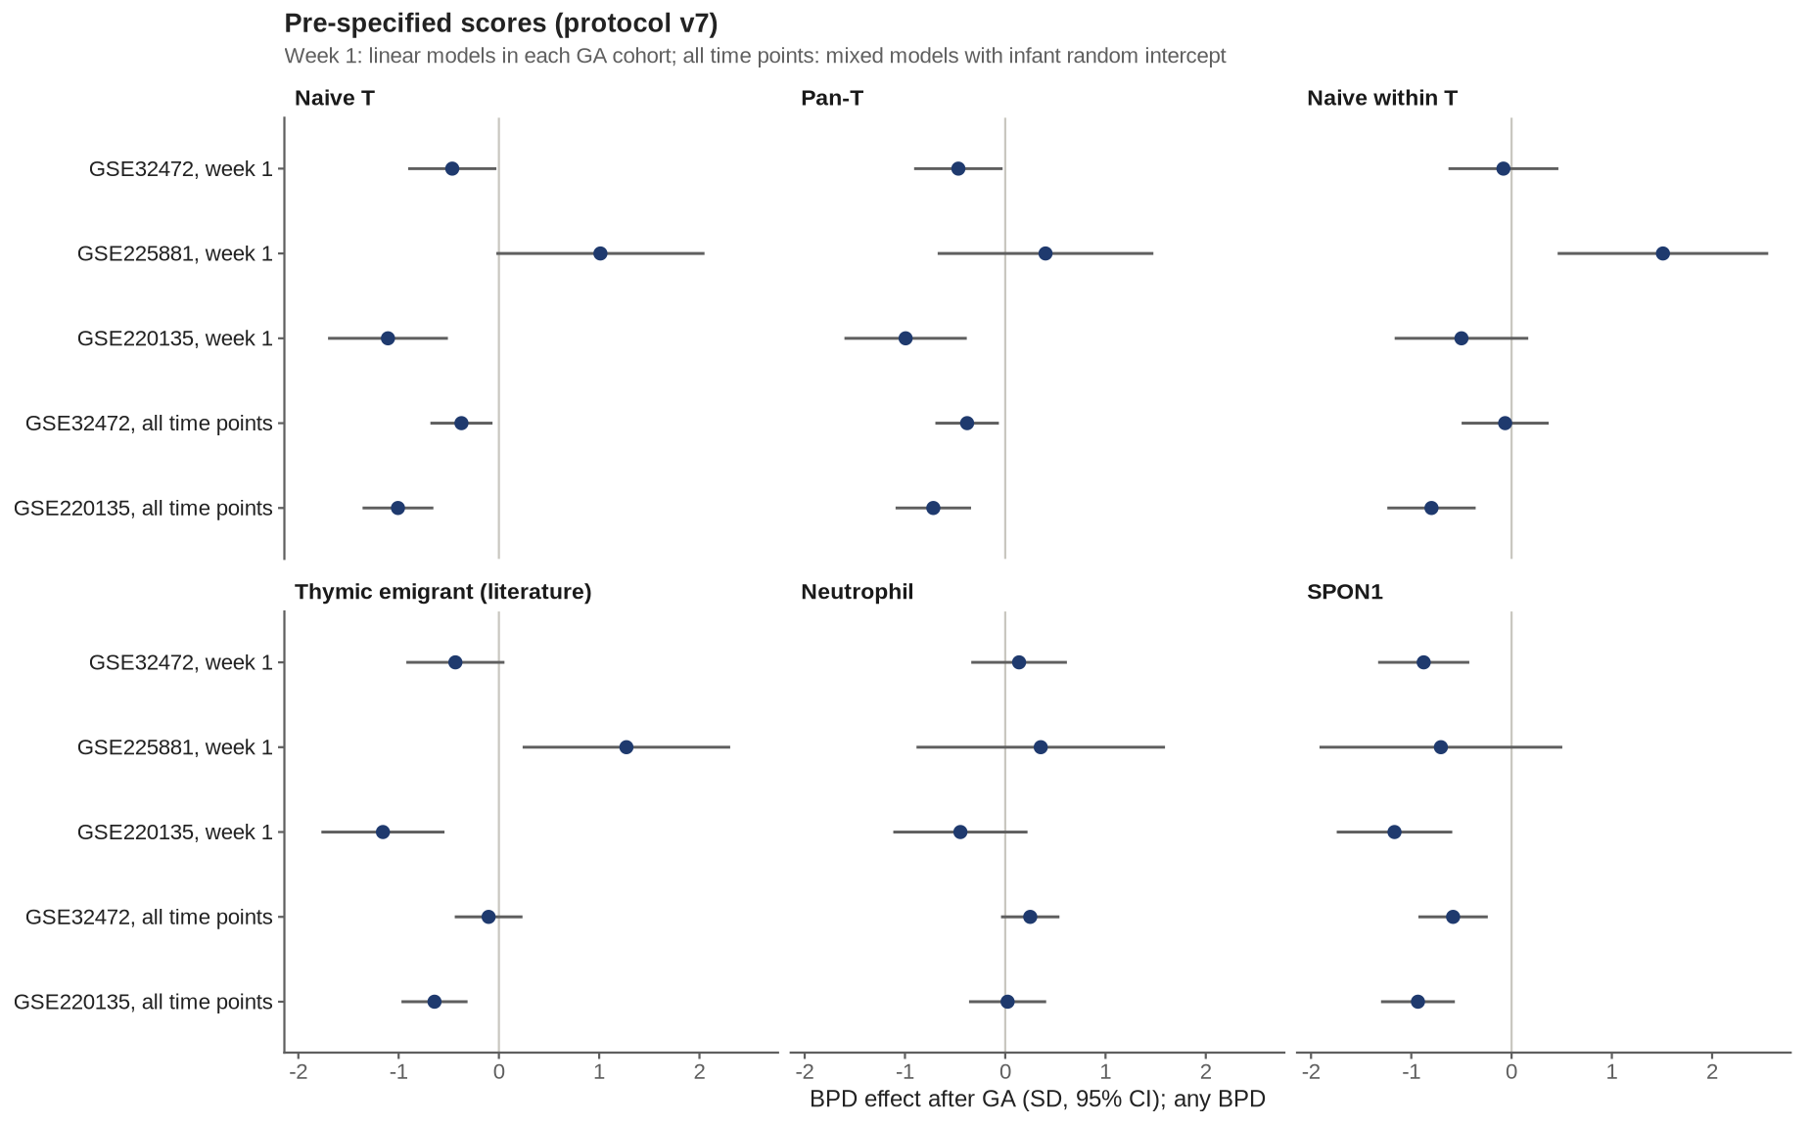
Figure S6. Pre-specified scores of the confirmatory protocol, related to Figure 4
BPD effect after GA adjustment (SD, 95% CI; any BPD) for canonical naive T-cell, pan-T, naive-within-T, literature recent-thymic-emigrant, neutrophil, and SPON1 scores, at week 1 in each cohort reporting GA (linear models) and across all time points in the two longitudinal cohorts (mixed models). The primary test (pooled week-1 naive T-cell score) was not met (p = 0.54); estimates were lower in BPD in GSE32472 and GSE220135 and higher in GSE225881 (Table S13).

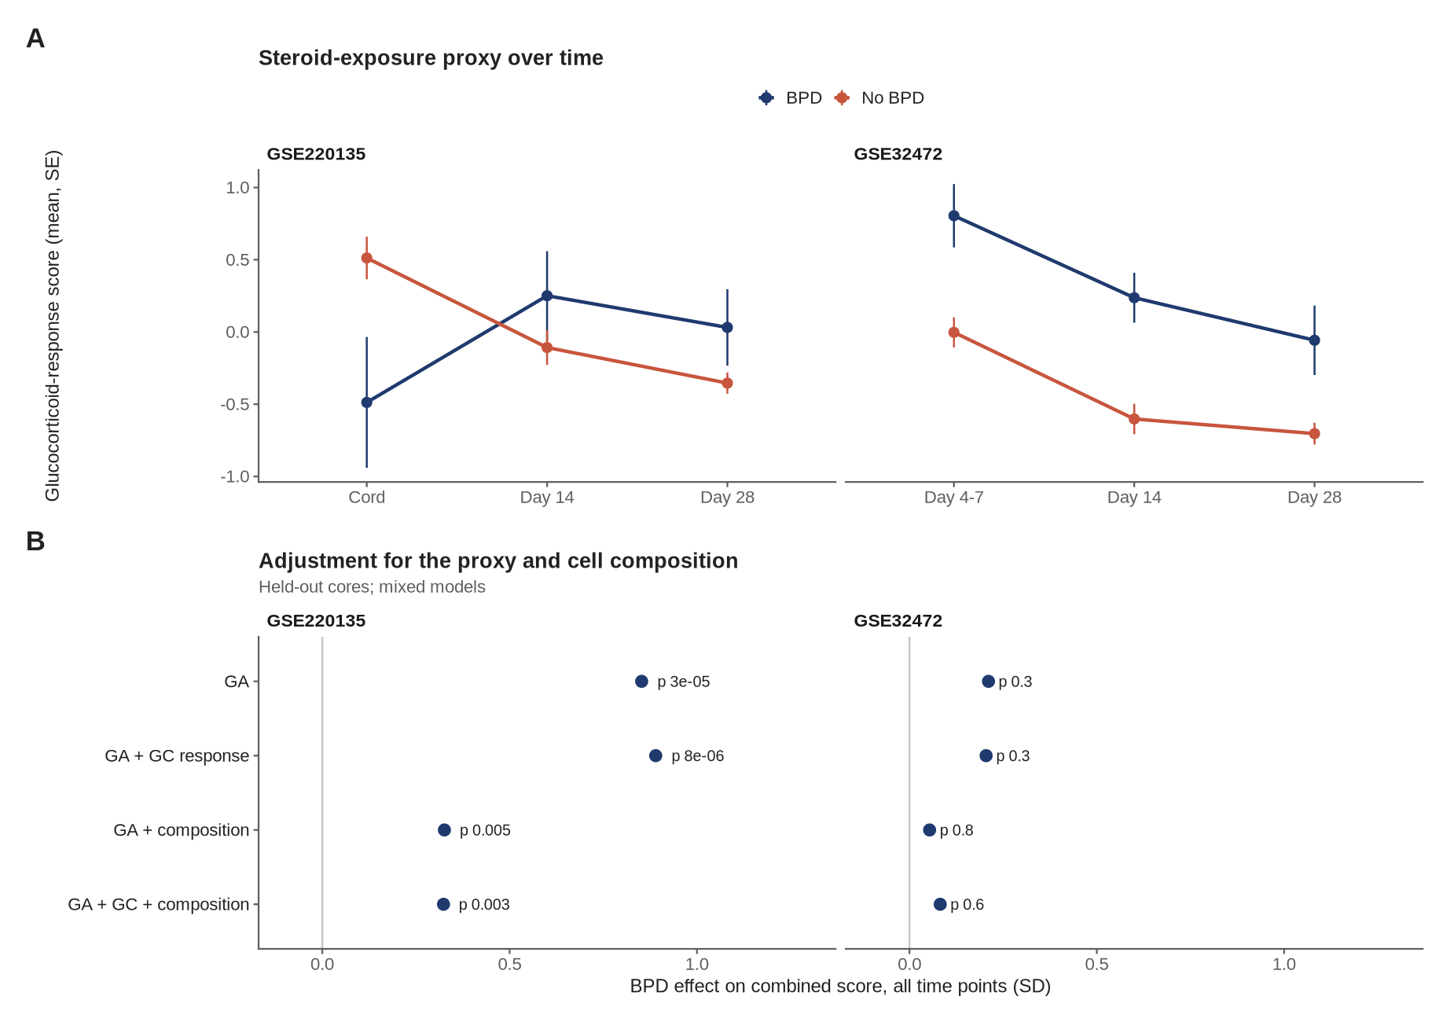
Figure S7. Steroid-exposure proxy and composition, related to Figure 4
(A) Glucocorticoid-response score (FKBP5, TSC22D3, ZBTB16, DDIT4, PER1, KLF9, IRS2, CD163, VSIG4, ADAMTS2; adapted from Molendijk and Koenderman, 2026, with FKBP5 and CD163 added from Menke et al., 2012, and Olnes et al., 2016; ADAMTS2, Hofer et al., 2008) over time by BPD status (mean ± SE). (B) BPD effect on the combined program score (held-out core genes) across all time points, adjusted for GA, GA and the proxy, GA and composition, and all three (mixed models).

Supplemental references
Hofer, T.P.J., Frankenberger, M., Mages, J., et al. (2008). Tissue-specific induction of ADAMTS2 in monocytes and macrophages by glucocorticoids. J. Mol. Med. 86, 323–332. https://doi.org/10.1007/s00109-007-0284-0
Menke, A., Arloth, J., Pütz, B., et al. (2012). Dexamethasone stimulated gene expression in peripheral blood is a sensitive marker for glucocorticoid receptor resistance in depressed patients. Neuropsychopharmacology 37, 1455–1464. https://doi.org/10.1038/npp.2011.331
Molendijk, A., and Koenderman, L. (2026). Glucocorticoid-driven gene expression in circulating monocytes and neutrophils in health and severe inflammation. J. Leukoc. Biol. 118, qiag068. https://doi.org/10.1093/jleuko/qiag068
Olnes, M.J., Kotliarov, Y., Biancotto, A., et al. (2016). Effects of systemically administered hydrocortisone on the human immunome. Sci. Rep. 6, 23002. https://doi.org/10.1038/srep23002

