Supplemental Figure S1. Cohort details. A: Expression of canonical markers within the 343-gene panel across the six broad populations. Dot size, percentage of cells expressing; color, scaled mean expression. B: Xenium immune composition per donor; numbers give immune cells per donor, and Other denotes populations outside the six broad groups. C: LungMAP donor life courses against PMA: open circle, birth (gestational age); bar, postnatal life; filled symbol, tissue collection. Shading marks the period before term-equivalent age (40 weeks). D: LungMAP immune composition per donor; numbers give immune nuclei per donor.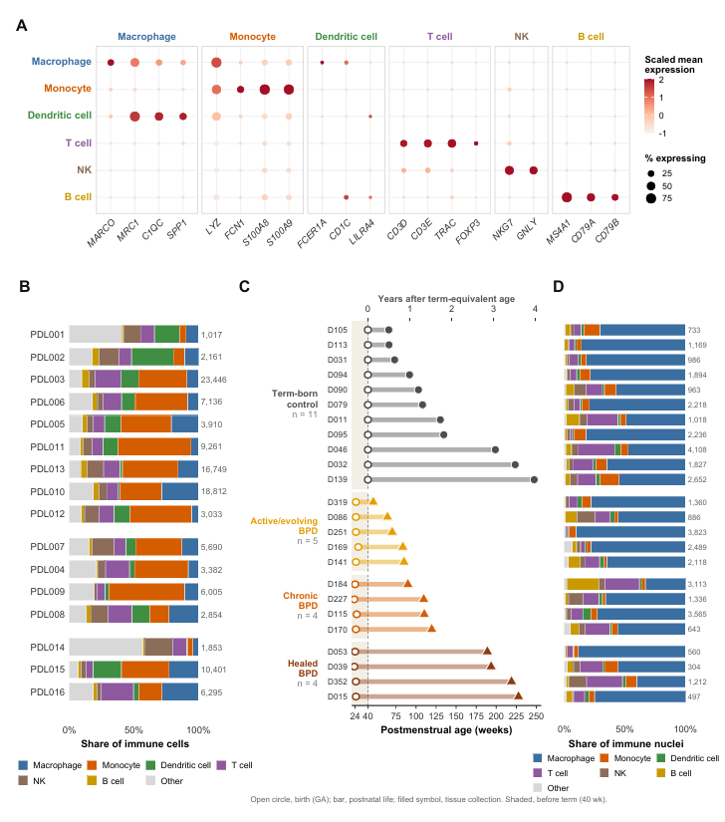
Supplemental Figure S2. Transcript spillover and niches. A: Share of each immune cell’s transcripts derived from predominantly endothelial, epithelial or mesenchymal genes, by niche class of the immune cell. Points are donors; bars are medians. B: Spillover-filtered (77 non-immune genes removed) vs. full-panel global score; filtered axis ρ = 0.68, selection-aware P = 0.256. C: Lineage composition of the 11 source-defined niches, with the assigned niche class and the largest single-donor contribution.
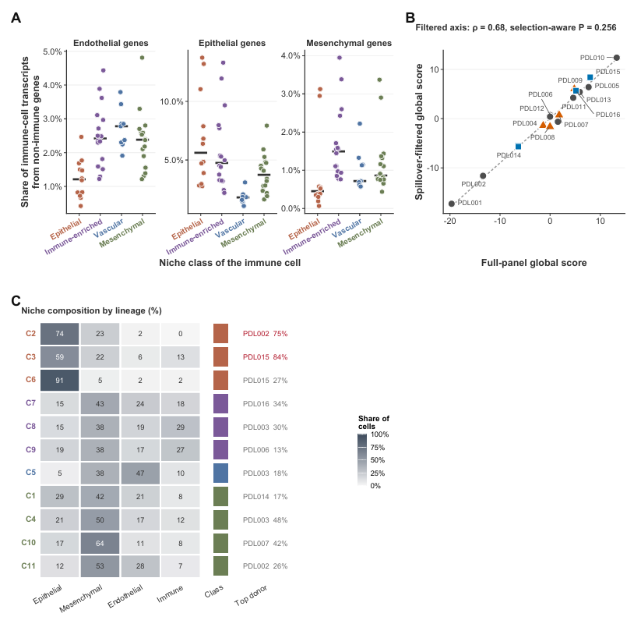

Supplemental Figure S3. Gene-level tests and shared off-path direction (Xenium). A: Donor pseudobulk DESeq2, ~ PMA + injury (9 reference, 4 injured). Labeled genes have nominal P < 0.05; none reached FDR < 0.05. B: Concordance of log₂ fold changes with PDL016 added to the injury group (Spearman ρ = 0.987). C: Shared direction of departure among injured donors (mean pairwise cosine of standardized residuals); triangle, observed; grey, exact refit-permutation null. D: The same statistic across sensitivity sets (injured donors only; plus PDL016; without PDL008); filled symbols, P < 0.05.
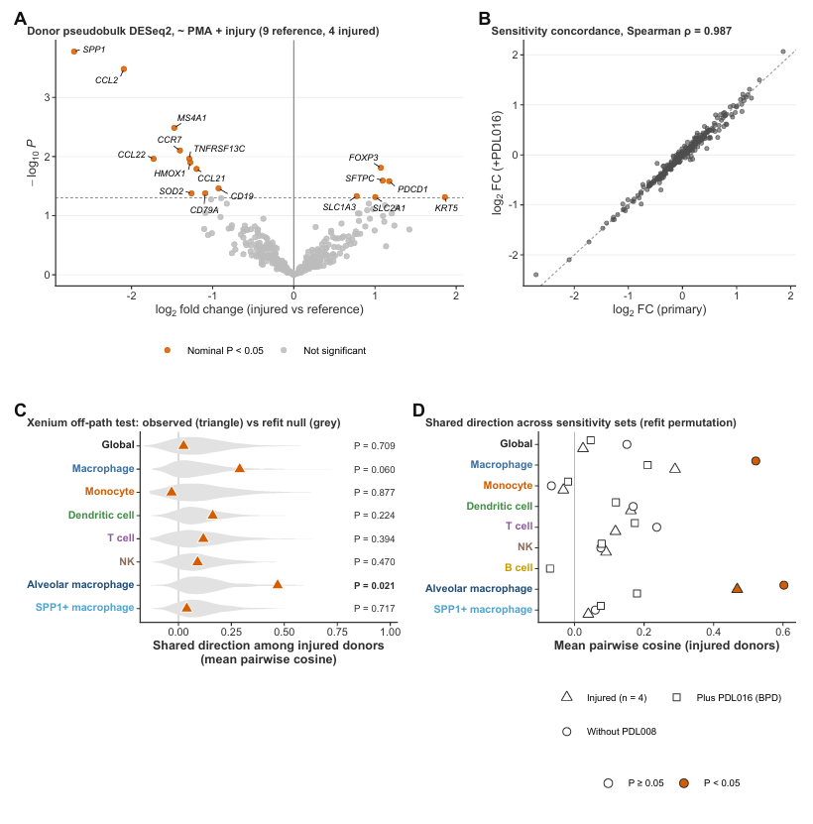

Supplemental Figure S4. Alveolar macrophages. A: Alveolar-macrophage expression of selected mature (CD68, PPARG) and monocyte/SPP1-like (SPP1, CCL2) genes against PMA. Line and band show the reference fit and 95% prediction interval; ringed, the postnatal reference donor. B: Cosine similarity of off-path residual vectors between donors. C: Genes contributing to the shared injured direction, as deviation from the reference trajectory in prediction-SD units, colored by gene category. D: Shared-direction statistic with one injured donor left out, and with the leading genes removed. The dashed line marks the mean of the permutation null. E: Frozen alveolar-macrophage signature tested in LungMAP alveolar macrophages by stage. Text gives the pre-specified one-sided test (BPD vs. control, PMA-adjusted).
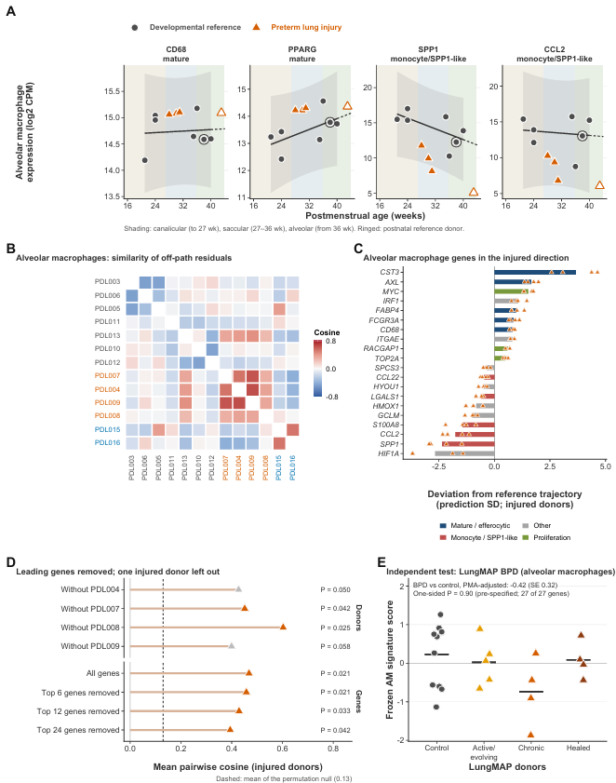

Supplemental Figure S5. LungMAP axes and composition deviations. A: LungMAP population axes learned from controls, against PMA, with BPD donors projected. Labels give ρ and selection-aware P. B: Strength of the age association by population: Xenium reference (15–44 weeks) vs. LungMAP controls (66–247 weeks); hollow symbols, P ≥ 0.05. C: Xenium composition deviation of injured and rare-disease donors. D: LungMAP composition deviation of BPD donors by stage. In C and D, outlined tiles fall outside the 95% prediction limit; † marks extrapolation.
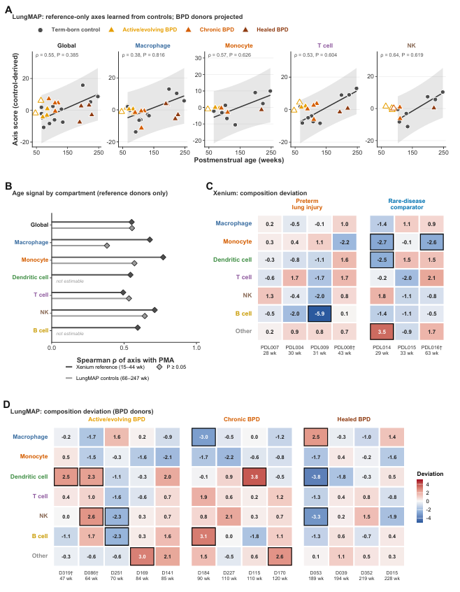

Supplemental Figure S6. Dendritic-cell cycling detail. A: Cycling DCs against postnatal age, showing that birth and injury overlap in Xenium (one postnatal reference donor). B: Odds ratios from leave-one-donor-out refits, for source-annotated and expanded DC definitions. C: Percentage of DCs retained at each rarefaction depth, per donor. D: LungMAP: odds of cycling by population, BPD vs. control (PMA-adjusted), with 95% confidence intervals.
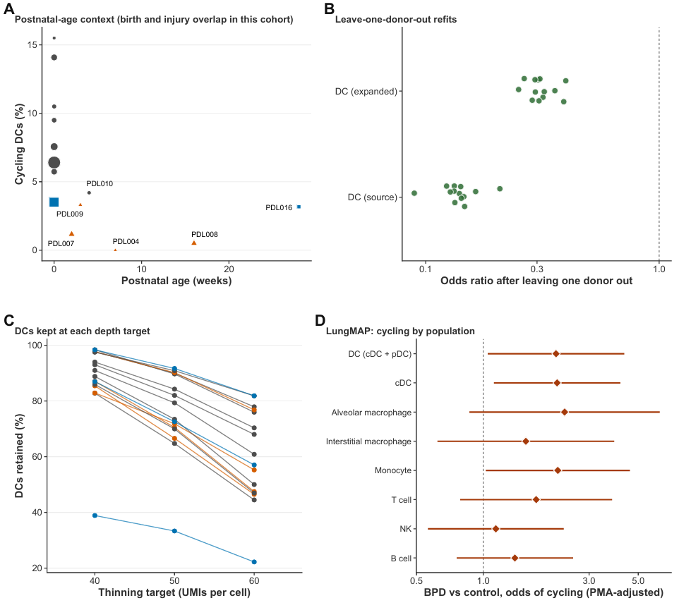

Supplemental Figure S7. Immune burden. A: Xenium: immune cells as a share of all cells, against PMA. B: LungMAP: immune nuclei as a share of all nuclei, against PMA. C: Xenium: immune-cell density per mm² of tissue. D: PMA-adjusted injury shifts for overall and population-specific burden, in residual-SD units. The shaded bar is the shift detectable with 80% power, and “All immune” is the primary measure. In A-C, the line and band show the reference or control fit and its 95% prediction interval, and text gives the PMA-adjusted shift.
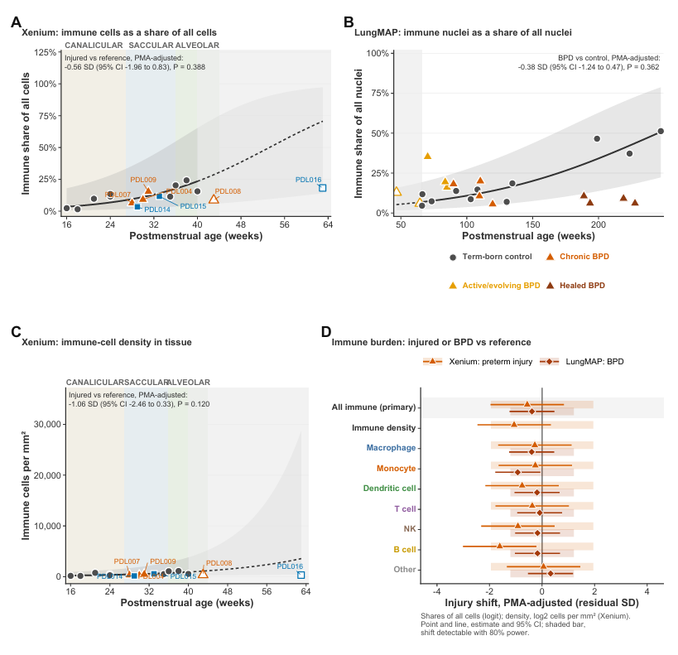

Supplemental Figure S8. Dendritic-cell localization (Xenium). A: Tissue maps of a reference donor and an injured donor; DCs (green) and cycling DCs (red) are overlaid on all other cells. Scale bar, 1 mm. B: Composition of cells within 40 µm of DCs, as deviation from age expectation; outlined tiles fall outside the 95% prediction limit, and † marks extrapolation. C: Within each donor with ≥5 cycling DCs, neighbor fraction of cycling minus non-cycling DCs. Bar, median; P, Wilcoxon signed-rank test. D: PMA-adjusted injury shift in DC neighbor composition; the shaded bar is the shift detectable with 80% power.
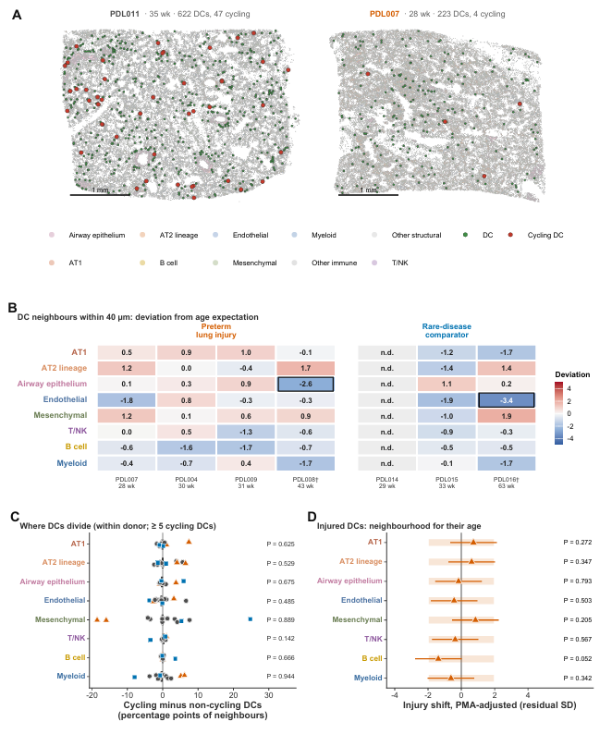

Supplemental Figure S9. Dendritic-cell transcriptional state (exploratory; gene sets fixed before scoring). A: PMA-adjusted shift in four program scores, in residual-SD units: maturation/migration, antigen presentation, interferon response and inflammation (cell-cycle genes excluded; Xenium restricted to immune-specific panel genes). Shown for Xenium non-cycling conventional DCs (injured vs. reference) and LungMAP conventional DCs (BPD vs. control); shaded bar, shift detectable with 80% power. B: Xenium reference donors: mean log₂ ratio between cycling and non-cycling conventional DCs within each donor. Bar, median; P, Wilcoxon signed-rank test. C: LungMAP conventional DCs: gene-level shifts for genes detected in ≥2/3 of donors; filled, FDR < 0.05. D: Maturation/migration score with the full gene set and with Xenium-scorable genes only; costimulation in nuclei without mature regulatory DC core genes; LAMP3⁺CCR7⁺ nuclei; and Xenium for comparison. E: LungMAP per-donor maturation/migration score against PMA; line, control fit. F: Robustness and stage (descriptive): all BPD donors, donors with ≥30 conventional-DC nuclei, the range of leave-one-donor-out estimates, and each stage vs. control.
