**Muon Detector Project: Setup**

Conrad Newfield

University of Hawaii at Manoa, 2017

Parts needed

|  |  |  |  |
| --- | --- | --- | --- |
| **Description** | **Unit Cost** | **Vendor** | **Link** |
| **Micro SD** card at least 8 Gb class 10 | $12.99 | Best Buy | <http://www.bestbuy.com/site/sandisk-ultra-8gb-microsdhc-uhs-i-class-10-memory-card-gray-red/5577759.p?skuId=5577759> |
| **Adapter** Micro SD to SD | $6.99 | Amazon | <https://www.amazon.com/Adapter-Standard-Connector-Smartphones-Function/dp/B01BXSKPES/ref=sr_1_4?s=pc&ie=UTF8&qid=1489542940&sr=1-4&keywords=sd+adapter> |
| **Raspberry Pi 3 - Model B** - ARMv8 with 1G RAM AND built-in WiFi | $39.95 | Adafruit | <https://www.adafruit.com/product/3055> |
| **5V 2.4A Switching Power Supply** w/ 6' MicroUSB Cable | $7.50 | Adafruit | <https://www.adafruit.com/product/1995> |
| **ADC: MCP3008** | $19.99 |  | <https://adafru.it/856> |
| Plugable USB 2.0 4-Port High Speed **Charging Hub** (power supply+ cable hub to USB are going to be inside) | $16.95 | Amazon | <https://www.amazon.com/Plugable-Charging-Adapter-Support-Android/dp/B005P2BY5I/ref=cm_cr_arp_d_product_top?ie=UTF8> |
| **Adafruit Parts Pal**  Where you can find:  -Green and Red LED 5mm  -Tactile Button switch (6mm)  -Breadboard  -560 ohm 5% axial resistors (x2)  - Male/Male Jumper Wires 6’’ (x6) | $19.95 | Adafruit | <https://www.adafruit.com/products/2975> |
| **Adafruit Assembled Pi Cobbler Plus with  GPIO Ribbon Cable** for Raspberry Pi Model A+/B+/Pi 2/Pi 3 - (40 pins) | $6.95 | Adafruit | <https://www.adafruit.com/products/2029> |
| **GPS Module** for Raspberry Pi 3B with USB Port | $27.71 | Gearbest | <http://www.gearbest.com/raspberry-pi/pp_436481.html?currency=USD&vip=988995&gclid=Cj0KEQjw76jGBRDm1K-X_LnrmuEBEiQA8RXYZ3mkDETFqQ7fMYozk2GGndECKIIpUreg0Eg1IK4xdCwaAt_k8P8HAQ> |

**Also needed:**

Monitor, VGA cable, VGA adaptor, keyboard, mouse, aluminum foil, scissors, black electrical tape

**Installation Guide**

If an error occurs:

* Double-check your spelling.
* Check that the Wi-Fi is connected

**1 Setting up the SD**

Insert the MicroSD into the adapter in your computer.

If your SD is new/empty, you need to format it. If not, go to step 2.

Download and run “[SD Card Formatter](https://www.sdcard.org/downloads/index.html)”.

Select “Format”.

**2 Installing the Operating System**

Download “[Raspian Stretch With Desktop](https://www.raspberrypi.org/downloads/raspbian/)” (1.5 GB) and unzip it.

Download and run “[Win 32 Disk Imager](https://sourceforge.net/projects/win32diskimager/)”.

In Win 32 Disk Imager, open Raspian Stretch as the image file.

Choose the right SD card.

Select “Write”, then “Yes”.

**3 Setting up the Raspi**

Connect a mouse, keyboard, and monitor to Raspi.

Turn on the monitor.

Connect the power for Raspi.

Follow the setup instructions on-screen.

In order to fix any possible partition problems, open LXTerminal (4th icon from the top left)

Enter: “sudo raspi-config”.

Go to “Advanced options” by navigating with the arrow keys and selecting with Enter

Select “Expand file system”.

Enter “sudo reboot” to reboot the Raspi.

To configure Wi-Fi, click on Wi-Fi icon.

Select your Wi-Fi network and enter the password.

Every week or so, it is wise to update the Raspi

In LXTerminal, enter “sudo apt-get update”, then “sudo apt-get dist-upgrade”

Reboot the Raspi.

**4 Setting up the GPS**

Connect the GPS to a Raspi USB port.

Wait for the GPS led to blink, indicating it fixed on a satellite.

To check if it works insert the following commands

LXTerminal: “stty –F/dev/ttyUSB0 9600 cs8 –parenb”

LXTerminal: “cat /dev/ttyUSB0”

A stream of GPS data will be produced.

To stop the stream of information, press CTRL+C.

**5 Wrapping the Silicon Photomultiplier (SiPM) and Plastic Scintillator**

Clean the SiPM and scintillator with your shirt.

While handling the SiPM and scintillator, it is useful to wrap aluminum foil on your fingers to avoid getting oil on either object.

Cut a square piece of foil three times the width of the scintillator.

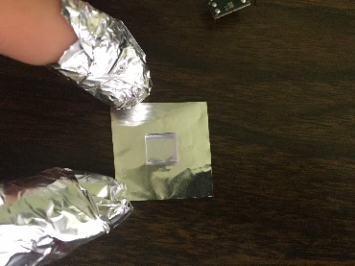

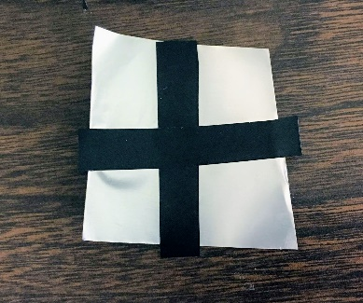Cut two pieces of black electrical tape with the width of the scintillator and with a length of three times the width of the scintillator. Attach these two pieces perpendicularly to the dull side of the foil.

Then cut off the excess foil.

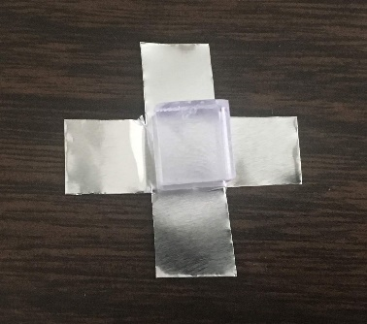

Fold up each of the four side of tape + foil and wrap a piece of tape around the cube. There’s no need for extra wraps. Just once around is good enough. Extra wraps create bulkiness which may let light leak in.

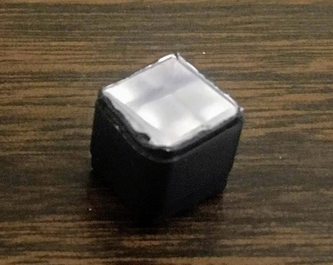

To cover the sixth side, place a square piece of foil with the dull side down on a piece of black tape, both with the width of the scintillator.

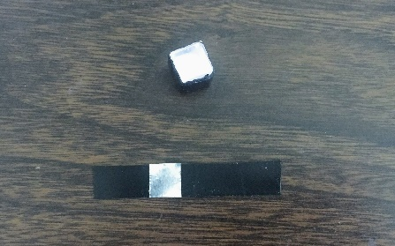

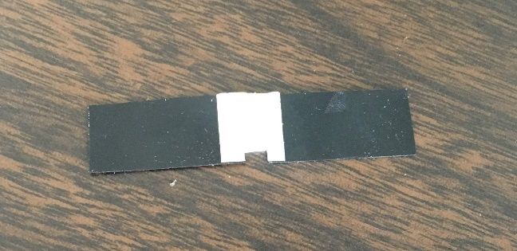Cut a 0.2cm by 0.2cm notch out of foil and tape as shown below.

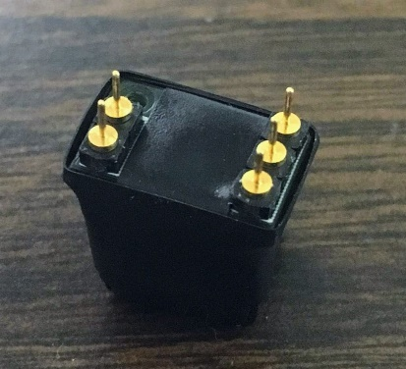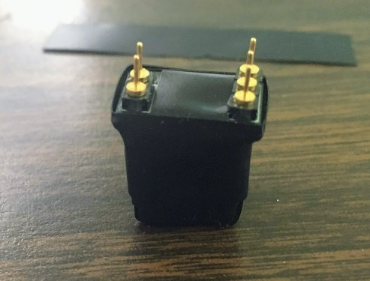Wrap this onto the last side of the scintillator. Line up this gap with the SiPM detector. Make sure the tape doesn’t touch the SiPM. Wrap a small piece of tape around the SiPM and scintillator to secure the two together. Then, very tightly wrap along the edge of the circuit board. Tightly wrapping makes the tape conform to the edge ensuring no gaps. Do this in as few wraps as possible; multiple wraps may cause the initial wrap to come undone. Finally, tightly wrap a small piece of tape over the hole in the circuit board.

**6 Setting Up the Breadboard**

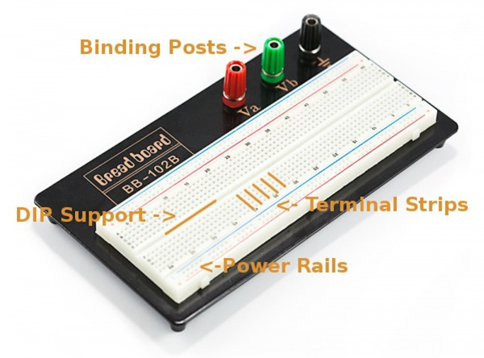

In a breadboard, each hole in a terminal strip is connected and each hole in a power rail is connected.

Turn on the power supply with no wires connected to it. Adjust the voltage to 28V. Turn it off.

The first connection should be the red and black wires to the binding posts. To connect them, unscrew the cap of the binding post and place the wire in the hole so that the wire goes through the entire hole. Then screw the cap back on. Do this for both the positive and negative terminals. Then connect red and black bananas to the positive and negative terminals of the power supply, respectively.

Follow the rest of the diagram below. Note the orientation of the ADC; the dot on it faces away from the cobbler. Each red dot represents where the end of the wire is placed into the breadboard.

R1s represent resistors with a resistance of 0.5Ω.

C1s represent capacitors with a resistance of 1µF.

The values of C1 and R1 can be changed so long as R*C (R times C) remains constant.

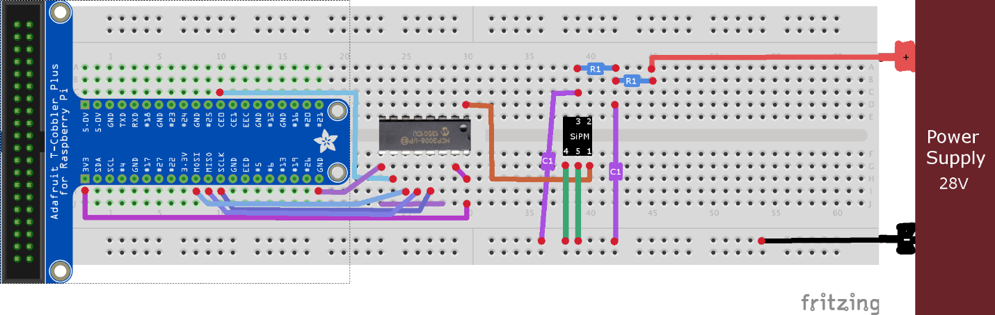

**7 Installing the Code**

For the Raspi to be able to interact with the ADC, you must alter a boot file.

To do so, open LXTerminal and enter “sudo nano /boot/config.txt”.

Use the arrow keys to navigate down to the line “#dtparam=spi=on”.

Remove the pound symbol (hashtag) from this line to make the line “dtparam=spi=on”.

In the line below, enter “dtoverlay=mcp3008:spi0-0-present”.

To save this file, press CTRL+O and then enter.

To exit the file, press CTRL+X.

In the command window, enter “sudo reboot” to reboot the Raspi.

Next, you must download the code.

In LXTerminal, enter “git clone [https://github.com/[INSERT](https://github.com/%5bINSERT) LINK HERE]”.

Then “cd mcp3008-UH [Change this]”.

Compile the code by typing “gcc -o readADC_data readADC_data.c”.

Turn on the power supply to power the SiPM.

Enter “ulimit -s 10000000000”

Then type “./readADC_data”.

The most useful thing to know about LXTerminal is to use the up and down arrow keys to re-use previous commands.