**Canterbury Christ Church University**

**Computing, Digital Forensics and Cybersecurity**

**BSc/BEng < BSc Computing >**

**< 2020-21>**

**Individual Project 20 MCOMD3PRT**

**< Developing an e-commerce affiliation website from scratch, as a first step to realising the vision for a free franchise template >**

**< Emereole Chinduji >   
Supervisor: < Richard Henson >**

**<ce233@canterbury.ac.uk>**

This report is submitted in partial fulfilment of the requirement for the BSc/BEng in <Bsc Computing> at Canterbury Christ Church University

I declare that this report is my own original work containing no personal data as defined in the Data Protection Act and that I have read, understood and accept the University’s regulations on plagiarism/intellectual property rights/research ethics (in particular the Research Governance Handbook) and the Individual Project 20 Module Handbook in its entirety.

Further, I accept that digital and/or hard copies of my Individual Project 20 , or parts thereof, may be made available to other students, individuals and organisations after it has been marked.

Finally, I accept that no copy of my Individual Project 20 will ever be returned regardless of the circumstances.

Signed: 

Date of Submission: **16/05/2021**

**Abstract**

Developing ane-commerce affiliation website from scratch, as a first step to realising the vision for a free franchise template,  
Chinduji Emereole, Canterbury Christ Church University.

Creating any business requires many resources that could be technical, financial, infrastructural, managerial know-how and other specific capacities. In the United States, according to the Bureau of Labor and Statistics, about 1/5th of start-ups fail in the first year, and 50% of the rest fail within the next 5-year period (Gustafson, 2020). Therefore, not only is it important to get started, but it is also equally important for start-ups not to fail after successfully being started. In today’s day and age, there are many ways of building a lucrative business without encountering the most common risks start-up businesses face. This project is all about the vision of providing a template for those who wish to start a referral e-commerce business quickly, and at low-cost while avoiding some of the issues associated with starting a business.

The scope of the present project (part 1) consists of developing the affiliation e-commerce website “NextHighFitness” from scratch. It will serve as a starting point for the vision of developing a free entry franchise[1], that proposes templates for starting affiliate e-commerce websites, in its concluding part.

Because of time constraints, the concluding part will eventually be the development, later, of the source code for the template of the free franchise planned to be called “NextHighLevel”, as part 2 (this is outside the scope of the present part).

Building a referral affiliation franchise is a solution chosen to realise the vision of facilitating an easy entry into e-commerce. It is a cost-effective way to present sellable content on a website without owning any stock nor products. It rewards the site owner for sales made through its referral link on a platform, with a commission on the sales. An affiliation e-commerce business is not easy to fail because of its low risk, low running cost, and low initial capital outlay (in the case of franchise members it is close to zero).

**Acknowledgement**

I would like to express my special thanks and gratitude to my supervisor Richard Henson who helped me to build up this wonderful project. His advice helped me in doing a lot of research and I came to gain so much knowledge and motivation.

**Content**

Introduction Chapter 3

Main Chapters 4

Legal consideration chapter 9

Ethical consideration chapter 10

Conclusion chapter 10

Reference 11

Bibliography 12

Appendix A: Glossary 15

Appendix B: Marking Scheme 17

Appendix C: Changes to the project initialisation document 18

Appendix D: Changes to the project initialisation document 18

Appendix E: Requirements Specification 18

Appendix F: Design report 18

Appendix G: Implementation 18

Appendix H: Testing 18

Appendix I: User Guide 18

Appendix J: Project Management 19

Appendix K: Meeting with supervisor 21

Appendix L: Agile development: Timebox 1 21

Appendix M: Agile development: Timebox 2 29

Appendix N: Agile development: Timebox 3 35

Appendix O: Growth of affiliate marketing 38

Appendix P: Fitness Market, an attractive niche on Amazon 39

Appendix Q: Wordpress file structure 40

Appendix R: Algorithm used for Search feature 40

Appendix S: Not yet implemented features 44

Appendix T: “stand-by” features 44

Introduction Chapter

The aim of this project consists of creating an e-commerce affiliation website from scratch as a first step to developing a free-entry template (franchise) for affiliation business using Amazon Associate as a first platform. This first referral website is to be built around the chosen strategic niche audience that corresponds to the fitness market.  
The website will have an income stream which comes from commissions on sales made on Amazon Associate platform, resulting from sales realised through customer clicks on the referral site which led to purchases on Amazon.

In part 2 of this project, a second income stream will be added through the franchise, using a reserved publicity space on all referral sites.

It is noted that starting an affiliation business is one of the fastest and easiest ways to start an e-commerce business at low-cost. The objective will be to make the affiliate website so easy to use, flexible, and effective as to attract as many customers as possible. It is believed that there is a potential for sustainable income to be generated from this project when fully developed. Therefore, it will be desirable in part 2, for the franchise template to reflect the same principles and properties as this present website, for the goal of attracting as many free joiners as possible to be achieved.

From an academic point of view, doing this project is a great opportunity to ameliorate skills in web design and programming (front end and backend). It also helped to learn new skills more oriented towards business; an example of which is learning the different ways to promote products and/or generate traffic on a website.

In this project, it is essential to be aware of the need for a good hosting plan and a good access provider that will offer complementary and robust security services.   
Even at this stage, there is the need to protect the source code and the business concept from piracy, hacking, and other attacks, through encryptions and other methods where necessary as ongoing project development progresses.   
It is also necessary to be careful about copyright issues concerning domain names, logos, images, and intellectual property issues.

To ensure that this project is developed to be competitive, steps have been taken for an acquaintance with best practices and cutting-edge developments in this sector. Research continues to be carried out on similar websites in the sector to see to it that this project remains strongly competitive.

A first attempt to create an affiliation e-commerce website undertaken by the author was during the period of the second year of university studies. The language used on that website is French, and the niche audience targeted was high-tech consumers.  
That website was built using plugins, made up WordPress themes, and other tools that do not require for the developer to write any lines of coding [nexthightech.net/](https://nexthightech.net/).   
In comparison, the present website is built from scratch using different programming languages. It has been published and can be consulted. There is still some work to be done however, to make it function properly [nexthightech.net/fitness/](https://nexthightech.net/fitness/).

The methodology used in the present project is the Agile methodology[2]; the project has in total three timeboxes[3]. The project was initially started on February 10th, 2021. The time taken on each timebox varied between 2 weeks and 4 weeks.

Initially, this website was programmed to have 16 pre-defined features. However, as the project went on, more features came along, and it ended up with a total of 24 features. At the time of writing this report, 15 features have been fully implemented and 2 more will be tested conclusively. Completing the remaining features will be done in an extra timebox.

Bluehost is the website hosting provider for this site because it is considered reliable and secure. WordPress, a well-known open-source creation software is used to create the site. HTML5[4] and CSS[5] were used to develop the website layout, JavaScript[6] and jQuery[7] for functionalities that need to have interactive elements, and PHP[8] to handle data and communicate with the database server.

The subsequent segment of this report will present the project itself in greater details. Legal and ethical issues about the project will be analysed, and finally, an overall conclusion will follow.

Main Chapters

The global vision of the marketing concept for the completed project   
 The concept of this project is basically a “free-entry franchise” template for e-commerce business start-ups that allows each joiner to choose its affiliation platform and its niche market. This proprietary free entry franchise is planned to be called “NextHighLevel”. When completed, it will be a secured franchise website that proposes a downloadable e-commerce affiliation template that will be compatible with leading open-source creation software such as WordPress or Shopify, and so allow the joiners to develop their sites on them.

The vision and the strategic choice of “free franchise” as an option, is to enlarge the scope of the project, and allow as many members as possible to join, in order to expand the income potential of the project when completed.  
In order to make it technically simple for joiners to install the template easily, an installer instructor guide will be made available at the time of download as well as a complete user guide of the full potential and use of the template. There will also be a 24/7 online chat-window on the franchise website, and this will be at the disposal of all, and accessible to those who need assistance.   
The possibility to choose from a list of affiliating platforms on offer, and the option to choose a niche to develop a referral website based on chosen areas of particular interest or specialisation, will lead to the creation of different types of websites, which will correspond to diverse business choices.   
This is a very significant advantage of what “NextHighLevel” will offer to its members.   
Offers and conditions differ from one platform to the other, and so, downloadable templates are customized to correspond to terms and conditions of a given platform.  
Should any given platform fail or stop their program, or should a member decide to change its line of business, it is very easy for the referral site to switch to another platform and niche by simply downloading the template that corresponds to its new choice without delay and develop its new area of interest.

A serious overview of affiliation marketing e-commerce will easily bring to light the great business potential that exists in this sector (see Appendix O).   
A template that will make it a lot easier for more people to establish their e-commerce websites will surely be the leading option that will stimulate development in this sector. It will particularly encourage people that have some difficulties in starting a business on the internet, or others who may desire to increase their income source, as well as, yet to be employed young people who have just come out of school.   
For this reason, it is believed that the opportunities that will be offered by “NextHighLevel” will become popular very quickly, and so, attract easy membership. This will achieve one of the objectives of this franchise; that of having a large membership, leading to an improved income potential and leadership in this sector.   
Developing the NextHighLevel franchise idea in this sector represents a lot of advantages to all member referral affiliate sites.  
 For example, “whole-sale[9] level” bonuses and privileges negotiated by NextHighLevel are passed on automatically, free of charge, and at no hidden cost to referral affiliate sites. This is one of the reasons why NextHighLevel will be the preferred opportunity to develop a revenue source for both active and passive income.  
The publicity space which will be on the referral sites will not be able to be modified or disabled by the joiners on the referral template. A joiner who expressly opts for a publicity disabled version will have to subscribe to a token monthly rental contract with NextHighLevel.   
  
 The publicity will come as a pop-up, or a small space for placement. This space is privileged first, to the affiliating platform partner such as Amazon Associates. The conditions for publicity will be based on a negotiated contractual agreement between the platform and NextHighLevel. This offer of publicity space will be used by NextHighLevel as a bargaining chip, to obtain privileged commissions and other conditions which will be passed on freely and automatically to all member referral sites at no cost.  
Such levels of publicity which correspond strictly to the businesses of the platform, will act to enhance the quality, validity, prestige, and legitimacy of participating local referral affiliate websites. Other advantages accruing to membership of the franchise include privileged tips on how to maximise income on referral websites among others to come.   
Joiners who expressly opt out of the publicity version and choose a rental option will not benefit from some of these negotiated advantages and tips.

Amazon Associate is an affiliate marketing[10] program that allows a website owner to add referral monetized content to its website. The Amazon Associate program was chosen for this present part (part 1) of the global project mainly to take advantage of the reputation of the multinational corporation, Amazon. It is one of the largest and most successful online retailer companies (REIFF, 2021). Another reason for choosing this platform is because of its relative ease to get on board, especially for people that are beginners in the affiliation business.   
The program provides many advantages to affiliate joiners such as receiving general commissions that can be as much as 10% of the price of the product sold. It proposes a diverse choice of goods and services that permits a niche market to be easily created. Moreover, when someone clicks on an affiliate link and decides to buy something else different from what the original link was, the commission on any sales therefrom will still be valid.   
However, the constraint of this platform is that clicking on an affiliate link can only result into a commission income if purchase is made withing 24 hours of the first click on that link. This means that if the same customer comes back to buy something after 24 hours, using the same affiliate link, there will be no commission received by the referral site owner for purchases therefrom.

The chosen niche in developing the website of this project “NextHighFitness”, is the fitness market. That is because after doing market research to determine the trending products sold online, it was found that the fitness market was lucrative and growing in popularity (see Appendix P).  
Choosing a niche is a critical strategic decision that will help to establish a loyal audience, retain clientele, and make customers return to the same business instead of going to competition. This will obviously improve the income stream for a small business.   
Developing a niche helps to emphasise an area of interest, passion, or preferred business activity. For this reason, a niche opens the door for a limitless number of professions to develop an e-commerce presence.   
Creating a niche, therefore, opens the door for e-commerce to venture into areas that have not been exploited, and so, kick start activity in new horizons with potential.

Process of developing this project

Bluehost is the hosting provider[11] for this project. It has been chosen among many other access providers such as SiteStripe or Hostinger because at the time of this project, its offers were considered the most cost-effective hosting plans compared to the others. The hosting plan chosen for this project is “CHOICE PLUS”. It offers the possibility to create custom website templates, create an unlimited number of websites, have access to a free SSL encryption, create a free domain name, and allow users to transfer files via FTP (File transfer protocol) client software. This hosting plan costs £4.98/month.

WordPress is the open-source creation software used to build this project. It is a content management system[12] (CMS) that allows users to build their own websites or blogs and publish them on the internet. The reason WordPress was chosen was because it remains one of the most popular CMS used on the internet. Research has revealed that there are at least 34% of websites created on the internet, using WordPress (Osman, 2021). Creating a customized theme on WordPress requires a certain knowledge of WordPress files; the minimum of which are “style.css”, “index.php”, “header.php” and “footer.php” (see Appendix Q).   
The project at present has in total 18 php files, 1 css file 1 Jquery file. Out of the 18 php files, 13 are used to create the present website. The other files will be used for further improvement. Two extra folders for logo and image are also used.

The software development methodology[13] used was Agile[14] to develop this project. Before starting the actual project, a project planning has been conducted to clarify the end goal of this project and how it will be achieved. The project planning[15] led to 16 user stories[16]. The user stories were made through ideas from the author and by doing extensive research concerning the marketplace targeted. Then, a release planning[17] was made to determine in what timebox each user story will be implemented. During the release planning, each feature was given a weight/size and time to evaluate the amount of work and time needed to accomplish it. Also, each user story was categorized using the MoScoW[18] system to determine the importance of each user story. At the end of each timebox there was a sprint review[19] and a sprint retrospective[20]. The sprint review consisted of reviewing the e-commerce website at the end of each timebox and determining if it could be a potential shippable product. The sprint retrospective was used here to analyse what happened during the process of making the project; for example, what was achieved and what was not. At the end of the first timebox, a velocity[21] calculation was done to come up with a number that measured the amount of work it took to complete the first timebox and compare it with the other timeboxes to determine the comparative efficiency of each timebox. Moreover, many tests were done at the end of each sprint with various tools to test the features of the website, find coding errors and test the loading speed.  
Agile was used in this project because it allowed the project management to be flexible by adding, editing, and removing user stories from timeboxes. Also, it gave the opportunity to analyse the work done after each iteration to adjust some points to make the project better.

The PID was composed of six features. During development changes were made and the new first timebox was now composed of seven features which include: Menu, Product catalogue, toggle menu, product page, about page, Homepage, and navigating ease.   
The second sprint had five features to implement which include: logo navigation, Category, Top scroll button, and redesigned scroll bar. The second timebox was supposed to have the Search and Tab features, however, many errors were found in these features, and this led to moving those features to the next timebox.  
Timebox three was planned to have seven features and two more from the previews timebox.  
A total of tree features have been implemented which are: high loading speed, security, and responsive website. The other features that were not implemented are product details, product choice, newsletter, and the cart features (see Appendix S). These features were not implemented because of a lack of time and a bad estimation of the amount of work these features would take. The two features that needed to be tested were not finished. The reason being a high number of errors, and the time required to correct them.  
There are three more features that were placed on “standby” which are: sub-menu, product slider, and dark mode (see Appendix T). They were good to implement but did not add any values of what the project was about.

Three programming languages (JQuery, PHP and JavaScript), as well as HTML5 (Hypertext markup language) and CSS (Cascading Style Sheets) have been used to create this project to date. The code was developed and edited using notepad++ (free source code editor) and files were transferred from local to the hosting platform using FileZilla as an FTP client software.  
CSS was mainly used in the “style.css” file, to stylise, add colours, and organize the website. “style.css” was designed in a way to make the website responsive to all types of user devices (smart-phones, tablets, laptops, smart-TV, etc…).   
jQuery was privileged over JavaScript for the WordPress compatible version of the website. This is because jQuery is less complex than JavaScript and more suitable for use on WordPress. It was used to implement three features on the website which are Toggle menu, Top scroll, and the Tab feature.   
However, at the initial stage of development, JavaScript was used to implement same features, as with jQuery, but on the static HTML version of the website, as a fallback for further development on other CMS.

The search feature on the project affiliate website was built with a very complex algorithm that does not function perfectly as at now. The algorithm behaves in such a way that when a search is made, it looks for the published product names on the website to organise and display them in an order of the most relevant to least relevant. See Appendix R to see the algorithm in more details. This is one of the areas that will be investigated for further development.

Design and HCI

The project affiliation website was developed using three principal colours which are light-blue, light-grey, and white. The text format is Poppins, and the font is black for easy reading. This combination of colours was inspired by a calm distant blue sky with few clouds on a beautiful day. The vision for the website is to create peace, harmony, and stability on the minds of visitors to this site, and not to cause them stress.   
Moreover, on the website, blue appears to be the colour that catches the attention of the customers and transmits a feeling of reassurance. It has been proven that blue creates a feeling of trust in the customers mind (Ferreira, 2019).   
  
 Conclusions based on tests to determine the response rate of this affiliate website have shown results of an acceptable rapid loading speed. This demonstrates that the website is effective, efficient, and responsive.  
The strategy adopted to make this site user-friendly, enjoyable, and comfortable is informed by the conclusions of studies in HCI[22] (Human Computer Interaction).  
This standard will be continued in the ongoing development of the NextHighLevel franchise website going forward.

The website name “NextHighFitness” invokes an image of newness, high and cutting-edge standards in the fitness world and general wellbeing.   
The principal pivotal slogan on the referral website is “Shape it”. This slogan is in harmony with the fitness and wellbeing culture and trend; a choice that catches the attention of visitors on the site.   
The logo of the project website was developed around the eye of the lynx, known for its keen vision. This choice mirrors the very meticulous culture of excellence and professionalism of the “NextHighLevel” franchise package, as portrayed on this “NextHighFitness” website.  
The logo was developed using the software 3D Paint and will continued to be improved upon with time. The colours employed are in concordance with the website colour code.

The project was developed from scratch using notepad++. Subsequent development and update will follow the same policy onto conclusion and going forward. Developing from scratch gives the franchise full ownership and intellectual proprietary control over the source code.   
Continuous ongoing development, improvement, and control will ensure the protection of intellectual property rights and the integrity of the source code. The franchise owner will take steps to protect the source code from hacking and destruction on a non-stop basis to protect the franchise, websites and the businesses that depend on them.

Legal consideration chapter

When building this project, legal concerns had to be put into constant consideration.   
Firstly, before starting an affiliation business, it is highly recommended to read the contract made by the affiliation platform. In the case of “NextHighFitness”, the affiliation platform is Amazon Associate, and there is a certain number of rules that must be respected to continue exercising in this domain. Some of the rules imposed by the platform on the project website “NextHighFitness” are: “You are not allowed to modify links in such a way that conceals the Amazon website” “You cannot state the price for any product. For example, if you have a website, you are not allowed to put the price of the product down.” (amazonassociates, 2021).

When future improvements will be applied on the affiliate website that involves personal data, data protection legislations such as GDPR[23] (General Data Protection Regulation), will have to be seriously considered. The website will need to be compliant with these types of legislation to inform the users that they have a more secure level of control.

Ethical consideration chapter

Ethics and protection issues had to be considered while building this project. It is important to inform the users that the website is an affiliation website to vehicle a feeling of transparency[24] between the users and the owner.

Conclusion chapter

The primary aim of this project was to develop ane-commerce affiliation website from scratch and to introduce the vision for a free franchise template to be developed at a future date.   
Developing this website provided a good opportunity to learn what it takes to build a website. Issues concerning hosting, content management systems, web programming languages, optimisation on different and most used browsers, compatibility with IoT[25] (internet of things) devices, site referencing (e.g., on google search engine), and others were all confronted during the project.  
This referral site is attached to the Amazon affiliate program, built on a chosen strategic niche of the fitness market. The choice for the niche was made after graphic results of market research on trending products sold online and on Amazon, revealed that the fitness market was lucrative and growing rapidly.  
The strategic choice of a niche market helped to expose the marketing principle of targeting an audience.   
Overall, this website is the first step of a bigger picture; that of the vision for a free proprietary source code and franchise template.  
The present project is an example of what a downloadable referral website on the free franchise will look like when fully developed.

This project is already a potential source of passive income to the author.  
It serves as a pointer to the future free franchise template, which will give the opportunity to other people to create their own e-commerce websites, easily and at a low-cost.   
The franchise will be of particular interest to young people who are yet to be employed after graduating, and others who wish to diversify their sources of active and passive income when the second part is completed.

The website (part 1) of this project has been completed and running effectively, even though there is still some improvement to be made.  
The project affiliate website has in total 24 features. So far, 15 features have been fully implemented, and these are: Menu, Product catalogue, toggle menu, Product page, About page, Homepage, navigation bar, Logo navigation, category, top scroll button, Page navigation, customised scroll bar, high loading speed, security, website responsiveness.   
Two further features that need to be tested are: Search and Tab.   
Other four features will require an extra timebox to be implemented; and they include: Product details, Product choice, Newsletter, and add to cart.  
Additional three features are on stand-by and are expected to be validated before implementation. They include: Sub-menu, Product slider, and Dark mode.  
  
Through this website, the foundation of the vision of the completing part of this project has been laid and elaborated. This is also one of the things building this website has achieved.   
The final development of the vision will be completed in the future as the next part of this project.

The way forward will be to complete and showcase the attractiveness and viability of the referral affiliate website which is part 1.  
The site should be promoted with various e-commerce tools to prove the validity of the hypothesis that a referral e-commerce website can constitute a source of income.

Part 2 will consist of developing the source code for the free franchise template. The template should be so easy to use and flexible as to attract as many members as possible.  
From the start of the development of part 2, it will be critically necessary to own the proprietary rights and to protect the source code, logo, images, script, and all matters related to intellectual property.  
The full income potential of the vision of this project will be achieved when the second income stream plan, through publicity placed on all referral member sites on the franchise is implemented.

Reference

Ferreira, N. M., 2019. *COLOR PSYCHOLOGY: HOW COLOR MEANINGS AFFECT YOUR BRAND.* [En ligne]   
Available at: https://www.oberlo.com/blog/color-psychology-color-meanings#:~:text=Color%20can%20be%20used%20by,people%20decide%20what%20is%20important.  
[Accès le 07 05 2021].

Gustafson, K., 2020. *What Percentage of Businesses Fail and How to Improve Your Chances of Success.* [En ligne]   
Available at: https://www.lendingtree.com/business/small/failure-rate/#:~:text=year%20of%20business-,Percentage%20of%20businesses%20that%20fail,%2C%20roughly%2050%25%20have%20faltered.  
[Accès le 07 05 2021].

Osman, M., 2021. *Wild and Interesting WordPress Statistics and Facts (2021).* [Online]   
Available at: https://kinsta.com/blog/wordpress-statistics/#:~:text=WordPress%20is%20the%20world's%20most,of%20the%20world's%20top%20websites  
[Accessed 05 05 2020].

REIFF, N., 2021. *10 Biggest Companies in the World.* [Online]   
Available at: https://www.investopedia.com/articles/active-trading/111115/why-all-worlds-top-10-companies-are-american.asp#:~:text=Amazon%20is%20the%20world's%20largest%20online%20retailer%20by%20market%20cap.&text=Besides%20selling%20products%20through%20its,and%20hom  
[Accessed 07 05 2021].

Bibliography

Cambridge_Dictionnary, 2021. *Cambridge Dictionnary.* [Online]   
Available at: https://dictionary.cambridge.org/dictionary/english/wholesale  
[Accessed 10 05 2021].

Canbridge_Dictionary, 2021. *Canbridge Dictionnary.* [Online]   
Available at: https://dictionary.cambridge.org/dictionary/english/franchise  
[Accessed 10 05 2021].

Enfroy, A., 2021. *Affiliate Marketing in 2021: What It Is and How You Can Get Started.* [Online]   
Available at: https://www.bigcommerce.com/blog/affiliate-marketing/#what-is-affiliate-marketing  
[Accessed 10 05 2021].

Ferreira, N. M., 2019. *COLOR PSYCHOLOGY: HOW COLOR MEANINGS AFFECT YOUR BRAND.* [Online]   
Available at: https://www.oberlo.com/blog/color-psychology-color-meanings#:~:text=Color%20can%20be%20used%20by,people%20decide%20what%20is%20important.  
[Accessed 07 05 2021].

GDPR.EU, 2021. *Complete guide to GDPR compliance.* [Online]   
Available at: https://gdpr.eu/  
[Accessed 10 05 2021].

getsmarter, 2021. *What is Human-Computer Interaction (HCI) ?.* [Online]   
Available at: https://www.getsmarter.com/blog/career-advice/what-is-human-computer-interaction-hci/  
[Accessed 10 05 2021].

Guru99, 2021. *Agile Methodology: What is Agile Software Development Model?.* [Online]   
Available at: https://www.guru99.com/agile-scrum-extreme-testing.html  
[Accessed 10 05 2021].

Guru99, 2021. *What is PHP? Write your first PHP Program.* [Online]   
Available at: https://www.guru99.com/what-is-php-first-php-program.html  
[Accessed 10 05 2021].

Gustafson, K., 2020. *What Percentage of Businesses Fail and How to Improve Your Chances of Success.* [Online]   
Available at: https://www.lendingtree.com/business/small/failure-rate/#:~:text=year%20of%20business-,Percentage%20of%20businesses%20that%20fail,%2C%20roughly%2050%25%20have%20faltered.  
[Accessed 07 05 2021].

Kulach, K., 2021. *Top selling items on Amazon in 2021: what to sell online right now.* [Online]   
Available at: https://www.webinterpret.com/uk/blog/top-selling-items-amazon/  
[Accessed 11 05 2021].

LAMPTON, J., 2019. *TRANSPARENCY IS THE BEDROCK OF ETHICS.* [Online]   
Available at: https://sfmagazine.com/post-entry/september-2019-transparency-is-the-bedrock-of-ethics/#:~:text=Transparency%20is%20an%20attribute%20of,and%20interactions%20within%20the%20organization.  
[Accessed 10 05 2021].

mondayproject, 2021. *Agile planning: a step-by-step guide [+template].* [Online]   
Available at: https://monday.com/blog/project-management/agile-planning/#:~:text=Agile%20planning%20is%20a%20project,units%20called%20iterations%20or%20sprints.&text=Agile%20planning%20defines%20which%20items,how%20much%20they%20can%20achieve.  
[Accessed 10 05 2021].

mondayr&d, 2021. *Everything you need to know about Agile release planning.* [Online]   
Available at: https://monday.com/blog/rnd/agile-release-planning/#:~:text=Agile%20release%20planning%20is%20a%20product%20management%20method%20where%20you,several%20different%20sprints%20or%20iterations.  
[Accessed 10 05 2021].

namecheap, 2021. *What is Web Hosting?.* [Online]   
Available at: https://www.namecheap.com/hosting/what-is-web-hosting-definition/  
[Accessed 10 05 2021].

Osman, M., 2021. *Wild and Interesting WordPress Statistics and Facts (2021).* [Online]   
Available at: https://kinsta.com/blog/wordpress-statistics/#:~:text=WordPress%20is%20the%20world's%20most,of%20the%20world's%20top%20websites  
[Accessed 05 05 2020].

planview, 2021. *What is Velocity in Agile?.* [Online]   
Available at: https://www.planview.com/fr/resources/articles/lkdc-velocity-agile/#:~:text=Velocity%20in%20Agile%20is%20a,iterations%2C%20sprints%2C%20or%20weeks.  
[Accessed 10 05 2021].

ProductPlan, 2021. *MoSCoW Prioritization.* [Online]   
Available at: https://www.productplan.com/glossary/moscow-prioritization/  
[Accessed 10 05 2021].

Ranger, S., 2020. *What is the IoT? Everything you need to know about the Internet of Things right now.* [Online]   
Available at: https://www.zdnet.com/article/what-is-the-internet-of-things-everything-you-need-to-know-about-the-iot-right-now/  
[Accessed 10 05 2021].

Rastas, J., 2020. *Useful affiliate marketing statistics in 2021.* [Online]   
Available at: https://supermetrics.com/blog/affiliate-marketing-statistics  
[Accessed le 11 05 2021].

REIFF, N., 2021. *10 Biggest Companies in the World.* [Online]   
Available at: https://www.investopedia.com/articles/active-trading/111115/why-all-worlds-top-10-companies-are-american.asp#:~:text=Amazon%20is%20the%20world's%20largest%20online%20retailer%20by%20market%20cap.&text=Besides%20selling%20products%20through%20its,and%20hom  
[Accessed 07 05 2021].

Scrum.org, 2021. *What is a Sprint Retrospective?.* [Online]   
Available at: https://www.scrum.org/resources/what-is-a-sprint-retrospective  
[Accessed 10 05 2021].

scruminc, 2019. *Sprint Review.* [Online]   
Available at: https://www.scruminc.com/sprint-review/#:~:text=The%20Sprint%20Review%20takes%20place,the%20product%20(Product%20Backlog).  
[Accessed 10 05 2021].

scruminc, 2019. *What is timeboxing?.* [Online]   
Available at: https://www.scruminc.com/what-is-timeboxing/  
[Accessed 10 05 2021].

ShareIT, 2021. *3 Software Development Methodologies Explained.* [Online]   
Available at: https://www.shareitsolutions.com/blog/software-development-methodologies  
[Accessed 10 05 2021].

Staff, E., 2016. *Beginner’s Guide to WordPress File and Directory Structure.* [Online]   
Available at: https://www.wpbeginner.com/beginners-guide/beginners-guide-to-wordpress-file-and-directory-structure/  
[Accessed 14 05 2021].

VisualParadigm, 2021. *What is User Story?.* [Online]   
Available at: https://www.visual-paradigm.com/guide/agile-software-development/what-is-user-story/#:~:text=A%20user%20story%20is%20a,simplified%20description%20of%20a%20requirement.  
[Accessed 10 05 2021].

w3schools, 2021. *CSS Introduction.* [Online]   
Available at: https://www.w3schools.com/css/css_intro.asp  
[Accessed 10 05 2021].

w3schools, 2021. *HTML Introduction.* [Online]   
Available at: https://www.w3schools.com/html/html_intro.asp  
[Accessed 10 05 2021].

w3schools, 2021. *jQuery Introduction.* [Online]   
Available at: https://www.w3schools.com/jquery/jquery_intro.asp  
[Accessed 10 05 2021].

w3schools, 2021. *What is JavaScript?.* [Online]   
Available at: https://www.w3schools.com/whatis/whatis_js.asp  
[Accessed 10 05 2021].

whatcms.org, 2021. *What CMS Is This Site Using?.* [Online]   
Available at: https://whatcms.org/  
[Accessed 10 05 2021].

**Appendices:**

Appendix A: Glossary

|  |  |
| --- | --- |
| Terms | Description |
| Franchise | “a [right](https://dictionary.cambridge.org/dictionary/english/right) to [sell](https://dictionary.cambridge.org/dictionary/english/sell) a company's [products](https://dictionary.cambridge.org/dictionary/english/product) in a [particular](https://dictionary.cambridge.org/dictionary/english/particular) [area](https://dictionary.cambridge.org/dictionary/english/area) using the company's [name](https://dictionary.cambridge.org/dictionary/english/name)” (Canbridge_Dictionary, 2021). |
| Agile Methodology | “AGILE methodology is a practice that promotes **continuous iteration**of development and testing throughout the software development lifecycle of the project. In the Agile model, both development and testing activities are concurrent, unlike the Waterfall model.” (Guru99, 2021) |
| Timebox | “Timeboxing is allotting a fixed, maximum unit of time for an activity. That unit of time is called a time box. The goal of timeboxing is to define and limit the amount of time dedicated to an activity. Scrum uses timeboxing for all of the Scrum events and as a tool for concretely defining open-ended or ambiguous tasks.” (scruminc, 2019) |
| HTML | “HTML is the standard markup language for creating Web pages.” (w3schools, 2021) |
| CSS | “CSS is the language we use to style a Web page.” (w3schools, 2021) |
| JavaScript | “JavaScript is the Programming Language for the Web. JavaScript can calculate, manipulate and validate data.” (w3schools, 2021) |
| jQuery | “The purpose of jQuery is to make it much easier to use JavaScript on your website.” (w3schools, 2021) |
| PHP | “PHP is a server-side scripting language. that is used to develop Static websites or Dynamic websites or Web applications. PHP stands for Hypertext Pre-processor, that earlier stood for Personal Home Pages.” (Guru99, 2021) |
| Wholesale | “the [selling](https://dictionary.cambridge.org/dictionary/english/selling) of [goods](https://dictionary.cambridge.org/dictionary/english/goods) in [large](https://dictionary.cambridge.org/dictionary/english/large) [amounts](https://dictionary.cambridge.org/dictionary/english/amount) at [low](https://dictionary.cambridge.org/dictionary/english/low) [prices](https://dictionary.cambridge.org/dictionary/english/price) to [shops](https://dictionary.cambridge.org/dictionary/english/barbershop) and [businesses](https://dictionary.cambridge.org/dictionary/english/business), [rather](https://dictionary.cambridge.org/dictionary/english/rather) than the [selling](https://dictionary.cambridge.org/dictionary/english/selling) of [goods](https://dictionary.cambridge.org/dictionary/english/goods) in [shops](https://dictionary.cambridge.org/dictionary/english/barbershop) to [customers](https://dictionary.cambridge.org/dictionary/english/customer)” (Cambridge_Dictionnary, 2021) |
| Affiliate marketing | “Affiliate marketing is the process by which an affiliate earns a commission for marketing another person’s or company’s products.” (Enfroy, 2021) |
| Hosting provider | “web hosting is the process of renting or buying space to house a website on the World Wide Web” (namecheap, 2021) |
| Content management system (CMS) | “A Content Management System, or CMS, is a piece of software designed to help users create and edit a website.” (whatcms.org, 2021) |
| Software development methodology | “In its essence, this is a process where you split the software building work into different stages that have different types of activities assigned to each phase. The main purpose of this is to help software development teams effectively plan and manage their workload.” (ShareIT, 2021) |
| Project Planning | “Agile planning defines which items are done in each sprint, and creates a repeatable process, to help teams learn how much they can achieve.” (mondayproject, 2021) |
| User story | “A user story is a tool used in Agile software development to capture a description of a software feature from an end-user perspective. A user story describes the type of user, what they want and why. A user story helps to create a simplified description of a requirement.” (VisualParadigm, 2021) |
| Release planning | “In Agile release planning, you prepare for staged releases and then break those down into several different sprints or iterations.” (mondayr&d, 2021) |
| MoSCoW | “MoSCoW prioritization, also known as the MoSCoW method or MoSCoW analysis, is a popular [prioritization technique](https://www.productplan.com/strategies-prioritize-product-features/) for managing requirements. The method is commonly used to help key stakeholders understand the significance of initiatives in a specific release.” (ProductPlan, 2021) |
| Sprint review | “The Sprint Review takes place at the end of the Sprint and is designed to gather actionable feedback on what the Team has completed. This ceremony, also known as the "Demo", is an exciting opportunity for the team to showcase its work and to inspect the overall roadmap for the product (Product Backlog).” (scruminc, 2019) |
| Sprint retrospective | “The Sprint Retrospective concludes the Sprint” (Scrum.org, 2021) |
|  |  |
| Velocity | “Velocity in Agile is a simple calculation measuring units of work completed in a given timeframe. Units of work can be measured in several ways, including engineer hours, user stories, or story points.” (planview, 2021) |
| HCI | “HCI is the study of designing computers and machines so that they best serve their users (i.e. humans). HCI is closely related to the field of User Experience (UX) design and is considered by many to be the forefather of this more modern approach.” (getsmarter, 2021) |
| GDPR | “What is the GDPR? Europe’s new data privacy and security law” (GDPR.EU, 2021) |
| Transparency | “Transparency is an attribute of corporate culture that’s revealed through the behaviors of an organization’s leaders, employees, and stakeholders.” (LAMPTON, 2019) |
| IoT | “The Internet of Things, or IoT, refers to the billions of physical devices around the world that are now connected to the internet, all collecting and sharing data.” (Ranger, 2020) |

Appendix B: Marking Scheme

|  |  |  |  |  |
| --- | --- | --- | --- | --- |
| **Weighting** |  | **Rating/10** | **Score** |  |
| 5 | Introduction: background to the problem, justification for the chosen task, etc., which maybe contained in more than just the Introduction chapter. |  | 0,00 |  |
| 15 | Phase 1 Development: Initial Hand-in version. Appropriate selection of functionality. Appropriate Analysis and Design Methods chosen, and well used for this phase of development. Appropriate data structures and coding. Good testing of elements in this phase. User Guide, *if* appropriate. |  | 0,00 |  |
| 10 | Phase 2 Development: As per Phase 1, plus appropriate re-factoring, when needed. (optionally presented to supervisor, on a date to be arranged). |  | 0,00 |  |
| 10 | Phase 3 Development: as Per Phase 2 . As presented at the final demonstration. |  | 0,00 |  |
| 5 | Final deliverable code quality: Good classes or data structures used, consistent coding standards and appropriate secondary notations and commentary used. Code refactoring performed to minimise duplication across development phases. |  | 0,00 |  |
| 15 | Final deliverable usability. Consistent, minimal and approachable design with close attention paid to user profiles, task requirements and context of use. |  | 0,00 |  |
| 15 | Final deliverable functionality. How well the system works and meets the requirements for the functionality selection. |  | 0,00 |  |
| 5 | Final functionality selection. Appropriate prioritisation in MoSCoW ruleset for a useful product given the level of development undertaken. |  | 0,00 |  |
| 5 | Project management procedures: schedules; monitoring of progress; Audit trail of development, etc. |  | 0,00 |  |
| 10 | Presentation, organisation and style: quality of English (with few editorial, grammatical or spelling errors); appropriate writing style with due emphasis on formality; relevant use of jargon, technical terms and glossary; physical and logical layout of the report; formatting; headings/sub-headings; page numbering; binding; table of contents; margins and white space; tables; diagrams; sequencing of chapters/topics; appropriate use of appendices; cross referencing; ease of auditing; appropriate abstract; acknowledgments; quoting and in-text referencing of sources; departmental standards for report layout & presentation; references and bibliographies; etc. |  | 0,00 |  |
| 10 | Achievement: Generally, and more specifically with respect to meeting the specified requirements and the requirements detailed in the (amended) PID. |  | 0,00 |  |
| 10 | Conclusions, critical perspective, evaluation and suggestions for further work. |  | 0,00 |  |
| 115 |  | **Mark Out of 85** | **0,00** |  |
|  |  |  |  |  |
| **Rating Scale:** | **GRAND TOTAL** |  | **0,00** | **%** |
| 0 | Non-existent |  |  |  |
| 0.1 - 3.4 | Poor |  |  |  |
| 3,5 | Narrow fail |  |  |  |
| 4 | Just Acceptable, but less than adequate |  |  |  |
| 5 | Adequate |  |  |  |
| 6 | Good |  |  |  |
| 7 | Very good |  |  |  |
| 8+ | Excellent |  |  |  |

Appendix C: Changes to the project initialisation document

Deliberately left blank.

Appendix D: Changes to the project initialisation document

Not Applicable, see Appendices L, M, and possibly N for Agile development method timeboxes.

Appendix E: Requirements Specification

Not Applicable, see Appendices L, M, and possibly N for Agile development method timeboxes.

Appendix F: Design report

Not Applicable, see Appendices L, M, and possibly N for Agile development method timeboxes.

Appendix G: Implementation

Not Applicable, see Appendices L, M, and possibly N for Agile development method timeboxes.

Appendix H: Testing

Not Applicable, see Appendices L, M, and possibly N for Agile development method timeboxes.

Appendix I: User Guide

Not Applicable, see Appendices L, M, and possibly N for Agile development method timeboxes.

Appendix J: Project Management

|  |  |
| --- | --- |
| **Days** | **Actual – features realised timebox 1** |
| **10/02/2021** |  |
| **11/02/2021** |  |
| **12/02/2021** | Homepage, product page, about us page - **Start** |
| **13/02/2021** | Homepage, product page, about us page - **Done** |
| **14/02/2021** | Toggle Menu and Menu - **Start** |
| **15/02/2021** | / |
| **16/02/2021** | / |
| **17/02/2021** | / |
| **18/02/2021** | Toggle Menu and Menu - **Done** |
| **19/02/2021** | Product catalogue - **Start** |
| **20/02/2021** | Product catalogue - **Done** |
| **21/02/2021** | Navigation ease – **start and done** |

|  |  |
| --- | --- |
| **Days** | **Actual – features realised timebox 2** |
| **01/03/2021** |  |
| **02/03/2021** |  |
| **03/03/2021** | Customized scroll bar – **Start and Done** |
| **04/03/2021** | Page navigation - **Start** |
| **05/03/2021** | / |
| **06/03/2021** | Page navigation - **Done** |
| **07/03/2021** | Scroll top button - **Start** |
| **08/03/2021** | Scroll top button - **Done** |
| **09/03/2021** | Category -**Start** |
| **10/03/2021** | / |
| **11/03/2021** | Category - **Done** |
| **12/03/2021** | Logo navigation - **Start** |
| **13/03/2021** | Logo navigation - **Done** |

|  |  |
| --- | --- |
| **Days** | **Actual – features realised timebox 3** |
| **05/04/2021** |  |
| **06/04/2021** | Website responsivity - **Start** |
| **07/04/2021** | Website responsivity - **Done** |
| **08/04/2021** | Website security – **Start and done** |
| **09/04/2021** | Website loading speed – **Start and Done** |
| **10/04/2021** | Testing of tab feature, and Search |
| **11/04/2021** | / |
| **12/04/2021** | / |
| **13/04/2021** | / |
| **14/04/2021** | / |
| **15/04/2021** | / |
| **16/04/2021** | / |
| **17/04/2021** | / |
| **18/04/2021** | / |
| **19/04/2021** | / |

Appendix K: Meeting with supervisor

Left Blank

Appendix L: Agile development: Timebox 1

Release planning: (Timebox 1)  
  
 The purpose of this timebox is to set the core functionalities of an e-commerce website to enable user to navigate through the website and buy products.

Seven user stories selected:

|  |  |  |  |  |
| --- | --- | --- | --- | --- |
| **User stories for sprint 1** | **Priority** | **Condition of satisfaction** | **Time estimated to complete in hours** | **Sizing** |
| **As a** shopper  **I want to** easily navigate through the website  **So that** I can make my shopping faster | Must Have | Verifies that the website is easy to navigate to. | 2 hours | 2 |
| **As a** shopper  **I want to** have access to a website homepage  **So that** I have a better user experience | Must Have | Verifies that the website has a homepage | 1 hour | 2 |
| **As a** shopper  **I want to** know what the website is about  **So that** I can have better understanding of the website | Should have | Verifies that the website has an about page | 2 hours | 2 |
| **As a** shopper  **I want to** have access to a product page  **So that** I can make my shopping | Must have | Verifies that the website has a dedicated product page | 1 hour | 2 |
| **As a** shopper  **I want** the website to have a toggle menu on my phone and tablet.  **So that** I easily navigate through the website | Could have | Verifies that mobile users have access to a functioning toggle menu | 3 hours | 4 |
| **As a** shopper  **I want to** have access to a product catalogue  **So that** I can view the different products | Must have | Verifies that products are presented on the website | 10 hours | 8 |
| **As a** shopper  **I want to** have a menu section  **So that** I can easily navigate through the website. | Must have | Verifies that there is a section on all pages | 5 hours | 6 |

The prioritized features were to create 3 functional pages which are the homepage, the product page and the about page. The Homepage is the first page the user will come across. Therefore, it needs to be well design and attractive. The product page is where the user will make its shopping. The about page will give more information about the website, also, it will give more details about legal issues. Another 2 prioritized features which are the Product catalogue and the Menu. These features were prioritized to allow the user to select product and to easily navigate through the website.

The process goes like this:  
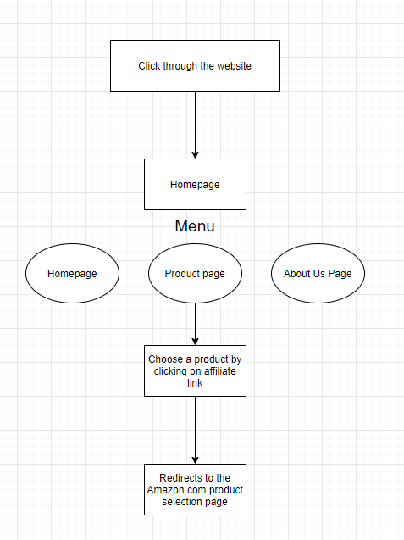

Sprint review and retrospective: (Timebox 1)In the course of developing this timebox, six features were meant to be implemented for the PID. Which were:

1. Homepage
2. Product page
3. About page
4. Product Catalogue
5. Navigation menu
6. Cart feature

However, seven features have been implemented instead:

1. Homepage
2. Product page
3. About page
4. Product Catalogue
5. Navigation menu
6. Toggle menu
7. Navigation ease

The cart features have been replaced to the toggle menu feature because the estimated amount of word needed to do this feature was too important and the toggle menu features gave the advantage of optimising the platform for IoT devices users.   
  
The End product delivered for this timebox can be considered as a potential shippable product because it fulfils the basic functionalities of a normal e-commerce website.

User Guide :

Home page:  
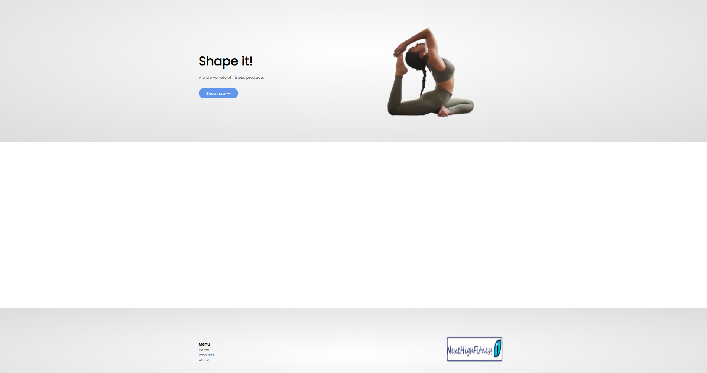

Product Page:

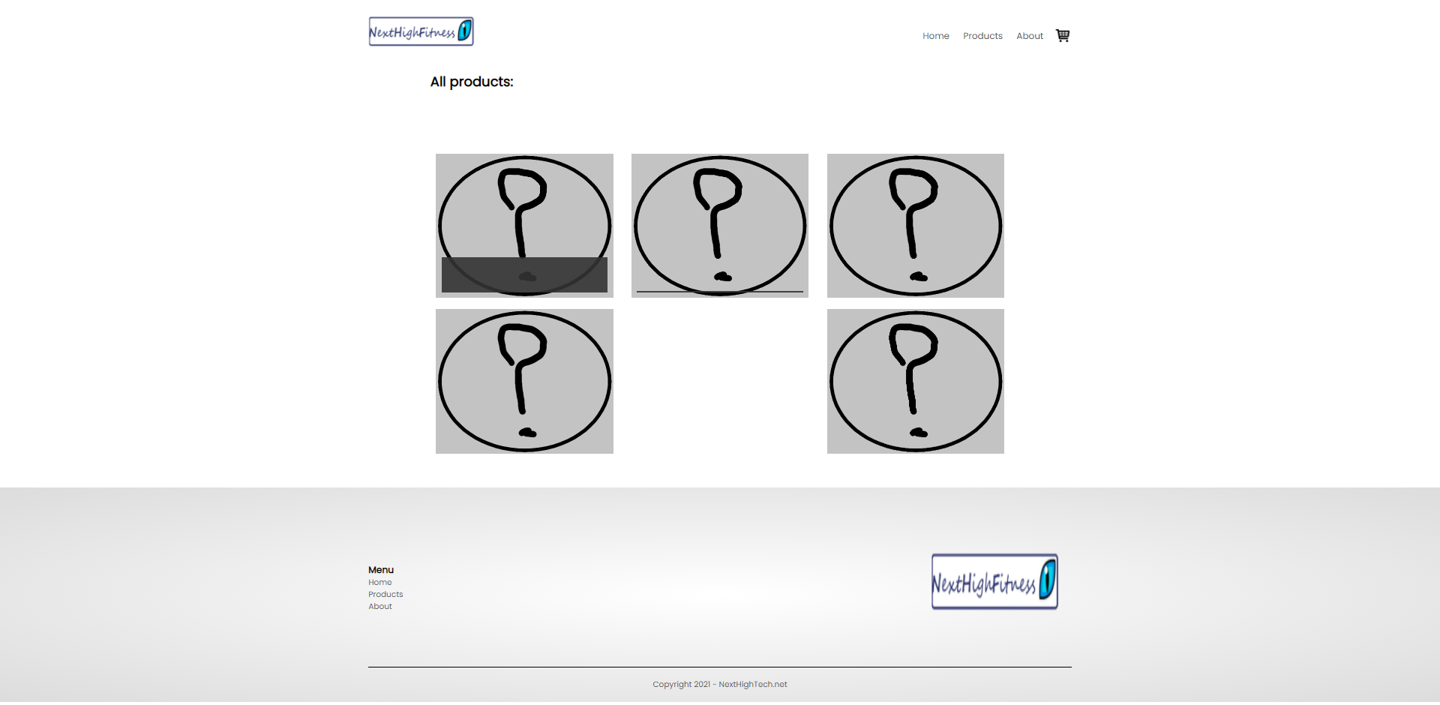

About Page:

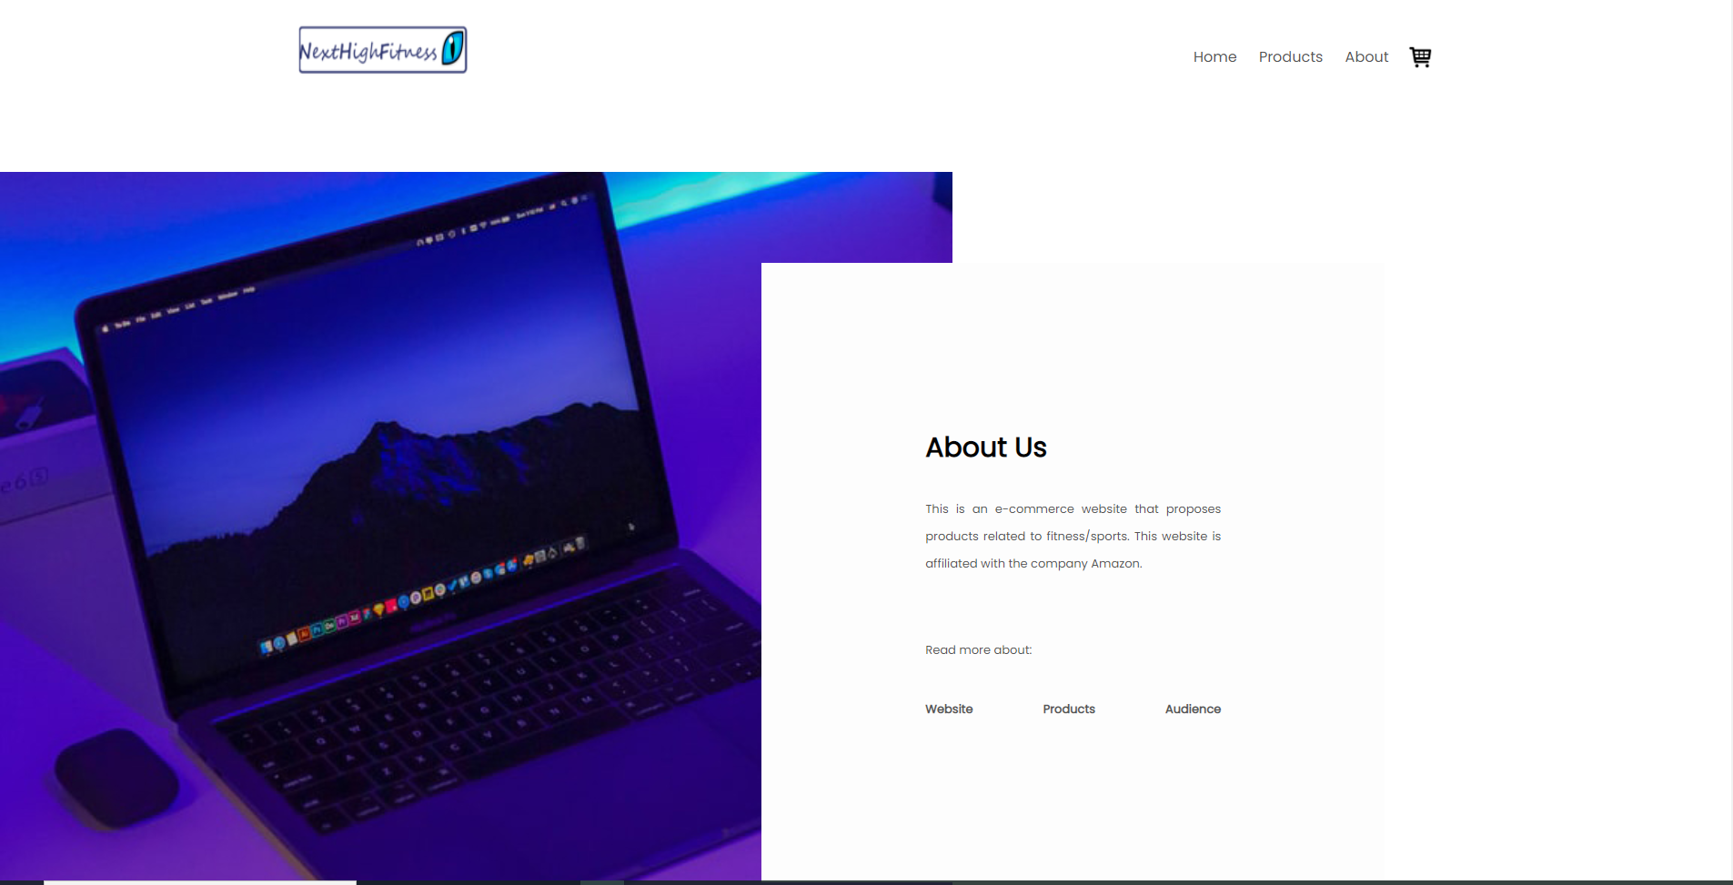

Product catalogue:

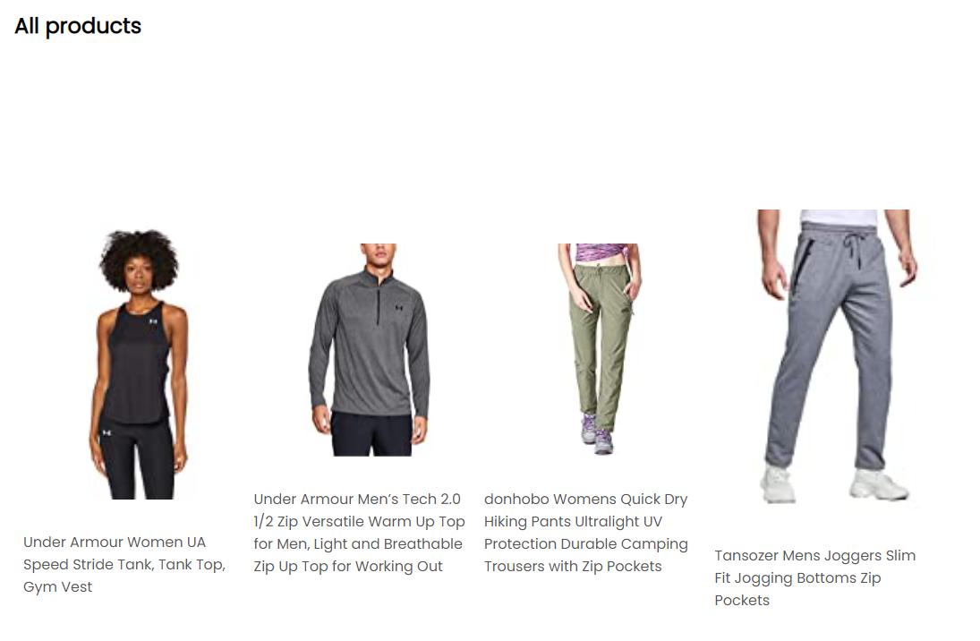

Navigation menu



Toggle menu



Velocity calculation

User stories completed x total number of story points achieved

7 x 26 = 182.  
  
This represents the amount of work that will possibly done for timeboxe 2.

Testing

Testing was made in 3 different ways.

The first way was to look test each feature by looking at the three most used browsers which are: Google chrome, Mozilla Firefox, and Microsoft Edge. Each feature was tested on those three browsers to see if it worked.

The second way was to use a tool called NIBBLER to test the features of the website in more details

And the third way was to use a tool called PAGESCORING that test the loading speed of a website.

For timebox 1 the all the features worked in the 3 browsers.  
  
Test on Nibbler:  
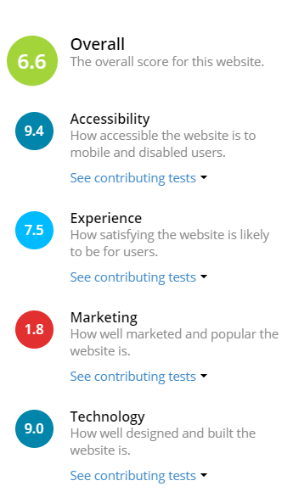

Test shown on Pagescoring:

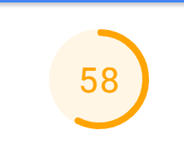

Appendix M: Agile development: Timebox 2

Release planning: (Timebox 2)

The aim of this timebox was to make the website more users friendly by making it more usable and by customized elements for the design.

5 user stories:

|  |  |  |  |  |
| --- | --- | --- | --- | --- |
| **User stories for sprint 2** | **Priority** | **Condition of satisfaction** | **Time estimated to complete in hours** | **Sizing** |
| **As a** shopper  **I want to** view a better scroll bar  **So that** I can have a better experience on the website | Could have | Verifies that the customized scrollbar appears the same on all browsers | 1 hour | 3 |
| **As a** shopper  **I want to** have a page navigation when there are too many products  **So that** I can have more comfort navigating through the website | Should have | Verifies that there is a page navigation when more than 8 products on a category page | 3 hours | 4 |
| **As a** shopper  **I want to** have a scroll to top button  **So that** I can easily go at the top of the page when I am too far down. | Should have | Verifies that there is a button to scroll to the top | 3 hours | 4 |
| **As a** shopper  **I want to** view products by category  **So that** I can have a better shopping experience | Must have | Verifies that there is the possibility to view products from a specific category | 10 hours | 12 |
| **As a** shopper  **I want to** be redirected to the homepage when I click on the logo  **So that** I have a better experience when navigating through the website | Could have | Verifies that when the website logo is clicked, it redirects to the homepage | 1 hour | 2 |
| **As a** shopper  **I want to** have access to a tab feature on the homepage  **So that** I can see more types of products | Could have | Verifies that the tab displays products | 8 hours | 10 |
| **As a** shopper  **I want to** search for a specific product  **So that** I can more easily find it and buy it | Must have | Verifies that the search form works properly | 12 hours | 16 |

The prioritized feature for this timebox was Category. It was mainly prioritized because it was the hardest one out of all the other ones. It is also because the category features represent a major upgrade for the website by allowing the user to customize its shopping experience. The search feature was prioritised as well and have been implemented, however, it still needs a lot of testing to function well.

Sprint review and retrospective: (Timebox 2)

In the course of developing this timebox, seven features were meant to be implemented. Which were:

1. Customized scroll bar
2. Page navigation
3. Top scroll button
4. Category
5. Logo navigation
6. Tab feature
7. Search

Five features have been implemented and tested:

1. Customized scroll bar
2. Page navigation
3. Top scroll button
4. Category
5. Logo navigation

Tab and Search features have been moved to timebox 3 due to a lack of time to test it.

Timebox 2 did made the website more user friendly, however, it failed to provide all the features.

User guide

Customized scroll bar:



Page navigation:



Top scroll button:



Category:

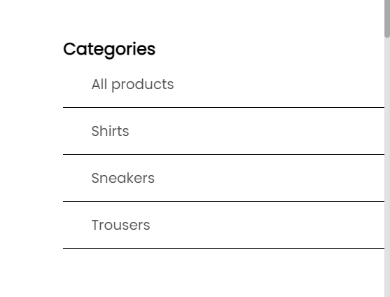

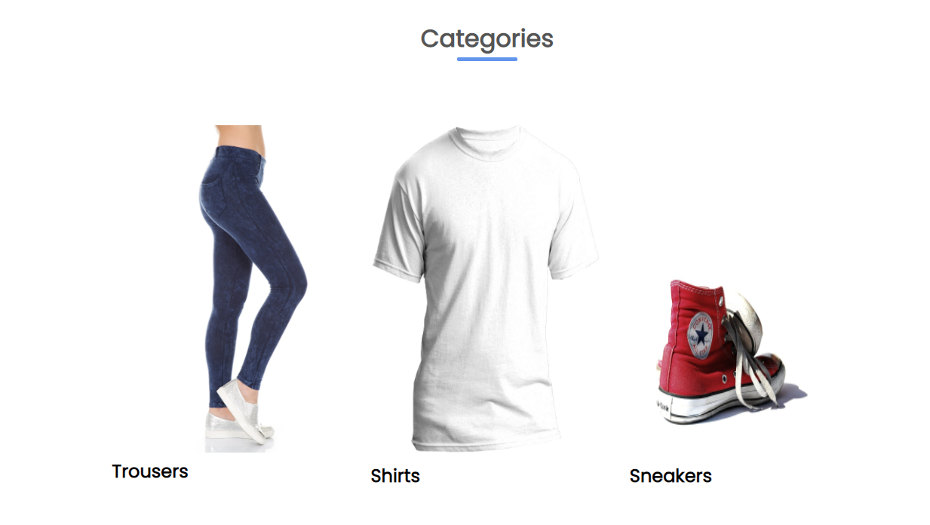

Logo navigation:



Tab feature:

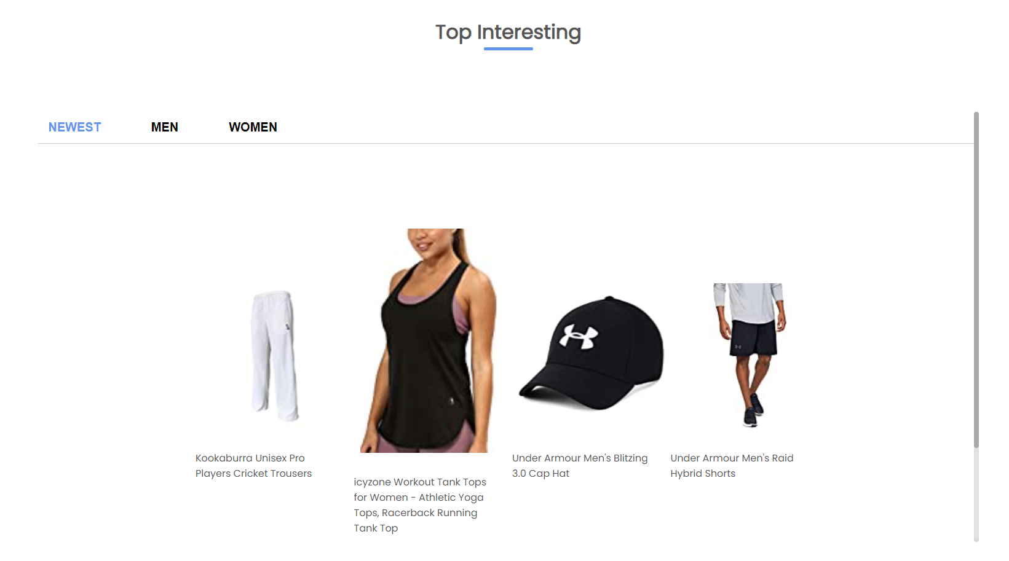

Search:





Velocity calculation

User stories completed x total number of story points achieved

5 x 25 = 125.

Two features failed to be fully implemented in this timebox.  
This represents the amount of work that will possibly done for timebox 3.

Testing

All the features added for this timebox worked perfectly on Google Chrome, Mozilla Firefox and Microsoft Edge.

Test on Nibbler:

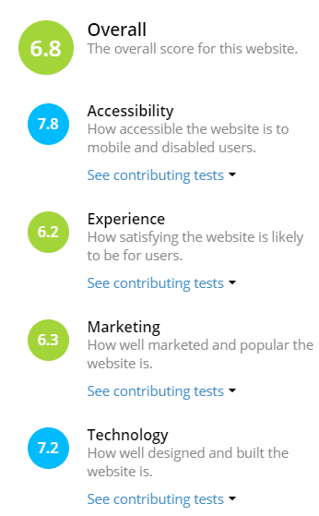

Test on page scoring:

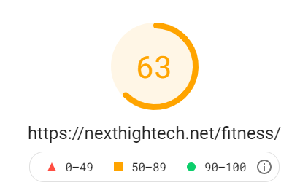

Appendix N: Agile development: Timebox 3

Release planning: (Timebox 3)

The aim of this final timebox was to make the website reliable for customers.

Three user stories:

|  |  |  |  |
| --- | --- | --- | --- |
| **User stories for sprint 3** | **Priority** | **Condition of satisfaction** | **Sizing** |
| **As a** shopper  **I want** the website to be responsive.  **So that** I can shop through the website with any of my devices | Must have | Verifies that the website is compatible for all devices | 6 |
| **As a** shopper  **I want to** ensure that the website is secured  **So that** I will not be subject to hackers | Must have | Verifies that the lock logo on top of the website shows “secured” | 1 |
| **As a** shopper  **I want to** navigate through the website with a high speed  **So that** I can have a better shopping experience | Should have | Verifies that the website loads fast | 3 |

Two left over from timebox 2:

|  |  |  |  |
| --- | --- | --- | --- |
| **User stories that need testing** | **Priority** | **Condition of satisfaction** | **Sizing** |
| **As a** shopper  **I want to** have access to a tab feature on the homepage  **So that** I can see more types of products | Could have | Verifies that the tab displays products | 10 |
| **As a** shopper  **I want to** search for a specific product  **So that** I can more easily find it and buy it | Should have | Verifies that the search form works properly | 16 |

The prioritized user stories for this timebox were the one that provided security and reliability. Two other features from the previous timebox were imported in this one to complete their implementation.

Sprint review and retrospective: (Timebox 3)

For this timebox, three features were meant to be completed plus two others that needed to be tested.

1. Website responsivity
2. Security
3. Fast loading
4. Tab feature
5. Search

The three features were successfully implemented. However, due to a lack of time, Tab and Search features.

Velocity calculation

User stories completed x total number of story points achieved

7 x 26 = 182.  
5 x 25 = 125.  
3 x 10 = 30.

182 + 125 + 30 = 337

337 / 3 = 112,3  
  
112 is the average sprint velocity. So, for future sprints, 112 will be the average number of story point to have.

Testing

The features added for this timebox fully worked on Google Chrome, Mozilla Firefox, and Microsoft Edge.

Test on Nibbler:



Test on page scoring:



Appendix O: Growth of affiliate marketing

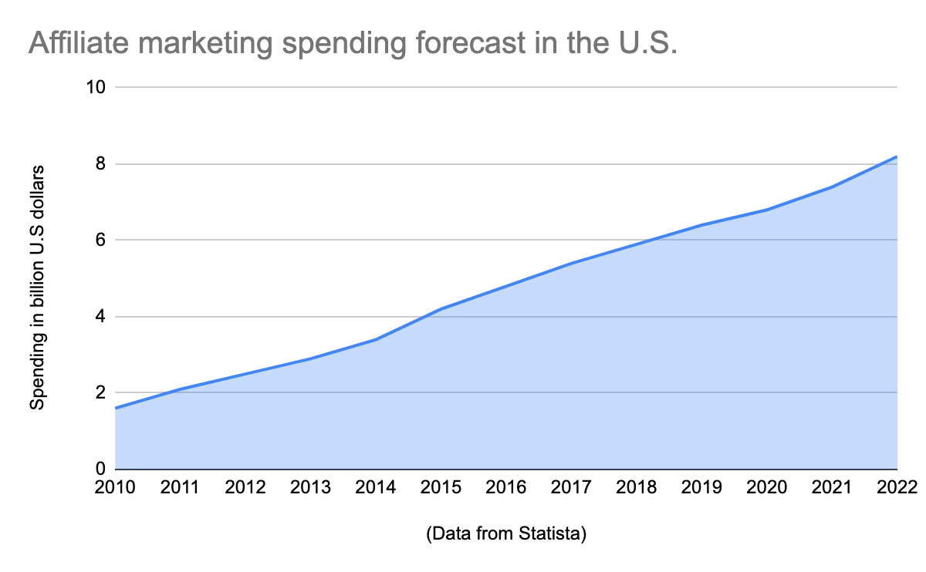

Image source - (Rastas, 2020)

Appendix P: Fitness Market, an attractive niche on Amazon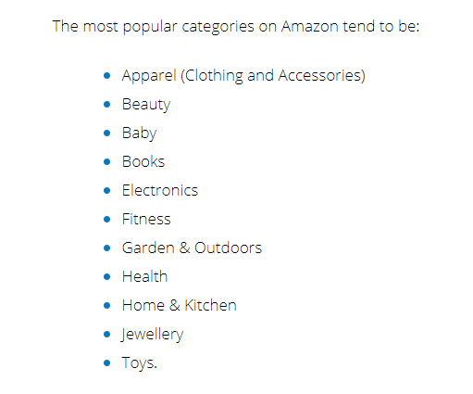

Image source - (Kulach, 2021)

Appendix Q: Wordpress file structure

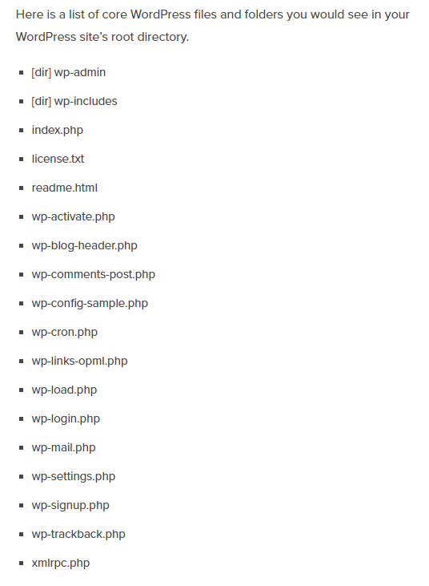

Source image - (Staff, 2016)

Appendix R: Algorithm used for Search feature

<?php get_header(); ?>

<div class="small-container">

<h2>Search Results:</h2>

<div class="row row2">

<?php

$term = $_GET['s'];

$expTerm = explode(" ",$term);

$search = "(";

foreach($expTerm as $ek=>$ev)

{

if($ek == 0)

{

$search .= " post_title LIKE '%".$ev."%' ";

}

else

{

$search .= " OR post_title LIKE '%".$ev."%'";

}

}

$search .= ")";

$query = $wpdb->get_results(" SELECT * FROM ".$wpdb->prefix."posts WHERE post_status='publish' AND $search ");

/* build a position array for the term */

$position = 101;

$rate = [];

for($i=0; $i<=100; $i++)

{

$position = $position - 1; // first run will equal 100

$rate[$i] = $position; // rate the position on the title

}

/* build the array based on type and position */

/* loop through the query */

$newArray = [];

foreach($query as $k=>$v)

{

$title = $v->post_title;

/* loop though each term */

$calculate = 0;

foreach($expTerm as $tk=>$tv)

{

// Check if that term is in the titla and where that term is positioned in the title

if(strpos(strtolower($title), strtolower($tv)) !== false)

{

$calculate = $calculate + strlen($tv);

$pos = strpos(strtolower($title), strtolower($tv));

$calculate = $calculate + $rate[$pos];

} // end of if statement

} // end of the for each term

$newKey = $calculate.'.'.$v->ID;

$newArray[$newKey] = $v;

//print $newKey.'<br />';

} // end of for each result or query

/* sort in reverse DESC */

krsort($newArray);

foreach($query as $qk=>$qv)

{

?>

<div class="colNo4">

<p><?php print $qv->post_content;?></p>

<p><?php print $qv->post_title; ?></p>

</div>

<?php

}

?>

</div>

</div>

<?php

?>  
<?php get_footer(); ?>

Firstly, “term” is a variable the represents the string value input onto the search form. “expTerm” is an array that separates each “term” value into their own individual values.  
The foreach in the search variable will loop through to all the values in “expTerm”  
The “if” condition in the foreach statement will check if one or more than one “term” have been input.   
If one term is input, then the foreach loop will return results that corresponds to that term.   
If more than one term is input, then the foreach statement will examine all those terms and return the values that corresponds to those terms.  
The reason of doing so was to avoid errors when using the search form.  
The query value returns all the post information from the database.

Appendix S: Not yet implemented features

|  |  |  |  |
| --- | --- | --- | --- |
| **User stories that need to be done** | **Priority** | **Condition of satisfaction** | **Sizing** |
| **As a** shopper  **I want to** add my products to a cart  **So that** I can buy multiple products at a time | Should have | Verifies that multiple products can be selected | 16 |
| **As a** shopper  **I want to** register to a newsletter  **So that** I can stay informed on the products available on the website | Could have | Verifies that registered customers receive mails from the website. | 8 |
| **As a** shopper  **I want to** decide of the size and/or colour of the product that I want  **So that** I can have a more flexible shopping experience | Should have | Verifies that it is possible to modify product aspect on the website | 12 |
| **As a** shopper  **I want to** view products images and details  **So that** I can have a better idea of the product | Should have | Verifies that product details can be viewed | 4 |

Appendix T: “stand-by” features

|  |  |  |  |
| --- | --- | --- | --- |
| **User stories on stand by** | **Priority** | **Condition of satisfaction** | **Sizing** |
| **As a** shopper  **I want to** have access to a dark mode system  **So that** I can have a more ergonomic experience | Will not have | Verifies that the website background colour can turn to black | 4 |
| **As a** shopper  **I want to** have access to a product slider on the homepage  **So that** I can see more types of products | Will not have | Verifies that there is a product slider on the homepage | 4 |
| **As a** shopper  **I want to** have access to a sub-menu when I hover on "products" to display the categories  **So that** I can navigate more easily through the website | Will not have | Verifies that there is access to sub-menus | 2 |

1. See Appendix A: Glossary
2. See Appendix A: Glossary
3. See Appendix A: Glossary
4. See Appendix A: Glossary
5. See Appendix A: Glossary
6. See Appendix A: Glossary
7. See Appendix A: Glossary
8. See Appendix A: Glossary
9. See Appendix A: Glossary
10. See Appendix A: Glossary
11. See Appendix A: Glossary
12. See Appendix A: Glossary
13. See Appendix A: Glossary
14. See Appendix A: Glossary
15. See Appendix A: Glossary
16. See Appendix A: Glossary
17. See Appendix A: Glossary
18. See Appendix A: Glossary
19. See Appendix A: Glossary
20. See Appendix A: Glossary
21. See Appendix A: Glossary
22. See Appendix A: Glossary
23. See Appendix A: Glossary
24. See Appendix A: Glossary
25. See Appendix A: Glossary