Table of Contents

Installation 2

Import data into the mysql 5

Result 8

# Installation

Download the Eclipse **“Eclipse IDE for Enterprise Java and Web Developers”** if you don’t have this one for convenience to run my code if necessary. Don’t know how to download the eclipse? [Watch this video](https://youtu.be/1MO0v3_Wx9w), hope it can help you ＜（＾－＾）＞.

Also download the **tomcat**. I am using the tomcat **version 10.0.** [This is a tomcat version 10.0 for download website](https://tomcat.apache.org/download-10.cgi). After downloaded the tomcat then click the **Windows > Show View > Other > Servers from the eclipse**. Because you don’t have the tomcat server if you see the images below of “No servers are available” thus you should click it and select the **Apache > tomcat v10 and put the just now you downloaded the tomcat v10 into the “Browse”**.

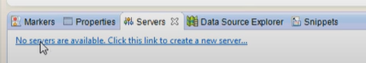

Finally, please install the Mysql Workbench or any mysql (if you have another idea to open the data file). [Watch this video how to install the Mysql Workbench](https://youtu.be/WuBcTJnIuzo). Also, you need to install the connector mysql to connect the eclipse. [This is a website for your download the connector mysql](https://dev.mysql.com/downloads/connector/j/).

**Guide to install connector mysql:**

**First Step:**

Choose “Platform Independent” as shown images below:

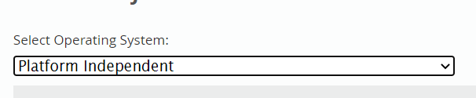

**Second Step:**

Click the **Download** button and make sure it is “ZIP” file.

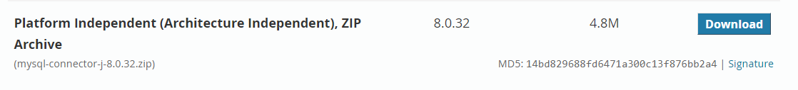

After download the connector mysql then extract the zip file and right click the project file and click Build Path > Configure Build Path as shown images below:

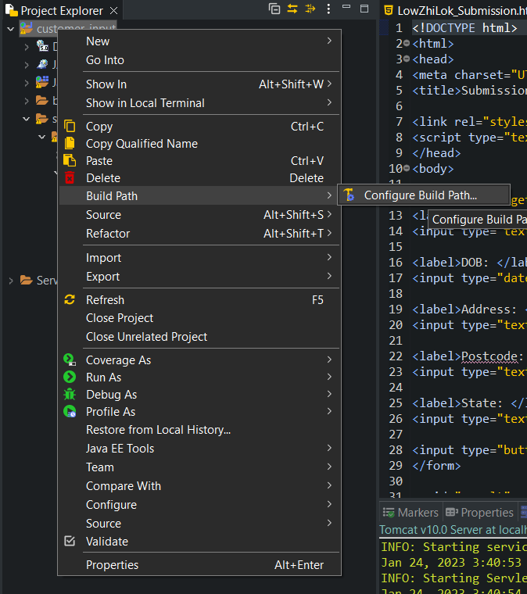

Click the Modulepath > Add external JARs… (At your right hand side) as shown images below:

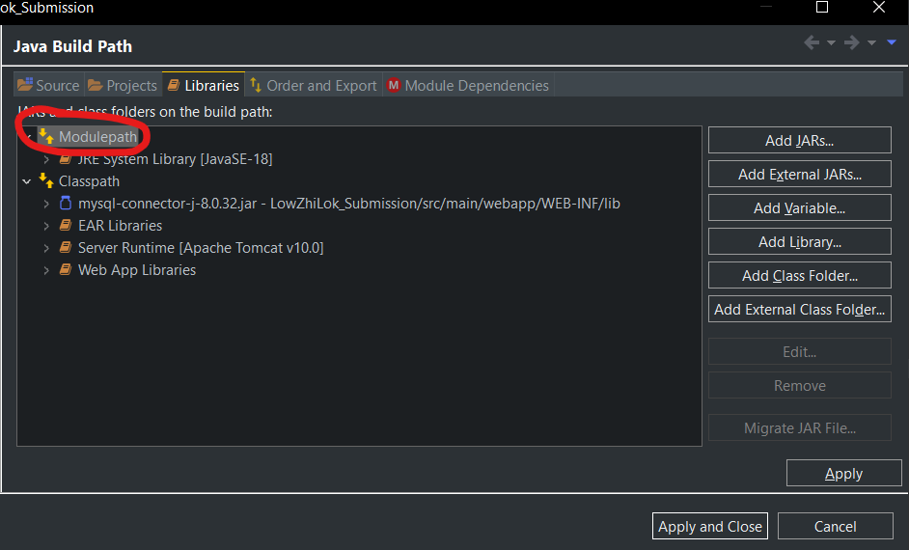

Find the connector mysql just now you downloaded it then click the mysql-connector-j-8.0.32.jar and click “Open”.

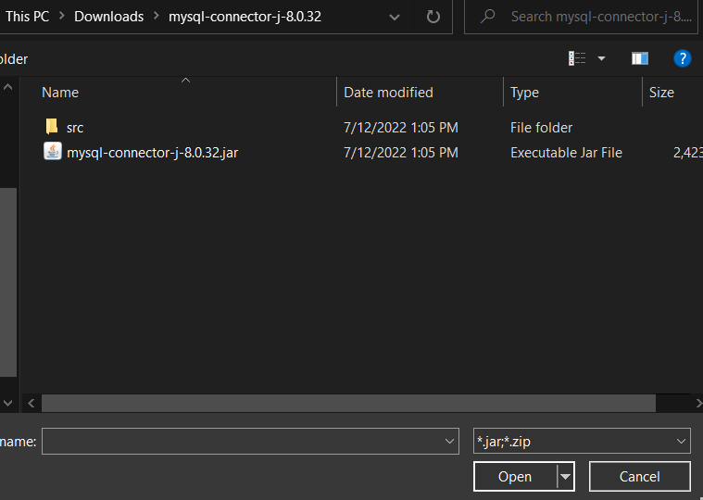

Finally step is click “Apply” and “Apply and Close” as shown images below:

# Import data into the mysql

Go to MySQL Workbench and click Server > Data Import as shown images below:

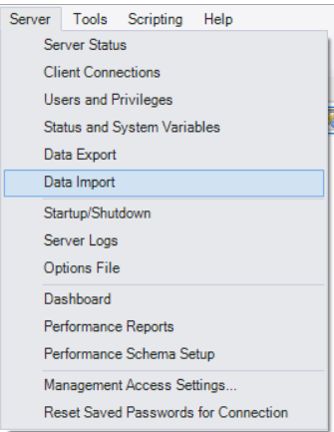

Choose **Import from Self-Contained File** and click “…”



Find the Submission.sql



After select the Submission.sql then click “Start Import”.



Right click from the **SCHEMAS** and click **Refresh ALL.**

You will see the submission database as shown images below:

**Implement**

After installed, put my file into the eclipse workspace (some like the images below) and open it from Eclipse.

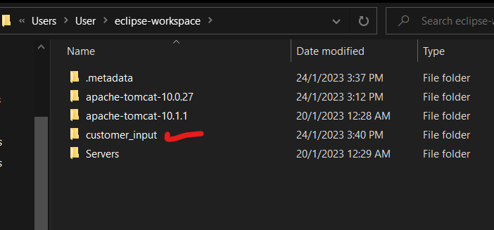

How to run the website? Right click from the space and **Run As > Run on Server** as the images below:

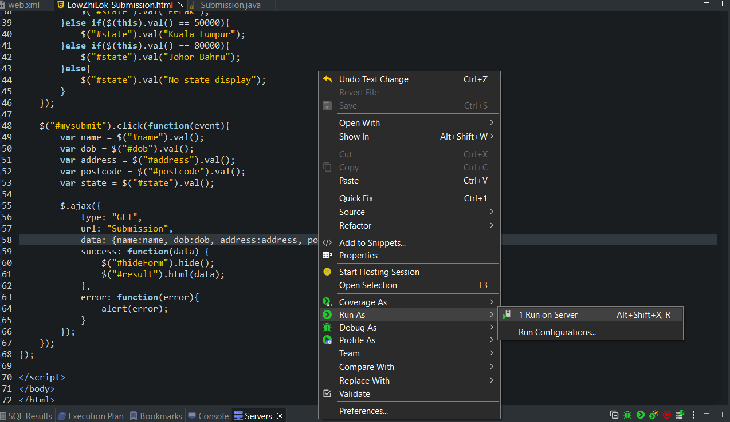

# Result

This is output result.

Try to fill the information.

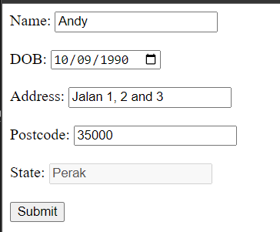

Data inserted successfully.

Database is showing successfully inserted at row 41.

Inserted 2 new rows data at 42 and 43.

