USE CASE DIAGRAM

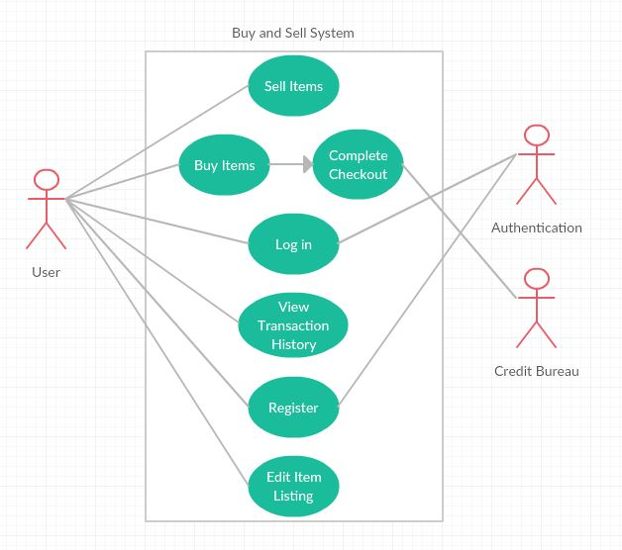

ACTIVITY DIAGRAM

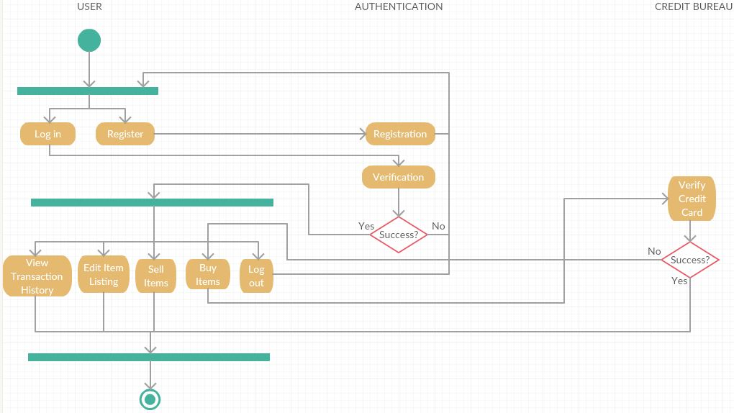

CONCEPTUAL CLASS DIAGRAM

DETAILED CLASS DIAGRAM