1. Use cd to go to file location then type:

**Docker-compose up -d –build**

1. 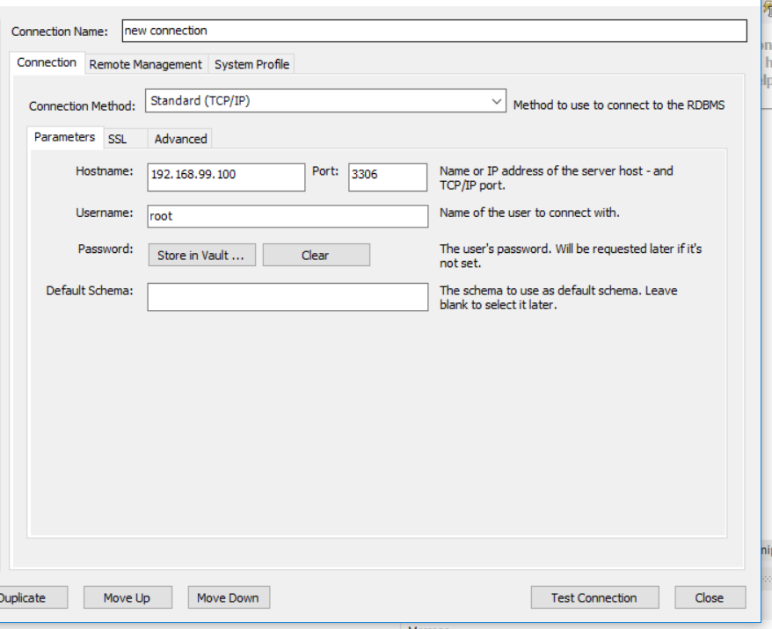In your mysql Workbench, click Database > Manage connections > New, then input as follows:

Don’t forget to click **Store in vault** the password which is **root**

Note: In the field **Hostname** substitute your **machine ip** if it is different

(See docker command **docker-machine ip)**

And then connect to the newly created database.

1. Back to docker, type:

**Docker-compose exec backend python app.py init_db**

And wait for the Message for tables to be created

1. Proceed to app in browser:

**<machine ip here>/login.html**

1. When exiting app, type:

**Docker-compose down -v**

Note: deletes database too, meaning all data will be erased

APP REMINDERS:

Creditcard will only be verified if 8th and 12th digit are the same.