Railway Ticket Booking and Tracking System
– Hanoi, February 2026 –

Record of changeS
Date | A*  M, D | In charge | Change Description
31/Jan | A | LongBB | Initialized system architecture and high-level requirements.
01/Feb | M | LongBB | Designed System Context Diagram, Use Cases and defined external actor interactions.
02/Feb | M | LongBB | Developed Entity Relationship Diagram (ERD)
03/Feb | M | LongBB | Developed Functional and Non-Functional
*A - Added M - Modified D - Deleted
Table of Contents
I. Overview 2
1. Introduction 3
1.1 System Overview 3
1.2 Objectives 4
1.3 Scope of the System 4
2. User Requirements 6
2.1 Actor 6
2.2 Use Cases 7
2.2.1 Customer 7
2.2.2 Admin 8
3. System Functions 12
3.1. Screen Flow 12
3.2. Screen Details 13
3.3 Entity Relationship Diagram 16
II. Functional Requirements 17
2.1 login 17
2.2 Register 19
2.3 Trip Search Screen 21
2.4 Trip Result / Schedule List 22
2.5 Seat Selection & Locking 24
2.6 Booking Information 25
2.7 Payment Processing 26
2.8 Booking Confirmation / E-Ticket 27
2.9 My Bookings 27
2.10 Cancel / Change Ticket 28
III. Non-Functional Requirements 29
3.1. Performance 29
3.2. Availability & Reliability 29
3.3. Security 30
3.4. Maintainability 30
IV. Requirement Appendix 30
4.1 Business Rules 30
4.2 System Messages 32
4.3 Other Requirements 33

I. Overview

1. Introduction
This document provides a detailed description of the software requirements for the Railway Ticket Booking & Tracking System (RTBTS), Version 1.0.
The purpose of this Software Requirements Specification (SRS) is to define the functional and non-functional requirements of the system. It serves as a reference for developers, testers, project managers, and stakeholders throughout the system’s design, implementation, testing, and maintenance phases.
This SRS covers the complete railway ticket booking and tracking solution, including user account management, train resource configuration, schedule generation, ticket search, seat selection, booking, payment processing, ticket cancellation and changes, maintenance handling, reporting, and system authorization.

1.1 System Overview
The Railway Ticket Booking & Tracking System is a centralized software platform designed to support online railway ticket sales and operational management.
The system allows customers to:
- Search train trips
- Select seats
- Book tickets
- Make online payments
- View booking history
- Cancel or change tickets
At the same time, the system provides administrators with tools to:
- Configure trains, carriages, seats, stations, routes, and price rules
- Generate and manage schedules
- Handle incidents and maintenance
- Manage bookings
- Monitor revenue and system performance
The system is built around two main roles:
- Customer – end users who search and buy tickets
- Admin – railway staff who manage data, schedules, operations, and reports

1.2 Objectives
The main objectives of the system are:
- To provide a convenient and fast online ticket booking experience for passengers
- To reduce manual work and errors in railway ticket operations
- To ensure real-time seat availability and booking accuracy
- To support automated and efficient schedule generation
- To improve business control through reporting and monitoring
- To ensure secure access through role-based authorization

1.3 Scope of the System
In Scope
The system includes the following major functional areas:
- User Account Management (Customer)
  - Register, login/logout
  - Update profile, change password
  - View booking history
- Train Resource Management (Admin – Core Configuration)
  - Manage Trainset Templates & Configurations
  - CRUD Station, Route, Price Rules
- Schedule Management (Admin + Auto Generate)
  - Manual schedule creation
  - Auto-generate schedules based on rules
  - Assign trains to routes
  - Manage Price Matrix & Fare Rules
- Trip Search (Customer)
  - Search by stations, date, time
  - Sort and filter results
  - Show only available seats
- Seat Selection & Locking
  - Real-time Atomic Seat Locking
- Booking & Payment (Core Module)
  - Create booking
  - Hold seats
  - Online payment
  - Generate e-ticket
- Cancel & Change Ticket
  - Cancel booking
  - Refund handling
  - Change trip / seat
- Maintenance & Incident Handling (Admin)
  - Mark train under maintenance
  - Cancel schedules
  - Send notifications
  - Train Swapping & Standby Management
- Reports & Monitoring (Admin)
  - Revenue reports
  - Ticket sales
  - Seat utilization
  - Payment success rate
  - System logs
- Authorization
- Role-based access: Customer / Admin
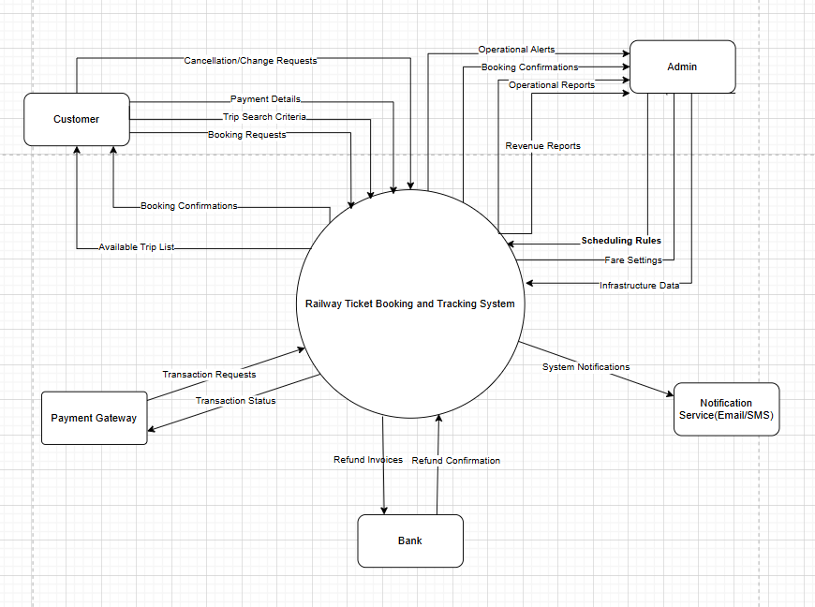

2. User Requirements

2.1 Actor
Automated Essay Scoring System has 8 actors:

# | Actor | Description
1 | Customer | A user who uses the system to search for train trips, select seats, book tickets, make online payments, cancel or change tickets, and view booking and payment history. Customers must register and log in to perform booking and payment actions.
2 | Admin | The system administrator or railway staff responsible for managing system data and operations. Admins can manage trains, carriages, seats, routes, price rules, and schedules; handle bookings; manage maintenance and incidents; and view reports and statistics

2.2 Use Cases

2.2.1 Customer

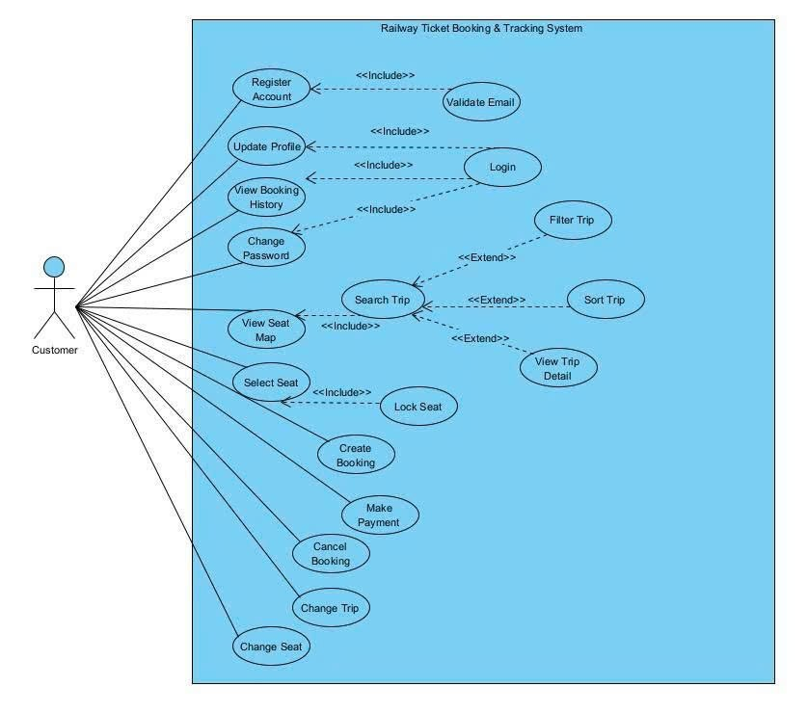

2.2.2 Admin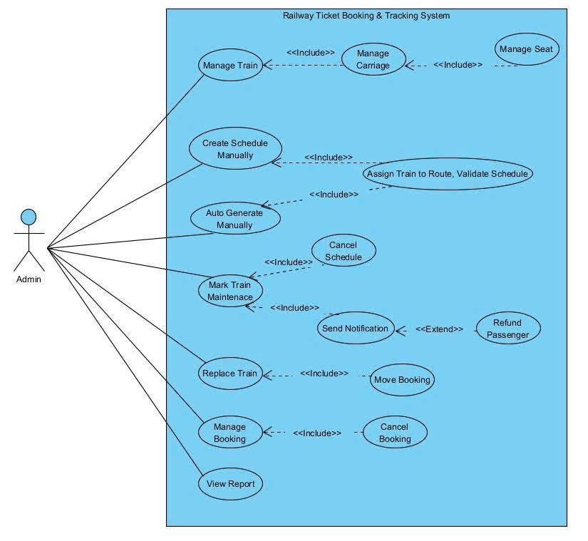

ID | Use Case | Actors | Use Case Description | Scope
UC-01 | Register Account | Guest | Allows a new user to create an account by providing an email and validating it. | SC-01
UC-02 | Login / Logout | Customer | Authenticates the user to access booking features and personal data. | SC-01
UC-03 | Update Profile | Customer | Enables users to manage personal information and security settings. | SC-01
UC-04 | Search Trip | Customer | Users search for available high-speed trains using Departure/Arrival stations and dates. | SC-02
UC-05 | Filter & Sort Trip | Customer | Student purchases a selected course | SC-02
UC-06 | View Seat Map | Customer | Displays real-time seat availability for the specific high-speed train model. | SC-02
UC-07 | Select & Lock Seat | Customer | Temporarily reserves a seat (Lock) while the customer proceeds to payment. | SC-02
UC-08 | Make Payment | Customer | Processes the transaction through the external Payment Gateway. | SC-02
UC-09 | View History | Customer | Allows users to view past trips and download active QR E-Tickets. | SC-01
UC-10 | Cancel Booking | Customer | Requests a cancellation and initiates the refund process based on policy. | SC-02
UC-11 | Change Trip/Seat | Customer | Allows modifications to the itinerary or seat selection before departure. | SC-02
UC-12 | Manage Train/Carriage | Admin | Defines train profiles, carriage layouts, and fixed seat configurations. | SA-01
UC-13 | Manage Seat | Admin | Configures specific seat types (VIP, Soft, Hard) and pricing rules. | SA-02
UC-14 | Create Schedule Manually | Admin | Manually creates a one-off trip for special holiday demands. | SA-02
UC-15 | Auto-Generate Schedule | Admin | Automatically generates daily trips based on fixed time-slots and train availability. | SA-02
UC-16 | Mark Train Maintenance | Admin | Instructor answers questions from students | SA-02
UC-17 | Manage Users | Admin | Sets a train status to 'Maintenance' to prevent it from being assigned to new trips. | SA-03
UC-18 | Replace Train | Admin | Swaps a faulty train with a standby unit within an existing schedule. | SA-03
UC-19 | Manage Booking | Admin | Oversees all transactions and manually overrides bookings if needed. | SA-04
UC-20 | Refund Passenger | Admin | Approves and triggers the refund flow to the customer's bank account. | SA-04
UC-21 | Send Notification | Admin | Triggers manual or automated alerts (Email/SMS) for delays or cancellations. | SA-04
UC-22 | View Report | Admin | Analyzes revenue, occupancy rates, and system performance logs. | SA-05

3. System Functions

3.1. Screen Flow
1.Customer’s Screen Flow
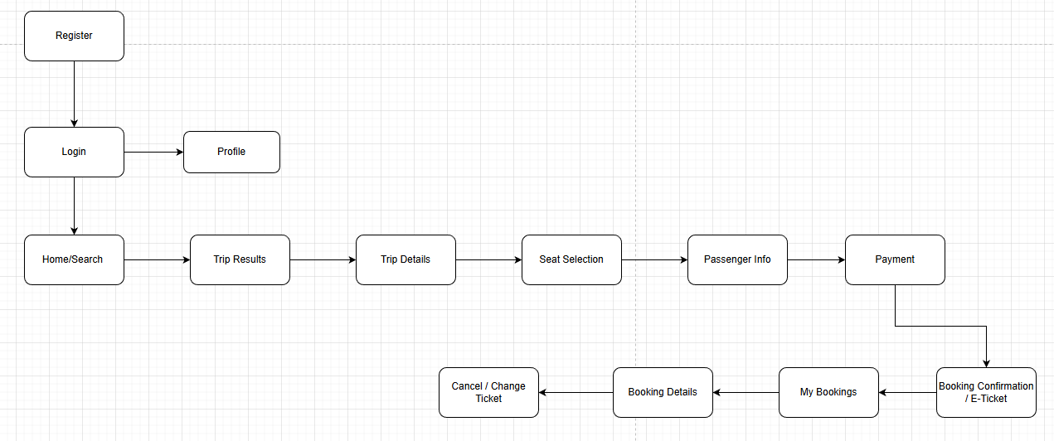

2.Admin’s Screen Flow
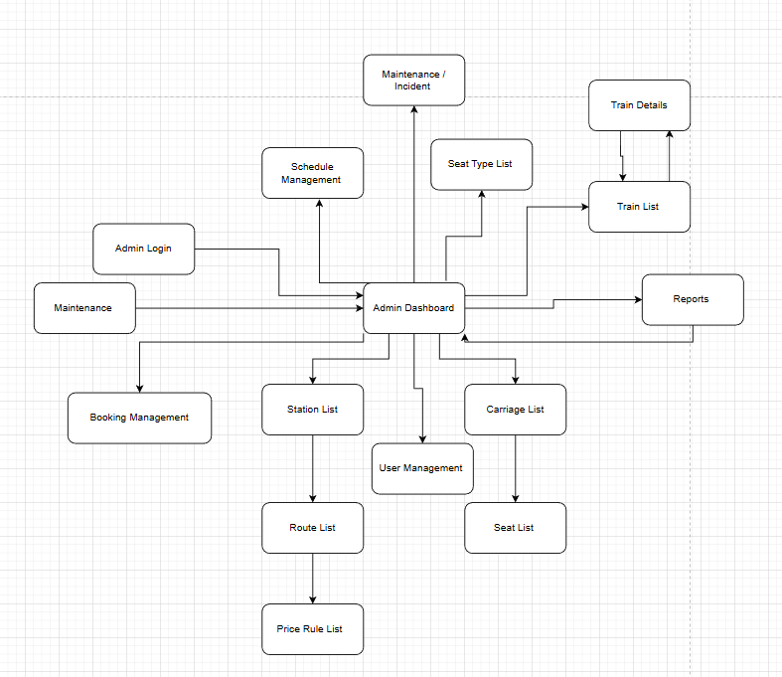

3.2. Screen Details
# | Screen | Description
1 | Login | The screen where the customer logs into the system using email and password.
2 | Register | The screen where the user creates an account for the system.
3 | Home / Search Trip | The screen where the customer searches for trips by selecting departure station, destination station, and date
4 | Trip Results | The screen that displays a list of available trips based on the search criteria
5 | Seat Selection | The screen where the customer selects specific seats from the seat map.
6 | Passenger Info | The screen where the customer enters passenger information for the booking.
7 | Payment | The screen where the customer chooses a payment method and completes the paymen
8 | Booking Confirmation | The screen that shows the e-ticket and booking details after successful payment
9 | My Bookings | The screen where the customer views booking history and manages tickets
10 | Admin Login | The screen where the admin logs into the administration system
11 | Dashboard | The main screen that provides an overview and navigation to all admin functions
12 | Train Management | The screen where the admin creates, updates, and deletes train information.
13 | Schedule Management | The screen where the admin creates and manages train schedules
14 | Booking Management | The screen where the admin views and manages customer bookings
15 | Maintence / Incident | The screen where the admin handles train maintenance and incidents
16 | Reports | The screen where the admin views system reports and statistics

c. User Authorization

Screen | Admin | Customer
Login | X | X
Register |  | X
Home / Search Trip |  | X
Trip Results |  | X
Seat Selection |  | X
Passenger Info |  | X
Payment |  | X
Booking Confirmation / E-Ticket |  | X
My Bookings |  | X
Cancel / Change Ticket |  | X
Profile / Change Password |  | X
Admin Dashboard | X
Train Management | X
Schedule Management | X
Booking Management | X
Maintenance / Incident | X
Reports | X
User Management | X

In which:
- Role 1: Customer – A registered user who searches trips, books tickets, makes payments, and manages bookings.
- Role 2: Admin – A system administrator who manages system data, schedules, bookings, maintenance, and reports.
d. Non-Screen Functions
[Provide the descriptions for the non-screen system functions, i.e batch/cron job, service, API, etc.]
# | Feature | System Function | Description
1 | Email | Send Email | Send email with contents that are defined within workflow
2 | SMS Notification | Send SMS | Send OTP, alerts, and important trip notifications via SMS
3 | Seat Lock Expiry | Auto Unlock Seat | Automatically unlock seats if payment is not completed within X minutes
4 | Booking Expiry | Auto Cancel Booking | Automatically cancel unpaid bookings after a defined timeout
5 | Payment Sync | Sync Payment Status | Receive and process payment status from Payment Gateway API
6 | Schedule Generator | Auto Generate Schedule | Automatically generate train schedules based on rules and available trains
7 | Maintenance Monitor | Block Schedule on Maintenance | Prevent schedule generation when a train is in maintenance status
8 | Refund Processor | Refund | Auto Refund is supported for online payments via integrated payment gateways.  For offline or unsupported payment methods, refunds will be processed manually by Admin
9 | System Logging | Write Logs | Record system activities and errors for monitoring and audit

3.3 Entity Relationship Diagram
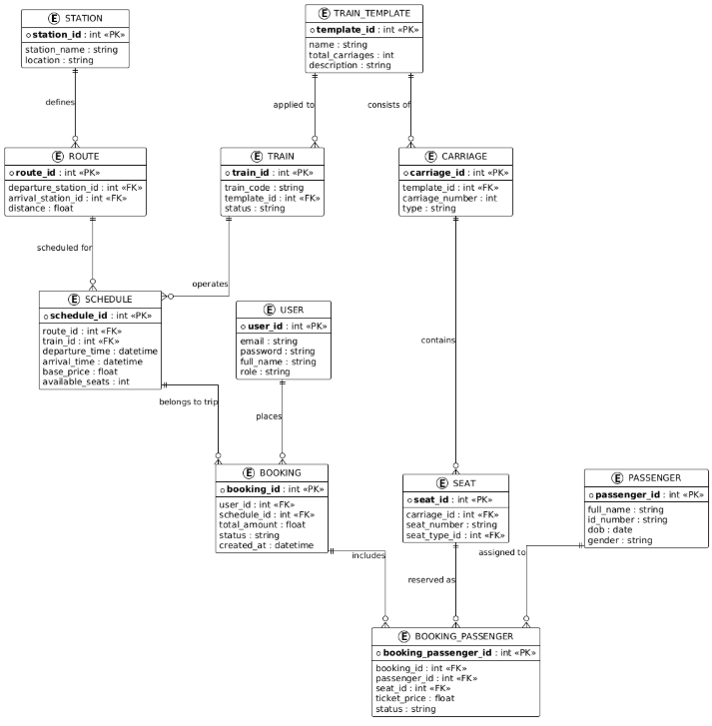

Entities Description
# | Entity | Description
1 | User | Stores system login credentials. It categorizes users into two primary roles: Customer (for booking tickets) and Admin (for managing system operations and resources).
2 | Passenger | Stores the personal identification details of the actual traveler (Full Name, ID/Passport Number, DOB). This data is used for printing e-tickets and applying discount rules (e.g., for children or seniors).
3 | Train Template | Acts as a master blueprint for different high-speed train models. It defines the fixed number of carriages, carriage types, and seat layouts to be reused across multiple trains
4 | Train | Represents a physical train unit in the fleet. Each train is assigned a unique code and inherits its internal structure from a specific Train Template
5 | Carriage | Sections of a train template. It stores the carriage sequence number and service class (e.g., Business or Economy) used to determine fare multipliers.
6 | Seat | The specific physical seat location within a carriage. Each seat has a unique number and a type (e.g., Window/Aisle) to be displayed on the visual seat map for customers.
7 | Station | Represents physical stops along the North-South high-speed rail line where trains pick up and drop off passengers
8 | Route | Defines the permanent travel path and fixed distance between station pairs. It serves as the static reference for calculating standard segment-based fares
9 | Schedule | Represents a specific trip instance. It contains departure/arrival times, the assigned physical train, and tracks the real-time count of available seats.
10 | Booking | A high-level transaction record created by a User. it stores the total amount, payment status, and a timestamp for a group of tickets purchased together
11 | Booking Passenger | The core link between a Booking, a Passenger, and a Seat. This acts as the "E-Ticket," tracking the specific seat status (Locked/Sold) and the final price after discounts.

II. Functional Requirements

2.1 login
ID and Name: | UC-1: Login
Created By: | NghiaNV | Date Created: | 03/02/2026
Last Updated By: | NghiaNV | Last Revision Date: | 03/02/2026
Description: | This use case describes how a user logs into the online train ticket booking system using a registered account in order to access system functionalities based on their role.
Actor: | User (Customer, Admin)
Preconditions: | - The user has a registered account in the system.  - The user account is active.
Postconditions: | - The user is successfully authenticated.  - The system redirects the user to the appropriate home page based on their role (Customer or Admin).
Trigger: | The user wants to access the system.
Flow: | - The user navigates to the Login page.  - The user enters username/email and password.  - The user clicks the Login button.  - The system validates the entered credentials.  - The system logs the user into the system.  - The system redirects the user to the corresponding home page.
Alternative Flows: | - If the username/email or password is incorrect, the system displays an error message and allows the user to re-enter credentials.  - If the account is inactive, the system displays an account inactive message and denies access.
Exceptions: | N/A
Business Rules: | Passwords must meet system security requirements.
Frequence of Use: | Frequent
Priority: | High
Special REQs: | N/A
Assumptions: | The system authentication service is available.
Open Issues | N/A

2.2 Register

ID and Name: | UC-2: Register Account
Created By: | NghiaNV | Date Created: | 03/02/2026
Last Updated By: | NghiaNV | Last Revision Date: | 03/02/2026
Description: | This use case describes how a customer registers a new account in the online train ticket booking system in order to use booking and payment functionalities.
Actor: | Customer
Preconditions: | - The customer does not have an existing account in the system.  - The system is available.
Postconditions: | - A new customer account is created successfully.  - The account is stored in the system with an active status.  - The customer can proceed to log in.
Trigger: | The customer wants to create a new account.
Flow: | - The customer navigates to the Register page.  - The customer enters required information:  - Full name  - Email  - Phone number  - Password  - Confirm password  - The customer clicks the Register button.  - The system validates the input data.  - The system checks whether the email already exists.  - The system creates a new customer account.  - The system displays a successful registration message.
Alternative Flows: | - If the email already exists, the system displays an error message and requests the customer to enter a different email.  - If the password and confirm password do not match, the system displays an error message.
Exceptions: | N/A
Business Rules: | - Email must be unique.  - Password must meet system security requirements.  - Only registered users are allowed to book tickets.
Frequence of Use: | Occasional
Priority: | High
Special REQs: | N/A
Assumptions: | The registration service is available.
Open Issues | N/A

2.3 Trip Search Screen

ID and Name: | UC-4:Trip Search Screen
Created By: | NghiaNV | Date Created: | 03/02/2026
Last Updated By: | NghiaNV | Last Revision Date: | 03/02/2026
Description: | This screen allows customers to search for available train trips based on departure station, arrival station, date, and time. The system displays only schedules that still have available seats.
Actor: | Customer
Preconditions: | - The system is available.  - The train schedules have been created by Admin.
Postconditions: | - A list of available trips matching the search criteria is displayed.  - The customer can select a trip to continue booking.
Trigger: | The customer wants to find available train trips.
Flow: | - The customer navigates to the Trip Search screen.  - The customer enters search criteria.  - The customer clicks the Search button.  - The system retrieves matching schedules from cache or database.  - The system displays a list of available trips.  - The customer can apply sorting or filtering.  - The customer selects a trip to proceed to seat selection.
Alternative Flows: | - If no trips are found, the system displays a message: “No available trips found.”  - If required fields are missing, the system prompts the customer to complete the form.
Exceptions: | N/A
Business Rules: | - Only schedules with available seats are displayed.  - Search results are cached to improve performance.
Frequence of Use: | Very Frequent
Priority: | High
Special REQs: | - The search response time should be fast.  - Results should update correctly when filters or sorting options change.
Assumptions: | Station, route, and schedule data are correctly configured.
Open Issues | N/A

2.4 Trip Result / Schedule List

ID and Name: | UC-5: Trip Result / Schedule List
Created By: | NghiaNV | Date Created: | 03/02/2026
Last Updated By: | NghiaNV | Last Revision Date: | 03/02/2026
Description: | This use case describes how the system displays a list of available train schedules based on the customer’s search criteria and allows the customer to select a trip for seat selection.
Actor: | Customer
Preconditions: | - The customer has accessed the Trip Search screen.  - Departure station, arrival station, and date have been provided.  - Train schedules have been created and configured by Admin.
Postconditions: | - A list of matching train schedules is displayed.  - The customer can select one schedule to proceed to seat selection.
Trigger: | The customer submits search criteria to find train trips.
Flow: | - The customer submits trip search criteria.  - The system retrieves matching schedules from cache or database.  - The system filters out schedules with no available seats.  - The system displays the trip result list, including:  - Train information  - Departure time and arrival time  - Ticket price  - Number of available seats  - The customer applies sorting or filtering options if needed.  - The customer clicks Select Trip on a desired schedule.  - The system redirects the customer to the Seat Selection screen.
Alternative Flows: | - If no schedules match the search criteria, the system displays the message:“No available trips found.”  - If the customer changes filters or sorting options, the system updates the displayed results.
Exceptions: | N/A
Business Rules: | - Only schedules with available seats are shown.  - Search results may be cached to improve performance.
Frequence of Use: | Very Frequent
Priority: | High
Special REQs: | - The result list must load quickly.  - Sorting and filtering should update results immediately.
Assumptions: | Station, route, and schedule data are correctly configured.
Open Issues | N/A

2.5 Seat Selection & Locking

ID and Name: | UC-6:Seat Selection & Locking
Created By: | NghiaNV | Date Created: | 03/02/2026
Last Updated By: | NghiaNV | Last Revision Date: | 03/02/2026
Description: | This screen allows the customer to view the seat layout of the selected train trip, select specific seats, and temporarily lock them before proceeding to booking.
Actor: | Customer
Preconditions: | - The customer has selected a trip from the Trip Result / Schedule List.  - The selected schedule still has available seats.  - The customer is logged into the system.
Postconditions: | - Selected seats are locked for the customer for a limited time.  - The customer can proceed to booking information.
Trigger: | The customer selects a trip and wants to choose seats.
Flow: | - The system displays the seat map of the selected train and carriage.  - The system shows seat status (Available, Locked, Sold).  - The customer selects one or more available seats.  - The system temporarily locks the selected seats.  - The system starts a lock countdown timer.  - The customer clicks Continue Booking.  - The system navigates to the Booking Information screen.
Alternative Flows: | - If a seat becomes unavailable, the system notifies the customer and refreshes the seat map.  - If the lock time expires, the system unlocks the seats automatically.
Exceptions: | N/A
Business Rules: | - Seats can be locked only for a maximum of X minutes.  - Locked seats cannot be selected by other customers.  - Seats marked as Sold cannot be selected.
Frequence of Use: | Very Frequent
Priority: | High
Special REQs: | - The search response time should be fast.  - Results should update correctly when filters or sorting options change.
Assumptions: | Station, route, and schedule data are correctly configured.
Open Issues | N/A

2.6 Booking Information

ID and Name: | UC-6: Booking Information
Created By: | QuangND
Last Updated By: | QuangND
Description: | This screen allows customers to enter passenger information for the booking before proceeding to payment.
Actor: | Customer
Preconditions: | 1. Seats have been successfully locked  .2. The customer is logged into the system.
Postconditions: | 1. Passenger information is saved with the booking draft.  2. The customer can proceed to the Payment screen.
Trigger: | The customer wants to enter passenger information.
Flow: | 1. The customer navigates to the Booking Information screen.  2. The customer enters passenger details.  3. The system validates required information.  4. The customer clicks Continue to Payment.
Alternative Flows: | • If required information is missing or invalid, the system displays an error message and requests correction.
Exceptions: | N/A
Business Rules: | • Passenger information must be completed before payment.
Frequency of Use: | Very Frequent
Priority: | High

2.7 Payment Processing

ID and Name: | UC-7: Make Payment
Created By: | QuangND
Last Updated By: | QuangND
Description: | This screen allows the customer to complete payment for the booking via an integrated payment gateway.
Actor: | Customer
Preconditions: | 1. Booking information has been completed.  2. Seats are still locked.
Postconditions: | 1. Payment is processed  .2. Booking is confirmed if payment is successful.
Trigger: | The customer wants to pay for the booking.
Flow: | 1. The customer selects a payment method.  2. The system redirects to the Payment Gateway.  3. The customer completes payment.  4. The Payment Gateway returns the result.  5. The system confirms booking or displays failure message.
Alternative Flows: | • If payment fails or is cancelled, the system displays a failure message and allows retry within seat lock time.
Exceptions: | N/A
Business Rules: | • Payment must be completed within seat lock duration.• Booking is confirmed only after successful payment.
Frequency of Use: | Very Frequent
Priority: | High

2.8 Booking Confirmation / E-Ticket

ID and Name: | UC-8: Booking Confirmation / E-Ticket
Created By: | QuangND
Last Updated By: | QuangND
Description: | This screen displays booking details and generates an electronic ticket after successful payment.
Actor: | Customer
Preconditions: | Payment has been completed successfully.
Postconditions: | 1. E-ticket is generated and stored in the system.  2. Booking confirmation is displayed to the customer.
Trigger: | Successful payment completion.
Flow: | 1. The system generates the e-ticket.  2. The system displays booking details and QR code.  3. The system sends confirmation via Email/SMS.
Alternative Flows: | N/A
Exceptions: | N/A
Business Rules: | • Only paid bookings generate e-tickets.
Frequency of Use: | Very Frequent
Priority: | High

2.9 My Bookings

ID and Name: | UC-9: View Booking History
Created By: | Dattd
Last Updated By: | Dattd
Description: | This screen allows customers to view booking history and manage existing tickets.
Actor: | Customer
Preconditions: | The customer is logged into the system.
Postconditions: | The list of bookings is displayed.
Trigger: | The customer wants to view booking history.
Flow: | 1. The customer navigates to My Bookings.  2. The system retrieves booking history.  3. The system displays booking list.  4. The customer selects a booking to view details.
Alternative Flows: | • If no bookings exist, the system displays an empty message.
Exceptions: | N/A
Business Rules: | • Customers can view only their own bookings.
Frequency of Use: | Frequent
Priority: | Medium

2.10 Cancel / Change Ticket

ID and Name: | UC-10: Cancel / Change Ticket
Created By: | Dattd
Last Updated By: | Dattd
Description: | This use case allows customers to cancel or modify an existing booking before departure according to policy.
Actor: | Customer
Preconditions: | 1. The customer is logged in.2. The booking exists and is valid.3. The train has not departed.
Postconditions: | 1. Booking is cancelled or updated.  2. Refund or rebooking is processed based on rules.
Trigger: | The customer wants to cancel or change a ticket.
Flow: | 1. The customer selects a booking from My Bookings.  2. The customer chooses Cancel or Change option.  3. The system validates policy.  4. The system processes refund or updates booking.  5. The system displays confirmation message.
Alternative Flows: | • If cancellation/change is not allowed, the system displays a policy restriction message.
Exceptions: | N/A
Business Rules: | • Cancellation and changes must follow refund and change policies.
Frequency of Use: | Occasional
Priority: | High

III. Non-Functional Requirements
These requirements define the quality attributes and constraints of the Railway Ticket Booking & Tracking System (RTBTS).

3.1. Performance
- Response Time: The system shall process trip search queries and return results in less than 2 seconds.
- Throughput: The system must support at least 1,000 concurrent users during peak booking hours without performance degradation.
- Automation Speed: The auto-generation of 100 daily schedules based on the 10-train resource pool should take less than 1 minute.

3.2. Availability & Reliability
- System Uptime: The platform shall be available 24/7 with a minimum uptime of 99.9%.
- Data Integrity: The Seat Locking mechanism must ensure zero double-booking instances; once a seat is locked, it must be unavailable to others until the timer expires or payment fails.

3.3. Security
- Authorization: Access to administrative functions (train configuration, revenue reports) must be restricted to users with the Admin role via Role-Based Access Control (RBAC).
- Data Protection: All passenger personal data and payment transactions must be encrypted during transmission.

3.4. Maintainability
- Resource Swapping: The system must allow admins to swap a "Maintenance" train with an "Available" train in the schedule within 5 clicks.

IV. Requirement Appendix

4.1 Business Rules
ID | Rule Definition
BR-01 | Each train, carriage, seat, station, route, schedule, booking, and ticket must have a unique system-generated identifier for tracking and management.
BR-02 | A customer must register and log in before performing booking, payment, cancellation, or ticket change actions.
BR-03 | Seat availability must be updated in real time; a seat can only be in one state at a time: Available, Locked, or Sold.
BR-04 | When a customer selects a seat, the system must lock the seat for a limited time window (e.g., 10 minutes) to prevent double booking.
BR-05 | If payment is not completed within the seat-lock time window, the system must automatically release the locked seats back to Available status.
BR-06 | A booking is confirmed only after successful payment confirmation from the Payment Gateway.
BR-07 | Each booking may include one or more tickets but must belong to exactly one customer.
BR-08 | Ticket prices are determined based on route, seat type, train type, and price rules defined by the Admin.
BR-09 | A ticket can be cancelled or changed only before the train departure time and according to the refund/change policy.
BR-10 | Refund amounts must be calculated automatically based on cancellation time and business refund rules.
BR-11 | Trains marked as “Under Maintenance” cannot be assigned to new schedules or trips.
BR-12 | If a scheduled trip is cancelled due to maintenance or incidents, affected customers must be notified via Email/SMS.
BR-13 | Admin users can override bookings, replace trains, or adjust schedules only within their authorized role permissions.
BR-14 | The system must keep an immutable log of all payments, cancellations, refunds, and schedule changes for audit purposes.
BR-15 | Reports on revenue, seat utilization, and ticket sales must be generated from confirmed (paid) bookings only.

4.2 System Messages
ID | Message Code | Description
SM-01 | LOGIN_FAIL | Displayed when the user enters an invalid email or password.
SM-02 | LOGIN_SUCCESS | Displayed when the user logs in successfully.
SM-03 | REGISTER_SUCCESS | Displayed when a new account is created successfully.
SM-04 | SEARCH_NO_RESULT | Displayed when no train trips match the search criteria.
SM-05 | SEAT_LOCKED | Displayed when a seat is successfully locked for booking.
SM-06 | SEAT_LOCK_EXPIRED | Displayed when the seat lock time expires before payment.
SM-07 | PAYMENT_SUCCESS | Displayed after successful payment and booking confirmation.
SM-08 | PAYMENT_FAILED | Displayed when payment is unsuccessful or cancelled.
SM-09 | BOOKING_CANCEL_SUCCESS | Displayed when a booking is cancelled successfully.
SM-10 | REFUND_PROCESSED | Displayed when a refund is processed successfully.
SM-11 | TRAIN_MAINTENANCE | Displayed when a selected train is under maintenance.
SM-12 | SYSTEM_ERROR | Displayed when an unexpected system error occurs.

4.3 Other Requirements

Sequence Diagram Search & Lock

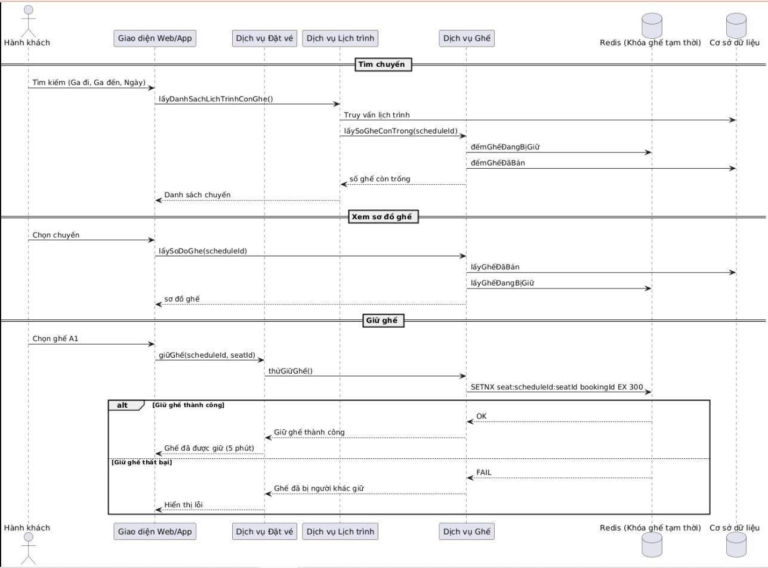

Sequence Diagram (Booking → Payment)

