

**Team id: NM2025TMID14066**

**Team members:**

**Harini k**

**Lavanya B**

**Sindhuja B**

**Dharshini v**

**EDUCATIONAL ORGANAIZATION USING SERVICE NOW**

# Problem statement

In an educational institution, managing academic and administrative tasks efficiently is a major challenge. Faculty members often face difficulties in assigning tasks to students, while students are confused about their responsibilities due to the lack of structured workflows and proper access control.

Currently, there is no clear distinction between faculty and student roles in the system, which leads to unauthorized edits, task duplication, and poor accountability. Without automation, monitoring student progress and generating timely reports is also difficult, creating delays in academic activities.

**Objectives**

# 1. Define User Roles Clearly

* Faculty (Academic Coordinator) → Can create, assign, edit, and monitor tasks.
* Student → Can only view and update assigned tasks.

**2. Implement Access Control Mechanisms**

• Use Access Control List (ACL) to restrict student access while giving full privileges to faculty.

# 3. For transparency and accountability Workflow Processes using ServiceNow Flow Designer

* Faculty creates and assigns tasks.
* Students receive notifications, update task progress, and mark completion.
* Faculty monitors progress, approves completion, and closes the task. • Reports are generated

**Skills**:

Users, Groups, Roles, Tables, Access Control List (ACL), Flow Designer, Notifications, Reporting & Dashboards.

**TASK INITIATION**

**Milestone 1 Users:**

**Activity 1: setting up service now instance**

# Go to the ServiceNow Developer site: [https://developer.servicenow.com](https://developer.servicenow.com/)

1. Create a developer account (sign up / log in).
2. Open the Personal Developer Instance section.
3. Click Request Instance to get your own ServiceNow instance.
4. Fill in the required details and submit.
5. You will receive an email with your instance link and login details.
6. Use those credentials to log in and start using ServiceNow.

**Creating a Update Set:**

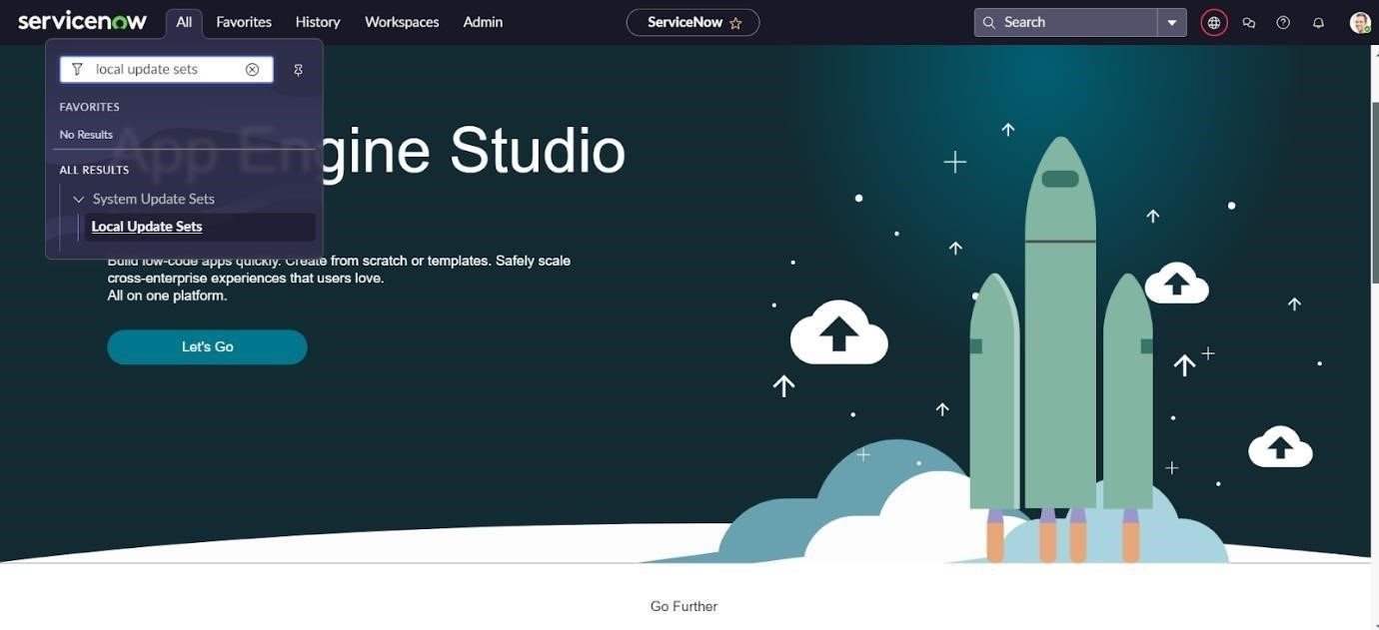

1. click on new table
2. enter a details and name is Educational organization in progress 3. submit button

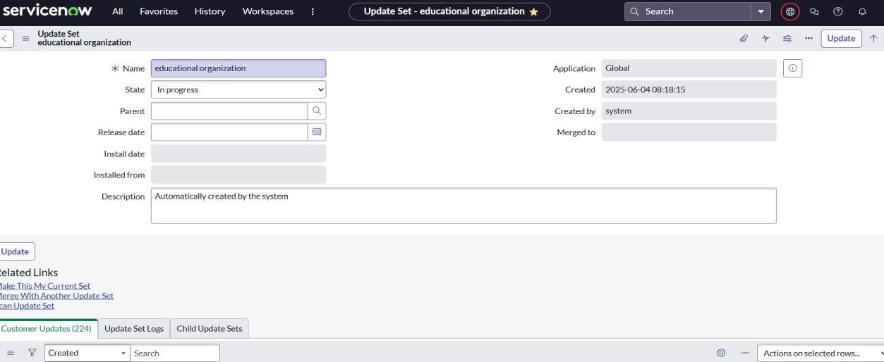

**Milestone 2:**

**Create a tables :**

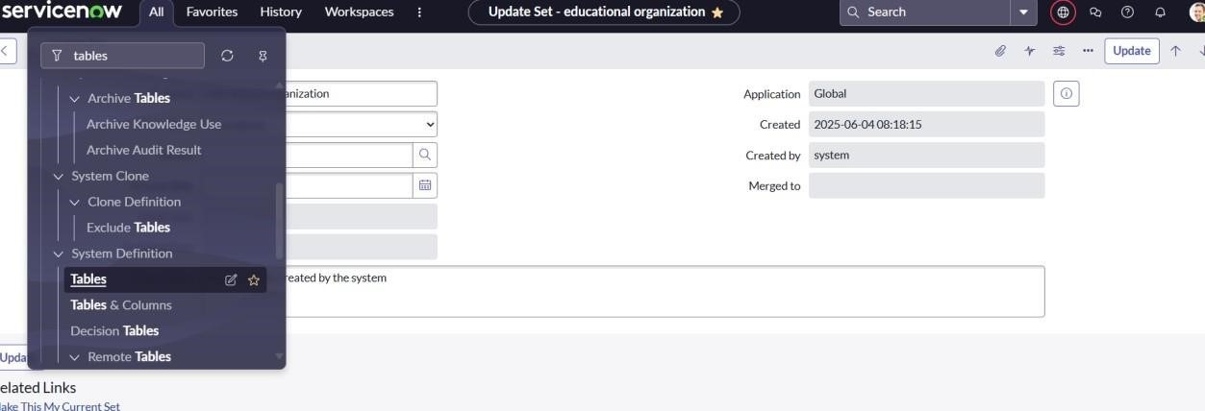

# Click on new table

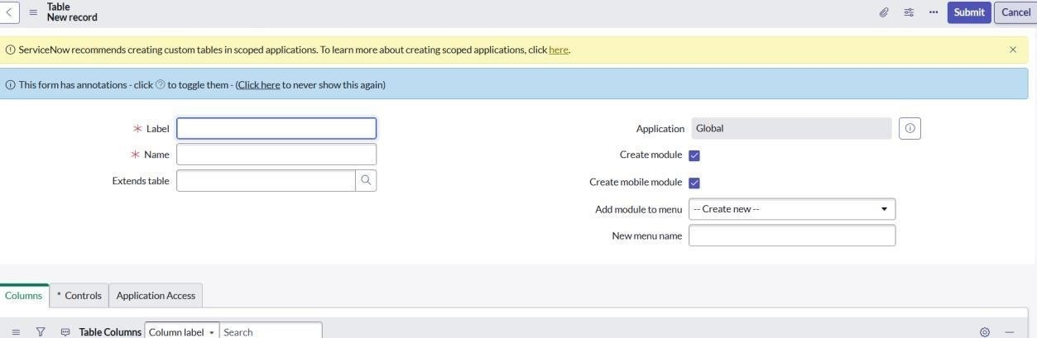

# Creating a column

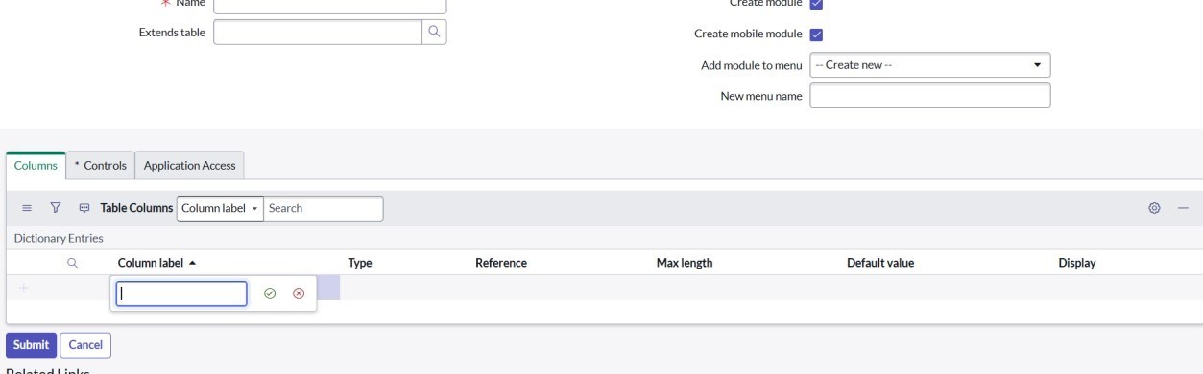

# To give a label name for sales force and display the screen &given display to create admin number

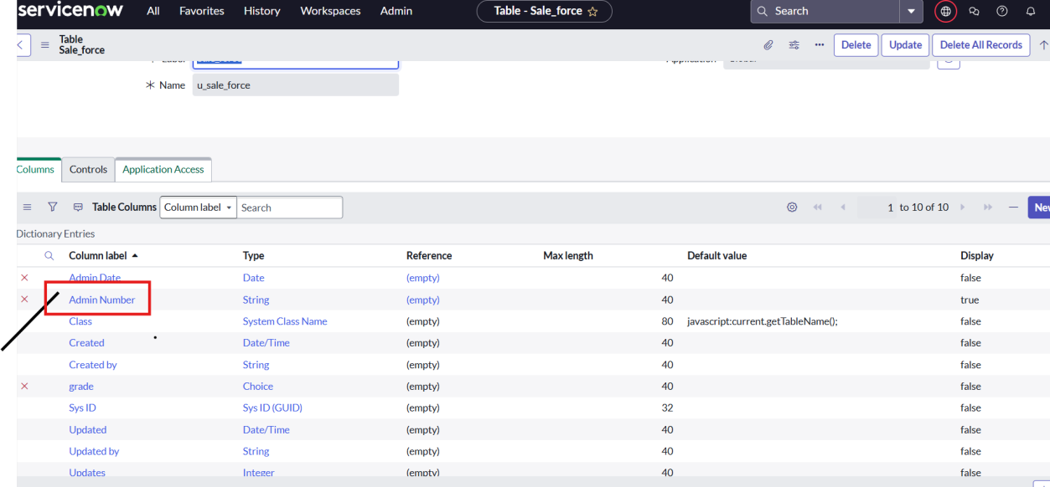

# The last step is click on grade column and <<choice>>column to give a grade I,II,III to we want

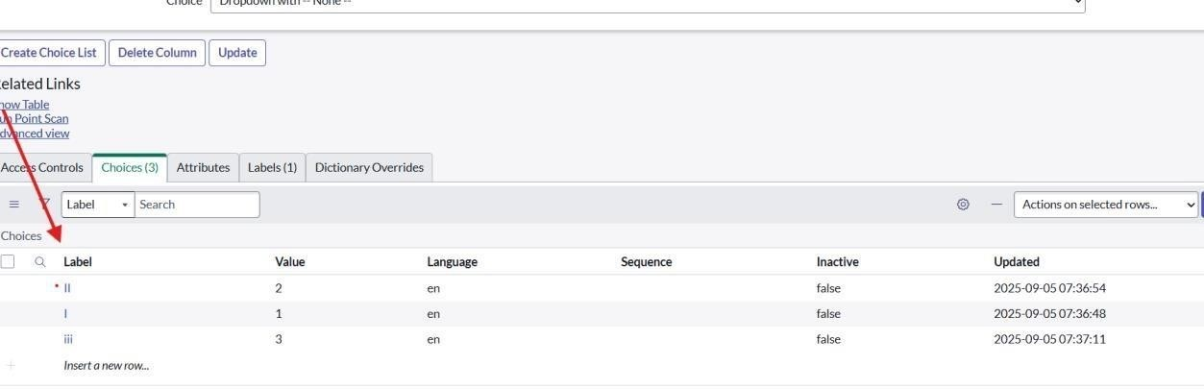

**Creating a admission table for sales force**  1. Go to Tables module and click Create Table.

1. Enter Table Label as Admission.
2. In Extends Table, select Salesforce.
3. Tick Add module to menu and select Salesforce.
4. Add the required Fields/Columns
5. .Save the table and check the new module under Salesforce.

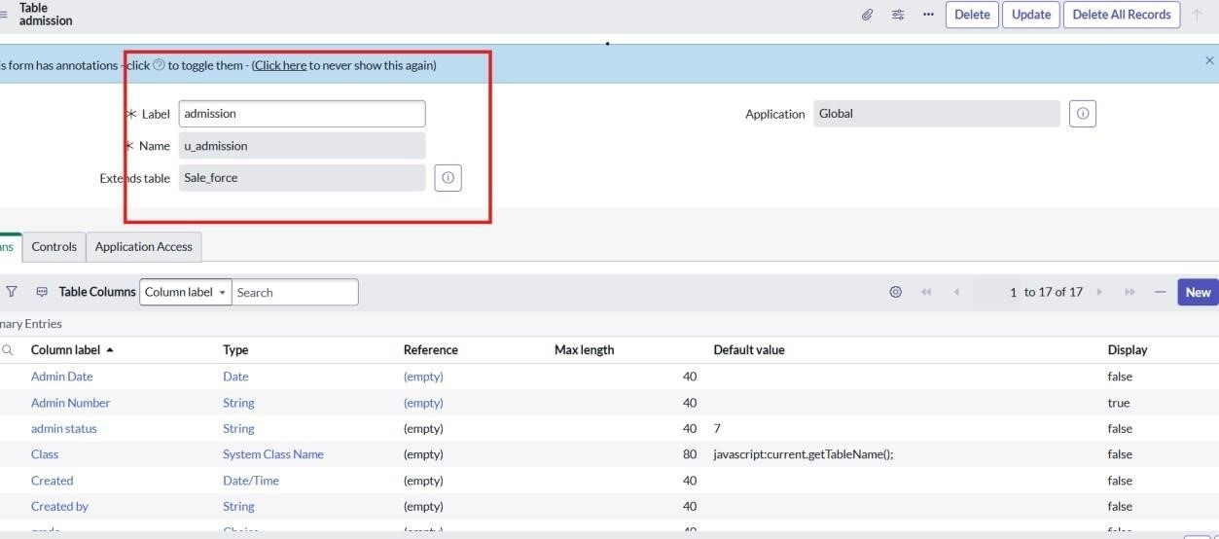

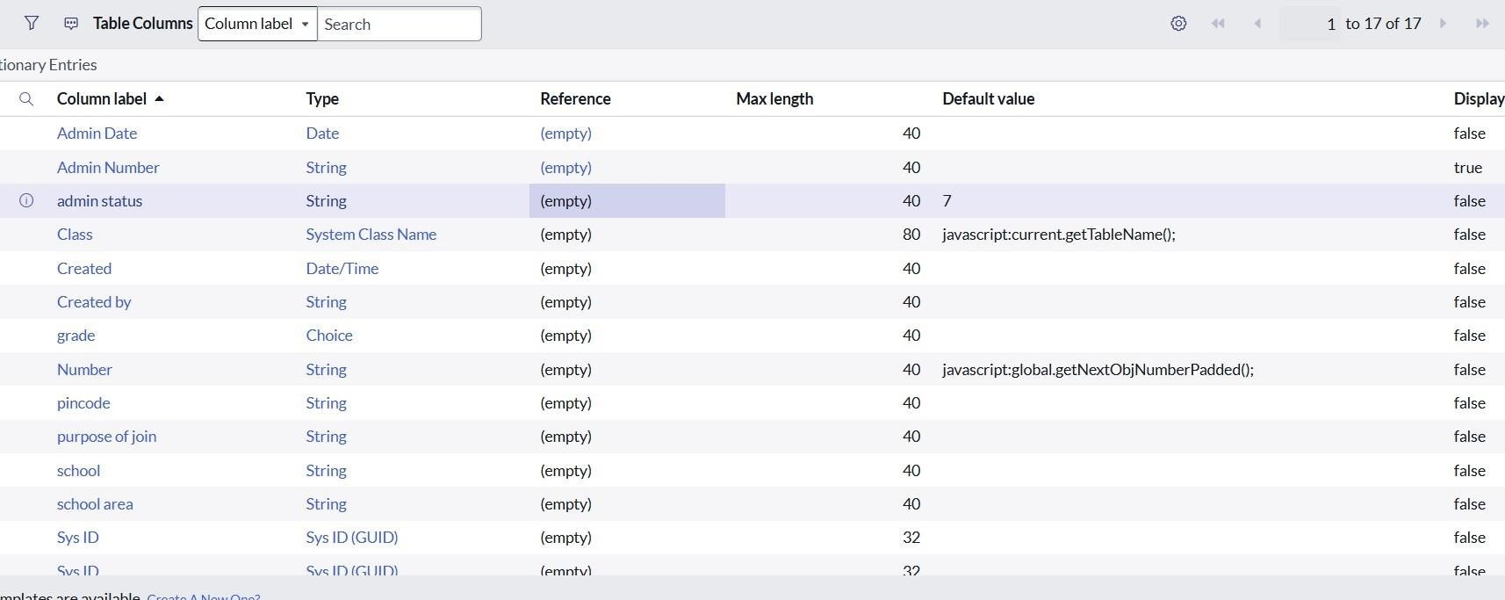

**Create student progress table:**

* + Create a Student Progress Table with Columns given.
  + Select Add module to menu Salesforce.
  + Create Fields as shown

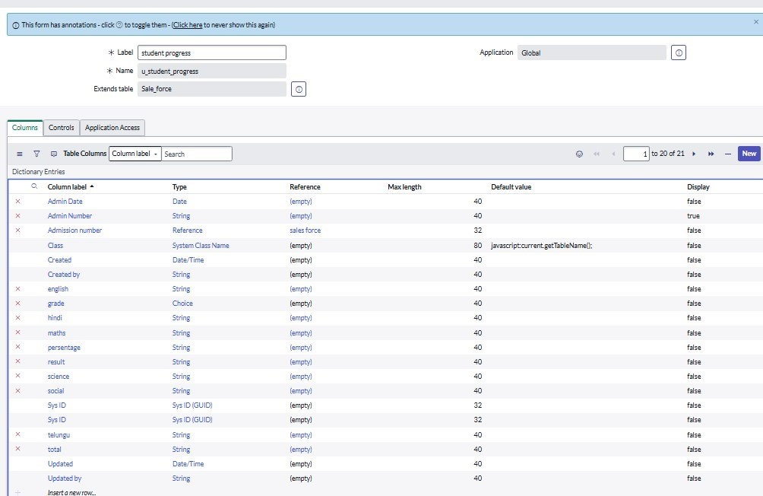

# Milestone 3 Form layout

1. Open the Admission Table.
2. Click on Configure → Form Layout.
3. In Form Layout, you can add, remove, or reorder fields for the form.
4. Use the **toggle button

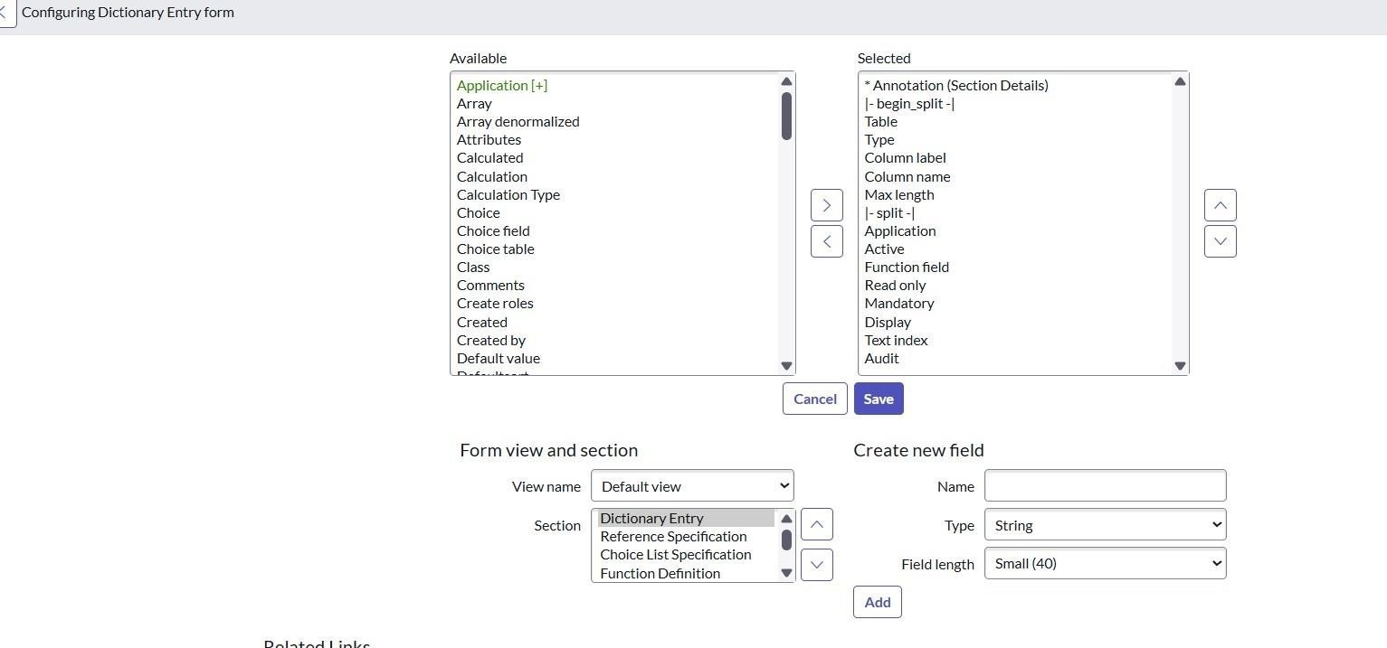

**Milestone 4**

# Activity: Create form design

1. Go to Setup → Object Manager → Create → Custom Object.
2. Enter Object Name (e.g., Admission) and save.
3. Add Fields (Student Name, Course, Admission Date).
4. Arrange fields in Page Layout and save

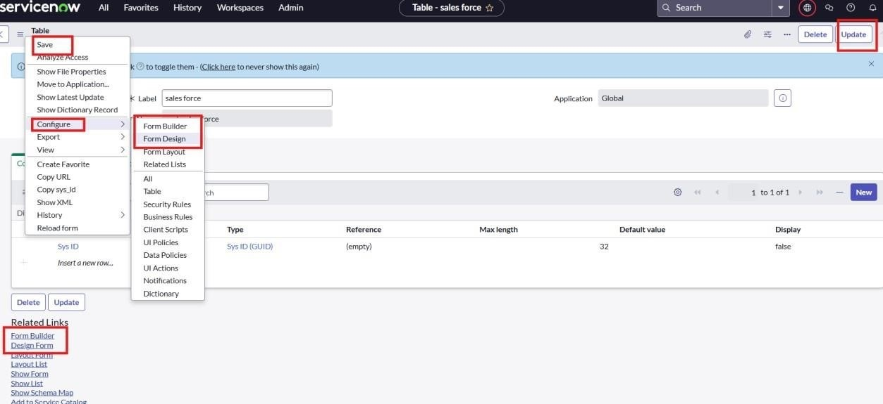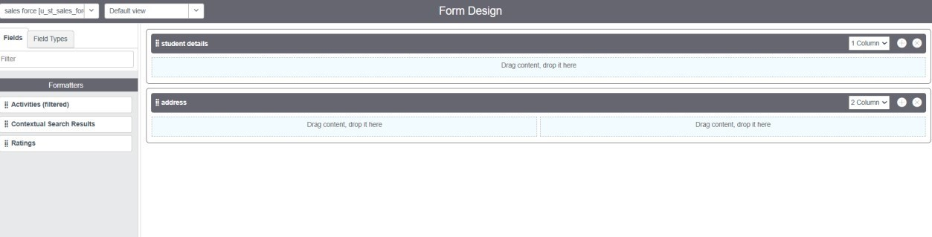

# To drag

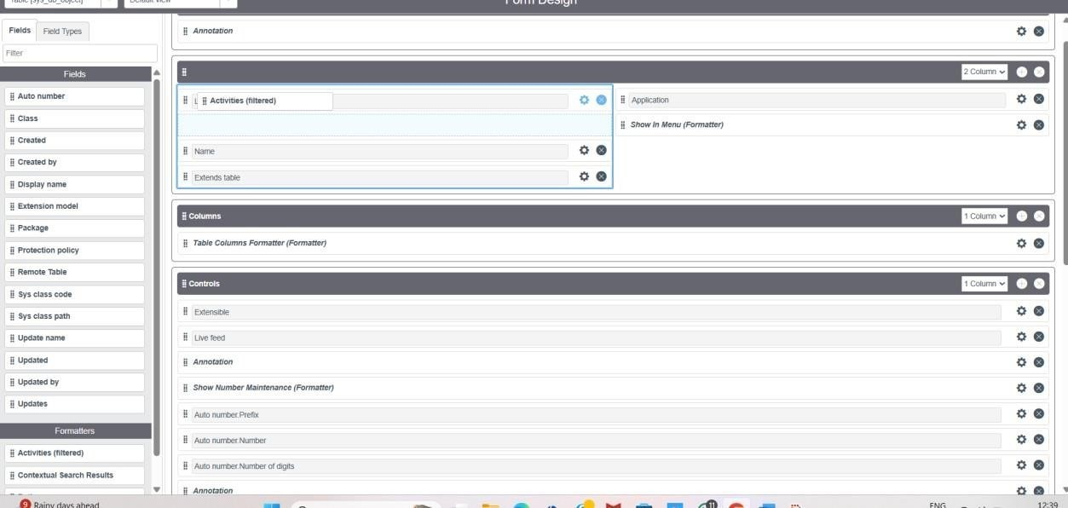

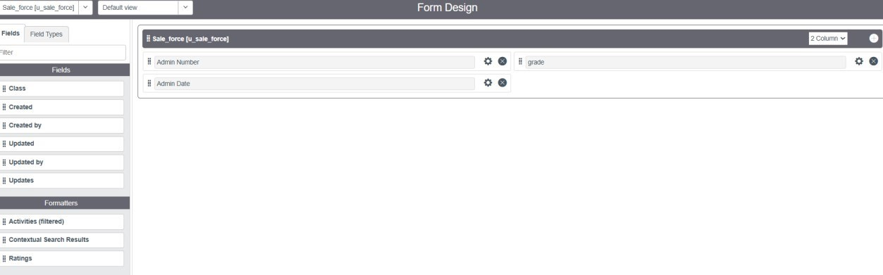

# Then last step save create admission table for form design

1. Open the Admission Table.
2. Click Configure → Form Layout (or Page Layout in Salesforce).
3. In Form Layout, you will see Available Fields and Selected Fields.
4. Drag fields from Available to Selected to include them in the form.
5. Reorder fields by dragging up or down to set the display sequence.
6. Click Save to apply the form layout.
7. Open the Admission form to verify the design.

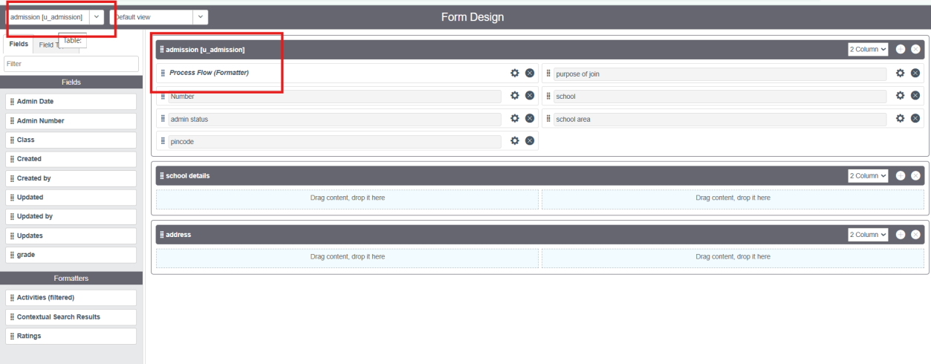

# Creating a student progress in form design

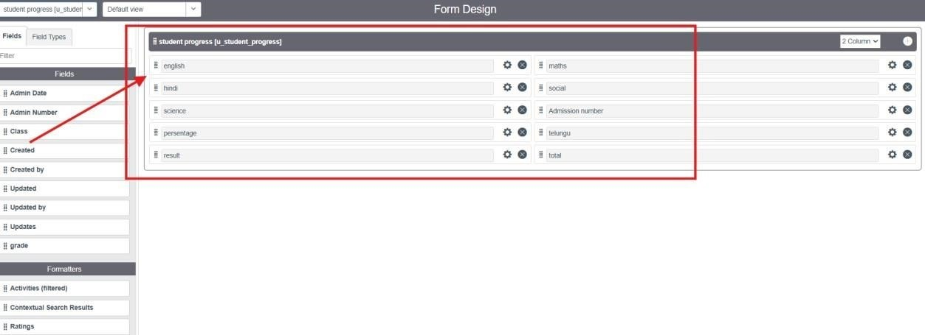

**Milestone 5**

# Activity to create a number maintenance

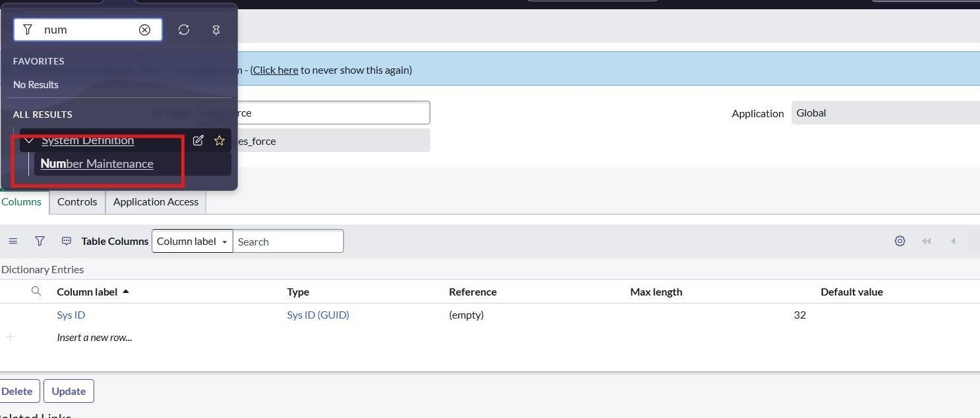

# To give a salesforce for label name

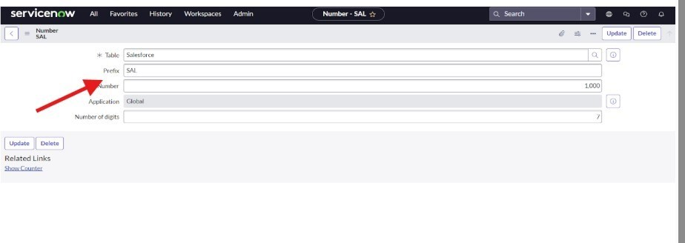

**Milestone 6:**

# Activity: create processes flow for admission table

1. Create Admission Table – Make a new table for storing admission details.
2. Add Fields – Include Student Name, Age, Course, Admission Date.
3. Design Form Layout – Arrange fields using drag & drop.
4. Save & Use – Save the table and start entering admission records

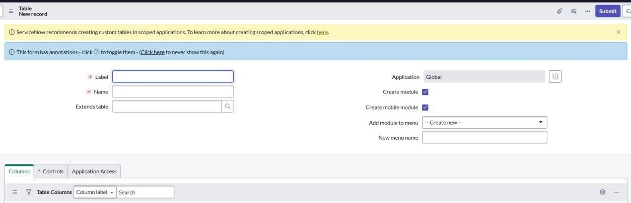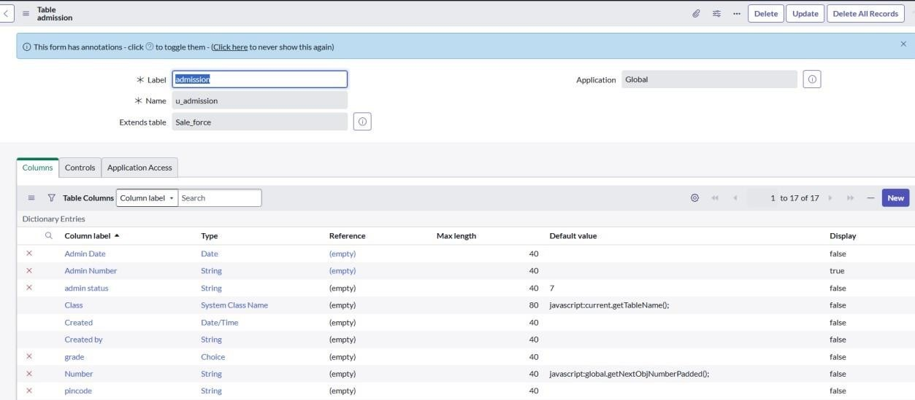

**Milestone 7**

# Activity1: Creating “Auto populate” Client Scripts for Admission Table

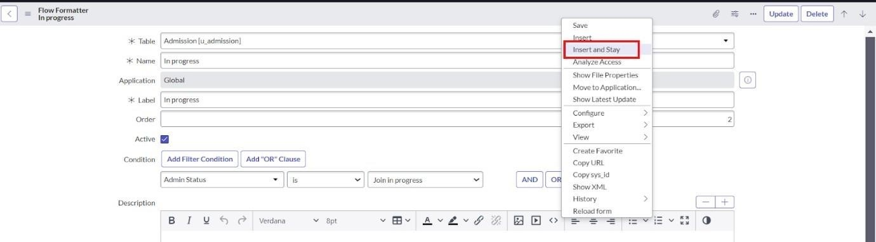

# Activity: 2 To create clint script

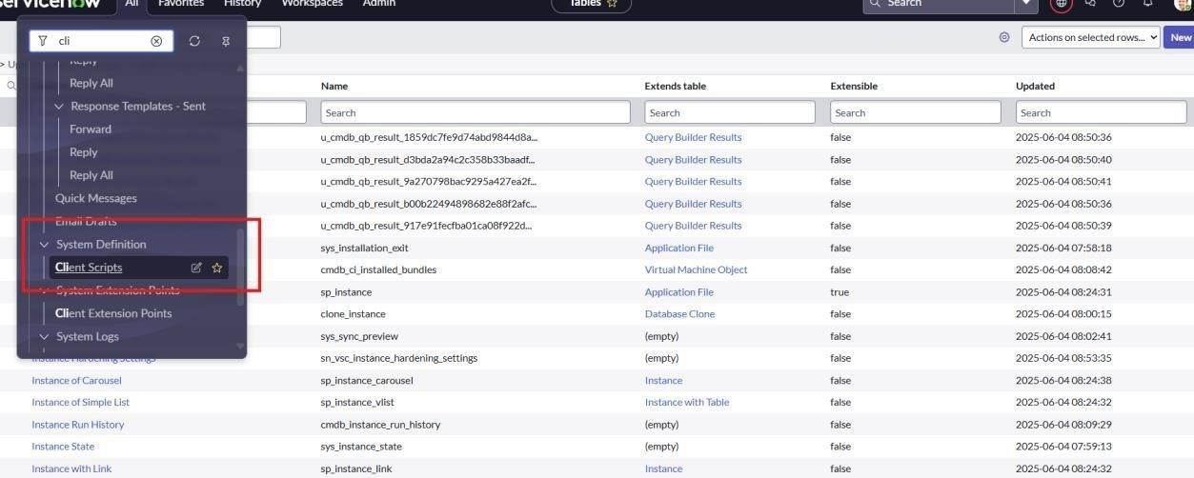

**Click on new:**

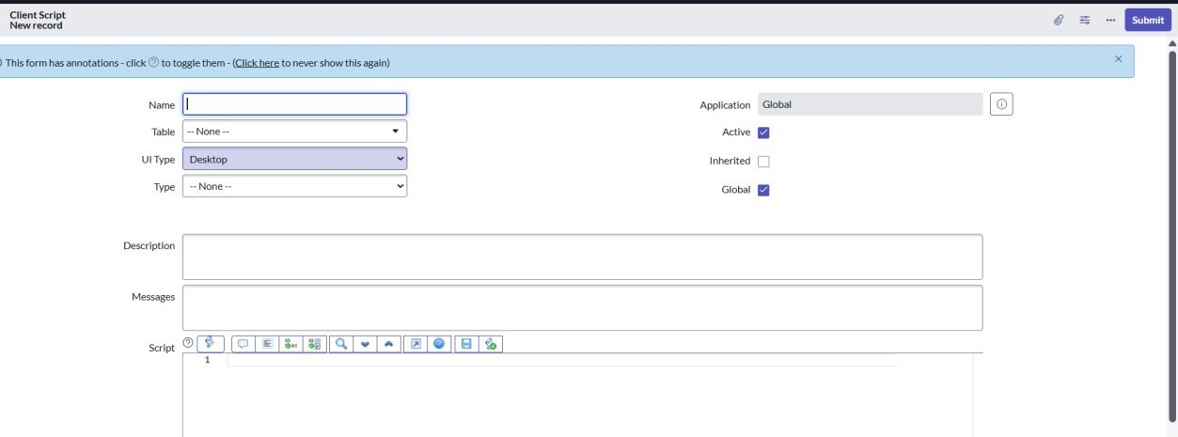

**Activity: 3Display the given details:**

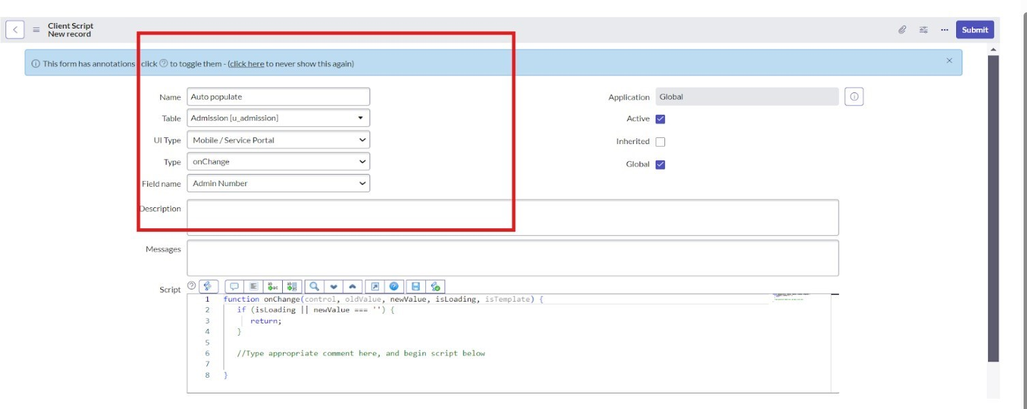

# To given the copy code in display

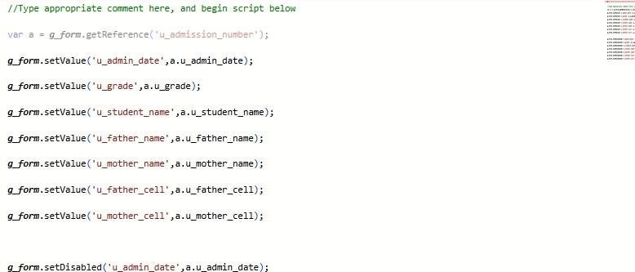

**Activity: 4 Creating a pin code:**

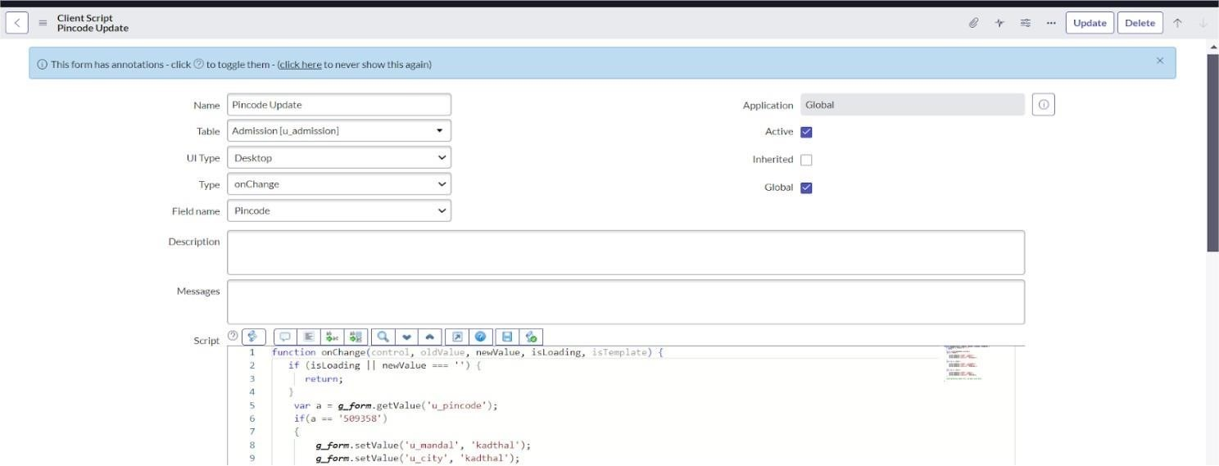

# Activity: 5 Creating “Disable Fields” Client Scripts for Student progress Table

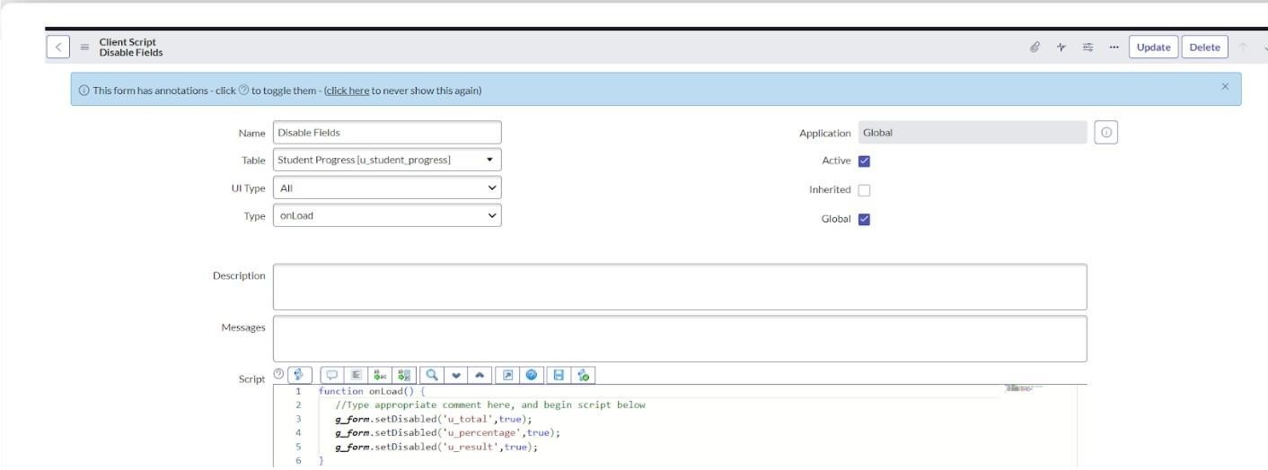

# Activity: 6 Creating “Total Update” Client Scripts for Student progress Table

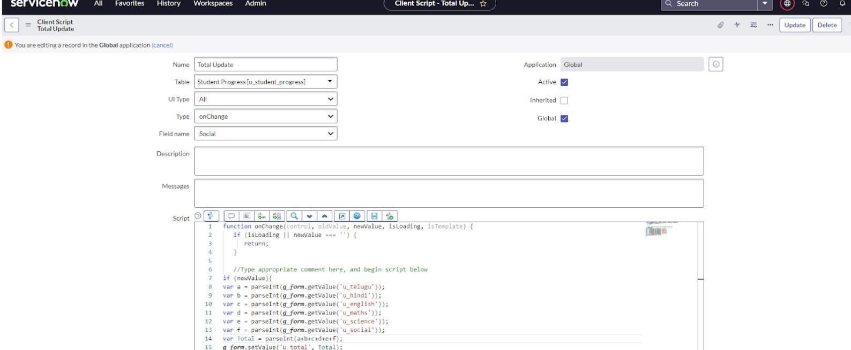

# Activity: 7 Creating “Result” Client Scripts for Student progress Table

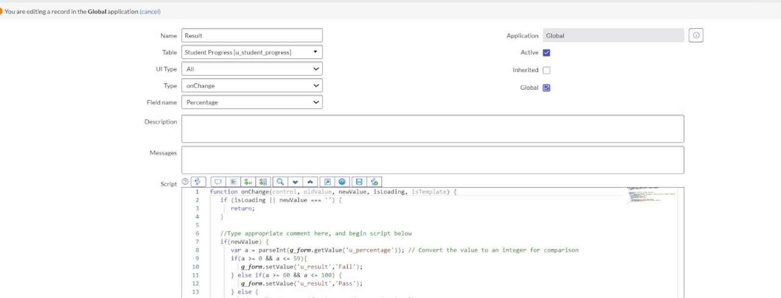

Activity: 8 Creating “Percentage” Client Scripts for Student progress Table

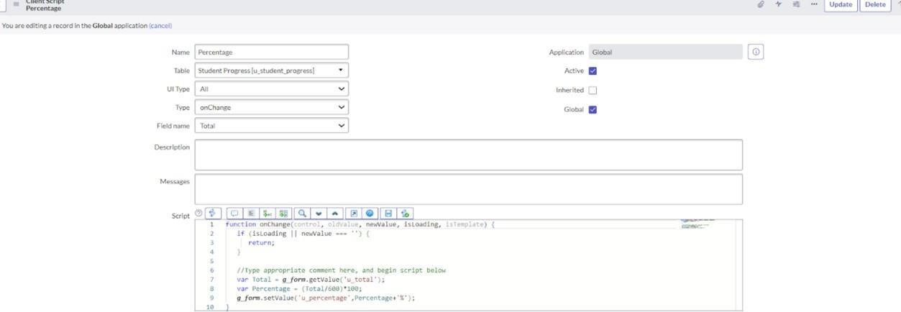

# Result

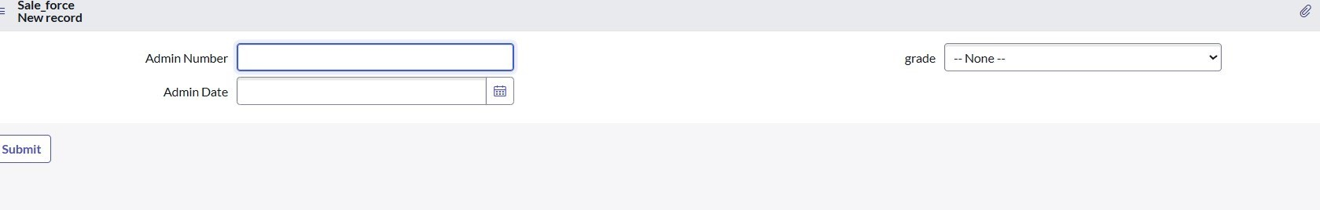

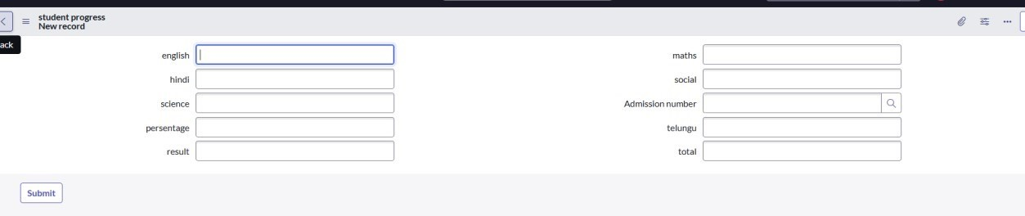

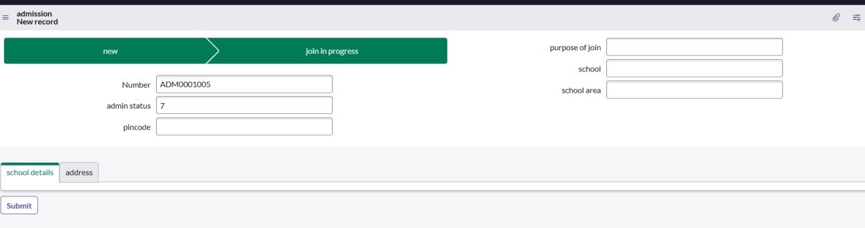

# Conclusion

By creating tables, adding fields, designing form layouts, and applying workflows in ServiceNow / Salesforce, educational organizations can manage admissions and tasks more efficiently. Using Users, Roles, ACL, Flow Designer, and Reporting, the system ensures clear responsibilities, secure access, structured workflows, and smooth data management. This improves transparency, accountability, and productivity in the institution.