

Amrita Vishwa Vidyapeetham

Department of Computer Science and Engineering, School of Computing

Coimbatore –112.

19CSE446 – Internet of Things

Semester : VI

Group 21

[**Intelligent-IoT-Based-Soil-Monitoring-and-Adaptive-Plant-Irrigation-System**](https://github.com/Praveen20cent/Intelligent-IoT-Based-Soil-Monitoring-and-Adaptive-Plant-Irrigation-System/tree/main)

MRINENDRAA S – CB.EN.U4CSE22235

LOWKIK SAI POTNURU – CB.EN.U4CSE22242

PRAVEEN K - CB.EN.U4CSE22243

**1. Problem Statement and Justification for the Need**

The agricultural sector in India and around the globe faces challenges related to efficient water management and labor-intensive irrigation practices. With increasing water scarcity and the growing demand for sustainable farming solutions, there is a need for an intelligent system that can monitor soil conditions and automate irrigation. The proposed IoT-based project addresses this problem by providing:

* **Automated irrigation** to reduce water wastage and labor dependency.
* **Real-time monitoring** of soil moisture, environmental temperature, and rainfall to make informed watering decisions.
* **Flexibility** for users to choose between manual and automatic irrigation modes.

This system aims to enhance productivity, conserve water, and reduce human intervention, making it a practical solution for farmers, gardeners, and urban households.

**2. Selection of Hardware and Software Components**

* **Hardware:**
  + Microcontroller: ESP32 (for its built-in Wi-Fi capabilities and GPIO pins).
  + Sensors: Soil moisture sensor, DHT22 (temperature and humidity), rain sensor, Soil temperature sensor.
  + Actuators: Relay module for pump control, water pump for water flow regulation.
  + Additional Components: Power supply module, jumper wires, breadboard, water pump, pipes.
* **Software:**
  + Arduino IDE: For programming the ESP32 microcontroller.
  + Firebase: For cloud-based data storage and retrieval.
  + Development Environment: VS Code for building the user application.
  + Communication Protocol: MQTT for efficient and lightweight messaging.

**3. Sensor and Actuator Selection and Placement**

* **Sensors:**
  + **Soil Moisture Sensor:** Placed at the root level of plants to measure soil moisture.
  + **DHT22:** Installed in a shaded outdoor area to monitor temperature and humidity.
  + **Rain Sensor:** Positioned in an open area to detect rainfall and avoid unnecessary watering.
  + **Soil temperature Sensor:** Positioned in the soil to monitor temperature variations affecting plant health.
* **Actuators:**
  + **Relay Module:** Controls the water pump based on sensor input.
  + **Water pump:** Regulates water flow to specific plant areas as required.

**4. Hardware Architecture Design and Data Acquisition - Model Overview**

The system is structured into three main components:

1. **Input Layer:** Collects data from the soil moisture sensor, DHT22, soil temperature sensor, and rain sensor.
2. **Processing Layer:** ESP32 processes sensor data and makes decisions based on predefined thresholds.
3. **Output Layer:** Controls the water pump and solenoid valve based on the processed data.

The ESP32 communicates with Firebase to store sensor data and retrieve user commands from the application.

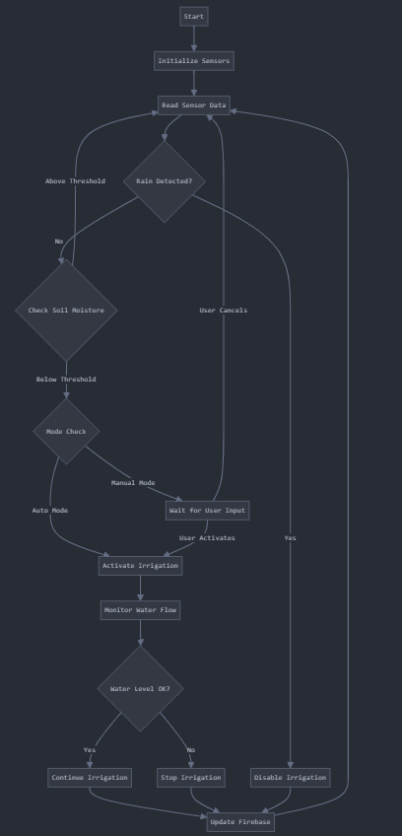

**5. Control Unit / End Node Design using TinkerCAD / Fritzing**

* **Control Unit Design:**
  + The ESP32 microcontroller serves as the central node, connected to sensors and actuators.
  + The wiring ensures seamless data flow between sensors, actuators, and the ESP32.

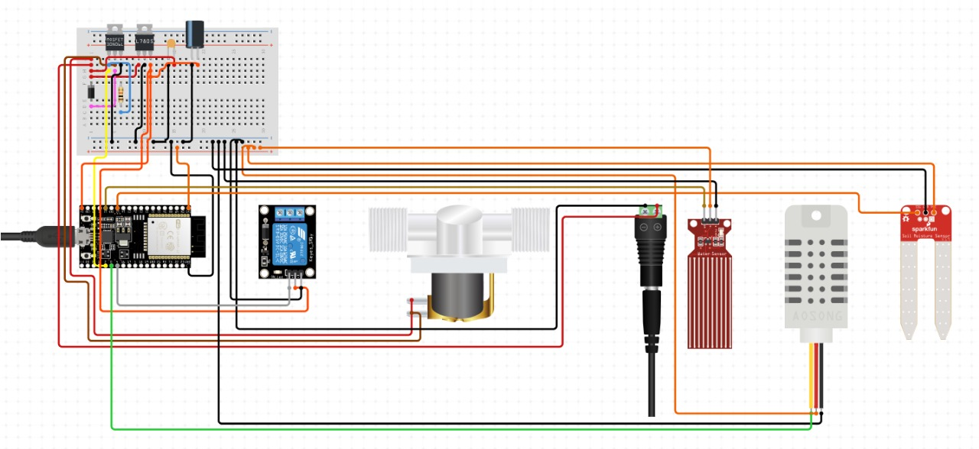

**6. Selected Communication Protocol (Lower Layers) and Data Transmission Protocol (Upper Layers) - Justification**

To ensure efficient, reliable, and scalable communication, the system leverages:

* **Lower Layers:**
  + **Wi-Fi Protocol (IEEE 802.11):**
    - Selected for its widespread availability and compatibility with the ESP32 microcontroller.
    - Enables high-speed communication over local networks, allowing the system to send and receive real-time data efficiently.
    - Provides the necessary bandwidth to handle multiple sensor inputs and actuator commands simultaneously.
* **Upper Layers:**
  + **MQTT Protocol (Message Queuing Telemetry Transport):**
    - Chosen for its lightweight nature, making it ideal for IoT devices with limited computational resources.
    - Features include:
      * Publish/Subscribe Model: Ensures seamless communication between ESP32, Firebase, and the user application.
      * Low Bandwidth Usage: Reduces data transmission costs, making the system efficient for long-term use.
      * Quality of Service (QoS): Offers reliable message delivery with adjustable levels to balance performance and resource constraints.
    - Justified for its ability to handle frequent updates (e.g., sensor data) and real-time commands (e.g., irrigation control) effectively.

These protocols collectively ensure robust, secure, and scalable communication for the IoT system.

**7. Software Architecture Diagram**

The software architecture consists of:

1. **Data Acquisition Module:** Reads data from sensors.
2. **Decision Module:** Processes data and determines actuator actions.
3. **Communication Module:** Sends data to Firebase and retrieves commands.
4. **Application Module:** Displays sensor data and controls irrigation through a GUI.

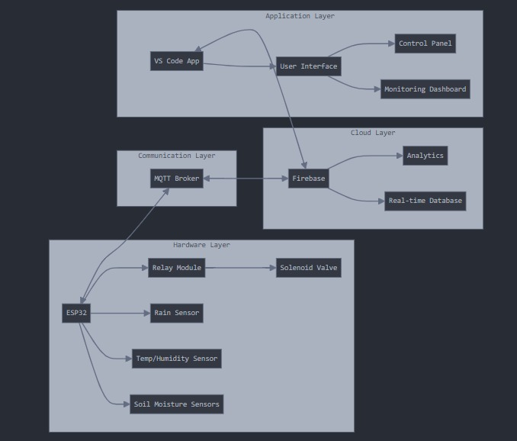

**8. Integration of Hardware and Software - Plan**

**Hardware Configuration**:

* **Connection Security**: Ensure all connections between sensors, actuators, and the ESP32 are secure and protected from physical tampering.
* **Power Management**: Use voltage regulators and protection circuits to prevent hardware damage due to power fluctuations.

**Firmware Development**:

* **Secure Coding Practices**: Implement secure coding practices to prevent vulnerabilities in the firmware.
* **Data Validation**: Validate all sensor inputs to ensure they fall within expected ranges, mitigating the risk of erroneous data affecting system operations.
* **Encryption**: Encrypt sensitive data (e.g., user commands and sensor data) before transmission to protect against interception.

**Communication Setup**:

* **Secure MQTT**: Use MQTT over TLS (Transport Layer Security) to encrypt communication between the ESP32 and Firebase, ensuring data confidentiality and integrity.
* **Authentication**: Implement mutual authentication between the ESP32 and Firebase to prevent unauthorized access. Use API keys or OAuth tokens for secure access control.

**Application Integration**:

* **Secure API Endpoints**: Ensure all API endpoints in the application are secure, using HTTPS for encrypted communication.
* **User Authentication**: Implement user authentication (e.g., username and password, two-factor authentication) in the application to restrict access to authorized users only.
* **Access Control**: Define role-based access control (RBAC) to limit user permissions based on their roles (e.g., admin, user).

**Testing and Debugging**:

* **Security Testing**: Conduct security testing, including penetration testing and vulnerability scanning, to identify and fix security flaws.
* **Audit Logs**: Maintain audit logs for all significant actions (e.g., irrigation control commands, user logins) to monitor and trace any suspicious activities.

**Ongoing Security Measures**:

* **Firmware Updates**: Regularly update the firmware to patch security vulnerabilities and improve performance.
* **Incident Response Plan**: Develop an incident response plan to handle security breaches or system failures promptly.
* **User Education**: Educate users on best practices for securing their devices and accounts, such as using strong passwords and recognizing phishing attempts.

**Identification**

* **Device IDs**: Unique identifiers for hardware components.
* **User Authentication**: Verifies authorized access to the system.
* **Service Tags**: Ensure services like irrigation are correctly mapped to sensors/actuators.

**Device Management**

Effective device management ensures system reliability and ease of maintenance:

* **Provisioning**: Adding new devices to the system securely.
* **Monitoring**: Real-time tracking of device performance and health.
* **Decommissioning**: Safe removal of obsolete devices.

**9. Plan for Data Analytics and Integration with GUI**

**Data Analysis Plan:**

1. **Data Storage:**
   * Database: Use Firebase Realtime Database to store sensor data with accurate timestamps.
   * Data Structure: Organize data based on sensors (soil moisture, temperature, rainfall) and respective timestamps to facilitate easy retrieval and analysis.

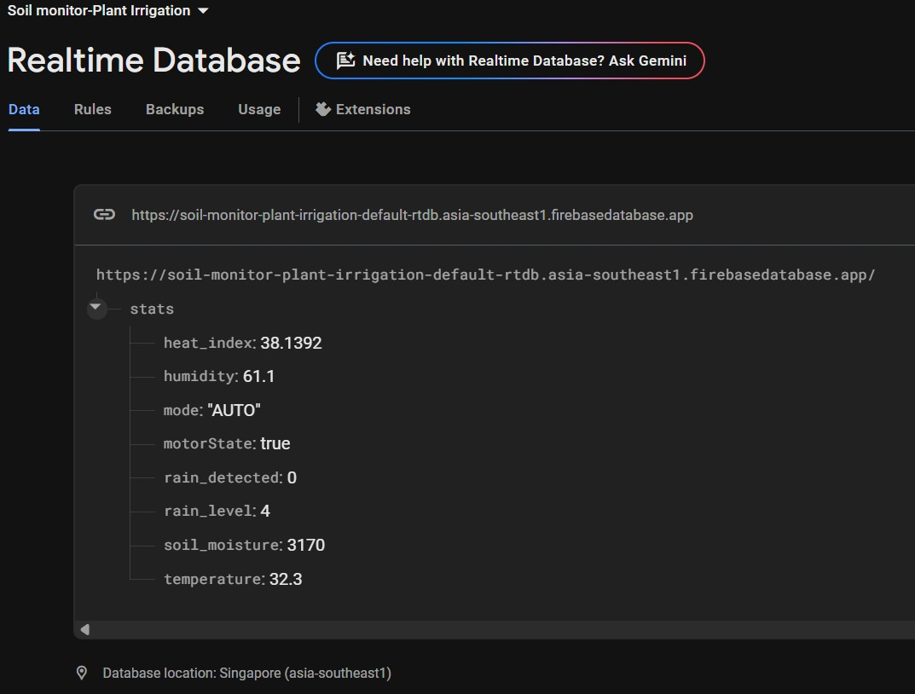

**Influx DB :**

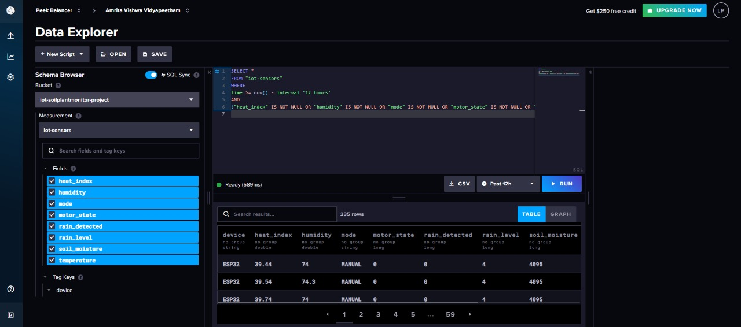

1. **Data Processing:**
   * Real-time Analysis: Implement real-time processing to trigger immediate actions based on sensor inputs (e.g., starting/stopping irrigation).
   * Historical Analysis: Analyze historical data to identify trends, such as average soil moisture levels, temperature fluctuations, and rainfall patterns over time.
2. **Insights Generation:**
   * Trend Analysis: Use data visualization tools to create graphs showing trends in soil moisture, temperature, and rainfall.
   * Predictive Analysis: Apply machine learning models (e.g., regression analysis) to predict future soil moisture levels and optimize irrigation schedules.
3. **Optimization:**
   * Irrigation Scheduling: Use insights from data analysis to recommend optimal watering times and quantities.
   * Resource Utilization: Provide feedback on water usage efficiency and suggest ways to conserve water.

**GUI Development Plan:**

1. **Design:**
   * User Interface: Develop an intuitive, user-friendly interface with clear navigation.
   * Real-Time Dashboard: Display current sensor readings (e.g., soil moisture, temperature) in real-time.
   * Historical Data Visualization: Implement charts and graphs for visualizing historical data trends.

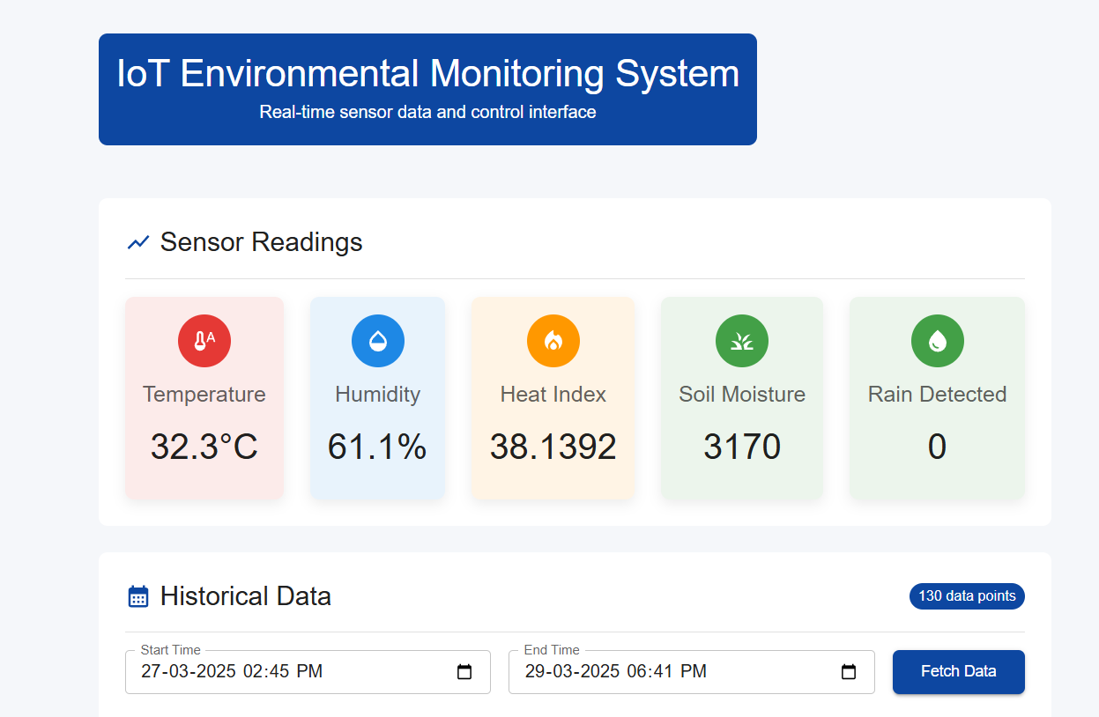

1. **Features:**
   * Manual Control: Provide options for users to manually control the irrigation system.
   * Automatic Mode: Display the system's current mode and allow users to switch between manual and automatic control.
   * Alerts and Notifications: Integrate a notification system to alert users of critical conditions, such as low soil moisture or extreme temperatures.

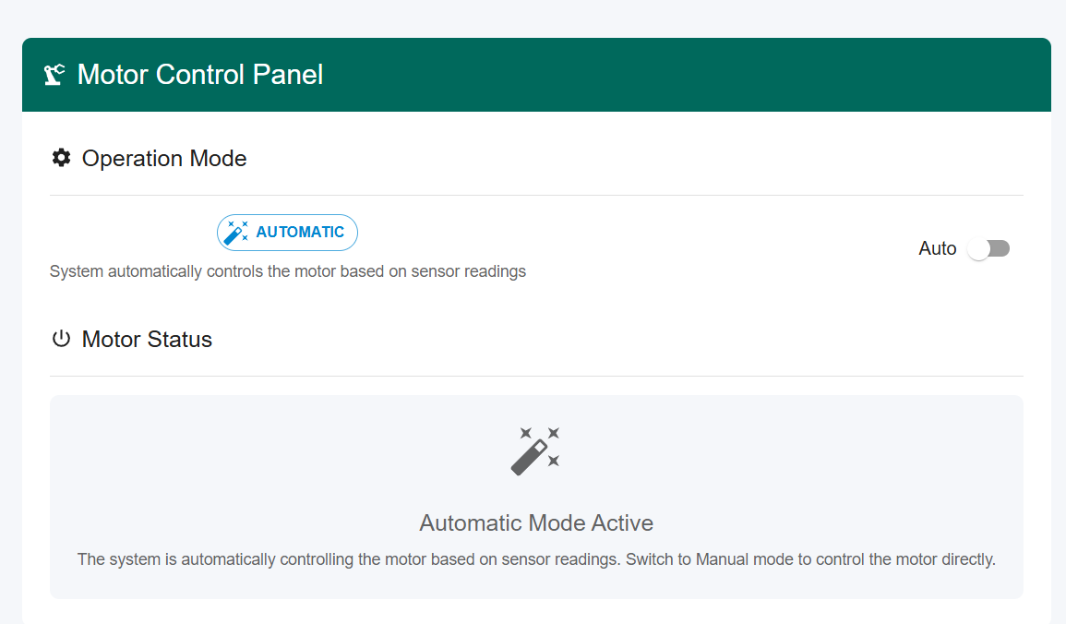

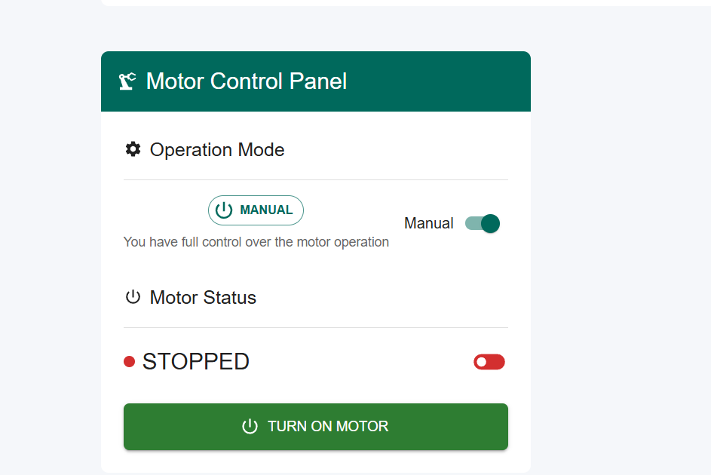

1. **Development Tools:**
   * Front-End Framework: Use web technologies such as frameworks like React js for the GUI.
   * Back-End Integration: Utilize Node.js for backend services to handle data processing and communication with Firebase.
   * Charting Libraries: Integrate charting libraries like Chart.js or D3.js for data visualization.
2. **Testing and Debugging:**
   * User Testing: Conduct usability testing to ensure the GUI is easy to use and meets user needs.
   * Performance Testing: Test the system's performance under various conditions to ensure it handles real-time data efficiently.
3. **Deployment:**
   * Cross-Platform: Ensure the application is compatible with both mobile (Android) and desktop (Windows) platforms.
   * Continuous Integration/Continuous Deployment (CI/CD): Set up CI/CD pipelines for seamless updates and maintenance.

**Software Requirements:**

* Firebase: For real-time database management.
* Arduino IDE: For ESP32 programming.
* VS Code: For development environment.
* MQTT Protocol: For efficient communication.
* Chart.js/D3.js: For creating interactive charts and graphs.
* React/Vue.js: For building the front-end application.

**10. Plan for Application Development and Deployment of Overall System**

1. **Development:**
   * Use VS Code to build a cross-platform application with:
     + Real-time sensor data display.
     + Options to toggle between automatic and manual irrigation modes.
     + Historical data visualization and trend analysis.
2. **Deployment:**
   * Deploy the application on mobile and desktop platforms for wide accessibility.
   * Ensure compatibility with Android and Windows systems.
3. **Scalability:**
   * Design the application and system architecture to accommodate additional sensors or expanded irrigation zones in future implementations.
4. **Maintenance and Support:**
   * Provide a simple troubleshooting guide for users to address potential issues without requiring regular updates or support.
5. **Service Management:**
   * **Scheduling**: Automates irrigation tasks based on data analytics.
   * **Manual Overrides**: Allows user control in critical conditions

.

**11.Conclusion**

The Intelligent IoT-Based Soil Monitoring and Adaptive Plant Irrigation System presents a smart solution to water management in agriculture by combining real-time environmental sensing, automated irrigation, and cloud-based data analytics. Powered by the ESP32 microcontroller and integrated with sensors for soil moisture, temperature, humidity, and rainfall, the system ensures timely and efficient watering with minimal human intervention.

Challenges such as reliable connectivity, sensor calibration, and secure cloud integration were effectively addressed, resulting in a stable and user-friendly application. With Firebase enabling real-time monitoring and control, and a user interface built for intuitive interaction, the project demonstrates how IoT can revolutionize traditional farming practices.

This system reflects the potential of IoT in making agriculture more sustainable, resource-efficient, and adaptive to environmental conditions, providing a scalable solution for both rural and urban applications.

**Prepared by:** Team No. 21  
**Institution:** Amrita Vishwa Vidyapeetham, Coimbatore, Tamil Nadu  
**Guide**: Dr. Anantha Narayanan V.