ELECTRIC MOTOR TEMPERATURE PREDICTION USING MACHINE LEARNING

Project Description:

Electric motors are widely used in industrial applications, robotics, and transportation systems. Monitoring and predicting their temperature is critical for ensuring efficiency, preventing overheating, and avoiding potential damage. Manual monitoring of motor temperature is time-consuming and may not always provide timely alerts, which can lead to operational failures. Therefore, developing an automated system for predicting motor temperature is highly important.

Predicting motor temperature is challenging due to variations in voltage, current, load, and environmental conditions. These parameters interact in complex ways that can affect motor performance and thermal behavior. By applying machine learning techniques, it is possible to model these interactions and accurately predict the temperature of an electric motor under different operating conditions. Such predictions help in preventive maintenance, energy optimization, and extending motor lifespan.

In this project, we use a dataset containing historical operational data of electric motors, including voltage, current, and load measurements, along with recorded temperature values. The dataset was preprocessed by handling missing values, scaling numerical features, and performing exploratory data analysis to identify patterns and correlations.

We implemented a predictive model using regression-based machine learning algorithms. The model was trained to learn the relationship between input parameters (voltage, current, load) and motor temperature. Hyperparameter tuning and cross-validation were applied to optimize model performance. The final trained model was saved using a pickle file (motor_model.pkl) for deployment.

Finally, the model was integrated with a Flask-based web application, where users can input operational parameters and receive real-time predictions of motor temperature. This project demonstrates the practical application of machine learning techniques combined with web deployment for predictive maintenance in industrial systems.

Technical Architecture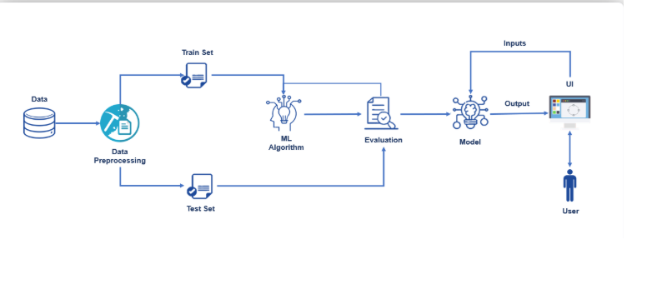

Pre requisites:
To complete this project, you must require the following software’s, concepts, and packages

To complete this project, you will need the following software, concepts, and packages:
Anaconda Navigator:
Anaconda Navigator is a free and open-source distribution of the Python programming language for data science and machine learning applications. It can be installed on Windows, Linux, and macOS. Conda, which comes with Anaconda, is an open-source, cross-platform package management system. Anaconda provides several useful tools, including Jupyter Notebook, JupyterLab, Spyder, QtConsole, Glueviz, Orange, RStudio, and Visual Studio Code. For this project, we will primarily use Jupyter Notebook and VS Code to develop and run the machine learning models.

Python Libraries:
You will need basic knowledge of Python programming and should install the following Python packages:
• NumPy and Pandas for data handling and manipulation.
• Matplotlib and Seaborn for data visualization.
• Scikit-learn for machine learning model building, training, and evaluation.
• Pickle for saving and loading trained models.
• Flask for creating the web application interface to input parameters and predict motor temperature in real-time.

Python Package Installation:
- Open Anaconda Prompt as Administrator.
- Type the following commands and press Enter after each:
  - pip install numpy
  - pip install pandas
  - pip install scikit-learn
  - pip install matplotlib
  - pip install seaborn
  - pip install Flask
  - pip install pickle-mixin (optional if using Pickle for model saving)
2.Deep Learning & Machine Learning Concepts:
- Regression Models: Regression is used to predict continuous numerical values, such as motor temperature, based on input features like voltage, current, and load.
  - Linear Regression, Random Forest Regression, and Gradient Boosting Regression are commonly applied in this project.
- Data Preprocessing: Techniques such as scaling, normalization, and handling missing values are essential to improve model accuracy.
- Flask Basics: Flask is a lightweight Python web framework for building interactive web applications, allowing users to input parameters and get real-time predictions.

Prior Knowledge:
You must have prior knowledge of following topics to complete this project.
- ML Concepts
You must have prior knowledge of the following topics to complete this project:
● Machine Learning Concepts:
- Supervised Learning: https://www.javatpoint.com/supervised-machine-learning
- Unsupervised Learning: https://www.javatpoint.com/unsupervised-machine-learning
- Regression Techniques (Linear, Random Forest, Gradient Boosting, etc.)
- Decision Tree: https://www.javatpoint.com/machine-learning-decision-tree-classification-algorithm
- Random Forest: https://www.javatpoint.com/machine-learning-random-forest-algorithm
- K-Nearest Neighbors (KNN): https://www.javatpoint.com/k-nearest-neighbor-algorithm-for-machine-learning
- XGBoost: https://www.analyticsvidhya.com/blog/2018/09/an-end-to-end-guide-to-understand-the-math-behind-xgboost/
- Evaluation Metrics: https://www.analyticsvidhya.com/blog/2019/08/11-important-model-evaluation-error-metrics/
- Flask Basics : https://www.youtube.com/watch?v=lj4I_CvBnt0

Project Objectives:
By the end of this project you will:
- Understand fundamental concepts and techniques of regression-based machine learning models for predicting continuous values.
- Gain a broad understanding of electric motor data, including voltage, current, load, and temperature.
- Learn how to pre-process and clean data using different data preprocessing techniques such as scaling, normalization, and handling missing values.
- Know how to build a web application using the Flask framework for real-time prediction.

Project Flow:
- The user interacts with the UI (User Interface) to input motor parameters such as voltage, current, and load.
- The input data is analyzed by the trained regression model integrated with the Flask application.
- The model predicts the motor temperature, and the result is displayed on the Flask UI.
To accomplish this, we have to complete all the activities listed below:
- Data collection
- Gather historical motor operational data.
- Organize the dataset into input features (Voltage, Current, Load) and target variable (Temperature).
- Data pre-processing
- Handle missing values, outliers, and anomalies in the dataset.
- Perform feature scaling and normalization.
- Split the dataset into training and testing sets.
- Model building
  - Import machine learning libraries such as Scikit-learn.
  - Initialize and configure regression models (Linear Regression, Random Forest, Gradient Boosting).
  - Train and validate the model using the training and testing data.
  - Evaluate model performance using metrics such as RMSE and R².
  - Save the best-performing model using Pickle for deployment.
- Application Building
- Create HTML/CSS files for the web interface.
- Build Flask application to load the trained model and accept user input.
- Display real-time predicted motor temperature on the web UI

Project Structure:
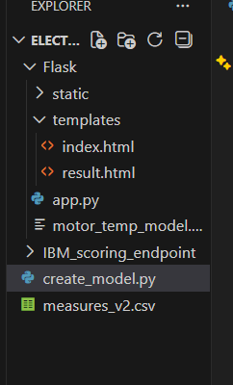
Create the Project folder which contains files as shown below

- We are building a Flask Application that needs HTML pages stored in the templates.folder and a python script app.py for server-side scripting
- we need the model which is saved and the saved model in this content is a dogbreed.h5
- templates folder contains index.html, predict.html & output.html pages.
- The Static folder contains css file, images.

Milestone 1: Data Collection
In this milestone, we first collect historical operational data of electric motors, which includes measurements such as Voltage, Current, Load, and Motor Temperature. The collected dataset is organized into a structured format (CSV file) with separate columns for each feature and the target variable. Proper organization ensures the dataset is ready for preprocessing and model building.
Activity1:Downloadthedataset
The dataset can be obtained from open-source platforms such as Kaggle or public industrial datasets. For this project, the dataset was collected from Kaggle, containing sensor readings and corresponding motor temperatures.
Link: https://www.kaggle.com/datasets
Milestone 2: Visualizing and Analyzing the Data
After downloading the dataset, the next step is to understand it using visualization and analysis techniques. This helps in identifying patterns, trends, or anomalies in the motor data.
Activity 1: Importing the libraries
Import libraries such as:
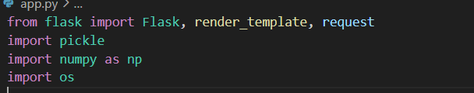
Activity 2: Read the Dataset
We can load the dataset using pandas and inspect the first few rows:
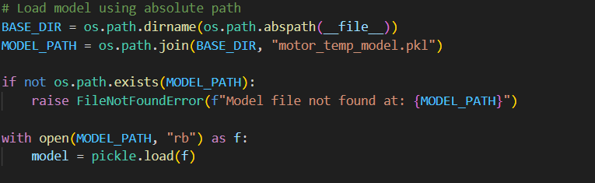

Milestone 3: Data Pre-processing
After understanding the dataset in Milestone 2, the next step is to clean and preprocess the data to make it suitable for building a machine learning model. Proper preprocessing ensures better model accuracy and avoids errors during predictions.Handling missing values.
Activity 1: Handle Missing Values and Check Data Types
Even though most sensor datasets are complete, it is important to check for any missing or invalid entries:
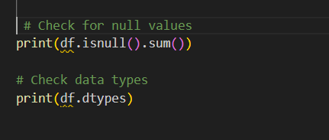
• In this dataset, all values are numeric, and there are no missing values.
• This ensures that all features can be directly fed into the regression model.

Activity 2: Feature Selection and Target Variable
We separate the dataset into input features (X) and the target variable (y):
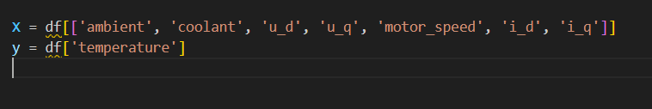
• Input Features (X): Collected from the web interface in app.py as user inputs.
• Target Variable (y): The motor temperature that the model will predict.

Activity 3: Feature Scaling
Scaling ensures that all input features are on a similar scale, which improves model training:

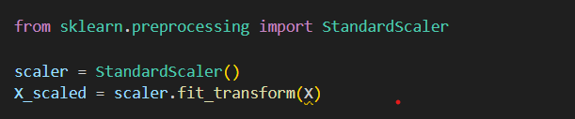

• This scaling step corresponds to the normalized features expected by your trained model in app.py.
• The same scaling method should be applied to user inputs in production if required.

Activity 4: Split Dataset into Training and Test Sets
We split the dataset to train the model and evaluate its performance:

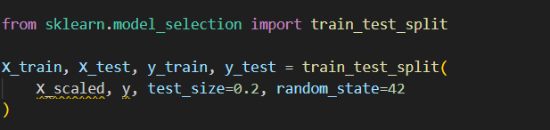

• The training set is used to fit the model.
• The test set evaluates how well the model predicts motor temperature for unseen inputs.

Activity 5: Map Pre processed Data to Flask Input
In your app.py, the pre processed data corresponds directly to the values collected from the web form:

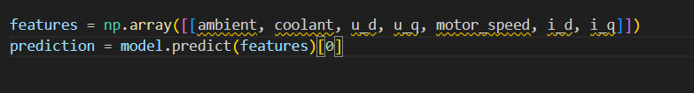

• The input array mirrors the pre processed columns of the dataset (X).
• Proper preprocessing ensures that the model handles these inputs correctly and returns an accurate prediction.

Milestone 4: Model Building

After preprocessing the dataset, the next step is to build a machine learning model that predicts motor temperature based on input features. In this project, regression models such as Random Forest Regressor, Gradient Boosting Regressor, or Linear Regression are used to learn the relationship between operational parameters and motor temperature.

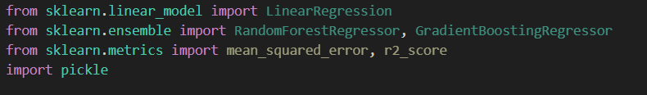

• Linear Regression: Simple model for predicting continuous values.

• Random Forest Regressor: Handles nonlinear relationships and reduces overfitting.

• Gradient Boosting Regressor: Provides higher accuracy with ensemble learning.
Activity 2: Initialize and Train the Model
Example using Random Forest Regressor:
• The model learns the relationship between Voltage, Current, Load, Motor Speed, and Temperature.
• Training is performed on the training dataset from Milestone 3.
Activity 3: Evaluate Model Performance
After training, we evaluate the model using the test set:
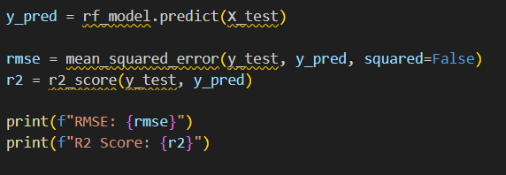
• RMSE (Root Mean Square Error): Measures prediction error.
• R² Score: Indicates how well the model explains variance in the data.
Activity 4: Save the Trained Model
Once satisfied with model performance, we save it using Pickle for later deployment in Flask:
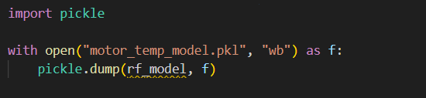
• The saved model (motor_temp_model.pkl) is loaded in app.py to make real-time predictions.
• This ensures the Flask app does not retrain the model every time it runs.
Activity 5: Map Model to Flask Input
In the Flask app:
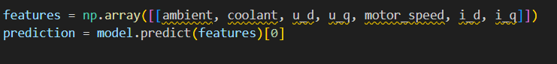
• User inputs from the web interface are directly fed to the trained model.
• The model predicts the motor temperature in real-time and returns it to the UI.
Milestone 5: Application Building (Final Code Completion Process)
After building and saving the regression model in Milestone 4, the final step is to deploy it in a web application using Flask, so users can predict motor temperature in real-time. This milestone focuses on integrating the trained model with a web interface and handling user inputs.
Activity 1: Setting Up the Flask Application
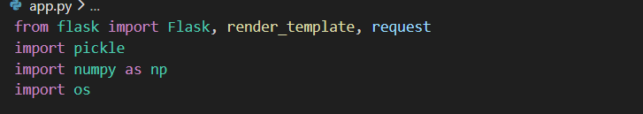
2.Initialize Flask app:
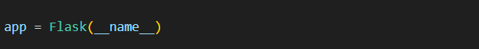
3.Load the trained model:
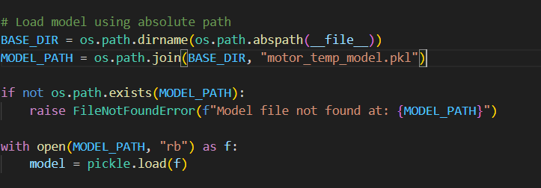
Note: Using an absolute path ensures the Flask app can always locate the model file.
• The trained model (motor_temp_model.pkl) contains the pre-trained Random Forest or regression model from Milestone 4.
Activity 2: Creating the Home Route
The home route renders the HTML form where users can input motor parameters: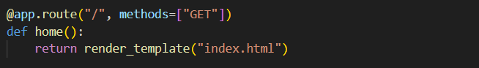
• index.html contains input fields for Ambient Temp, Coolant Temp, u_d, u_q, Motor Speed, i_d, i_q.
• The same features are required by the trained model.
Activity 3: Handling Predictions
The /predict route captures user input, validates it, predicts the motor temperature, and renders the result:
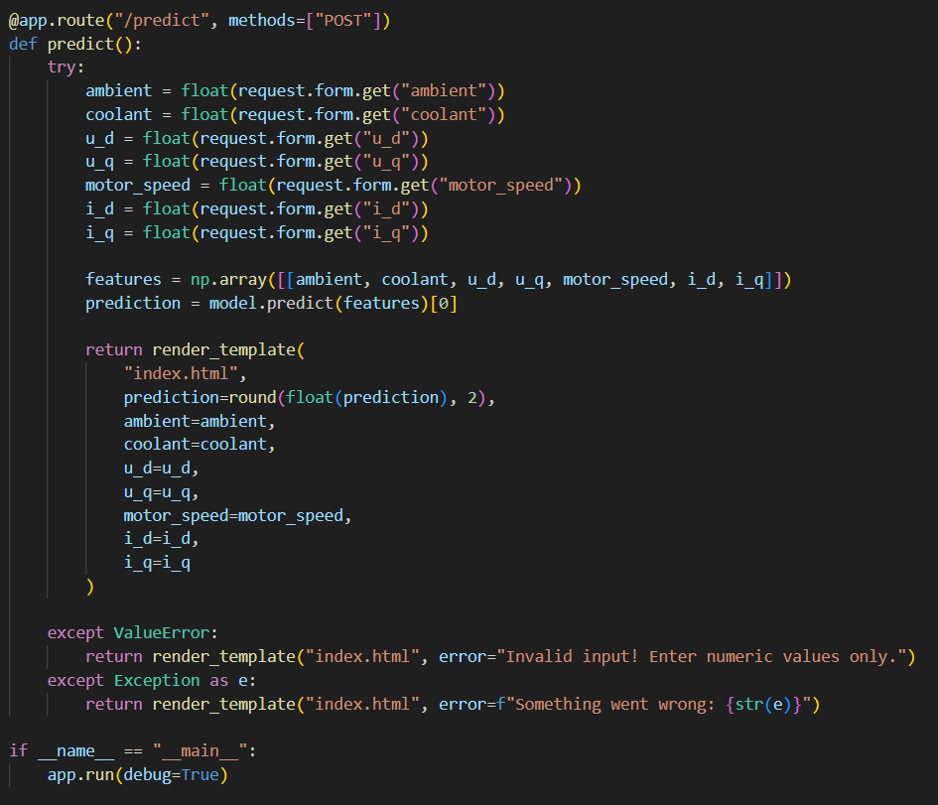
• The input array matches the preprocessed features used during model training.
• The predicted temperature is rounded to two decimal places for display.
• Input validation ensures the app handles invalid or missing inputs gracefully.
Activity 4: Running the Application
The Flask app is run in debug mode for local testing:
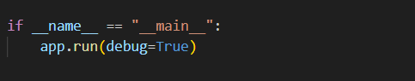
• The app starts a local web server.
• Users can open a browser, navigate to http://127.0.0.1:5000/, enter motor parameters, and get real-time temperature predictions.
SCREENSHOTS FOR RESULT:
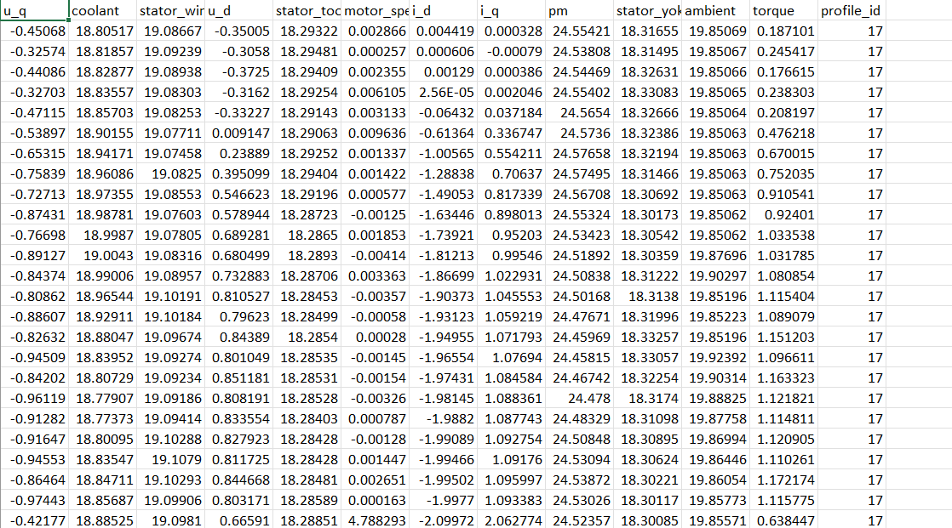

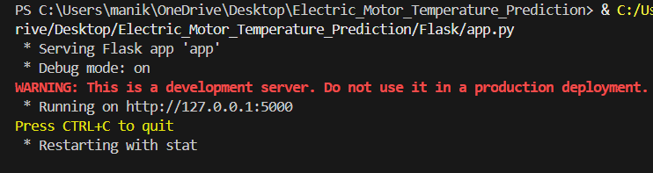
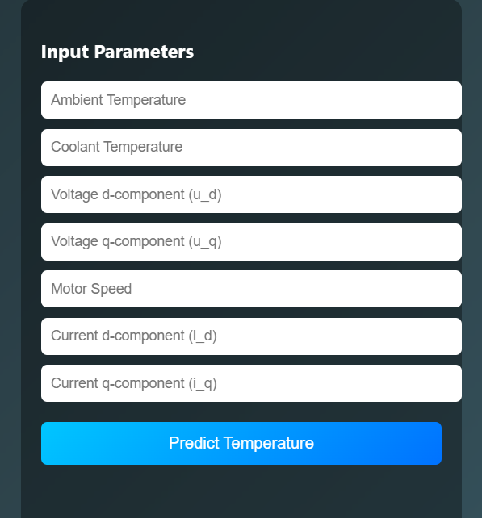
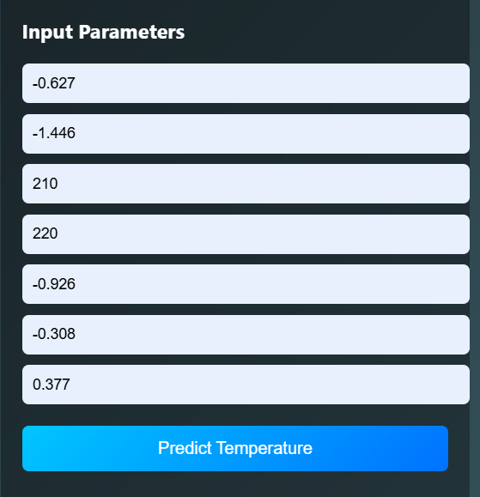
Activity 5: Run the application
- Open VS code from the start menu
- Navigate to the folder where your python script is.
- Now type “python app.py” command
- Navigate to the localhost where you can view your web page.
- Click on the predict button from top left corner, enter the inputs, click on the submit button, and see the result/prediction on the web.

