Gari Pahayo

Homework 2

Computational Methods

Question 1

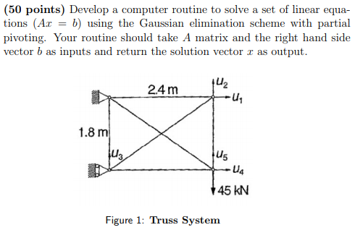

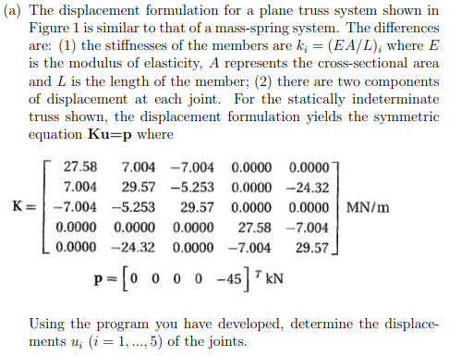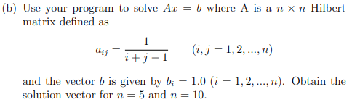

Results

Part a)

$\vec{u}= \left[\begin{matrix}1.44043701280587 \\ -6.48248565744001 \\ -0.810405015922897 \\ -1.8518167281592 \\ -7.29199105691471\end{matrix}\right] m$

Part b)

n = 5

$\vec{x}=\left[\begin{matrix}4.99999999999443 \\ -119.999999999913 \\ 629.999999999665 \\ -1119.99999999954 \\ 629.999999999788\end{matrix}\right]$

n = 10

$\vec{x}=$

$$-9.99765861488567$$

$$989.797482562022$$

$$-23755.6835643676$$

$$240200.742162159$$

$$-1261072.69524723$$

$$3783265.01075107$$

$$-6725874.97493985$$

$$7000463.3406193$$

$$-3937791.25466355$$

$$923685.713419866$$

Method

1. Rearrange the matrix so that A(k,k) from k = 1 to k=n-1 is not zero (partial pivoting)
2. Make the A matrix into an upper triangular matrix (elimination)
3. Apply back substitution.
   1. 

This applies to both parts.

Code written for the question will be given in the appendix (q1a.m and q1b.m)

Question 2

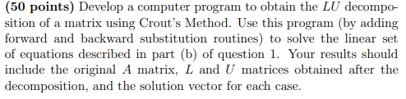

Results

n = 5

$$A= \left[\begin{matrix}1 & 0.5 & 0.333333333333333 & 0.25 & 0.2 \\ 0.5 & 0.333333333333333 & 0.25 & 0.2 & 0.1666666667 \\ 0.333333333333333 & 0.25 & 0.2 & 0.166666666666667 & 0.1428 \\ 0.25 & 0.2 & 0.166666666666667 & 0.1428 & 0.125 \\ 0.2 & 0.166666666666667 & 0.1428 & 0.125 & .11111\end{matrix}\right]$$

$$L=\left[\begin{matrix}1 & 0 & 0 & 0 & 0 \\ .5 & 0.0833333333333333 & 0 & 0 & 0 \\ .3333 & 1 & 0.00555555555555552 & 0 & 0 \\ .25 & .9 & 1.5 & 0.000357142857142872 & 0 \\ .2 & .8 & 1.7143 & 2 & 2.2676e-05\end{matrix}\right]$$

$$U= \left[\begin{matrix}1 & .5 & .3333 & .25 & .2 \\ 0 & 1 & .0833 & .075 & .0667 \\ 0 & 0 & 1 & .0083 & .0095 \\ 0 & 0 & 0 & 1 & 7.1429e-04 \\ 0 & 0 & 0 & 0 & 1\end{matrix}\right]$$

$$\vec{x}= \left[\begin{matrix} 4.99999999999443 \\ -119.999999999913 \\ 629.999999999665 \\ -1119.99999999954 \\ 629.999999999788\end{matrix}\right]$$

n =10

$A=$

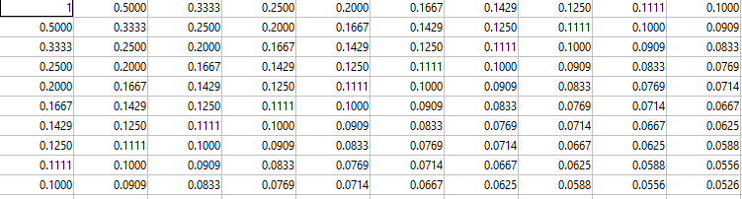 $L =$



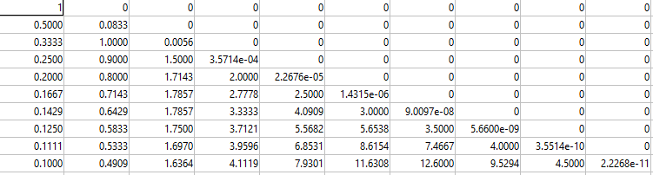



$$U=$$

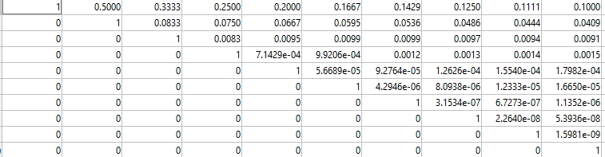



$$\vec{x}={ \left[\begin{matrix}-9.997 & 989.77 & -23755.13 & 240195.71 & -1261048.59 & 3783198.50 & -6725765.4 & 7000357.23 & -3937735.417 & 923673.408\end{matrix}\right]}^{T}$$

Method

1. Decompose A into L and U
   1. 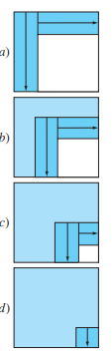
2. Forward substitute to get {D}
   1. L{D}={B}
   2. 
3. Backward substitution
   1. U{X}={D}
   2. 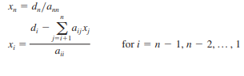

This applies to both parts.

Code written for the question will be given in the appendix (q2.m)

Appendix

%{

2/28/2020

Matthew Pahayo

file Name: q1a.m

%}

clc

clear all

close all

format longg

a = [27.58 7.004 -7.004 0 0;...

7.004 29.57 -5.253 0 -24.32;...

-7.004 -5.253 29.57 0 0;...

0 0 0 27.58 -7.004;...

30 -24.32 0 -7.004 29.57];

b = transpose([0 0 0 0 -45]);

n = length(a);

k = 1 ;

p = k ;

big = abs(a(k,k));

%\*\*\*\*\*\*\*\*\*\*\*\*\*\*\*\*\*\*\*\*\*\*\*\*\*\*\*\*\*\*\*\*\*\*\*\*\*\*\*\*\*\*\*\*\*\*\*\*\*\*\*

% pivoting portion

%\*\*\*\*\*\*\*\*\*\*\*\*\*\*\*\*\*\*\*\*\*\*\*\*\*\*\*\*\*\*\*\*\*\*\*\*\*\*\*\*\*\*\*\*\*\*\*\*\*\*\*

for ii=k+1:n

dummy = abs(a(ii,k));

if dummy > big

big = dummy;

p = ii ;

end

end

if p ~= k

for jj = k:n

dummy = a(p,jj);

a(p,jj) = a(k,jj);

a(k,jj) = dummy;

end

dummy = b(p);

b(p)=b(k);

b(k) = dummy;

end

%\*\*\*\*\*\*\*\*\*\*\*\*\*\*\*\*\*\*\*\*\*\*\*\*\*\*\*\*\*\*\*\*\*\*\*\*\*\*\*\*\*\*\*\*\*\*\*\*\*\*\*

% elimination step

%\*\*\*\*\*\*\*\*\*\*\*\*\*\*\*\*\*\*\*\*\*\*\*\*\*\*\*\*\*\*\*\*\*\*\*\*\*\*\*\*\*\*\*\*\*\*\*\*\*\*\*

for k=1:(n-1)

for i=k+1:n

factor = a(i,k)/a(k,k);

for j=k+1:n

a(i,j) = a(i,j) - factor\*a(k,j);

end

b(i) = b(i) - factor\*b(k);

end

end

%\*\*\*\*\*\*\*\*\*\*\*\*\*\*\*\*\*\*\*\*\*\*\*\*\*\*\*\*\*\*\*\*\*\*\*\*\*\*\*\*\*\*\*\*\*\*\*\*\*\*\*

% back substitution

%\*\*\*\*\*\*\*\*\*\*\*\*\*\*\*\*\*\*\*\*\*\*\*\*\*\*\*\*\*\*\*\*\*\*\*\*\*\*\*\*\*\*\*\*\*\*\*\*\*\*\*

x(n,1) = b(n)/a(n,n);

for i = n-1:-1:1

sum = b(i);

for j = i + 1:n

sum = sum - a(i,j)\*x(j,1);

end

x(i,1) = sum/a(i,i);

end

%}

%{

2/28/2020

Matthew Pahayo

file Name: q1b.m

%}

clc

clear all

close all

format longg

n = 10;

for i = 1:n

for j = 1:n

a(i,j) = 1/(i+j-1);

end

end

for i=1:n

b(i,1) = 1;

end

k = 1 ;

p = k ;

big = abs(a(k,k));

%\*\*\*\*\*\*\*\*\*\*\*\*\*\*\*\*\*\*\*\*\*\*\*\*\*\*\*\*\*\*\*\*\*\*\*\*\*\*\*\*\*\*\*\*\*\*\*\*\*\*\*

% pivoting portion

%\*\*\*\*\*\*\*\*\*\*\*\*\*\*\*\*\*\*\*\*\*\*\*\*\*\*\*\*\*\*\*\*\*\*\*\*\*\*\*\*\*\*\*\*\*\*\*\*\*\*\*

for ii=k+1:n

dummy = abs(a(ii,k));

if dummy > big

big = dummy;

p = ii ;

end

end

if p ~= k

for jj = k:n

dummy = a(p,jj);

a(p,jj) = a(k,jj);

a(k,jj) = dummy;

end

dummy = b(p);

b(p)=b(k);

b(k) = dummy;

end

%\*\*\*\*\*\*\*\*\*\*\*\*\*\*\*\*\*\*\*\*\*\*\*\*\*\*\*\*\*\*\*\*\*\*\*\*\*\*\*\*\*\*\*\*\*\*\*\*\*\*\*

% elimination step

%\*\*\*\*\*\*\*\*\*\*\*\*\*\*\*\*\*\*\*\*\*\*\*\*\*\*\*\*\*\*\*\*\*\*\*\*\*\*\*\*\*\*\*\*\*\*\*\*\*\*\*

for k=1:(n-1)

for i=k+1:n

factor = a(i,k)/a(k,k);

for j=k+1:n

a(i,j) = a(i,j) - factor\*a(k,j);

end

b(i) = b(i) - factor\*b(k);

end

end

%\*\*\*\*\*\*\*\*\*\*\*\*\*\*\*\*\*\*\*\*\*\*\*\*\*\*\*\*\*\*\*\*\*\*\*\*\*\*\*\*\*\*\*\*\*\*\*\*\*\*\*

% back substitution

%\*\*\*\*\*\*\*\*\*\*\*\*\*\*\*\*\*\*\*\*\*\*\*\*\*\*\*\*\*\*\*\*\*\*\*\*\*\*\*\*\*\*\*\*\*\*\*\*\*\*\*

x(n,1) = b(n)/a(n,n);

for i = n-1:-1:1

sum = b(i);

for j = i + 1:n

sum = sum - a(i,j)\*x(j,1);

end

x(i,1) = sum/a(i,i);

end

%}

%{

2/28/2020

Matthew Pahayo

file Name: q2.m

%}

clc

clear all

close all

format longg

n = 10;

for i = 1:n

for j = 1:n

a(i,j) = 1/(i+j-1);

end

end

A = a

for i=1:n

b(i,1) = 1;

end

%\*\*\*\*\*\*\*\*\*\*\*\*\*\*\*\*\*\*\*\*\*\*\*\*\*\*\*\*\*\*\*\*\*\*\*\*\*\*\*\*\*\*\*\*\*\*\*\*\*\*\*

% modified A

%\*\*\*\*\*\*\*\*\*\*\*\*\*\*\*\*\*\*\*\*\*\*\*\*\*\*\*\*\*\*\*\*\*\*\*\*\*\*\*\*\*\*\*\*\*\*\*\*\*\*\*

for i = 1:n

o(i) = i;

end

for k = 1:n-1

for i = 1+k:n

factor = a(o(i),k)/a(o(k),k);

a(o(i),k) = factor ;

for j = k+1:n

a(o(i),j) = a(o(i),j) - factor\*a(o(k),j);

end

end

end

%\*\*\*\*\*\*\*\*\*\*\*\*\*\*\*\*\*\*\*\*\*\*\*\*\*\*\*\*\*\*\*\*\*\*\*\*\*\*\*\*\*\*\*\*\*\*\*\*\*\*\*

% get L and U

%\*\*\*\*\*\*\*\*\*\*\*\*\*\*\*\*\*\*\*\*\*\*\*\*\*\*\*\*\*\*\*\*\*\*\*\*\*\*\*\*\*\*\*\*\*\*\*\*\*\*\*

for i = 1:n

L(i,1) = a(i,1);

U(i,i) = 1;

end

for k = 1:n

for j = k+1:n

U(k,j) = a(k,j);

end

end

for i = 1:n

for j = 1:i

L(i,j) = a(i,j);

end

end

(L)

(U)

%\*\*\*\*\*\*\*\*\*\*\*\*\*\*\*\*\*\*\*\*\*\*\*\*\*\*\*\*\*\*\*\*\*\*\*\*\*\*\*\*\*\*\*\*\*\*\*\*\*\*\*

% forward substitution

%\*\*\*\*\*\*\*\*\*\*\*\*\*\*\*\*\*\*\*\*\*\*\*\*\*\*\*\*\*\*\*\*\*\*\*\*\*\*\*\*\*\*\*\*\*\*\*\*\*\*\*

for i = 2:n

sum = b(i);

for j = 1:i-1

sum = sum - a(i,j)\*b(j);

end

b(i) = sum;

end

D = b

%\*\*\*\*\*\*\*\*\*\*\*\*\*\*\*\*\*\*\*\*\*\*\*\*\*\*\*\*\*\*\*\*\*\*\*\*\*\*\*\*\*\*\*\*\*\*\*\*\*\*\*

% back substitution

%\*\*\*\*\*\*\*\*\*\*\*\*\*\*\*\*\*\*\*\*\*\*\*\*\*\*\*\*\*\*\*\*\*\*\*\*\*\*\*\*\*\*\*\*\*\*\*\*\*\*\*

x(n,1) = b(n)/a(n,n);

for i = n-1:-1:1

sum = b(i);

for j = i + 1:n

sum = sum - a(i,j)\*x(j,1);

end

x(i,1) = sum/a(i,i);

end

x

%}