AE_5335 Project: Turbojet Component Matching

Gari M. Pahayo[1]

*Missouri University of Science and Technology, Rolla, Missouri, 65409, USA*

1. **Table of Contents**

**Introduction………………………………………………………………………………………………………… 1**

**Project Details……………………………………………………………………………………………………… 1**

**Results……………………………………………………………………………………………………………… 2**

**Methodology………………………………………………………………………………………………………. 13**

**App. A……………………………………………………………………………………………………………… 14**

**App. B……………………………………………………………………………………………………………… 18**

**App. C……………………………………………………………………………………………………………… 20**

**App. D……………………………………………………………………………………………………………… 22**

1. **Introduction**

This document is the completed project. The project will be given with the results found. A methodology section will also be given for each part. Code and other information will be given in the appendix.

1. **Project details**

**AE 5535 Assigned: March 5, 2021**   **Due: March 29, 2021**

***Project: Turbojet Engine Design/Off-Design Performance Analysis***

Consider a single-spool fixed-area turbojet missile-class engine which has compressor and turbine maps attached. The engine has a simple converging nozzle.

(i.e., station 8 is the exit of the engine). For consistency and simplicity, assume that 𝑚̇ 𝑓𝑢𝑒𝑙 << 𝑚̇ 𝑎𝑖𝑟 (i.e., f << 1). The engine “design point” values are as follows:

M0 = 0.8 Altitude = sea level (T0 = 288K, P0 = 101325 N/m2)

*C* = 15 A1 (inlet face area) = 0.00318 m2  π*b* = 1.0 η*t* = .90

M2 = 0.5 RPMdesign = 60,000 RPM Tt4 = 1500K 𝜋𝑑 = .9904

1. The flow is choked at both turbine inlet and nozzle throats. Assume fuel-air ratio is much less than 1.0 throughout all your work (including in part B and C) and use constant specific heats, etc. (γ=1.4, CP = 1004.5 J/kg-K, R = 287 J/kg-K.) The heating value of the fuel is 4.45x107 J/kg (fuel). At the design point, the compressor maintains constant axial velocity (i.e., u3 = u2) and the turbine exit velocity is 80% of the turbine entrance velocity (i.e., u5=0.8u4). Also assume that the engine is sized to mandate *full mass capture* at this ‘design point’.

Completely define the on-design engine fluid dynamics, areas. and performance. Specifically, fill out the relevant information (data table and other information) relevant to this section as given below.

1. Determine, tabulate (fill in information on the attached data table provided below for this section), and plot on the compressor map the steady-state operating line for this engine. Use a convergence requirement (between right hand side and left-hand side of the nozzle matching criteria) of at least 0.01 for all operating points.

Assume that that the flow remains choked at both *turbine* inlet and nozzle throats for the operating range of interest and that the turbine efficiency (η*t* ) is constant for the development of the operating line. Perform your analysis if the engine control system prevents compressor ratios higher than 19, shaft RPM greater than 66000 and burner exit temperatures higher than 1800K. After the operating line is developed, comment very briefly on the effect of the approximation of constant turbine efficiency by examining the turbine performance map provided and comparing the approximated turbine characteristics against the actual turbine performance map.

1. Develop the performance envelope of this engine by calculating and plotting raw engine thrust (uninstalled), turbo-machinery RPM, and engine spillage characteristics for flight Mach numbers from zero to 2.4, a full range of possible fuel throttle settings.

(ranging – as possible - from 20% of design throttle to max feasible throttle, in

increments of 20% design fuel flow rate), and three altitudes (sea level, 4500m, and 9000m). Assume in this performance analysis that the inlet (diffuser) total pressure drop is given using the following empirical inlet relationship: 𝜋𝑑 = 1 − 0.015 ∗

𝑀𝑜2. This will result in nine plots (see attached summary of required plots).

**Presentation (besides the requested data/plots):** Besides the requested data tables, information, operating line plot, and nine operating envelope plots, also include in appendices work (neatly presented) and code(s) used and methodology description, etc. I am looking for an intelligible summary of your work that is not everything you did, but provides a clear picture of what you did, how you did it.

*Note: This project will be graded based on 70% technical content, 30% presentation*.

1. **Results**

Numbering of the stations follows AIAA conventions. The face of the engine would be station 1 and the nozzle would be station 8.

**Fig. 1 Numbering Scheme**

1. **Part A**

**Table 1 Part A Data**



## Part B

**Table 2 Part B Data**



As seen in table 2, The total temperature ratio across the turbine and total pressure ratio across the turbine do not vary much. This is due to the assumption that the turbine efficiency is constant. This is indicative of the analytical method of solving fixed-area turbojets (FATs). These slight changes/nearly constant values can be seen on the turbine map (figure 3).

Figure 2 shows the operating points along the speed lines on the compressor map.

**Fig. 2 Operating Line**

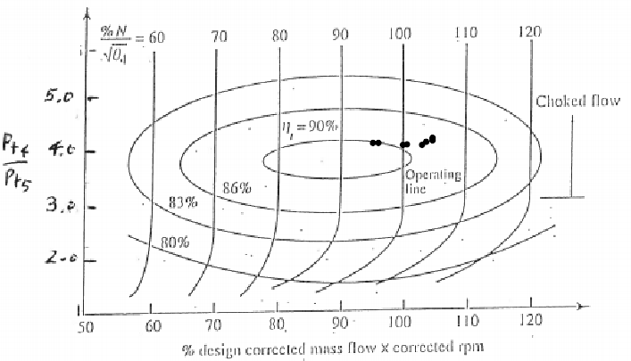

**Fig. 3 Turbine Map**

As stated above, total pressure ratio across the turbine is more or less constant.

## Part C

Part C is further broken into three sub-parts, where in each part consists of three graphs, meaning that there a total of nine graphs. Each sub-part is altitude constrained and the performance envelopes are examined. The green lines represent the speed lines given in Part B. Only the lowest and highest speed line, and speed lines between the min and max are the speed lines with values between min and max in ascending/descending order. Lines of constant fuel flow rate are marked with red, and follow the same rules as the speed lines, unless explicitly told the so. Additionally, fuel lines are incremented by 20%. (The color of the speed lines and the fuel line were deliberate, as red and green are complimentary colors and have a high contrast).

**Sea Level (0m)**

**Fig. 4 Thrust vs Flight Mach at Sea Level (0m)**

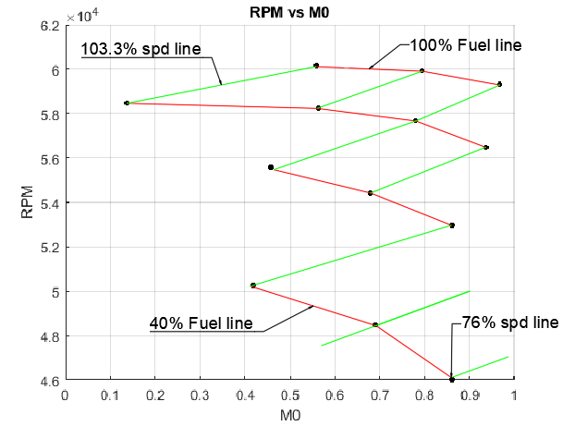

**Fig. 5 RPM vs Flight Mach at 0m**

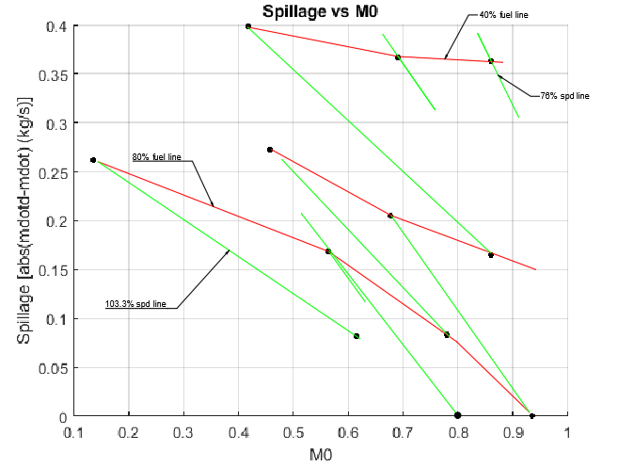

**Fig. 6 Spillage vs Flight Mach At Sea Level**

**4500 m**

**Fig. 7 Thrust vs Flight Mach at 4.5 km**

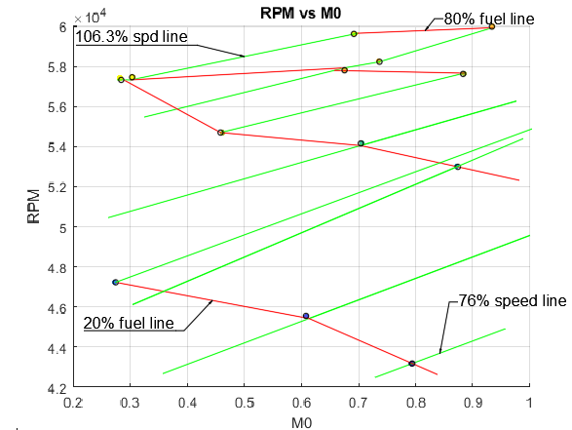

**Fig. 8 RPM vs Flight Mach at 4.5 km**

**Fig. 9 Spillage vs Flight Mach at 4.5 km**

**9000 m**

**Fig, 10 Thrust vs Flight Mach at 9 km**

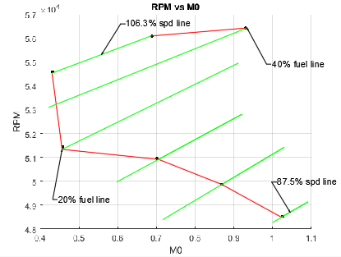

**Fig. 11 RPM vs Flight Mach at 9 km**

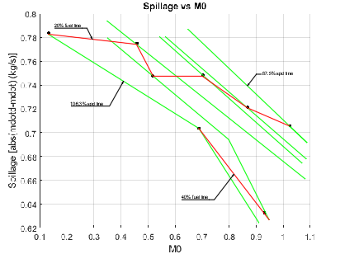

**Fig. 12 Spillage vs Flight Mach at 9 km**

1. **Methodology**

**Part A**

To get the values to part one, first chain through the engine, getting the total pressures and total temperatures at each station. The values that should now be acquired are the total pressures, total temperatures, and the corresponding ratios.

(1)

(2)

(3)

The static temperatures and pressures should now be able to find under the assumption that station 4 and 8 are chocked (Mach is 1) and with the additional velocity requirement through the compressor and the turbine; namely, velocity at the entrance of the compressor is the same as the velocity exiting the compressor and the velocity at the exit of the turbine is 80% of the velocity at the entrance of the turbine. Now velocities should also be tabulated. Finally get densities at each station to size the engine. Now performance should be able to be solved for. Use the thrust equation and fuel-air ratio definition under the assumption fuel-air ratio is much less than one. Also, see appendix A for scratch work.

**Part B**

To get the data from part 2, an iterative method must be used. First the design corrected RPM at the compressor face must be calculated. At the desired speed line, a guess for the compressor ratio is made by examining the compressor map. The total temperature across the compressor is found by using the equation 1. The corrected RPM at station 4 is calculated with equation 4. The total temperature at station 2 divided by the total temperature at station 4 is equal to the square of the quantity of the corrected RPM to the corrected RPM at station 4. Use turbine compressor balance to get the total temperature ratio across the turbine (use equation 2 and equation 3). Since the engine is chocked at station 4 and 8, corrected mass flow rate does not change. The corrected mass flow rate at station 8 over the corrected mass flow rate a station 2 must equal the right-hand side of equation 5.

(4)

(5)

A singular guess the 76% speed line is given in appendix B and code is given in appendix B (Match.m).

**Part C**

The first thing to do is to find the flight Mach number. Once the Mach number is found everything can be solved for. Values from part are used. An outline for the procedure and code (partC.m) are given in appendix C.

**Appendix A**

**A. Scratch work**

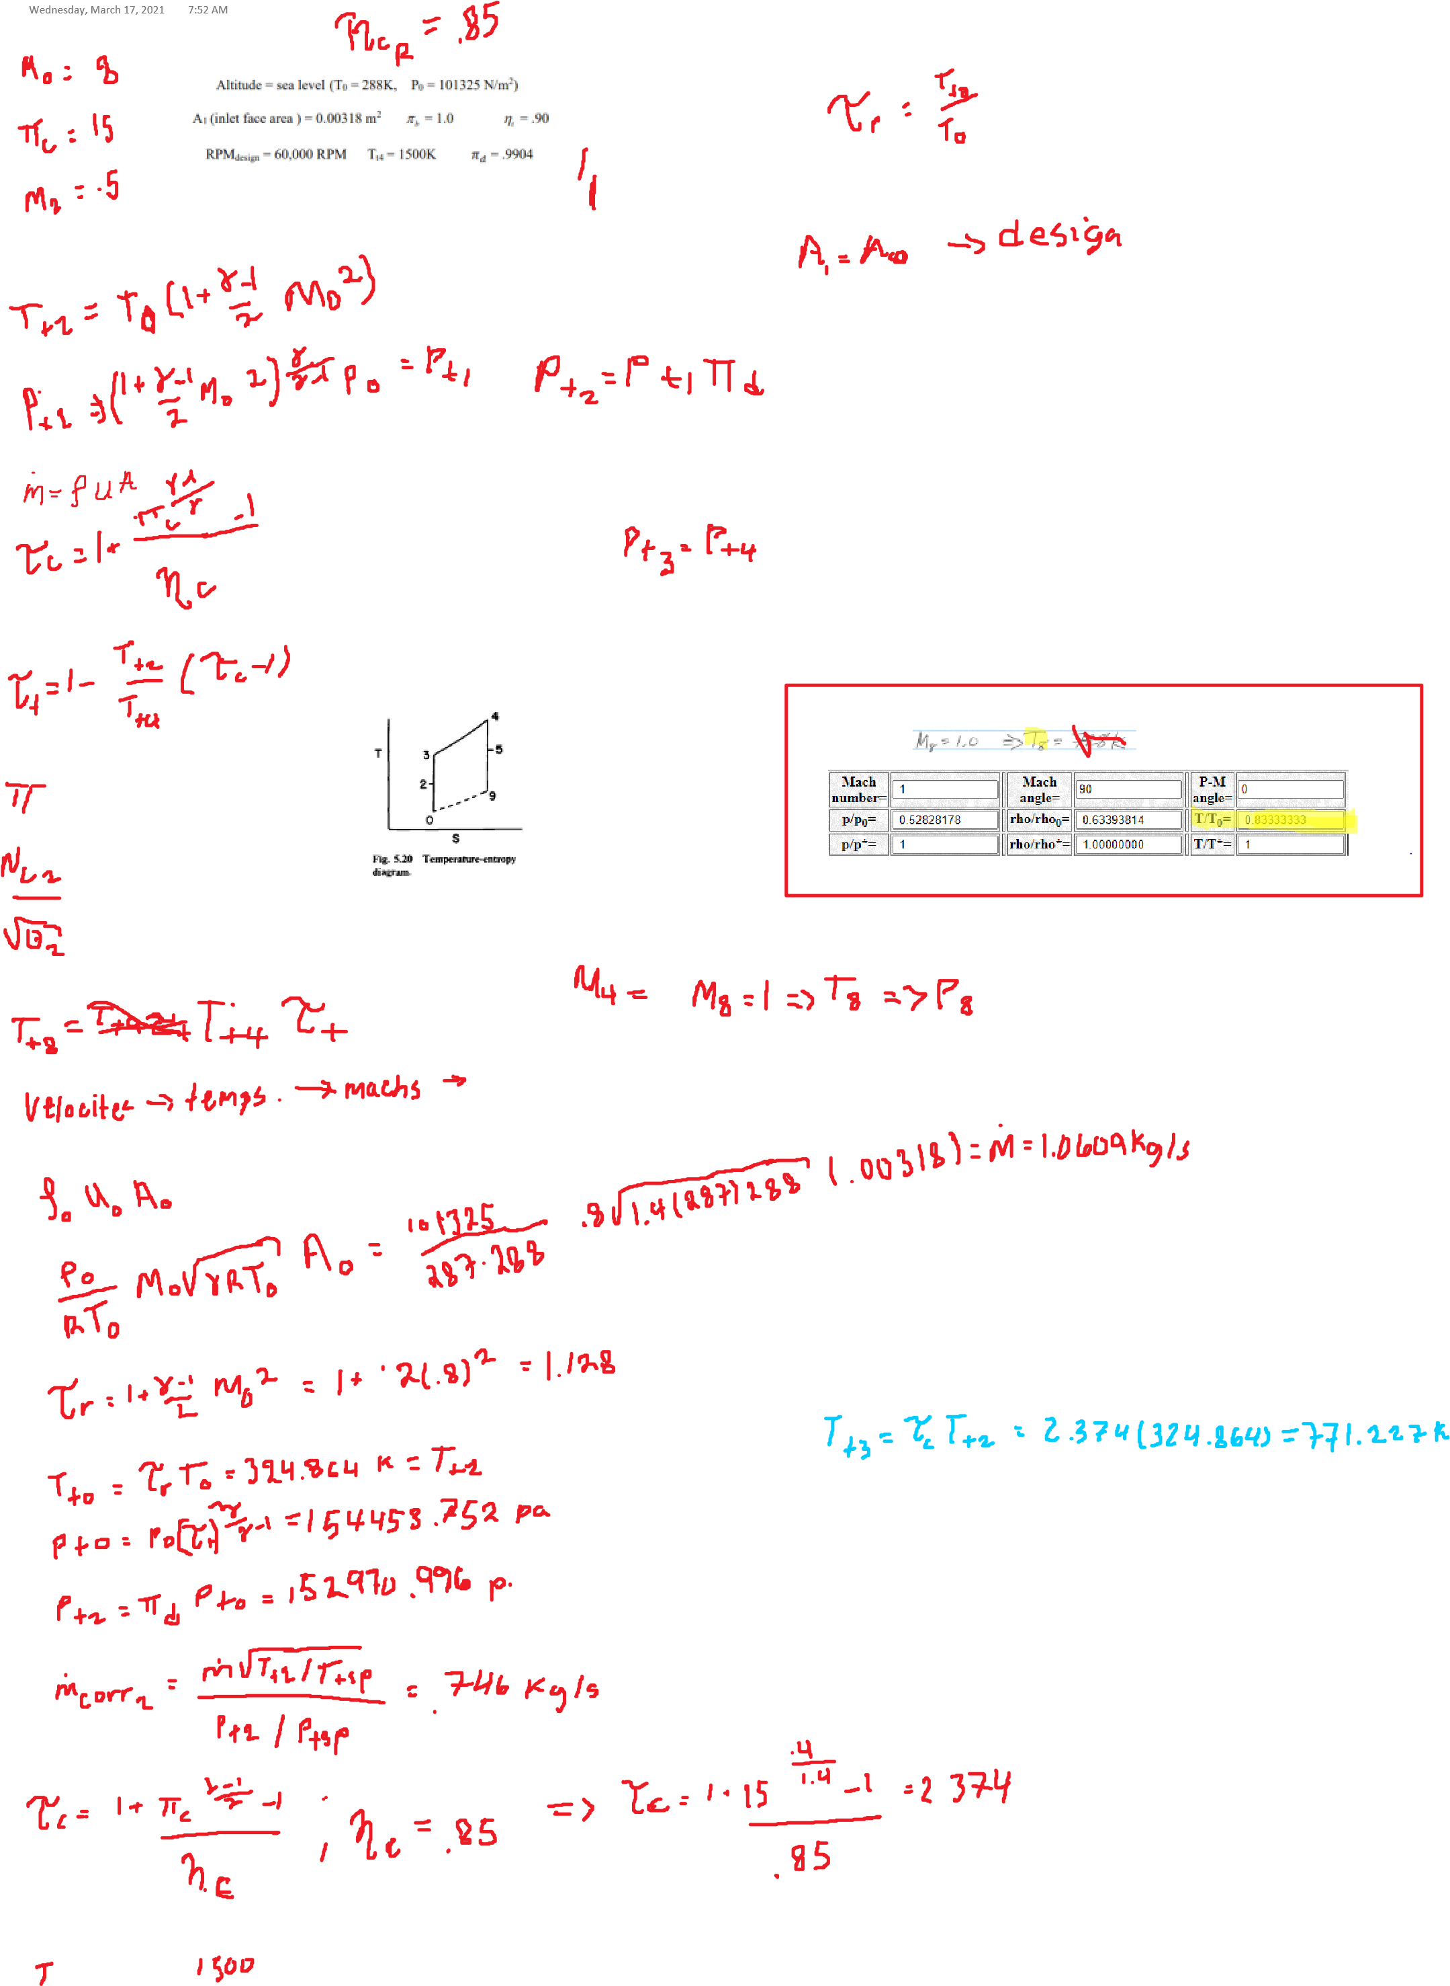

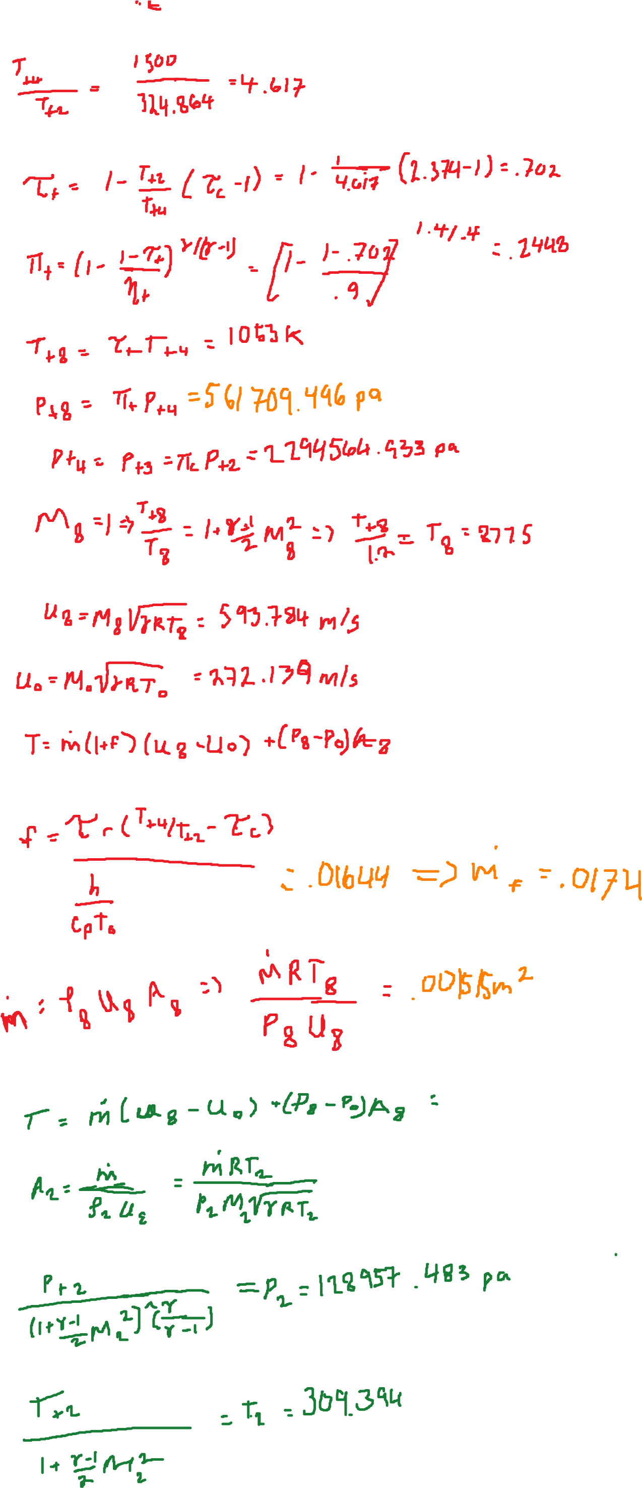

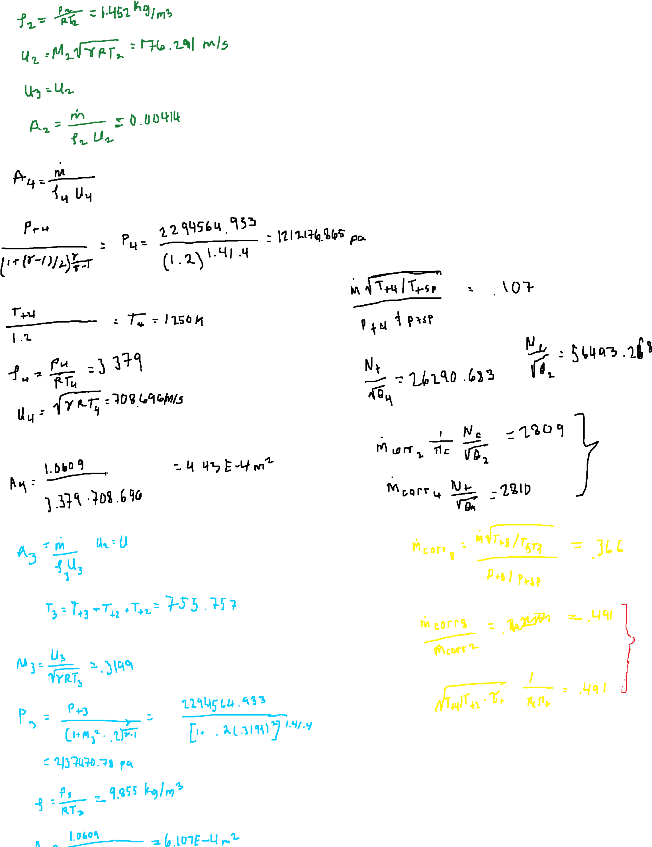

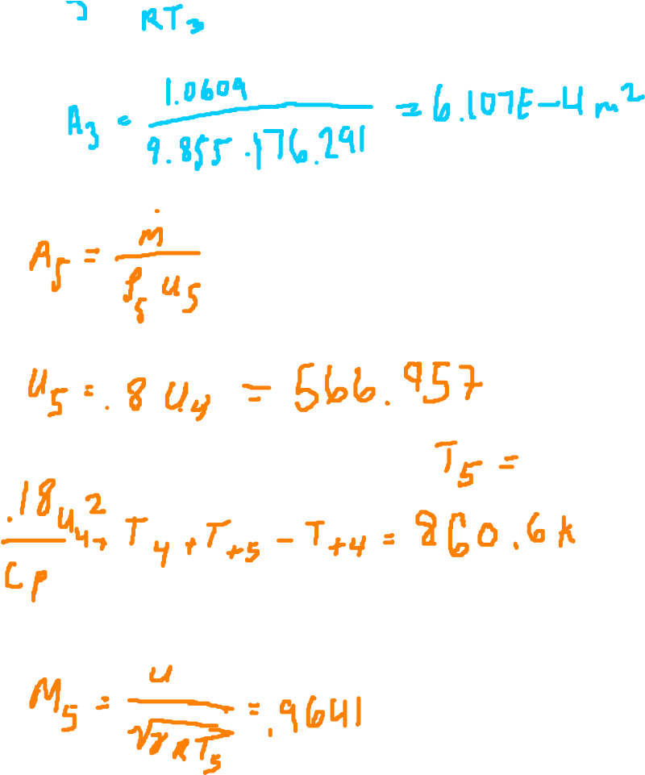

**Appendix B**

**A. Guess procedure**

PART B

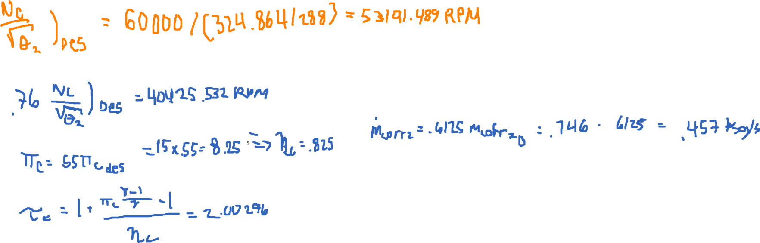Wednesday, March 24, 2021 1:29 PM

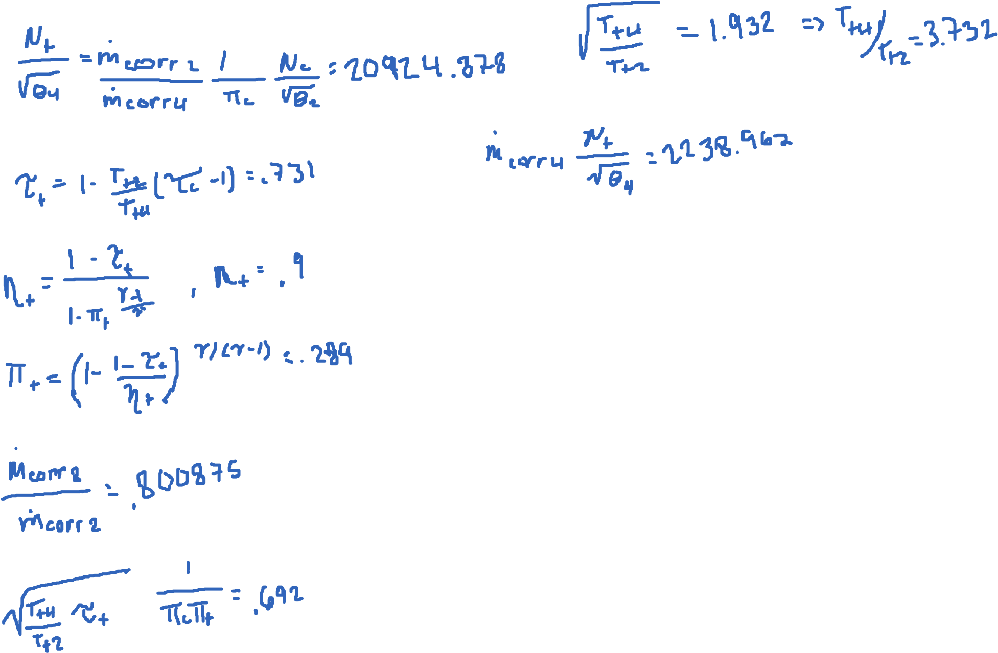

**B. code (Match.m)**

% Match.m

function [a,b,Pic,tauC,mdotcorr2,etaC,spdLine,M,tauT,Pit,G,del] = Match(ps,pp,pm,etaC)

%Match function for project 2

% will match components

gam =1.4;

mdotcorr4 = .107;

mdotcorr8 = .366;

etaT = .9;

spdLined = 56493.268;

spdLine = ps*spdLined;

Picd = 15;

Pic = pp*Picd;

mdotcorr2d = .746;

mdotcorr2 = pm*mdotcorr2d;

tauC = 1 + ((Pic^((gam-1)/gam)-1)/etaC);

M = mdotcorr2/mdotcorr4/Pic*spdLine;

G = (spdLine/M)^2;

tauT = 1-1/G*(tauC-1);

Pit = (1-(1-tauT)/etaT)^(gam/(gam-1));

a = mdotcorr8/mdotcorr2;

b = sqrt(G*tauT)/Pic/Pit;

del = abs(a-b);

end

**Appendix C**

**A. outline**

Part c

Thursday, March 25, 2021

2:48

PM

**B. Part C code**

classdef partC

% partC class

properties (Constant)

data = xlsread('part b copy.xlsx');

mdotfueld = .0174;

A8 = .1515;

h = 4.45*10^7;

gam = 1.4;

Tstp = 288;

Pstp = 101325;

cp = 1004.5;

R = 287;

RPMd = 56493.268;

mdotd = 1.0609;

end

methods (Static)

function [M0,thrust,RPM,spill,Tt4] = thrustM(P0,T0,perc,i)

syms x

f(x) = P0*(1-.015*x^2)*(1+(partC.gam-1)/2*x^2)^(partC.gam/(partC.gam-1))/partC.Pstp*...

sqrt(partC.Tstp)*partC.data(i,4)*partC.cp*...

sqrt(T0*(1+(partC.gam-1)/2*x^2))*(partC.data(i,10)-partC.data(i,3))-...

partC.mdotfueld*perc*partC.h;

M0 = newRap(f)

if M0<2.4 && M0>0

Pt2 = P0*(1-.015*M0^2)*(1+(partC.gam-1)/2*M0^2)^(partC.gam/(partC.gam-1));

Pt4 = partC.data(i,2)*Pt2;

Pt8 = Pt4*partC.data(i,9);

P8 = Pt8/(1+(partC.gam-1)/2)^(partC.gam/(partC.gam-1));

Tt2 = T0*(1+(partC.gam-1)/2*M0^2);

Tt4 = partC.data(i,10)*Tt2

Tt8 = Tt4*partC.data(i,8);

T8 = Tt8/(1+(partC.gam-1)/partC.gam);

mdot = partC.data(i,4)*Pt2/partC.Pstp/sqrt(Tt2/partC.Tstp);

u8 = sqrt(partC.gam*partC.R*T8);

u0 = M0*sqrt(partC.gam*partC.R*T0);

thrust = mdot*(u8-u0)+(P8-P0)*partC.A8;

RPM = partC.data(i,1)*partC.RPMd*sqrt(Tt2/partC.Tstp);

spill = abs(mdot-partC.mdotd);

else

thrust = 0;

RPM = 0;

spill = 0;

Tt4=0;

end

end

**Appendix D**

**A. Newton’s Method**

function x = newRap(f)

syms x

fp(x) = diff(f(x));

x=.1;

nmax=25;

eps=1;

n=0;

while eps>=1e-5&&n<=nmax

y=x-double(f(x))/double(fp(x));

eps=abs(y-x);

x=y;

n=n+1;

end

**B. main**

% matthew Pahayo

% main.m

clc

clear all

close all

format longg

% [a,b,Pic,tauC,mdotcorr2,etaC,spdLine,M,tauT,Pit,G,del] = ...

% Match(1,1,1,.85)

%

syms x

p=partC;

% % for k = 1:5

% % for i = 1:8

% % [M0,thrust,RPM,spill] = p.thrustM(30742.5,229.365,1/5*k,i)

% % sz = 15;

% % c = 20*i;

% % if M0<2.4 && M0>0

% % hold on

% % scatter(M0,thrust,sz,c,'filled')

% % hold off

% % end

% % end

% % end

% % grid on

% % xlabel('M0')

% % ylabel('Thrust (N)')

% % title('Thrust vs M0')

%

% for k = 1:5

% for i = 1:8

% [M0,thrust,RPM,spill,Tt4] = p.thrustM(57728.3,258.9,1/5*k,i)

% sz = 15;

% c = i;

% if M0<2.4 && M0>0 &&Tt4<1800 && RPM<66000

% hold on

% scatter(M0,RPM,sz,c,'filled')

% hold off

% end

% end

% end

% grid on

% xlabel('M0')

% ylabel('RPM')

% title('RPM vs M0')

%

for k = 1:5

for i = 1:8

[M0,thrust,RPM,spill,Tt4] = p.thrustM(101325,288,1/5*k,i)

sz = 15;

c = k;

if M0<2.4 && M0>0 &&Tt4<1800 && RPM<66000

hold on

scatter(M0,spill,sz,c,'filled')

hold off

end

end

end

grid on

xlabel('M0')

ylabel('Spillage [abs(mdotd-mdot) (kg/s)]')

title('Spillage vs M0')

1. Student, Aerospace Engineering, and AIAA Member Grade (if any) for first author.