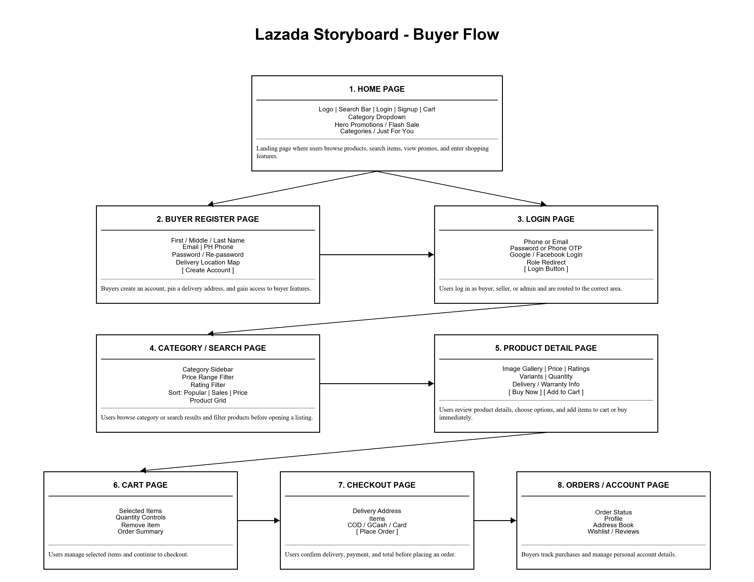
Name: Jhon Loyd D. Reyes Date: May 19, 2026
Subject: IT-IMDBSYS32 Section: BSIT-3D
