**SQL-camp for IXM Support team. Level 1. January 2019**

**“Car Parts reseller database”**

*Mentor:*

**Artem Bogomaz**

Software Development Expert, #R2. SEDO

*Students:*

**Taras Lozovskyi**

Customer Support Engineer, #R13. CSO

**Yevhen Shchyrba**

Customer Support Engineer, #R13. CSO

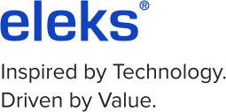**Lviv – 2019**

**Summary**

This is the specially organized SQL-camp for IXM support engineers. The basic goal is to get knowledge and understanding of Microsoft SQL-server, database deployment, and maintenance.

During 3 months students should develop a database for Car parts reseller. Make the business, logical and physical schemas of the database.

Normalize the database and organize database connections.

# Section 1. Logical schema of the database