Lecture-16:
Secure Shell (SSH) protocol for remote login over an insecure network.
SSH Stack:
SSH user authentication protocol SSH Connection Protocol
- Supports three user authentication methods:
  - Public key
  - Password
  - Host-based.
SSH Transport Layer Protocol
- encryption of user data
- server authentication
- integrity protection
- compression of data
TCP
IP
Message exchange:
- Establish TCP connection.
- Identification string exchange (protocol version and the software version of each party).
- Algorithm negotiation (that will be used to encrypt the subsequent communication).
- Key exchange
- End of key exchange: Once the key exchange is complete, both the client and server send messages confirming the end of this stage.
- Service request.
- Server response
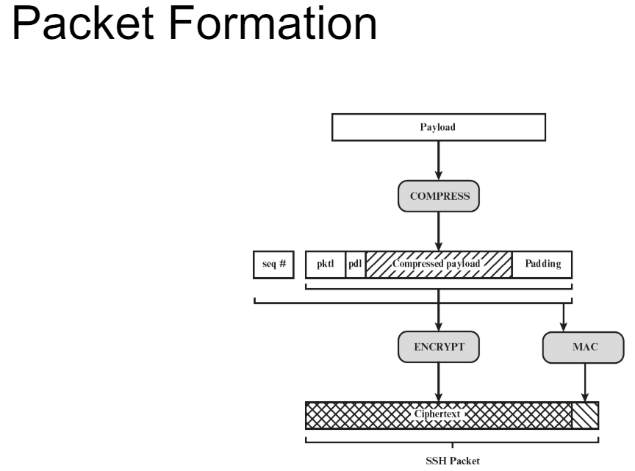
Lecture 17:
Internet Key Exchange (IKE)
  - Diffie-Hellman Key Exchange
  - Nonces
  - Public key encryption
  - Authentication using digital signatures.
Security Association (SA) is indeed a protocol or framework that specifies the parameters necessary for securing communication between two hosts or network entities.
Parameters like: (SA helps in setting these parameters)
  - Authentication algorithm and keys
  - Encryption algorithm and keys
  - Lifetime of security association
  - IPSec protocol mode (tunnel or transport)
  - Anti-replay service parameters
Two modes of ESP
Transport Mode: Original IP header remains intact.
- Simpler implementation compared to tunnel mode.
- No need to modify routing configurations.
- Original IP header remains unprotected, potentially revealing information like source and destination addresses.
Tunnel Mode: Original IP packet is encapsulated within a new IP header.
- Provides end-to-end security for the entire packet.
- Can work through NAT environments.
- More complex implementation compared to transport mode.
- Requires modifications to routing configurations on participating devices.
Replay attacks are thwarted by using sequence number integrity check value (truncated MAC).
Sequence numbers prevent the acceptance of duplicate packets, while integrity check values ensure that the content of the packets has not been altered or tampered with during transmission.
Security Policy Database (SPD): The SPD is a repository or database that contains a set of rules or policies governing how IP traffic is handled and secured.
Security Association Database (SAD): The SAD is another database that stores information about active Security Associations (SAs) established between network entities.
These 2 are used to enforce security policy in IPSec.

Lecture 18:
Vulnerabilities in Wireless Environment
  - Channel - Susceptible to eavesdropping and jamming.
  - Mobility -Wireless devices are portable and mobile.
  - Resources - Wireless devices have limited memory and resources.
  - Accessibility - Wireless devices may be left unattended.
Operation Phases
  - STA: Wireless station
Scans the available wireless networks to find nearby APs.
The AP periodically broadcasts frames to announce its presence and provide information about the network.
  - AP: Access point
The AP forwards the authentication request to the AS for verification.
  - AS: Authentication server
If the authentication is successful, the STA and AP establish cryptographic keys for securing the data transmission.
Data transmission.
  - End station: Server entity.
Evil Twin Attack
Set up a malicious AP with the same SSID as the legitimate AP.
  - Transmit with high power, Client will associate with the AP providing the strongest signal then Intercept traffic, replace data, harvest credentials, etc.
Attack - WEP Cracking
• WEP encrypts the payload of data frames using a pre-shared key (PSK) and RC4 (stream cipher) is the encryption algorithm
• Encryption key (64 bits) = IV (24 bits) (random) + PSK (40 bits)
The randomized IV values are bound to repeat at some point. Because of the birthday paradox, it is likely that after only a few thousand packets, two keys will share the same IV.
• Using existing tools, attackers can force the generation of enough IVs to crack a WEP key in minutes.
• Attackers can leverage “related-key attack” based on knowledge of some of the bits of the key.
• C1 = P1 ⊕ RC4(IV, K)
• C2 = P2 ⊕ RC4(IV, K)
• C1 ⊕ C2 = P1 ⊕ P2

Key Reinstallation Attack on WPA2???????

Lecture 19:
Bluetooth Security
  - Eavesdropping
  - Illegal device access
  - Data Manipulation
BLE Link-Layer Security Mechanism
  - Level 1: No security
  - Level 2: Encryption
  - Level 3: Encryption and authentication
  - Level 4: New encryption and authentication
Real-World: Security Level
  - Without I/O: Level 2 (no authentication)
  - With I/O: Level 3 and 4
The initial pairing process is often scrutinized for security vulnerabilities, the reconnection procedure after a Bluetooth device has been paired is an area that is overlooked.

Lecture 22:
Cloud Computing - delivery of computing services over the internet.
Massive concentration of risk - expected loss from a single breach can be significantly larger. concentration of “users” represents a concentration of threats.
Security Threats
  - Data loss or leakage
  - Account or service hijacking.
  - Insecure interfaces and APIs
  - Malicious insiders
Security Properties
  - Identity and access management
  - Software isolation
  - Data protection
  - Availability
  - Incident response
Multi-Level Security
Physical Security
  - Guarded facilities
  - Protection of your hardware and devices
  - Power redundancy
  - Facility redundancy
Network Security – Firewall, Intrusion prevention, Intrusion detection.
Transmission Security
  - Encryption and authentication
  - Transport Layer Security
  - Internet Protocol Security (IP-Sec)
Access Control
  - Distributing access to the right people
  - Training them with appropriate measures
Data Protection – Encryption, Backup and restore policy.
Lecture 23:
Malicious Software (Malware)
Some Popular Types
  - Virus - replicates itself into other benign executable code.
  - Worm - independently propagates onto other hosts.
  - Trojan - appears to be useful, but also has a hidden malicious function.
  - Bot - activated on an infected machine to launch attacks on other machines.
  - Spyware - collects information from a computer and transmits it to another system.
Virus, Worm: Phases
  - Dormant (the virus is inactive and lies dormant on the infected system or within infected files.)
  - Propagation
  - Triggering
  - Execution
Trojan types:
  - Continue original function – additional malicious activity.
  - Continue original function – modify it to perform malicious activity.
  - Perform malicious function which replaces the original function.
Bot Infected machine utilized to launch attacks on other machines
  - DDoS
  - Spamming
  - Keylogging
  - Installing malicious add-ons

Lecture 24:
Countermeasures against malware
Host-based:
Scanner: examine files and processes on individual computers. They compare file signatures or behavior against a database of known malware.
Behavior Blocking: monitor system activity in real-time and block actions that are characteristic of malware behavior.
Trusted Platform Module (TPM): that provides cryptographic functions and secure storage for encryption keys, passwords, and other sensitive data.
Perimeter:
Firewall
Intrusion Detection System (IDS): monitors network traffic for signs of suspicious activity or known attack patterns and generates alerts when potential threats are detected.
Rule/Signature – Based IDS: techniques match patterns or signatures of known malware against files or network traffic to identify and block malicious content. (maintains signature database)
Classification – Based IDS: classify network traffic or system behavior as either normal or malicious.
Anomaly Based IDS: Behavior-based analysis techniques monitor system behavior for anomalies and deviations from normal patterns.

Lecture 27:
Automated testing
Vulnerability Analysis: Automated tools can scan software code and configurations to identify potential vulnerabilities such as buffer overflows, injection flaws, insecure dependencies, and more. These tools help developers and security professionals proactively identify and address security weaknesses before they can be exploited by attackers.
Fuzzing
  - Generate (anomalous) test cases.
  - Feed the test cases.
  - Monitor for unexpected behavior, e.g., crash.
Fuzzing coverage metrics are essential for assessing the effectiveness of fuzzing techniques in exercising and testing software code.
- Function coverage
- Edge coverage (edge of a control flow graph)
- Branch coverage (branch of a control flow graph)
- Predicate coverage
Fuzzing Classification
- Mutation-based (Dumb) - Add anomalies to existing good inputs.
- Generative (Smart) - Generate inputs from specification of format.
- Evolutionary (Responsive) - Leverage program instrumentation, code analysis and use response of program to build input set.
- Coverage Guided (Efficient) - Generate inputs to cover most of the states.
Program Analysis - Analyzing program behavior to determine Security
• Static analysis - This technique involves examining the code or software without executing it.
• Dynamic analysis - Dynamic analysis involves executing the software and observing its behavior in a controlled environment.

Lecture 28:
Attestation
  - The gold hash value is the original hash computed when the software is delivered to the user by the vendor.
  - The user computes the hash at a certain time and compares it with the gold hash.
  - If the computed hash is not equal to the gold hash, it is determined that the software/application has been tampered.

Lecture 29:
Distributed Denial of Service (DDoS) attacks are malicious attempts to disrupt the normal functioning of a targeted system, network, or service by overwhelming it with a flood of traffic or requests from multiple sources.
Compromising the availability property
  - Physical Layer: jamming (attackers flood the target network with electromagnetic interference or radio signals.)
  - Link Layer: send too much traffic for switches/routers to handle.
  - TCP/UDP: require servers to maintain concurrent connections.
  - Application Layer: require servers to perform expensive operations.
DoS – Single malicious/compromised node
DDoS – Multiple compromised nodes
Typical DDoS Attack Procedure
  - Find a vulnerability.
  - Scan vulnerable hosts.
  - Malware to infect vulnerable hosts.
  - Attack network.
    - Master-slave (target knows about the slave)
    - Master-slave-reflector (target doesn’t know about slave)
SYN Flood Attack: Attacker floods the target server with a large number of SYN packets, pretending to be from legitimate IP. However, the attacker does not complete the three-way handshake (required for TCP) by sending the final ACK packet.
The target server allocates resources to keep track of each incoming SYN packet. These resources become tied up waiting for the completion of the handshake leading to DoS.
ICMP attack (Internet Control Message Protocol) attack involves the malicious use of ICMP packets to disrupt or degrade the performance of a network or a specific target system. ICMP is a fundamental protocol in the Internet Protocol Suite, primarily used for diagnostic and error reporting.
Prevention - Policy for resource consumption, Backup resources, Captcha, IP Firewall, Packet Filtering.
Lecture 30:
A firewall acts as a barrier between a local network and the internet, controlling the incoming and outgoing network traffic.
- single point
- easy to manage and audit.
- IPSec (firewall is equipped with IPSec, it means that the firewall has the capability to apply IPSec protocols to secure the packets passing through it.)
- VPN
Firewall Policies - Address ranges, Protocols, Applications, Content types.
Packet Filtering Firewall - makes decisions based on pre-defined rules. (Stateless)
Stateful Inspection Firewall - monitors the state of active connections and makes decisions.
Proxy Firewall - provide deep packet inspection and have a high degree of awareness of the application-layer protocols being used
Circuit-Level Firewall - verify whether the connection setup is legitimate.
circuit-level firewalls focus on controlling connections between network endpoints.

Lecture 31:
Building Blocks of Block Chain
  - Digital Signature – RSA based and ECC based.
  - Merkel Tree - The hash of each transaction is computed, and multiple hashes are combined in a Merkel tree structure.
  - Hash Chain - Hash value included in each block has Root of Merkel tree, Time stamp, Nonce, Hash of previous block.
Constraints on Hash Value - Hn < H0
  - Consensus Algorithm
Multiple chains can be generated due to the distributed nature of blockchain. These chains must be merged to have one agreed-upon blockchain.

Lecture 32:
Privacy-Preserving Authentication
• Pseudonym-based signatures
- Large number of pseudo identities (pseudonyms)
- For each pseudonym, there is a unique public-private key pair.
- Change the pseudonym, the public key and the private key for different messages after a certain duration.
• Group signatures
Group manager
  - Generate the group (private and public) keys.
  - Generate secret key of the signer.
  - Publish revocation list (if any)
Signer - Generate an anonymous signature
Verifier
  - Check the authenticity of the signature using the group public key.
  - Check the revocation status of the signer using the revocation list.

