TCSS 445 - Database Systems Design
Assignment 2 - eMath4ASEA Conceptual Design
Winter 2008
Team 03

Yong Shin, Software Engineer C
Parent/Student User View

Feb 15, 2008
Parent/Student User View
Step 1.1 Identify entity types
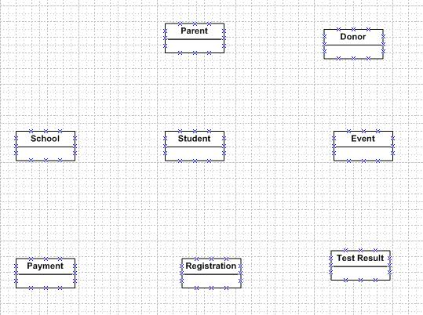
Step 1.2 Identify relationship types
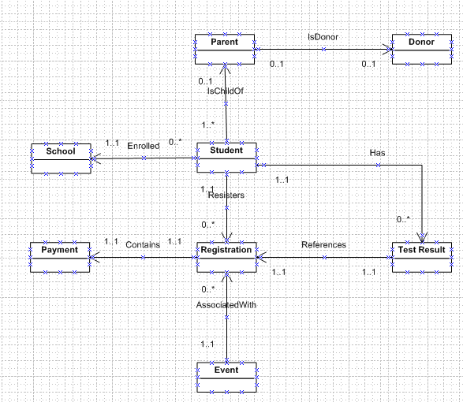
Step 1.3 Identify and associate attributes with entity or relationship types
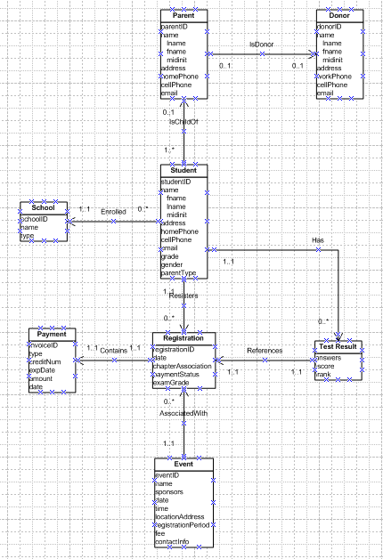
Step 1.4 Determine attribute domains
No changes from previous screenshot.
Step 1.5 Determine candidate, primary and alternate key attributes.
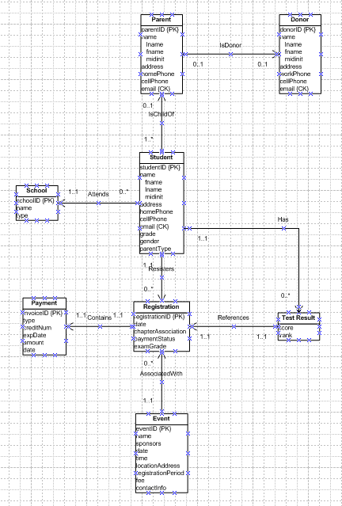
Step 1.6 Consider use of enhance modeling concepts (optional step)
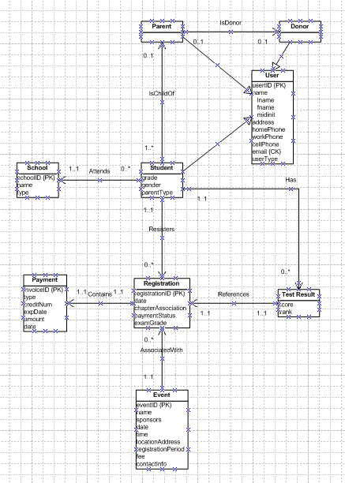
Step 1.7 Check model for redundancy
No changes from previous screenshot.
Step 1.8 Validate conceptual model against user transactions.
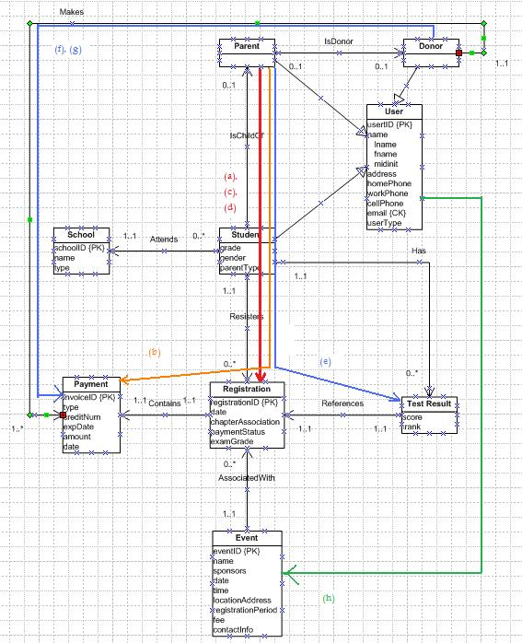

a) Parent/Student enter registration details.
b) Parent/Student enter their payment information
c) Parent/Student query registration status.
d) Parent/Student update registration information
e) Parent/Student generate a report on their score at an event
f) Donor enters payment information
g) Donor queries their donation status
h) User queries events open for registration

Step 1.9 Review conceptual data model with user.
No changes from previous screenshot.

