TCSS 445 - Database Systems Design
Assignment 1 - Internetworking and Interprocess Communication
Winter 2008
Team 03

Eric Smyth, Software Engineer A
Brian Fish, Software Engineer B
Yong Shin, Software Engineer C

Jan 23, 2008

Table of Contents
SE A- Individual Report 4
Step 2.1 4
Step 2.2 7
2. 1NF relational schema 8
3. 1NF relations 9
4. 2NF relational schema 11
5. 2NF relations 12
6. 3NF relational schema 14
7. 3NF relations 15
8. A logical database model diagram for the 3rd normalized relations 17
9. The data dictionary for the 3rd normalized relations 18
Step 2.3 21
Step 2.4 23
Step 2.5 24
SE B- Individual Report 25
2.1 Local relational schema 25
2.2 Dependency diagram 28
2.2.ii 1NF relational schema 30
2.2.iii 1NF relations 31
2.2.iv 2NF relational schema 33
2.2.v 2NF relations 34
2.2.vi 3NF relational schema 36
2.2.vii 3NF relations 37
2.2.viii logical database model 39
Step 2.3 Transaction pathways 42
2.4 44
2.5 45
SE C- Individual Report 46
Step 2.1 46
Step 2.2 49
2. 1NF relational schema 51
3. 1NF relations 52
4. 2NF relational schema 54
5. 2NF relations 55
6. 3NF relational schema 57
7. 3NF relations 58
8. A logical database model diagram for the 3rd normalized relations 60
9. The data dictionary for the 3rd normalized relations 61
Step 2.3 65
Step 2.4 66
Step 2.5 70
2.6 Combined Team steps: 71
2.6.1 Each team merges logical data models into a global model 71
A comparison of the names of relations and their candidate keys in all user views . 71
A comparison of the foreign keys in all user views 72
Global Relational Schema 73
Global Database Model Diagram 75
Description of Entities 76
Description of Relationships 78
Description of Attributes 79
2.6.2. Each team validates the global logical model. 83
2.6.3. Each team reviews the global logical model with users. 84
2.7. Each team checks the global logical model for future growth. 85

SE A- Individual Report

Step 2.1

Administrator View:

1. Local relational schema

Student (studentID, name, fName, lName, mi, schoolGrade, chapter)
Primary Key studentID

Registration (registrationID, paymentStatus, paymentMethod, date)
Primary Key registrationID

Event (eventID, name, sponsor, date, time, fee, address, city, street, state, zip, registrationStart, registrationEnd, contact)
Primary Key eventID

Administrator(adminID, name, fName, lName, mi, address, street, city, state, zip, telNo, email, company)
Primary Key adminID

Volunteer(email, name, fName, lName, mi, address, street, city, state, zip, workPhone, homePhone, willVolAgain, occupation)
Primary Key email

ExamResult(examID, score, answers, n1, n2, n3, g1, g2, g3)
Primary Key examID

2. Unnormalized local relations

Student
studentID | Name | fName | lName | Mi | schoolGrade | chapter
00001 | John A Smith | John | Smith | A | 5 | PNW
00002 | Frank B Samson | Frank | Samson | B | 6 | PNW
00003 | Tom C King | Tom | King | C | 7 | PNW
00004 | Lisa D Johnson | Lisa | Johnson | D | 8 | SoCal
00005 | Tina E McAdam | Tina | McAdam | E | 9 | NorCal
00006 | Kate F Calvary | Kate | Calvary | F | 10 | PNW
00007 | Joe G Smyth | Joe | Smyth | G | 11 | SoCal
00008 | Peter H Fish | Peter | Fish | H | 9 | SoCal
00009 | Sarah I Peterson | Sarah | Peterson | I | 6 | PNW
00010 | George J Allyne | George | Allyne | J | 11 | NorCal

VolunteerRegistration
registrationID | paymentStatus | paymentMethod | date
00001 | Pending | Credit Card | 02/10/2007
00002 | Delinquent | Credit Card | 03/12/2007
00003 | Paid | Credit Card | 06/21/2007

Event
eventID | name | sponsors | date | time | fee | address | street | city | state | zip | registrationStart | registrationEnd | contact
0001 | 5th ASEA National Mathematics Competition | Intel | 4/21/06 | 08:00 | 35 | Bldg 33 16070 NE 36th Way, Redmond WA 98052 | Bldg 33 16070 NE 36th Way | Redmond | WA | 98052 | 1/1/06 | 4/14/06 | John Doyle
0002 | 6th ASEA National Mathematics Competition | Microsoft | 4/21/07 | 09:00 | 35 | Bldg 33 16070 NE 36th Way, Redmond WA 98052 | Bldg 33 16070 NE 36th Way | Redmond | WA | 98052 | 1/1/07 | 4/14/07 | Sam Houston

Administrator
adminID | name | fName | lName | mi | address | street | city | state | zip | telNo | email | company
0001 | John A Doyle | John | Doyle | A | 123 Fake St, Tacoma, WA 98402 | 123 Fake St | Tacoma | WA | 98402 | 1235557890 | j.a.doyle@ausa.org | AUSA
0002 | Sam E Houston | Sam | Houston | E | 321 Real St Bellevue WA 98008 | 321 Real St | Bellevue | WA | 98008 | 3215550987 | s.e.houston@ausa.org | Intel

Volunteer
email | name | fName | lName | mi | address | street | city | state | zip | workPhone | homePhone | willVolAgain | occupation
0001 | Frank L Wright | Frank | Wright | L | 444 A Lane, Parkland, WA 98444 | 444 A Lane | Parkland | WA | 98444 | 2315551234 | 1235541234 | T | Architect
0002 | John E Hoover | John | Hoover | E | 84371 Super Drive, Seattle, WA 98101 | 84371 Super Drive | Seattle | WA | 98101 | 3125552341 | 3215541231 | F | Painter

ExamResult
examID | score | Answers | n1 | n2 | n3 | g1 | g2 | g3
00001 | 97 | a,b,c,d,a,b,d,e,a,c,b,d,e,a,c,d,d,e,b,c,d,a,e,d,a,d,c,e,d,b | 10 | 10 | 9 | 29 | 19 | 9
00002 | 73 | a,b,d,d,a,b,d,e,a,b,b,d,e,a,c,d,d,e,b,e,d,a,a,d,a,a,c,e,d,e | 8 | 9 | 5 | 22 | 14 | 5

Step 2.2

Student/Parent View:

1. Dependency diagram

Student

studentID | name | fName | lName | mi | schoolGrade | chapter

Registration

registrationID | paymentStatus | paymentMethod | date

Event

eventID | name | sponsor | date | time | fee | address | city | street | state | zip | registrationStart | registrationEnd | contact

Administrator

adminID | name | fName | lName | mi | address | street | city | state | zip | telNo | email | company

Volunteer

email | name | fName | lName | mi | address | street | city | state | zip | workPhone | homePhone | willVolAgain | occupation

ExamResult

examID | score | Answers | n1 | n2 | n3 | g1 | g2 | g3

2. 1NF relational schema

Student (studentID, name, fName, lName, mi, schoolGrade, chapter)
Primary Key studentID

Registration (registrationID, paymentStatus, paymentMethod, date)
Primary Key registrationID

Event (eventID, name, sponsor, date, time, fee, address, city, street, state, zip, registrationStart, registrationEnd, contact)
Primary Key eventID

Administrator(adminID, name, fName, lName, mi, address, street, city, state, zip, telNo, email, company)
Primary Key adminID

Volunteer(email, name, fName, lName, mi, address, street, city, state, zip, workPhone, homePhone, willVolAgain, occupation)
Primary Key email

ExamResult(examID, score, answers, n1, n2, n3, g1, g2, g3)
Primary Key examID

3. 1NF relations

Student
studentID | Name | fName | lName | Mi | schoolGrade | chapter
00001 | John A Smith | John | Smith | A | 5 | PNW
00002 | Frank B Samson | Frank | Samson | B | 6 | PNW
00003 | Tom C King | Tom | King | C | 7 | PNW
00004 | Lisa D Johnson | Lisa | Johnson | D | 8 | SoCal
00005 | Tina E McAdam | Tina | McAdam | E | 9 | NorCal
00006 | Kate F Calvary | Kate | Calvary | F | 10 | PNW
00007 | Joe G Smyth | Joe | Smyth | G | 11 | SoCal
00008 | Peter H Fish | Peter | Fish | H | 9 | SoCal
00009 | Sarah I Peterson | Sarah | Peterson | I | 6 | PNW
00010 | George J Allyne | George | Allyne | J | 11 | NorCal

VolunteerRegistration
registrationID | paymentStatus | paymentMethod | date
00001 | Pending | Credit Card | 02/10/2007
00002 | Delinquent | Credit Card | 03/12/2007
00003 | Paid | Credit Card | 06/21/2007

Event
eventID | name | sponsors | date | time | fee | address | street | city | state | zip | registrationStart | registrationEnd | contact
0001 | 5th ASEA National Mathematics Competition | Intel | 4/21/06 | 08:00 | 35 | Bldg 33 16070 NE 36th Way, Redmond WA 98052 | Bldg 33 16070 NE 36th Way | Redmond | WA | 98052 | 1/1/06 | 4/14/06 | John Doyle
0002 | 6th ASEA National Mathematics Competition | Microsoft | 4/21/07 | 09:00 | 35 | Bldg 33 16070 NE 36th Way, Redmond WA 98052 | Bldg 33 16070 NE 36th Way | Redmond | WA | 98052 | 1/1/07 | 4/14/07 | Sam Houston

Administrator
adminID | name | fName | lName | mi | address | street | city | state | zip | telNo | email | company
0001 | John A Doyle | John | Doyle | A | 123 Fake St, Tacoma, WA 98402 | 123 Fake St | Tacoma | WA | 98402 | 1235557890 | j.a.doyle@ausa.org | AUSA
0002 | Sam E Houston | Sam | Houston | E | 321 Real St Bellevue WA 98008 | 321 Real St | Bellevue | WA | 98008 | 3215550987 | s.e.houston@ausa.org | Intel

Volunteer
email | name | fName | lName | mi | address | street | city | state | zip | workPhone | homePhone | willVolAgain | occupation
0001 | Frank L Wright | Frank | Wright | L | 444 A Lane, Parkland, WA 98444 | 444 A Lane | Parkland | WA | 98444 | 2315551234 | 1235541234 | T | Architect
0002 | John E Hoover | John | Hoover | E | 84371 Super Drive, Seattle, WA 98101 | 84371 Super Drive | Seattle | WA | 98101 | 3125552341 | 3215541231 | F | Painter

4. 2NF relational schema

Student (studentID, fName, lName, mi, schoolGrade, chapter)
Primary Key studentID

StudentRegistration (eventID, studentID, paymentStatus, paymentMethod, date)
Partial Primary Key eventID
Partial Primary Key studentID
Foreign Key eventID references Event(eventID) ON UPDATE CASCADE ON DELETE CASCADE
Foreign Key userID references Student(studentID) ON UPDATE CASCADE ON DELETE CASCADE

VolunteerRegistration (eventID, volID, paymentStatus, paymentMethod, date)
Partial Primary Key eventID
Partial Primary Key volID
Foreign Key eventID references Event(eventID) ON UPDATE CASCADE ON DELETE CASCADE
Foreign Key volID references Volunteer(volID) ON UPDATE CASCADE ON DELETE CASCADE

Event (eventID, name, date, time, fee, registrationStart, registrationEnd, addressNo, adminId)
Primary Key eventID
Foreign Key addressNo references Address(addressNo) ON UPDATE CASCADE ON DELETE SET NULL
Foreign Key adminID references Administrator(adminID) ON UPDATE CASCADE ON DELETE SET NULL

Administrator(adminID, fName, lName, mi, telNo, email, company, addressNo)
Primary Key adminID
Foreign Key addressNo references Address(addressNo) ON UPDATE CASCADE ON DELETE SET NULL

Volunteer(volID, fName, lName, mi, workPhone, homePhone, willVolAgain, occupation, addressNo, adminID)
Primary Key volID
Foreign Key addressNo references Address(addressNo) ON UPDATE CASCADE ON DELETE SET NULL
Foreign Key adminID references Administrator(adminID) ON UPDATE CASCADE ON DELETE SET NULL

Address(addressNo, street, city, state, zip)
Primary Key addressNo

Sponsor(sponsorID, name, eventID)
Primary Key sponsorID
Foreign Key eventID references Event(eventID) ON UPDATE CASCADE ON SET DELETE NULL

ExamResult(testNo, eventID, studentID, score, n1, n2, n3, g1, g2, g3)
Primary Key testNo
Foreign Key eventID references Event(eventID) ON UPDATE CASCADE ON DELETE CASCADE
Foreign Key studentID references Student(studentID) ON UPDATE CASCADE ON DELETE CASCADE

Answer(questionNo, section, answer, correctAnswer, testNo)
Primary Key questionNo
Foreign Key testNo references ExamResult(testNo) ON UPDATE CASCADE ON DELETE CASCADE

5. 2NF relations

Student
studentID | fName | lName | Mi | schoolGrade | chapter
00001 | John | Smith | A | 5 | PNW
00002 | Frank | Samson | B | 6 | PNW
00003 | Tom | King | C | 7 | PNW
00004 | Lisa | Johnson | D | 8 | SoCal
00005 | Tina | McAdam | E | 9 | NorCal
00006 | Kate | Calvary | F | 10 | PNW
00007 | Joe | Smyth | G | 11 | SoCal
00008 | Peter | Fish | H | 9 | SoCal
00009 | Sarah | Peterson | I | 6 | PNW
00010 | George | Allyne | J | 11 | NorCal

StudentRegistration
eventID | studentID | paymentStatus | paymentMethod | date
00001 | 000001 | Pending | Credit Card | 02/12/2007
00002 | 000003 | Delinquent | Credit Card | 03/22/2007
00005 | 000010 | Pending | Credit Card | 06/01/2007
00007 | 000009 | Paid | Credit Card | 08/29/2007
00009 | 000006 | Paid | Credit Card | 09/23/2007
00010 | 000004 | Paid | Credit Card | 11/03/2007

VolunteerRegistration (eventID, volID, paymentStatus, paymentMethod, date)
eventID | volID | paymentStatus | paymentMethod | date
00001 | 000001 | Pending | Credit Card | 02/10/2007
00002 | 000003 | Delinquent | Credit Card | 03/12/2007
00005 | 000010 | Paid | Credit Card | 06/21/2007

Address
addressNo | Street | City | State | Zip
00001 | Bldg 33 16070 NE 36th Way | Redmond | WA | 98052
00002 | 123 Fake St | Tacoma | WA | 98402
00003 | 321 Real St | Bellevue | WA | 98008
00004 | 444 A Lane | Parkland | WA | 98444
00005 | 84371 Super Drive | Seattle | WA | 98101

Event
id | name | date | time | registrationStart | registrationEnd | fee | addressNo | adminID
0001 | 5th ASEA National Mathematics Competition | 4/21/06 | 08:00 | 1/1/06 | 4/14/06 | 35 | 00001 | 00001
0002 | 6th ASEA National Mathematics Competition | 4/21/07 | 09:00 | 1/1/07 | 4/14/07 | 35 | 00001 | 00002

Administrator
adminID | fName | lName | mi | telNo | email | company | addressNo
0001 | John | Doyle | A | 1235557890 | j.a.doyle@ausa.org | AUSA | 00002
0002 | Sam | Houston | E | 3215550987 | s.e.houston@ausa.org | Intel | 00003

Volunteer
volID | fName | lName | mi | workPhone | homePhone | willVolAgain | occupation | addressNo | adminID
0001 | Frank | Wright | L | 2315551234 | 1235541234 | T | Architect | 00004 | 0001
0002 | John | Hoover | E | 3125552341 | 3215541231 | F | Painter | 00005 | 0001

Sponsor
sponsorID | name | eventID
0001 | Real Networks | 0001
0002 | Amazon | 0002

ExamResult
testNo | eventID | studentID | score | n1 | n2 | n3 | g1 | g2 | g3
00001 | 0001 | 000001 | 97 | 10 | 10 | 9 | 29 | 19 | 9
00002 | 0002 | 000003 | 73 | 8 | 9 | 5 | 22 | 14 | 5

Answer
questionNo | section | answer | correctAnswer | testNo
01 | n1 | a | a | 00001
02 | n1 | c | c | 00001
03 | n1 | e | e | 00001

6. 3NF relational schema

Student (studentID, fName, lName, mi, schoolGrade, chapter)
Primary Key studentID

StudentRegistration (eventID, studentID, paymentStatus, paymentMethod, date)
Partial Primary Key eventID
Partial Primary Key studentID
Foreign Key eventID references Event(eventID) ON UPDATE CASCADE ON DELETE CASCADE
Foreign Key userID references Student(studentID) ON UPDATE CASCADE ON DELETE CASCADE

VolunteerRegistration (eventID, volID, paymentStatus, paymentMethod, date)
Partial Primary Key eventID
Partial Primary Key volID
Foreign Key eventID references Event(eventID) ON UPDATE CASCADE ON DELETE CASCADE
Foreign Key volID references Volunteer(volID) ON UPDATE CASCADE ON DELETE CASCADE

Event (eventID, name, date, time, fee, registrationStart, registrationEnd, addressNo, adminId)
Primary Key eventID
Foreign Key addressNo references Address(addressNo) ON UPDATE CASCADE ON DELETE SET NULL
Foreign Key adminID references Administrator(adminID) ON UPDATE CASCADE ON DELETE SET NULL

Administrator(adminID, fName, lName, mi, telNo, email, company, addressNo)
Primary Key adminID
Foreign Key addressNo references Address(addressNo) ON UPDATE CASCADE ON DELETE SET NULL

Volunteer(volID, fName, lName, mi, workPhone, homePhone, willVolAgain, occupation, addressNo, adminID)
Primary Key volID
Foreign Key addressNo references Address(addressNo) ON UPDATE CASCADE ON DELETE SET NULL
Foreign Key adminID references Administrator(adminID) ON UPDATE CASCADE ON DELETE SET NULL

Address(addressNo, street, city, state, zip)
Primary Key addressNo

Sponsor(sponsorID, name, eventID)
Primary Key sponsorID
Foreign Key eventID references Event(eventID) ON UPDATE CASCADE ON SET DELETE NULL

ExamResult(testNo, eventID, studentID, score, n1, n2, n3, g1, g2, g3)
Primary Key testNo
Foreign Key eventID references Event(eventID) ON UPDATE CASCADE ON DELETE CASCADE
Foreign Key studentID references Student(studentID) ON UPDATE CASCADE ON DELETE CASCADE

Answer(questionNo, section, answer, correctAnswer, testNo)
Primary Key questionNo
Foreign Key testNo references ExamResult(testNo) ON UPDATE CASCADE ON DELETE CASCADE

7. 3NF relations

Student
studentID | fName | lName | Mi | schoolGrade | chapter
00001 | John | Smith | A | 5 | PNW
00002 | Frank | Samson | B | 6 | PNW
00003 | Tom | King | C | 7 | PNW
00004 | Lisa | Johnson | D | 8 | SoCal
00005 | Tina | McAdam | E | 9 | NorCal
00006 | Kate | Calvary | F | 10 | PNW
00007 | Joe | Smyth | G | 11 | SoCal
00008 | Peter | Fish | H | 9 | SoCal
00009 | Sarah | Peterson | I | 6 | PNW
00010 | George | Allyne | J | 11 | NorCal

StudentRegistration
eventID | studentID | paymentStatus | paymentMethod | date
00001 | 000001 | Pending | Credit Card | 02/12/2007
00002 | 000003 | Delinquent | Credit Card | 03/22/2007
00005 | 000010 | Pending | Credit Card | 06/01/2007
00007 | 000009 | Paid | Credit Card | 08/29/2007
00009 | 000006 | Paid | Credit Card | 09/23/2007
00010 | 000004 | Paid | Credit Card | 11/03/2007

VolunteerRegistration (eventID, volID, paymentStatus, paymentMethod, date)
eventID | volID | paymentStatus | paymentMethod | date
00001 | 000001 | Pending | Credit Card | 02/10/2007
00002 | 000003 | Delinquent | Credit Card | 03/12/2007
00005 | 000010 | Paid | Credit Card | 06/21/2007

Address
addressNo | Street | City | State | Zip
00001 | Bldg 33 16070 NE 36th Way | Redmond | WA | 98052
00002 | 123 Fake St | Tacoma | WA | 98402
00003 | 321 Real St | Bellevue | WA | 98008
00004 | 444 A Lane | Parkland | WA | 98444
00005 | 84371 Super Drive | Seattle | WA | 98101

Event
id | name | date | time | registrationStart | registrationEnd | fee | addressNo | adminID
0001 | 5th ASEA National Mathematics Competition | 4/21/06 | 08:00 | 1/1/06 | 4/14/06 | 35 | 00001 | 00001
0002 | 6th ASEA National Mathematics Competition | 4/21/07 | 09:00 | 1/1/07 | 4/14/07 | 35 | 00001 | 00002

Administrator
adminID | fName | lName | mi | telNo | email | company | addressNo
0001 | John | Doyle | A | 1235557890 | j.a.doyle@ausa.org | AUSA | 00002
0002 | Sam | Houston | E | 3215550987 | s.e.houston@ausa.org | Intel | 00003

Volunteer
volID | fName | lName | mi | workPhone | homePhone | willVolAgain | occupation | addressNo | adminID
0001 | Frank | Wright | L | 2315551234 | 1235541234 | T | Architect | 00004 | 0001
0002 | John | Hoover | E | 3125552341 | 3215541231 | F | Painter | 00005 | 0001

Sponsor
sponsorID | name | eventID
0001 | Real Networks | 0001
0002 | Amazon | 0002

ExamResult
testNo | eventID | studentID | score | n1 | n2 | n3 | g1 | g2 | g3
00001 | 0001 | 000001 | 97 | 10 | 10 | 9 | 29 | 19 | 9
00002 | 0002 | 000003 | 73 | 8 | 9 | 5 | 22 | 14 | 5

Answer
questionNo | section | answer | correctAnswer | testNo
01 | n1 | a | a | 00001
02 | n1 | c | c | 00001
03 | n1 | e | e | 00001

8. A logical database model diagram for the 3rd normalized relations

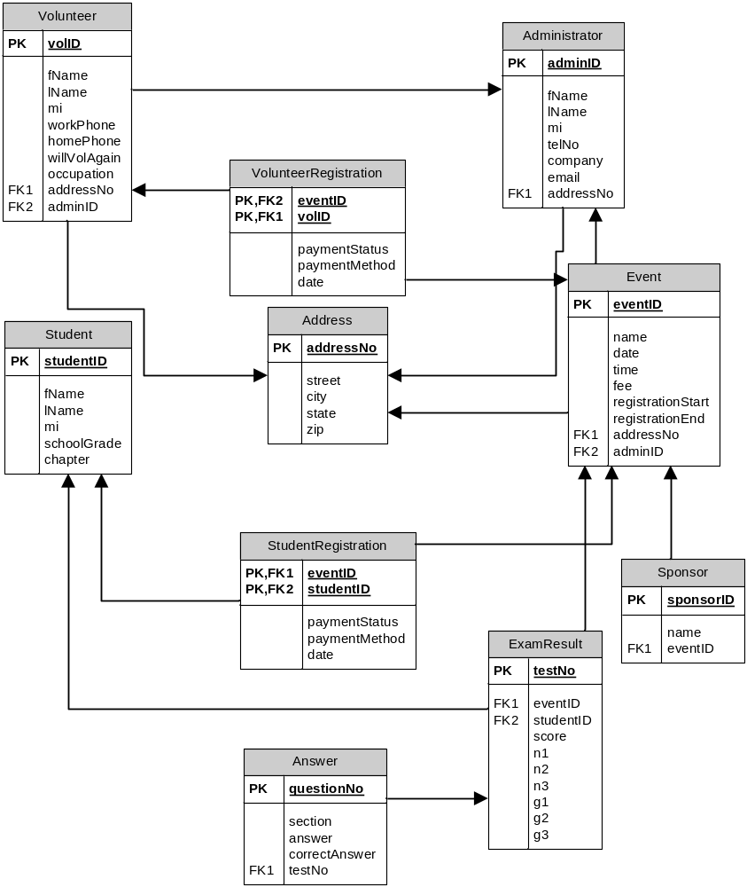

9. The data dictionary for the 3rd normalized relations

Entity Name | Description | Aliases | Occurrence
Administer | An administrator must be a member of ASEA. Also, the person must be the president of the local chapter or a designated officer for this event. An administrator can see all information in the system except for other administrator information. | ASEA officer | At least one per ASEA chapter
Volunteer | A volunteer is an unpaid assistant helping with managing the event. They can update student information (other than credit card data), proctor exams, enter exam results, and update their own information. | Volunteer | Several per event
Event | An ASEA national math competition | ASEA Competition, National Math Competition | At least one per year
StudentRegistration | A students information required to participate in an event | None | Several per event
VolunteerRegistration | A volunteers information required to participate in an event | None | Several per event
Address | A users address | None | One per user
Sponsor | The event corporate sponsor | None | One or more per event
ExamResult | The result of a student’s participation in an ASEA event. | Grade, exam result | One per student per event
Answer | The result of a student’s question on an exam | None | Thirty per student per event
Student | A Student is a student enrolled in a school system belonging to a school grade (4-11). A Student has the ability to register for an NMC event, pay for the NMC event registration (above 18 years of age only), and check their previous NMC event registration scores, and view test preparation material. | None | Several per event

Description of Relationships
Entity Name | Multiplicity | Relationship | Multiplicity | Entity Name
Administrator | 1..1 | Registers | 0..* | Administrator
Administrator | 0..* | Manages | 1..* | Event
Administrator | 1..* | Manages | 0..* | Student
Administrator | 0..* | Manages | 0..* | Volunteer
Volunteer | 0..* | Updates | 0..* | Event
Volunteer | 0..* | Manages | 1..* | Student
Event | 1..1 | Generates | 1..* | ExamResult
Student | 1..1 | Receives | 0..1 | ExamResult
Student | 1..1 | Attends | 0..* | Event
ExamResult | 1..1 | Has | 30..30 | Answers
Sponsor | 0..* | Sponsors | 0..* | Event
Address | 1..1 | Has | 1..* | Administrator
Address | 1..1 | Has | 1..* | Event
Address | 1..1 | Has | 1..* | Volunteer
Description of Attributes
Entity name | Attributes | Description | Data type & Length | Nulls | Multi-valued | Composite | Derived
Administrator | adminID (PK) | The administers ASEA ID number | Integer | No | No | No | No
Administrator | fName | The first name | Char(10) | Yes | No | No | No
Administrator | lName | The last name | Char(25) | No | No | No | No
Administrator | mi | The middle initial | Char(1) | Yes | No | No | No
Administrator | telNo | The telephone number | Char(10) | Yes | No | No | No
Administrator | company | The company the administer works for | Char(30) | Yes | No | No | No
Administrator | email | The email address | Char(30) | No | No | No | No
Administrator | addressNo (FK) | The address number | Integer | Yes | No | No | No
Volunteer | volID (PK) | The volunteer ID number | Integer | No | No | No | No
Volunteer | fName | The first name | Char(10) | Yes | No | No | No
Volunteer | lName | The last name | Char(25) | No | No | No | No
Volunteer | mi | The middle initial | Char(1) | Yes | No | No | No
Volunteer | workPhone | The work telephone number | Char(10) | Yes | No | No | No
Volunteer | homePhone | The home telephone number | Char(10) | Yes | No | No | No
Volunteer | willVolAgain | T/F if they will volunteer again | Single | Yes | No | No | No
Volunteer | occupation | Their job or occupation | Char(30) | Yes | No | No | No
Volunteer | addressNo (FK) | The address number | Integer | Yes | No | No | No
Volunteer | adminID (FK) | The adminID of the administrator who registered the volunteer | Integer | Yes | No | No | No
Student | studentID (PK) | The student’s ID number | Integer | No | No | No | No
Student | fName | The first name | Char(10) | Yes | No | No | No
Student | lName | The last name | Char(25) | No | No | No | No
Student | mi | The middle initial | Char(1) | Yes | No | No | No
Student | schoolGrade | The student’s grade in school | Integer | No | No | No | No
Student | Chapter | The student’s chapter | Char(5) | No | No | No | No
Event | eventID (PK) | The event ID number | Integer | No | No | No | No
Event | name | The name of the event | Char(30) | Yes | No | No | No
Event | date | The date of the event | DateTime | No | No | No | No
Event | time | The time of the event | DateTime | No | No | No | No
Event | fee | The registration fee | Currency | Yes | No | No | No
Event | registrationStart | The registration start date | DateTime | Yes | No | No | No
Event | registrationEnd | The registration end date | DateTime | Yes | No | No | No
Event | addressNo (FK) | The address number | Integer | No | No | No | No
Event | adminID (FK) | The event admin ID | Integer | Yes | No | No | No
Address | addressNo (PK) | The unique address number | Integer | No | No | No | No
Address | street | The street | Char(40) | No | No | No | No
Address | city | The city | Char(25) | Yes | No | No | No
Address | state | The state | Char(2) | No | No | No | No
Address | zip | The zip | Integer | No | No | No | No
StudentRegistration | eventID (PPK, FK) | The event ID for the registration | Integer | No | No | No | No
StudentRegistration | studentID (PPK, FK) | The student ID for the registration | Integer | No | No | No | No
StudentRegistration | paymentStatus | The status of the payment | Char(20) | Yes | No | No | No
StudentRegistration | paymentMethod | The method of payment | Char(20 | Yes | No | No | No
StudentRegistration | Date | The payment date | DateTime | Yes | No | No | No
VolunteerRegistration | eventID (PPK, FK) | The event ID for the registration | Integer | No | No | No | No
VolunteerRegistration | vollD (PPK, FK) | The volunteer ID for the registration | Integer | No | No | No | No
VolunteerRegistration | paymentStatus | The status of the payment | Char(20) | Yes | No | No | No
VolunteerRegistration | paymentMethod | The method of payment | Char(20 | Yes | No | No | No
VolunteerRegistration | Date | The payment date | DateTime | Yes | No | No | No
Sponsor | sponsorID (PK) | The sponsor ID number | Integer | No | No | No | No
Sponsor | name | The name of the sponsor | Char(30) | No | No | No | No
Sponsor | eventID (FK) | The event the sponsor is associated with | Integer | Yes | No | No | No
ExamResult | testNo (PK) | The test number | Integer | No | No | No | No
ExamResult | eventID (FK) | The event the test was given | Integer | No | No | No | No
ExamResult | studentID (FK) | The student who took the test | Integer | No | No | No | No
ExamResult | Score | The percentage score | Integer | Yes | No | No | Yes
ExamResult | n1 | Correct answers 1-10 | Integer | Yes | No | No | Yes
ExamResult | n2 | Correct answers 11-20 | Integer | Yes | No | No | Yes
ExamResult | n3 | Correct answers 21-30 | Integer | Yes | No | No | Yes
ExamResult | g1 | n1+n2+n3 | Integer | Yes | No | No | Yes
ExamResult | g2 | n1+n2 | Integer | Yes | No | No | Yes
ExamResult | g3 | n1 | Integer | Yes | No | No | Yes
Answer | questionNo (PK) | The unique question number | Integer | No | No | No | No
Answer | section | The section of the test | Char(2) | Yes | No | No | No
Answer | answer | The student’s answer | Char(1) | Yes | No | No | No
Answer | correctAnswer | The correct answer | Char(1) | Yes | No | No | No
Answer | testNo (FK) | The test number | Integer | No | No | No | No

Step 2.3

Student/Parent View:

1. A database model diagram with transaction pathways
Enter grades for an event
Enter the details for a new event
Modify event information
Update/delete student registration
Update score information
Generate a report of previous students
Generate a report of previous volunteers
Generate a report of events within the next three months
Generate a report of events within the next month
Generate a report of events within the next week
Generate a report of registered students for an event
Generate a report of registered volunteers for an event
Generate a report on event participation statistics (grade, age, sex, etc.)
Generate a report of the top three scores in each grade for an event
Generate a report of scoring statistics (highest score, lowest score, average score, score by section, etc.)
Generate a report of students who have not paid the event fee.
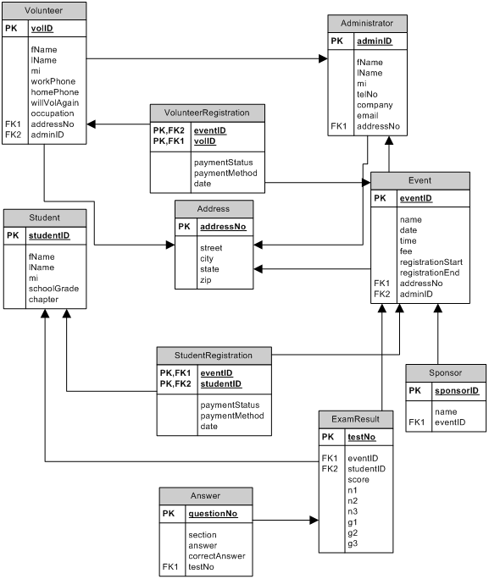

Step 2.4

Administrator View:

No Change

Step 2.5

Administrator View:

No Change

SE B- Individual Report

2.1 Local relational schema
Volunteer (volunteerId, fname, lname, workPhone, cellPhone, homePhone, street, city, state, zip, occupation, willVolAgain, email, eventID)  Primary Key volunteerId  Foreign Key eventID references Event(eventID) | Student (studentID, fName, lName, middleName, street, city, state, zip, homePhone, cellPhone, schoolLevel, schoolName, examGrade, gender, infoSource, studentEmail, eventID, email)  Primary Key studentID  Foreign Key eventID references Event (eventID) email references Parent (email)
Parent (email, fName, lName, middleName, cellPhone, workPhone)  Primary Key email | Event (eventID, date, street, city, state, zip, sponsor, regStart, regEnd, fee, time)  Primary Key eventID
Score (eventID, studentID, date, N1, N2, N3, G1, G2, G3, R2, R3)
Primary Key eventID, studentID
Foreign Key eventID references Event (eventID) studentID references Student (studentID)

2.1.ii Unnormalized relations
Volunteer
volunteerId | fname | lname | workPhone | cellPhone | homePhone | street | city | state | zip | occupation | willVolAgain | eMail | eventID
1 | Joe | Smith | Null | Null | Null | 123 Main | Tacoma | WA | 98122 | Null | Yes | joe@email.com | 1
2 | Pete | Smith | 206-567-1926 | 206-567-1926 | Null | Null | Seattle | WA | 98122 | Professor | Null | Pete@email.com | 1
3 | Suzy | Jones | 206-567-1936 | 206-567-1936 | Null | 234 South | Tacoma | WA | 98122 | Sales | Yes | Suzy@mail.com | 1
4 | Al | Chun | Null | Null | 425-555-8989 | 22 Jones | Gig harbor | WA | 98122 | Teacher | Yes | Al@mail.com | 1
5 | Jane | Doe | 206-567-1921 | 206-567-1921 | Null | 12 Main | Olympia | WA | 98122 | Null | No | Jane@gmail.com | 1
6 | Pete | Pen | 206-567-1922 | 206-567-1922 | Null | 3 Red | Bellevue | WA | 98122 | Homemmaker | Null | Pete@gmail.com | 1
7 | Jill | Jud | 206-567-1925 | 206-567-1925 | 425-222-1818 | 56 South | Tacoma | WA | 98122 | Null | Yes | Jill@mail.com | 1

Student
Student ID | fname | lName | middle Name | street | city | state | zip | Home Phone | Cell Phone | School Level | School Name | Exam Grade | gender | Info Source | Student Email | eventID | email
1 | Jim | Jones | E | 12 Main | Tacoma | WA | 98123 | Null | 206-777-2145 | 8 | Smith | 8 | M | School | Jim@mail.com | 1 | mom@mom.com
2 | Pete | Seeger | Null | 34 Main | Tacoma | WA | 98123 | 206-777-2345 | 206-777-2445 | 9 | Jones | 9 | M | Web | Pete@mail.com | 1 | dad@dad.com
3 | Alice | Wu | June | 34 South | Tacoma | WA | 98123 | 246-777-2345 | Null | 7 | Null | 7 | F | School | Alice@mail.com | 1 | mom@mom.net
4 | Jane | Smith | Null | 54 West | Tacoma | WA | 98123 | 226-777-2345 | 206-787-2345 | 7 | Jones | 7 | F | Teacher | Jane@mail.com | 1 | dad@dad.net
5 | Neve | Camb | S | 67 North | Tacoma | WA | 98123 | 206-777-8945 | 206-777-2346 | 9 | Jones | 9 | F | Web | Neve@mail.com | 1 | mom@mom.uk

Parent
Email | fName | lName | middleName | cellPhone | workPhone
mom@mom.com | June | Jones | Null | 206-555-1212 | Null
dad@dad.com | Pete | Seeger | Bert | Null | 425-676-2345
mom@mom.net | Jane | Wu | Alice | 425-234-9090 | null
dad@dad.net | Jimmy | Smith | Null | 425-212-9012 | Null
mom@mom.uk | Susan | Camb | jane | 206-345-1923 | 345-262-1234

Event
eventID | date | street | city | state | zip | sponsor | regStart | regEnd | fee | Time
1 | 6/15/2008 | 123 Main | Bellevue | WA | 91234 | MicroSoft | 1/1/2008 | 5/1/2008 | 45 | 9:00

Score
eventID | studentID | date | N1 | N2 | N3 | G1 | G2 | G3 | R2 | R3
2 | 1 | 1/1/2007 | 5 | 2 | 6 | 13 | 8 | 6 | Null | Null
3 | 2 | 7/1/2007 | 5 | 3 | 8 | 16 | 11 | 8 | Null | Null

2.2 Dependency diagram
Volunteer | Dependencies | Student | Dependencies
volunteerId |  | studentID
fname | volunteerId | fname | studentID
lname | volunteerId | lname | studentID
workPhone | volunteerId | middleName | studentID
cellPhone | volunteerId | street | studentID
homePhone | volunteerId | city | studentID
street | volunteerId | state | studentID, zip
city | volunteerId | zip | studentID
state | volunteered, zip | homePhone | studentID
zip | volunteerId | cellPhone | studentID
occupation | volunteerId | schoolLevel | studentID
willVolAgain | volunteerId | schoolName | studentID
eventID |  | examGrade | studentID
 |  | Gender | studentID
 |  | infoSource | studentID
 |  | studentEmail | studentID
 |  | eventID
 |  | email

Parent | Dependencies | Event | Dependencies
email |  | eventID
fName | email | date | eventID
lName | email | street | eventID
middleName | email | city | eventID
cellPhone | email | state | eventID, zip
workPhone | email | zip | eventID
 |  | sponsor | eventID
 |  | regStart | eventID
 |  | regEnd | eventID
 |  | fee | eventID
 |  | time | eventID

Score | Dependencies
eventID
studentID
Date | eventID, studentID
N1 | eventID, studentID
N2 | eventID, studentID
N3 | eventID, studentID
G1 | eventID, studentID
G2 | eventID, studentID
G3 | eventID, studentID
R2 | eventID, studentID
R3 | eventID, studentID

2.2.ii 1NF relational schema
Volunteer (volunteerId, fname, lname, workPhone, cellPhone, homePhone, street, city, state, zip, occupation, willVolAgain, eventID)  Primary Key volunteerId  Foreign Key eventID references Event(eventID) | Student (studentID, fName, lName, middleName, street, city, state, zip, homePhone, cellPhone, schoolLevel, schoolName, examGrade, gender, infoSource, studentEmail, eventID, email)  Primary Key studentID  Foreign Key eventID references Event (eventID) email references Parent (email)
Parent (email, fName, lName, middleName, cellPhone, workPhone)  Primary Key email | Event (eventID, date, street, city, state, zip, sponsor, regStart, regEnd, fee, time)  Primary Key eventID
Score (eventID, studentID, date, N1, N2, N3, G1, G2, G3, R2, R3)
Primary Key eventID, studentID
Foreign Key eventID references Event (eventID) studentID references Student (studentID)

2.2.iii 1NF relations
Volunteer
volunteerId | fname | lname | workPhone | cellPhone | homePhone | street | city | state | zip | occupation | willVolAgain | eMail | eventID
1 | Joe | Smith | Null | Null | Null | 123 Main | Tacoma | WA | 98122 | Null | Yes | joe@email.com | 1
2 | Pete | Smith | 206-567-1926 | 206-567-1926 | Null | Null | Seattle | WA | 98122 | Professor | Null | Pete@email.com | 1
3 | Suzy | Jones | 206-567-1936 | 206-567-1936 | Null | 234 South | Tacoma | WA | 98122 | Sales | Yes | Suzy@mail.com | 1
4 | Al | Chun | Null | Null | 425-555-8989 | 22 Jones | Gig harbor | WA | 98122 | Teacher | Yes | Al@mail.com | 1
5 | Jane | Doe | 206-567-1921 | 206-567-1921 | Null | 12 Main | Olympia | WA | 98122 | Null | No | Jane@gmail.com | 1
6 | Pete | Pen | 206-567-1922 | 206-567-1922 | Null | 3 Red | Bellevue | WA | 98122 | Homemmaker | Null | Pete@gmail.com | 1
7 | Jill | Jud | 206-567-1925 | 206-567-1925 | 425-222-1818 | 56 South | Tacoma | WA | 98122 | Null | Yes | Jill@mail.com | 1

Student
Student ID | fname | lName | middle Name | street | city | state | zip | Home Phone | Cell Phone | School Level | School Name | Exam Grade | gender | Info Source | Student Email | eventID | email
1 | Jim | Jones | E | 12 Main | Tacoma | WA | 98123 | Null | 206-777-2145 | 8 | Smith | 8 | M | School | Jim@mail.com | 1 | mom@mom.com
2 | Pete | Seeger | Null | 34 Main | Tacoma | WA | 98123 | 206-777-2345 | 206-777-2445 | 9 | Jones | 9 | M | Web | Pete@mail.com | 1 | dad@dad.com
3 | Alice | Wu | June | 34 South | Tacoma | WA | 98123 | 246-777-2345 | Null | 7 | Null | 7 | F | School | Alice@mail.com | 1 | mom@mom.net
4 | Jane | Smith | Null | 54 West | Tacoma | WA | 98123 | 226-777-2345 | 206-787-2345 | 7 | Jones | 7 | F | Teacher | Jane@mail.com | 1 | dad@dad.net
5 | Neve | Camb | S | 67 North | Tacoma | WA | 98123 | 206-777-8945 | 206-777-2346 | 9 | Jones | 9 | F | Web | Neve@mail.com | 1 | mom@mom.uk

Parent
Email | fName | lName | middleName | cellPhone | workPhone
mom@mom.com | June | Jones | Null | 206-555-1212 | Null
dad@dad.com | Pete | Seeger | Bert | Null | 425-676-2345
mom@mom.net | Jane | Wu | Alice | 425-234-9090 | null
dad@dad.net | Jimmy | Smith | Null | 425-212-9012 | Null
mom@mom.uk | Susan | Camb | jane | 206-345-1923 | 345-262-1234

Event
eventID | date | street | city | state | zip | sponsor | regStart | regEnd | fee | Time
1 | 6/15/2008 | 123 Main | Bellevue | WA | 91234 | MicroSoft | 1/1/2008 | 5/1/2008 | 45 | 9:00

Score
eventID | studentID | date | N1 | N2 | N3 | G1 | G2 | G3 | R2 | R3
2 | 1 | 1/1/2007 | 5 | 2 | 6 | 13 | 8 | 6 | Null | Null
3 | 2 | 7/1/2007 | 5 | 3 | 8 | 16 | 11 | 8 | Null | Null

2.2.iv 2NF relational schema
Volunteer (volunteerId, fname, lname, workPhone, cellPhone, homePhone, street, city, state, zip, occupation, willVolAgain, eventID)  Primary Key volunteerId  Foreign Key eventID references Event(eventID) | Student (studentID, fName, lName, middleName, street, city, state, zip, homePhone, cellPhone, schoolLevel, schoolName, examGrade, gender, infoSource, studentEmail, eventID, email)  Primary Key studentID  Foreign Key eventID references Event (eventID) email references Parent (email)
Parent (email, fName, lName, middleName, cellPhone, workPhone)  Primary Key email | Event (eventID, date, street, city, state, zip, sponsor, regStart, regEnd, fee, time)  Primary Key eventID
Score (eventID, studentID, date, N1, N2, N3, G1, G2, G3, R2, R3)
Primary Key eventID, studentID
Foreign Key eventID references Event (eventID) studentID references Student (studentID)

2.2.v 2NF relations
Volunteer
volunteerId | fname | lname | workPhone | cellPhone | homePhone | street | city | state | zip | occupation | willVolAgain | eMail | eventID
1 | Joe | Smith | Null | Null | Null | 123 Main | Tacoma | WA | 98122 | Null | Yes | joe@email.com | 1
2 | Pete | Smith | 206-567-1926 | 206-567-1926 | Null | Null | Seattle | WA | 98122 | Professor | Null | Pete@email.com | 1
3 | Suzy | Jones | 206-567-1936 | 206-567-1936 | Null | 234 South | Tacoma | WA | 98122 | Sales | Yes | Suzy@mail.com | 1
4 | Al | Chun | Null | Null | 425-555-8989 | 22 Jones | Gig harbor | WA | 98122 | Teacher | Yes | Al@mail.com | 1
5 | Jane | Doe | 206-567-1921 | 206-567-1921 | Null | 12 Main | Olympia | WA | 98122 | Null | No | Jane@gmail.com | 1
6 | Pete | Pen | 206-567-1922 | 206-567-1922 | Null | 3 Red | Bellevue | WA | 98122 | Homemmaker | Null | Pete@gmail.com | 1
7 | Jill | Jud | 206-567-1925 | 206-567-1925 | 425-222-1818 | 56 South | Tacoma | WA | 98122 | Null | Yes | Jill@mail.com | 1

Student
Student ID | fname | lName | middle Name | street | city | state | zip | Home Phone | Cell Phone | School Level | School Name | Exam Grade | gender | Info Source | Student Email | eventID | email
1 | Jim | Jones | E | 12 Main | Tacoma | WA | 98123 | Null | 206-777-2145 | 8 | Smith | 8 | M | School | Jim@mail.com | 1 | mom@mom.com
2 | Pete | Seeger | Null | 34 Main | Tacoma | WA | 98123 | 206-777-2345 | 206-777-2445 | 9 | Jones | 9 | M | Web | Pete@mail.com | 1 | dad@dad.com
3 | Alice | Wu | June | 34 South | Tacoma | WA | 98123 | 246-777-2345 | Null | 7 | Null | 7 | F | School | Alice@mail.com | 1 | mom@mom.net
4 | Jane | Smith | Null | 54 West | Tacoma | WA | 98123 | 226-777-2345 | 206-787-2345 | 7 | Jones | 7 | F | Teacher | Jane@mail.com | 1 | dad@dad.net
5 | Neve | Camb | S | 67 North | Tacoma | WA | 98123 | 206-777-8945 | 206-777-2346 | 9 | Jones | 9 | F | Web | Neve@mail.com | 1 | mom@mom.uk

Parent
Email | fName | lName | middleName | cellPhone | workPhone
mom@mom.com | June | Jones | Null | 206-555-1212 | Null
dad@dad.com | Pete | Seeger | Bert | Null | 425-676-2345
mom@mom.net | Jane | Wu | Alice | 425-234-9090 | null
dad@dad.net | Jimmy | Smith | Null | 425-212-9012 | Null
mom@mom.uk | Susan | Camb | jane | 206-345-1923 | 345-262-1234

Event
eventID | date | street | city | state | zip | sponsor | regStart | regEnd | fee | Time
1 | 6/15/2008 | 123 Main | Bellevue | WA | 91234 | MicroSoft | 1/1/2008 | 5/1/2008 | 45 | 9:00

Score
eventID | studentID | date | N1 | N2 | N3 | G1 | G2 | G3 | R2 | R3
2 | 1 | 1/1/2007 | 5 | 2 | 6 | 13 | 8 | 6 | Null | Null
3 | 2 | 7/1/2007 | 5 | 3 | 8 | 16 | 11 | 8 | Null | Null

2.2.vi 3NF relational schema
Volunteer (volunteerId, fname, lname, workPhone, cellPhone, homePhone, street, city, state, zip, occupation, willVolAgain, eventID)  Primary Key volunteerId  Foreign Key eventID references Event(eventID) | Student (studentID, fName, lName, middleName, street, city, state, zip, homePhone, cellPhone, schoolLevel, schoolName, examGrade, gender, infoSource, studentEmail, eventID, email)  Primary Key studentID  Foreign Key eventID references Event (eventID) email references Parent (email)
Parent (email, fName, lName, middleName, cellPhone, workPhone)  Primary Key email | Event (eventID, date, street, city, state, zip, sponsor, regStart, regEnd, fee, time)  Primary Key eventID
Score (eventID, studentID, date, N1, N2, N3, G1, G2, G3, R2, R3)
Primary Key eventID, studentID
Foreign Key eventID references Event (eventID) studentID references Student (studentID)

2.2.vii 3NF relations
Volunteer
volunteerId | fname | lname | workPhone | cellPhone | homePhone | street | city | state | zip | occupation | willVolAgain | eMail | eventID
1 | Joe | Smith | Null | Null | Null | 123 Main | Tacoma | WA | 98122 | Null | Yes | joe@email.com | 1
2 | Pete | Smith | 206-567-1926 | 206-567-1926 | Null | Null | Seattle | WA | 98122 | Professor | Null | Pete@email.com | 1
3 | Suzy | Jones | 206-567-1936 | 206-567-1936 | Null | 234 South | Tacoma | WA | 98122 | Sales | Yes | Suzy@mail.com | 1
4 | Al | Chun | Null | Null | 425-555-8989 | 22 Jones | Gig harbor | WA | 98122 | Teacher | Yes | Al@mail.com | 1
5 | Jane | Doe | 206-567-1921 | 206-567-1921 | Null | 12 Main | Olympia | WA | 98122 | Null | No | Jane@gmail.com | 1
6 | Pete | Pen | 206-567-1922 | 206-567-1922 | Null | 3 Red | Bellevue | WA | 98122 | Homemmaker | Null | Pete@gmail.com | 1
7 | Jill | Jud | 206-567-1925 | 206-567-1925 | 425-222-1818 | 56 South | Tacoma | WA | 98122 | Null | Yes | Jill@mail.com | 1

Student
Student ID | fname | lName | middle Name | street | city | state | zip | Home Phone | Cell Phone | School Level | School Name | Exam Grade | gender | Info Source | Student Email | eventID | email
1 | Jim | Jones | E | 12 Main | Tacoma | WA | 98123 | Null | 206-777-2145 | 8 | Smith | 8 | M | School | Jim@mail.com | 1 | mom@mom.com
2 | Pete | Seeger | Null | 34 Main | Tacoma | WA | 98123 | 206-777-2345 | 206-777-2445 | 9 | Jones | 9 | M | Web | Pete@mail.com | 1 | dad@dad.com
3 | Alice | Wu | June | 34 South | Tacoma | WA | 98123 | 246-777-2345 | Null | 7 | Null | 7 | F | School | Alice@mail.com | 1 | mom@mom.net
4 | Jane | Smith | Null | 54 West | Tacoma | WA | 98123 | 226-777-2345 | 206-787-2345 | 7 | Jones | 7 | F | Teacher | Jane@mail.com | 1 | dad@dad.net
5 | Neve | Camb | S | 67 North | Tacoma | WA | 98123 | 206-777-8945 | 206-777-2346 | 9 | Jones | 9 | F | Web | Neve@mail.com | 1 | mom@mom.uk

Parent
Email | fName | lName | middleName | cellPhone | workPhone
mom@mom.com | June | Jones | Null | 206-555-1212 | Null
dad@dad.com | Pete | Seeger | Bert | Null | 425-676-2345
mom@mom.net | Jane | Wu | Alice | 425-234-9090 | null
dad@dad.net | Jimmy | Smith | Null | 425-212-9012 | Null
mom@mom.uk | Susan | Camb | jane | 206-345-1923 | 345-262-1234

Event
eventID | date | street | city | state | zip | sponsor | regStart | regEnd | fee | Time
1 | 6/15/2008 | 123 Main | Bellevue | WA | 91234 | MicroSoft | 1/1/2008 | 5/1/2008 | 45 | 9:00

Score
eventID | studentID | date | N1 | N2 | N3 | G1 | G2 | G3 | R2 | R3
2 | 1 | 1/1/2007 | 5 | 2 | 6 | 13 | 8 | 6 | Null | Null
3 | 2 | 7/1/2007 | 5 | 3 | 8 | 16 | 11 | 8 | Null | Null

2.2.viii logical database model
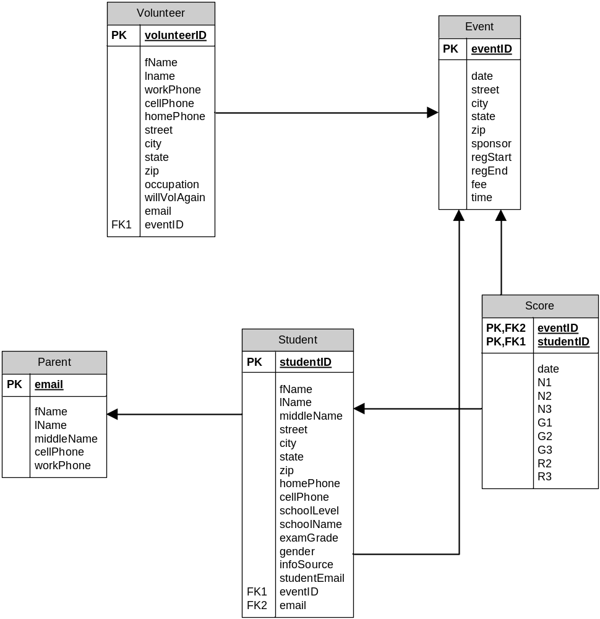
Data dictionary:
Entity Name | Description | Aliases | Occurrence
Volunteer | A volunteer is an unpaid assistant helping with managing the event. They can update student information (other than credit card data), proctor exams, enter exam results, and update their own information. |  | Typically many per event
Parent | Guardians are also considered as a Parent in the system. A parent chaperones family-related student(s) by paying for their NMC event registration, view the scores of the students being chaperoned, view chapter and nationwide statistics, can also donate money to the NMC. |  | One per student
Event | An ASEA national math competition | ASEA Competition, National Math Competition | At least one per year
Student | A Student is a student enrolled in a school system belonging to a school grade (4-11). A Student has the ability to register for an NMC event, pay for the NMC event registration (above 18 years of age only), and check their previous NMC event registration scores, and view test preparation material. |  | typically many per event
Score | The result of a students participation in an ASEA event. | exam result | One per student per event

Description of relationships
Entity Name | Multiplicity | Relationship | Multiplicity | Entity Name
Volunteer | 0-1 | manages | 0-* | Event
Volunteer | 0-1 | Updates | 0-* | Student
Volunteer | 0-1 | Updates | 0-* | Parent
Parent | 1-1 | Parents | 1-* | Student
Student | 1-1 | Attends | 0-* | Event
Student | 1-1 | TestResults | 0-* | Score

Step 2.3 Transaction pathways
Data Entry
Enter the details of a new volunteer | Volunteer
Enter the details of a new parent | green
Enter the details of a new student | Student
Enter grades for an event | Yellow
Enter the details for a new event | Event
Data Update/deletion
Update score information | yellow
Update volunteer information | Volunteer
Update/delete parent information | Green
Update/delete student information | Student
Update volunteer passwords | Volunteer
Update parent passwords | Parent
Update student passwords | Student
Update/delete student registration | Student
Data Queries
Generate a report of previous participants | Blue
Generate a report of events within the next three months | Event
Generate a report of events within the next month | Event
Generate a report of events within the next week | Event
Generate a report of registered students for an event | Blue
Generate a report of registered parents for an event | Blue, green
Generate a report of registered volunteers for an event | Red
Locate a parent’s record (by ID, name, address, location, etc.) | Parent
Locate a student’s record (by ID, name, address, location, etc.) | Student

2.4
Volunteer (volunteerId, fname, lname, workPhone, cellPhone, homePhone, street, city, state, zip, occupation, willVolAgain, eventID)  Primary Key volunteerId  Foreign Key eventID references Event(eventID) ON UPDATE CASCADE ON DELETE SET NULL | Student (studentID, fName, lName, middleName, street, city, state, zip, homePhone, cellPhone, schoolLevel, schoolName, examGrade, gender, infoSource, studentEmail, eventID, email)  Primary Key studentID  Foreign Key eventID references Event (eventID) ON UPDATE CASCADE ON DELETE SET NULL  email references Parent (email) ON UPDATE CASCADE ON DELETE SET NULL
Parent (email, fName, lName, middleName, cellPhone, workPhone)  Primary Key email | Event (eventID, date, street, city, state, zip, sponsor, regStart, regEnd, fee, time)  Primary Key eventID
Score (eventID, studentID, date, N1, N2, N3, G1, G2, G3, R2, R3)
Primary Key eventID, studentID
Foreign Key eventID references Event (eventID) ON UPDATE CASCADE ON DELETE CASCADE
studentID references Student (studentID) ON UPDATE CASCADE ON DELETE CASCADE

2.5
No changes

SE C- Individual Report

Step 2.1

Student/Parent View:

1. Local relational schema

User (userID, name, address, homePhone, workPhone, cellPhone, email, userType)
Primary Key userID
Alternate Key email

Student (studentID, grade, gender, parentType, parentID, schoolID)
Primary Key studentID
Foreign Key studentID references User(userID)
Foreign Key parentID references Parent(parentID)
Foreign Key schoolID references School(schoolID)

Parent (parentID, donorID)
Primary Key parentID
Foreign Key parentID references User(userID)
Foreign Key donorID references Donor(donorID)

Donor (donorID)
Primary Key donorID
Foreign Key donorID references User(userID)

School (schoolID, name, type)
Primary Key schoolID

Registration (registrationID, date, chapterAssociation, paymentStatus, examGrade, score, userID, eventID)
Primary Key registrationID
Foreign Key userID references Student(studentID)
Foreign Key eventID references Event(eventID)

Event (eventID, name, sponsors, date, time, locationAddress, registrationStart, registrationEnd, fee)
Primary Key eventID

Payment (invoiceID, type, creditNum, expDate, amount, date, type, userID)
Primary Key invoiceID
Foreign Key userID references User(userID)

2. Unnormalized local relations

User
userID | Name | Address | homePhone | workPhone | cellPhone | email | type
00001 | A1 Stu | 112 1st St | 223-2332 | Null | Null | astu@email.com | S
00002 | B Stu | 211 2nd St | Null | Null | Null | bstu@email.com | S
00003 | A Par | 112 1st St | 223-2332 | Null | 232-2132 | apar@email.com | P
00004 | A Don | 9 9th Ave | 123-2323 | 134-4322 | Null | adon@email.com | D
00005 | A2 Stu | 112 1st St | 223-2332 | Null | 433-3232 | apar@email.com | S
00006 | B Par | 112 1st St | 223-2332 | Null | Null | bpar@email.com | P
00007 | C Stu | 32 3rd St | Null | Null | Null | cstu@email.com | S
00008 | C Par | 32 3rd St | 432-3233 | 133-3232 | Null | cpar@email.com | P
00009 | D Stu | 113 4th St | 111-1111 | Null | Null | dstu@email.com | S
00010 | E Stu | 232 E st | 222-2222 | Null | Null | estu@email.com | S

Student
studentID | grade | gender | parentType | parentID | schoolID
00001 | 08 | M | Father | 00003 | 0001
00002 | 11 | F | Mother | 00006 | 0002
00005 | 09 | M | Father | 00003 | 0001
00007 | 10 | F | Guardian | 00008 | 0003
00009 | 10 | M | Null | Null | Null
00010 | 07 | F | Null | Null | 0005

Parent
parentID | donorID
00003 | 00003
00006 | Null
00008 | Null

Donor
donorID
00003
00004

School
schoolID | name | type
0001 | South Middle School | M
0002 | Null | Null
0003 | North High School | H
0004 | East Elementary School | E
0005 | Null | Null
0006 | Forest Gump Middle School | M

Registration
regID | Date | Chapter | payStatus | examGrade | Score | userID | eventID
00001 | 1/30/06 | PNC | T | 7 | 90 | 00001 | 0001
00002 | 2/30/06 | PNC | T | 11 | 50 | 00002 | 0001
00003 | 3/1/06 | SCC | T | 9 | 80 | 00005 | 0001
00004 | 3/1/06 | PNC | T | 9 | 50 | 00007 | 0001
00005 | 3/7/06 | PNC | T | 9 | 95 | 00009 | 0001
00006 | 1/30/07 | PNC | T | 8 | Null | 00001 | 0002
00007 | 2/30/07 | PNC | F | 11 | Null | 00002 | 0002
00008 | 3/17/07 | SCC | T | 9 | Null | 00005 | 0002
00009 | 3/17/07 | PNC | T | 10 | Null | 00009 | 0002
00010 | 3/18/07 | PNC | T | 7 | Null | 00010 | 0002

Event
id | name | sponsors | date | time | address | start | end | fee
0001 | 5th ASEA National Mathematics Competition | ASEA | 4/21/06 | 08:00 | Microsoft Conference Center (Building 33)  16070 NE 36th Way, Bldg. #33, Redmond, WA. 98052 | 1/1/06 | 4/14/06 | 35
0002 | 6th ASEA National Mathematics Competition | ASEA | 4/21/07 | 09:00 | Microsoft Conference Center (Building 33)  16070 NE 36th Way, Bldg. #33, Redmond, WA. 98052 | 1/1/07 | 4/14/07 | 35

Payment
invoiceID | type | creditNum | expDate | amount | date | userID
000001 | Credit | 1111222233334444 | 1/1/09 | 30 | 1/30/06 | 00003
000002 | Credit | 1010202030304040 | 10/1/06 | 35 | 2/30/06 | 00002
000003 | Credit | 1111222233334444 | 1/1/09 | 30 | 3/1/06 | 00003
000004 | Credit | 1234123412341234 | 4/4/10 | 35 | 3/1/06 | 00007
000005 | Credit | 2323333323233333 | 1/10/08 | 35 | 3/7/06 | 00009
000006 | Credit | 1111222233334444 | 1/1/09 | 30 | 1/30/07 | 00003
000007 | Credit | 1111222233334444 | 1/1/09 | 30 | 3/17/07 | 00003
000008 | Credit | 8765123487651234 | 2/2/10 | 35 | 3/17/07 | 00009
000009 | Credit | 1000200030004000 | 2/1/08 | 35 | 3/18/07 | 00010

Step 2.2

Student/Parent View:

1. Dependency diagram

User
userID | Name | Address | homePhone | workPhone | cellPhone | email | type
(primary key)

Student
studentID | grade | gender | parentType | parentID | schoolID
(primary key)

Parent
parentID | donorID
(primary key)
Donor
donorID
(primary key)
School
schoolID | name | type
(primary key)
Registration
regID | Date | Chapter | payStatus | examGrade | Score | userID | eventID
(primary key)
Event
id | name | sponsors | date | time | address | start | end | fee
(primary key)
Payment
invoiceID | type | creditNum | expDate | amount | date | userID
(primary key)

2. 1NF relational schema

User (userID, name, address, homePhone, workPhone, cellPhone, email, userType)
Primary Key userID
Alternate Key email

Student (studentID, grade, gender, parentType, parentID, schoolID)
Primary Key studentID
Foreign Key studentID references User(userID)
Foreign Key parentID references Parent(parentID)
Foreign Key schoolID references School(schoolID)

Parent (parentID, donorID)
Primary Key parentID
Foreign Key parentID references User(userID)
Foreign Key donorID references Donor(donorID)

Donor (donorID)
Primary Key donorID
Foreign Key donorID references User(userID)

School (schoolID, name, type)
Primary Key schoolID

Registration (registrationID, date, chapterAssociation, paymentStatus, examGrade, score, userID, eventID)
Primary Key registrationID
Foreign Key userID references Student(studentID)
Foreign Key eventID references Event(eventID)

Event (eventID, name, sponsors, date, time, locationAddress, registrationStart, registrationEnd, fee)
Primary Key eventID

Payment (invoiceID, type, creditNum, expDate, amount, date, type, userID)
Primary Key invoiceID
Foreign Key userID references User(userID)

3. 1NF relations

User
userID | Name | Address | homePhone | workPhone | cellPhone | email | type
00001 | A1 Stu | 112 1st St | 223-2332 | Null | Null | astu@email.com | S
00002 | B Stu | 211 2nd St | Null | Null | Null | bstu@email.com | S
00003 | A Par | 112 1st St | 223-2332 | Null | 232-2132 | apar@email.com | P
00004 | A Don | 9 9th Ave | 123-2323 | 134-4322 | Null | adon@email.com | D
00005 | A2 Stu | 112 1st St | 223-2332 | Null | 433-3232 | apar@email.com | S
00006 | B Par | 112 1st St | 223-2332 | Null | Null | bpar@email.com | P
00007 | C Stu | 32 3rd St | Null | Null | Null | cstu@email.com | S
00008 | C Par | 32 3rd St | 432-3233 | 133-3232 | Null | cpar@email.com | P
00009 | D Stu | 113 4th St | 111-1111 | Null | Null | dstu@email.com | S
00010 | E Stu | 232 E st | 222-2222 | Null | Null | estu@email.com | S

Student
studentID | grade | gender | parentType | parentID | schoolID
00001 | 08 | M | Father | 00003 | 0001
00002 | 11 | F | Mother | 00006 | 0002
00005 | 09 | M | Father | 00003 | 0001
00007 | 10 | F | Guardian | 00008 | 0003
00009 | 10 | M | Null | Null | Null
00010 | 07 | F | Null | Null | 0005

Parent
parentID | donorID
00003 | 00003
00006 | Null
00008 | Null

Donor
donorID
00003
00004

School
schoolID | name | type
0001 | South Middle School | M
0002 | Null | Null
0003 | North High School | H
0004 | East Elementary School | E
0005 | Null | Null
0006 | Forest Gump Middle School | M

Registration
regID | Date | Chapter | payStatus | examGrade | Score | userID | eventID
00001 | 1/30/06 | PNC | T | 7 | 90 | 00001 | 0001
00002 | 2/30/06 | PNC | T | 11 | 50 | 00002 | 0001
00003 | 3/1/06 | SCC | T | 9 | 80 | 00005 | 0001
00004 | 3/1/06 | PNC | T | 9 | 50 | 00007 | 0001
00005 | 3/7/06 | PNC | T | 9 | 95 | 00009 | 0001
00006 | 1/30/07 | PNC | T | 8 | Null | 00001 | 0002
00007 | 2/30/07 | PNC | F | 11 | Null | 00002 | 0002
00008 | 3/17/07 | SCC | T | 9 | Null | 00005 | 0002
00009 | 3/17/07 | PNC | T | 10 | Null | 00009 | 0002
00010 | 3/18/07 | PNC | T | 7 | Null | 00010 | 0002

Event
id | name | sponsors | date | time | address | start | end | fee
0001 | 5th ASEA National Mathematics Competition | ASEA | 4/21/06 | 08:00 | Microsoft Conference Center (Building 33)  16070 NE 36th Way, Bldg. #33, Redmond, WA. 98052 | 1/1/06 | 4/14/06 | 35
0002 | 6th ASEA National Mathematics Competition | ASEA | 4/21/07 | 09:00 | Microsoft Conference Center (Building 33)  16070 NE 36th Way, Bldg. #33, Redmond, WA. 98052 | 1/1/07 | 4/14/07 | 35

Payment
invoiceID | type | creditNum | expDate | amount | date | userID
000001 | Credit | 1111222233334444 | 1/1/09 | 30 | 1/30/06 | 00003
000002 | Credit | 1010202030304040 | 10/1/06 | 35 | 2/30/06 | 00002
000003 | Credit | 1111222233334444 | 1/1/09 | 30 | 3/1/06 | 00003
000004 | Credit | 1234123412341234 | 4/4/10 | 35 | 3/1/06 | 00007
000005 | Credit | 2323333323233333 | 1/10/08 | 35 | 3/7/06 | 00009
000006 | Credit | 1111222233334444 | 1/1/09 | 30 | 1/30/07 | 00003
000007 | Credit | 1111222233334444 | 1/1/09 | 30 | 3/17/07 | 00003
000008 | Credit | 8765123487651234 | 2/2/10 | 35 | 3/17/07 | 00009
000009 | Credit | 1000200030004000 | 2/1/08 | 35 | 3/18/07 | 00010

4. 2NF relational schema

User (userID, name, address, homePhone, workPhone, cellPhone, email, userType)
Primary Key userID
Alternate Key email

Student (studentID, grade, gender, parentType, parentID, schoolID)
Primary Key studentID
Foreign Key studentID references User(userID)
Foreign Key parentID references Parent(parentID)
Foreign Key schoolID references School(schoolID)

Parent (parentID, donorID)
Primary Key parentID
Foreign Key parentID references User(userID)
Foreign Key donorID references Donor(donorID)

Donor (donorID)
Primary Key donorID
Foreign Key donorID references User(userID)

School (schoolID, name, type)
Primary Key schoolID

Registration (registrationID, date, chapterAssociation, paymentStatus, examGrade, score, userID, eventID)
Primary Key registrationID
Foreign Key userID references Student(studentID)
Foreign Key eventID references Event(eventID)

Event (eventID, name, sponsors, date, time, locationAddress, registrationStart, registrationEnd, fee)
Primary Key eventID

Payment (invoiceID, type, creditNum, expDate, amount, date, type, userID)
Primary Key invoiceID
Foreign Key userID references User(userID)

5. 2NF relations

User
userID | Name | Address | homePhone | workPhone | cellPhone | email | type
00001 | A1 Stu | 112 1st St | 223-2332 | Null | Null | astu@email.com | S
00002 | B Stu | 211 2nd St | Null | Null | Null | bstu@email.com | S
00003 | A Par | 112 1st St | 223-2332 | Null | 232-2132 | apar@email.com | P
00004 | A Don | 9 9th Ave | 123-2323 | 134-4322 | Null | adon@email.com | D
00005 | A2 Stu | 112 1st St | 223-2332 | Null | 433-3232 | apar@email.com | S
00006 | B Par | 112 1st St | 223-2332 | Null | Null | bpar@email.com | P
00007 | C Stu | 32 3rd St | Null | Null | Null | cstu@email.com | S
00008 | C Par | 32 3rd St | 432-3233 | 133-3232 | Null | cpar@email.com | P
00009 | D Stu | 113 4th St | 111-1111 | Null | Null | dstu@email.com | S
00010 | E Stu | 232 E st | 222-2222 | Null | Null | estu@email.com | S

Student
studentID | grade | gender | parentType | parentID | schoolID
00001 | 08 | M | Father | 00003 | 0001
00002 | 11 | F | Mother | 00006 | 0002
00005 | 09 | M | Father | 00003 | 0001
00007 | 10 | F | Guardian | 00008 | 0003
00009 | 10 | M | Null | Null | Null
00010 | 07 | F | Null | Null | 0005

Parent
parentID | donorID
00003 | 00003
00006 | Null
00008 | Null

Donor
donorID
00003
00004

School
schoolID | name | type
0001 | South Middle School | M
0002 | Null | Null
0003 | North High School | H
0004 | East Elementary School | E
0005 | Null | Null
0006 | Forest Gump Middle School | M

Registration
regID | Date | Chapter | payStatus | examGrade | Score | userID | eventID
00001 | 1/30/06 | PNC | T | 7 | 90 | 00001 | 0001
00002 | 2/30/06 | PNC | T | 11 | 50 | 00002 | 0001
00003 | 3/1/06 | SCC | T | 9 | 80 | 00005 | 0001
00004 | 3/1/06 | PNC | T | 9 | 50 | 00007 | 0001
00005 | 3/7/06 | PNC | T | 9 | 95 | 00009 | 0001
00006 | 1/30/07 | PNC | T | 8 | Null | 00001 | 0002
00007 | 2/30/07 | PNC | F | 11 | Null | 00002 | 0002
00008 | 3/17/07 | SCC | T | 9 | Null | 00005 | 0002
00009 | 3/17/07 | PNC | T | 10 | Null | 00009 | 0002
00010 | 3/18/07 | PNC | T | 7 | Null | 00010 | 0002

Event
id | name | sponsors | date | time | address | start | end | fee
0001 | 5th ASEA National Mathematics Competition | ASEA | 4/21/06 | 08:00 | Microsoft Conference Center (Building 33)  16070 NE 36th Way, Bldg. #33, Redmond, WA. 98052 | 1/1/06 | 4/14/06 | 35
0002 | 6th ASEA National Mathematics Competition | ASEA | 4/21/07 | 09:00 | Microsoft Conference Center (Building 33)  16070 NE 36th Way, Bldg. #33, Redmond, WA. 98052 | 1/1/07 | 4/14/07 | 35

Payment
invoiceID | type | creditNum | expDate | amount | date | userID
000001 | Credit | 1111222233334444 | 1/1/09 | 30 | 1/30/06 | 00003
000002 | Credit | 1010202030304040 | 10/1/06 | 35 | 2/30/06 | 00002
000003 | Credit | 1111222233334444 | 1/1/09 | 30 | 3/1/06 | 00003
000004 | Credit | 1234123412341234 | 4/4/10 | 35 | 3/1/06 | 00007
000005 | Credit | 2323333323233333 | 1/10/08 | 35 | 3/7/06 | 00009
000006 | Credit | 1111222233334444 | 1/1/09 | 30 | 1/30/07 | 00003
000007 | Credit | 1111222233334444 | 1/1/09 | 30 | 3/17/07 | 00003
000008 | Credit | 8765123487651234 | 2/2/10 | 35 | 3/17/07 | 00009
000009 | Credit | 1000200030004000 | 2/1/08 | 35 | 3/18/07 | 00010

6. 3NF relational schema

User (userID, name, address, homePhone, workPhone, cellPhone, email, userType)
Primary Key userID
Alternate Key email

Student (studentID, grade, gender, parentType, parentID, schoolID)
Primary Key studentID
Foreign Key studentID references User(userID)
Foreign Key parentID references Parent(parentID)
Foreign Key schoolID references School(schoolID)

Parent (parentID, donorID)
Primary Key parentID
Foreign Key parentID references User(userID)
Foreign Key donorID references Donor(donorID)

Donor (donorID)
Primary Key donorID
Foreign Key donorID references User(userID)

School (schoolID, name, type)
Primary Key schoolID

Registration (registrationID, date, chapterAssociation, paymentStatus, examGrade, score, studentID, eventID)
Primary Key registrationID
Foreign Key studentID references Student(studentID)
Foreign Key eventID references Event(eventID)

Event (eventID, name, sponsors, date, time, locationAddress, registrationStart, registrationEnd, fee)
Primary Key eventID

Payment (invoiceID, type, creditNum, expDate, amount, date, type, userID)
Primary Key invoiceID
Foreign Key userID references User(userID)

7. 3NF relations

User
userID | name | address | homePhone | workPhone | cellPhone | email | type
00001 | A1 Stu | 112 1st St | 223-2332 | Null | Null | astu@email.com | S
00002 | B Stu | 211 2nd St | Null | Null | Null | bstu@email.com | S
00003 | A Par | 112 1st St | 223-2332 | Null | 232-2132 | apar@email.com | P
00004 | A Don | 9 9th Ave | 123-2323 | 134-4322 | Null | adon@email.com | D
00005 | A2 Stu | 112 1st St | 223-2332 | Null | 433-3232 | apar@email.com | S
00006 | B Par | 112 1st St | 223-2332 | Null | Null | bpar@email.com | P
00007 | C Stu | 32 3rd St | Null | Null | Null | cstu@email.com | S
00008 | C Par | 32 3rd St | 432-3233 | 133-3232 | Null | cpar@email.com | P
00009 | D Stu | 113 4th St | 111-1111 | Null | Null | dstu@email.com | S
00010 | E Stu | 232 E st | 222-2222 | Null | Null | estu@email.com | S

Student
studentID | grade | gender | parentType | parentID | schoolID
00001 | 08 | M | Father | 00003 | 0001
00002 | 11 | F | Mother | 00006 | 0002
00005 | 09 | M | Father | 00003 | 0001
00007 | 10 | F | Guardian | 00008 | 0003
00009 | 10 | M | Null | Null | Null
00010 | 07 | F | Null | Null | 0005

Parent
parentID | donorID
00003 | 00003
00006 | Null
00008 | Null

Donor
donorID
00003
00004

School
schoolID | name | type
0001 | South Middle School | M
0002 | Null | Null
0003 | North High School | H
0004 | East Elementary School | E
0005 | Null | Null
0006 | Forest Gump Middle School | M

Registration
regID | Date | Chapter | payStatus | examGrade | Score | userID | eventID
00001 | 1/30/06 | PNC | T | 7 | 90 | 00001 | 0001
00002 | 2/30/06 | PNC | T | 11 | 50 | 00002 | 0001
00003 | 3/1/06 | SCC | T | 9 | 80 | 00005 | 0001
00004 | 3/1/06 | PNC | T | 9 | 50 | 00007 | 0001
00005 | 3/7/06 | PNC | T | 9 | 95 | 00009 | 0001
00006 | 1/30/07 | PNC | T | 8 | Null | 00001 | 0002
00007 | 2/30/07 | PNC | F | 11 | Null | 00002 | 0002
00008 | 3/17/07 | SCC | T | 9 | Null | 00005 | 0002
00009 | 3/17/07 | PNC | T | 10 | Null | 00009 | 0002
00010 | 3/18/07 | PNC | T | 7 | Null | 00010 | 0002

Event
id | name | sponsors | date | time | address | start | end | fee
0001 | 5th ASEA National Mathematics Competition | ASEA | 4/21/06 | 08:00 | Microsoft Conference Center (Building 33)  16070 NE 36th Way, Bldg. #33, Redmond, WA. 98052 | 1/1/06 | 4/14/06 | 35
0002 | 6th ASEA National Mathematics Competition | ASEA | 4/21/07 | 09:00 | Microsoft Conference Center (Building 33)  16070 NE 36th Way, Bldg. #33, Redmond, WA. 98052 | 1/1/07 | 4/14/07 | 35

Payment
invoiceID | type | creditNum | expDate | amount | date | userID
000001 | Credit | 1111222233334444 | 1/1/09 | 30 | 1/30/06 | 00003
000002 | Credit | 1010202030304040 | 10/1/06 | 35 | 2/30/06 | 00002
000003 | Credit | 1111222233334444 | 1/1/09 | 30 | 3/1/06 | 00003
000004 | Credit | 1234123412341234 | 4/4/10 | 35 | 3/1/06 | 00007
000005 | Credit | 2323333323233333 | 1/10/08 | 35 | 3/7/06 | 00009
000006 | Credit | 1111222233334444 | 1/1/09 | 30 | 1/30/07 | 00003
000007 | Credit | 1111222233334444 | 1/1/09 | 30 | 3/17/07 | 00003
000008 | Credit | 8765123487651234 | 2/2/10 | 35 | 3/17/07 | 00009
000009 | Credit | 1000200030004000 | 2/1/08 | 35 | 3/18/07 | 00010

8. A logical database model diagram for the 3rd normalized relations

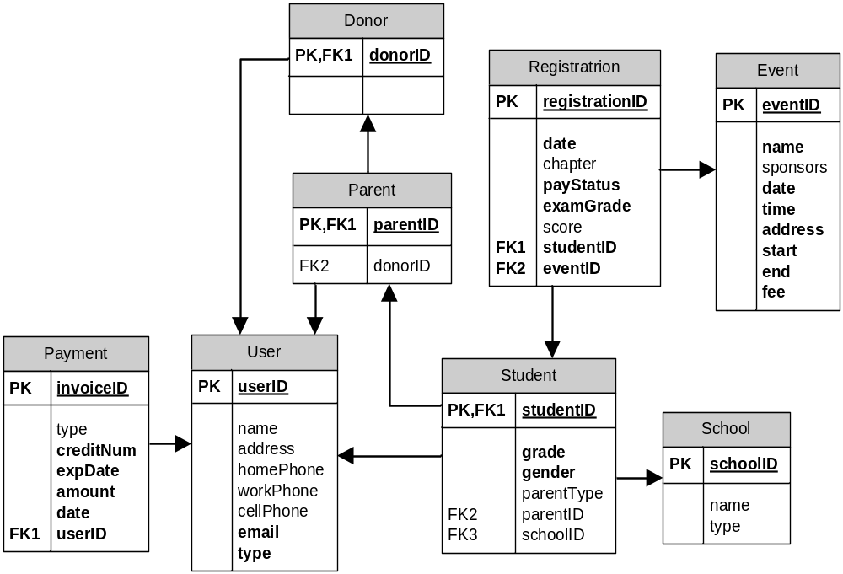

9. The data dictionary for the 3rd normalized relations

Entity Name | Description | Aliases | Occurrence
Parent | Guardians are also considered as a Parent in the system. A parent chaperones family-related student(s) by paying for their NMC event registration, view the scores of the students being chaperoned, view chapter and nationwide statistics, can also donate money to the NMC. |  | One per student
Student | A Student is a student enrolled in a school system belonging to a school grade (4-11). A Student has the ability to register for an NMC event, pay for the NMC event registration (above 18 years of age only), and check their previous NMC event registration scores, and view test preparation material. |  | typically many per event
Event | An ASEA national math competition | ASEA Competition, National Math Competition | At least one per year
Registration | A students information required to participate in an event | None | Several per event
School | A K-4 to 11 school. |  | One per student
User | User is a generic entity that generalizes Student, Parent and Donor.
Donor | A person making a donation to ASEA. Can be a parent, or any other person. |  | Many.
Payment | Payment description and amount. |  | One per registration.

Description of Relationships
Entity Name | Multiplicity | Relationship | Multiplicity | Entity Name
Student | 0..* | Is | 1..1 | User
Parent | 0..* | Is | 1..1 | User
Donor | 0..* | Is | 1..1 | User
Student | 1..* | IsChildOf | 0..1 | Parent
Student | 0..* | Attends | 1..1 | School
Student | 1..1 | Registers | 0..* | Registration
Event | 1..1 | AssociatedWith | 0..* | Registration
Registration | 1..1 | Contains | 1..1 | Payment
Parent | 0..1 | IsDonor | 0..1 | Donor
Donor | 1..1 | Makes | 1..* | Payment
Description of Attributes
Entity name | Attributes | Description | Data type & Length | Nulls | Multi-valued | Composite | Derived | Default Value
Parent | parentID {PK} | Identification number. | Integer | No | No
 | donorID {FK} | Identification number. | Integer | Yes | No
Student | studentID {PK} | Identification number. | Integer | No | No
 | grade | School grade | Char[2] | No | No
 | gender | Gender | Char[1] | No | No
 | parentType | Parent relationship | Char[20] | Yes | No
 | parented {FK} | Identification number. | Integer | No | No
 | schoolID {FK} | Identification number. | Integer | No | No
User | userID {PK} | Identification Number | Integer | No | No
 | name | Donor Name | Char[25] | Yes | No
 | address | Address | Char[50] | Yes | No
 | homePhone | Home phone number. | Char[10] | Yes | No
 | workPhone | Work phone number. | Char[10] | Yes | No
 | cellPhone | Cell phone number. | Char[10] | Yes | No
 | Email {AK} | Email Address | Char[25] | No | No
Event | eventID {PK} | Identification number. | Integer | No | No
 | name | Event Name | Char[25] | No | No
 | sponsors | Sponsor names | VarChar[50] | Yes | No
 | date | Date of event | Date | No | No
 | time | Time of event | Time | No | No
 | locationAddress | Addess of the event location. | Char[50] | No | No
 | registrationStart | Start date of registration | Date | No | No
 | registrationEnd | End date of registration | Date | No | No
 | fee | Event fee. | Money | No | No
Registration | regID {PK} | Identification Number | Integer | No | No
 | date | Date registered | Date | No | No
 | chapterAssociation | Chapter Association | Char[25] | Yes | No
 | paymentStatus | Payment status. | Char[10] | No | No |  | Yes
 | examGrade | Grade level of exam. | Char[2] | No | No
 | score | Exam score | Integer | Yes | No
 | studentID {FK} | Identification number. | Integer | No | No
 | eventide {FK} | Identification number. | Integer | No | No
School | schoolID {PK} | Identification Number | Integer | No | No
 | name | School Name | Char[25] | Yes | No
 | type | School Type | Char[10] | Yes | No
Payment | invoiceID {PK} | Identification Number | Integer | No | No
 | type | Payment type | Char[10] | No | No
 | creditNum | Credit card number. | Char[25] | No | No
 | expDate | Expiration date. | Date | No | No
 | amount | Amount | Money | No | No
 | date | Payment Date | Date | No | No
 | userID {FK} | Identification number. | Integer | No | No

Step 2.3

Student/Parent View:

1. A database model diagram with transaction pathways

a) Parent/Student enter registration details.
b) Parent/Student enter their payment information
c) Parent/Student query registration status.
d) Parent/Student update registration information
e) Parent/Student generate a report on their score at an event
f) Donor enters payment information
g) Donor queries their donation status
h) User queries events open for registration

Step 2.4

Student/Parent View:

1. The revised relational schema

User (userID, name, address, homePhone, workPhone, cellPhone, email, userType)
Primary Key userID
Alternate Key email

Student (studentID, grade, gender, parentType, parentID, schoolID)
Primary Key studentID
Foreign Key studentID references User(userID) ON UPDATE CASCADE ON DELETE CASCADE
Foreign Key parentID references Parent(parentID) ON UPDATE CASCADE ON DELETE SET NULL
Foreign Key schoolID references School(schoolID) ON UPDATE CASCADE ON DELETE SET NULL

Parent (parentID, donorID)
Primary Key parentID
Foreign Key parentID references User(userID) ON UPDATE CASCADE ON DELETE CASCADE
Foreign Key donorID references Donor(donorID) ON UPDATE CASCADE ON DELETE SET NULL

Donor (donorID)
Primary Key donorID
Foreign Key donorID references User(userID) ON UPDATE CASCADE ON DELETE CASCADE

School (schoolID, name, type)
Primary Key schoolID

Registration (registrationID, date, chapterAssociation, paymentStatus, examGrade, score, studentID, eventID)
Primary Key registrationID
Foreign Key studentID references Student(studentID) ON UPDATE CASCADE ON DELETE CASCADE
Foreign Key eventID references Event(eventID) ON UPDATE CASCADE ON DELETE CASCADE

Event (eventID, name, sponsors, date, time, locationAddress, registrationStart, registrationEnd, fee)
Primary Key eventID

Payment (invoiceID, type, creditNum, expDate, amount, date, type, userID)
Primary Key invoiceID
Foreign Key userID references User(userID) UPDATE CASCADE ON DELETE CASCADE

2. The revised relations with occurrences

User
userID | name | address | homePhone | workPhone | cellPhone | email | type
00001 | A1 Stu | 112 1st St | 223-2332 | Null | Null | astu@email.com | S
00002 | B Stu | 211 2nd St | Null | Null | Null | bstu@email.com | S
00003 | A Par | 112 1st St | 223-2332 | Null | 232-2132 | apar@email.com | P
00004 | A Don | 9 9th Ave | 123-2323 | 134-4322 | Null | adon@email.com | D
00005 | A2 Stu | 112 1st St | 223-2332 | Null | 433-3232 | apar@email.com | S
00006 | B Par | 112 1st St | 223-2332 | Null | Null | bpar@email.com | P
00007 | C Stu | 32 3rd St | Null | Null | Null | cstu@email.com | S
00008 | C Par | 32 3rd St | 432-3233 | 133-3232 | Null | cpar@email.com | P
00009 | D Stu | 113 4th St | 111-1111 | Null | Null | dstu@email.com | S
00010 | E Stu | 232 E st | 222-2222 | Null | Null | estu@email.com | S

Student
studentID | grade | gender | parentType | parentID | schoolID
00001 | 08 | M | Father | 00003 | 0001
00002 | 11 | F | Mother | 00006 | 0002
00005 | 09 | M | Father | 00003 | 0001
00007 | 10 | F | Guardian | 00008 | 0003
00009 | 10 | M | Null | Null | Null
00010 | 07 | F | Null | Null | 0005

Parent
parentID | donorID
00003 | 00003
00006 | Null
00008 | Null

Donor
donorID
00003
00004

School
schoolID | name | type
0001 | South Middle School | M
0002 | Null | Null
0003 | North High School | H
0004 | East Elementary School | E
0005 | Null | Null
0006 | Forest Gump Middle School | M

Registration
regID | Date | Chapter | payStatus | examGrade | Score | userID | eventID
00001 | 1/30/06 | PNC | T | 7 | 90 | 00001 | 0001
00002 | 2/30/06 | PNC | T | 11 | 50 | 00002 | 0001
00003 | 3/1/06 | SCC | T | 9 | 80 | 00005 | 0001
00004 | 3/1/06 | PNC | T | 9 | 50 | 00007 | 0001
00005 | 3/7/06 | PNC | T | 9 | 95 | 00009 | 0001
00006 | 1/30/07 | PNC | T | 8 | Null | 00001 | 0002
00007 | 2/30/07 | PNC | F | 11 | Null | 00002 | 0002
00008 | 3/17/07 | SCC | T | 9 | Null | 00005 | 0002
00009 | 3/17/07 | PNC | T | 10 | Null | 00009 | 0002
00010 | 3/18/07 | PNC | T | 7 | Null | 00010 | 0002

Event
id | name | sponsors | date | time | address | start | end | fee
0001 | 5th ASEA National Mathematics Competition | ASEA | 4/21/06 | 08:00 | Microsoft Conference Center (Building 33)  16070 NE 36th Way, Bldg. #33, Redmond, WA. 98052 | 1/1/06 | 4/14/06 | 35
0002 | 6th ASEA National Mathematics Competition | ASEA | 4/21/07 | 09:00 | Microsoft Conference Center (Building 33)  16070 NE 36th Way, Bldg. #33, Redmond, WA. 98052 | 1/1/07 | 4/14/07 | 35

Payment
invoiceID | type | creditNum | expDate | amount | date | userID
000001 | Credit | 1111222233334444 | 1/1/09 | 30 | 1/30/06 | 00003
000002 | Credit | 1010202030304040 | 10/1/06 | 35 | 2/30/06 | 00002
000003 | Credit | 1111222233334444 | 1/1/09 | 30 | 3/1/06 | 00003
000004 | Credit | 1234123412341234 | 4/4/10 | 35 | 3/1/06 | 00007
000005 | Credit | 2323333323233333 | 1/10/08 | 35 | 3/7/06 | 00009
000006 | Credit | 1111222233334444 | 1/1/09 | 30 | 1/30/07 | 00003
000007 | Credit | 1111222233334444 | 1/1/09 | 30 | 3/17/07 | 00003
000008 | Credit | 8765123487651234 | 2/2/10 | 35 | 3/17/07 | 00009
000009 | Credit | 1000200030004000 | 2/1/08 | 35 | 3/18/07 | 00010

3. The revised logical (MS Visio) database model diagram

The revised data dictionary

No changes from previous step.

Step 2.5

Student/Parent View:

No changes from previous step.

2.6 Combined Team steps:

2.6.1 Each team merges logical data models into a global model

A comparison of the names of relations and their candidate keys in all user views .

Parent/Student View |  | Volunteer View |  | Administrator View
Entity | Candidate Keys | Entity | Candidate Keys | Entity | Candidate Keys
User | userID
Parent | parentID | Parent | email
Student | studentID | Student | studentID | Student | studentID
Donor | donorID
 |  | Volunteer | volunteerID | Volunteer | volID
 |  |  |  | Administrator | adminID
Registration | registrationID |  |  | StudentRegistration | eventID
 |  |  |  |  | studentID
 |  |  |  | VolunteerRegistration | eventID
 |  |  |  |  | volID
Event | eventID | Event | eventID | Event | eventID
School | schoolID
Payment | invoiceID
 |  | Score | eventID | ExamResult | testNo
 |  |  | studentID
 |  |  |  | Address | addressNo
 |  |  |  | Sponsor | sponsorID
 |  |  |  | Answer | questionNo

A comparison of the foreign keys in all user views

Parent/Student View |  |  | Volunteer View |  |  | Administrator View
Child Releation | Foreign Keys | Parent Relation | Child Releation | Foreign Keys | Parent Relation | Child Releation | Foreign Keys | Parent Relation
Student | studentID | User(userID) | Student | eventID | Event(eventID)
 | parentID | Parent(parentID) |  | email | Parent(email)
 | schoolID | School(schoolID)
Parent | parentID | User(userID)
 | donorID | Donor(donorID)
Donor | donorID | User(userID)
 |  |  | Volunteer | eventID | Event(eventID) | Volunteer | addressNo | Address(addressNo)
 |  |  |  |  |  |  | adminID | Administrator(adminID)
 |  |  |  |  |  | Administrator | addressNo | Address(addressNo)
 |  |  |  |  |  | Event | addressNo | Address(addressNo)
 |  |  |  |  |  |  | adminID | Administrator(adminID)
Registration | userID | User(userID) |  |  |  | StudentRegistration | userID | Student(studentID)
 | eventID | Event(eventID) |  |  |  |  | eventID | Event(eventID)
 |  |  |  |  |  | VolunteerRegistration | volID | Volunteer(volID)
 |  |  |  |  |  |  | eventID | Event(eventID)
Payment | userID | User(userID)
 |  |  | Score | eventID | Event(eventID) | ExamResult | eventID | Event(eventID)
 |  |  |  | studentID | Student(studentID) |  | studentID | Student(studentID)
 |  |  |  |  |  | Answer | testNo | ExamResult(testNo)

Global Relational Schema
School (schoolID, name, type)
Primary Key schoolID

Parent (parentID, donorID)
Primary Key parentID
Foreign Key donorID references Donor(donorID) ON UPDATE CASCADE ON DELETE SET NULL

Donor (donorID)
Primary Key donorID

Student (studentID, grade, gender, relation, parentID, schoolID)
Primary Key studentID
Foreign Key schoolID references School(schoolID) ON UPDATE CASCADE ON DELETE CASCADE
Foreign Key parentID references Parent(parentID) ON UPDATE CASCADE ON DELETE SET NULL

Score (registrationID, n1, n2, n3, g1, g2, g3)
Primary Key registrationID
Foreign Key registrationID references Registration(registrationID) ON UPDATE CASCADE ON DELETE CASCADE

User (userID, fName, lName, mi, address, homePhone, workPhone, cellPhone, chapter, email, type)
Primary Key userID

Volunteer (volID, willVolAgain, occupation, adminID, userID)
Primary Key volID
Foreign Key adminID references Administrator(adminID) ON UPDATE CASCADE ON DELETE SET NULL
Foreign Key userID references User(userID) ON UPDATE CASCADE ON DELETE CASCADE

Registration (registrationID, userID, eventID, date, payStatus, examGrade, score, infosource)
Primary Key registrationID
Foreign Key userID references User(userID) ON UPDATE CASCADE ON DELETE CASCADE
Foreign Key eventID references Event(eventID) ON UPDATE CASCADE ON DELETE CASCADE

Adminstrator (adminID, company)
Primary Key adminID

Sponsor (sponsorID, name, eventID)
Primary Key sponsorID
Foreign Key eventID references Event(eventID) ON UPDATE CASCADE ON DELETE SET NULL

Payment (invoiceID, type, creditNum, expDate, amount, date, userID)
Primary Key invoiceID
Foreign Key userID references User(userID) ON UPDATE CASCADE ON DELETE CASCADE

Event (eventID, name, date, time, fee, address, start, end, adminID)
Primary Key eventID
Foreign Key adminID references Administrator(adminID) ON UPDATE CASCADE ON DELETE CASCADE

Global Database Model Diagram
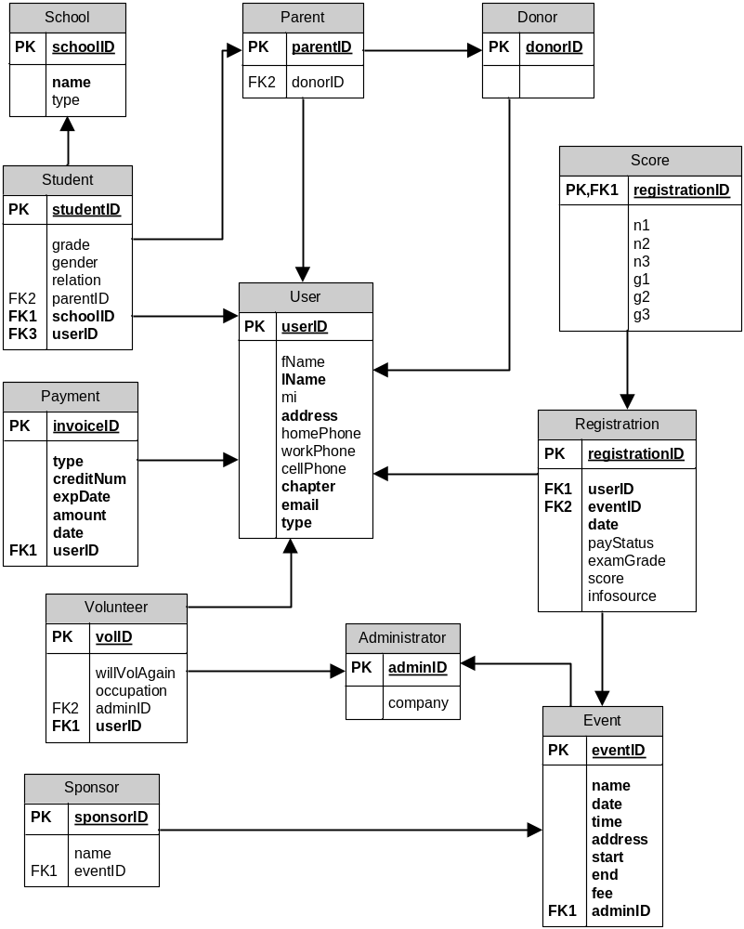

Description of Entities
Entity Name | Description | Aliases | Occurrence
Parent | Guardians are also considered as a Parent in the system. A parent chaperones family-related student(s) by paying for their NMC event registration, view the scores of the students being chaperoned, view chapter and nationwide statistics, can also donate money to the NMC. |  | One per student
Student | A Student is a student enrolled in a school system belonging to a school grade (4-11). A Student has the ability to register for an NMC event, pay for the NMC event registration (above 18 years of age only), and check their previous NMC event registration scores, and view test preparation material. |  | typically many per event
Event | An ASEA national math competition | ASEA Competition, National Math Competition | At least one per year
Registration | A students information required to participate in an event | None | Several per event
School | A K-4 to 11 school. |  | One per student
User | User is a generic entity that generalizes Student, Parent and Donor.
Donor | A person making a donation to ASEA. Can be a parent, or any other person. |  | Many.
Payment | Payment description and amount. |  | One per registration.
Score | The result of a students participation in an ASEA event. | ExamResult | One per student per event
Volunteer | A volunteer is an unpaid assistant helping with managing the event. They can update student information (other than credit card data), proctor exams, enter exam results, and update their own information. |  | Several per event
Administrator | An administrator must be a member of ASEA. Also, the person must be the president of the local chapter or a designated officer for this event. An administrator can see all information in the system except for other administrator information. | ASEA officer | At least one per ASEA chapter
Sponsor | The event corporate sponsor |  | Typically one or more per event

Description of Relationships
Entity Name | Multiplicity | Relationship | Multiplicity | Entity Name
Student | 0..* | Is | 1..1 | User
Parent | 0..* | Is | 1..1 | User
Donor | 0..* | Is | 1..1 | User
Student | 1..* | IsChildOf | 0..1 | Parent
Student | 0..* | Attends | 1..1 | School
Student | 1..1 | Registers | 0..* | Registration
Event | 1..1 | AssociatedWith | 0..* | Registration
Registration | 1..1 | Contains | 1..1 | Payment
Parent | 0..1 | IsDonor | 0..1 | Donor
Donor | 1..1 | Makes | 1..* | Payment
Administrator | 1..1 | Registers | 0..* | Administrator
Administrator | 0..* | Manages | 1..* | Event
Administrator | 1..* | Manages | 0..* | Student
Administrator | 0..* | Manages | 0..* | Volunteer
Volunteer | 0..* | Updates | 0..* | Event
Volunteer | 0..* | Manages | 1..* | Student
Event | 1..1 | Generates | 1..* | Score
Student | 1..1 | Receives | 0..1 | Score
Student | 1..1 | Attends | 0..* | Event
Sponsor | 0..* | Sponsors | 0..* | Event
Volunteer | 0..1 | manages | 0..* | Event
Volunteer | 0..1 | Updates | 0..* | Student
Volunteer | 0..1 | Updates | 0..* | Parent
Parent | 1..1 | Parents | 1..* | Student
Student | 1..1 | Attends | 0..* | Event
Student | 1..1 | TestResults | 0..* | Score

Description of Attributes
Entity name | Attributes | Description | Data type & Length | Nulls | Multi-valued | Composite | Derived
School | schoolID | Identification Number | Integer | No | No | No | No
School | name | School Name | Char(20) | No | No | No | No
School | type | School Type | Char(1) | Yes | No | No | No
Parent | parentID | Identification number. | Integer | No | No | No | No
Parent | donorID | Identification number. | Integer | Yes | No | No | No
Donor | donorID | Identification number. | Integer | No | No | No | No
Student | studentID | Identification number. | Integer | No | No | No | No
Student | grade | School grade | Char(2) | Yes | No | No | No
Student | gender | Gender | Char(1) | Yes | No | No | No
Student | relation | Parent relationship | Char(1) | Yes | No | No | No
Student | parentID | Identification number. | Integer | Yes | No | No | No
Student | schoolID | Identification number. | Integer | No | No | No | No
Student | userID | Identification number | Integer | No | No | No | No
Score | registrationID | Identification number | Integer | No | No | No | No
Score | n1 | Correct answers 1-10 | Integer | Yes | No | No | No
Score | n2 | Correct answers 11-20 | Integer | Yes | No | No | No
Score | n3 | Correct answers 21-30 | Integer | Yes | No | No | No
Score | g1 | n1+n2+n3 | Integer | Yes | No | No | Yes
Score | g2 | n1+n2 | Integer | Yes | No | No | Yes
Score | g3 | n1 | Integer | Yes | No | No | Yes
User | userID | Identification Number | Integer | No | No | No | No
User | fName | User’s first name | Char(10) | Yes | No | No | No
User | lName | User’s last name | Char(25) | No | No | No | No
User | mi | User’s middle initial | Char(1) | Yes | No | No | No
User | address | User’s address | Char(60) | No | No | No | No
User | homePhone | Home phone number. | Char(10) | Yes | No | No | No
User | workPhone | Work phone number. | Char(10) | Yes | No | No | No
User | cellPhone | Cell phone number. | Char(10) | Yes | No | No | No
User | chapter | ASEA chapter | Char(10) | No | No | No | No
User | email | User’s email address | Char(30) | No | No | No | No
User | type | User type | Char(1) | No | No | No | No
Volunteer | volID | The volunteer ID number | Integer | No | No | No | No
Volunteer | willVolAgain | T/F if they will volunteer again | Single | Yes | No | No | No
Volunteer | Occupation | Their job or occupation | Char(30) | Yes | No | No | No
Volunteer | adminID | The ID of the administrator who registered the volunteer | Integer | Yes | No | No | no
Volunteer | userID | The user ID | Integer | No | No | No | No
Registration | registrationID | The registration ID | Integer | No | No | No | No
Registration | userID | User ID | Integer | No | No | No | No
Registration | eventID | Event ID | Integer | No | No | No | No
Registration | Date | Registration date | Datetime | No | No | No | No
Registration | payStatus | Payment status. | Char(1) | Yes | No | No | No
Registration | examGrade | Grade level of exam. | Char(3) | Yes | No | No | No
Registration | score | Exam score | Char(10) | Yes | No | No | No
Registration | infosource | How the user found about the event | Char(20) | Yes | No | No | No
Administrator | adminID | The administers ASEA ID number | Integer | No | No | No | No
Administrator | company | The company the administer works for | Char(20) | Yes | No | No | No
Sponsor | sponsorID | The sponsor ID number | Integer | No | No | No | No
Sponsor | name | The name of the sponsor | Char(20) | Yes | No | No | No
Sponsor | eventID | The event the sponsor is associated with | Integer | Yes | No | No | No
Payment | invoiceID | Identification Number | Integer | No | No | No | No
Payment | type | Payment type | Char(20) | No | No | No | No
Payment | creditNum | Credit card number. | Char(16) | No | No | No | No
Payment | expDate | Expiration date. | Datetime | No | No | No | No
Payment | amount | Amount | Currency | No | No | No | No
Payment | date | Payment Date | Datetime | No | No | No | No
Payment | userID | Identification number. | Integer | No | No | No | No
Event | eventID | The event ID number | Integer | No | No | No | No
Event | name | The name of the event | Char(30) | No | No | No | No
Event | date | The date of the event | Datetime | No | No | No | No
Event | time | The time of the event | Datetime | No | No | No | No
Event | fee | The registration fee | Currency | No | No | No | No
Event | address | The event address | Char(60) | No | No | No | No
Event | start | The registration start date | Datetime | No | No | No | No
Event | end | The registration end date | Datetime | No | No | No | No
Event | adminID | The event admin ID | Integer | No | No | No | No

2.6.2. Each team validates the global logical model.

No changes

2.6.3. Each team reviews the global logical model with users.

No changes.

2.7. Each team checks the global logical model for future growth.
No Changes.

