2.1.i Local relational schema
Volunteer (volunteerId, fname, lname, workPhone, cellPhone, homePhone, street, city, state, zip, occupation, willVolAgain, email, eventID)  Primary Key volunteerId  Foreign Key eventID references Event(eventID) | Student (studentID, fName, lName, middleName, street, city, state, zip, homePhone, cellPhone, schoolLevel, schoolName, examGrade, gender, infoSource, studentEmail, eventID, email)  Primary Key studentID  Foreign Key eventID references Event (eventID) email references Parent (email)
Parent (email, fName, lName, middleName, cellPhone, workPhone)  Primary Key email | Event (eventID, date, street, city, state, zip, sponsor, regStart, regEnd, fee, time)  Primary Key eventID
Score (eventID, studentID, date, N1, N2, N3, G1, G2, G3, R2, R3)
Primary Key eventID, studentID
Foreign Key eventID references Event (eventID) studentID references Student (studentID)

2.1.ii Unnormalized relations
Volunteer
volunteerId | fname | lname | workPhone | cellPhone | homePhone | street | city | state | zip | occupation | willVolAgain | eMail | eventID
1 | Joe | Smith | Null | Null | Null | 123 Main | Tacoma | WA | 98122 | Null | Yes | joe@email.com | 1
2 | Pete | Smith | 206-567-1926 | 206-567-1926 | Null | Null | Seattle | WA | 98122 | Professor | Null | Pete@email.com | 1
3 | Suzy | Jones | 206-567-1936 | 206-567-1936 | Null | 234 South | Tacoma | WA | 98122 | Sales | Yes | Suzy@mail.com | 1
4 | Al | Chun | Null | Null | 425-555-8989 | 22 Jones | Gig harbor | WA | 98122 | Teacher | Yes | Al@mail.com | 1
5 | Jane | Doe | 206-567-1921 | 206-567-1921 | Null | 12 Main | Olympia | WA | 98122 | Null | No | Jane@gmail.com | 1
6 | Pete | Pen | 206-567-1922 | 206-567-1922 | Null | 3 Red | Bellevue | WA | 98122 | Homemmaker | Null | Pete@gmail.com | 1
7 | Jill | Jud | 206-567-1925 | 206-567-1925 | 425-222-1818 | 56 South | Tacoma | WA | 98122 | Null | Yes | Jill@mail.com | 1

Student
Student ID | fname | lName | middle Name | street | city | state | zip | Home Phone | Cell Phone | School Level | School Name | Exam Grade | gender | Info Source | Student Email | eventID | email
1 | Jim | Jones | E | 12 Main | Tacoma | WA | 98123 | Null | 206-777-2145 | 8 | Smith | 8 | M | School | Jim@mail.com | 1 | mom@mom.com
2 | Pete | Seeger | Null | 34 Main | Tacoma | WA | 98123 | 206-777-2345 | 206-777-2445 | 9 | Jones | 9 | M | Web | Pete@mail.com | 1 | dad@dad.com
3 | Alice | Wu | June | 34 South | Tacoma | WA | 98123 | 246-777-2345 | Null | 7 | Null | 7 | F | School | Alice@mail.com | 1 | mom@mom.net
4 | Jane | Smith | Null | 54 West | Tacoma | WA | 98123 | 226-777-2345 | 206-787-2345 | 7 | Jones | 7 | F | Teacher | Jane@mail.com | 1 | dad@dad.net
5 | Neve | Camb | S | 67 North | Tacoma | WA | 98123 | 206-777-8945 | 206-777-2346 | 9 | Jones | 9 | F | Web | Neve@mail.com | 1 | mom@mom.uk

Parent
Email | fName | lName | middleName | cellPhone | workPhone
mom@mom.com | June | Jones | Null | 206-555-1212 | Null
dad@dad.com | Pete | Seeger | Bert | Null | 425-676-2345
mom@mom.net | Jane | Wu | Alice | 425-234-9090 | null
dad@dad.net | Jimmy | Smith | Null | 425-212-9012 | Null
mom@mom.uk | Susan | Camb | jane | 206-345-1923 | 345-262-1234

Event
eventID | date | street | city | state | zip | sponsor | regStart | regEnd | fee | Time
1 | 6/15/2008 | 123 Main | Bellevue | WA | 91234 | MicroSoft | 1/1/2008 | 5/1/2008 | 45 | 9:00

Score
eventID | studentID | date | N1 | N2 | N3 | G1 | G2 | G3 | R2 | R3
2 | 1 | 1/1/2007 | 5 | 2 | 6 | 13 | 8 | 6 | Null | Null
3 | 2 | 7/1/2007 | 5 | 3 | 8 | 16 | 11 | 8 | Null | Null

2.2.i Dependency diagram
Volunteer | Dependencies | Student | Dependencies
volunteerId |  | studentID
fname | volunteerId | fname | studentID
lname | volunteerId | lname | studentID
workPhone | volunteerId | middleName | studentID
cellPhone | volunteerId | street | studentID
homePhone | volunteerId | city | studentID
street | volunteerId | state | studentID, zip
city | volunteerId | zip | studentID
state | volunteered, zip | homePhone | studentID
zip | volunteerId | cellPhone | studentID
occupation | volunteerId | schoolLevel | studentID
willVolAgain | volunteerId | schoolName | studentID
eventID |  | examGrade | studentID
 |  | Gender | studentID
 |  | infoSource | studentID
 |  | studentEmail | studentID
 |  | eventID
 |  | email

Parent | Dependencies | Event | Dependencies
email |  | eventID
fName | email | date | eventID
lName | email | street | eventID
middleName | email | city | eventID
cellPhone | email | state | eventID, zip
workPhone | email | zip | eventID
 |  | sponsor | eventID
 |  | regStart | eventID
 |  | regEnd | eventID
 |  | fee | eventID
 |  | time | eventID

Score | Dependencies
eventID
studentID
Date | eventID, studentID
N1 | eventID, studentID
N2 | eventID, studentID
N3 | eventID, studentID
G1 | eventID, studentID
G2 | eventID, studentID
G3 | eventID, studentID
R2 | eventID, studentID
R3 | eventID, studentID

2.2.ii 1NF relational schema
Volunteer (volunteerId, fname, lname, workPhone, cellPhone, homePhone, street, city, state, zip, occupation, willVolAgain, eventID)  Primary Key volunteerId  Foreign Key eventID references Event(eventID) | Student (studentID, fName, lName, middleName, street, city, state, zip, homePhone, cellPhone, schoolLevel, schoolName, examGrade, gender, infoSource, studentEmail, eventID, email)  Primary Key studentID  Foreign Key eventID references Event (eventID) email references Parent (email)
Parent (email, fName, lName, middleName, cellPhone, workPhone)  Primary Key email | Event (eventID, date, street, city, state, zip, sponsor, regStart, regEnd, fee, time)  Primary Key eventID
Score (eventID, studentID, date, N1, N2, N3, G1, G2, G3, R2, R3)
Primary Key eventID, studentID
Foreign Key eventID references Event (eventID) studentID references Student (studentID)

2.2.iii 1NF relations
Volunteer
volunteerId | fname | lname | workPhone | cellPhone | homePhone | street | city | state | zip | occupation | willVolAgain | eMail | eventID
1 | Joe | Smith | Null | Null | Null | 123 Main | Tacoma | WA | 98122 | Null | Yes | joe@email.com | 1
2 | Pete | Smith | 206-567-1926 | 206-567-1926 | Null | Null | Seattle | WA | 98122 | Professor | Null | Pete@email.com | 1
3 | Suzy | Jones | 206-567-1936 | 206-567-1936 | Null | 234 South | Tacoma | WA | 98122 | Sales | Yes | Suzy@mail.com | 1
4 | Al | Chun | Null | Null | 425-555-8989 | 22 Jones | Gig harbor | WA | 98122 | Teacher | Yes | Al@mail.com | 1
5 | Jane | Doe | 206-567-1921 | 206-567-1921 | Null | 12 Main | Olympia | WA | 98122 | Null | No | Jane@gmail.com | 1
6 | Pete | Pen | 206-567-1922 | 206-567-1922 | Null | 3 Red | Bellevue | WA | 98122 | Homemmaker | Null | Pete@gmail.com | 1
7 | Jill | Jud | 206-567-1925 | 206-567-1925 | 425-222-1818 | 56 South | Tacoma | WA | 98122 | Null | Yes | Jill@mail.com | 1

Student
Student ID | fname | lName | middle Name | street | city | state | zip | Home Phone | Cell Phone | School Level | School Name | Exam Grade | gender | Info Source | Student Email | eventID | email
1 | Jim | Jones | E | 12 Main | Tacoma | WA | 98123 | Null | 206-777-2145 | 8 | Smith | 8 | M | School | Jim@mail.com | 1 | mom@mom.com
2 | Pete | Seeger | Null | 34 Main | Tacoma | WA | 98123 | 206-777-2345 | 206-777-2445 | 9 | Jones | 9 | M | Web | Pete@mail.com | 1 | dad@dad.com
3 | Alice | Wu | June | 34 South | Tacoma | WA | 98123 | 246-777-2345 | Null | 7 | Null | 7 | F | School | Alice@mail.com | 1 | mom@mom.net
4 | Jane | Smith | Null | 54 West | Tacoma | WA | 98123 | 226-777-2345 | 206-787-2345 | 7 | Jones | 7 | F | Teacher | Jane@mail.com | 1 | dad@dad.net
5 | Neve | Camb | S | 67 North | Tacoma | WA | 98123 | 206-777-8945 | 206-777-2346 | 9 | Jones | 9 | F | Web | Neve@mail.com | 1 | mom@mom.uk

Parent
Email | fName | lName | middleName | cellPhone | workPhone
mom@mom.com | June | Jones | Null | 206-555-1212 | Null
dad@dad.com | Pete | Seeger | Bert | Null | 425-676-2345
mom@mom.net | Jane | Wu | Alice | 425-234-9090 | null
dad@dad.net | Jimmy | Smith | Null | 425-212-9012 | Null
mom@mom.uk | Susan | Camb | jane | 206-345-1923 | 345-262-1234

Event
eventID | date | street | city | state | zip | sponsor | regStart | regEnd | fee | Time
1 | 6/15/2008 | 123 Main | Bellevue | WA | 91234 | MicroSoft | 1/1/2008 | 5/1/2008 | 45 | 9:00

Score
eventID | studentID | date | N1 | N2 | N3 | G1 | G2 | G3 | R2 | R3
2 | 1 | 1/1/2007 | 5 | 2 | 6 | 13 | 8 | 6 | Null | Null
3 | 2 | 7/1/2007 | 5 | 3 | 8 | 16 | 11 | 8 | Null | Null
2.2.iv 2NF relational schema
Volunteer (volunteerId, fname, lname, workPhone, cellPhone, homePhone, street, city, state, zip, occupation, willVolAgain, eventID)  Primary Key volunteerId  Foreign Key eventID references Event(eventID) | Student (studentID, fName, lName, middleName, street, city, state, zip, homePhone, cellPhone, schoolLevel, schoolName, examGrade, gender, infoSource, studentEmail, eventID, email)  Primary Key studentID  Foreign Key eventID references Event (eventID) email references Parent (email)
Parent (email, fName, lName, middleName, cellPhone, workPhone)  Primary Key email | Event (eventID, date, street, city, state, zip, sponsor, regStart, regEnd, fee, time)  Primary Key eventID
Score (eventID, studentID, date, N1, N2, N3, G1, G2, G3, R2, R3)
Primary Key eventID, studentID
Foreign Key eventID references Event (eventID) studentID references Student (studentID)

2.2.v 2NF relations
Volunteer
volunteerId | fname | lname | workPhone | cellPhone | homePhone | street | city | state | zip | occupation | willVolAgain | eMail | eventID
1 | Joe | Smith | Null | Null | Null | 123 Main | Tacoma | WA | 98122 | Null | Yes | joe@email.com | 1
2 | Pete | Smith | 206-567-1926 | 206-567-1926 | Null | Null | Seattle | WA | 98122 | Professor | Null | Pete@email.com | 1
3 | Suzy | Jones | 206-567-1936 | 206-567-1936 | Null | 234 South | Tacoma | WA | 98122 | Sales | Yes | Suzy@mail.com | 1
4 | Al | Chun | Null | Null | 425-555-8989 | 22 Jones | Gig harbor | WA | 98122 | Teacher | Yes | Al@mail.com | 1
5 | Jane | Doe | 206-567-1921 | 206-567-1921 | Null | 12 Main | Olympia | WA | 98122 | Null | No | Jane@gmail.com | 1
6 | Pete | Pen | 206-567-1922 | 206-567-1922 | Null | 3 Red | Bellevue | WA | 98122 | Homemmaker | Null | Pete@gmail.com | 1
7 | Jill | Jud | 206-567-1925 | 206-567-1925 | 425-222-1818 | 56 South | Tacoma | WA | 98122 | Null | Yes | Jill@mail.com | 1

Student
Student ID | fname | lName | middle Name | street | city | state | zip | Home Phone | Cell Phone | School Level | School Name | Exam Grade | gender | Info Source | Student Email | eventID | email
1 | Jim | Jones | E | 12 Main | Tacoma | WA | 98123 | Null | 206-777-2145 | 8 | Smith | 8 | M | School | Jim@mail.com | 1 | mom@mom.com
2 | Pete | Seeger | Null | 34 Main | Tacoma | WA | 98123 | 206-777-2345 | 206-777-2445 | 9 | Jones | 9 | M | Web | Pete@mail.com | 1 | dad@dad.com
3 | Alice | Wu | June | 34 South | Tacoma | WA | 98123 | 246-777-2345 | Null | 7 | Null | 7 | F | School | Alice@mail.com | 1 | mom@mom.net
4 | Jane | Smith | Null | 54 West | Tacoma | WA | 98123 | 226-777-2345 | 206-787-2345 | 7 | Jones | 7 | F | Teacher | Jane@mail.com | 1 | dad@dad.net
5 | Neve | Camb | S | 67 North | Tacoma | WA | 98123 | 206-777-8945 | 206-777-2346 | 9 | Jones | 9 | F | Web | Neve@mail.com | 1 | mom@mom.uk

Parent
Email | fName | lName | middleName | cellPhone | workPhone
mom@mom.com | June | Jones | Null | 206-555-1212 | Null
dad@dad.com | Pete | Seeger | Bert | Null | 425-676-2345
mom@mom.net | Jane | Wu | Alice | 425-234-9090 | null
dad@dad.net | Jimmy | Smith | Null | 425-212-9012 | Null
mom@mom.uk | Susan | Camb | jane | 206-345-1923 | 345-262-1234

Event
eventID | date | street | city | state | zip | sponsor | regStart | regEnd | fee | Time
1 | 6/15/2008 | 123 Main | Bellevue | WA | 91234 | MicroSoft | 1/1/2008 | 5/1/2008 | 45 | 9:00

Score
eventID | studentID | date | N1 | N2 | N3 | G1 | G2 | G3 | R2 | R3
2 | 1 | 1/1/2007 | 5 | 2 | 6 | 13 | 8 | 6 | Null | Null
3 | 2 | 7/1/2007 | 5 | 3 | 8 | 16 | 11 | 8 | Null | Null
2.2.vi 3NF relational schema
Volunteer (volunteerId, fname, lname, workPhone, cellPhone, homePhone, street, city, state, zip, occupation, willVolAgain, eventID)  Primary Key volunteerId  Foreign Key eventID references Event(eventID) | Student (studentID, fName, lName, middleName, street, city, state, zip, homePhone, cellPhone, schoolLevel, schoolName, examGrade, gender, infoSource, studentEmail, eventID, email)  Primary Key studentID  Foreign Key eventID references Event (eventID) email references Parent (email)
Parent (email, fName, lName, middleName, cellPhone, workPhone)  Primary Key email | Event (eventID, date, street, city, state, zip, sponsor, regStart, regEnd, fee, time)  Primary Key eventID
Score (eventID, studentID, date, N1, N2, N3, G1, G2, G3, R2, R3)
Primary Key eventID, studentID
Foreign Key eventID references Event (eventID) studentID references Student (studentID)

2.2.vii 3NF relations
Volunteer
volunteerId | fname | lname | workPhone | cellPhone | homePhone | street | city | state | zip | occupation | willVolAgain | eMail | eventID
1 | Joe | Smith | Null | Null | Null | 123 Main | Tacoma | WA | 98122 | Null | Yes | joe@email.com | 1
2 | Pete | Smith | 206-567-1926 | 206-567-1926 | Null | Null | Seattle | WA | 98122 | Professor | Null | Pete@email.com | 1
3 | Suzy | Jones | 206-567-1936 | 206-567-1936 | Null | 234 South | Tacoma | WA | 98122 | Sales | Yes | Suzy@mail.com | 1
4 | Al | Chun | Null | Null | 425-555-8989 | 22 Jones | Gig harbor | WA | 98122 | Teacher | Yes | Al@mail.com | 1
5 | Jane | Doe | 206-567-1921 | 206-567-1921 | Null | 12 Main | Olympia | WA | 98122 | Null | No | Jane@gmail.com | 1
6 | Pete | Pen | 206-567-1922 | 206-567-1922 | Null | 3 Red | Bellevue | WA | 98122 | Homemmaker | Null | Pete@gmail.com | 1
7 | Jill | Jud | 206-567-1925 | 206-567-1925 | 425-222-1818 | 56 South | Tacoma | WA | 98122 | Null | Yes | Jill@mail.com | 1

Student
Student ID | fname | lName | middle Name | street | city | state | zip | Home Phone | Cell Phone | School Level | School Name | Exam Grade | gender | Info Source | Student Email | eventID | email
1 | Jim | Jones | E | 12 Main | Tacoma | WA | 98123 | Null | 206-777-2145 | 8 | Smith | 8 | M | School | Jim@mail.com | 1 | mom@mom.com
2 | Pete | Seeger | Null | 34 Main | Tacoma | WA | 98123 | 206-777-2345 | 206-777-2445 | 9 | Jones | 9 | M | Web | Pete@mail.com | 1 | dad@dad.com
3 | Alice | Wu | June | 34 South | Tacoma | WA | 98123 | 246-777-2345 | Null | 7 | Null | 7 | F | School | Alice@mail.com | 1 | mom@mom.net
4 | Jane | Smith | Null | 54 West | Tacoma | WA | 98123 | 226-777-2345 | 206-787-2345 | 7 | Jones | 7 | F | Teacher | Jane@mail.com | 1 | dad@dad.net
5 | Neve | Camb | S | 67 North | Tacoma | WA | 98123 | 206-777-8945 | 206-777-2346 | 9 | Jones | 9 | F | Web | Neve@mail.com | 1 | mom@mom.uk

Parent
Email | fName | lName | middleName | cellPhone | workPhone
mom@mom.com | June | Jones | Null | 206-555-1212 | Null
dad@dad.com | Pete | Seeger | Bert | Null | 425-676-2345
mom@mom.net | Jane | Wu | Alice | 425-234-9090 | null
dad@dad.net | Jimmy | Smith | Null | 425-212-9012 | Null
mom@mom.uk | Susan | Camb | jane | 206-345-1923 | 345-262-1234

Event
eventID | date | street | city | state | zip | sponsor | regStart | regEnd | fee | Time
1 | 6/15/2008 | 123 Main | Bellevue | WA | 91234 | MicroSoft | 1/1/2008 | 5/1/2008 | 45 | 9:00

Score
eventID | studentID | date | N1 | N2 | N3 | G1 | G2 | G3 | R2 | R3
2 | 1 | 1/1/2007 | 5 | 2 | 6 | 13 | 8 | 6 | Null | Null
3 | 2 | 7/1/2007 | 5 | 3 | 8 | 16 | 11 | 8 | Null | Null
2.2.viii logical database model
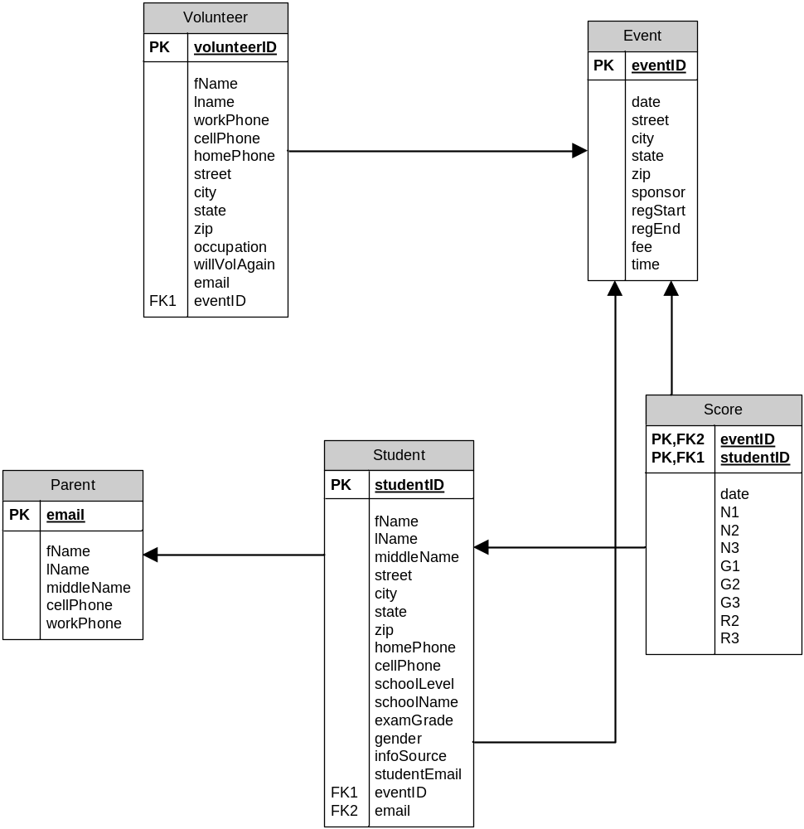
Data dictionary:
Entity Name | Description | Aliases | Occurrence
Volunteer | A volunteer is an unpaid assistant helping with managing the event. They can update student information (other than credit card data), proctor exams, enter exam results, and update their own information. |  | Typically many per event
Parent | Guardians are also considered as a Parent in the system. A parent chaperones family-related student(s) by paying for their NMC event registration, view the scores of the students being chaperoned, view chapter and nationwide statistics, can also donate money to the NMC. |  | One per student
Event | An ASEA national math competition | ASEA Competition, National Math Competition | At least one per year
Student | A Student is a student enrolled in a school system belonging to a school grade (4-11). A Student has the ability to register for an NMC event, pay for the NMC event registration (above 18 years of age only), and check their previous NMC event registration scores, and view test preparation material. |  | typically many per event
Score | The result of a students participation in an ASEA event. | exam result | One per student per event

Description of relationships
Entity Name | Multiplicity | Relationship | Multiplicity | Entity Name
Volunteer | 0-1 | manages | 0-* | Event
Volunteer | 0-1 | Updates | 0-* | Student
Volunteer | 0-1 | Updates | 0-* | Parent
Parent | 1-1 | Parents | 1-* | Student
Student | 1-1 | Attends | 0-* | Event
Student | 1-1 | TestResults | 0-* | Score

Step 2.3 Transaction pathways
Data Entry
Enter the details of a new volunteer | Volunteer
Enter the details of a new parent | green
Enter the details of a new student | Student
Enter grades for an event | Yellow
Enter the details for a new event | Event
Data Update/deletion
Update score information | yellow
Update volunteer information | Volunteer
Update/delete parent information | Green
Update/delete student information | Student
Update volunteer passwords | Volunteer
Update parent passwords | Parent
Update student passwords | Student
Update/delete student registration | Student
Data Queries
Generate a report of previous participants | Blue
Generate a report of events within the next three months | Event
Generate a report of events within the next month | Event
Generate a report of events within the next week | Event
Generate a report of registered students for an event | Blue
Generate a report of registered parents for an event | Blue, green
Generate a report of registered volunteers for an event | Red
Locate a parent’s record (by ID, name, address, location, etc.) | Parent
Locate a student’s record (by ID, name, address, location, etc.) | Student

2.4
Volunteer (volunteerId, fname, lname, workPhone, cellPhone, homePhone, street, city, state, zip, occupation, willVolAgain, eventID)  Primary Key volunteerId  Foreign Key eventID references Event(eventID) ON UPDATE CASCADE ON DELETE SET NULL | Student (studentID, fName, lName, middleName, street, city, state, zip, homePhone, cellPhone, schoolLevel, schoolName, examGrade, gender, infoSource, studentEmail, eventID, email)  Primary Key studentID  Foreign Key eventID references Event (eventID) ON UPDATE CASCADE ON DELETE SET NULL  email references Parent (email) ON UPDATE CASCADE ON DELETE SET NULL
Parent (email, fName, lName, middleName, cellPhone, workPhone)  Primary Key email | Event (eventID, date, street, city, state, zip, sponsor, regStart, regEnd, fee, time)  Primary Key eventID
Score (eventID, studentID, date, N1, N2, N3, G1, G2, G3, R2, R3)
Primary Key eventID, studentID
Foreign Key eventID references Event (eventID) ON UPDATE CASCADE ON DELETE CASCADE
studentID references Student (studentID) ON UPDATE CASCADE ON DELETE CASCADE

2.5
No changes

