Step 2.1

Administrator View:

1. Local relational schema

Student (studentID, name, fName, lName, mi, schoolGrade, chapter)
Primary Key studentID

Registration (registrationID, paymentStatus, paymentMethod, date)
Primary Key registrationID

Event (eventID, name, sponsor, date, time, fee, address, city, street, state, zip, registrationStart, registrationEnd, contact)
Primary Key eventID

Administrator(adminID, name, fName, lName, mi, address, street, city, state, zip, telNo, email, company)
Primary Key adminID

Volunteer(email, name, fName, lName, mi, address, street, city, state, zip, workPhone, homePhone, willVolAgain, occupation)
Primary Key email

ExamResult(examID, score, answers, n1, n2, n3, g1, g2, g3)
Primary Key examID

2. Unnormalized local relations

Student
studentID | Name | fName | lName | Mi | schoolGrade | chapter
00001 | John A Smith | John | Smith | A | 5 | PNW
00002 | Frank B Samson | Frank | Samson | B | 6 | PNW
00003 | Tom C King | Tom | King | C | 7 | PNW
00004 | Lisa D Johnson | Lisa | Johnson | D | 8 | SoCal
00005 | Tina E McAdam | Tina | McAdam | E | 9 | NorCal
00006 | Kate F Calvary | Kate | Calvary | F | 10 | PNW
00007 | Joe G Smyth | Joe | Smyth | G | 11 | SoCal
00008 | Peter H Fish | Peter | Fish | H | 9 | SoCal
00009 | Sarah I Peterson | Sarah | Peterson | I | 6 | PNW
00010 | George J Allyne | George | Allyne | J | 11 | NorCal

VolunteerRegistration
registrationID | paymentStatus | paymentMethod | date
00001 | Pending | Credit Card | 02/10/2007
00002 | Delinquent | Credit Card | 03/12/2007
00003 | Paid | Credit Card | 06/21/2007

Event
eventID | name | sponsors | date | time | fee | address | street | city | state | zip | registrationStart | registrationEnd | contact
0001 | 5th ASEA National Mathematics Competition | Intel | 4/21/06 | 08:00 | 35 | Bldg 33 16070 NE 36th Way, Redmond WA 98052 | Bldg 33 16070 NE 36th Way | Redmond | WA | 98052 | 1/1/06 | 4/14/06 | John Doyle
0002 | 6th ASEA National Mathematics Competition | Microsoft | 4/21/07 | 09:00 | 35 | Bldg 33 16070 NE 36th Way, Redmond WA 98052 | Bldg 33 16070 NE 36th Way | Redmond | WA | 98052 | 1/1/07 | 4/14/07 | Sam Houston

Administrator
adminID | name | fName | lName | mi | address | street | city | state | zip | telNo | email | company
0001 | John A Doyle | John | Doyle | A | 123 Fake St, Tacoma, WA 98402 | 123 Fake St | Tacoma | WA | 98402 | 1235557890 | j.a.doyle@ausa.org | AUSA
0002 | Sam E Houston | Sam | Houston | E | 321 Real St Bellevue WA 98008 | 321 Real St | Bellevue | WA | 98008 | 3215550987 | s.e.houston@ausa.org | Intel

Volunteer
email | name | fName | lName | mi | address | street | city | state | zip | workPhone | homePhone | willVolAgain | occupation
0001 | Frank L Wright | Frank | Wright | L | 444 A Lane, Parkland, WA 98444 | 444 A Lane | Parkland | WA | 98444 | 2315551234 | 1235541234 | T | Architect
0002 | John E Hoover | John | Hoover | E | 84371 Super Drive, Seattle, WA 98101 | 84371 Super Drive | Seattle | WA | 98101 | 3125552341 | 3215541231 | F | Painter

ExamResult
examID | score | Answers | n1 | n2 | n3 | g1 | g2 | g3
00001 | 97 | a,b,c,d,a,b,d,e,a,c,b,d,e,a,c,d,d,e,b,c,d,a,e,d,a,d,c,e,d,b | 10 | 10 | 9 | 29 | 19 | 9
00002 | 73 | a,b,d,d,a,b,d,e,a,b,b,d,e,a,c,d,d,e,b,e,d,a,a,d,a,a,c,e,d,e | 8 | 9 | 5 | 22 | 14 | 5

Step 2.2

Student/Parent View:

1. Dependency diagram

Student

studentID | name | fName | lName | mi | schoolGrade | chapter

Registration

registrationID | paymentStatus | paymentMethod | date

Event

eventID | name | sponsor | date | time | fee | address | city | street | state | zip | registrationStart | registrationEnd | contact

Administrator

adminID | name | fName | lName | mi | address | street | city | state | zip | telNo | email | company

Volunteer

email | name | fName | lName | mi | address | street | city | state | zip | workPhone | homePhone | willVolAgain | occupation

ExamResult

examID | score | Answers | n1 | n2 | n3 | g1 | g2 | g3

2. 1NF relational schema

Student (studentID, name, fName, lName, mi, schoolGrade, chapter)
Primary Key studentID

Registration (registrationID, paymentStatus, paymentMethod, date)
Primary Key registrationID

Event (eventID, name, sponsor, date, time, fee, address, city, street, state, zip, registrationStart, registrationEnd, contact)
Primary Key eventID

Administrator(adminID, name, fName, lName, mi, address, street, city, state, zip, telNo, email, company)
Primary Key adminID

Volunteer(email, name, fName, lName, mi, address, street, city, state, zip, workPhone, homePhone, willVolAgain, occupation)
Primary Key email

ExamResult(examID, score, answers, n1, n2, n3, g1, g2, g3)
Primary Key examID

3. 1NF relations

Student
studentID | Name | fName | lName | Mi | schoolGrade | chapter
00001 | John A Smith | John | Smith | A | 5 | PNW
00002 | Frank B Samson | Frank | Samson | B | 6 | PNW
00003 | Tom C King | Tom | King | C | 7 | PNW
00004 | Lisa D Johnson | Lisa | Johnson | D | 8 | SoCal
00005 | Tina E McAdam | Tina | McAdam | E | 9 | NorCal
00006 | Kate F Calvary | Kate | Calvary | F | 10 | PNW
00007 | Joe G Smyth | Joe | Smyth | G | 11 | SoCal
00008 | Peter H Fish | Peter | Fish | H | 9 | SoCal
00009 | Sarah I Peterson | Sarah | Peterson | I | 6 | PNW
00010 | George J Allyne | George | Allyne | J | 11 | NorCal

VolunteerRegistration
registrationID | paymentStatus | paymentMethod | date
00001 | Pending | Credit Card | 02/10/2007
00002 | Delinquent | Credit Card | 03/12/2007
00003 | Paid | Credit Card | 06/21/2007

Event
eventID | name | sponsors | date | time | fee | address | street | city | state | zip | registrationStart | registrationEnd | contact
0001 | 5th ASEA National Mathematics Competition | Intel | 4/21/06 | 08:00 | 35 | Bldg 33 16070 NE 36th Way, Redmond WA 98052 | Bldg 33 16070 NE 36th Way | Redmond | WA | 98052 | 1/1/06 | 4/14/06 | John Doyle
0002 | 6th ASEA National Mathematics Competition | Microsoft | 4/21/07 | 09:00 | 35 | Bldg 33 16070 NE 36th Way, Redmond WA 98052 | Bldg 33 16070 NE 36th Way | Redmond | WA | 98052 | 1/1/07 | 4/14/07 | Sam Houston

Administrator
adminID | name | fName | lName | mi | address | street | city | state | zip | telNo | email | company
0001 | John A Doyle | John | Doyle | A | 123 Fake St, Tacoma, WA 98402 | 123 Fake St | Tacoma | WA | 98402 | 1235557890 | j.a.doyle@ausa.org | AUSA
0002 | Sam E Houston | Sam | Houston | E | 321 Real St Bellevue WA 98008 | 321 Real St | Bellevue | WA | 98008 | 3215550987 | s.e.houston@ausa.org | Intel

Volunteer
email | name | fName | lName | mi | address | street | city | state | zip | workPhone | homePhone | willVolAgain | occupation
0001 | Frank L Wright | Frank | Wright | L | 444 A Lane, Parkland, WA 98444 | 444 A Lane | Parkland | WA | 98444 | 2315551234 | 1235541234 | T | Architect
0002 | John E Hoover | John | Hoover | E | 84371 Super Drive, Seattle, WA 98101 | 84371 Super Drive | Seattle | WA | 98101 | 3125552341 | 3215541231 | F | Painter

4. 2NF relational schema

Student (studentID, fName, lName, mi, schoolGrade, chapter)
Primary Key studentID

StudentRegistration (eventID, studentID, paymentStatus, paymentMethod, date)
Partial Primary Key eventID
Partial Primary Key studentID
Foreign Key eventID references Event(eventID) ON UPDATE CASCADE ON DELETE CASCADE
Foreign Key userID references Student(studentID) ON UPDATE CASCADE ON DELETE CASCADE

VolunteerRegistration (eventID, volID, paymentStatus, paymentMethod, date)
Partial Primary Key eventID
Partial Primary Key volID
Foreign Key eventID references Event(eventID) ON UPDATE CASCADE ON DELETE CASCADE
Foreign Key volID references Volunteer(volID) ON UPDATE CASCADE ON DELETE CASCADE

Event (eventID, name, date, time, fee, registrationStart, registrationEnd, addressNo, adminId)
Primary Key eventID
Foreign Key addressNo references Address(addressNo) ON UPDATE CASCADE ON DELETE SET NULL
Foreign Key adminID references Administrator(adminID) ON UPDATE CASCADE ON DELETE SET NULL

Administrator(adminID, fName, lName, mi, telNo, email, company, addressNo)
Primary Key adminID
Foreign Key addressNo references Address(addressNo) ON UPDATE CASCADE ON DELETE SET NULL

Volunteer(volID, fName, lName, mi, workPhone, homePhone, willVolAgain, occupation, addressNo, adminID)
Primary Key volID
Foreign Key addressNo references Address(addressNo) ON UPDATE CASCADE ON DELETE SET NULL
Foreign Key adminID references Administrator(adminID) ON UPDATE CASCADE ON DELETE SET NULL

Address(addressNo, street, city, state, zip)
Primary Key addressNo

Sponsor(sponsorID, name, eventID)
Primary Key sponsorID
Foreign Key eventID references Event(eventID) ON UPDATE CASCADE ON SET DELETE NULL

ExamResult(testNo, eventID, studentID, score, n1, n2, n3, g1, g2, g3)
Primary Key testNo
Foreign Key eventID references Event(eventID) ON UPDATE CASCADE ON DELETE CASCADE
Foreign Key studentID references Student(studentID) ON UPDATE CASCADE ON DELETE CASCADE

Answer(questionNo, section, answer, correctAnswer, testNo)
Primary Key questionNo
Foreign Key testNo references ExamResult(testNo) ON UPDATE CASCADE ON DELETE CASCADE

5. 2NF relations

Student
studentID | fName | lName | Mi | schoolGrade | chapter
00001 | John | Smith | A | 5 | PNW
00002 | Frank | Samson | B | 6 | PNW
00003 | Tom | King | C | 7 | PNW
00004 | Lisa | Johnson | D | 8 | SoCal
00005 | Tina | McAdam | E | 9 | NorCal
00006 | Kate | Calvary | F | 10 | PNW
00007 | Joe | Smyth | G | 11 | SoCal
00008 | Peter | Fish | H | 9 | SoCal
00009 | Sarah | Peterson | I | 6 | PNW
00010 | George | Allyne | J | 11 | NorCal

StudentRegistration
eventID | studentID | paymentStatus | paymentMethod | date
00001 | 000001 | Pending | Credit Card | 02/12/2007
00002 | 000003 | Delinquent | Credit Card | 03/22/2007
00005 | 000010 | Pending | Credit Card | 06/01/2007
00007 | 000009 | Paid | Credit Card | 08/29/2007
00009 | 000006 | Paid | Credit Card | 09/23/2007
00010 | 000004 | Paid | Credit Card | 11/03/2007

VolunteerRegistration (eventID, volID, paymentStatus, paymentMethod, date)
eventID | volID | paymentStatus | paymentMethod | date
00001 | 000001 | Pending | Credit Card | 02/10/2007
00002 | 000003 | Delinquent | Credit Card | 03/12/2007
00005 | 000010 | Paid | Credit Card | 06/21/2007

Address
addressNo | Street | City | State | Zip
00001 | Bldg 33 16070 NE 36th Way | Redmond | WA | 98052
00002 | 123 Fake St | Tacoma | WA | 98402
00003 | 321 Real St | Bellevue | WA | 98008
00004 | 444 A Lane | Parkland | WA | 98444
00005 | 84371 Super Drive | Seattle | WA | 98101

Event
id | name | date | time | registrationStart | registrationEnd | fee | addressNo | adminID
0001 | 5th ASEA National Mathematics Competition | 4/21/06 | 08:00 | 1/1/06 | 4/14/06 | 35 | 00001 | 00001
0002 | 6th ASEA National Mathematics Competition | 4/21/07 | 09:00 | 1/1/07 | 4/14/07 | 35 | 00001 | 00002

Administrator
adminID | fName | lName | mi | telNo | email | company | addressNo
0001 | John | Doyle | A | 1235557890 | j.a.doyle@ausa.org | AUSA | 00002
0002 | Sam | Houston | E | 3215550987 | s.e.houston@ausa.org | Intel | 00003

Volunteer
volID | fName | lName | mi | workPhone | homePhone | willVolAgain | occupation | addressNo | adminID
0001 | Frank | Wright | L | 2315551234 | 1235541234 | T | Architect | 00004 | 0001
0002 | John | Hoover | E | 3125552341 | 3215541231 | F | Painter | 00005 | 0001

Sponsor
sponsorID | name | eventID
0001 | Real Networks | 0001
0002 | Amazon | 0002

ExamResult
testNo | eventID | studentID | score | n1 | n2 | n3 | g1 | g2 | g3
00001 | 0001 | 000001 | 97 | 10 | 10 | 9 | 29 | 19 | 9
00002 | 0002 | 000003 | 73 | 8 | 9 | 5 | 22 | 14 | 5

Answer
questionNo | section | answer | correctAnswer | testNo
01 | n1 | a | a | 00001
02 | n1 | c | c | 00001
03 | n1 | e | e | 00001

6. 3NF relational schema

Student (studentID, fName, lName, mi, schoolGrade, chapter)
Primary Key studentID

StudentRegistration (eventID, studentID, paymentStatus, paymentMethod, date)
Partial Primary Key eventID
Partial Primary Key studentID
Foreign Key eventID references Event(eventID) ON UPDATE CASCADE ON DELETE CASCADE
Foreign Key userID references Student(studentID) ON UPDATE CASCADE ON DELETE CASCADE

VolunteerRegistration (eventID, volID, paymentStatus, paymentMethod, date)
Partial Primary Key eventID
Partial Primary Key volID
Foreign Key eventID references Event(eventID) ON UPDATE CASCADE ON DELETE CASCADE
Foreign Key volID references Volunteer(volID) ON UPDATE CASCADE ON DELETE CASCADE

Event (eventID, name, date, time, fee, registrationStart, registrationEnd, addressNo, adminId)
Primary Key eventID
Foreign Key addressNo references Address(addressNo) ON UPDATE CASCADE ON DELETE SET NULL
Foreign Key adminID references Administrator(adminID) ON UPDATE CASCADE ON DELETE SET NULL

Administrator(adminID, fName, lName, mi, telNo, email, company, addressNo)
Primary Key adminID
Foreign Key addressNo references Address(addressNo) ON UPDATE CASCADE ON DELETE SET NULL

Volunteer(volID, fName, lName, mi, workPhone, homePhone, willVolAgain, occupation, addressNo, adminID)
Primary Key volID
Foreign Key addressNo references Address(addressNo) ON UPDATE CASCADE ON DELETE SET NULL
Foreign Key adminID references Administrator(adminID) ON UPDATE CASCADE ON DELETE SET NULL

Address(addressNo, street, city, state, zip)
Primary Key addressNo

Sponsor(sponsorID, name, eventID)
Primary Key sponsorID
Foreign Key eventID references Event(eventID) ON UPDATE CASCADE ON SET DELETE NULL

ExamResult(testNo, eventID, studentID, score, n1, n2, n3, g1, g2, g3)
Primary Key testNo
Foreign Key eventID references Event(eventID) ON UPDATE CASCADE ON DELETE CASCADE
Foreign Key studentID references Student(studentID) ON UPDATE CASCADE ON DELETE CASCADE

Answer(questionNo, section, answer, correctAnswer, testNo)
Primary Key questionNo
Foreign Key testNo references ExamResult(testNo) ON UPDATE CASCADE ON DELETE CASCADE

7. 3NF relations

Student
studentID | fName | lName | Mi | schoolGrade | chapter
00001 | John | Smith | A | 5 | PNW
00002 | Frank | Samson | B | 6 | PNW
00003 | Tom | King | C | 7 | PNW
00004 | Lisa | Johnson | D | 8 | SoCal
00005 | Tina | McAdam | E | 9 | NorCal
00006 | Kate | Calvary | F | 10 | PNW
00007 | Joe | Smyth | G | 11 | SoCal
00008 | Peter | Fish | H | 9 | SoCal
00009 | Sarah | Peterson | I | 6 | PNW
00010 | George | Allyne | J | 11 | NorCal

StudentRegistration
eventID | studentID | paymentStatus | paymentMethod | date
00001 | 000001 | Pending | Credit Card | 02/12/2007
00002 | 000003 | Delinquent | Credit Card | 03/22/2007
00005 | 000010 | Pending | Credit Card | 06/01/2007
00007 | 000009 | Paid | Credit Card | 08/29/2007
00009 | 000006 | Paid | Credit Card | 09/23/2007
00010 | 000004 | Paid | Credit Card | 11/03/2007

VolunteerRegistration (eventID, volID, paymentStatus, paymentMethod, date)
eventID | volID | paymentStatus | paymentMethod | date
00001 | 000001 | Pending | Credit Card | 02/10/2007
00002 | 000003 | Delinquent | Credit Card | 03/12/2007
00005 | 000010 | Paid | Credit Card | 06/21/2007

Address
addressNo | Street | City | State | Zip
00001 | Bldg 33 16070 NE 36th Way | Redmond | WA | 98052
00002 | 123 Fake St | Tacoma | WA | 98402
00003 | 321 Real St | Bellevue | WA | 98008
00004 | 444 A Lane | Parkland | WA | 98444
00005 | 84371 Super Drive | Seattle | WA | 98101

Event
id | name | date | time | registrationStart | registrationEnd | fee | addressNo | adminID
0001 | 5th ASEA National Mathematics Competition | 4/21/06 | 08:00 | 1/1/06 | 4/14/06 | 35 | 00001 | 00001
0002 | 6th ASEA National Mathematics Competition | 4/21/07 | 09:00 | 1/1/07 | 4/14/07 | 35 | 00001 | 00002

Administrator
adminID | fName | lName | mi | telNo | email | company | addressNo
0001 | John | Doyle | A | 1235557890 | j.a.doyle@ausa.org | AUSA | 00002
0002 | Sam | Houston | E | 3215550987 | s.e.houston@ausa.org | Intel | 00003

Volunteer
volID | fName | lName | mi | workPhone | homePhone | willVolAgain | occupation | addressNo | adminID
0001 | Frank | Wright | L | 2315551234 | 1235541234 | T | Architect | 00004 | 0001
0002 | John | Hoover | E | 3125552341 | 3215541231 | F | Painter | 00005 | 0001

Sponsor
sponsorID | name | eventID
0001 | Real Networks | 0001
0002 | Amazon | 0002

ExamResult
testNo | eventID | studentID | score | n1 | n2 | n3 | g1 | g2 | g3
00001 | 0001 | 000001 | 97 | 10 | 10 | 9 | 29 | 19 | 9
00002 | 0002 | 000003 | 73 | 8 | 9 | 5 | 22 | 14 | 5

Answer
questionNo | section | answer | correctAnswer | testNo
01 | n1 | a | a | 00001
02 | n1 | c | c | 00001
03 | n1 | e | e | 00001

8. A logical database model diagram for the 3rd normalized relations

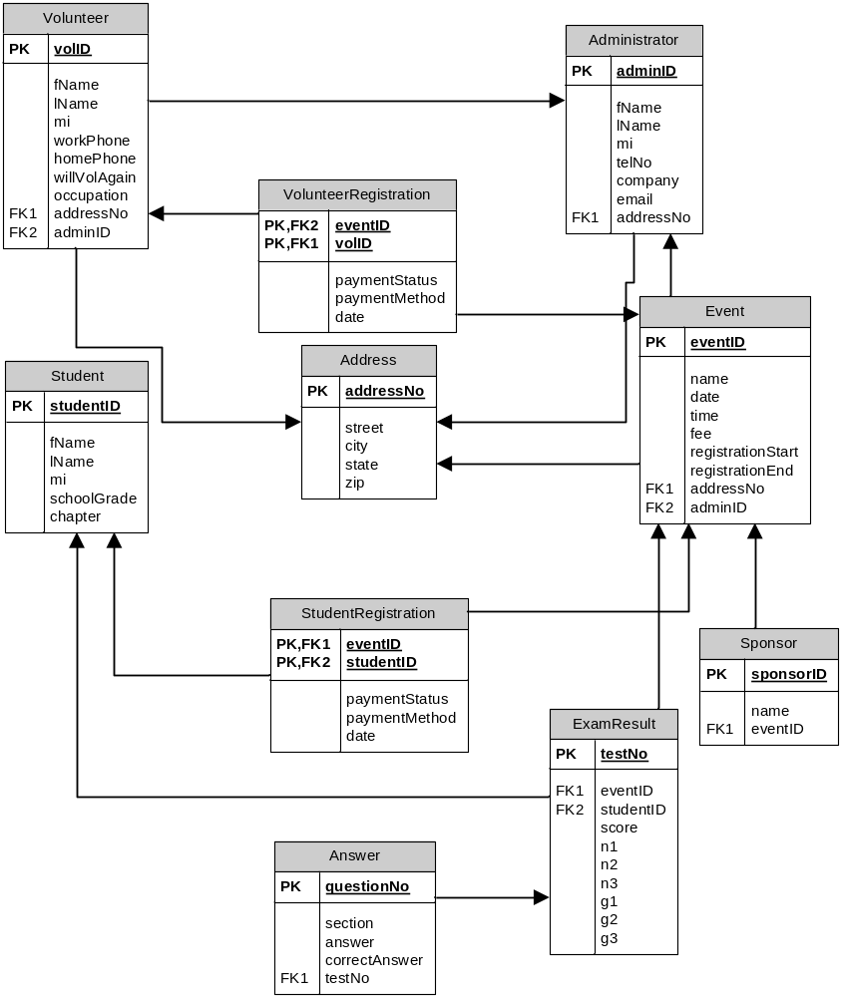

9. The data dictionary for the 3rd normalized relations

Entity Name | Description | Aliases | Occurrence
Administer | An administrator must be a member of ASEA. Also, the person must be the president of the local chapter or a designated officer for this event. An administrator can see all information in the system except for other administrator information. | ASEA officer | At least one per ASEA chapter
Volunteer | A volunteer is an unpaid assistant helping with managing the event. They can update student information (other than credit card data), proctor exams, enter exam results, and update their own information. | Volunteer | Several per event
Event | An ASEA national math competition | ASEA Competition, National Math Competition | At least one per year
StudentRegistration | A students information required to participate in an event | None | Several per event
VolunteerRegistration | A volunteers information required to participate in an event | None | Several per event
Address | A users address | None | One per user
Sponsor | The event corporate sponsor | None | One or more per event
ExamResult | The result of a student’s participation in an ASEA event. | Grade, exam result | One per student per event
Answer | The result of a student’s question on an exam | None | Thirty per student per event
Student | A Student is a student enrolled in a school system belonging to a school grade (4-11). A Student has the ability to register for an NMC event, pay for the NMC event registration (above 18 years of age only), and check their previous NMC event registration scores, and view test preparation material. | None | Several per event

Description of Relationships
Entity Name | Multiplicity | Relationship | Multiplicity | Entity Name
Administrator | 1..1 | Registers | 0..* | Administrator
Administrator | 0..* | Manages | 1..* | Event
Administrator | 1..* | Manages | 0..* | Student
Administrator | 0..* | Manages | 0..* | Volunteer
Volunteer | 0..* | Updates | 0..* | Event
Volunteer | 0..* | Manages | 1..* | Student
Event | 1..1 | Generates | 1..* | ExamResult
Student | 1..1 | Receives | 0..1 | ExamResult
Student | 1..1 | Attends | 0..* | Event
ExamResult | 1..1 | Has | 30..30 | Answers
Sponsor | 0..* | Sponsors | 0..* | Event
Address | 1..1 | Has | 1..* | Administrator
Address | 1..1 | Has | 1..* | Event
Address | 1..1 | Has | 1..* | Volunteer
Description of Attributes
Entity name | Attributes | Description | Data type & Length | Nulls | Multi-valued | Composite | Derived
Administrator | adminID (PK) | The administers ASEA ID number | Integer | No | No | No | No
Administrator | fName | The first name | Char(10) | Yes | No | No | No
Administrator | lName | The last name | Char(25) | No | No | No | No
Administrator | mi | The middle initial | Char(1) | Yes | No | No | No
Administrator | telNo | The telephone number | Char(10) | Yes | No | No | No
Administrator | company | The company the administer works for | Char(30) | Yes | No | No | No
Administrator | email | The email address | Char(30) | No | No | No | No
Administrator | addressNo (FK) | The address number | Integer | Yes | No | No | No
Volunteer | volID (PK) | The volunteer ID number | Integer | No | No | No | No
Volunteer | fName | The first name | Char(10) | Yes | No | No | No
Volunteer | lName | The last name | Char(25) | No | No | No | No
Volunteer | mi | The middle initial | Char(1) | Yes | No | No | No
Volunteer | workPhone | The work telephone number | Char(10) | Yes | No | No | No
Volunteer | homePhone | The home telephone number | Char(10) | Yes | No | No | No
Volunteer | willVolAgain | T/F if they will volunteer again | Single | Yes | No | No | No
Volunteer | occupation | Their job or occupation | Char(30) | Yes | No | No | No
Volunteer | addressNo (FK) | The address number | Integer | Yes | No | No | No
Volunteer | adminID (FK) | The adminID of the administrator who registered the volunteer | Integer | Yes | No | No | No
Student | studentID (PK) | The student’s ID number | Integer | No | No | No | No
Student | fName | The first name | Char(10) | Yes | No | No | No
Student | lName | The last name | Char(25) | No | No | No | No
Student | mi | The middle initial | Char(1) | Yes | No | No | No
Student | schoolGrade | The student’s grade in school | Integer | No | No | No | No
Student | Chapter | The student’s chapter | Char(5) | No | No | No | No
Event | eventID (PK) | The event ID number | Integer | No | No | No | No
Event | name | The name of the event | Char(30) | Yes | No | No | No
Event | date | The date of the event | DateTime | No | No | No | No
Event | time | The time of the event | DateTime | No | No | No | No
Event | fee | The registration fee | Currency | Yes | No | No | No
Event | registrationStart | The registration start date | DateTime | Yes | No | No | No
Event | registrationEnd | The registration end date | DateTime | Yes | No | No | No
Event | addressNo (FK) | The address number | Integer | No | No | No | No
Event | adminID (FK) | The event admin ID | Integer | Yes | No | No | No
Address | addressNo (PK) | The unique address number | Integer | No | No | No | No
Address | street | The street | Char(40) | No | No | No | No
Address | city | The city | Char(25) | Yes | No | No | No
Address | state | The state | Char(2) | No | No | No | No
Address | zip | The zip | Integer | No | No | No | No
StudentRegistration | eventID (PPK, FK) | The event ID for the registration | Integer | No | No | No | No
StudentRegistration | studentID (PPK, FK) | The student ID for the registration | Integer | No | No | No | No
StudentRegistration | paymentStatus | The status of the payment | Char(20) | Yes | No | No | No
StudentRegistration | paymentMethod | The method of payment | Char(20 | Yes | No | No | No
StudentRegistration | Date | The payment date | DateTime | Yes | No | No | No
VolunteerRegistration | eventID (PPK, FK) | The event ID for the registration | Integer | No | No | No | No
VolunteerRegistration | vollD (PPK, FK) | The volunteer ID for the registration | Integer | No | No | No | No
VolunteerRegistration | paymentStatus | The status of the payment | Char(20) | Yes | No | No | No
VolunteerRegistration | paymentMethod | The method of payment | Char(20 | Yes | No | No | No
VolunteerRegistration | Date | The payment date | DateTime | Yes | No | No | No
Sponsor | sponsorID (PK) | The sponsor ID number | Integer | No | No | No | No
Sponsor | name | The name of the sponsor | Char(30) | No | No | No | No
Sponsor | eventID (FK) | The event the sponsor is associated with | Integer | Yes | No | No | No
ExamResult | testNo (PK) | The test number | Integer | No | No | No | No
ExamResult | eventID (FK) | The event the test was given | Integer | No | No | No | No
ExamResult | studentID (FK) | The student who took the test | Integer | No | No | No | No
ExamResult | Score | The percentage score | Integer | Yes | No | No | Yes
ExamResult | n1 | Correct answers 1-10 | Integer | Yes | No | No | Yes
ExamResult | n2 | Correct answers 11-20 | Integer | Yes | No | No | Yes
ExamResult | n3 | Correct answers 21-30 | Integer | Yes | No | No | Yes
ExamResult | g1 | n1+n2+n3 | Integer | Yes | No | No | Yes
ExamResult | g2 | n1+n2 | Integer | Yes | No | No | Yes
ExamResult | g3 | n1 | Integer | Yes | No | No | Yes
Answer | questionNo (PK) | The unique question number | Integer | No | No | No | No
Answer | section | The section of the test | Char(2) | Yes | No | No | No
Answer | answer | The student’s answer | Char(1) | Yes | No | No | No
Answer | correctAnswer | The correct answer | Char(1) | Yes | No | No | No
Answer | testNo (FK) | The test number | Integer | No | No | No | No

Step 2.3

Student/Parent View:

1. A database model diagram with transaction pathways
- Enter grades for an event
- Enter the details for a new event
- Modify event information
- Update/delete student registration
- Update score information
- Generate a report of previous students
- Generate a report of previous volunteers
- Generate a report of events within the next three months
- Generate a report of events within the next month
- Generate a report of events within the next week
- Generate a report of registered students for an event
- Generate a report of registered volunteers for an event
- Generate a report on event participation statistics (grade, age, sex, etc.)
- Generate a report of the top three scores in each grade for an event
- Generate a report of scoring statistics (highest score, lowest score, average score, score by section, etc.)
- Generate a report of students who have not paid the event fee.
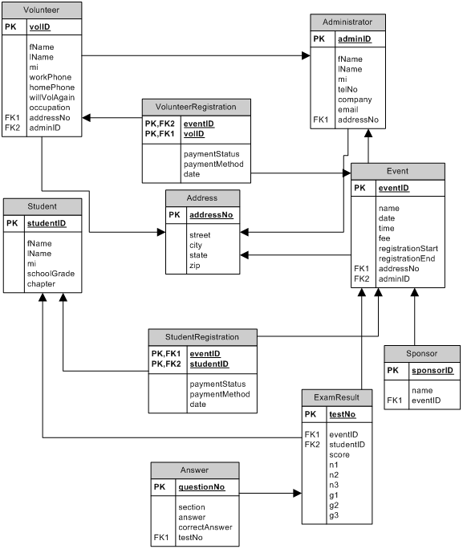

Step 2.4

Administrator View:

No Change

Step 2.5

Administrator View:

No Change

