TCSS 445 - Database Systems Design
Assignment 1 - Internetworking and Interprocess Communication
Winter 2008
Team 03

Eric Smyth, Software Engineer A
Brian Fish, Software Engineer B
Yong Shin, Software Engineer C

Jan 23, 2008

Table of Contents

1 DATABASE PLANNING 3
1.1 Mission Statement 3
1.2 Mission Objectives 3
1.3 Project Standards 4
Data Collection Methods 4
Format Specification 4
Documentation Needed 4
Design and Implementation 4
1.4 Key Terms 4
1.5 Policy Description 5
2 SYSTEM DEFINITION 5
2.1 Actors and their roles 5
2.2 Systems Boundary 6
2.3 Major User Views Matrix 7
2.4 Use Case Summary 8
2.5 Use Cases 8
Register Account 8
Update Account 9
User Logs In 9
Update Event 9
View Information 10
3 REQUIREMENTS COLLECTION AND ANALYSIS 10
3.1 Users’ Requirements Specification 10
3.1.1 Administrative User View 10
Data Requirements 11
Transaction Requirements 11
3.1.2 End User View 12
Data Requirements 12
Transaction Requirements 14
3.2 Systems Specification 14
Initial Database Size 14
Database Rate of Growth 15
The types and average number of record searches 15
Networking and shared access requirements 15
Performance 15
Security 15
Backup and Recovery 16
Legal Issues 16
1 DATABASE PLANNING
1.1 Mission Statement
The purpose of eMath4KSEA database system is to maintain the data of all participants of the ASEA math competition, including the administrators, volunteers, students and parents, and facilitates the preparation, registration, administration and report generation tasks involved in all facets of administering a math competition.

1.2 Mission Objectives
To maintain (enter, update, and delete) data on math competition administrators.
To maintain (enter, update, and delete) data on volunteers.
To maintain (enter, update, and delete) data on students.
To maintain (enter, update, and delete) data on parents.
To maintain (enter, update, and delete) data on competition scores and results.

To perform searches on students.
To perform searches on student registration.
To perform searches on competition results.
To perform secure credit card transactions

To report on competition results.
To report on student participation statistics.
To report on NMC events for each chapter.
To report on volunteer statistics
To report on registration finances
To report on donor finances

To send confirmation
To send reminder emails
To send exam result emails
To send thank you emails

To print address labels
To print exam results
To print invitation letters
To print nametags

To secure access to data based on user type
To secure the web access using https
1.3 Project Standards

Data Collection Methods
Registrants via web form
Volunteers via web form
Administrator via web form
Exam information entered by volunteer via web form
Credit card information via web form, with confirmation data collected from the credit card processor.

Format Specification
Web form information will be checked for format upon entry. Registrants, volunteers, and administrators will be shown a confirmation screen to verify correctness before data is sent to the database. Web forms will be based on existing paper forms

Documentation needed
Organizational documentation
Desired credit card processors
Existing paper registration forms
IT Infrastructure

Design and Implementation
Design will proceed utilizing the database development life cycle
Milestones will be utilized to track progress
1.4 Key Terms

eMath4KSEA | The overall system handing the NMC event functionality.
ASEA | ASEA (American Scientists and Engineers Association) is the main funding source of NMC.
NMC | The National Math Competition.
Registration number | The registration number consists of the following terms:  User Type (S: Student, V: Volunteer, and A: Administrator) + Exam Date (mm-dd-yyyy) + Chapter Name (PNC) + 4 digits number (xxxx) + Competition Type (M for Math, S for Science, B for Both)+ Grade (00) + Gender (M for male, F for Female) + the last four digits of home telephone number (xxxx) + family member code (N for Not Applicable). For example, A04212007PNC013M00M5127 shows the fact that the administrator supports the PNC (Pacific Northwest) chapter competition on April 21 in 2007, registered in the event at 13-th place, participated in B (Both). This volunteer is nothing to do with the grade code (00) and is male (M). The last four digit of his home phone number is 5127, and this volunteer is nothing to do with the first family member code (N).

1.5 Policy Description

NMC Event Registration Policy | Students must be in grades 4-11. Must have login id and password with the system. Valid email address and valid billing information.
eMath4KSEA Registration Policy | All Visitors who are registering for a role-specific account with the system must abide with this policy. The visitor must be associated with their local Chapter, provide valid personal information, and choose their correct role (whether they are Student, Volunteer, etc).

2 SYSTEM DEFINITION
2.1 Actors and Their Roles

Student | A Student is a student enrolled in a school system belonging to a school grade (4-11). A Student has the ability to register for an NMC event, pay for the NMC event registration (above 18 years of age only), and check their previous NMC event registration scores, and view test preparation material.
Parent | Guardians are also considered as a Parent in the system. A parent chaperones family-related student(s) by paying for their NMC event registration, view the scores of the students being chaperoned, view chapter and nationwide statistics, can also donate money to the NMC.
Volunteer | A volunteer is an unpaid assistant helping with managing the event. They can update student information (other than credit card data), proctor exams, enter exam results, and update their own information.
Administrator | An administrator must be a member of ASEA. Also, the person must be the president of the local chapter or a designated officer for this event. An administrator can see all information in the system except for other administrator information.
Visitor | A visitor is a person browsing the eMath4SEA system that has not registered as one of other actors and has not yet logged on to the system.
Donor | A benevolent enthusiast of math and science who makes a financial contribution to support the ASEA
User | Systems users are students, parents, volunteers, donors and administrators registered with the system

2.2 Systems Boundary
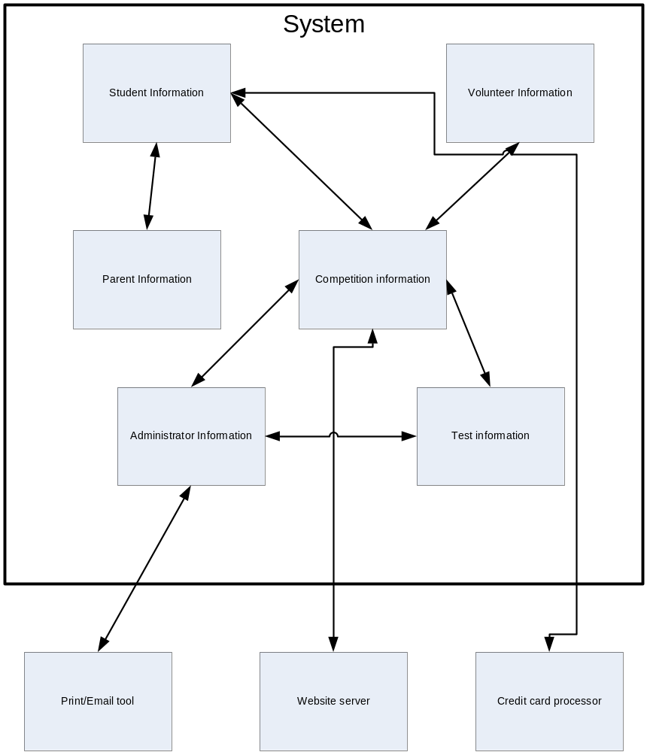

2.3 Major User Views Matrix

Data | Access Type | Administrator | Volunteer | Parent | Student | Donor | Visitor
Administrator  Registrations | Maintain | X
Administrator  Registrations | Query | X
Administrator  Registrations | Report | X
Volunteer Registrations | Maintain | X | X*
Volunteer Registrations | Query | X
Volunteer Registrations | Report | X | X*
Parent Registrations | Maintain | X | X | X*
Parent Registrations | Query | X | X
Parent Registrations | Report | X | X | X*
Student Registrations | Maintain | X | X | X** | X*
Student Registrations | Query | X | X | X**
Student Registrations | Report | X | X | X** | X*
Donor Registrations | Maintain | X | X |  |  | X
Donor Registrations | Query | X | X
Donor Registrations | Report | X | X |  |  | X
All Login | Maintain | X
All Login | Query | X
All Login | Report | X
Login | Maintain | X | X | X | X
Login | Query | X | X | X | X
Login | Report | X
All Events | Maintain | X
All Events | Query | X
All Events | Report | X
Event | Maintain | X
Event | Query | X | X | X | X | X | X
Event | Report | X
All Event Registrations | Maintain | X
All Event Registrations | Query | X | X
All Event Registrations | Report | X | X
Event Registration | Maintain | X | X | X | X
Event Registration | Query | X | X | X | X
Event Registration | Report | X
All Grades | Maintain | X
All Grades | Query | X
All Grades | Report | X
Grades | Maintain | X | X
Grades | Query | X
Grades | Report | X |  | X | X
Payment Information | Maintain |  |  | X | X | X
Payment Information | Query |  |  | X | X | X
Payment Information | Report |  |  | X | X | X

*Only for Volunteer, Parent or Students own registration
**Only for a their own children
2.4 Use Case Summary

Name | Primary Actor | Goal
Register Account | Visitor | Visitor creates a new eMath4ASEA account and becomes a User
Update Account | User | A User updates registration information in the eMath4ASEA web based system
User Logs In | User | A User logs into the eMath4ASEA web based system
Update Event | Administrator | A chapter Administrator updates a competition event
View Information | User | A User reviews their registration, grade or other information in the eMath4SEA web based system

2.5 Use Cases
Register Account
Name | Register Account
Primary Actor | Visitor
Goal | Visitor’s desired account is registered with the system.
Precondition | None
Main Scenario | - Visitor views account registration area.  - Visitor chooses their role for all NMC events (Student, Parent, etc).  - Visitor fills in account information containing their desired login id and login password.  - Visitor fills in personal information containing their email address, first and last name, Korean name, address, email address, home phone, cell phone, work phone, date of birth, and gender.  - Visitor fills in role-specific information.  - Visitor Search for Chapter and the Visitor is then associated with the selected Chapter.  - Visitor confirms information. The account is registered with the system.
Alternate Scenarios | 3a.) If desired login id is taken or the login id does not abide with the Login ID Policy, notify Visitor to select a new login id.  3b.) If desired login password does not abide with the Login Password Policy, then notify Visitor to fill in a new desired login password.
Comments | It is important to note that at this time, the system does not support role changes, but this is considered as a desired feature to be implemented in the future. For example, if a Student graduates and later wishes to volunteer to help at an NMC event, the system will not be able to change their role to Volunteer from Student.  In the Main Scenario at Step 5, an example of role-specific information is when the Visitor has selected Student as their role which means that role-specific information will include their school name, school grade, etc. related to the role selected.

Update Account
Name | Update Account
Primary Actor | User
Goal | A User's registration information is updated in the eMath4ASEA web based system
Precondition | User has a valid account
Main Scenario | 1. User logs in using their login ID and password  2. User selects 'update account information'  3. User updates fields as needed.  4. User confirms update of information.  5. System saves the changes.
Alternate Scenarios | 3a. If user does not submit valid information, retain old data and prompt for valid entry.
Comments
User Logs In
Name | User Logs In
Primary Actor | User
Goal | A User logs into the eMath4ASEA web based system
Precondition | User has a valid account
Main Scenario | 1. User navigates to the website.  2. User enters their login ID and password.  3. User clicks the login button.
Alternate Scenarios | 3a. If login ID is not recognized, display an "Invalid login ID or password" message and do not allow login.  3b. If the password does not match the login ID, display an "Invalid login ID or password" message and do not allow login.
Comments | A system to recover forgotten password will also be available.
Update Event
Name | Update Event
Primary Actor | Administrator
Goal | An Administrator updates details about an event
Precondition | Administrator has an active session
Main Scenario | - Administrator selects the appropriate link to update event information  - Administrator enters/changes desired values  - The system checks that all values have been submitted  - The system checks all submitted values  - The system updates the event entry in the database  - The system informs the Administrator that the update was successful
Alternate Scenarios | 4a. The Administrator is attempting to create or modify a past event  5a. The update is denied  6a. System informs Administrator of error  4b. The Administrator is attempting to enter grade data for a future event  5b. The update is denied  6b. System informs Administrator of error
Comments | The links available for events would include creating, modifying and entering scoring information.
View Information
Name | View Information
Primary Actor | User
Goal | A User views available information in the eMath4ASEA web based system
Precondition | The list of reports available is appropriate for User access privileges
Main Scenario | - The User selects the appropriate view information hyperlink  - The system verifies the User has an active session  - If not the User Logs In  - The system generates report based upon User access privileges  - The User reviews desired information
Alternate Scenarios | None
Comments | Information available is based on the type of User. Students would be able to view their registration and grade details, volunteers would be able to view their own and students registration information, Administrators would be able to view event registration statistics and grades, etc

3 REQUIREMENTS COLLECTION AND ANALYSIS
3.1 Users’ Requirements Specification
3.1.1 Administrative User View

Data requirements

Administrator
An administrator is either someone who is a Chapter President of ASEA, or is an ASEA member who is a designated officer for an event managed by the system. Data held on an administrator includes ASEA id number, title, name (last, first, and middle initial), address, phone number, email address, and company information. An administrator can view and update all information except other administrators.

Volunteer
A volunteer is someone who is volunteering their time and skills to ASEA. A volunteer can be any person who applies to be a volunteer and is accepted by an administrator. Data held on a volunteer includes name (last, first, and middle initial), address, phone number, email address, and willingness to volunteer for next year’s events. Volunteers can update their own information, and the information of any student (except credit card information).

Event
An event describes an upcoming math competition event. The data held on event include event name, sponsor(s), exam date and time, address of exam location, valid registration periods, registration fee, and registration contact information. This information should be viewable to all users of eMath4SEA system including visitors.

Registration
A registration keeps track of which students are registered for which of events. The data held on registration include student info, event info, payment status and info, date of registration, the student’s exam grade and the student’s chapter association. Registration data should be available to administrators and volunteers.

Test Result
A test result stores detailed test scores for a past math competition event. The data held on test results include registration number, student name, exam grade, school grade, school name, chapter name and student answers to all exam questions.

Transaction Requirements

Data Entry
Enter the details of a new administrator
Enter the details of a new volunteer
Enter the details of a new parent
Enter the details of a new student
Enter the details of a new donor
Enter grades for an event
Enter the details for a new event

Data Update/deletion
Modify event information
Update score information
Update administrator information
Update/delete volunteer information
Update/delete parent information
Update/delete student information
Update/delete donor information
Update administrator passwords
Update volunteer passwords
Update parent passwords
Update student passwords
Update donor passwords

Data Queries
Generate a report of previous participants
Generate a report of previous volunteers
Generate a report of events within the next three months
Generate a report of events within the next month
Generate a report of events within the next week
Generate a report of an administrator’s data
Generate a report of registered students for an event
Generate a report of registered parents for an event
Generate a report of registered volunteers for an event
Generate a report of registered donors
Generate a report on event participation statistics (grade, age, sex, etc.)
Generate a report of the top three scores in each grade for an event
Generate a report of scoring statistics (highest score, lowest score, average score, score by section, etc.)
Generate a report of students who have not paid the event fee.
Locate an administrator’s record (by ID, name, address, location, etc.)
Locate a volunteer’s record (by ID, name, address, location, etc.)
Locate a parent’s record (by ID, name, address, location, etc.)
Locate a student’s record (by ID, name, address, location, etc.)
Locate a donor’s record (by ID, name, address, location, etc.)

3.1.2 End User View

Data Requirements

Student
A student is currently enrolled in a school at K-4 to K-11 level and has registered for a previous or upcoming math competition. The data held on a student include the name (Last, First and Middle initial), address, home and cellular phone numbers (optional), email address, school level (i.e. Elementary, Junior-High, or High), grade (K-4 to K-11), gender (Male or Female) and the information on who the parent/guardian is (optional). If the student has participated in a previous math competition, all past exam scores should be available. If the student has registered for an upcoming math competition, all relevant registration information, including fee payment status, and the event information, should be available.

Parent
A parent is a legal guardian of a student. If a student is old enough and is able to pay for the competition fee herself, then the parental information is not required. The data held on a parent include name (Last, First and Middle initial), work and cellular phone numbers (optional), email address, relationship to the student (i.e. father, mother or a generic guardian) and the information on who the students are. A parent can be a guardian to more than one student. A parent should be able to access all registration and test score results available to students.

Donor
A donor is someone who makes a financial donation to ASEA. A donor can be a registered student, a parent of a registered student, or someone without any affiliation to a registered student. The data held on a donor include name (Last, first and Middle initial), address, work or cellular phone numbers (optional), email address, and the donation amount and dates. A donor should be able to view past donation information.

Visitor
A visitor is someone who is browsing eMath4SEA system without having registered or logged in. There is no data held on visitors.

Event
An event describes an upcoming math competition event. The data held on event include event name, sponsor(s), exam date and time, address of exam location, valid registration periods, the registration fee and registration contact information. This information should be viewable to all users of eMath4SEA system including visitors.

Registration
A registration keeps track of which students are registered for which of events. The data held on registration include student info, event info, payment status and info, date of registration, the student’s exam grade and the student’s chapter association.

Payment
A payment stores the method of payment used for registration. The data held on payment include the name of the card holder, payment type (i.e. credit card, check), credit card number or bank account number, and the expiration dates.

Test Result
A test result stores detailed test scores for a past math competition event. The data held on test results include registration number, student name, exam grade, school grade, school name, chapter name and student answers to all exam questions.

Transaction Requirements

Data Entry
Parents enter their own registration details
Parents enter the registration details for a student
Students enter their own registration details
Donors enter their own registration details
Parents enter their payment information
Students over 18 enter their payment information
Donors enter their payment information
Parents register a student for an event
Students register for an event

Data Modification
Parent, student and donor data cannot be deleted by end users
Parents update their registration information
Parents update their student’s registration information
Students update their registration information
Donors update their registration information
Parents update their payment information
Students over 18 update their payment information
Donors update their payment information

Data Queries
Students generate a report on their score at an event
Parents generate a report on their student’s score at an event
Students query their registration status
Parents query their student’s registration status
Students query their payment status
Parent query their student’s payment status
Donor’s query their payment status
Students query events open for registration
Parents query events open for registration
Students generate a report on their participation history
Parents generate a report on their student’s participation history
Donors generate a report on their contribution history
3.2 Systems Specification
Initial Database Size
- There are currently 5 administrators, paper forms will be manually added to the system.
- There are currently 30 volunteers, paper forms will be manually added to the system.
- No parent, student or donor data will be transferred from historical paper forms.
- The data for the first event will be entered.
Database Rate of Growth
- The number of Students is expected to grow by 150 to 250 per chapter per year.
- The number of Parents is expected to grow at nearly 150 to 250 per chapter per year.
- The number of Volunteers is expected to remain constant requiring no more than 30 new volunteers per chapter per year in the event of a return rate of zero.
- The number of Administrators is expected to remain constant requiring no more than 5 new Administrators per chapter per year in the event of a one hundred percent turnover rate.
- There will be one new event per year per chapter.

The types and average number of record searches
- Each Student will run at least one grade query within three months of the end of the event.
- Each Parent is expected to run at least one grade query within three months of the end of the event.
- Each Administrator is expected to run at least seven grade queries within six months of the end of the event.
- Each Administrator is expected to run at least five registration queries prior to an event.
- Volunteers may run as many as 250 registration queries the day of the event.
- Each Student will make at least one registration query prior to the event.
- Students and Parents are expected to run at least one payment query prior to the event.
Networking and shared access requirements
- Visitors and Users will be able to access the eMath4ASEA system from the public Internet.
- The database and web interface will initially reside on the same system.
- A business class always on Internet connection will be used.
- The system will need to allow up to 10 simultaneous connections.
Performance
- The week after the creation of the event, and the week prior to the event, and the week following announcement of grades expect less than 1 second response for all single record searches.
- The week after the creation of the event, and the week prior to the event expect, and the week following announcement of grades less than 3 second response for all multiple record searches.
- During non peak days expect less than 1 second response for all single record searches.
- During non peak days expect less than 2 second response for all multiple record searches.
- Total downtime for scheduled and unscheduled outages should not exceed 1.2%.
Security
- Administrators will use their ASEA ID as their system username
- All other Users will use their email address as their system username.
- All Users will receive a randomly generated password by email.
- Parents of students under the age of 18 will receive a copy of the student’s password.
- The password will be at least seven digits in length containing an uppercase letter, a lowercase letter, a number and a special character.
- Users may change their password at any time but must provide their current password.
- Administrator passwords expire six months after the event or upon term expiration, whichever is sooner.
- All other User passwords will expire three months after the event.
- Only Administrators, Visitors and Volunteers will not have access to any credit card information.
- Students, Parents and Donors will only be able to view the last four digits of any entered credit card.
- All sensitive information will be encrypted.
- Access to the website will be secure.
Backup and Recovery
- Backups will be formed by a designated administrator.
- Backups will occur at the beginning of weekly scheduled downtime between 0300 and 0400 on Sunday mornings.
- In the event of hardware failure, the website will suspend operations, the replacement will be set up and the most recent backup will be loaded. A notice will be displayed on the web site for a period of one month notifying users of the outage.
Legal Issues
- The system will reside in Tacoma, Washington and will comply with all relevant local, state and federal regulations.
- All transactions, to include registration, queries, and payments, made across multiple will comply with originating, destination and federal regulations.
- The parents of registered students over the age of 18 will not have access to grades without written permission on file.

