B99303103 張博凱 Algorithm programming assignment #3
$ The run time, memory needed, and total distance of different versions of different input sizes by two tasks

 |  | DFS |  | BFS |  | Coloring (greedy )
input file | input size  vertices/  edges | runtime  (s) | memory (MB) | runtime  (s) | memory (MB) | Number of colors | runtime  (s) | memory (MB)
n4 | 4/5 | 0 | 12.72 | 0 | 12.72 | 3 | 0 | 12.72
n10 | 10/21 | 0 | 12.72 | 0 | 12.72 | 4 | 0 | 12.72
n100 | 100/290 | 0 | 12.72 | 0 | 12.72 | 5 | 0 | 12.72
n1000 | 1000/2989 | 0.008 | 13.06 | 0.004 | 13.06 | 5 | 0.008 | 13.06
n10000 | 1000/29990 | 0.032 | 16.648 | 0.028 | 17.168 | 6 | 0.088 | 17.168

Figure for Mem needed:
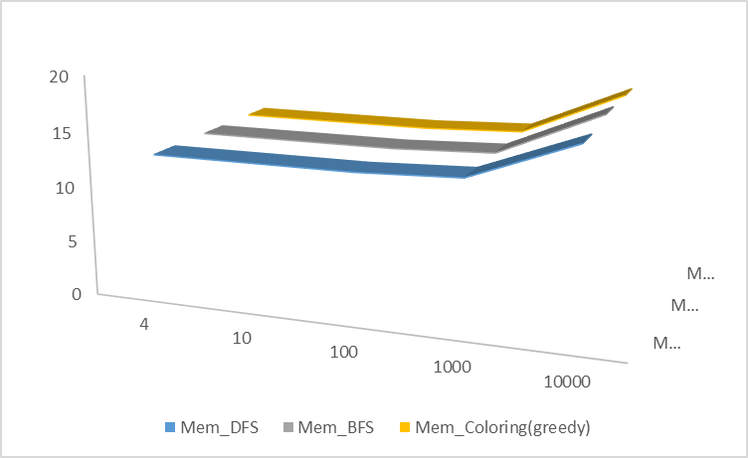
Figure for Runtime needed:
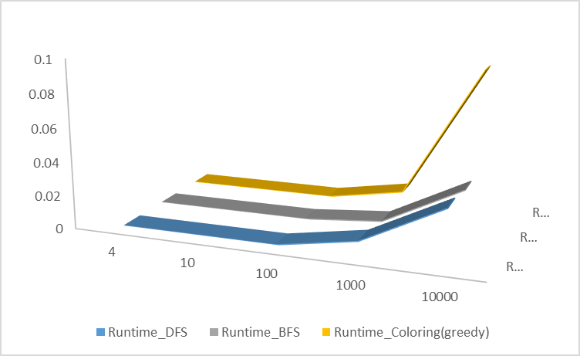
$ The complexity of the greedy algorithm
In my greedy algorithm:
N:= total number of nodes
M:= total number of edges
Max := the maximum number of adjacent nodes that each node could have
Need to sort an array which could show the degree of nodes (say, from lowest to highest) → (assume we have the degree of each nodes first, which may need O(N))need O(NlogN)
Since each node just need to search its adjacent nodes to discuss its color, so need at most O(max*N) → need O(N)

Thus, the time complexity of my greedy algorithm is of O(NlogN)

