Weak Prompts
1 Explain regression
2 Help me understand SQL
3 Create a dataset

Improved Prompts
1. Explain regression for the Python coding language, talk to me like a high school student as well as provide practice problems to further my understanding.
2. Help me understand SQL for an exam that I have coming up within 4 weeks. The exam covers the basics of SQL as well as the history.
3. Create a mock dataset for a student council event for an annual sports festival for the last 25 years. There are 4 different classes, Culinary, Theater, Sports and Accelerated Academics. The class average class has 30 students and the budget has be 10,000 – 20,000 dollars from fundraisers. In an excel file divide each class into different sections as well as predict the amount of money each class should have. Propose ideas in the excel file for each class for the student festival.

Why the prompt is stronger
- Specifies the context of regression, then goes on the way to explain. It adds for details compared to the results of the first prompt was very vague in its explanation, whereas the improved prompt gave detailed examples with different charts, example code and real-life examples.
- The original prompt produced a very generalized, my improved prompt adds more detail and goes more in-dept with practice problems, commands and example data sets.
- The dataset that was made with the weak prompt used the context of SQL rather than a regular dataset. My improved prompt adds needed context as well as constraints for the dataset.
Improved Prompts Screen Shots
- 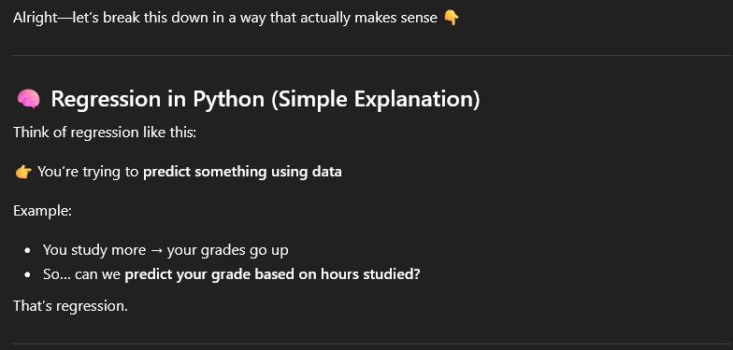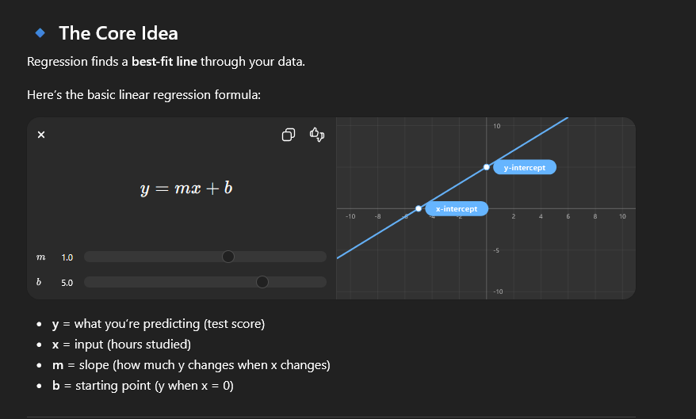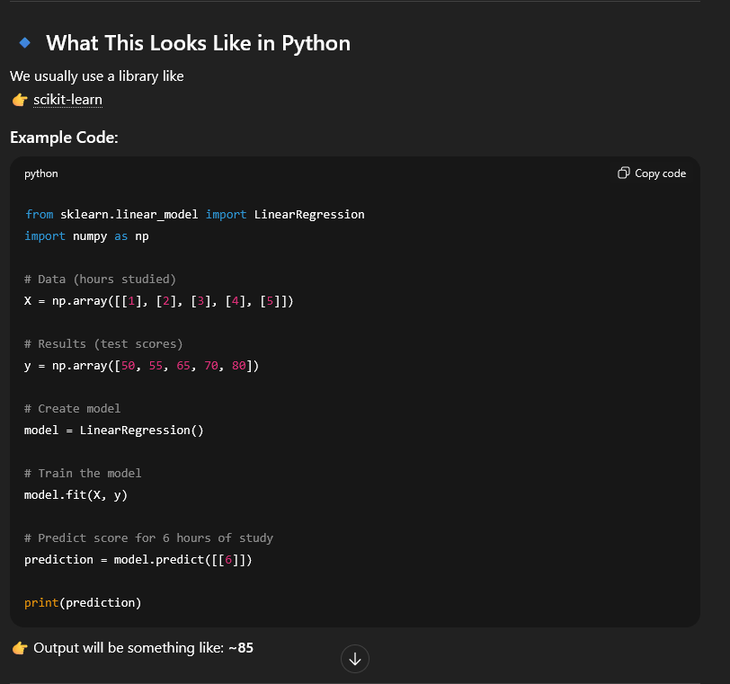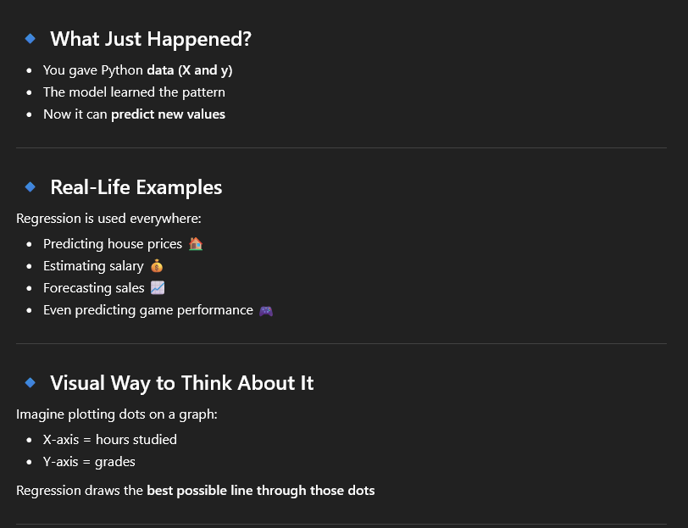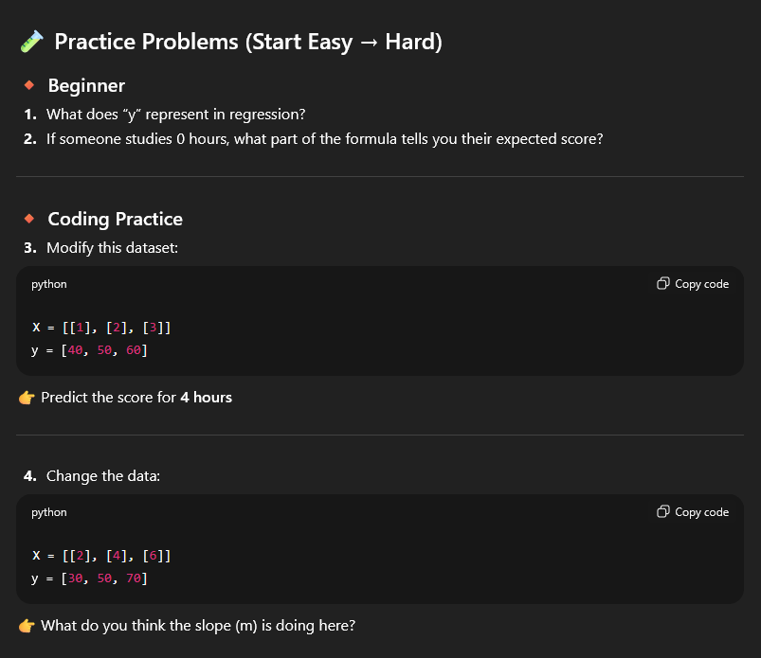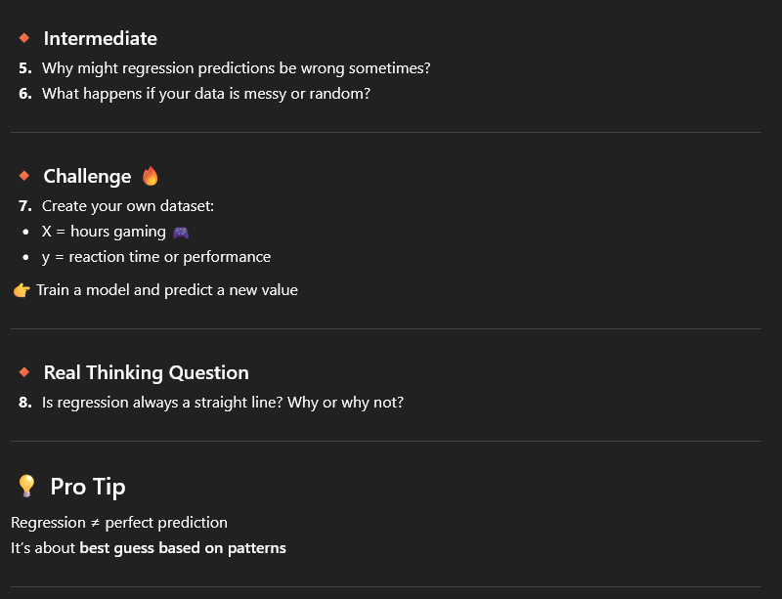

2 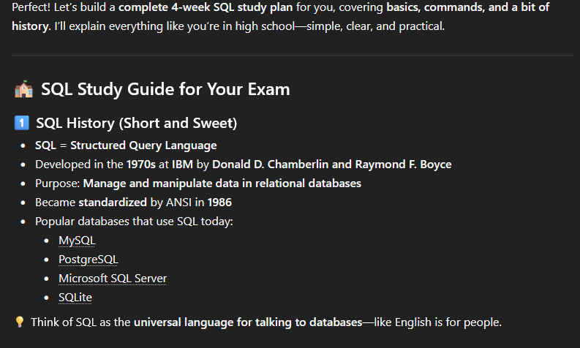 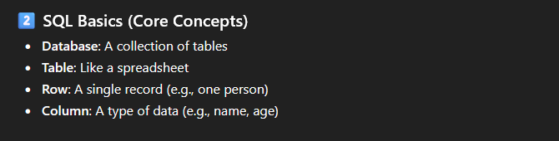
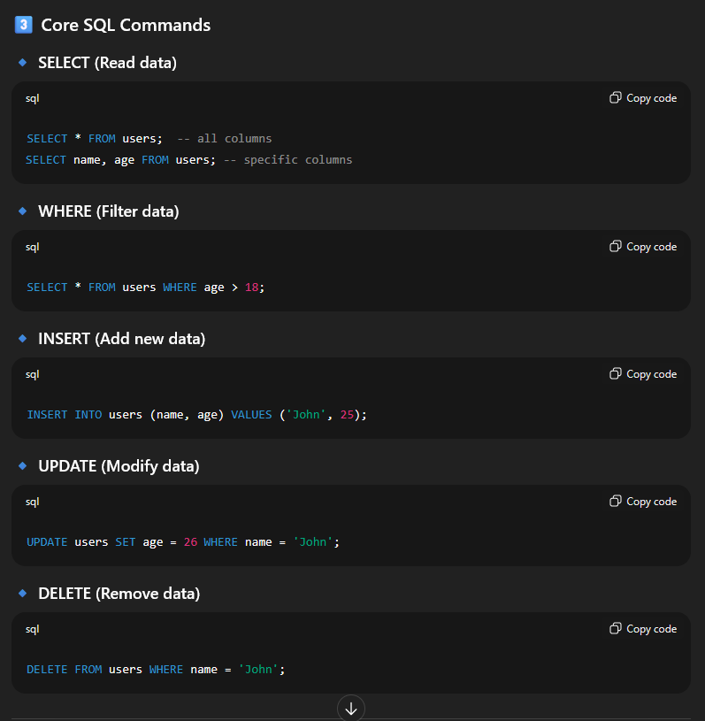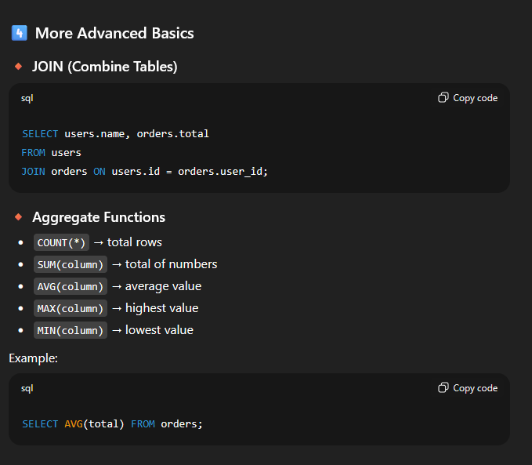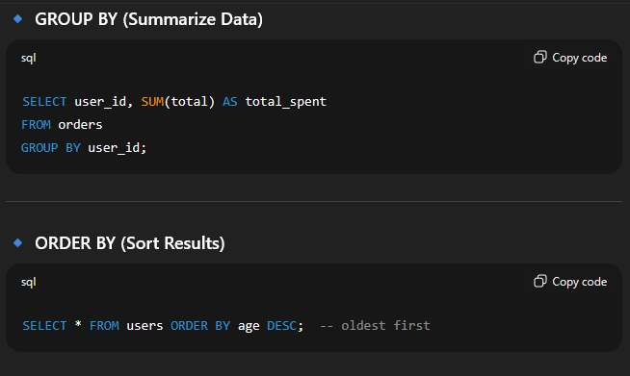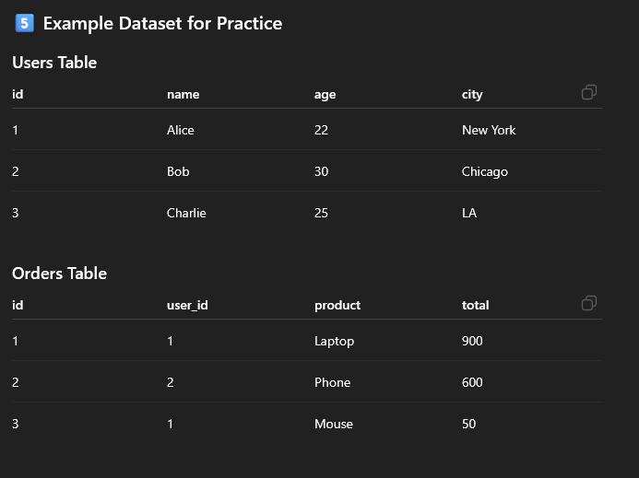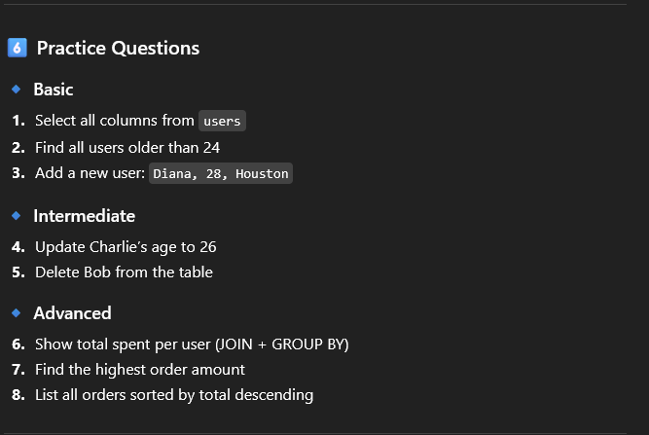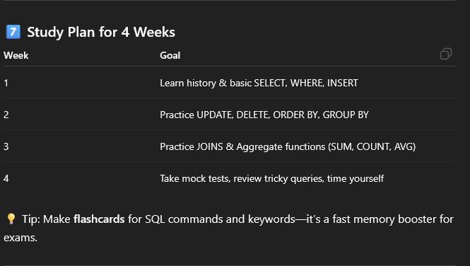
3
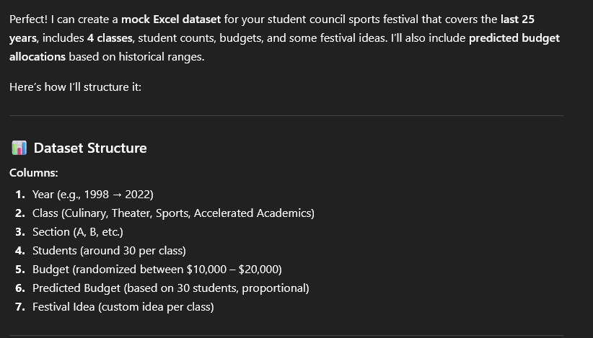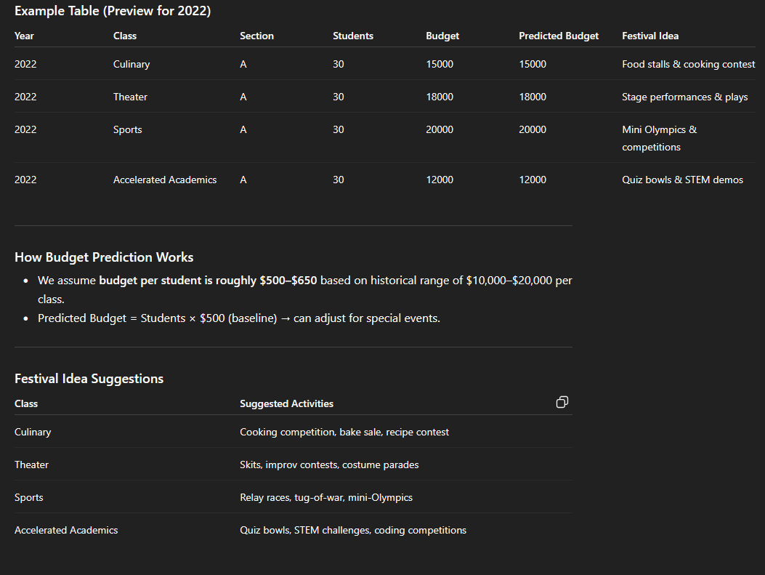

Weak Prompts Screen Shots
- 
 