D.K.T.E. Society’s Textile and Engineering Institute, Ichalkaranji

(An Autonomous Institute, Affiliated to Shivaji University, Kolhapur) Accredited with ‘A+’ Grade by NAAC

Department of Computer Science (Artificial Intelligence) & Engineering 2023-2024



THE MINI PROJECT REPORT ON

“University Exam Registration Portal”

Under the guidance of Prof. R. S. Kamble

Devloped By:

1.Anushka Karade 22UAI051

2.Shruti Khavate 22UAI057

3.Payal Khot 22UAI058

4.Priyanka Langote 22UAI064

D.K.T.E. Society’s Textile and Engineering Institute, Ichalkaranji

(An Autonomous Institute, Affiliated to Shivaji University, Kolhapur) Accredited with ‘A+’ Grade by NAAC

CERTIFICATE

This is to certify that,

1.Anushka Karade 22UAI051

2.Shruti Khavate 22UAI057

3.Payal Khot 22UAI058

4.Priyanka Langote 22UAI064

Have successfully completed the project work, entitled

“University Exam Registration Portal”

In partial fulfilment for the award of degree of Bachelor of Technology in Computer Science and Engineering. This is record of their work carried out during academic year 2023-24.

Date: Place: Ichalkaranji

Prof. R. S. Kamble Prof. Dr. S. S. Shirgave

[Project Guide] [Head of Department]

DECLARATION

We the undersigned students of T.Y. CSE(AI) declare that the mini project work report entitled “University Exam Registration Portal” written and submitted under the guidance of Prof. R. S. Kamble is our original work. The empirical findings in this report are based on the data collected by us. The matter assimilated in this report is not reproduction from any readymade report.

Date: Place: Ichalkaranji

1.Anushka Karade 22UAI051

2.Shruti Khavate 22UAI057

3.Payal Khot 22UAI058

4.Priyanka Langote 22UAI064

**INDEX**

CONTENTS

1.Abstract

2.Problem Statement

3.Problem Description

4.Introduction

5.Implementation

6.Requirement Analysis

7.System Requirements

8.System Design

9.Testing Table

10.Snapshot

11.Conclusion

12.References

ABSTRACT

The University Exam Registration Portal is a web-based application designed to streamline and automate the exam registration process for students and administrators. The system enables students to register for exams, view available exam schedules, and track their registration status through an intuitive user interface. For university staff, the portal provides a centralized platform for managing exam-related information, including course offerings exam slots, and student records. This project addresses the inefficiencies of manual exam registration systems, such as long processing times, errors, and delays in data synchronization. By implementing this portal, the university aims to enhance user experience, reduce administrative burden, and ensure data accuracy. The system is built using modern web technologies, ensuring security, scalability, and accessibility. Key features include role-based access control, real-time notifications, automated seat allocation, and the ability for students to make changes to their registrations within predefined deadlines. The portal was developed with a focus on usability, ensuring that students and staff can interact with the system with minimal technical knowledge. This report covers the design, development, testing, and deployment of the University Exam Registration Portal, along with an analysis of its performance and user feedback. The successful implementation demonstrates the potential for further expansion to accommodate future university needs.

PROJECT STATEMENT

To develop the online university exam registration portal for college students.

PROJECT DESCRIPTION

Currently, university exam registration is a manual and time-consuming process where students must fill out paper-based forms, submit them in person, and wait for confirmations. This approach often leads to errors in data entry, delayed processing, long queues, and inefficient management of resources. To streamline this process, there is a need for an online “University Exam Registration Portal”.

The portal will allow students to easily fill out and submit their exam registration forms online, reducing paperwork, minimizing errors, and providing instant confirmations. Additionally, the portal will enable secure payment of exam fees, track form submissions, and provide automated updates on exam schedules and statuses, enhancing overall efficiency and student experience.

Key functionalities would include:

- Online form submission.

- Secure fee payment integration.

- Instant form validation and submission tracking.

- Notifications on exam schedules and form status.

- A user-friendly interface for both students and university staff.

This will simplify the exam registration process, reduce administrative workload, and ensure timely and accurate form processing.

INTRODUCTION

“The University Exam Registration Portal” is your one-stop solution for managing your examination registration process efficiently. This user-friendly platform is designed to streamline the registration of exams, ensuring that students can easily navigate through the necessary steps to secure their examination slots.

Key Features:

1. User Account Management: - Create and manage your personal account using your student credentials. - Update your profile information and reset your password securely.
2. Exam Registration: - Register for all upcoming exams within your designated time frame. - Select courses and view available exam dates and times. - Check for any prerequisites or eligibility requirements before registration.
3. Scheduling: - View your exam schedule at a glance. - Receive reminders for upcoming exams and important deadlines.
4. Payment Processing: - Complete any required fee payments through a secure payment gateway. - Access payment history and receipts for your records.
5. Support and Resources: - Access FAQs and troubleshooting tips for common registration issues. - Contact support via email or chat for personalized assistance.
6. Updates and Notifications: - Stay informed with real-time updates about any changes to exam schedules or registration procedures. - Receive notifications about important deadlines and events related to your exams.
7. How to Register:
8. Log In: Use your student ID and password to access your account.
9. Select Exams: Browse the list of available exams and select the courses you wish to register for.
10. Confirm Details: Review your selections, ensuring all information is correct.
11. Payment: Complete the registration by making the necessary payments.
12. Print Confirmation: After successful registration, print or save your confirmation for future reference.
13. Important Dates: -

* Registration Period: Check the portal for specific dates when registration opens and closes.
* Exam Dates: Be aware of the scheduled dates for your exams to plan accordingly.
* Contact Information: For any inquiries or assistance, please reach out to the exam administration office at [studentsection@dkte.ac.in] or call [0230 242 1300]. Our support team is available during business hours to help you with any concerns. Thank you for choosing our university! We wish you the best of luck in your upcoming exams.

IMPLEMENTATION

* Implementation Steps:

1. Frontend Development

* Build a responsive UI with a clear navigation system.
* Design forms with form validation (use libraries like Formik or React Hook Form).
* Create a dashboard for students to view their registration and payment history.
* Ensure admin interface allows viewing and managing all student submissions.

1. Backend Development

* Implement REST APIs for the following:
* User Authentication: Handle login/registration, token-based authentication (JWT).
* Exam Form Submission: Endpoint for students to submit and update their exam registration.
* Payment Processing: Integrate the payment gateway’s API to collect and track fees.
* Notifications: Schedule notification triggers when specific actions occur (submission, payment, schedule release).
* Data validation and error handling to ensure data integrity.

1. Database Setup

* Design tables for users, registration forms, payments, and exam schedules.
* Implement foreign keys and relationships to track which users submitted which forms and payments.
* Write stored procedures or triggers to handle data updates (e.g., when payment is confirmed, update the registration status).

1. Admin Panel

* Build a panel that allows administrators to:
* View all student registrations.
* Approve or deny registration.
* Monitor payment status.
* Send bulk notifications (e.g., about exam dates).

1. Testing

* Unit testing: Test all individual modules.
* Integration testing: Ensure the frontend and backend communicate seamlessly.
* Security testing: Test for vulnerabilities, such as SQL injection and XSS.
* Load testing: Test the system’s performance under heavy user load (e.g., during peak registration times).

REQUIREMENT ANYALSIS

The **requirement analysis** phase is crucial to understanding and defining the functionality, scope, and limitations of the University Exam Registration Portal. This ensures the system meets user expectations and addresses all stakeholder needs.

**1. Functional Requirements**

These are the core features and operations that the University Exam Registration Portal must provide for both students and administrators.

1.1. User Roles and Authentication

1.2. Exam Registration Features

1.3. Exam Management (Admin)

1.4. Notification System

1.5. Security

**2. Non-Functional Requirements**

These requirements deal with the performance, usability, and quality of the system.

2.1. Performance

2.2. Usability

2.3. Reliability

2.4. Scalability

2.5. Security

SYSTEM REQUIREMENTS

The system requirements for the University Exam Registration Portal include:

- Frontend: A modern browser (Chrome, Firefox, Edge) for accessing the portal.

- Backend: A server running Node.js/Express or Python/Django with a minimum of 4GB RAM, 2 CPU cores, and 20GB storage.

- Database: MySQL or PostgreSQL with at least 10GB storage.

- Payment Gateway: Integration with Stripe, PayPal, or Razor

pay for secure transactions.

- Security: SSL certificates, token-based authentication (JWT), and encryption for user data.

- Cloud Hosting: AWS, Azure, or Google Cloud for scalable deployment, with load balancers for high traffic.

SYSTEM DESIGN

Use Case Diagram:

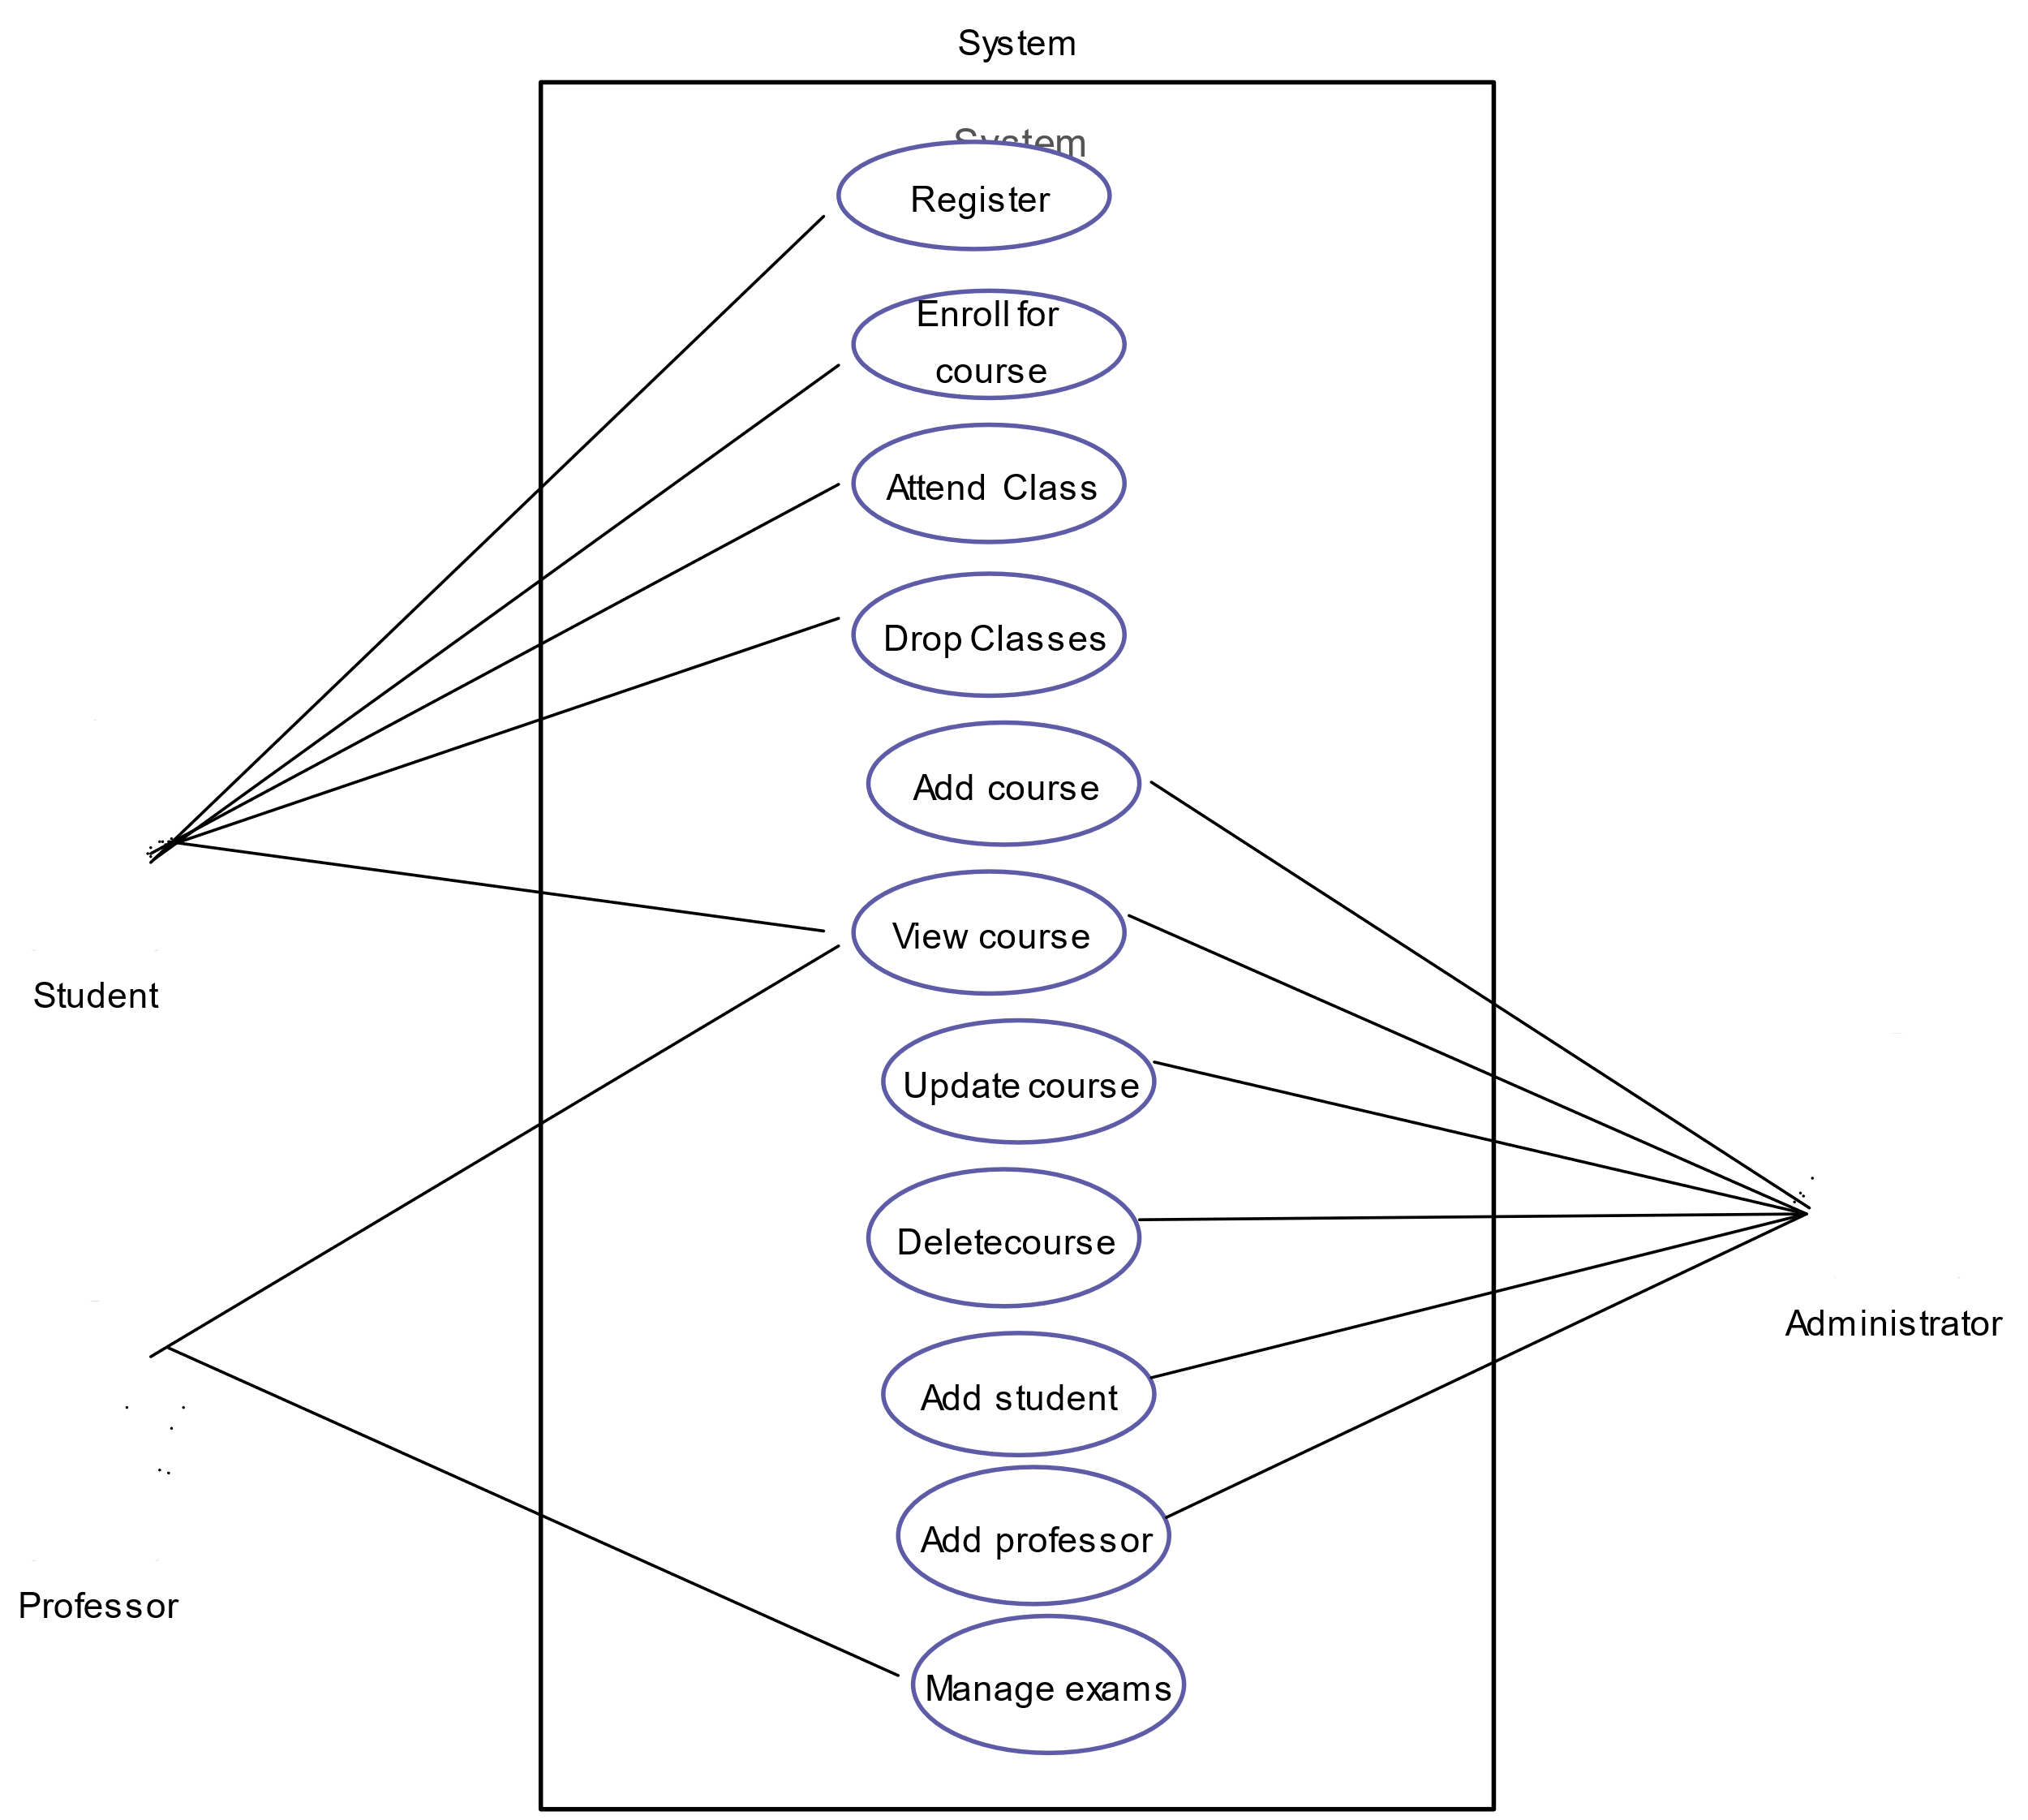

Sequence Diagram:

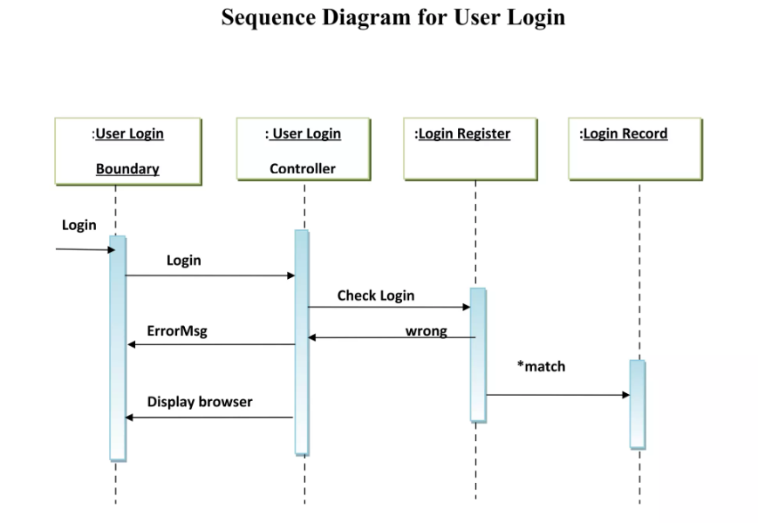

TESTING TABLE

|  |  |  |  |  |  |  |  |  |  |  |  |  |  |
| --- | --- | --- | --- | --- | --- | --- | --- | --- | --- | --- | --- | --- | --- |
| **Test Case ID** | **Test Case Description** | |  | | --- | | **Test Steps** |  |  | | --- | |  | | |  | | --- | | **Expected Result** |  |  | | --- | |  | | |  | | --- | | **Actual Result** |  |  | | --- | |  | | | **Status (Pass/Fail)** | | --- |  |  | | --- | |  | |
| |  | | --- | | TC01 |  |  | | --- | |  | | User login functionality | 1. Navigate to login page 2. Enter valid credentials 3. Click "Login" | User is redirected to the dashboard | As expected | Pass |
| |  | | --- | | TC02 |  |  | | --- | |  | | |  | | --- | | View available exams |  |  | | --- | |  | | 1. Login 2. Navigate to "Exam Schedule" page | List of available exams is displayed | |  | | --- | | As expected |  |  | | --- | |  | | Pass |
| TC03 | Register for an exam | 1. Login 2. Select an exam 3. Click "Register" | User receives confirmation of registration | |  | | --- | | As expected |  |  | | --- | |  | | Pass |
| TC04 | |  | | --- | |  |  |  | | --- | | View registration status | | 1. Login 2. Navigate to "My Exams" page | Registered exams with status are displayed | |  | | --- | | As expected |  |  | | --- | |  | | Pass |
| TC05 | Check system security for SQL injection | 1. Attempt SQL injection in login form | System blocks the injection and shows an error message | |  | | --- | | As expected |  |  | | --- | |  | | Pass |

SNAPSHOT

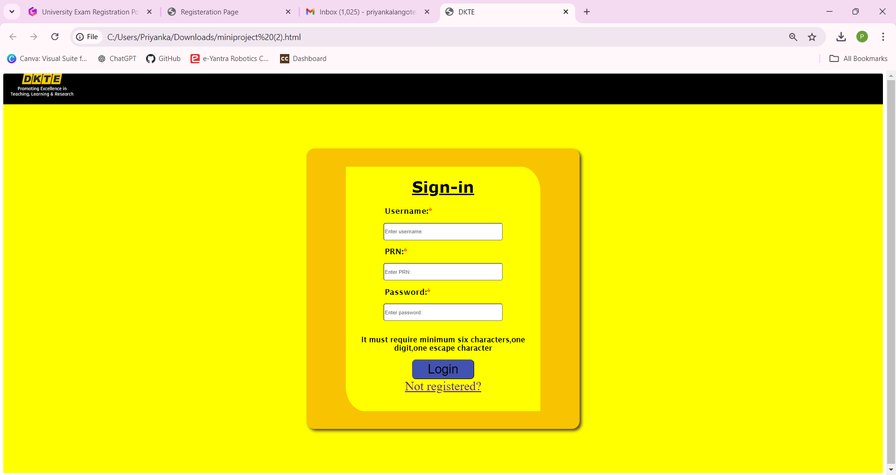

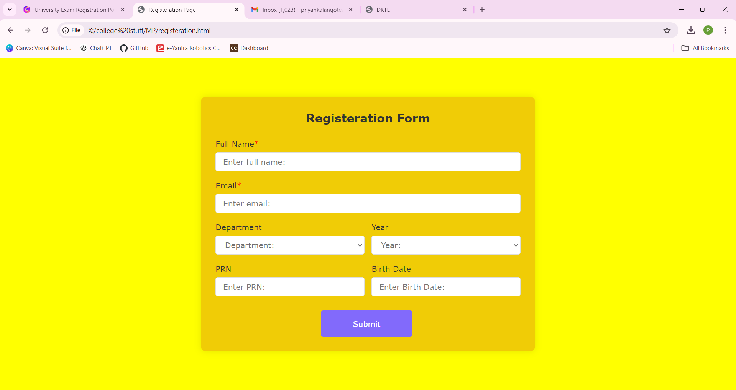

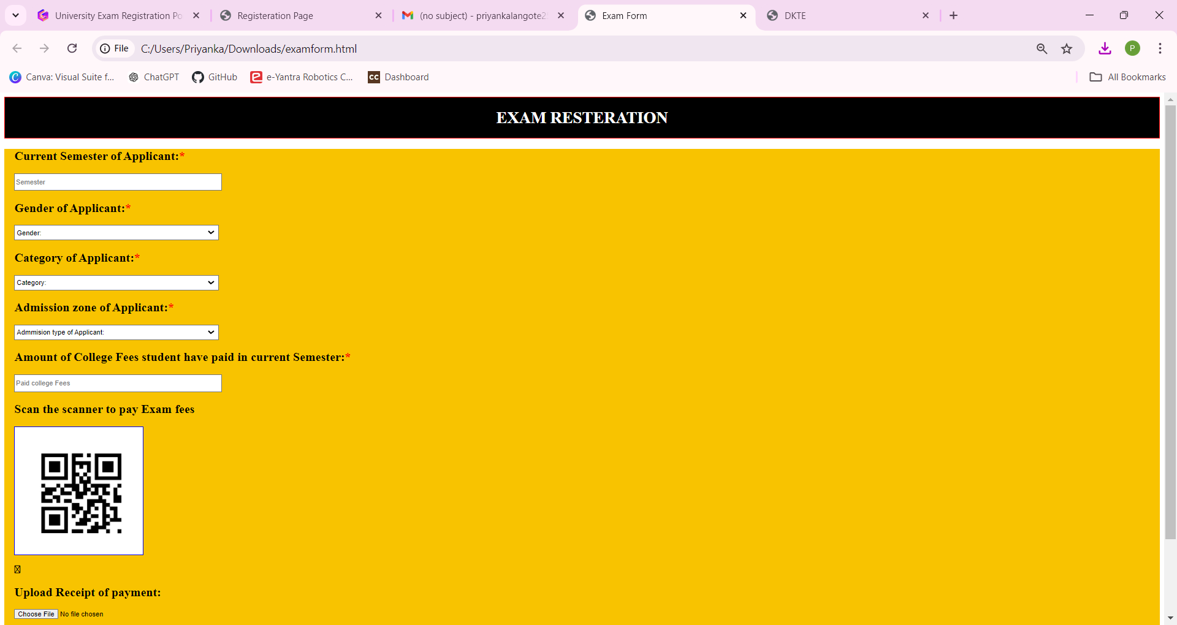

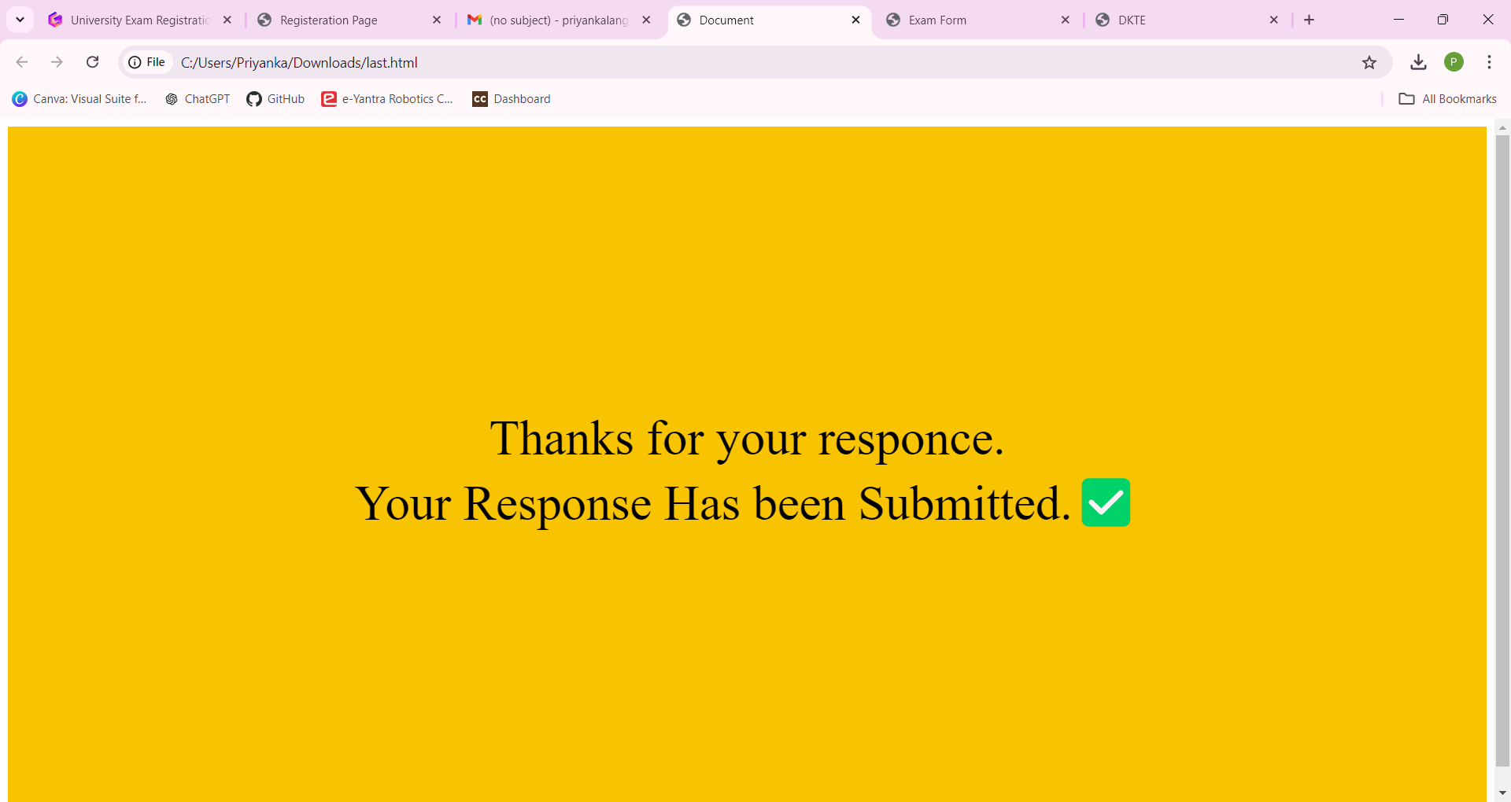

CONCLUSION

In conclusion, the “University Exam Registration Portal” offers a modern, efficient solution to streamline the exam registration process. By replacing manual paperwork with an online system, it reduces errors, saves time, and enhances the overall user experience for both students and university staff. With secure payment processing, real-time notifications, and scalable cloud infrastructure, the portal ensures smooth operation even during peak registration periods. Implementing this system will improve operational efficiency, minimize administrative workload, and provide a seamless, user-friendly registration process, ultimately benefiting the university and its students.

REFERENCES

[www.google.com](http://www.google.com)

[www.chatgpt.com](http://www.chatgpt.com)

[www.youtube.com](http://www.youtube.com)