Four Arenas Analysis
1. Cost/Quality
Bridgestone:
Leverages its advanced R&D capabilities to produce high-quality, durable tires, often commanding a premium price.
  - Focuses on achieving economies of scale by centralizing manufacturing in Asia, reducing per-unit costs while maintaining quality.
  - Strategy: Targets premium and performance segments, catering to luxury car manufacturers.
Michelin:
  - Prioritizes innovation in sustainability, offering eco-friendly tires with reduced rolling resistance and long-lasting tread life.
  - Invests heavily in technology to maintain superior quality, which allows for premium pricing.
  - Strategy: Differentiates through sustainable innovations, appealing to environmentally conscious markets.
2. Timing/Know-How
Bridgestone:
  - Quick to launch advanced technologies such as airless tires and tires for autonomous vehicles.
  - Utilizes its first-mover advantage in high-performance tire segments to establish market dominance.
  - Challenges: Maintaining its pace against imitators and managing cost escalations.
Michelin:
  - Pioneers green tire technologies, creating an early foothold in the sustainability-driven market.
  - Uses its extensive know-how in tire performance optimization to penetrate the electric vehicle segment quickly.
  - Challenges: Staying ahead of competitors in developing economies where affordability trumps innovation.
3. Stronghold Creation/Invasion
Bridgestone:
  - Dominates the Asian market, leveraging regional expertise and government partnerships to fortify its position.
  - Focus: Defends its stronghold by innovating in mid-tier and high-end products, limiting competitor encroachment.
Michelin:
  - Strong presence in Europe and North America, focusing on premium and specialty tires.
  - Strategy: Invests in marketing and innovation to retain its market share while cautiously expanding into emerging markets.
4. Deep Pockets
Bridgestone:
  - Allocates significant financial resources to R&D and global marketing campaigns.
  - Challenges: Maintaining flexibility in financial decisions while competing in diverse markets.
  - Response: Forms alliances with automotive OEMs to bolster cash flow.
Michelin:
  - Utilizes its financial resources to drive sustainability and innovation campaigns.
  - Challenges: Countering cost pressures from premium product lines.
  - Response: Seeks partnerships in green technology to mitigate R&D costs.

7S Framework Analysis
S1: Stakeholder Satisfaction
Bridgestone:
  - Focuses on delivering value to automotive manufacturers and end consumers through innovative tire solutions.
  - Example: Partnerships with electric vehicle manufacturers to develop specialized tires.
Michelin:
  - Places a high emphasis on customer satisfaction with eco-friendly and long-lasting products.
  - Example: Introduction of low-carbon tires for environmentally conscious customers.
S2: Strategic Soothsaying
Bridgestone:
  - Invests in predictive analytics to anticipate shifts in automotive technologies, like autonomous and EV-focused designs.
Michelin:
  - Forecasts trends in sustainability and proactively develops green tires to align with future regulations.
S3: Positioning for Speed
Bridgestone:
  - Quick to scale production capacity for high-demand segments like EV tires.
Michelin:
  - Leverages advanced production techniques to introduce new products faster than competitors.
S4: Positioning for Surprise
Bridgestone:
  - Launches unexpected product lines (e.g., smart tires with embedded sensors) to disrupt competitors’ strategies.
Michelin:
  - Surprises competitors by unveiling groundbreaking sustainable initiatives, like 100% renewable material tires.
S5: Shifting Rules of Competition
Bridgestone:
  - Redefines competition by integrating digital services, such as fleet management solutions, alongside tire sales.
Michelin:
  - Shifts the focus from product quality alone to holistic environmental impact, raising industry standards.
S6: Signaling Strategic Intent
Bridgestone:
  - Strongly signals its dominance in innovation through global advertising campaigns and auto industry partnerships.
Michelin:
  - Highlights its commitment to sustainability with public initiatives like "Michelin Challenge Bibendum."
S7: Simultaneous and Sequential Strategic Thrusts
Bridgestone:
  - Balances investments in premium markets and mid-tier products to secure revenues across segments.
Michelin:
  - Simultaneously focuses on innovation and market expansion, ensuring steady growth in diverse regions.
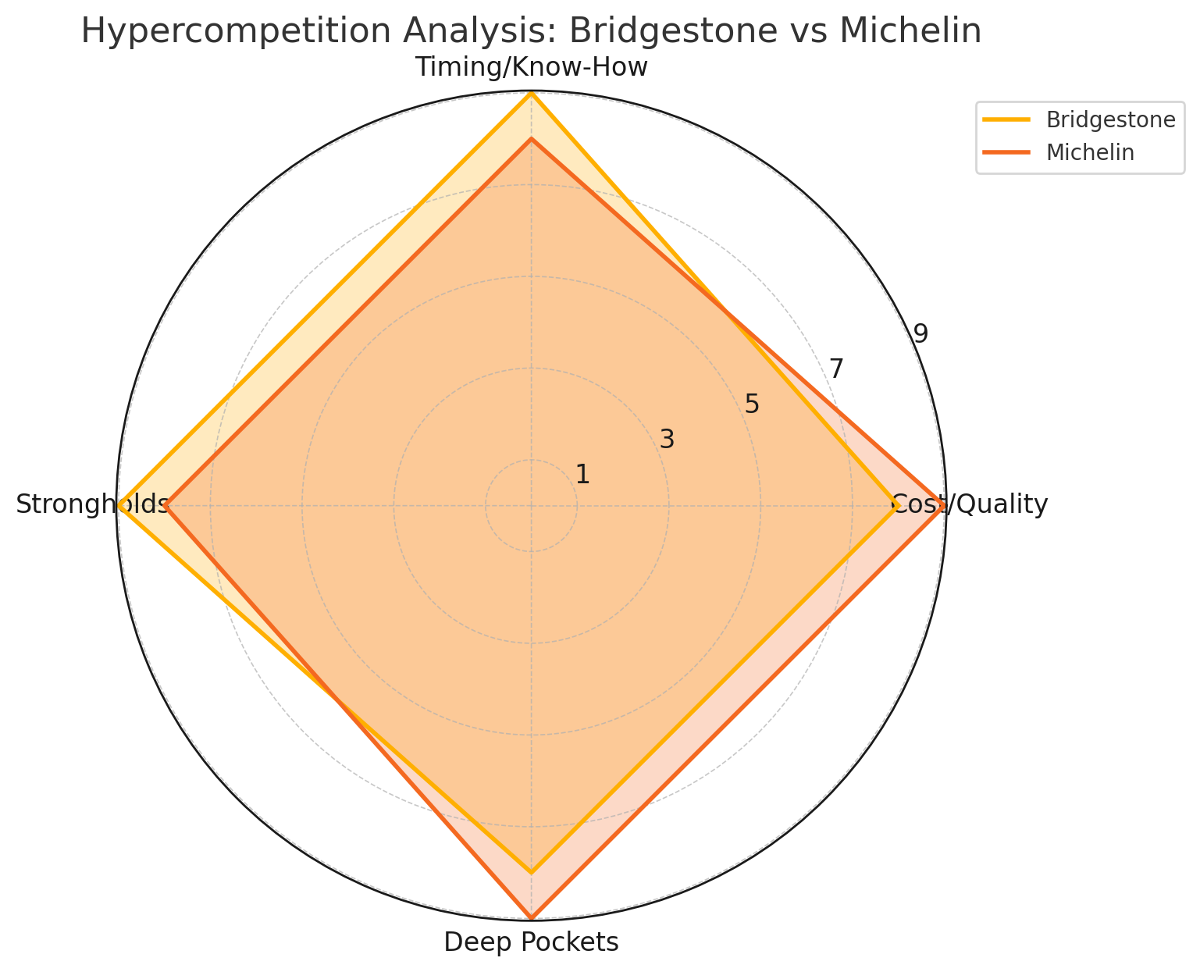

Explanation of the Radar Chart
The radar chart provides a graphical comparison of Bridgestone and Michelin's performance across the Four Arenas of Hypercompetition. Each axis represents one of the arenas, and the values plotted on the chart (on a 1-10 scale) indicate the relative strength of each company's strategies in that arena.
Breakdown of Arenas
- Cost/Quality:
  - Bridgestone (8):
    - Strong focus on premium quality and economies of scale, especially in Asia.
  - Michelin (9):
    - Differentiates with sustainable, high-quality tires and eco-friendly innovations, making it slightly more competitive in this arena.
- Timing/Know-How:
  - Bridgestone (9):
    - Excels as a first-mover in introducing advanced technologies like airless tires.
  - Michelin (8):
    - Leads in green technologies and segments like EV tires but follows a more cautious approach compared to Bridgestone's aggressive timing strategies.
- Strongholds:
  - Bridgestone (9):
    - Dominates the Asian market through strategic regional partnerships and investments.
  - Michelin (8):
    - Holds strong positions in Europe and North America but is more cautious in expanding into emerging markets.
- Deep Pockets:
  - Bridgestone (8):
    - Allocates significant financial resources to R&D and marketing campaigns, though it faces challenges in maintaining flexibility.
  - Michelin (9):
    - Leads in leveraging financial strength for innovation and sustainability, establishing strong industry partnerships to offset costs.
Key Insights from the Radar Chart
- Overall Strengths:
  - Michelin leads in Cost/Quality and Deep Pockets, showcasing its edge in sustainability and financial leverage.
  - Bridgestone outperforms in Timing/Know-How and Strongholds, reflecting its proactive market strategies and strong presence in Asia.
- Balanced Competition:
  - Both companies display comparable strengths, with no clear overall dominance. Each has its unique strengths suited to different market needs and competitive pressures.

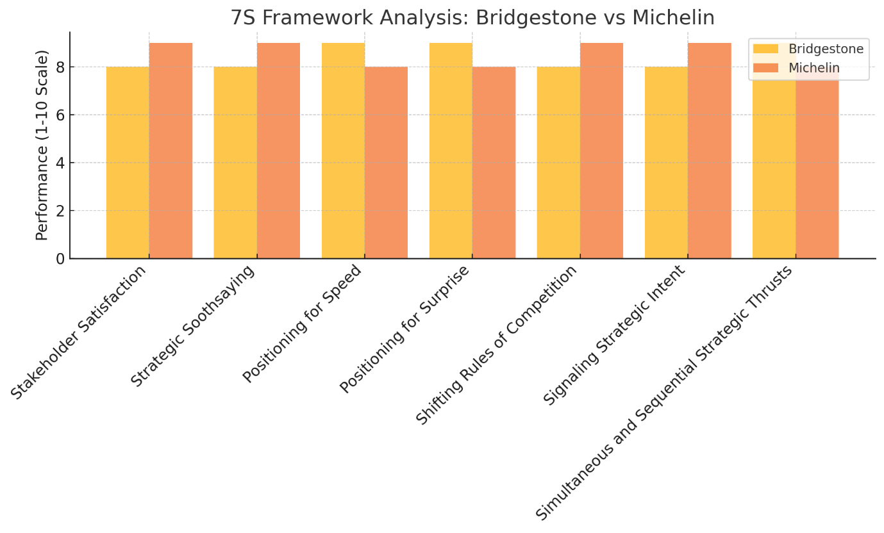
Bar Chart Explanation
- Each bar represents a company's performance on a 1-10 scale for the corresponding 7S framework element.
- Key Observations:
  - Michelin scores higher on Stakeholder Satisfaction, Strategic Soothsaying, and Shifting Rules of Competition, reflecting its focus on sustainability and forward-looking strategies.
  - Bridgestone excels in Positioning for Speed, Positioning for Surprise, and Simultaneous and Sequential Strategic Thrusts, showcasing its agility and disruptive innovation.

Hypercompetition is a business environment where companies compete fiercely and constantly, making it hard for anyone to hold onto a lasting advantage.
Challenges Driving Hypercompetition
Technological Disruption:
Electric and autonomous vehicles demand new tyre designs.
Smart tyres with sensors for real-time performance monitoring are gaining traction.
Environmental Pressures:
Regulations push manufacturers to create eco-friendly, low-emission tyres.
Recycling and sustainability initiatives add competitive complexity.
Globalization:
Entry of low-cost competitors from China intensifies price competition.
Global players must defend their market share while expanding into new territories.
Consumer Expectations:
Customers demand better performance, fuel efficiency, and longevity, forcing companies to innovate continuously.
Hypercompetitive Trends in the Tyre Industry
Digital Transformation:
Use of data analytics, IoT, and AI to optimize production and offer personalized tyre recommendations.
Shift to EV Tyres:
Specialized tyres with lower rolling resistance to enhance EV efficiency.
Airless Tyres:
Bridgestone and Michelin are pioneers in developing puncture-proof, airless tyres.
Focus on Sustainability:
Tyres made from renewable materials and efforts to recycle old tyres are becoming key differentiators.

https://www.bridgestone.com/corporate/library/data_book/pdf/BSDATA2020.pdf
https://www.michelin.com/en/investor/presentation-events/results-sales
https://www.tirebusiness.com/global-tire-report/michelin-bridgestone-goodyear-top-tire-makers-again
https://tireadvise.com/bridgestone-vs-michelin/

