PROJECT TITLE:
SHOPPING COMPLEX
SUBMITTED TO :Dr. Mahesh Kumar
SUBMITTED BY :Ravi Singh(161B171)

First my project will start with splash screen and in splash screen my details are given.
We can see the image given below of splash screen.
After 4 to 5 sec splash screen will disappear
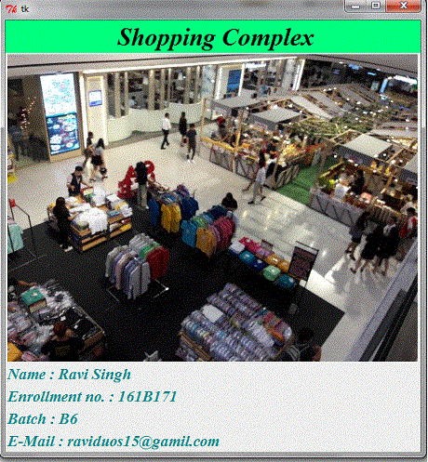

And after closing of splash screen ,we have to enter into the shopping mall and for that
we have to press GO Button.
After pressing GO Button our root window will look like this and is shown below :
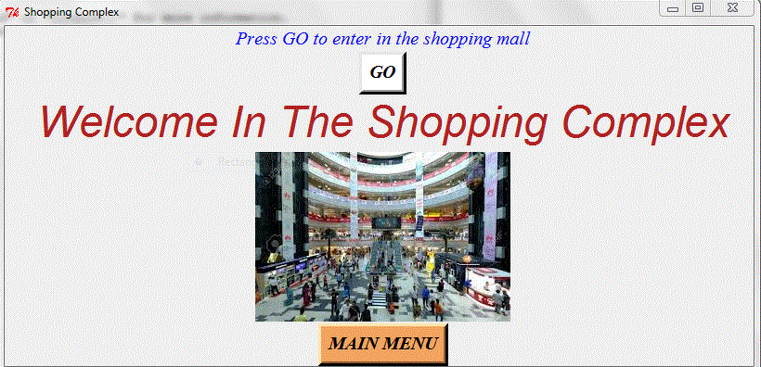

After 10 to 12 sec this root window will disappear. So,we have to click on MAIN MENU Button.
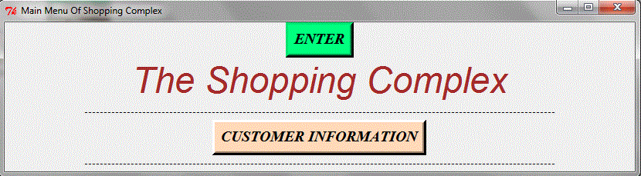
By clicking on the button we get new main menu of shopping complex which is shown below :

Now we have to click on the CUSTOMER INFORMATION Button to get the details of customer.

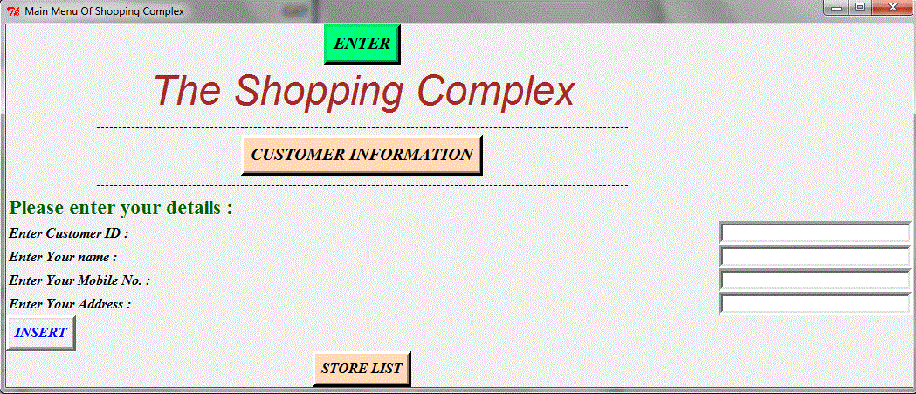
Now if we leave the customer details then we get the message showing error ,which is shown below :
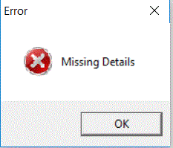
So we have to enter the customer information and after entering customer information ,again a message box will appear which is shown below :
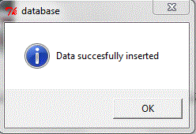
Then we have to click on the STORE LIST Button to see the different stores name :
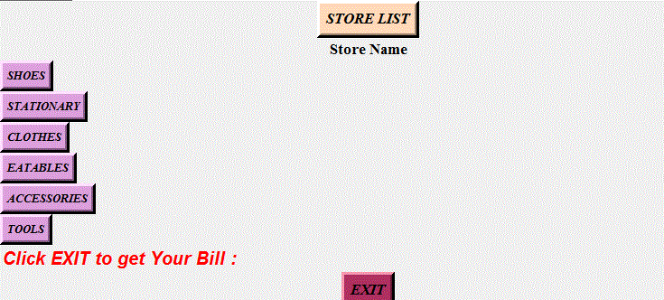

Now its upto us that in which store we want to enter .Suppose if we want to enter in the shoes store then just we have
to click the SHOES Button.
After clicking the Shoes Button we get new window and is shown below :
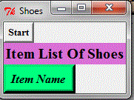
If we want to see the item name then,we have to click on the ITEM NAME Button.
By clicking on the Button our window will look like this which is shown below :
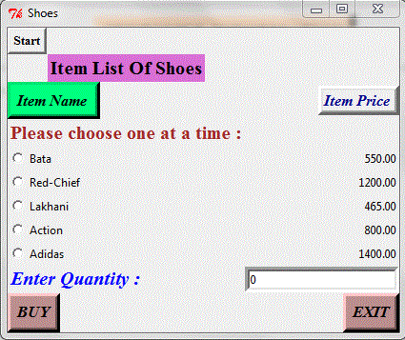
Suppose we want to buy Adidas then,we have to click on the Radio Button named Adidas.
After selecting that button ,we have to enter the the quantity .
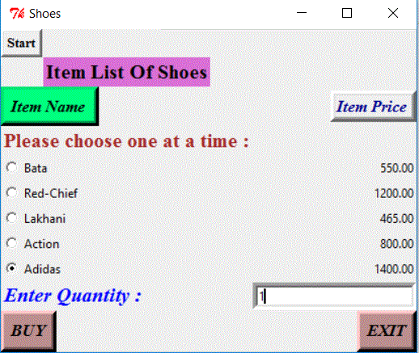
By clicking BUY Button,a message box will appear showing the information of item you have purchased
which is shown below :
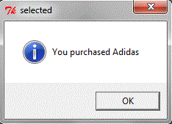
If we want to select another item from the same store the just we just have to click on the Radiobutton.

Suppose if we don’t enter the quantity,then message boxs will appear and is shown below :
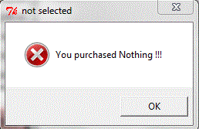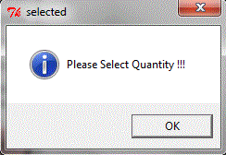
If we want to exit the shoes shop,we have to click on the EXIT Button.
Now if customer wants to buy more things then he/she have to select in which store they want to do the shopping.
To get the BILL, customer have to click on the EXIT Button .
By clicking on the Button we get new window which is shown below :

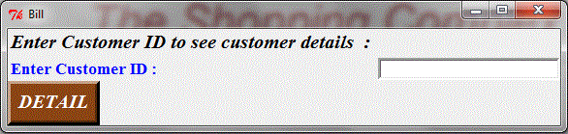
Now we have to enter the Customer ID to get details of Customer.
By clicking on the DEATAIL Button,we can the information about customer
which is shown below :
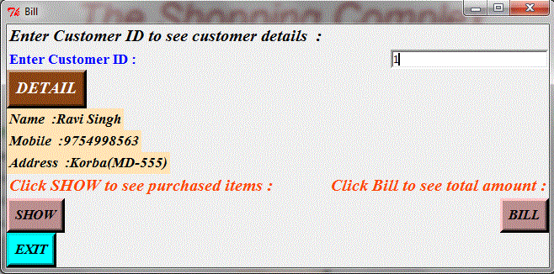
If we want to see the purchased items,we have to click on the SHOW Button.
If we want to see the BILL ,we have click on the BILL Button.
By clicking on the Button, message box will appear showing the amount of money,which is shown below :
