PUZZLE BANK

Introduction :
A puzzle is a game , toy or problem that tests a person’s thinking way or knowledge . There are different catogeries of puzzles such as mathematical puzzle, logical puzzle , number puzzles....

Page View :

Add Question :

Enter text (problem statement)

Category : choose a category

Question Tittle :

Enter question tittle

List of questions :

s.no | Q-Id | Question Tittle | Status
1 | 1231 | Crossing a bridge | Pending
2 | 864 | One bulb three rooms | appeared
3 | 484 | Candlees puzzle | Spam

Answer providing :
Question will visible here and the user have to provide answers s shown below

User 1 :
provide answer here
comments: like: dislike: ans_by:

User 2 :
provide answer here
comments: like: dislike: ans_by:

User 3 :
provide answer here
comments: like: dislike: ans_by:

Total page view :
Total questions and answers will be visible here in the short way is he wants more information there will be available read more option asshow in the below picture
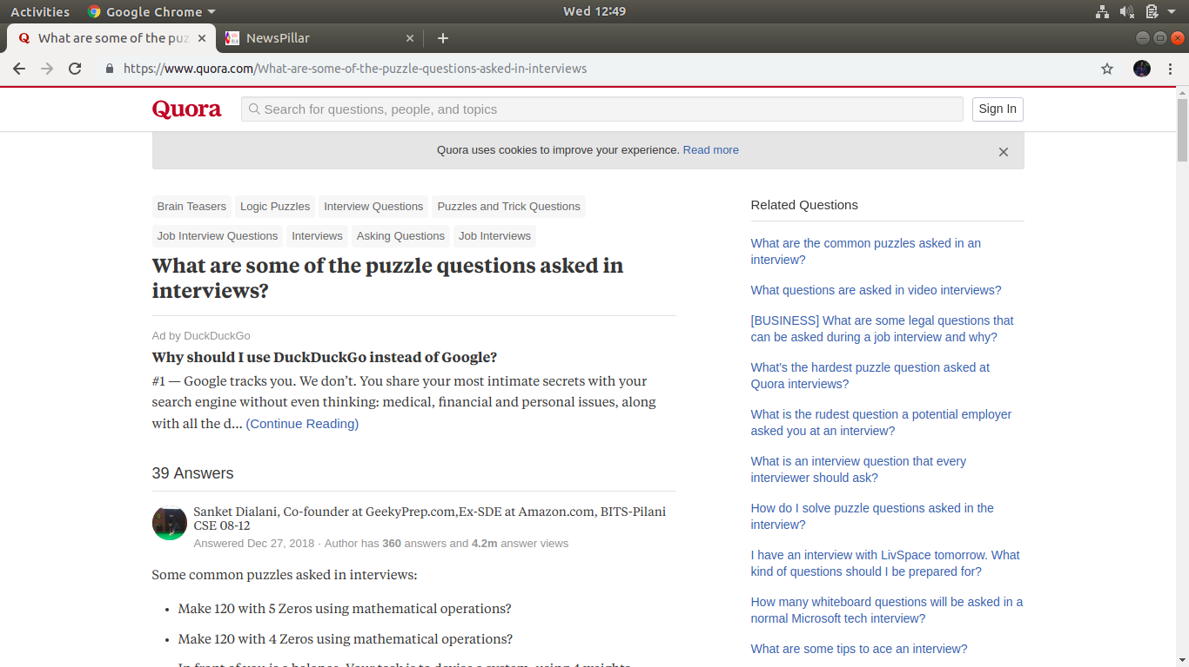
There we also provide category section for easy identifying

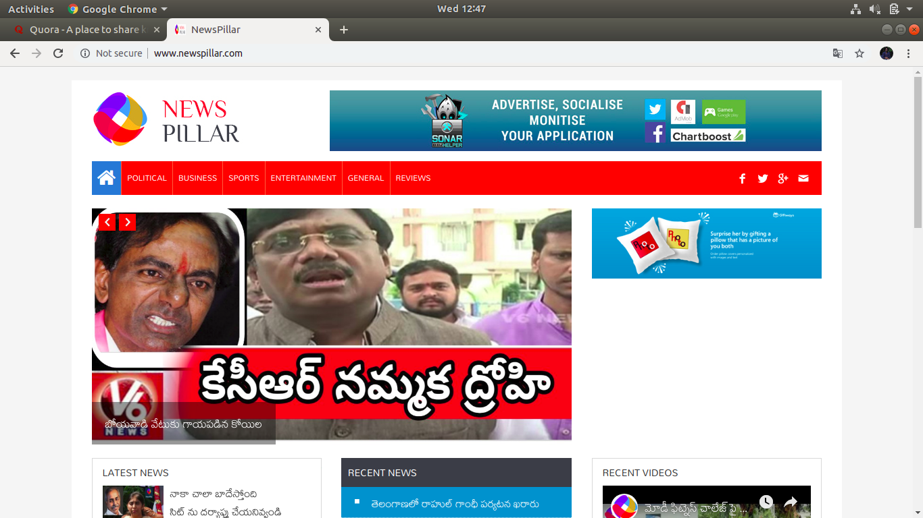
The user will also get recent views and latest updates about the question and answers

