# 架构

## 模块框图

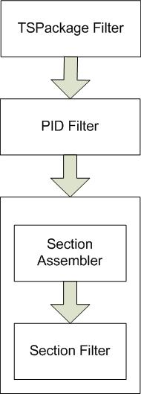

## Filter

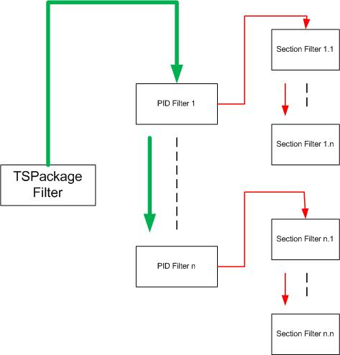

# 2 Filter设计

## 2.1 TSPackage Filter

## 2.2 PID Filter

## 2.3 Section Filter

## 2.4 PES Filter

# 3 Optimization matters

## 3.1 CFieldLoopContainer

1. 建立单件形式Factory (Done)

## 3.2 Descriptor Parser

## 3.3 Visualization