Game Design Document

**Game Engine:** Godot

**Idea:** You are an enemy ship trying to take over Earth. Each level is a military base that gets

harder in difficulty.

**Modified Idea:** A co-op game where you are the enemy ship and the other player is the shield protecting the enemy ship. Each level, you must destroy the military base.

**Roles:**

Scripting/Coding - *Ibrahim, Anthony, Lincoln*

Graphics - *Ibrahim*

Sound - *Anthony*

Version Control - *Lincoln*

File Manager - *Lincoln*

**States:** Game will begin at the main menu state. From the main menu state, users will have options to an instruction page, controls page, and a play page. The play page is essentially the game state. The game state has 2 possible states; it can transition to the pause menu or the gameover state. Pause menu will halt execution of the game state and pop up a menu, which in turn, can jump back to the game state or the main menu (quit). Here's the list:

* Main menu
* Instructions
* Controls
* Gameover
* Game (play)
* Pause menu

We can shrink these down to 3 states:

* Pause
* Menu
* Game

...and just send different data to each state when needed.

**Sprites:** A few essential sprites will exist:

* Button
* Label
* Player
* Enemy
* Projectile
* Effect

More specific sprites can be inherited from these.

Have two options to beat levels

-Destroy base

- Kill all enemies which implies you win.

Scores a 100pt for getting hit

1000pts = 1 upgrade

Level1 Interaction

Bomber

Spawn at the top of the screen

can move left or right

Can shoot lasers

Can die by enemy lasers

Guardian

Spawn below Bomber

Can move left or right

Can destroy enemy lasers to earn gems

Can’t die

Turret

Spawn in level on base and ground

Dies when loses health

Shoots laser at enemy

Laser

Spawns in front of player

Destroys after colliding

Destroys off screen

Enemy Laser

Spawns in front of turret

Destroys after colliding

Destroys off screen

Base

Spawn at the bottom middle of screen

Dies when loses health

Change States in level1

Press Q to change level1 state to Menu state

Press P to change level1 state to pause state

Press Resume to change pause state to level1 state

Level 2 Interaction

Bomber

Spawn at the top of the screen

can move left or right

Can shoot lasers

Can die by enemy lasers

Guardian

Spawn below Bomber

Can move left or right

Can destroy enemy lasers to earn gems

Can’t die

Turret

Spawn in level on base and ground

Dies when loses health

Shoots laser at enemy

Laser

Spawns in front of player

Destroys after colliding

Destroys off screen

Enemy Laser

Spawns in front of turret

Destroys after colliding

Destroys off screen

Mover

Spawn in level on ground

Dies when loses health

Shoots stun laser at player

Stun Laser

Bombr and Guardian can’t move for a limited time

Dies when colliding with player or defender

Base2

Spawn at the bottom middle of screen

Dies when lost health

Change States in level 2

Press Q to change level 2 state to Menu state

Press P to change level 2 state to pause state

Press Resume to change pause state to level 2 state

Level 3 Interaction

Bomber

Spawn at the top of the screen

can move left or right

Can shoot lasers

Can die by enemy lasers

Guardian

Spawn below Bomber

Can move left or right

Can destroy enemy lasers to earn gems

Can’t die

EnemyShip 1,2,3

Shoots green laser

Spawns from base

Dies when lost all health

EnemyShip 4,5

Shoots missile

Spawns from base

Dies when lost all health

Missile

Spawns in front of Enemyship 4 and 5

Destroys after colliding

Destroys off screen

Laser

Spawns in front of player

Destroys after colliding

Destroys off screen

Enemy Laser

Spawns in front of enemyship

Destroys after colliding

Destroys off screen

Base3

Spawn at the bottom middle of screen

Dies when loses health

Change States in level 3

Press Q to change level 3 state to Menu state

Press P to change level 3 state to pause state

Press Resume to change pause state to level 3 state

**Software Engineering Plan**

Scripting/Coding - *Ibrahim, Anthony, Lincoln*

Graphics - *Ibrahim*

Sound/Music - *Anthony*

Version Control - *Lincoln*

File Manager - *Lincoln*

*Timeline*

|  |  |
| --- | --- |
| *Date* | *Milestone* |
| *November 22* | *Get used to Godot’s User Interface* |
| *November 25* | *Everybody Works on Collision* |
| *November 29* | *Lincoln Work on level 1*  *Anthony Work on level 2*  *Ibriham Work on level 3* |
| *December 1* | *Finished levels* |
| *December 3* | *Work on upgrade shop* |
| *December 5* | *Make little changes to make game better* |

State Transition Diagram

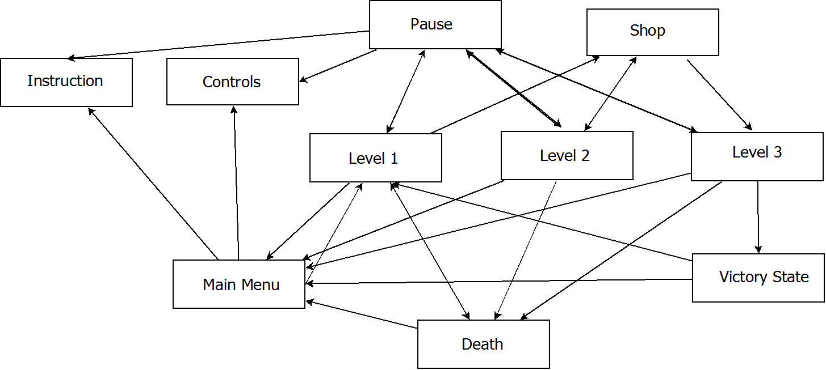

User Instructions

**It can run on multiple platforms such as linux, windows, and mac.**

**Installation**

**1.Extract zip file**

**2.Go inside game file**

**3.Find Godot_v2.1.1-stable_win64.**

**4. Click it to run void invaders to play our game**

**Side Note: Godot_v2.1.1-stable_win64 application will use the engine.cfg file to run the game.**