译文

校园信息管理系统的Java应用

**摘要：**在线校园信息系统的可用性使学生能够更好地规划教育规划。帮助大学做好管理和战略信息管理。在本文中，我们描述了一个面向本科生的在线校园信息系统的模型，并将其进行了整合。收集到的数据使我们能够为校园信息系统准备一个Java应用程序，旨在帮助学生以及以最佳方式解决问题。

1引言

早些时候，领先的大学找到了一项具有挑战性的工作来管理大学校园的信息交流，因为这是一项出色的任务。因此，在90年代，他们开始通过使用www（万维网）向更好的方向转变。20世纪末，利用信息技术和电子通信，校园内信息交换的潜力得到了提升。从20世纪到今天的时代，从黑白手机走向智能手机或微型电脑，移动操作系统（OS）离我们很远。从1996年的Palm OS开始，到2000年的windows袖珍PC到Java和黑莓操作系统，智能手机操作系统从去年开始戏剧性地消失，并彻底改变了每个人的生活。电脑和移动设备以无数方式影响着我们的日常生活，包括个人和职业。PC/笔记本电脑/台式机访问的Web服务器应用程序正在慢慢退出。尽管这款手机成为最常用的小工具之一，但它要么用于商业用途，要么用于个人用途。此外，这些移动应用程序是一个经济高效的过程。现在，大多数大学和机构都在应用程序上共享他们的大学杂志和期刊，这有助于节省印刷和纸张成本。提出了一种基于Java的校园解决方案，它将学生、家长、员工和校友与学院或大学联系起来。在这个应用程序的帮助下，工作人员可以快速输入或维护学生的出勤率和内部分数。他们正在分享笔记和其他学院或大学的官方通知，也可以在应用程序上获得，学生和家长可以使用手机轻松访问。因此，学生可以获得有关考试日程、活动的通知，家长也可以访问该应用程序，远程查看孩子的成绩、出勤情况或孩子和大学的成绩。甚至这个应用程序最引人注目的特点是，校友或学生会收到通知，要求他们使用这个应用程序收集优惠表格和证书。因此，本研究试图以尽可能好的方式使管理和处理校园内信息交换的概念现代化。目标是通过使用可访问的技术来简化信息交换，并以最佳方式使其更加方便用户。这样做的目的是为了让领先的大学能够完成他们的任务，并为学生和大学教师提供一个管理良好的系统。网络信息系统提高了校园的能力，并被证明是处理这一问题以及向用户提供管理系统的最佳方式

2文献综述

现有的校园活动管理应用程序多种多样。每个应用程序都有其特点、缺点和优点。这些应用程序是考虑到某个特定机构的需求而制作的。这些应用程序只提供单一目的，我们需要不同的应用程序来实现不同的机构活动。基于Java的校园解决方案有助于使用手机完成几乎所有的机构活动。Nethaji等人。描述了Java BasedCampus Solution应用程序的拟议工作。Bhattacharya等人。描述了MOBILE CAMPUS应用程序的思想和实现。Ghandi等人。介绍了在开发应用程序时所遵循的各种方法、指南和标准，也在“移动应用程序开发-实用方法”中列出。Xhafa等人。8从学习和技术角度描述和分析了使用手机的学习方法。Li等人介绍了客户端设计。Chou等人描述了移动设备技术在我们日常生活中的重要性。Malhotra等人。描述了设备障碍物检测的结构和设计。Cardei（12）定义了移动和传感器领域的技术进步。一位研究人员描述了“智能校园”提供校内注册的应用程序。此外，这个初始原型可以自动定位和识别用户的熟人，无论是否在校园内。该原型使用SDA架构实现。推理和查询在语义盒组件中进行。所有这些作者都使用各种技术描述了不同应用程序的布局，但都没有讨论如何维护大学信息系统。在下一节中，作者介绍了面向学生和教师的校园信息系统的特点。

3方法论

由于当今时代是一个具有许多进步的数字和技术时代；同样，教育是这一时期的关键因素。但在印度，大多数机构、学院和大学都缺乏与最新趋势和技术的互动。拟议中的Java应用程序帮助学生直接收集学习材料，而无需任何麻烦。由于该应用程序用于学术目的，学生可以在校园以外的任何地方、任何时间访问该应用程序，无需创建用于下载文件的登录名。构建该应用程序的主要目的是在一个应用程序下为学生、教师和教育机构的管理人员提供各种用途。它提供了一个可移植的环境，但应用程序的工作方式取决于用户对用户的要求。学生可以联系并更新与他们的班级、部门或计算机上即将发生的任何事情相关的最近事件或活动。同样，教师、家长和行政人员也与每个学生有联系。父母可以跟踪孩子的表现。行政官员可以毫无问题地向学生颁发证书，通过这个基于手机的应用程序，可以方便地记录出勤情况，标记细节。本文作者在JavaStudio和Sqlite数据库的帮助下设计并开发了一个应用程序。此应用程序在robotium下测试。作者还使用promethe检查应用程序的性能

3.1 特征化模型

为了公式化校园信息系统的概念化和特征化，以适合所处理的案例和上下文，我们考虑了作为原型的Java应用程序的准备。该应用程序将包含关于校园背景的必要信息，以及教师和学生的看法。

3.2 特点和规格

今天的时代是一个科技世界，有许多进步，并支持大量智能手机使生活更加高级和舒适的应用程序。Java，一个著名的开源移动操作系统由谷歌开发的用Java编写的Java应用程序附带了一个在线商店，大约2.0缺少游戏、小部件和应用程序。用户还可以下载和使用应用程序由第三方开发人员开发。用于软件开发Java软件开发工具包（JDK），到目前为止，大约有20000个Java应用程序的下载量超过30亿次。对于核心系统服务，如内存和进程管理、网络堆栈、安全性和驱动程序模型，Java依赖于Linux版本2.6。图1表示学院信息系统。描述了应用程序的模块。

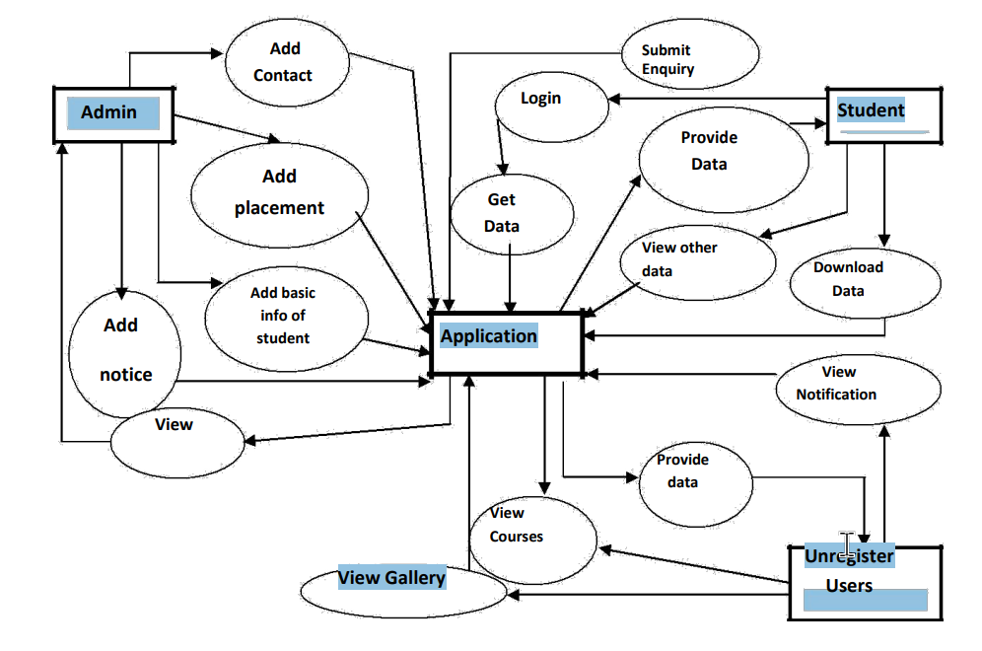

图1：高校信息系统的表示

3.3 应用程序的工作

在此，我们构建了一个基于学院信息系统的应用程序，它有助于维护学院和学生信息

3.4 印度的信息分类

在印度，有四种类型的大学——中央大学、国立大学、私立大学和认定大学。印度有227所私立大学、49所中央大学、318所州立大学和123所被视为大学。因此，要处理如此庞大的学生群体，就需要一个管理良好、分类良好的校园信息系统，它可以充当学生学术、行政和社会意识的处理手。这个概念对学生和校园都非常有用。它有助于提高大学处理学生事务的能力，并将被视为迈向智慧印度的良好一步。图12显示应用程序的用户每年都在增加。

3.5 结论

这项研究试图以最佳方式实现校园内信息交换管理和处理理念的现代化。构建该应用程序的主要动机是在单一应用程序下为学生、教师和教育机构管理人员的各种目的服务。因此，网络信息系统提高了校园的能力，并为用户提供了一个管理良好的系统。此外，教师和家长可以通过单指触摸查询任何学生的详细信息。事实证明，这一概念对学生、教师、家长以及校园都非常有用，有助于提高大学处理学生事务的能力，并将被视为迈向智能印度的良好一步。用户可以在此应用程序中轻松探索他/她的目标或事情。

3.6 未来使用范围

由于所提出的应用程序具有成本效益、用户友好和易于使用的特点，因此它可以在不同的情况下实现。新功能可以增加用户和应用程序的需求。由于其各种特性，可重用性也是可行的，应用程序中的所有模块都提供了灵活性和易访问性。

译文原文出处：

A Java Application for Campus Information System

An Java Application for Campus Information System

**Abstract:**

The availability of an online campus information system enables the students to get a better layout of education planning . Ithelps the university regarding well managed and strategic information management . In this paper , we describe andcontextualize the model for an online campus information system for undergraduate students as well as university facultInformation gathered employing structured interviews from a recognized University . The collected data enables us to preparean Java application for the campus information system , aims to help students as well as faculty in the best possible way.

**1. Introduction**

Earlier the leading universities found a challenging Job to manage the exchange of information on theuniversity campus as it was an excellent task to perform . So in the 1990s , they started shifting towards a betterway by the use of www ( World Wide Web ) . At the end of the 20 " century , the potential for the exchange ofinformation within the campus has boosted by making use of information techand electronicommunication . From the 20 century to todays era , starting from the black and white phones trend tosmartphones or mini computers , mobile Operating Systems ( OS ) I come far away . Started from Palm O996 to 2000 pattern of windows pocket PC to Java and Blackberry OS , smartphones OS has dramaticallyevolved from last year and drastically changed every singular life 2 . The computers and mobile devices areaffecting our daily routines in endless ways , including personal and professional . The PC / Laptop / Desktoaccessed Web Server applications are gently getting out of the way . Although this mobile phone becomes one othe most cher uses It for business purposes or personal . Moreover , these mobileapplications are a cost-effective process , e.g. , now a days most of the colleges and institutions share their collegmagazines and journals on apps 4 ) , which help in saving the cost of printing and paper . An Java-basedcampus solution 5 ] app proposed , which connects the students , parents , staff , and alumni with the collegeuniversity . With the help of this app , staff can quickly enter or maintain the attendance , internal marks of thestudents . They are sharing notes and other official notifications of college or university also available on the apwhich can be easily accessed by students and parents using mobile phones . Hence the students can getnotifications regarding their test schedules , events , along with their parents also able to access the app to chetheir childs performance , attendance detail , or achievements of their child and college remotely . Even the moststriking feature of this app is that the alumni or students get notified regarding their document to collect theirconcessions forms and certificates using this app . Thus , this research attempts to modernize the concept ofmanaging and handling the exchange of information within the campus in the best possible way . The objectiveto ease information exchange by the use of accessible technologies and to make it more user-friendly in the bestpossible ways . The purpose is that it could be beneficial for the leading universities to perform their tasks andoffer a well-managed system to both students as well as faculty of the university . The network informationsystem improves the capabilities of the campus and proves to be the best way of dealing with the Issue as well as offering a managed systemto the users.

**2. Literature Survey**

There are various existing applications for the management of campus activities. Every application has its characteristics, disadvantages, and advantages. These applications (apps) made by taking into consideration the needs of a particular institute. These apps provide a single purpose only, and we necessitate different apps for diverse institutional activities. Java Based Campus Solutions help in the accomplishment of almost all institutional activities using mobile phones. Nethaji et al. [6] described the proposed work of the Java Based Campus Solution app. Bhattacharya et al. [1] described the idea and implementation of the MOBILE-CAMPUS application. Ghandi et al. [7] presented the various approaches, guidelines, and standards followed while developing an application also listed in the "Mobile application development –a practical approach." Xhafa et al. [8] described and analyzed the learning methods using mobile phones from both learning and technological perspectives. Li et al. [9] introduced the client terminal's design. Chou et al. [10] described the essentiality and need for mobile gadgets technology in our daily life. Malhotra et al. [3] described construction and design of a device obstacle detection. Cardei [12] defined the advancement of technology in mobile and sensors field. One researcher described the "Smart Campus" application that providing on-campus registration. Moreover, this initial prototype automatically locates and identifies the users' acquaintances, available on campus or not. This prototype implements with the SDA architecture. Reasoning and query are taken place at the semantic box component. All these authors described the layout of different apps using various techniques, but none of them discuss how to maintain the college information system. In the next section, the authors present a characterization of the campus information system for students and faculty.

**3. Methodology**

As today's time is a digital and tech era with many advancements; similarly, education is the crucial factor of this time. But in India, most of the institutions, colleges, and universities are lacking interaction with the latest trends and technology. The proposed Java app helps students to gather their study material directly without any hassle. As this app is serving for academic purposes, students can access the application anywhere, anytime beyond the campus, and there is no need to create a login for downloading files.

The main motive to build the app is to serve various purposes of students, teachers, and administrative staff of an educational institution under a single application. It provides a portable environment, but the working of the application varies depending upon the requirement of the user to the user. Students get connected and updated with recent events or activities relevant to their class, department, or anything going to happen on the campus. Similarly, teachers, parents, and administrative staff also connected with each student. Parents can track their child's performance. Administrative officials able to issue certificates to a student without any issue, faculty maintains the attendance, marks details easily through this mobile-based application. In this paper, the authors designed and develop an application with the help of Java Studio and SQLite Database. This application tested under the robotium. The authors also check the performance of the application using promethee.

***3.1 Characterization Model***

To formulae conceptualize and characterization of campus information systems adequate to the case and context dealt with, we took into account the preparation of an Java app that would act as a prototype. The app would contain necessary information regarding the campus affairs on the perception of both faculty as well as students.

***3.2 Features and Specifications***

Today's era is a tech world with many advancements and supporting a large number of Smartphone applications that make life more advanced and comfortable. Java, a famous open-source mobile OS is written in Java, developed by Google comes with an online store as an Java market consisting of software, approximately 2.0 lack + games, widgets, and applications. Users can also download and use applications developed by third-party developers. Java Software Development Kit (SDK) used for software development, and till now, around 20, 0000, Java apps developed with over billion+ downloads. For core system services This is an open access article under the CC BY-NC-ND licensend/3.0/).Selection and peer-review under responsibility of the scientific committee of WEEF 2019 such as memory and process management, network stack, security and driver model, Java lean on Linux version 2.6. Fig. 1 shows the faculty and student modules. Fig. 2 represents the college information system. Fig. 3 depicts the modules of an application.

*3.3* ***Working of an Application***

In this, we built an application based on the college information system,which helps to maintain the faculty as well as student information. Fig.4 represents the user interface. Fig.5 shows the home mage of an app. Fig.6 represents the login page. Fig.7 represents the history of a college. Fig.8 shows the notification module. Fig.9 represents the courses of a college. Fig.10 shows the student detail page. Fi.11 shows that the performance of this application is to increase.

***3.4 Info Classification in India***

In India, there are four types of universities- Centraluniversities, State universities, Private Universities, and Deemed universities. There are 227 private universities, 49 central universities, 318 state universities, and 123 deemed universities in India. So to handle such a massive amount of students’ particular, there is a need for well managed and classified campus information systems, which acts as a dealing hand with the student’s academics, administrative and social senses. The concept stands out to be very useful for both the students as well as the campus. It helps in increasing the capability of a university to handle the student affairs and would be considered as a good step towards smart India. Fig.12 shows that the users of the application are increasing every year.

**4. Conclusion**

This research attempts to modernize the concept of managing and handling the exchange of information within the campus in a best possible way. The main motive to build the app is to serve various purposes of students, teachers and administrative staff of an educational institution under single application. Thus, network information system improves the capabilities of the campus and offers a well managed system to the users. Also, the teachers and parents can enquire about the details of any student on a single finger touch. The concept stands out to be very useful for students, teachers, parents as well as the campus and help in increasing the capability of a university to handle the student affairs and would be considered as a good step towards smart India. User can easily explore his/her goals or things in this app.

5. **Future Scope of Application**

As the proposed application is cost-effective, user-friendly, and easy to use so that it can implement under different situations. New features can add to the requirement of users and apps. Due to its various features, reusability is also feasible, and all modules in the application provide flexibility and ease of access.



Fig.1Representation of College Information System

**REFERENCES**   
 [1] Bhattacharya, Sagnik, and M. B. Panbu.(2013) "Design and development of mobile campus, an Java- based mobile application for university campus tour guide.”.*International Journal of Innovative* *Technology and Exploring Engineering*, **3** : 25-29.

[2] Little, Geoffrey. (2011) "Keeping moving: Smartphone and mobile technologies in the academic library." *The* *Journal of Academic Librarianship* **37**, **2(3)**: 267-269.

[3] Malhotra, R.,Vanshika and Neha (2019), “Construction and design of a device for obstacle detection,” *International Journal of Recent Technology and Engineering* **8(4):**2312-2315.

[4] Kadam, A. J., Aradhana Singh, Komal Jagtap, and Srujana Tankala.Mobile(2017) Web-Based Java Application for College Management System. *International Journal of Engineering and Computer* *Science* **6(2 )**: 20206-20209.

[5] Harnale, S., Thakur G., and Syed Hussain A. (2014), “Java College Campus.” *International Journal of*  *Ethics in Engineering & Management Education,* 2348-4748.

[6] Nethaji, T. S., and Suganthalakshmi R., (2019), “ Muti Utility Mobile Application.” *Pacifier* **24(1)**: 1-3. [7] Ghandi, Li., Catarina S., Martínez, D. and Gualotuña T. (2017) , “.Mobile application development process: A practical experience.” *12th Iberian Conference on Information Systems* *and Technologies*  *(CISTI)*, 1-6.

[8] Xhafa, Fatos, Santi Caballé, Isaac Rustarazo, and Leonard Barolli.Implementing a mobile campus Using MLE Moodle.In *2010 International Conference on P2P, Parallel, Grid, Cloud and Internet* *Computing*, pp. 207-214. IEEE, 2010.

[9] Biqing, Li, Wenya Lai, Yang, C. and Zheng. S.(2016), “The Design and Implementation of the APP of Experiencing Guangxi Folk Custom.”*International Conference on Economics and* *Management Innovations*. Atlantis Press, 2016.

[10] Chou, Te-Lien, and Lih-Juan Chan Lin. (2012), “Augmented reality smartphone environment orientation application: a case study of the Fu-Jen University mobile campus touring system.” *Procedia-Social and* *Behavioral Sciences* **46** : 410-416.

[11] Chen, Xian, Ruofan Jin, Kyoungwon Suh, Bing Wang, and Wei Wei.Network performance of smart mobile handhelds in a university campus WiFi network.In *Proceedings of the 2012 Internet* *Measurement Conference*, pp. 315-328. ACM, 2012.

[12] Cardei, M., Zankina,I., Cardei, I. and Daniel R.(2013) "Campus assistant application on an Java platform." In *2013 Proceedings of IEEE southeastcon*, 1-6.