Individual project

report

(comp1101)

LI Shuhang

21102658D

**Project Description**

This project is mainly about blockchain, a new technology that has become very popular in recent years. This technology is used to protect the integrity of data. The blockchain is essentially a linked list data structure, each fast data corresponds to a specific hash value. When the data is illegally or illegally tampered with, this data chain will be interrupted. The reason is that this data chain is associated by the hash value of each data. When the data is tampered with, the hash value cannot be correlated.

**the objectives of the program**

1. Allows users to add data blocks, enter block information by themselves, and the program automatically generates its hash value.

2. Allows the user to find information about a data block. And provide a variety of search methods. For example, search by value or number of a data block.

3. Allow users to audit the integrity of the data chain to see if the data has been tampered with.

**The structure of the program**

I divided the program into five parts. The first part is building the structure.

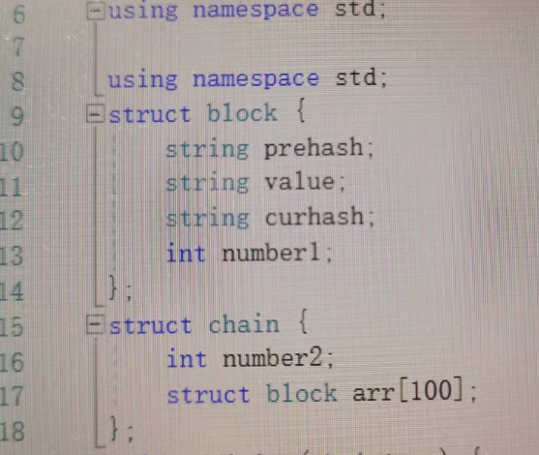as you can see, I created two structures. The first one is the block structure. It contains the all information. And the second one is used to link each block.

The second part applies to functions that add blocks of data.

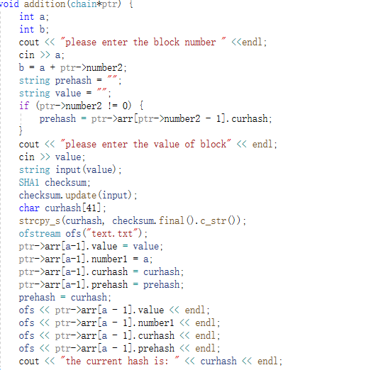In this function, the most difficult code to generate the hash value is given. Then just store the user input into the prepared array.

Regarding the third part, it is the function that implements the lookup function.

In the query system, I provide three query methods. First let the user choose one of the methods. When the user selects the latter two, use the while loop to find the data of the data block that the user wants to find. When the user chooses the first method, the corresponding other information is given directly according to the number.

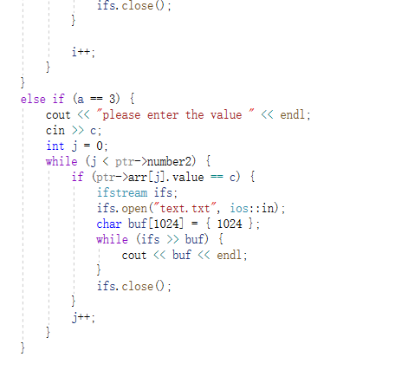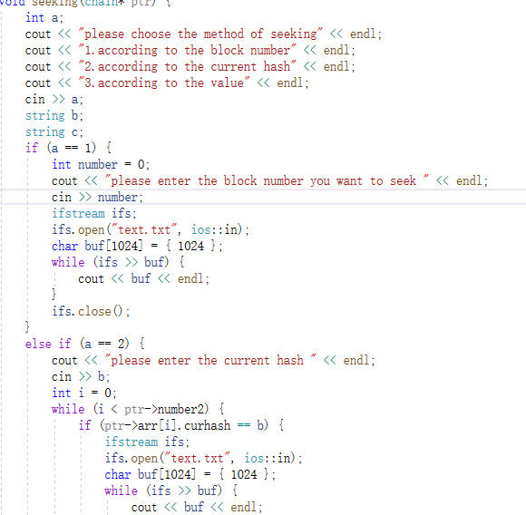

The fourth part is to check the integrity of the data. The code iterates through the entire array to see if the current hash of the previous block is equal to the previous hash of the next block. If they are equal, it proves that the data is complete.

The last part is the main function.

In this function, the program asks the user to select the function to perform. The corresponding function is called according to the user's selection. and repeat the step using a while loop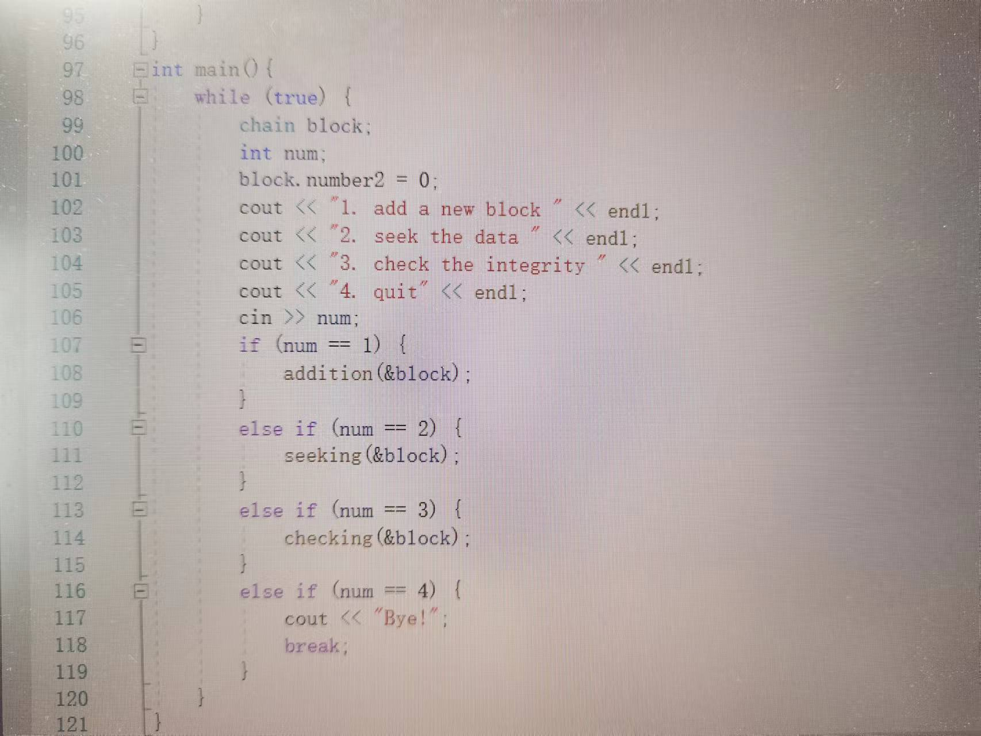.

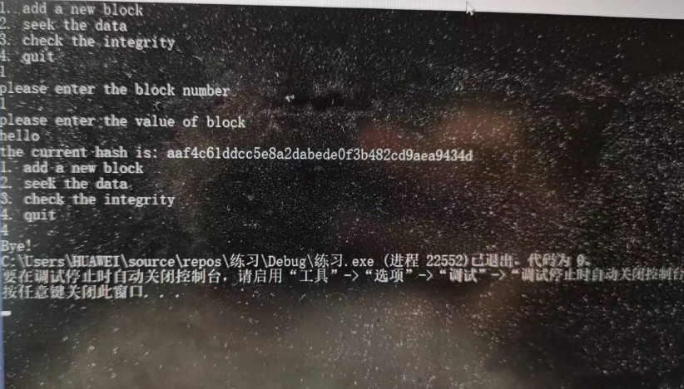**User Manual**

For users, they will see four options at the beginning. The last one is the exit function. After the user selects one, as shown in the figure above, first assign the number and then enter the value, and then the program will automatically generate a hash value. The user can then view the data by entering two. Then there will be three options for the user to choose a different query method. Select which query method to enter what kind of information, and then the program will display other information that the user wants to query. For the third function, if the data is complete, the upper part of the screen will inform that the data is complete, if the data is not complete, the opposite is true.