____________________________________________________________________________

HOW TO RUN CANLAB 2ND LEVEL ANALYSIS TEMPLATE SCRIPTS

walkthrough by Marianne Reddan, 2017

code & videos by tor, 2017

This document (editable version, may be updated) :

<https://docs.google.com/document/d/1bGpiXUyxxzu6aG0zAU4x8ELNy3bdUMogW_TiuoDaH0s/edit?ts=591b73b7#>

GENERAL INFORMATION

Videos (see below):

Example HTML output from these scripts:

What you will need to run:

1. INSTALL THE CANlab_help_examples FOLDER FROM GITHUB

2. ADD ALL THE FOLDERS TO PATH

3. SET UP YOUR DATA ANALYSIS FOLDER

STEP A - SET UP NEW FOLDERS

STEP B - SET UP THE STUDY INFO DOCUMENT

4. MODIFY THE TEMPLATE SCRIPTS

4. RUN THE BATCH AND PUBLISH

MORE

____________________________________________________________________________

# GENERAL INFORMATION

## 

## Videos (see below):

On Youtube [note: youtube video audio not working] and CANlab slack

Or on [Drive](https://drive.google.com/drive/folders/0B-FyQiYIUnS5MkRIeFU1M1VmYjg?usp=sharing)

## Example HTML output from these scripts:

<https://www.dropbox.com/s/rt8xzf6yq4h0h6e/Example_CANlab_second_level_html_output.zip?dl=0>

## What you will need to run:

1. CANlab core tools <https://github.com/canlab/CanlabCore>
2. SPM (e.g., SPM12)
3. CANlab second-level analysis scripts <https://github.com/canlab/CANlab_help_examples>
4. For “signature”-based analysis: CANlab signatures (e.g., NPS); some private

If you are sharing data with CANlab, here is a post with details:

<https://slack-files.com/T09S4HMUL-F1866CCER-6f7a17803b>

If you are applying the NPS and other “signatures” here are two posts about how to do it, and some notes about image scaling across studies:

<https://slack-files.com/T09S4HMUL-F17M8PFS7-09e72ec85b>

<https://slack-files.com/T09S4HMUL-F1J0TF0H5-2885e964cc>

To do: add instructions on the behavioral data

____________________________________________________________________________

# 1. INSTALL THE CANlab_help_examples FOLDER FROM GITHUB

Found here <https://github.com/canlab>

This video provides further instruction.

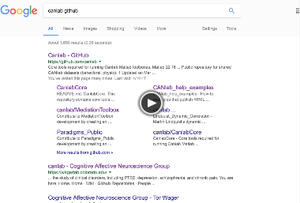

# 2. ADD ALL THE FOLDERS TO PATH

In MATLAB

* genpath(addpath(‘/CANLab_help_examples/’))
* genpath(addpath(‘/YOUR_ANALYSIS_FOLDER/’))

*This video provides further instruction.*

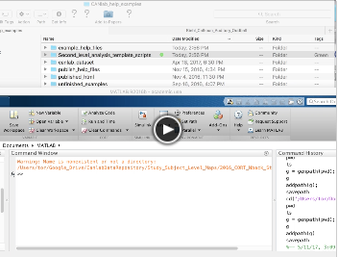

Check and make sure you have all the paths and dependencies before you get started by running this script (found in CANLab_help_examples):

* run('/CANlab_help_examples/Second_level_analysis_template_scripts/**a2_second_level_toolbox_check_dependencies.m**')

You may need files from our [lab’s google drive](https://drive.google.com/open?id=0B_iGd2quo0mAR2k5bWQ5bEpJOTA) which is *not* public. However, these are not necessary for all analyses.

# 3. SET UP YOUR DATA ANALYSIS FOLDER

## 

Are your data set up so that the folders represent conditions and inside those folders are subject data? If not, maybe this bash reorganization [script](https://github.com/mariannnne/Bash-Tools/blob/master/Move_Rename.sh) will help you. Alternatively you can change the way the 2nd Level Scripts look at your folders. However, I recommend you keep their inherent structure the same and just conform. Path of least resistance. Do not apply this advice to your social life.

## STEP A - SET UP NEW FOLDERS

There is a script you can use which will auto set up your folders to play well with the 2nd level analysis pipeline. Go to your new **Analysis** folder and run this from within it:

* a_set_up_new_analysis_folder_and_script.m

If you want to do this by hand you can go to your **Analysis** folder set up these subfolders:

* data
* extras
* results
* scripts
  + Here copy in a series of scripts from CANLab_help_examples

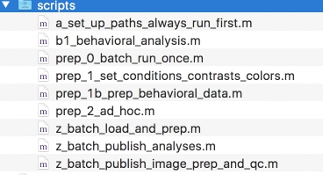

## STEP B - SET UP THE STUDY INFO DOCUMENT

* Copy over to your **Analysis** folder ‘study_info.json’

*This video provides further instruction.*

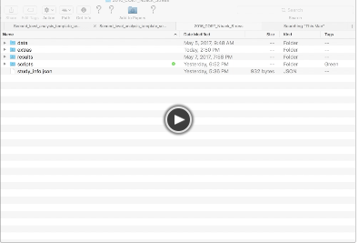

# 4. MODIFY THE TEMPLATE SCRIPTS

1. In a text editor, edit the **study_info.json** file to fit your data

For example:

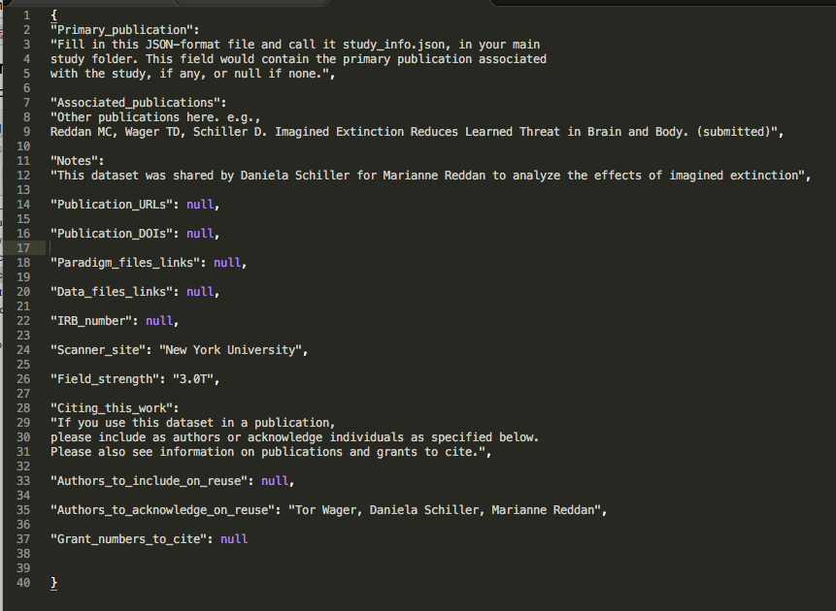

*This video provides further instruction.*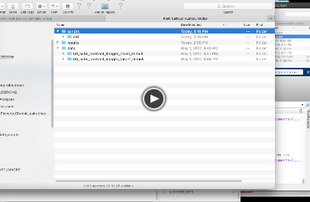

1. Next, in MATLAB open **a_set_up_paths_always_run_first.m** and change:
   1. basedir *to the filepath of your analysis folder*
2. Next, open up **prep_1_set_conditions_constrasts_colors.m** and change the paths and wildcards referring to the contrast images in your data folder:
   1. Update the *conditions* to reflect how *your* data are set up
      1. DAT.subfolders
      2. DAT.conditions
      3. DAT.structural_wildcard

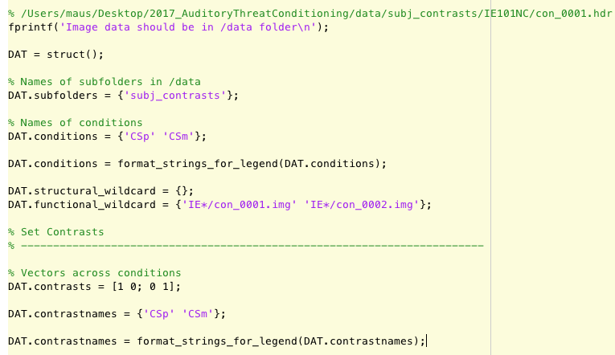

* 1. Update the *contrasts* to reflect what contrasts you are interested in
     1. DAT.contrasts
     2. DAT.contrastnames

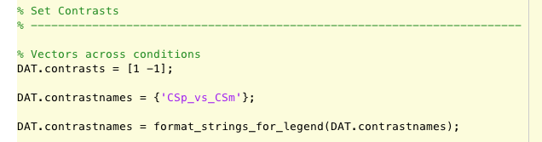

* 1. Update the *colors* or leave to default
  2. Update *between-condition* *contrasts* if you have more than one subject group. If you only one group - leave it empty.

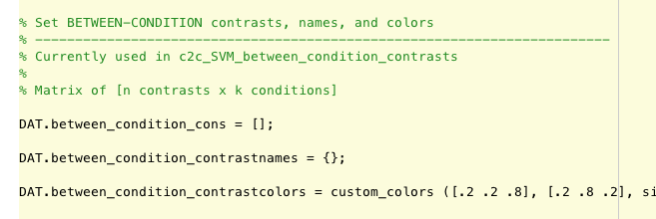

1. Save & run your **a_set_up_paths_always_run_first.m** and **prep_1_set_conditions_constrasts_colors.m** in MATLAB
2. Run prep_2, 3, and 4
3. It will be saved here in **data_objects.mat**

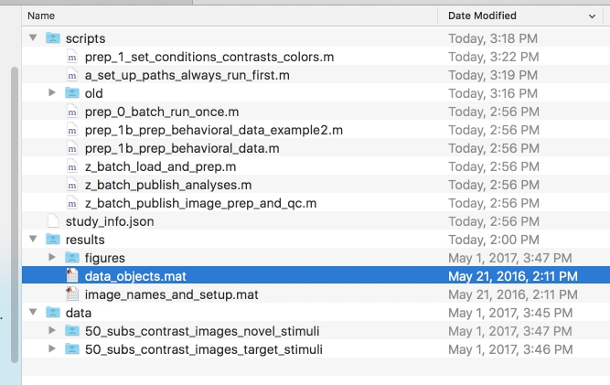

*This video provides further instruction on steps 4.2 to 4.6.*

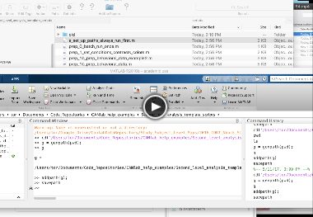

# 4. RUN THE BATCH AND PUBLISH

1. There are multiple options for what to run. Try **z_batch_publish_analyses.m**

And you are set. If you have issues with your file structure check out the [youtube channe](https://www.youtube.com/channel/UCKlRfGa03PZqu349IiexlNg)l to learn more ways to use the wildcards.

# USER OPTIONS FOR CLASSIFICATION

**c2_SVM_contrasts** has user-controlled functionality. Prep script **prep_3b_run_SVMs_on_contrasts_and_save** runs SVMs and saves results. **c2_SVM_contrasts** reloads them from the saved mat files and displays results.

You can copy this script **a2_set_default_options** to your analysis/scripts folder and change the following options:

* Bootstrapping -- Default OFF
* Save the stats maps -- Default ON

Those options will be called by the classification analysis scripts.

# MORE

Look through the folder: CANlab_help_examples/Second_level_analysis_template_scripts/**core_scripts_to_run_without_modifying**

There you can run specific additional analyses, like lasso-pcr or the buckner parcellations

For example:

5. Run z_batch_bucknerlab_network_analyses.m

Or load up the data_objects.mat from your results folder and run some predictions like LASSO-PCR, etc