本系统的数据库表，有以下：

1. 用户数据库表（user表）

ID号是主键，用户数据表主要说明用户个人信息，如表3-1所示：

表 3-1用户数据库表

|  |  |  |  |  |  |
| --- | --- | --- | --- | --- | --- |
| 字段名称 | 类型 | 是否为空 | 是否为主键 | 说明 | 长度 |
| id | int | × | √ | ID号 |  |
| nickname | varchar | √ | × | 用户名 | 100 |
| sex | varchar | √ | × | 性别 | 2 |
| open_id | varchar | √ | × | 账号 | 100 |
| staues | varchar | √ | × | 用户状态 | 100 |
| create_time | varchar | √ | × | 创建时间 | 100 |
| photo | varchar | √ | × | 照片 | 2000 |

1. 医生数据库表（Doctor表）

ID号是主键，医生数据表主要说明医生信息，如表3-2所示：

表 3-2医生数据库表

|  |  |  |  |  |  |
| --- | --- | --- | --- | --- | --- |
| 字段名称 | 类型 | 是否为空 | 是否为主键 | 说明 | 长度 |
| pid | varchar | × | √ | ID号 |  |
| sex | varchar | √ | × | 性别 | 2 |
| photo | varchar | √ | × | 照片 | 2000 |
| birthday | varchar | √ | × | 生日 | 2000 |
| school | varchar | √ | × | 学校 | 2000 |
| degree | varchar | √ | × | 学位 | 2000 |
| tel | varchar | √ | × | 电话 | 2000 |
| address | varchar | √ | × | 地址 | 2000 |
| email | varchar | √ | × | 邮箱 | 2000 |
| job | varchar | √ | × | 职位 | 2000 |
| remark | varchar | √ | × | 备注 | 2000 |
| description | varchar | √ | × | 描述 | 2000 |
| tag | varchar | √ | × | 标签 | 2000 |
| recommended | varchar | √ | × | 推荐 | 2000 |
| status | varchar | √ | × | 状态 | 2000 |
| Create_time | varchar | √ | × | 创建时间 | 2000 |

1. 宠物基础信息数据库表（Pet）

ID号是主键，宠物数据表主要说明宠物基础信息，如表3-3所示：

表 3-3宠物基础信息数据库表

|  |  |  |  |  |  |
| --- | --- | --- | --- | --- | --- |
| 字段名称 | 类型 | 是否为空 | 是否为主键 | 说明 | 长度 |
| id | int | × | √ | ID号 |  |
| petname | varchar | √ | × | 宠物名 | 100 |
| petsex | varchar | √ | × | 宠物性别 | 2 |
| petage | varchar | √ | × | 宠物年龄 | 100 |
| petweight | varchar | √ | × | 宠物体重 | 100 |
| sterilization | varchar | √ | × | 宠物绝育情况 | 100 |

1. 疾病百科数据库表(illness表)

ID号是主键，疾病百科数据表主要说明相关疾病信息，如表3-4所示：

表 3-4疾病病历数据库表

|  |  |  |  |  |  |
| --- | --- | --- | --- | --- | --- |
| 字段名称 | 类型 | 是否为空 | 是否为主键 | 说明 | 长度 |
| id | int | × | √ | ID号 |  |
| Name | varchar | √ | × | 标题 | 100 |
| Symptom | varchar | √ | × | 症状 | 2000 |
| Cause | varchar | √ | × | 形成 | 2000 |
| Method | varchar | √ | × | 治疗方法 | 2000 |
| description | varchar | √ | × | 描述 | 2000 |

1. 医生出诊数据库表（Doctor_price表）

ID号是主键，医生出诊数据表主要说明出诊信息，如表3-5所示

表 3-5医生出诊数据库表

|  |  |  |  |  |  |
| --- | --- | --- | --- | --- | --- |
| 字段名称 | 类型 | 是否为空 | 是否为主键 | 说明 | 长度 |
| mid | int | × | √ | ID号 |  |
| doctor_id | int | √ | × | 医生id |  |
| level | varchar | √ | × | 医生级别 | 100 |
| price_1 | varchar | √ | × | 价格1 | 2000 |
| price_2 | varchar | √ | × | 价格2 | 2000 |

1. 科室数据库表(MEDICAL_DEPT表)

ID号是主键，科室数据表主要说明医院科室信息，如表3-6所示：

表 3-6科室数据库表

|  |  |  |  |  |  |
| --- | --- | --- | --- | --- | --- |
| 字段名称 | 类型 | 是否为空 | 是否为主键 | 说明 | 长度 |
| id | int | × | √ | ID号 |  |
| name | varchar | √ | × | 科室名字 | 2000 |
| outpatioent | varchar | √ | × | 门诊 | 2000 |
| description | varchar | √ | × | 描述 | 2000 |
| recommended | varchar | √ | × | 推荐 | 2000 |

1. 诊室数据库表(MEDICAL_DEPT_SUB)

ID号是主键，诊室数据表主要说明对应科室的诊室信息，如表3-7所示：

表 3-7诊室数据库表

|  |  |  |  |  |  |
| --- | --- | --- | --- | --- | --- |
| 字段名称 | 类型 | 是否为空 | 是否为主键 | 说明 | 长度 |
| id | int | × | √ | ID号 |  |
| name | varchar | √ | × | 诊室名字 | 2000 |
| dept_id | int | √ | × | 科室ID |  |
| location | varchar | √ | × | 所在位置 | 2000 |

1. 医生工作计划数据库表（DOCTOR_PRICE）

ID号是主键，医生工作计划数据表主要说明健康百科信息，如表3-8所示：

表 3-8医生工作计划数据库表

|  |  |  |  |  |  |
| --- | --- | --- | --- | --- | --- |
| 字段名称 | 类型 | 是否为空 | 是否为主键 | 说明 | 长度 |
| id | int | × | √ | ID号 |  |
| doctor_id | int | √ | × | 医生ID |  |
| dept_sub_id | int | √ | × | 诊室ID |  |
| date | varchar | √ | × | 日期 | 2000 |
| maximum | varchar | √ | × | 最大挂号数量 | 2000 |
| num | varchar | √ | × | 挂号数量 | 2000 |

1. 挂号数据库表（MEDICAL_REGISTRATION表）

ID号是主键，挂号数据表主要说明挂号信息，如表3-9所示：

表 3-9挂号数据库表

|  |  |  |  |  |  |
| --- | --- | --- | --- | --- | --- |
| 字段名称 | 类型 | 是否为空 | 是否为主键 | 说明 | 长度 |
| id | int | × | √ | ID号 |  |
| patient_id | int | √ | × | 病患ID |  |
| work_plan_id | int | √ | × | 医生工作ID |  |
| doctor_schedule_id | int | √ | × | 医生时间id |  |
| doctor_id | int | √ | × | 医生时间id |  |
| dept_sub_id | int | √ | × | 诊室id |  |
| date | varchar | √ | × | 日期 | 2000 |
| slot | varchar | √ | × | 数 | 2000 |
| amount | varchar | √ | × | 数量 | 2000 |
| out_trade_no | varchar | √ | × | 出诊号 | 2000 |
| prepay_id | int | √ | × | 预付id |  |
| transction_id | int | √ | × | 交易id |  |
| payment_status | varchar | √ | × | 支付状态 | 2000 |
| create_time | varchar | √ | × | 创建时间 | 2000 |

# 疾病百科(illness)

|  |  |  |  |  |  |
| --- | --- | --- | --- | --- | --- |
| Id | Name | Symptom（症状） | Cause(形成) | Method（治疗方法） | description |
|  |  |  |  |  |  |
|  |  |  |  |  |  |
|  |  |  |  |  |  |
|  |  |  |  |  |  |
|  |  |  |  |  |  |
|  |  |  |  |  |  |
|  |  |  |  |  |  |

-- 百科表 --------------------------------------------------

DROP TABLE IF EXISTS pethospital.illness;

CREATE TABLE pethospital.illness

(

"id" INTEGER NOT NULL PRIMARY KEY,

"name" VARCHAR(50),

"cause" VARCHAR(65535),

"symptom" VARCHAR(65535),

"method" VARCHAR(65535),

"description" VARCHAR(65535)

);

DROP SEQUENCE IF EXISTS pethospital.illness_sequence;

CREATE SEQUENCE pethospital.illness_sequence START WITH 1 increment BY 1;

UPSERT INTO pethospital.illness("id","name","cause","symptom","method","description") VALUES(NEXT VALUE FOR pethospital.illness_sequence,'白内障','原因', '症状', '方法','白内障的描述');

##### 宠物档案

|  |  |  |  |  |  |  |  |  |  |  |
| --- | --- | --- | --- | --- | --- | --- | --- | --- | --- | --- |
| Id | name | Master_id | sex | hobby | Birthday | DiseaseHistory | Breed(品种) | Weight（体重） | image | Vaccine（疫苗） |
|  |  |  |  |  |  |  |  |  |  |  |
|  |  |  |  |  |  |  |  |  |  |  |
|  |  |  |  |  |  |  |  |  |  |  |
|  |  |  |  |  |  |  |  |  |  |  |
|  |  |  |  |  |  |  |  |  |  |  |
|  |  |  |  |  |  |  |  |  |  |  |
|  |  |  |  |  |  |  |  |  |  |  |

DROP TABLE IF EXISTS pethospital.pet_doc;

CREATE TABLE pethospital.pet_doc

(

"id" INTEGER NOT NULL PRIMARY KEY,

"name" VARCHAR(50),

"master_id" INTEGER,

"sex" VARCHAR(2),

"hobby" VARCHAR(500),

"birthday" DATE,

"disease_history" VARCHAR(500),

"breed" VARCHAR(50),

"weight" VARCHAR(50),

"image" VARCHAR(255),

"vaccine" VARCHAR(500)

);

DROP SEQUENCE IF EXISTS pethospital.pet_doc_sequence;

CREATE SEQUENCE pethospital.pet_doc_sequence START WITH 1 increment BY 1;

UPSERT INTO pethospital.pet_doc("id","name","master_id","sex","hobby","birthday","disease_history","breed","weight","image","vaccine") VALUES(NEXT VALUE FOR hospital.pet_doc_sequence,'小白',1, '雄', '游泳，运动，跑步机','2020-5-31','无疾病','柯基','20kg','xxx','疫苗全部打完');

##### 添加视频会诊用户

UPSERT INTO hospital.mis_user(

"id","username","password","name","sex","tel","email","dept_id","job","status","create_time"

)

VALUES(

NEXT VALUE FOR HOSPITAL.MIS_USER_SEQUENCE,'chengcm','061575f43e456772015c0032c0531edf','chengcm','男',NULL,NULL,NULL,NULL,1,NOW()

);

UPSERT INTO hospital.mis_user(

"id","username","password","name","sex","tel","email","dept_id","job","status","create_time","ref_id"

)

VALUES(

1,'chengcm','038cd1b6978b951a0d32285065732073','chengcm','男',NULL,NULL,NULL,'医生',1,NOW(),1

);

038cd1b6978b951a0d32285065732073

DELETE FROM HOSPITAL.mis_user

WHERE "id"=1;

关联角色

UPSERT INTO hospital.mis_user_role(

"id", "user_id", "role_id")

VALUES(

NEXT VALUE FOR HOSPITAL.MIS_USER_ROLE_SEQUENCE,1,1

);

UPSERT INTO hospital.mis_user_role(

"id", "user_id", "role_id")

VALUES(

NEXT VALUE FOR HOSPITAL.MIS_USER_ROLE_SEQUENCE,1,2

);

医生表

Doctor

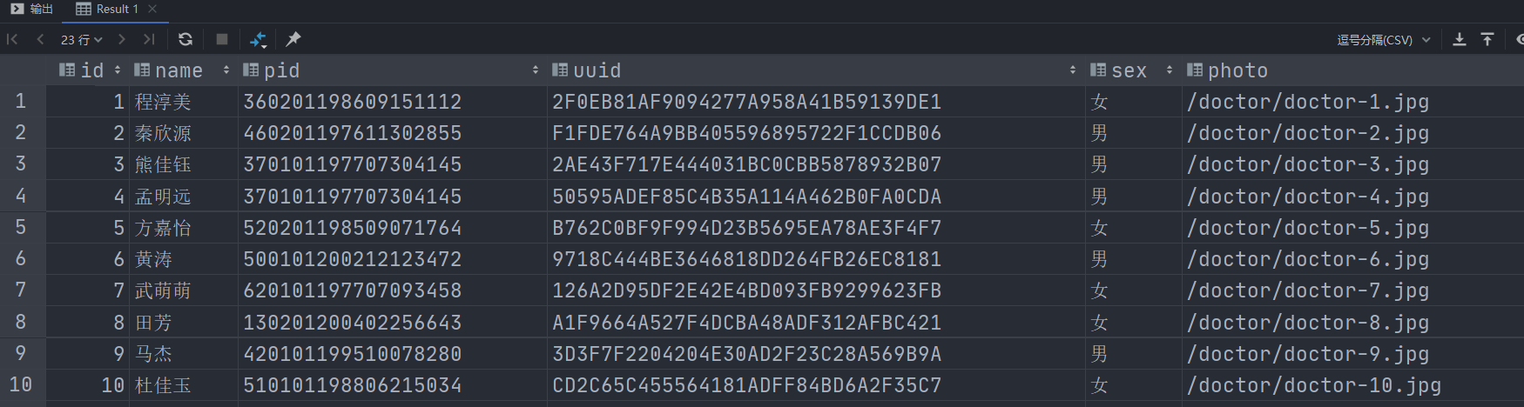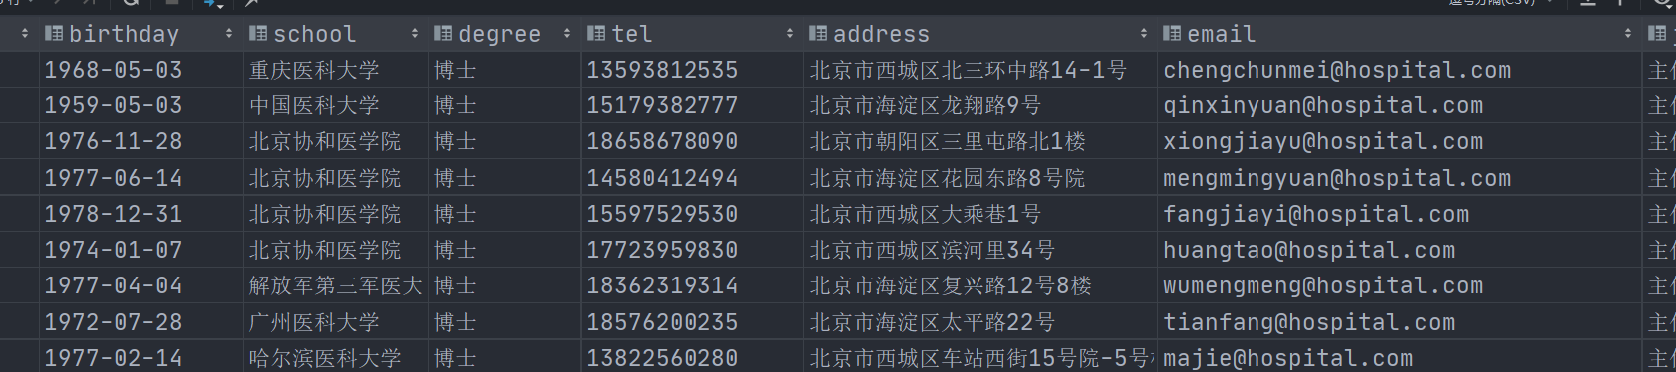

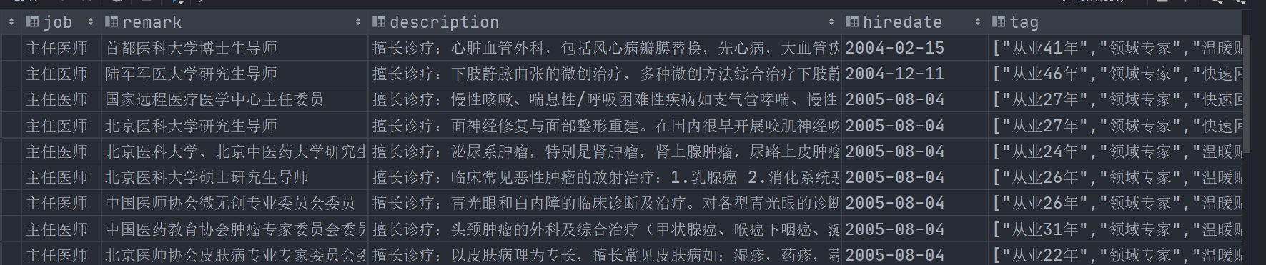

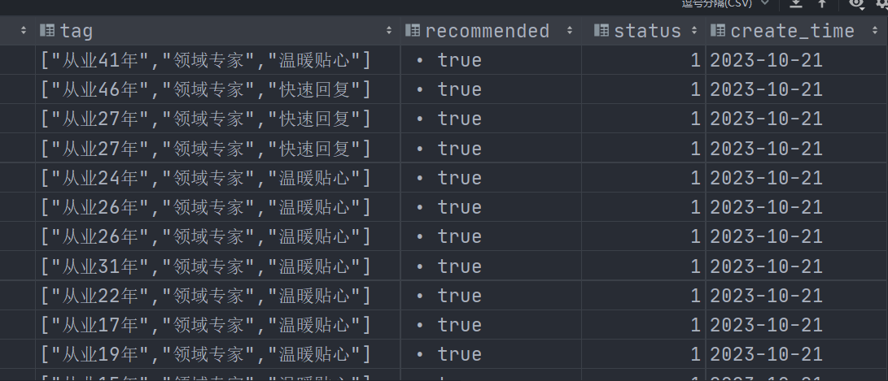

医生出诊表

Doctor_price

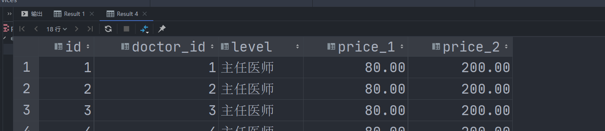

医生工作计划表

DOCTOR_PRICE

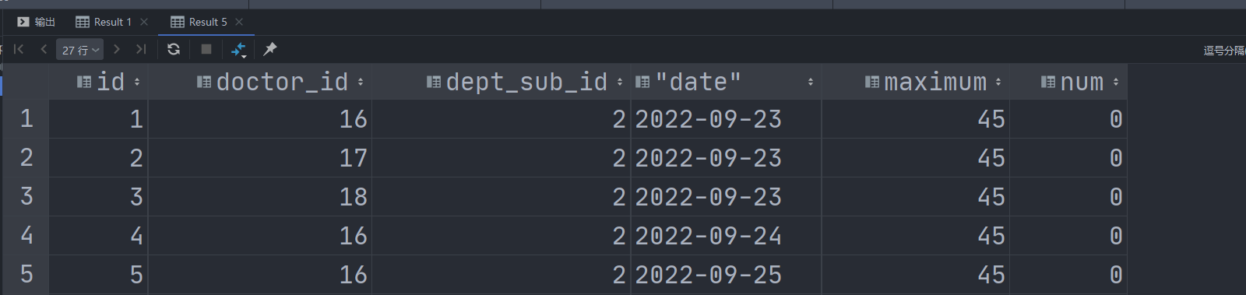

疾病表

Illness



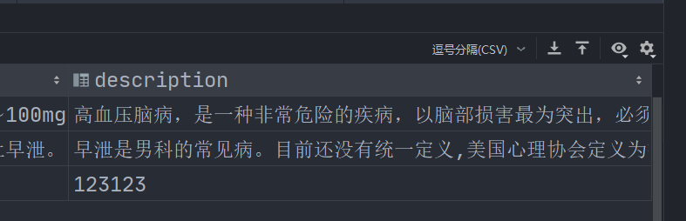

科室表

MEDICAL_DEPT

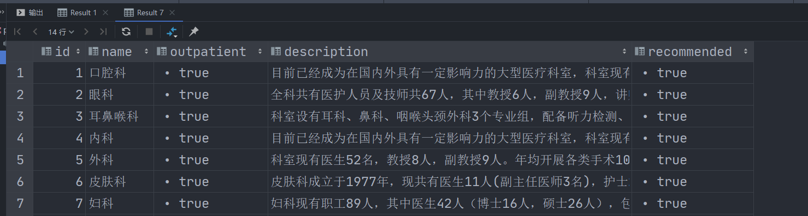

诊室表

MEDICAL_DEPT_SUB

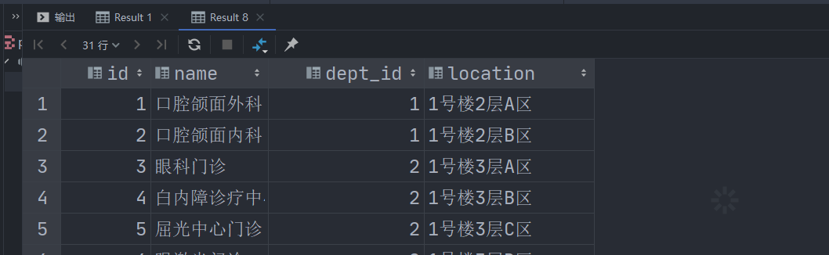

科室与医生关联表

MEDICAL_DEPT_SUB_AND_DOCTOR

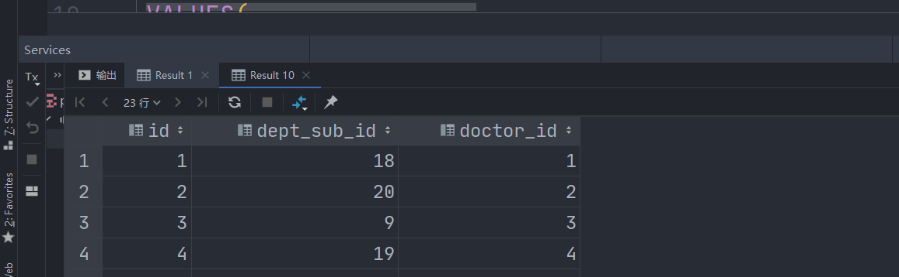

患者表

PATIENT_USER

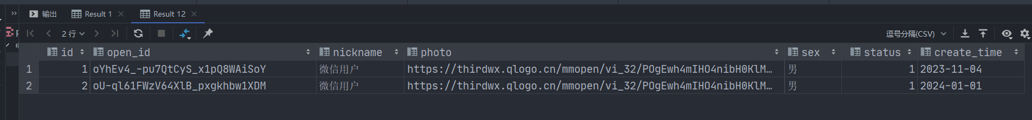

患者人脸权限表

PATIENT_FACE_AUTH

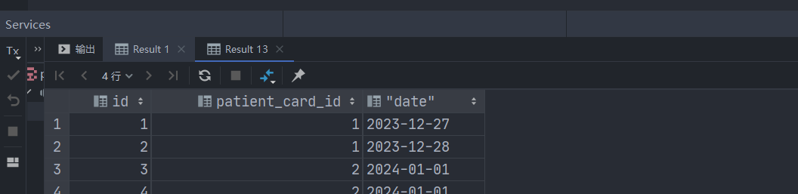

医院管理系统用户表

MIS_USER

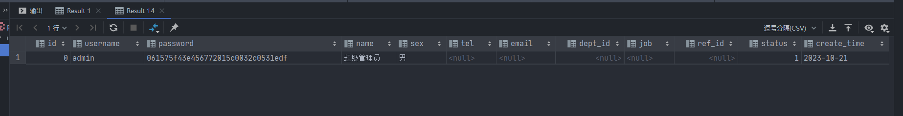

医院管理系统用户权限表

MIS_PERMISSION

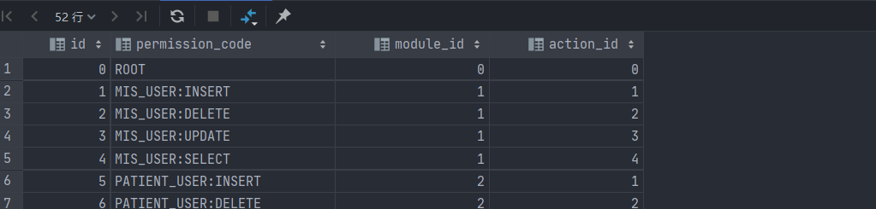

医院管理系统模块表

MIS_MODULE

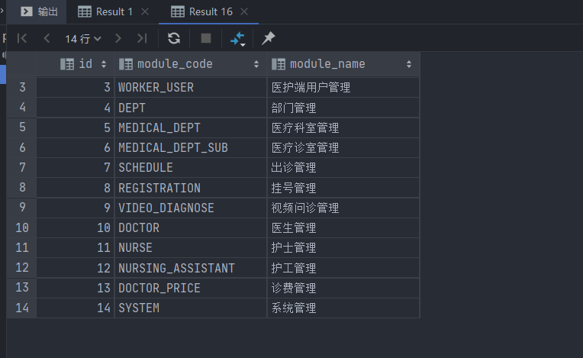

挂号信息表

MEDICAL_REGISTRATION

