Autorius: Danielius Strašunskis

**Užduotis**

3 sudėtingi select’ai (sumos, grupavimas, rūšiavimas)

2 update’ai (suskaičiuoti sumą ir medžiagų kiekį; su join’ais)

2 delete’ai

3 insert’ų precesai (po 1 įrašą, po 1000 įrašų, “load from file”)

**Duomenų bazė**

+------------------------+

| Tables_in_nd3 |

+------------------------+

| JobsRegister |

| JobsRegister_Materials |

| JobsRegister_Services |

| Materials |

| Services |

+------------------------+

MariaDB [nd3]> SHOW COLUMNS FROM JobsRegister;

+---------------------------+-----------------------------------------+------+-----+---------+

| Field | Type | Null | Key | Default |

+---------------------------+-----------------------------------------+------+-----+---------+

| jobsRegisterId | int(11) | NO | PRI | NULL |

| contractId | int(11) unsigned | YES | | NULL |

| objectId | int(11) | YES | | NULL |

| kkTechnicianArrivalDate | datetime | YES | | NULL |

| kkTechnicianDepartureDate | datetime | YES | | NULL |

| kkTechnicianId | int(11) | YES | | NULL |

| arrivalDate | date | YES | | NULL |

| goal | enum('primary','secondary','sectional') | YES | | NULL |

| type | enum('register_jobs','inspection') | YES | | NULL |

+---------------------------+-----------------------------------------+------+-----+---------+

MariaDB [nd3]> SHOW COLUMNS FROM JobsRegister_Materials;

+------------------------+------------------+------+-----+---------+----------------+

| Field | Type | Null | Key | Default | Extra |

+------------------------+------------------+------+-----+---------+----------------+

| JobsRegisterMaterialId | int(11) unsigned | NO | PRI | NULL | auto_increment |

| jobsRegisterServiceId | int(11) unsigned | NO | | NULL | |

| jobsRegisterId | int(11) unsigned | NO | | NULL | |

| materialId | int(10) unsigned | NO | | 0 | |

| count | decimal(8,3) | YES | | NULL | |

+------------------------+------------------+------+-----+---------+----------------+

MariaDB [nd3]> SHOW COLUMNS FROM JobsRegister_Services;

+-----------------------+-------------------------------------+------+-----+---------+----------------+

| Field | Type | Null | Key | Default | Extra |

+-----------------------+-------------------------------------+------+-----+---------+----------------+

| jobsRegisterServiceId | int(11) unsigned | NO | PRI | NULL | auto_increment |

| jobsRegisterId | int(11) unsigned | NO | | 0 | |

| serviceId | int(11) unsigned | NO | | 0 | |

| goal | enum('primary','secondary','order') | YES | | NULL | |

+-----------------------+-------------------------------------+------+-----+---------+----------------+

MariaDB [nd3]> SHOW COLUMNS FROM Materials;

+------------+------------------------+------+-----+---------+----------------+

| Field | Type | Null | Key | Default | Extra |

+------------+------------------------+------+-----+---------+----------------+

| materialId | int(11) | NO | PRI | NULL | auto_increment |

| name | varchar(255) | YES | | NULL | |

| unit | varchar(10) | YES | | NULL | |

| code | varchar(255) | NO | | | |

| price | decimal(15,2) unsigned | NO | | NULL | |

| cost | decimal(15,2) unsigned | NO | | NULL | |

+------------+------------------------+------+-----+---------+----------------+

MariaDB [nd3]> SHOW COLUMNS FROM Services;

+-----------+------------------+------+-----+---------+----------------+

| Field | Type | Null | Key | Default | Extra |

+-----------+------------------+------+-----+---------+----------------+

| serviceId | int(11) unsigned | NO | PRI | NULL | auto_increment |

| name | varchar(255) | NO | | | |

| shortName | varchar(15) | NO | | NULL | |

+-----------+------------------+------+-----+---------+----------------+

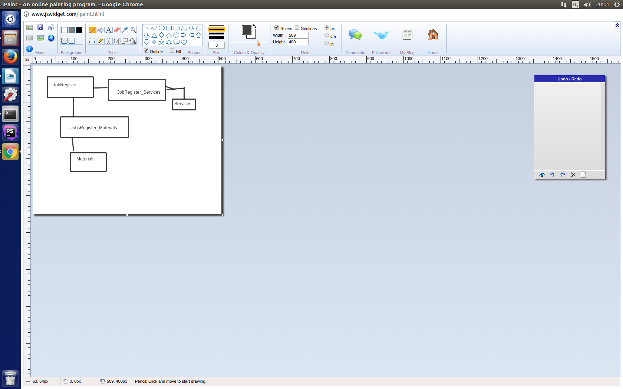

Select

Užklausos

1. Atspaudinama visų medžiagų sąrašas ir kiek buvo išleista pinigų ant jų iki 2008 metų.   
   Praktinė nauda galima žinoti kiek reikės užsakinėt medžiagų pagal ankstesnių rodiklių kaita.

(EXPLAIN) SELECT SQL_NO_CACHE Materials.name, SUM(Materials.price) AS sum FROM JobsRegister

INNER JOIN JobsRegister_Materials ON JobsRegister.jobsRegisterId = JobsRegister_Materials.jobsRegisterId

INNER JOIN Materials ON JobsRegister_Materials.materialId = Materials.materialId

WHERE ((JobsRegister.arrivalDate < '2008-00-00') AND ((JobsRegister.arrivalDate > '2000-00-00')))

GROUP BY Materials.name

ORDER BY sum DESC;

21 rows in set (0,94 sec)

CREATE INDEX register_material_index ON JobsRegister_Materials ( jobsRegisterId );

21 rows in set (0,12 sec)

1. Suskaičiuoja suskaičiuoja kiek pirminių servisų buvo užsakyta.

Praktinė nauda žinoma, į kurią puse plėsti darbą.

(EXPLAIN) SELECT SQL_NO_CACHE Services.name, COUNT(Services.serviceId) AS service_count FROM Services

LEFT JOIN JobsRegister_Services ON JobsRegister_Services.serviceId = Services.serviceId

WHERE (JobsRegister_Services.goal = 'primary')

GROUP BY Services.name

ORDER BY service_count DESC;

20 rows in set (2,18 sec)

CREATE INDEX index_service ON JobsRegister_Services ( serviceId );

20 rows in set (2,16 sec)

1. Atspausdina kiekvieno mėnesio užsakymų skaičių.

Praktinė nauda galima matyti darbų kiekį pagal metų laiką ir darbo jėga lengviau paskirstyti atostogas.

(EXPLAIN) SELECT SQL_NO_CACHE CONCAT_WS(" ", YEAR(JobsRegister.arrivalDate), MONTH(JobsRegister.arrivalDate)) AS Date, COUNT(JobsRegister_Services.serviceId) AS Service_sum

FROM JobsRegister_Services

LEFT JOIN JobsRegister ON JobsRegister.jobsRegisterId=JobsRegister_Services.jobsRegisterId

WHERE JobsRegister.arrivalDate > '2000-00-00'

GROUP BY Date;

94 rows in set, 1 warning (0,88 sec)

CREATE INDEX index_service ON JobsRegister_Services ( jobsRegisterId );

CREATE INDEX index_service ON JobsRegister ( jobsRegisterId );

94 rows in set, 1 warning (2,63 sec)

|  |  |  |
| --- | --- | --- |
| Užklausa | Laikas be indeksų(s) | Laikas su indeksais(s) |
| 1 | 0.94 | 0.12 |
| 2 | 2.16 | 2.16 |
| 3 | 0.88 | 2.63 |

**3 variantai su indeksu**:

* pirmam pagerina paieška
* antram nieko nekeičia nes eina per visus elementus COUNT ir nepagreitina
* trečiam variante, eina per visus ir indexas paieškai nereikalingas tik sulėtina

Update

ALTER TABLE JobsRegister ADD something varchar(20);

**Nepadariau, kadangi pasiteisinimu nepriimat tai, tiesiog nėra :(**

Delete

užklausos

1. Ištrinami visi registracijos darbų, darbo registrai.

DELETE FROM JobsRegister WHERE goal < "register_jobs";

1. Ištrinamos nepanaudotos medžiagos.

DELETE Materials from Materials

LEFT JOIN JobsRegister_Materials ON JobsRegister_Materials.materialId=Materials.materialId

WHERE JobsRegister_Materials.materialId IS null;

|  |  |  |
| --- | --- | --- |
| Užklausa | Laikas be indeksų(s) | Laikas su indeksais(s) |
| 1 | 0.40 | 0.36 |
| 2 | 21.27 | 0.02 |

Insert

* Sukuriama temp

CREATE TABLE temp

(

ID Integer PRIMARY KEY AUTO_INCREMENT,

text varchar(20),

number INT

);

|  |  |  |
| --- | --- | --- |
| Vykdymas | Key = id  Laikas(s) | Raktas visi laukai  Laikas(s) |
| 100k (insert.php) | 384.368 | 397.145 |
| 100 x 1000 (insert.php) | 1.155 | 1.712 |
| Iš failo | 1.7 | 2.9 |

**Load from file:**

* Įsirašomas csv failas

SELECT * FROM temp INTO OUTFILE '/var/lib/mysql-files/temp.csv' FIELDS TERMINATED BY ',' ENCLOSED BY '"' LINES TERMINATED BY '\n';

* Loadinam mūsų sukurtą failą

LOAD DATA INFILE '/var/lib/mysql-files/temp.csv' INTO TABLE temp FIELDS TERMINATED BY ',' ENCLOSED BY '"' LINES TERMINATED BY '\n';

**Išvados: kad teisingai naudot indeksus reikia daugiau praktikos žinių. Kai kurie mano indeksai išvis nepagreitina paieškos iš esmės reiškia bloga jų naudojimą.**