**Final Project Proposal**

Idea and Overview:

We propose to design and implement a car obstacle avoidance arcade game on the FPGA as a system-on-chip. We will implement essential components like the System Bus, RAM, Video Display, Keyboard, and LEDs using SystemVerilog. We will also include a NIOS II CPU to interface the USB keyboard inputs as a game controller.

Additional features implemented in hardware include the obstacles and power-ups. A word on the on-chip memory will store an obstacle’s or power-up's sprite glyph address, color, and location on the screen. Features in the software would be reading the objects’ location comparing it with car’s location to determine whether they have made contact. The software will also set the VGA colors at the start of the game. One existing library we plan to use is a random generator that will write random obstacles and random locations in the OCM. We also plan to build off our Lab 6 to get us started with the USB interface and will also incorporate elements from Lab 7 like the color palette. Our final goal is to demonstrate our game using the USB keyboard and VGA monitor.

Block Diagram:

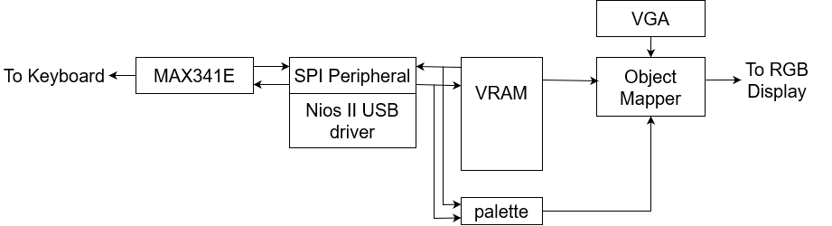

List of Features:

Baseline Features:

1. We will have a five-lane road with a car driving toward the top of the screen.
2. We will also have obstacles that show up in each of the lanes on the road, and when they encounter the car, the car will crash, and the game will come to an end.
3. The user may come into contact with power-ups like a shield, making them invincible to the obstacles.
4. The car can switch between lanes to avoid obstacles and gain power-ups.

Additional Features:

1. We want to make the game customizable. This includes:
   1. Choosing the color of the car.
   2. Choosing the time of day (morning, afternoon, evening, night).
   3. Difficulty level (easy, medium, hard -> speed low, medium, high, respectively).
2. The car will have a certain number of lives. Every time the car hits an obstacle, the user will lose a life. The total number of lives remaining will be displayed on the LEDs of the FPGA.
3. Additional graphics like a cop car chasing the main car.
4. On the screen that shows up at the end of the game, display a message that tells the user to press the ‘R’ key to restart the game.
5. Background music (possibly with a cop car siren).
6. Additional power-up effects

Expected Difficulty:

We expect the difficulty of our baseline project to be a 5. This is because the baseline closely resembles the game of Tetris. However, instead of blocks, we have obstacles and power-ups moving down (or car moving up) the screen. This medium difficulty includes accurate gameplay with functional lanes, obstacle crashes, and power-ups. We plan to ramp up the difficulty to a 7 or 8 with a plethora of additional features. We would like the car to be customizable to the user. We plan to add more graphics, like a cop car chasing the main car. We also plan to add lives (shown on LEDs) so the game won’t end until the player has used up all their lives. Another additional feature could be music, including soundtrack as well as a cop car siren to accompany the cop car graphic. Increasing the clock speed of the read from VRAM would place more obstacles on the road, effectively increasing difficulty and vice versa. The last thing that would make this project much more difficult would be expanding the power-ups. We could make the car have special effects beyond just invincibility.

Proposed Timeline:

* Week 1: Submit project proposal and create and connect all required IP modules, SV modules, interfaces, and software project files. Obtain external glyphs and begin VRAM, palette, and object mapper.
* Week 2: Finish VRAM, palette, object mapper and write C code to set colors to implement car and object interactions. Most of baseline features completed by end of week.
* Mid-checkpoint: Demo a baseline project with minimal bugs.
* Week 3: Debug and tweak baseline features. Begin to implement additional features.
* Week 4: Finish build sprint for additional features.
* Demo completed final project.