DPRC Diffusion FBA Pipeline

This pipeline takes the data from the CSD pipeline. Now, we will conduct *fixel-based analysis (FBA)* in order to derive 3 diffusion fibre metrics, known as *apparent fibre density (AFD)* aka *fibre density (FD), fibre cross-section (FC)*, and a combination of both of them, *fibre density and cross-section (FDC)*. We will perform statistical analysis on these metrics. We will also perform whole-brain fibre tractography.

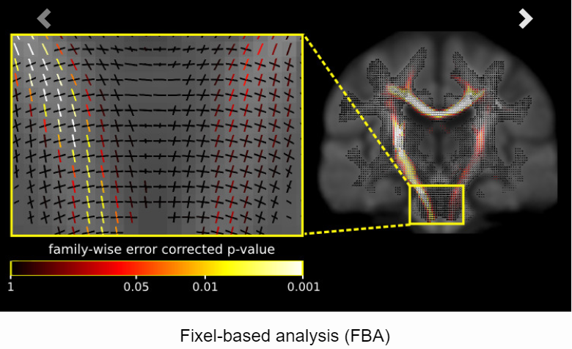

<https://mrtrix.readthedocs.io/en/latest/fixel_based_analysis/mt_fibre_density_cross-section.html>

*Steps:

1. Compute a white matter template analysis fixel mask
2. Estimate participants’ fixels and FBA metrics
3. Warp FOD images to template space
4. Segment FOD images to estimate fixels and their FD metric
5. Reorient fixels
6. Assign subject fixels to template fixels
7. Compute FC metric
8. Compute FDC metric
9. Perform whole-brain fibre tractography on the FOD template
10. Reduce biases in tractogram densities (using SIFT)
11. Generate fixel-fixel connectivity matrix
12. Smooth fixel data using fixel-fixel connectivity
13. Perform statistical analysis of FD, FC, and FDC
14. Visualise results
15. Display results with streamlines
16. Reduce number of streamlines to 200k
17. Create .tsf file (map fixel values to streamlines)
18. Visualise .tsf files in mrview
19. FBA post-statistical inference
20. Calculate whole-brain FBA metrics per each participant and put onto a text file
21. Express the effect size relative to controls

On the dementia vm (8 CPU cores with 8 GB RAM), steps 1-9 take approximately ~36 hours for 30 participants. All timings are elapsed from 1 participant, unless otherwise stated.

**\*Note that before these running these steps in this pipeline, you must decide upon the statistical analysis tests that you will do. You will need to create the design and contrast matrix files for this. See** **here** **in step 7 for more info.**

1. **Compute a white matter template analysis fixel mask**

In this step, we segment fixels from the FOD template. The result is the *fixel mask* that defines the fixels for which statistical analysis will later on be performed (and hence also which fixels’ statistics can support others via the mechanism of connectivity-based fixel enhancement (CFE) [[Raffelt2015]](https://mrtrix.readthedocs.io/en/latest/reference/references.html#raffelt2015))

Command: fod2fixel

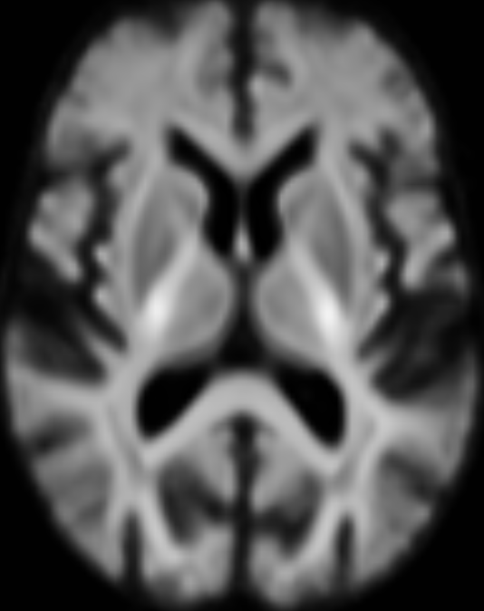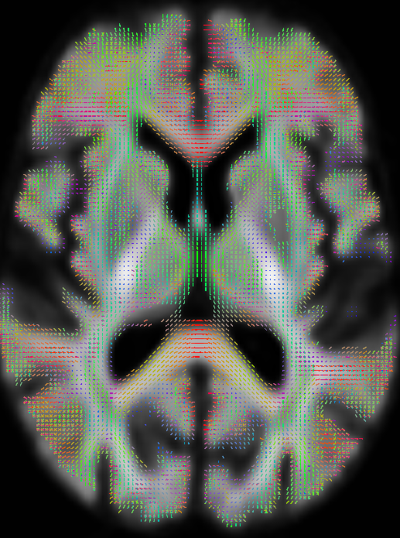

wmfod_template.mif fixel_mask (index and direction values)

*You can view fixels by using the *fixel plot tool* on *mrview*. To view the fixels, you need to load in the directions.mif, index.mif, and any metric file (e.g. fd.mif), if available.

Elapsed time: 36 sec

1. **Estimate participants’ fixels and FBA metrics**

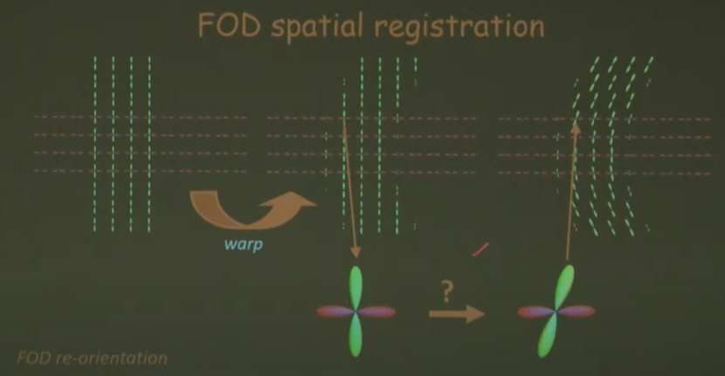

This is FOD reorientation that needs to be applied after warping to template space.

1. **Warp FOD images to template space**

Here, we warp FOD images into template space without FOD reorientation, as reorientation will be performed in a separate subsequent step (after fixel segmentation).

Command: mrtransform

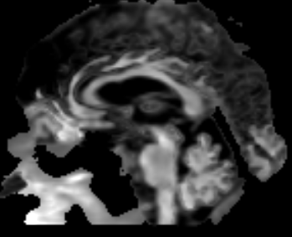  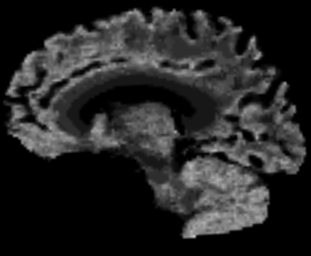

wmfod_norm.mif subject2template.mif (the warp)

fod_in_template_space_NOT_REORIENTED.mif

Elapsed time: 16 sec

1. **Segment FOD images to estimate fixels and their FD metric**

Here we segment each FOD lobe to identify the number and orientation of fixels in each voxel. The output also contains the apparent fibre density (AFD) value per fixel (estimated as the FOD lobe integral).

Command: fod2fixel

 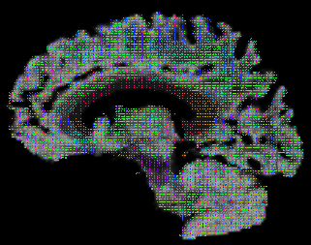

fod_in_template_space_NOT_REORIENTED.mif NOT REORIENTED

Elapsed time: 42 sec

1. **Reorient fixels**

Here we reorient the fixels of all subjects in template space based on the local transformation at each voxel in the warps used previously.

Command: fixelreorient

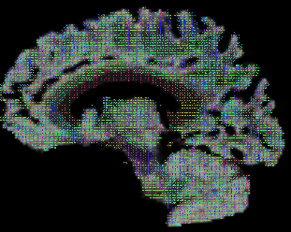

REORIENTED

Zoom into the fixels:

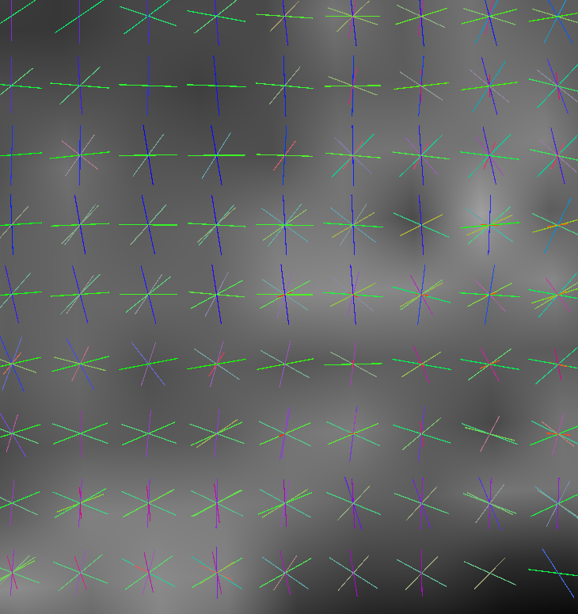 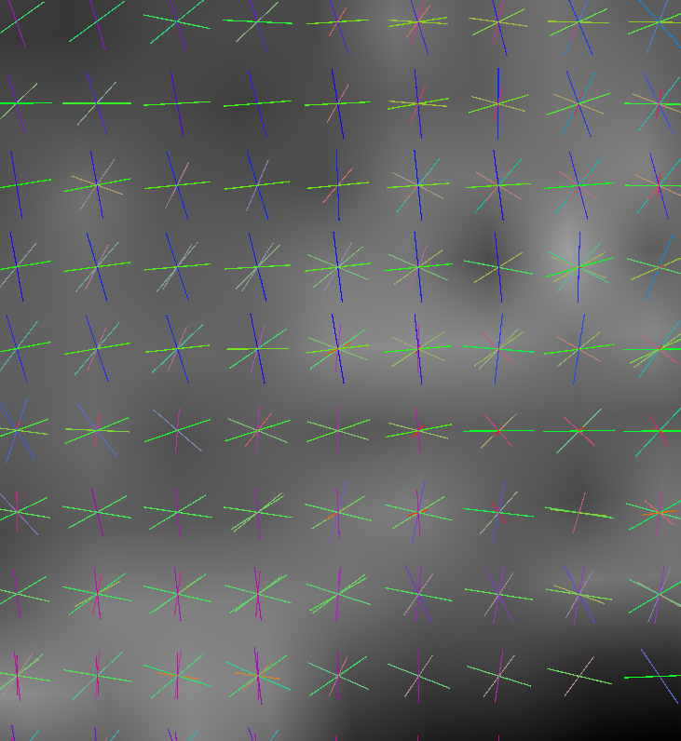

NOT REORIENTED REORIENTED

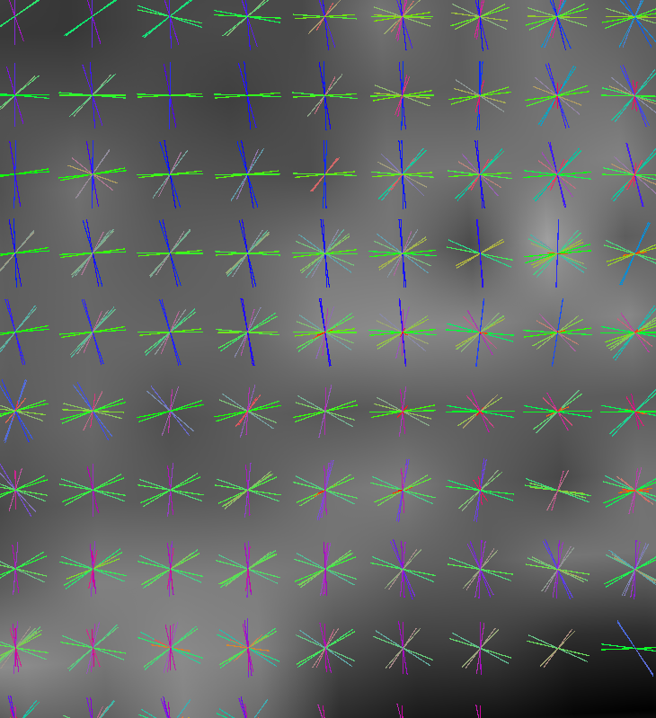

You can see that there is a DIFFERENCE between these fixels (NOT REORIENTED vs. REORIENTED) when you overlay them together. Tournier talks in great detail about how this works in orientating fixels here, at around 6 min + <https://www.youtube.com/watch?v=adACBScwBJ4>

Elapsed time: 3 sec

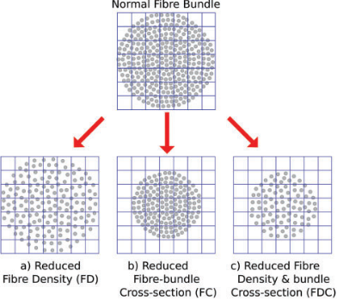

*This figure shows the fixel-based metrics. FD is showing reduction in the fibres within the voxels – within-voxel fibre density (more microstructural), while FC is showing a reduction across the fibre bundels (more macroscopic). FDC is a combination of both of these measurements.*

1. **Assign subject fixels to template fixels (compute FD)**

While each subject’s data has already been (spatially) warped to the common template space, and subject fixels have been reoriented accordingly, there is still no specification of which fixels match (across subjects, and between the subject and template fixels). This step establishes exactly that, by matching the fixels of each individual subject to the single common set of template fixels (which then inherently also defines how they match across subjects). This is achieved by, for each fixel in the template fixel mask, identifying the corresponding fixel in the matching voxel of the subject image and assigning the FD value of this corresponding subject fixel to that fixel in template space. If no fixel exists or can be found in a subject that corresponds to a given template fixel then it is assigned a value of zero (as the absence of a subject fixel at this stage is most likely due to a very low, or even zero, FD).

Command: fixelcorrespondence

Note that the output fixel directory ../fixel_directory/PAR_NAME/fd is the same for all subjects. This makes sense, since after this operation, there is only a single remaining set of fixels (i.e. the template fixels), with corresponding FD values as obtained from each subject. This resulting directory ../fixel_directory/PAR_NAME /fd now stores these data as individual fixel data files: one for each subject, and all with respect to a single set of corresponding template fixels. This way of storing the entire population’s FD data is then ready for input to fixelcfestats later on.

Elapsed time: 3 sec

1. **Compute FC metric**

The fibre density metric, mapped directly without any modulation to the fixel template space as above, is only sensitive to the original density of intra-axonal space in each voxel (see figure above). In other words, it ignores the cross-sectional size of the bundle, which is another property that would factor into the bundle’s total intra-axonal space across its full cross-sectional extent, and hence influence its total capacity to carry information. In certain cases, for example, atrophy may impact this cross-sectional size, but not per se the local fibre density metric.

In this step, we compute a fixel-based metric related to morphological differences in fibre cross-section (FC), where information is derived entirely from the warps generated during registration (see [[Raffelt2017]](https://mrtrix.readthedocs.io/en/latest/reference/references.html#raffelt2017) for more information)

Command: warp2metric

Elapsed time: 3 sec

You need to also take the log of the FC because FC alone is a *relative* metric, expressing the local fixel-wise cross-sectional size *relative* to this study’s population template. While this makes it possible to interpret differences of FC *within* a single study (because only a single unique template is used in the study), the FC values should not be compared across different studies that each have their own population template. Reporting absolute quantities of FC, or absolute effect sizes of FC, also provides little information; as again, it is only meaningful with respect to the template.

Command: mrcalc -log

Elapsed time: < 1 sec

1. **Compute FDC metric**

The total capacity of a fibre bundle to carry information, is modulated both by the local fibre density at the voxel (fixel) level, as well as its cross-sectional size (see figure above). Here we compute a combined metric, which factors in the effects of both FD and FC, resulting in a fibre density and cross-section (FDC) metric.

Command: mrcalc -mult

Elapsed time: < 1 sec

1. **Perform whole-brain fibre tractography on the FOD template**

Statistical analysis using connectivity-based fixel enhancement (CFE) [[Raffelt2015]](https://mrtrix.readthedocs.io/en/latest/reference/references.html#raffelt2015) exploits local connectivity information derived from probabilistic fibre tractography, which acts as a neighbourhood definition for threshold-free enhancement of locally clustered statistic values. To generate a whole-brain tractogram from the FOD template (note the remaining steps from here on are executed from the template directory). Tckgen’s default algorithm is iFOD2.

1. We will generate 20 million tracts, using a 0.06 cut-off value (as suggested by MRtrix). You can also start out with 100K tracts to generate a smaller number of streamlines in order to visually confirm that the generated streamlines exhibit an appropriate extent of propagation at the ends of white matter pathways, before committing to generation of the dense tractogram.

Command: tckgen

**(image too big to show)**

Elapsed time: 6 hours and 33 min, for 36 participants

If we want to use the -act option, are we supposed to get some kind of group average of the 5tt image? Such as, make a population template of the 5tt image, or take the mean across all participant images to get 1 image?

<https://community.mrtrix.org/t/using-act-to-track-fibers-in-population-template-space/3353>

Or is tckgen supposed to be running per each participant only? Or, are we supposed to be using just one 5tt image from one participant? Or one t1w image?

<https://community.mrtrix.org/t/outcome-streamlines-vary-too-much-across-participants/1129>

1. **Reduce biases in tractogram densities (using SIFT)**

Perform Spherical-deconvolution Informed Filtering of Tractograms (SIFT) to reduce tractography biases in the whole-brain tractogram. Use this to make improve the quantitative nature of whole-brain streamlines reconstructions. By producing a reconstruction where the streamlines densities are proportional to the fibre densities as estimated by spherical deconvolution throughout the white matter, the number of streamlines connecting two regions becomes a proportional estimate of the cross-sectional area of the fibres connecting those two regions.

This will weight the streamlines selectively to match the contribution to the FODs. Good for false positives – kind of ‘cleans up’ the data. Removes the non-relevant streamlines. Makes it more representative, and this is especially good for when generating a connectome. We will filter with 2 million tracts (as suggested by MRtrix).

Command: tcksift

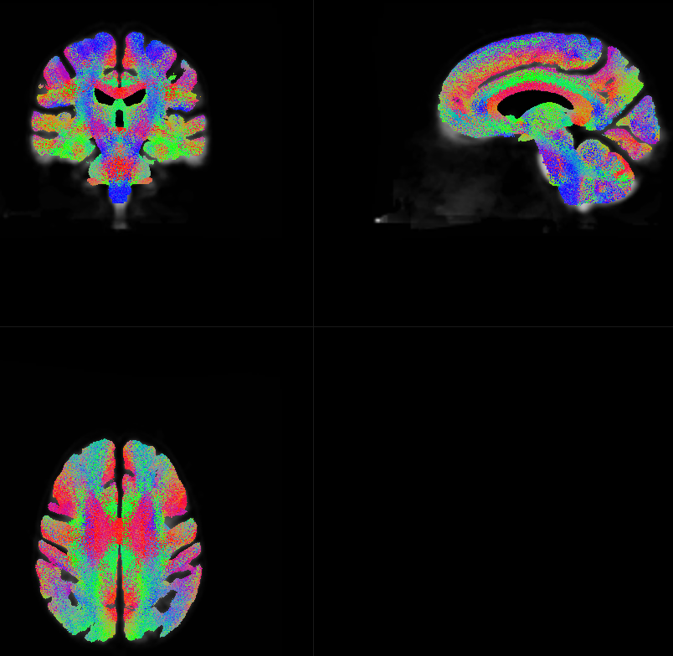

Tracks w/ SIFT overlayed on wmfod_template.mif

Elapsed time: 1 hour and 39 min, for 36 participants

1. **Generate fixel-fixel connectivity matrix**

Generation of the fixel-fixel connectivity matrix based on the whole-brain streamlines tractogram.

Command: fixelconnectivity

The output directory should contain three images: index.mif, fixels.mif and values.mif; these are used to encode the fixel-fixel connectivity that is by its nature sparse.

Elapsed time: 17 min, for 36 participants

1. **Smooth fixel data using fixel-fixel connectivity**

Smoothing of fixel data is performed based on the sparse fixel-fixel connectivity matrix.

Command: fixelfilter

Elapsed time: 18 min, for 36 participants

1. **Perform statistical analysis of FD, FC, and FDC**

Statistical analysis using CFE is performed separately for each metric (FD, log(FC), and FDC).

Command: fixelcfestats

The input files.txt (e.g. *files_fd.txt, files_log_fc.txt*, and *files_fdc.txt*) are text files containing the filename of each file (i.e. not the full path) to be analysed inside the input fixel directory, each filename on a separate line. The line ordering should correspond to the lines in the file design_matrix.txt.

There are 3 input files.txt (for the 3 metrics) that contain the list of the participants on a separate line in your study. Using the **CreateParticipantFixelList.m** function, my script will create these lists for you based upon the participants you ran, automatically.

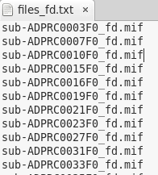

**\*Note that you must create these matrices previous to running the pipeline. This will determine the statistical tests that you will run.**

The *design_matrix.txt* file contains the group (i.e. status) of each of the participants. This is dummy-coded (e,g. 0, 1, 2, 3…etc). This must be manually done (so far).

The *contrast_matrix.txt* file is specified as rows of weights (e.g. -1, 1 or -1, 1, 0, 0). This must be manually done (so far).

Below is an example of running a two-sample unpaired t-test. -

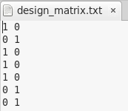 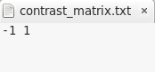

Another example: If you had 4 groups/conditions (i.e. 1-way between-subjects ANOVA), your design and contrast matrix, may look like this:

design_matrix.txt contrast_matrix.txt

1 0 0 0 1 0 0 -1

1 0 0 0 0 1 0 -1

0 1 0 0 0 0 1 -1

0 1 0 0

0 0 1 0

0 0 1 0

0 0 0 1

0 0 0 1

(2 participants per group) (3 contrasts)

Your output will be in the stats folder of each apparent fibre density (AFD) metric (e.g. stats_fd). Use this for step 8, to visualise the results.

Elapsed time: 27 hours and 12 min, for 29 participants

Some more info on how to set your design and contrast matrices, depending on the type of statistical tests that you are running, and if you want to include co-variates:

<https://community.mrtrix.org/t/fba-design-contrast-matrices-for-three-groups/1791>

<https://fsl.fmrib.ox.ac.uk/fsl/fslwiki/GLM>

1. **Visualise results**

To view the results load the population FOD template image in mrview, and overlay the fixel images using the vector plot tool. Note that p-value images are saved as (1 - p-value). Therefore to visualise all results at a threshold of p < 0.05, within the mrview fixel plot tool, apply a lower threshold at a value of 0.95.

There is no ‘hard fix’ on what you should use to view your results – but for the most basic visualisation, you can load the *index.mif* file into the fixel. Then, use the *directions.mif* file for the ‘coloured by’ option (this is set as the default, anyways). Then, use the *fwe_pvalue.mif* as the ‘threshold’ option, and set the lower threshold (on the left side, make sure to tick the box) to 0.95, so that it will display the significant fixels with a p < 0.05.

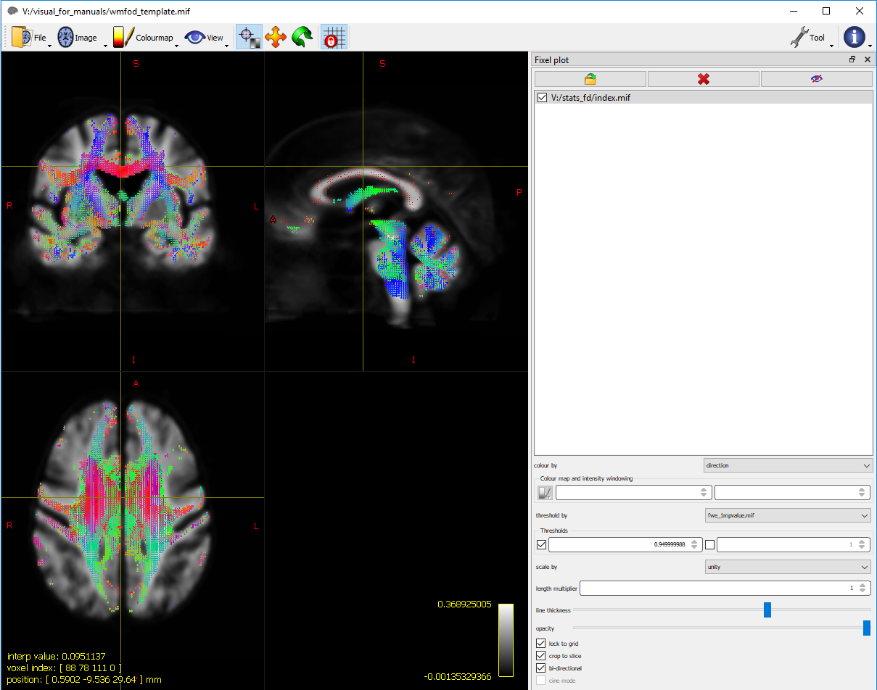

Whole-brain FBA with the FD metric comparing healthy controls with aMCI from the 29 ADPRC participants (I think these are the groups statuses, but may need to re-check).

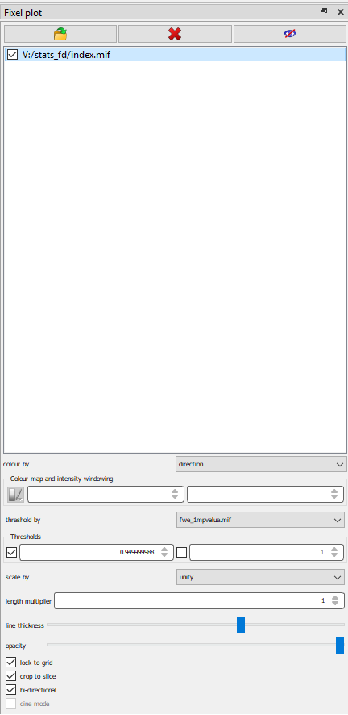

You can change other options, like the line thickness and opacity for visualisation.

See here for more information on which files to choose from to view and which files to use for setting the threshold: <https://community.mrtrix.org/t/fba-displaying-significant-results/993>

1. **Display results with streamlines**

Display the streamlines from the whole-brain tractography analysis which correspond to the significant fixels (with FD, FC, and FDC metrics).

1. **Reduce number of streamlines to 200,000.**

Command: tckedit

1. **Map fixel values to streamline points, and save them as a ‘track scalar file’ (.tsf).**

Command: fixel2tsf

1. **Visualise the track scalar files with the tractogram tool, using mrview.**

First, load the streamlines (tracks_200k_sift.tck). Then to dynamically threshold (remove) streamline point by p-value select the “Thresholds” dropdown and select “Separate Scalar file” and set to 0.95.

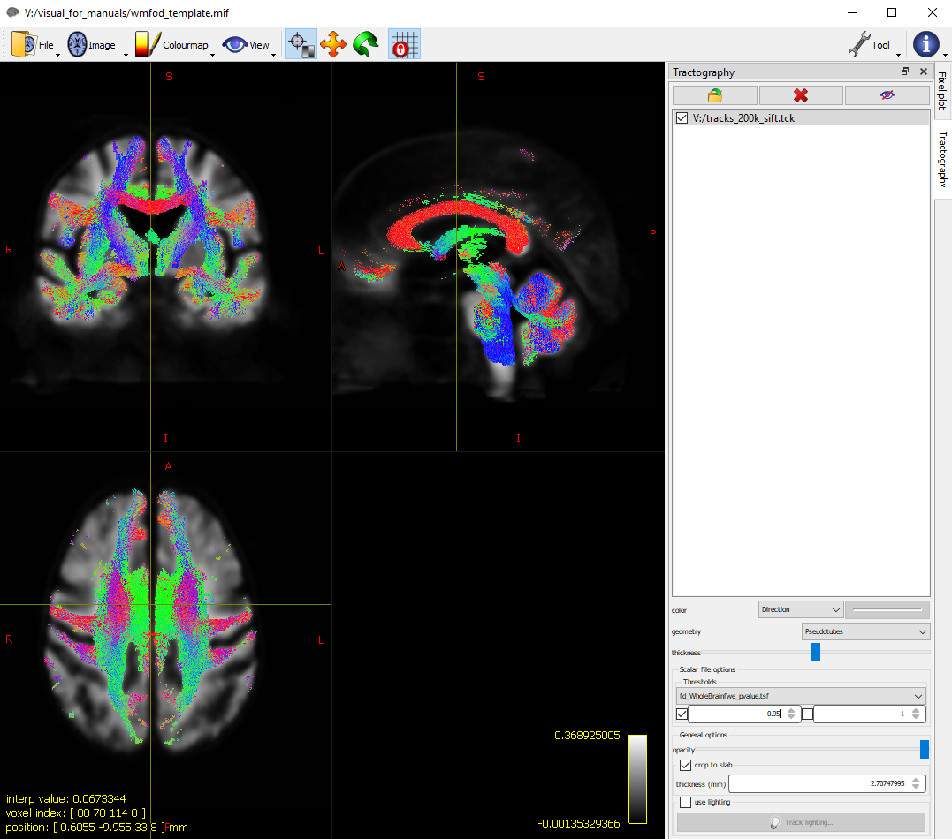

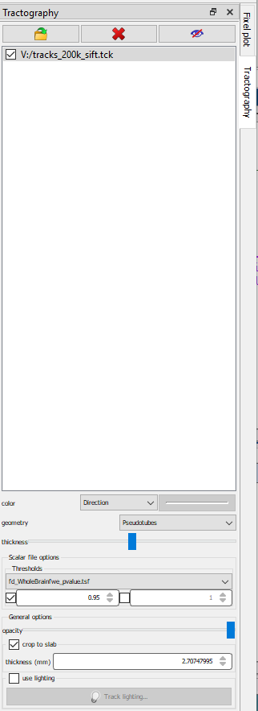

See MRtrix documentation here for further information: <https://mrtrix.readthedocs.io/en/3.0_rc3/fixel_based_analysis/displaying_results_with_streamlines.html>

1. **FBA post-statistical inference**
2. **Calculate whole-brain FBA metrics per each participant and put onto a text file.**

If you want to calculate a single measurement of the FBA metrics, of either the whole-brain tract analysis or a specific tract, you can do so by taking the average of all participants. We will use the in-house function, **CreateWholeBrainFBAMetricFiles.m**, which will call upon MRtrix’s mrstats command to do this. Specifically, this function will generate the mean, median, std, std_rv (standard error), min, max, and count per each metric (FD, log_FC, and FDC) per each participant. This will be used for group comparisons.

Command: mrstats

%Sample output: FD.txt

FC_log.txt

FDC.txt

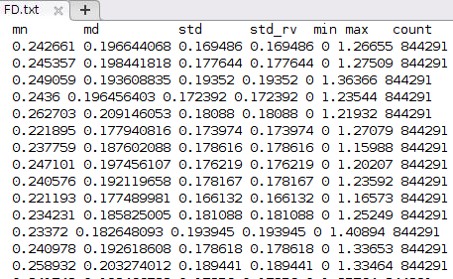

If you want to do this with specific tracts, you can by comparing the fixels against the fixel mask of that region / tract of interest.

<https://community.mrtrix.org/t/calculating-average-fba-metrics-of-specific-tracts/1805>

See more on MRtrix wiki post here: <https://community.mrtrix.org/t/fba-post-statistical-inference-tricks/2255>

1. **Express the effect size relative to controls**

The apparent Fibre Density (FD) and Fibre Density and Cross-section (FDC) are relative measures and have arbitrary units. Therefore, the units of *abs_effect.mif* are not directly interpretable. In a patient-control group comparison t-test, one way to present results is to express the absolute effect size as a percentage relative to the control group mean.

Command: mrcalc

See more on MRtrix documentation here: <https://mrtrix.readthedocs.io/en/latest/fixel_based_analysis/computing_effect_size_wrt_controls.html>

Generate & Map Tracks. We will generate a map of the primary white matter tracts. We will randomly seed fibre beginnings in different parts of the brain. Usually, around 100,000 tracts are recommended to select. But there will be some false-positives, so we need some thresholding, which is similar to fMRI data conceptually.

1. Also, use the anatomically constrained (ACT) option to input in the different tissue types of the brain to generate more biological plausible orientations (using the 5tt image).

The default algorithm is iFOD2.

Command: tckgen -act

Elapsed time: 1 min 26 sec

1. Generate track density images (TDI) using tckmap. Tckmap performs the mapping of streamlines to voxels. This will also allow us to compare diffusion indices to one another (FA, MD, etc.) between groups.

Command: tckmap

Elapsed time: 1 sec

*Calamante, F., Tournier, J. D., Jackson, G. D., & Connelly, A. (2010). Track-density imaging (TDI): Super-resolution white matter imaging using whole-brain track-density mapping*

1. **SLF tractography**

Interest in the SLF tracts.

Command: tckgen -seed_sphere (choose seeds for SLF tract)

*Van Hecke, W., Emsell, L., & Sunaert, S. (2016). Diffusion Tensor Imaging: a practical handbook*

1. **Connectome**

Command: tck2connectome

* Performs assignment of streamlines to grey matter parcels.

Command: connectome2tck

* Look at separate nodes of interest. Extracts streamlines (or generates exemplars) between parcellated nodes of interest.

**Things to consider/add in:**

**Group analyses:**

Compute response function per subject, using multi-shell data, then estimate a group average response function.

<https://community.mrtrix.org/t/response-function-for-group-analysis/1077>

**Spherical-deconvolution Informed Filtering of Tractograms (SIFT)**

Use this to make improve the quantitative nature of whole-brain streamlines reconstructions. By producing a reconstruction where the streamlines densities are proportional to the fibre densities as estimated by spherical deconvolution throughout the white matter, the number of streamlines connecting two regions becomes a proportional estimate of the cross-sectional area of the fibres connecting those two regions.

This will weight the streamlines selectively to match the contribution to the FODs. Good for false positives – kind of ‘cleans up’ the data. Removes the non-relevant streamlines. Makes it more representative, and this is especially good for when generating a connectome.

Command: tcksift2

tcksift2 may be good to use for tracks of interest analysis.