Diffusion Superior Longitudinal Fasciculus (SLF), Tract of Interest (TOI) Pipeline

This pipeline is done after doing the FBA pipeline. It will utilize the generated tracts from the whole-brain tractography analysis. We will first generate a track density image map in order to see the tracts, and then will apply manual allocations to the track of interest (SLF). In terms of conducting the fixel analysis, it will be similar to what was done in the FBA pipeline, but this time with the tract of interest. Unlike the other pipelines, this pipeline will require more manual user input, depending on which tract you select. I will have selected for the SLF tract.

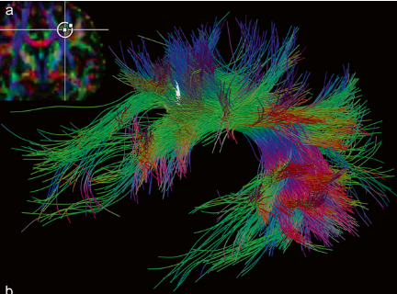

Figure: Selection of the SLF with white matter tract. Inclusion and exclusion applied.

Steps:

1. Compute track density image (TDI)
2. Create mask for the track of interest (TOI)
   1. Superior longitudinal fasciculus (SLF)
3. Generate tracks with TOI mask as input
4. Manually include/exclude fibres
5. **Compute track density image (TDI)**

Generate track density images (TDI) on the generated tracks *(tracks_2_million_sift.tck*

) file in order to visualise the tracts better. This will perform the mapping of streamlines to voxels.

Command: tckmap

Elapsed time: 1 sec

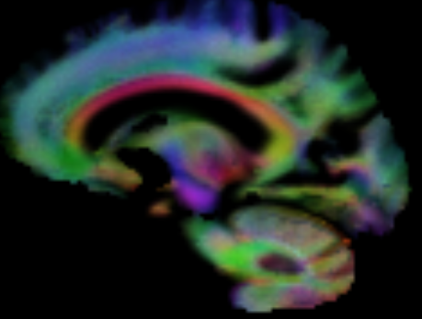

*Calamante, F., Tournier, J. D., Jackson, G. D., & Connelly, A. (2010). Track-density imaging (TDI): Super-resolution white matter imaging using whole-brain track-density mapping*

1. **Create mask for the track of interest (TOI)**

Create a mask on the interested tract. You will need to do this manually through mrview, using the ROI editor. Once done, save the mask as a .mif file.

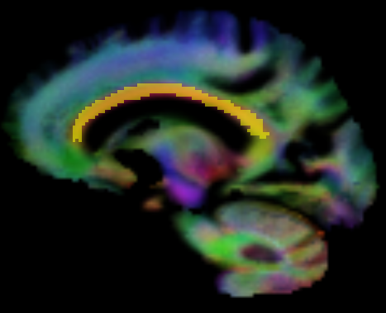

Example of the mask of the corpus callosum as a TOI.

As a guide, I have found that this textbook has many useful diagrams for choosing the tracts of interest. You can get this for free via UOA library website.

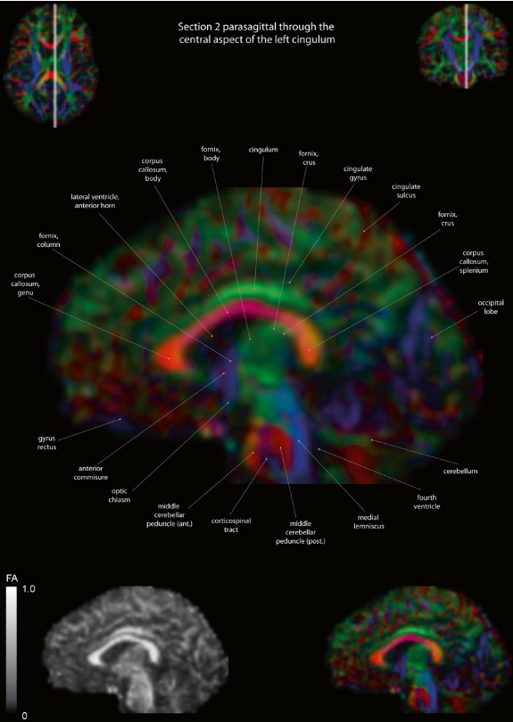

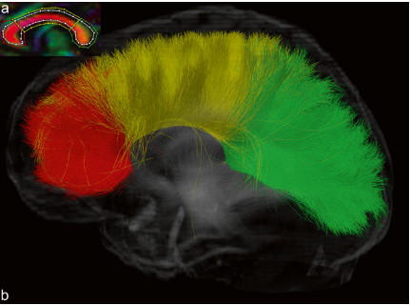

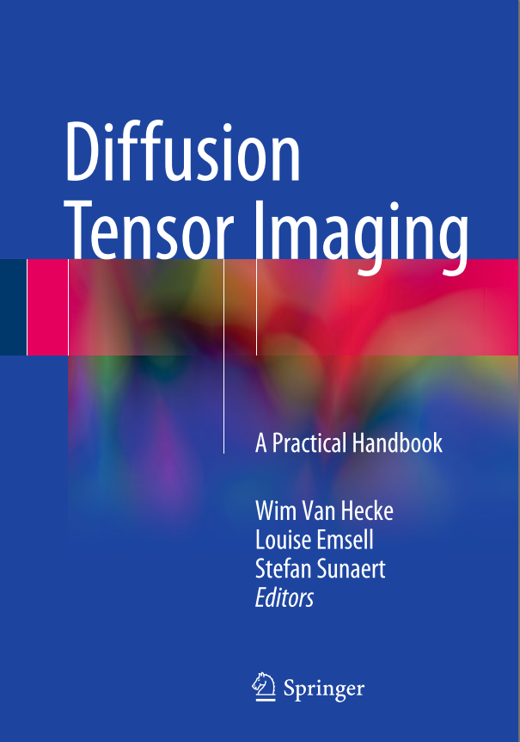

*Van Hecke, W., Emsell, L., & Sunaert, S. (2016). Diffusion Tensor Imaging: a practical handbook*