The frontoparietal network (FPN)

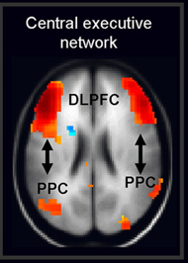 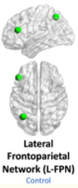 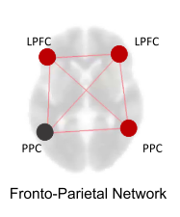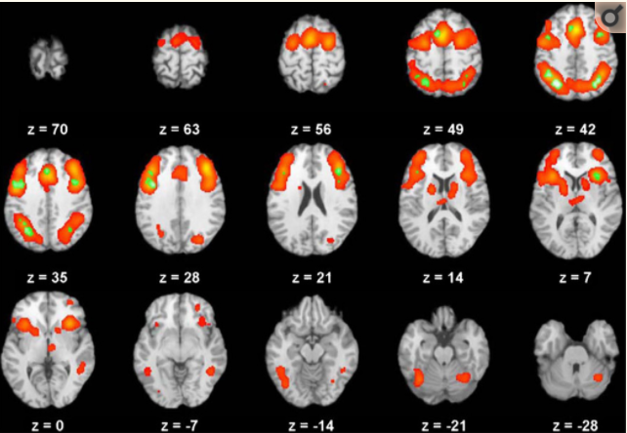

The **frontoparietal network (FPN)** is also known as the **central executive network (CEN)** (and many other names), and is generally comprised of the lateral prefrontal cortex, such as the dorsolateral prefrontal cortex (DLPFC), the mid cingulate cortex, and the posterior parietal cortex (PPC), which divides into the superior parietal cortex, the inferior parietal cortex, and the intraparietal sulcus (IPS). Other less prominent regions also include the dorsal precuneus, the posterior inferior temporal lobe, anterior to MT+, and the dorsomedial thalamus and head of the caudate. (Uddin, Yeo, & Spreng, 2019). The FPN is supposed to be anti-correlated with the resting network, the default mode network (DMN), while the salience network acts as a sort of ‘mediator’ in switching between these two networks (Sridharan, Levitin, & Menon, 2008).

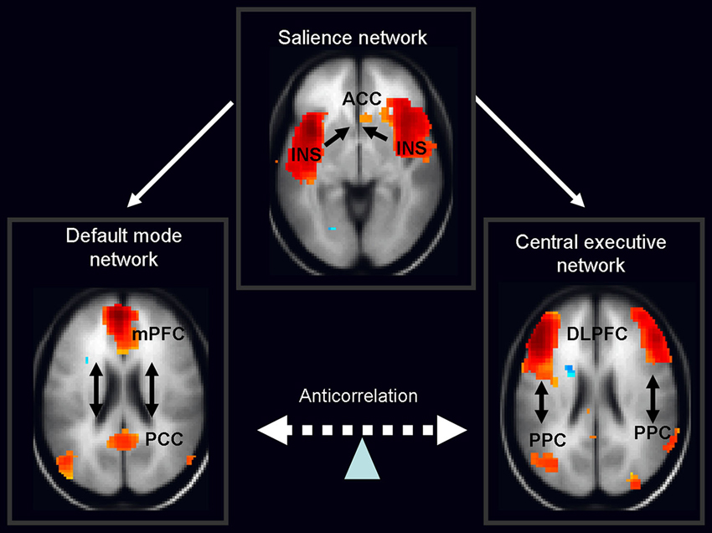

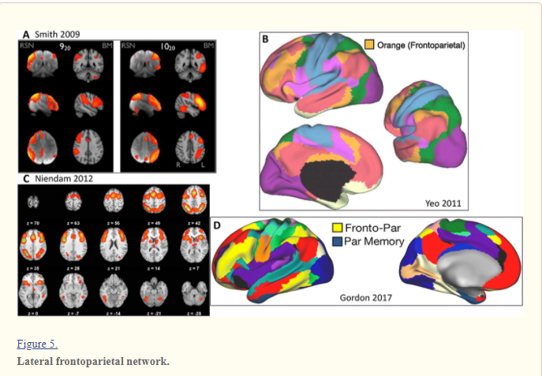

For the structural connectome (SC) from diffusion MRI, I am following the B.A.T.M.A.N. tutorial (<https://osf.io/fkyht/>), which uses the *Human Connectome Project Multi-Modal Parcellation 1.0* (HCP MMP 1.0) atlas to parcellate the brain (Glasser et al., 2016 - <https://doi.org/10.1038/nature18933>). Specific details of the their parcellation of these interested regions can be found in their Supplementary Neuroanatomical Results section, as [here](https://static-content.springer.com/esm/art%3A10.1038%2Fnature18933/MediaObjects/41586_2016_BFnature18933_MOESM330_ESM.pdf).

Following their paper (Glasser et al., 2016), we have subdivided these regions of the FPN in the tables below. **41 nodes** have been selected, therefore with a total of **82 nodes**, to account for the left and right brain hemisphere. Accompanying brain images for reference of the regions of interest are from the free software, BrainVoyager Brain Tutor Ver 2.5.



The **dorsolateral prefrontal cortex (DLPFC)** has been divided into 13 areas:

|  |  |
| --- | --- |
| Area | Parcel Index |
| L_8c, R_8c | 73, 253 |
| L_8Av, R_8av | 67, 247 |
| L_i6-8, R_i6-8 | 97, 277 |
| L_s6-8, R_s6-8 | 98, 278 |
| L_SFL, R_SFL | 26, 206 |
| L_8BL, R_8BL | 70, 250 |
| L_9p, R_9p | 71, 251 |
| L_9a, R_9a | 87, 267 |
| L_8Ad, R_8Ad | 68, 248 |
| L_p9-46v, R_p9-46v | 83, 263 |
| L_a9-46v, R_a9-46v | 85, 265 |
| L_46, R_46 | 84, 264 |
| L_9-46d, R_9-46d | 86, 266 |

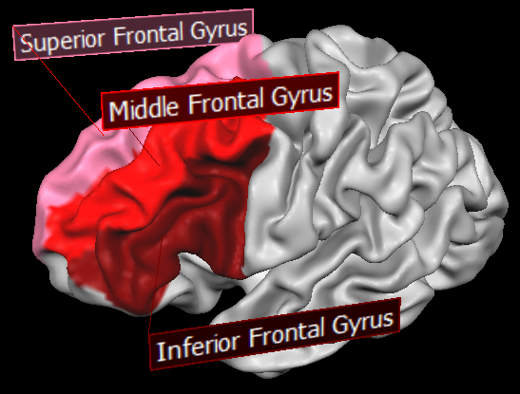

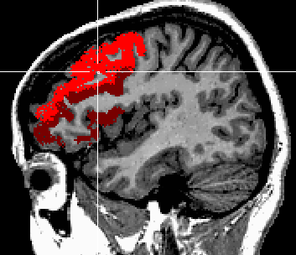 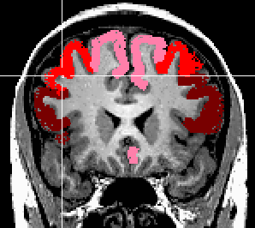 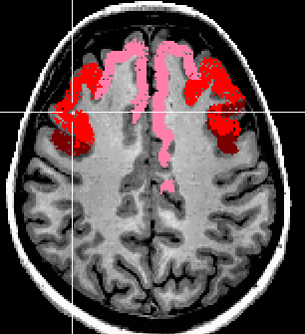

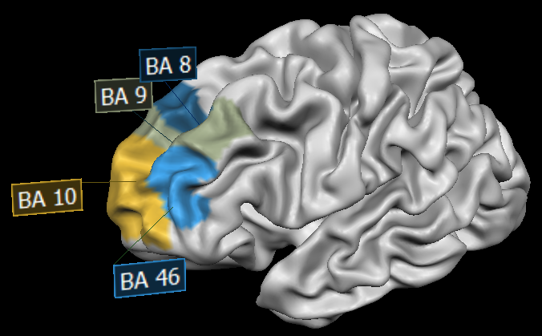

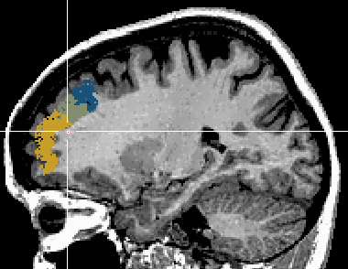 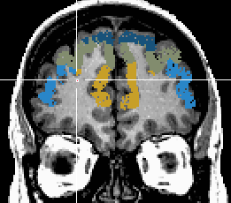 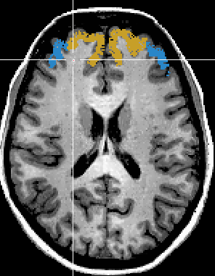

DLPFC defined by Brodmann areas - (Cieslik et al., 2013; Sanches et al., 2009)

They are surrounded by areas 55b, FEF, 6a, 6ma, SCEF, 8BM, 9m, 10d, p10p, a10p, a47r, p47r, IFSa, IFSp, IFJa, IFJp, and PEF.

The **mid cingulate cortex** (+ paracentral lobule) has been identified by 8 areas:

|  |  |
| --- | --- |
| Area | Parcel Index |
| L_24dd, R_24dd | 40, 220 |
| L_24dv, R_24dv | 41, 221 |
| L_6mp, R_6mp | 55, 235 |
| L_6ma, R_6ma | 44, 224 |
| L_SCEF, R_SCEF | 43, 223 |
| L_5m, R_5m | 36, 216 |
| L_5L, R_5L | 39, 219 |
| L_5mv, R_5mv | 37, 217 |

They are surrounded by areas 4, 3a, 3b, 1, 2, 7AL, 7Am, PCV, 23c, p24pr, p32pr, 8BM, SFL, s6-8, 6a, and 6d.

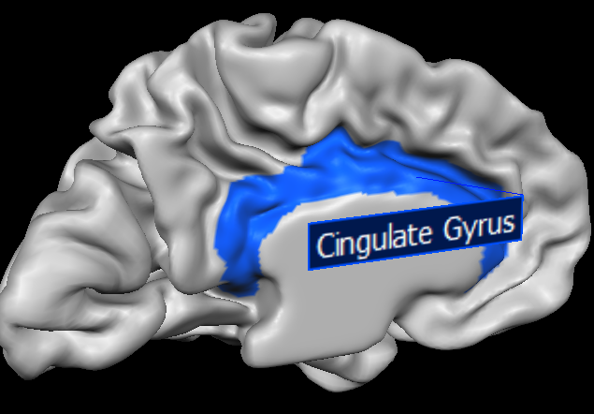

**Mid**

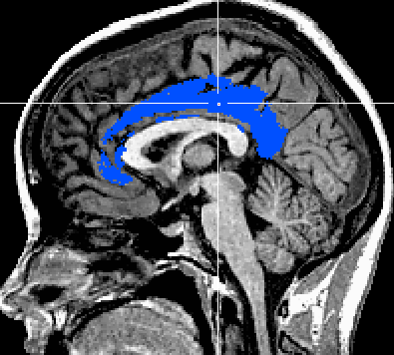 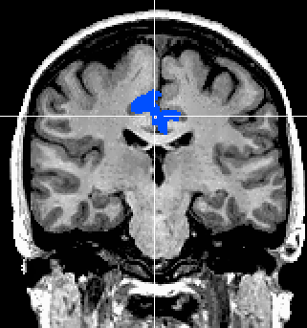 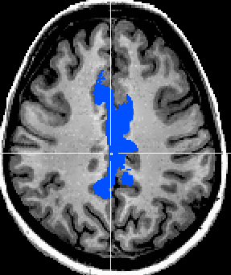

The **superior parietal cortex** **+ intraparietal sulcus (IPS)\*** has been divided in these 10 areas:

|  |  |
| --- | --- |
| Area | Parcel Index |
| L_LIPv, R_LIPv * | 48, 228 |
| L_LIPd, R_LIPd * | 95, 275 |
| L_VIP, R_VIP * | 49, 229 |
| L_AIP, R_AIP * | 117, 297 |
| L_MIP, R_MIP * | 50, 230 |
| L_7PC, R_7PC | 47, 227 |
| L_7AL, R_7AL | 42, 222 |
| L_7Am, R_7Am | 45, 225 |
| L_7PL, R_7PL | 46, 226 |
| L_7Pm, R_7Pm | 29, 209 |

* IPS regions

These areas are surrounded by areas IP0, IP1, IP2, PFm, PF, PFt, 2, 5L, PCV, 7m, POS2, DVT, and IPS1

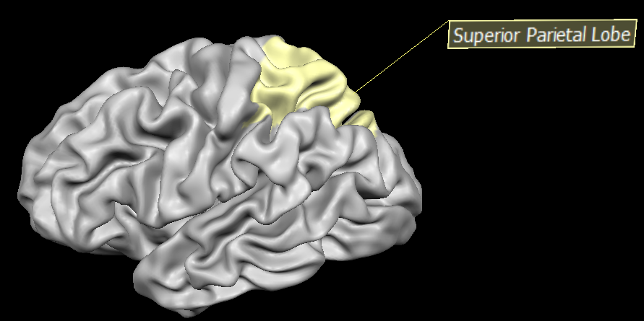

The **inferior parietal cortex** has been identified by 10 areas:

|  |  |
| --- | --- |
| Area | Parcel Index |
| L_PGp, R_PGp | 143, 323 |
| L_PGs, R_PGs | 151, 331 |
| L_PGi, R_PGi | 150, 330 |
| L_PFm, R_PFm | 149, 329 |
| L_PF, R_PF | 148, 328 |
| L_PFt, R_PFt | 116, 296 |
| L_PFop, R_PFop | 147, 327 |
| L_IP0, R_IP0 * | 146, 326 |
| L_IP1, R_IP1 * | 145, 325 |
| L_IP2, R_IP2 * | 144, 324 |

* IPS regions

These areas are surrounded by PFcm, OP4, 1, 2, AIP, LIPd, MIP, IPS1, V3B, V3CD, LO3, TPOJ1, TPOJ2, TPOJ3, STV, and PSL.

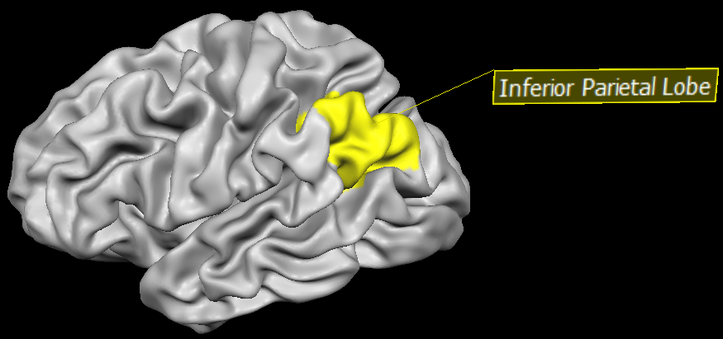

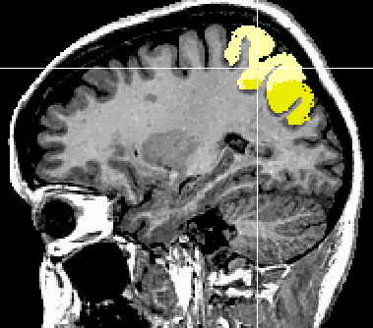 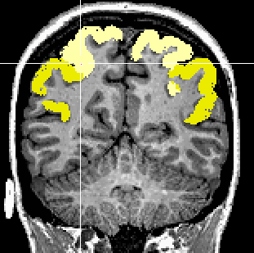 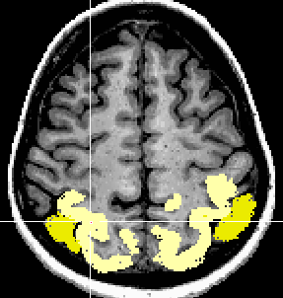

Superior (light yellow) and inferior (darker yellow) parietal lobules.

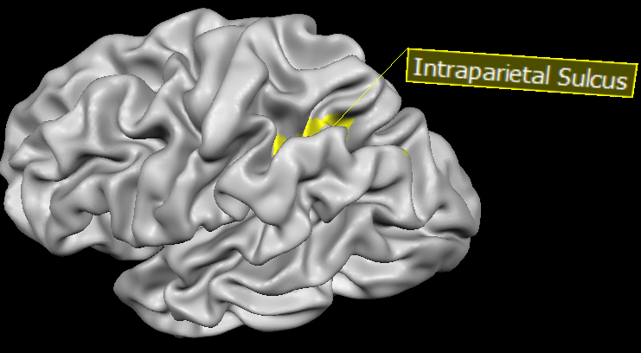

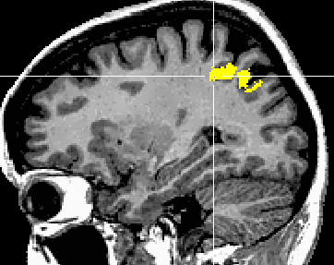 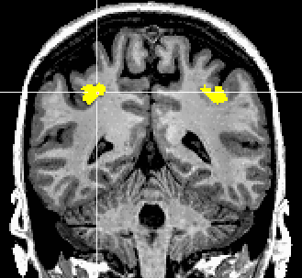 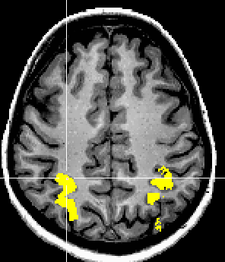

Following Benson et al., 2018, this is sort of how I would like to ‘model’ the FPN between these nodes of interest:



The FPN regions of activation from a metanalysis:

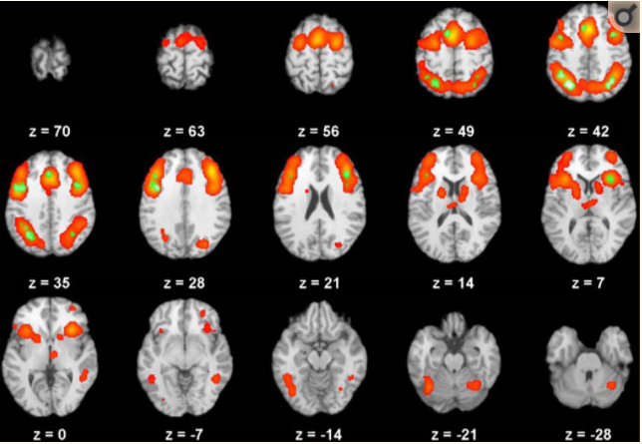

Global analysis of 193 healthy adults, with regions in red showing significant activation across all executive function domains, while regions in green showing significant activation in conjunction with three domains (flexibility, inhibition, and working memory) from more than nine studies. (Niendam, Laird, Ray, Dean, & Carter, 2012)

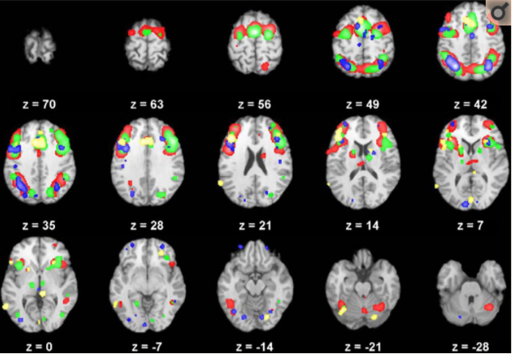

Red = working memory (78 studies)

Green = inhibition (79 studies)

Blue = flexibility (21 studies)

Yellow = initiation (9 studies)

(Niendam et al., 2012)

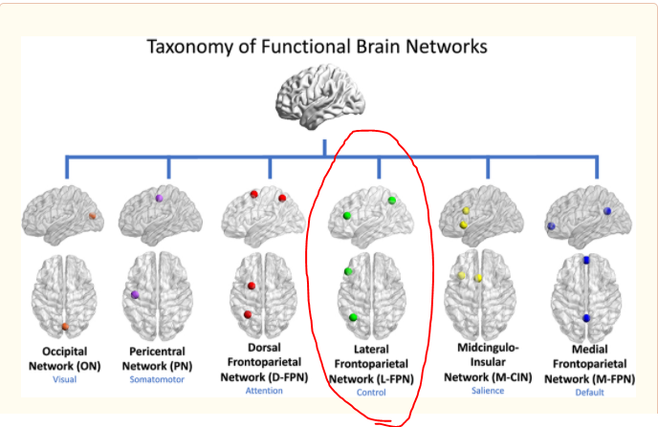

References

Benson, G., Hildebrandt, A., Lange, C., Schwarz, C., Köbe, T., Sommer, W., … Wirth, M. (2018). Functional connectivity in cognitive control networks mitigates the impact of white matter lesions in the elderly. Alzheimer’s Research and Therapy, 10(1), 1–13. https://doi.org/10.1186/s13195-018-0434-3

Cieslik, E. C., Zilles, K., Caspers, S., Roski, C., Kellermann, T. S., Jakobs, O., … Eickhoff, S. B. (2013). Is there one DLPFC in cognitive action control? Evidence for heterogeneity from Co-activation-based parcellation. Cerebral Cortex, 23(11), 2677–2689. https://doi.org/10.1093/cercor/bhs256

Glasser, M.F., Coalson, T.S., Robinson, E.C., Hacker, C.D., Harwell, J., Yacoub, E., Ugurbil, K., Andersson, J., Beckmann, C.F., Jenkinson, M., Smith, S.M., Van Essen, D.C., 2016b. A multi-modal parcellation of human cerebral cortex. Nature 536, 171–178. https://doi.org/10.1038/nature18933

Niendam, T. A., Laird, A. R., Ray, K. L., Dean, Y. M., & Carter, C. S. (2012). Meta-Analytic Evidence for a Superordinate Cognitive Control Network. *Cognitive, Affective and Behavioral Neuroscience*, *12*(2), 241–268. https://doi.org/10.3758/s13415-011-0083-5.Meta-analytic

Sanches, M., Caetano, S., Nicoletti, M., Monkul, E. S., Chen, H. H., Hatch, J. P., … Soares, J. C. (2009). An MRI-based approach for the measurement of the dorsolateral prefrontal cortex in humans. Psychiatry Research - Neuroimaging Neuroimaging, 173(2), 150–154. https://doi.org/10.1016/j.pscychresns.2009.02.007

Sridharan, D., Levitin, D. J., & Menon, V. (2008). A critical role for the right fronto-insular cortex in switching between central-executive and default-mode networks. Proceedings of the National Academy of Sciences of the United States of America, 105(34), 12569–12574. https://doi.org/10.1073/pnas.0800005105

Uddin, L. Q., Yeo, T. B. T., & Spreng, N. R. (2019). Towards a universal taxonomy of macro-scale functional human brain networks. Brain Topography, 32(6), 926–942. https://doi.org/10.1007/s10548-019-00744-6