Calculating diffusion voxel metrics (e.g., FA, MD, etc.) with MRtrix3

Visualise whole-brain DTI metrics

Voxel-based analysis (VBA), similar to fixel-based analysis (FBA), follows the same principles as threshold-free cluster enhancement permutation testing (Smith & Nichols, 2009; Winkler et al., 2014). This is similar to what [Mito et al., 2018](https://pubmed.ncbi.nlm.nih.gov/29309541/) had done – you can find this in their supplementary files.

1. You will need to first create an FA (or other DTI metric) map for every participant. You can do this with dwi2tensor and then tensor2metric.

Sample commands:

dwi2tensor sub-ADPRC0001F0_acq_data_dwi.mif sub-ADPRC0001F0_dt_image.mif

tensor2metric sub-ADPRC0001F0_dt_image.mif -fa sub-ADPRC001F0_fa.mif

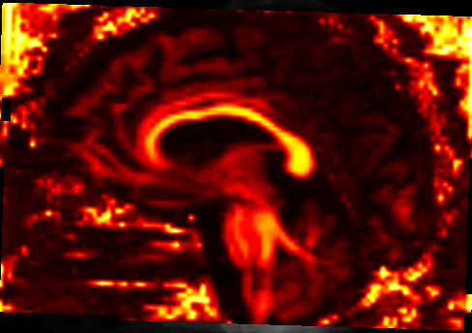

FA image of a participant in their native space

1. You then need to warp (using mrtransform) the subject DTI maps to the population template. The population template is the white matter fibre orientation density population template (wmfod_template.mif) which was used in the FBA. You can also use the subject-to-template registration and warps which was used in FBA.

Sample command:

mrtransform sub-ADPRC0001F0_fa.mif -warp sub-ADPRC0001F0_subject2template_warp.mif sub-ADPRC0001F0_template_space_fa.mif

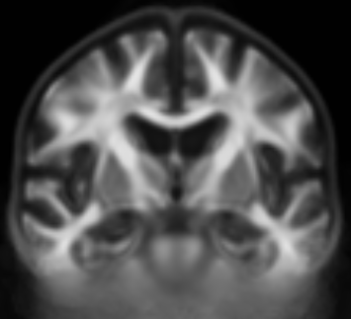

Wmfod population template

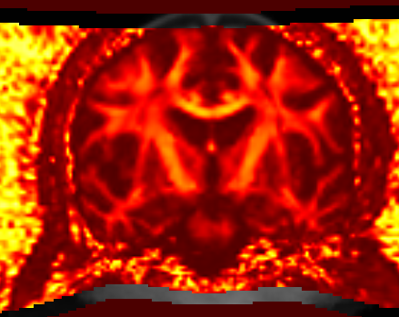

Warped subject FA map onto wmfod population template space

1. Run voxel-based statistical analysis on the DTI metrics. VBA can be down with mrclusterstats with the default parameters (*dh* = 0.1, *E* = 0.5, *H* = 2). You will need to use the wmfod template mask, which was also done in the FBA.

Sample command:

mrclusterstats whole-brain_DTI_FA_input.txt design_matrix.txt contrast_matrix.txt template_mask.mif stats_results/stats_fa/fa_

You can then visualise significant differences in the DTI metrics between groups.

Derive tract-specific DTI metrics

This can be done with tcksample. Similar steps are done from the whole-brain DTI metric pipeline, and so you can use the same output files for this.

1. You will need to first create an FA (or other DTI metric) map for every participant. You can do this with dwi2tensor and then tensor2metric. You will also need to have the tract of interest template file (in .tck format).

Sample commands:

dwi2tensor sub-ADPRC0001F0_acq_data_dwi.mif sub-ADPRC0001F0_dt_image.mif

tensor2metric sub-ADPRC0001F0_dt_image.mif -fa sub-ADPRC001F0_fa.mif



FA image of a participant in their native space

1. Run tcksample to extract the tract-specific DTI metrics.

tcksample SLF1_track_L.tck sub-ADPRC0001F0_fa.mif FA_LSLF1_sub-ADPRC0001F0.txt -stat_tck mean

tcksample will give you a .txt output file (can also specify to other .ascii files, like .csv). It will give you a value for every streamline; e.g., so it will give you 10,000 mean FA values for a 10,000-fibre superior longitudinal fasciculus (SLF) tract.

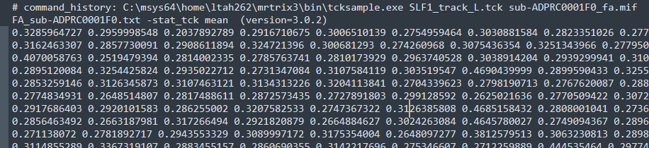

You can then take the mean of all 10,000 values to get one singular, mean FA value for each participant.

Further information:

(For tcksample):

<https://community.mrtrix.org/t/how-to-compute-tract-specific-metrics/2410>

<https://community.mrtrix.org/t/how-to-extract-fa-value-from-extracted-fibers/4497/4>